**ACM Hackathon**

**Team : PEC**

**MEMBERS :**

**1. Pritish Thakkar**

**2. Sahil Khosla**

Topic : TIC TAC TOE using socket programming

**OS** : Ubuntu 16.04

**Software / Framework** : Netbeans

**Language** : JAVA

**IDEA** : When i was learning java i create a simple chatting app using socket programming and i extend that simple chatting app to make this multiplayer game. That’s why my project name is chatting app.

**GUI :** Whole GUI is created using drag and drop option in Netbeans.

**Game Files :**

1. **HOSTPLAYER.java :** This program is for the player who wants to host the game i.e. want to act as a server.

**2. CLIENTPLAYER.java :** As the name suggests it’s for player who will send a request to host player for connection. This program will ask for ip address for the host player.

**HOW TO RUN THE GAME ?**

1. Install Netbeans IDE

2. Extract the files from zip folder i’ve uploaded on hackerearth.

3. Open Netbeans.

4. Go to **File > Open Project ..**

5.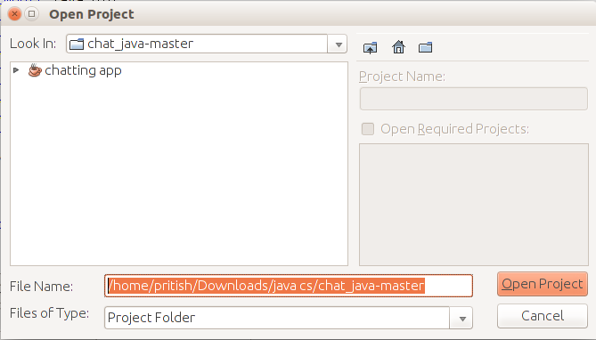 Now Locate the folder 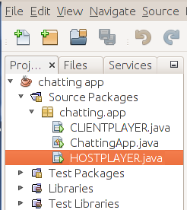**chat_java-master.**

6. Click on chatting app and then open project.

7. And now following packages will be included in Netbeans.

8. Now Click in the following order **chatting app > Source Packages > chatting.app**

9. Right click on **HOSTPLAYER.java** and click **Run File.**

10. Following screen will appear.

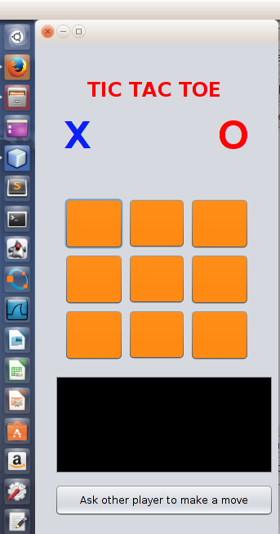

11. Similarly run **CLIENTPLAYER.java.**

12. Following screen will appear.

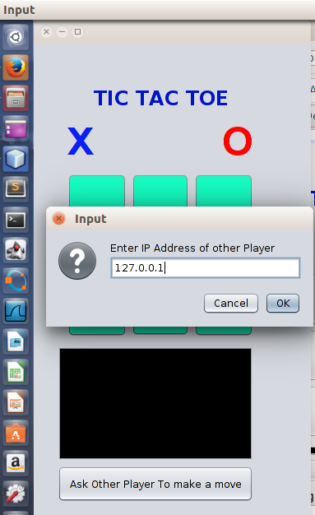

13. As we are running our app on LocalHost so use IP address i used “127.0.0.1”.

14. Now 2 Players can play the game.

15. This is for testing purposes only.

16. If the programms are properly installed on 2 different machines and IP address of HOSTPLAER is known the program will successfully run on 2 different Computers.

**SCREENSHOTS AND SOME NOTES :**

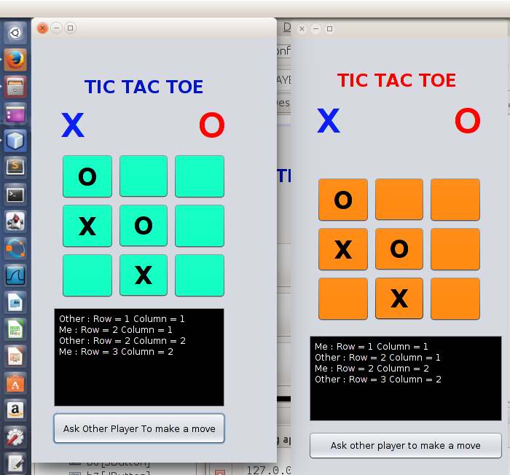

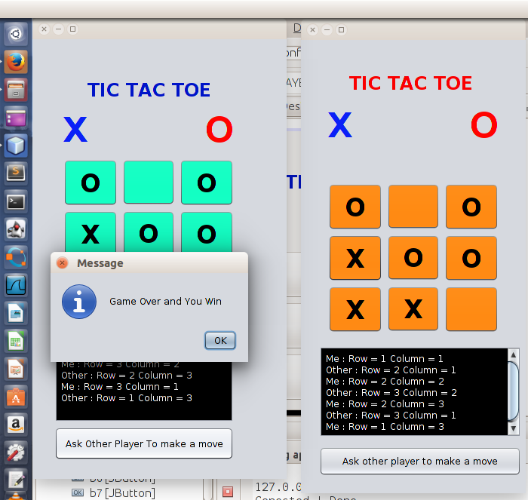

**Note :**

> In above picture Green player won and orange player lose.

> As soon as the green player click ok, a similar message dialog will get appeared on orange’s player screen :

**“GAME OVER AND YOU LOSE”**

> This game also tests for TIE and a message dialog will appear “**GAME OVER AND MATCH DRAW**”

> Port Number we are using is 3000.

“**THANK YOU**”