Activity Lifecycle

------------------------------------------------------------

BackStack

------------------------------------------------------------

android:screenOrientation="landscape"

-------------------------------------------------------------------------------------------------------------------------

android:configChanges="orientation" (in Manifest File)

@Override  
**public void** onConfigurationChanged(Configuration newConfig) {  
 **super**.onConfigurationChanged(newConfig);  
  
 *// Checks the orientation of the screen* **if** (newConfig.**orientation** == Configuration.***ORIENTATION_LANDSCAPE***) {  
 Toast.*makeText*(**this**, **"landscape"**, Toast.***LENGTH_SHORT***).show();  
 } **else if** (newConfig.**orientation** == Configuration.***ORIENTATION_PORTRAIT***){  
 Toast.*makeText*(**this**, **"portrait"**, Toast.***LENGTH_SHORT***).show();  
 }  
}

-------------------------------------------------------------------------------------------------------------------------

Save Activity State: id of component allow automatically our app to save edit text data when screen orientation changes.

onSaveInstanceState() & onRestoreInstanceState() : they called when screen rotated.

@Override  
**protected void** onSaveInstanceState(Bundle outState) {  
 **super**.onSaveInstanceState(outState);  
 outState.putInt(**"counter"** , **counter**);  
 Log.*d*(**"vvv"** , **counter**+**"was saved"**);  
}  
  
  
@Override  
**protected void** onRestoreInstanceState(Bundle savedInstanceState) {  
 **super**.onRestoreInstanceState(savedInstanceState);  
 **int** val = savedInstanceState.getInt(**"counter"**);  
 Log.*d*(**"vvv"** , val+**""**);  
 Toast.*makeText*(**this**, val+**""**, Toast.***LENGTH_SHORT***).show();  
}

----------------------------------------------------------------------------------------------------------------------------

Intent used for

1- Transmit between two activities.

2- Start Services

3- used with broadcast receiver.

4-used to determine launcher activity (intent filter in manifest).

Intent i = **new** Intent(MainActivity.**this** , SecondActivity.**class**); startActivity(i);

Another way for Intent

Intent i = **new** Intent();

i.setClassName("com.mahfouz.android.apps.mytestapp" , "com.mahfouz.android.apps.mytestapp.SecondActivity");

startActivity(i);

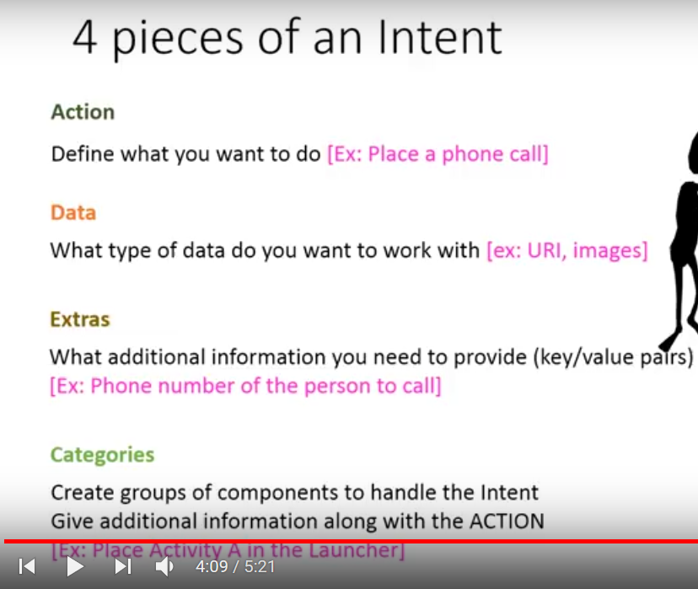

Intent Filter

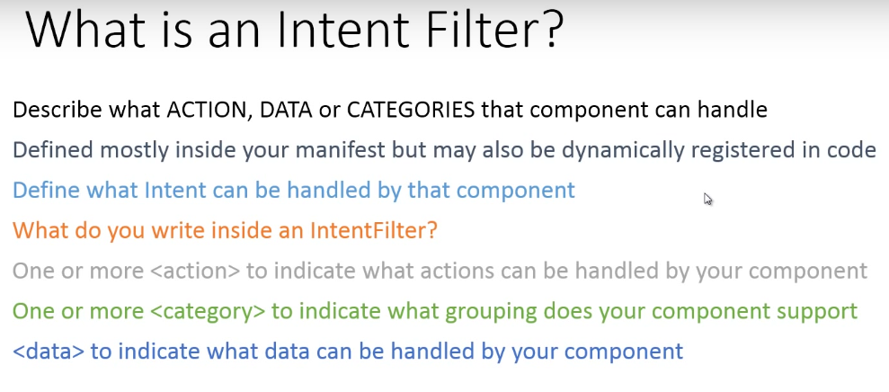

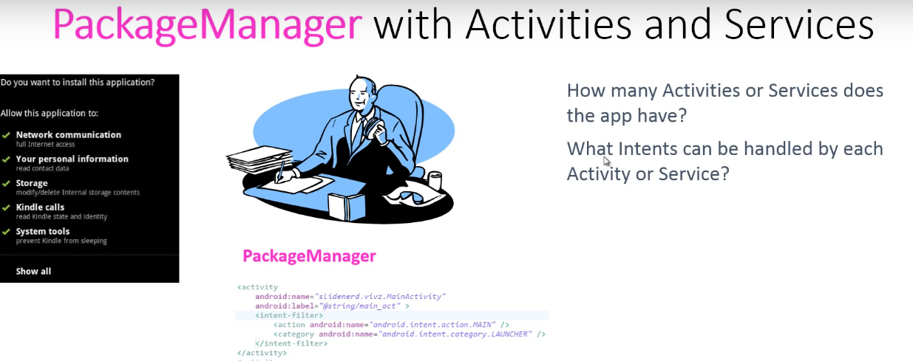

ولما ال package Manager يبدأ ي check ال intent filter بتاع ال activities الموجوده عنده على الجهاز يبدأ يرجع list بال activities اللى تقدر ت هندل ال request بتاع ال intent المبعوته دى (ده بيسموه ال intent resolution) يعنى لما package Manager يcheck ال action,data,category اللى موجودين فى كل ال intent filter الخاص بكل activity ويرجع list بال activities اللى تقدر تهندل ال request ده لو ال list كبيرة نقول ان ال intent resolution كبيرة والعكس

(Dealing with google Maps)

Intent i = **new** Intent(Intent.***ACTION_VIEW***);  
i.setData(Uri.*parse*(**"geo:19.067,72.8777?z=28"**)); *// z:for Zomming*startActivity(i);

(Used to open web Page)

*//note chooser used to pop up dialog to select among more than one app can handel your intent request*

Intent intent = **new** Intent(Intent.***ACTION_VIEW***);  
intent.setData(Uri.*parse*(**"market://details?id=dolphin.developers.com"**));  
Intent intentChooser = Intent.*createChooser*(intent , **"Lunch Market"**);  
startActivity(intentChooser);

(Send Email)

**if** (view.getId() == R.id.***button1***) {  
 Intent i = **new** Intent(Intent.***ACTION_SEND***);  
 i.setData(Uri.*parse*(**"mailto:"**));  
 String[]to = {**"ma7fozm@gmail.com"** , **"ma7fozm@yahoo.com"**};  
 i.putExtra(Intent.***EXTRA_EMAIL*** , to);  
 i.putExtra(Intent.***EXTRA_SUBJECT*** , **"Ay 7aga"**);  
 i.putExtra(Intent.***EXTRA_TEXT*** , **"this is my android test"**);  
 i.setType(**"message/rfc822"**); //very important to send email through emulator  
 Intent intentChooser = Intent.*createChooser*(i , **"Send Email"**);  
 startActivity(intentChooser);

(Send Image from drawable)

Uri imgUri = Uri.*parse*(**"android.resource://com.mahfouz.android.apps.mytestapp/drawable /"**+R.drawable.***img***);  
Intent i = **new** Intent(Intent.***ACTION_SEND***);  
i.setType(**"image/*"**);  
i.putExtra(Intent.***EXTRA_STREAM*** , imgUri);  
i.putExtra(Intent.***EXTRA_TEXT*** , **"Hey I have attached this Image"**);  
Intent intentChooser = Intent.*createChooser*(i , **"Send Image"**);  
startActivity(intentChooser)

(Sharing multiple images from internal storage)

File pictures = Environment.*getExternalStoragePublicDirectory*(Environment.*DIRECTORY_DCIM*);  
String[]listOfPictures = pictures.list();  
Uri uri = **null**;  
ArrayList<Uri> arrayList = **new** ArrayList<Uri>();  
**for**(String picture : listOfPictures){  
   
 uri = Uri.*parse*(**"file://"**+pictures.toString()+**"/"**+picture);  
 arrayList.add(uri);  
}  
Intent i =**new** Intent(Intent.***ACTION_SEND_MULTIPLE***);  
i.setType(**"image/*"**);  
i.putExtra(Intent.***EXTRA_STREAM*** , arrayList);  
Intent intentChooser = Intent.*createChooser*(i , **"Send Multiple Images"**);  
startActivity(intentChooser);

Toast and control its position with gravity

Toast toast = Toast.makeText (MainActivity.**this**, **"Hi, I’m Mohamed Mahfouz"**, Toast.***LENGTH_LONG***);  
 toast.setGravity(Gravity.***CENTER*** , 100 , 400);  
 toast.show();

View & View Group

