Map Routingm

*Team members :-

1. Wael Mohammed Abd El_Moati.

ID :-2016170615.

Gmail🡪 Wael.mohamed91.22@gmail.com

1. Mahmoud Hamed Mohammed Hassan.

ID :-2016170605.

1. Gehad Khaled Sayed.

ID :-2016170142.

1. Ahmed Mohammed Saadallah

ID :-2016170048.

1. Asmaa Hamed Mohammed Abd El_Rahman.

ID :-2016170089.

Now discuss the code (*_*)

*Let’s start with class queries :- this class read from **Queries** file (this file contain the coordinates of source and destination and R (R it’s maximum distance the person can walk for maximum R meters to get from an intersection to the source).

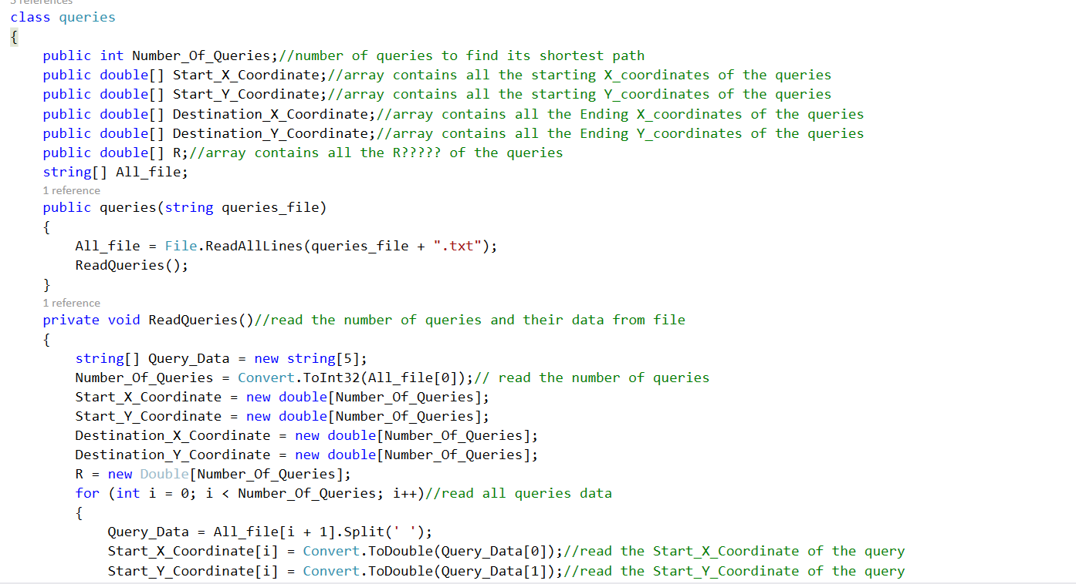

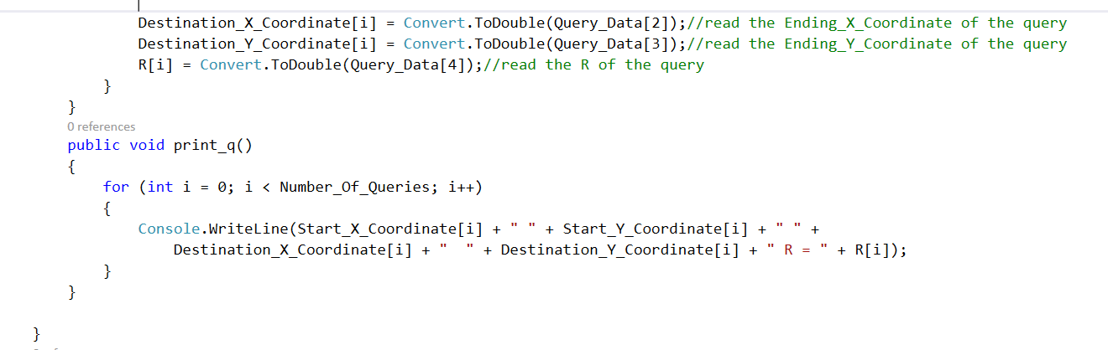

(*_*) Hear We Discuss The Code Line by Line (*_*)

/* Notes :-

1)each vertices contain x,y coordinates .

2)each edge contain 2 vertices ,speed of route ,distance).

3)the meaning of start (source:The place of person ).

4)V::mean node or intersection .

5)E::mean edge or road .

6)n :: number of queries.

*/

class queries

{

public int Number_Of_Queries;

🡺number of queries to find its shortest path

🡺Complexity:o(1).

public double[] Start_X_Coordinate;

🡺array contains all the starting X_coordinates of the queries

🡺Complexity:o(1).

public double[] Start_Y_Coordinate;

🡺array contains all the starting Y_coordinates of the queries

🡺Complexity:o(1).

public double[] Destination_X_Coordinate;

🡺array contains all the Ending X_coordinates of the queries

🡺Complexity:o(1).

public double[] Destination_Y_Coordinate;

🡺array contains all the Ending Y_coordinates of the queries

🡺Complexity:o(1).

public double[] R;

🡺array contains all the R????? of the queries

🡺Complexity:o(1).

string[] All_file;

🡺Complexity:o(1).

public queries(string queries_file)

{

All_file = File.ReadAllLines(queries_file + ".txt");

🡺Complexity:o(1).

ReadQueries();

🡺Complexity:o(1).

}

◆🡻🡻The complexity of function(ReadQueries)=o(body)=o(n).

private void ReadQueries()

🡺read the number of queries and their data from file

{

string[] Query_Data = new string[5];

🡺Complexity:o(1).

Number_Of_Queries = Convert.ToInt32(All_file[0]);

🡺read the number of queries

🡺Complexity:o(1).

Start_X_Coordinate = new double[Number_Of_Queries];

🡺Complexity:o(1).

Start_Y_Coordinate = new double[Number_Of_Queries];

🡺Complexity:o(1).

Destination_X_Coordinate = new double[Number_Of_Queries];

🡺Complexity:o(1).

Destination_Y_Coordinate = new double[Number_Of_Queries];

🡺Complexity:o(1).

R = new Double[Number_Of_Queries];

🡺Complexity:o(1).

⍟◆🡻Complexity of loop =number of iterations * o(body of loop)--🡪here=n*o(1)=o(n).

for (int i = 0; i < Number_Of_Queries; i++)

🡺read all queries data

{

Query_Data = All_file[i + 1].Split(' ');

🡺Complexity:o(1).

Start_X_Coordinate[i] = Convert.ToDouble(Query_Data[0]);

🡺read the Start_X_Coordinate of the query

🡺Complexity:o(1).

Start_Y_Coordinate[i] = Convert.ToDouble(Query_Data[1]);

🡺read the Start_Y_Coordinate of the query

🡺Complexity:o(1).

Destination_X_Coordinate[i] = Convert.ToDouble(Query_Data[2]);

🡺read the Ending_X_Coordinate of the query

🡺Complexity:o(1).

Destination_Y_Coordinate[i] = Convert.ToDouble(Query_Data[3]);

🡺read the Ending_Y_Coordinate of the query

🡺Complexity:o(1).

R[i] = Convert.ToDouble(Query_Data[4]);

🡺read the R of the query

🡺Complexity:o(1).

}

}

◆🡻🡻The complexity of function(print_q)=o(body)=o(n).

public void print_q()

{

⍟◆🡻Complexity of loop =number of iterations * o(body of loop)--🡪here=n*o(1)=o(n).

for (int i = 0; i < Number_Of_Queries; i++)

{

Console.WriteLine(Start_X_Coordinate[i] + " " + Start_Y_Coordinate[i] + " " +

Destination_X_Coordinate[i] + " " + Destination_Y_Coordinate[i] + " R = " + R[i]);

🡺Complexity:o(1).

}

}

}

*Now We Finish discussion of Class Queries(*_*)

*Let’s start with class graph :- this class read from map file (this file contain the number of vertices and for each vertices found its coordinates and R then number of edges , each edge contain 2 vertices with its speed and distance ).

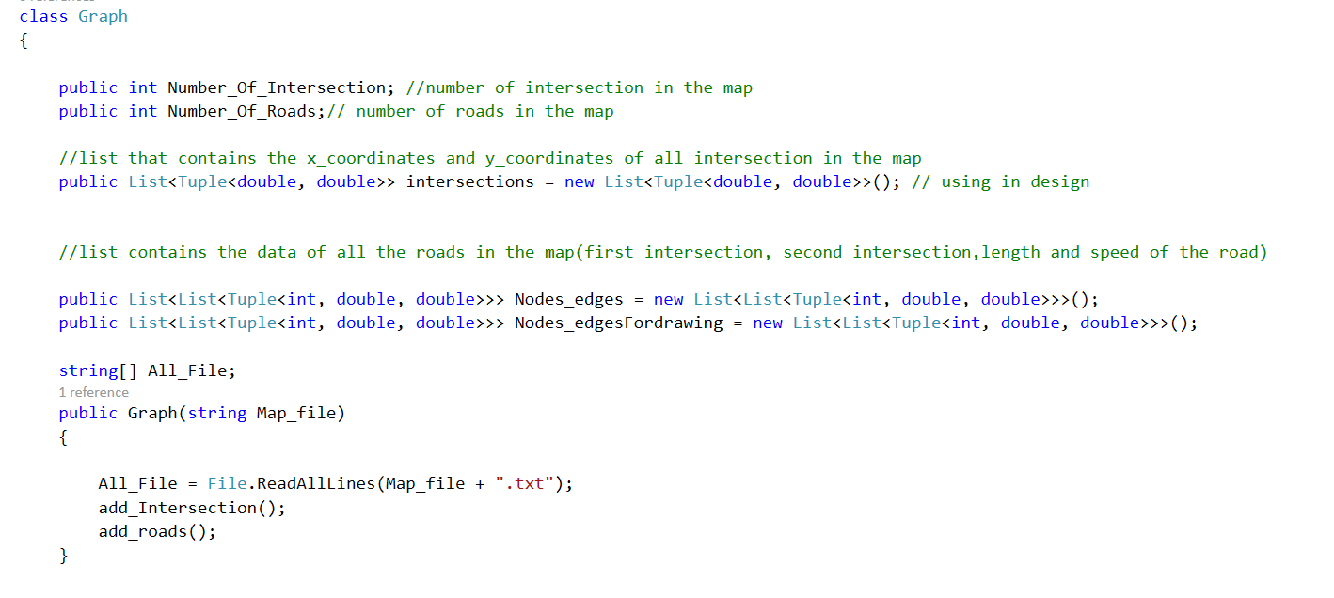

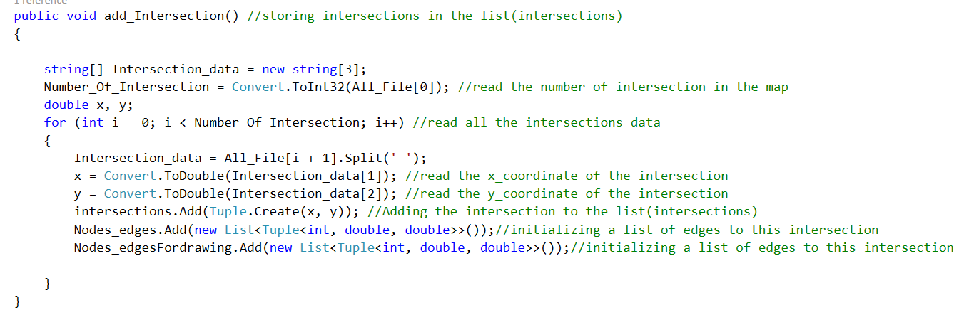

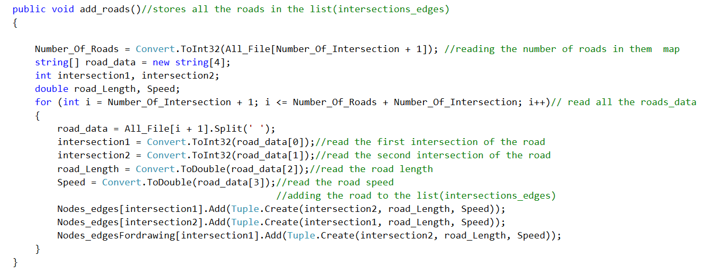

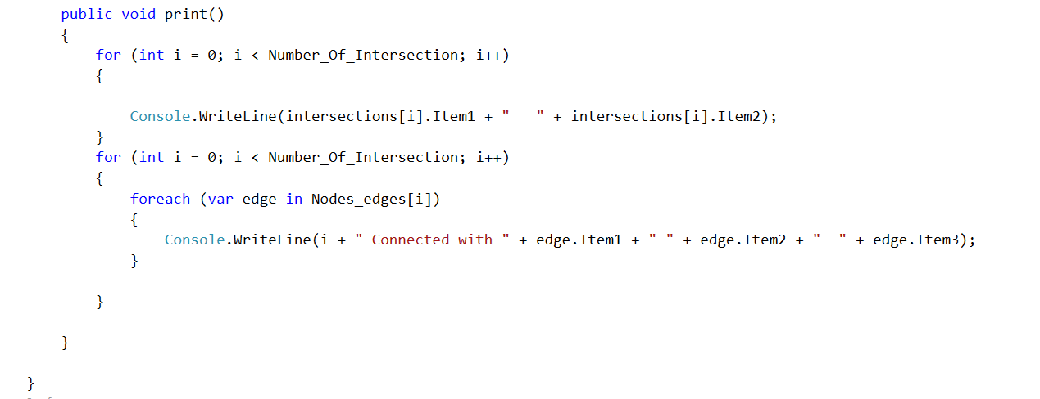

(*_*)Here WE Discuss Class Graph Line BY line (*_*)

class Graph

{

public int Number_Of_Intersection;

🡺number of intersection in the map

🡺Complexity:o(1).

public int Number_Of_Roads;

🡺 number of roads in the map

🡺Complexity:o(1).

🡺list that contains the x_coordinates and y_coordinates of all intersection in the map

public List<Tuple<double, double>> intersections = new List<Tuple<double, double>>();

🡺Complexity:o(1).

🡺using in design

🡺 list contains the data of all the roads in the map(first intersection, second intersection,length and speed of the road)

public List<List<Tuple<int, double, double>>> Nodes_edges = new List<List<Tuple<int, double, double>>>();

🡺Complexity:o(1).

public List<List<Tuple<int, double, double>>> Nodes_edgesFordrawing = new List<List<Tuple<int, double, double>>>();

🡺Complexity:o(1).

string[] All_File;

🡺Complexity:o(1).

public Graph(string Map_file)

{

All_File = File.ReadAllLines(Map_file + ".txt");

🡺Complexity:o(1).

add_Intersection();

🡺Complexity:o(1).

add_roads();

🡺Complexity:o(1).

}

◆🡻🡻The complexity of function(add_Intersection)=o(body)=o(V).

public void add_Intersection()

🡺storing intersections in the list(intersections)

{

string[] Intersection_data = new string[3];

🡺Complexity:o(1).

Number_Of_Intersection = Convert.ToInt32(All_File[0]);

🡺read the number of intersection in the map

🡺Complexity:o(1).

double x, y;

🡺Complexity:o(1).

⍟◆🡻Complexity of loop =number of iterations * o(body of loop)--🡪here=V*o(1)=o(V).

for (int i = 0; i < Number_Of_Intersection; i++)

🡺read all the intersections_data

{

Intersection_data = All_File[i + 1].Split(' ');

🡺Complexity:o(1).

x = Convert.ToDouble(Intersection_data[1]);

🡺read the x_coordinate of the intersection

🡺Complexity:o(1).

y = Convert.ToDouble(Intersection_data[2]);

🡺read the y_coordinate of the intersection

🡺Complexity:o(1).

intersections.Add(Tuple.Create(x, y));

🡺Adding the intersection to the list(intersections)

🡺Complexity:o(1).

Nodes_edges.Add(new List<Tuple<int, double, double>>());

🡺initializing a list of edges to this intersection

🡺Complexity:o(1).

Nodes_edgesFordrawing.Add(new List<Tuple<int, double, double>>());

🡺initializing a list of edges to this intersection

🡺Complexity:o(1).

}

}

◆🡻🡻The complexity of function(add_roads)=o(body)=o(E).

public void add_roads()

🡺stores all the roads in the list(intersections_edges)

{

Number_Of_Roads = Convert.ToInt32(All_File[Number_Of_Intersection + 1]); 🡺reading the number of roads in them map

🡺Complexity:o(1).

string[] road_data = new string[4];

🡺Complexity:o(1).

int intersection1, intersection2;

🡺Complexity:o(1).

double road_Length, Speed;

🡺Complexity:o(1).

⍟◆🡻Complexity of loop =number of iterations * o(body of loop)--🡪here=V+E*o(1)=o(V+E).

for (int i = Number_Of_Intersection + 1; i <= Number_Of_Roads + Number_Of_Intersection; i++)

🡺read all the roads_data

{

road_data = All_File[i + 1].Split(' ');

🡺Complexity:o(1).

intersection1 = Convert.ToInt32(road_data[0]);

🡺read the first intersection of the road

🡺Complexity:o(1).

intersection2 = Convert.ToInt32(road_data[1]);

🡺read the second intersection of the road

🡺Complexity:o(1).

road_Length = Convert.ToDouble(road_data[2]);

🡺read the road length

🡺Complexity:o(1).

Speed = Convert.ToDouble(road_data[3]);

🡺read the road speed

🡺Complexity:o(1).

🡺adding the road to the list(intersections_edges)

Nodes_edges[intersection1].Add(Tuple.Create(intersection2, road_Length, Speed));

🡺Complexity:o(1).

Nodes_edges[intersection2].Add(Tuple.Create(intersection1, road_Length, Speed));

🡺Complexity:o(1).

Nodes_edgesFordrawing[intersection1].Add(Tuple.Create(intersection2, road_Length, Speed));

🡺Complexity:o(1).

}

}

◆🡻🡻The complexity of function(print)=o(body)=o(V).

public void print()

{

⍟◆🡻Complexity of loop =number of iterations * o(body of loop)--🡪here=V*o(1)=o(V).

for (int i = 0; i < Number_Of_Intersection; i++)

{

Console.WriteLine(intersections[i].Item1 + " " + intersections[i].Item2);

🡺Complexity:o(1).

}

⍟◆🡻Complexity of nested loop =number of iterations * o(inner loop)--🡪here=V*o(v)=o(V^2).

for (int i = 0; i < Number_Of_Intersection; i++)

{

foreach (var edge in Nodes_edges[i])

{

Console.WriteLine(i + " Connected with " + edge.Item1 + " " + edge.Item2 + " " + edge.Item3);

🡺Complexity:o(1).

}

}

}

}

*Now We Finish discussion of Class graph (*_*)

**Let’s Start with class Shortest_Path :-

*IN This Class We Calculate Shortest Path From Source to Destination depends on dijkstra algorithm .

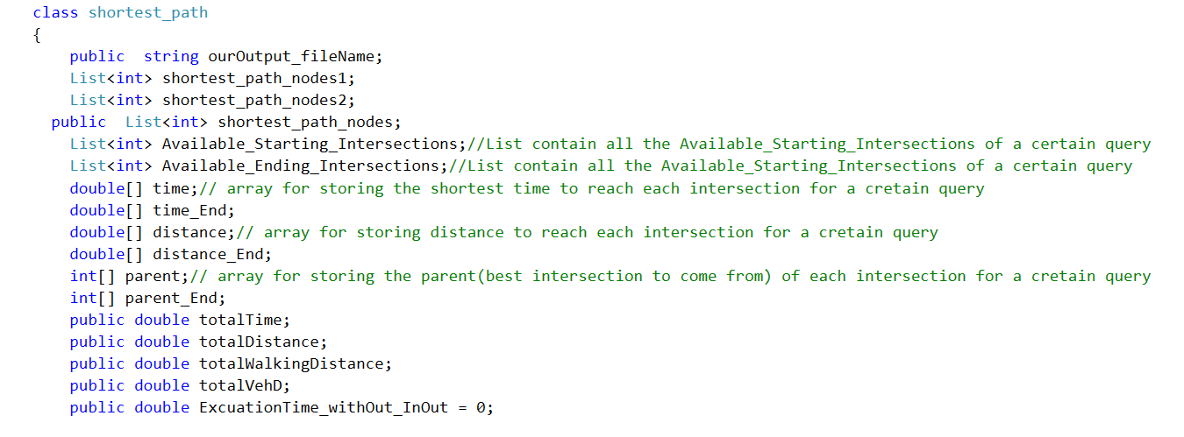

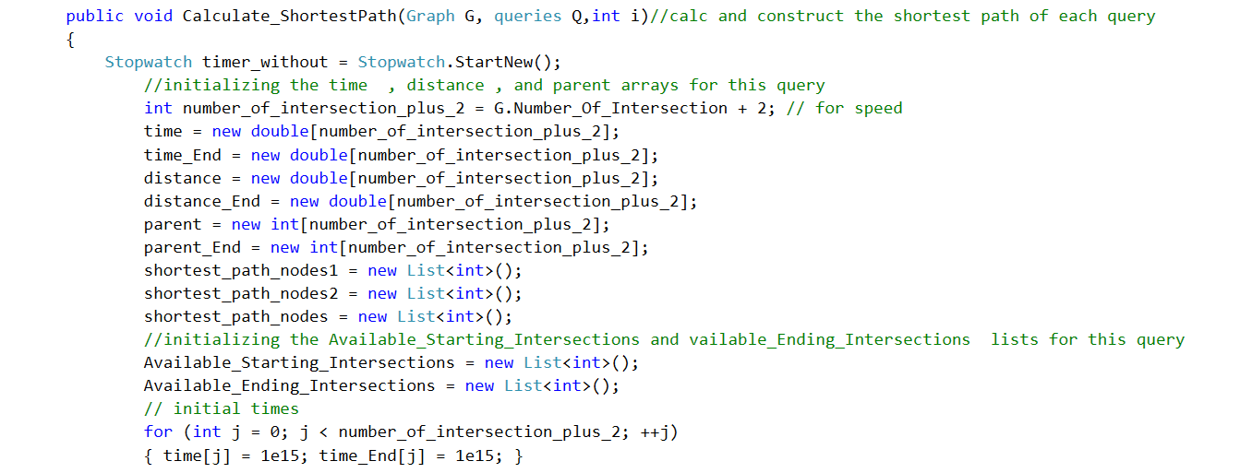

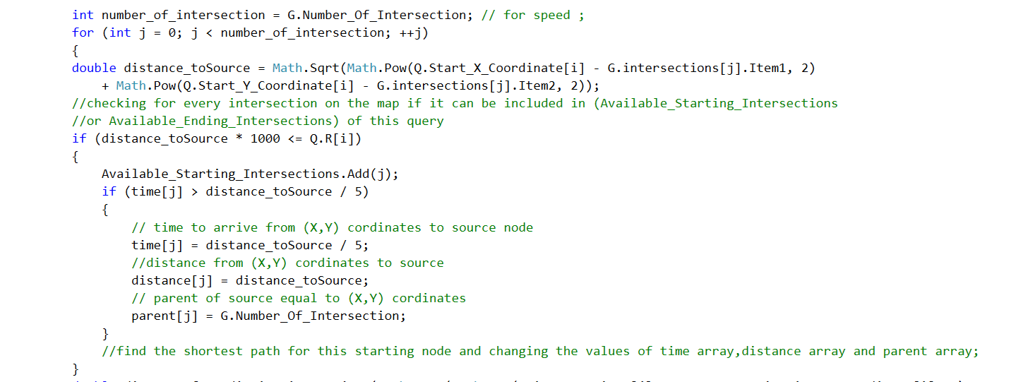

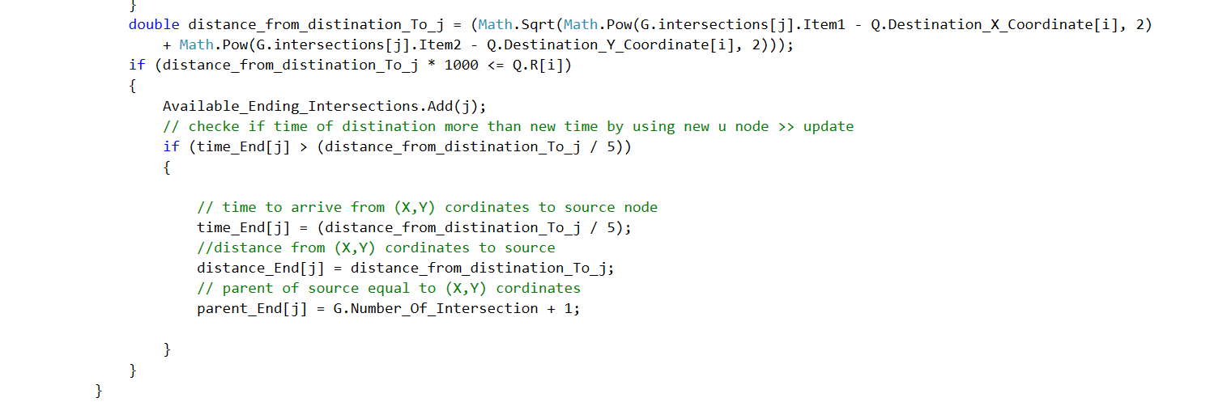

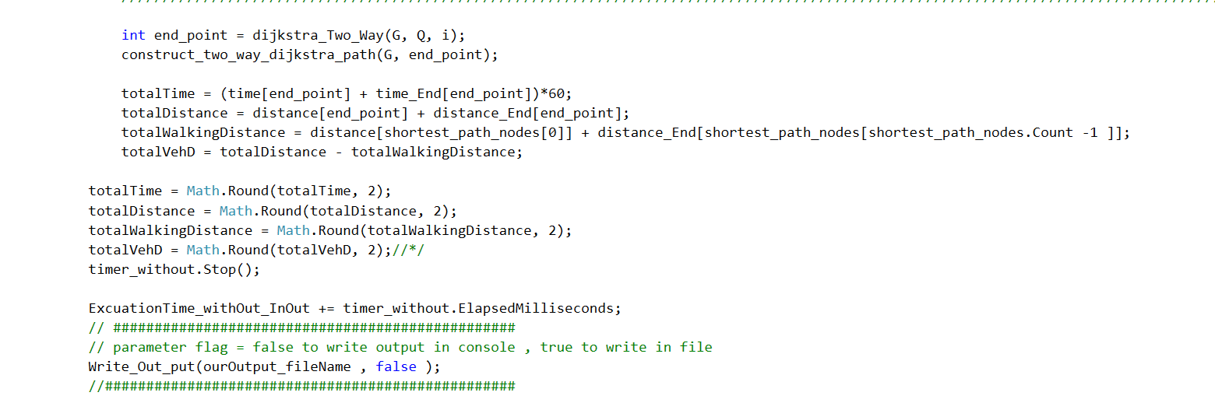

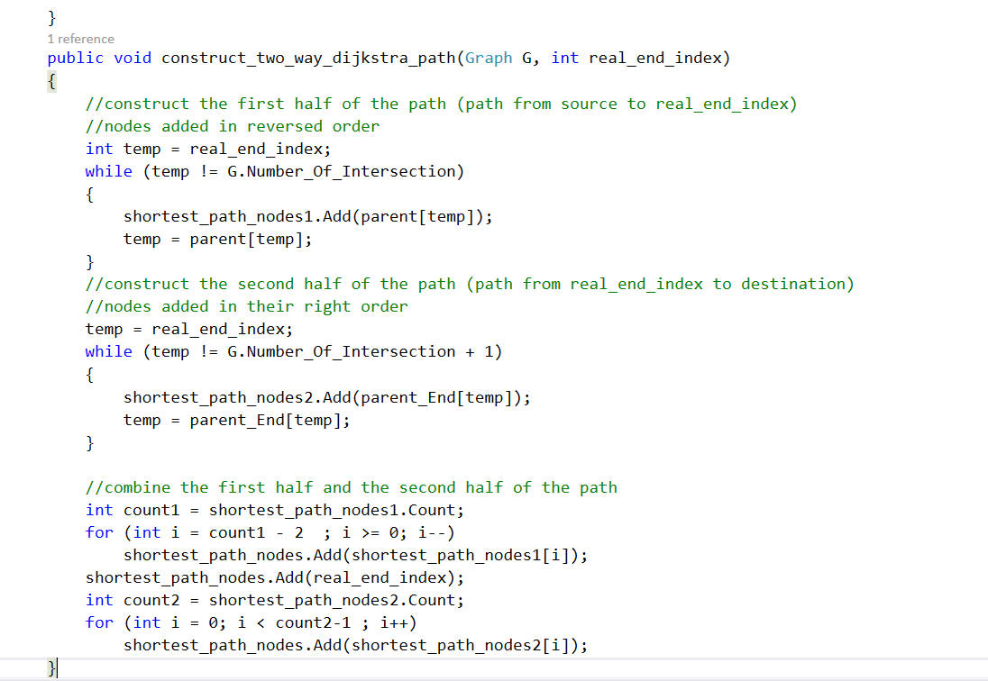

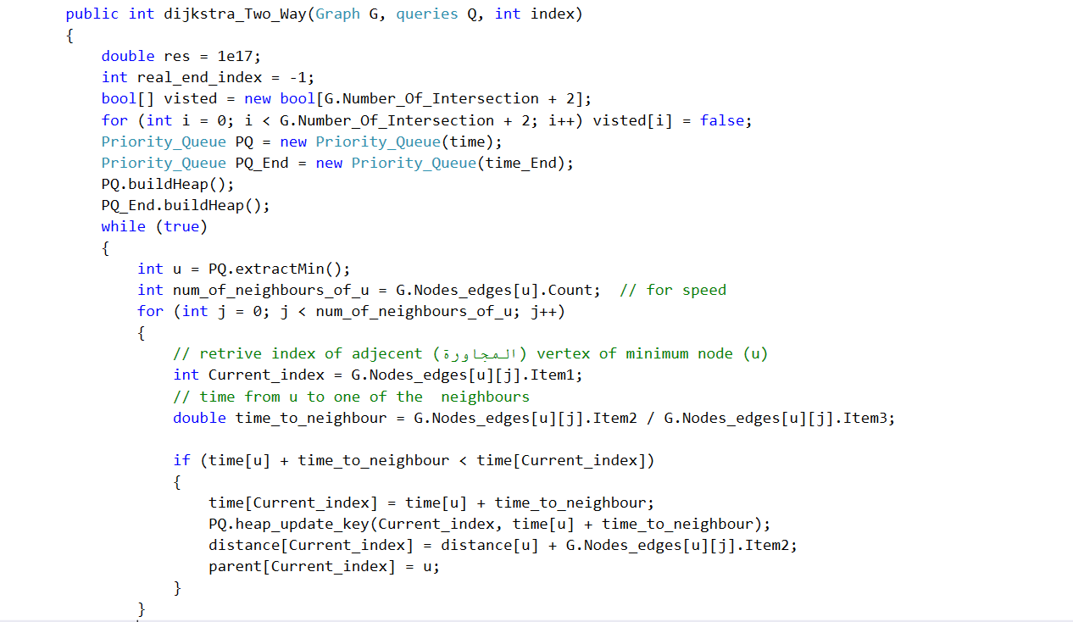

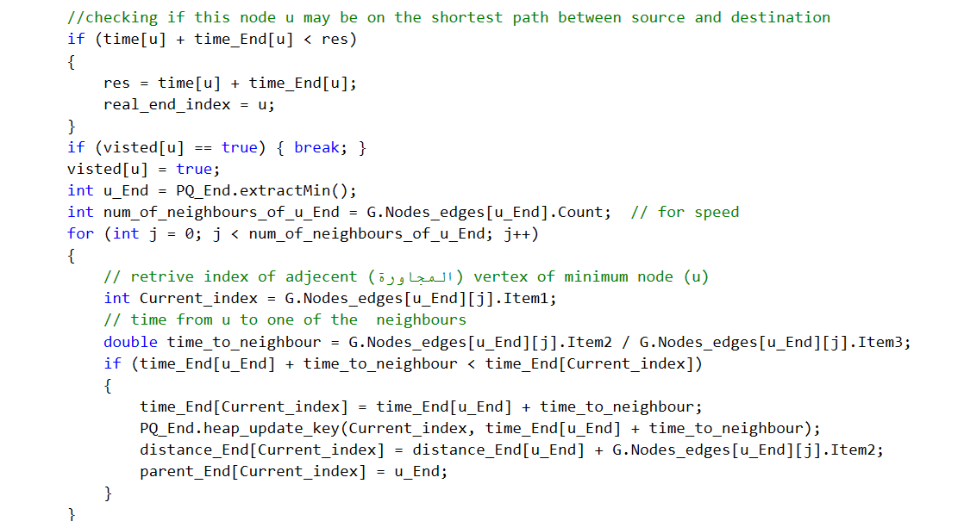

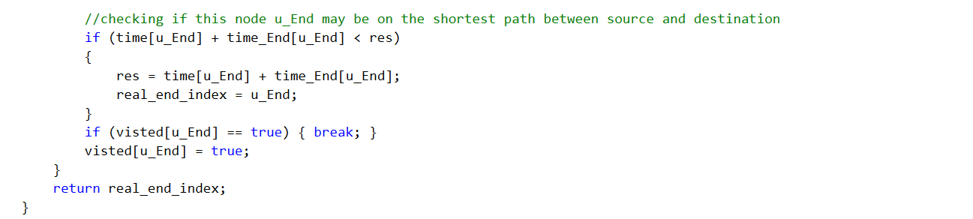

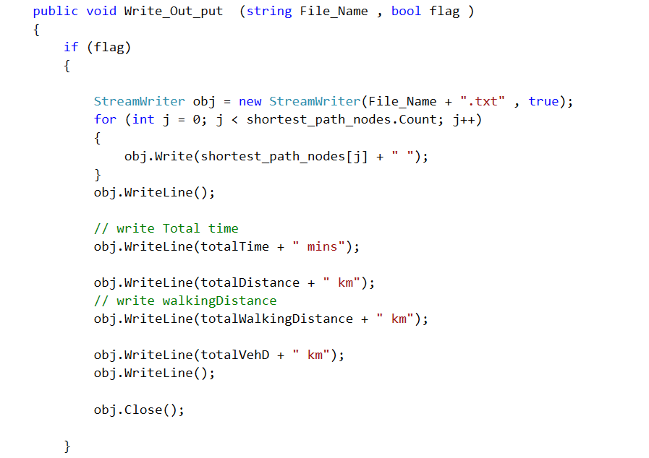

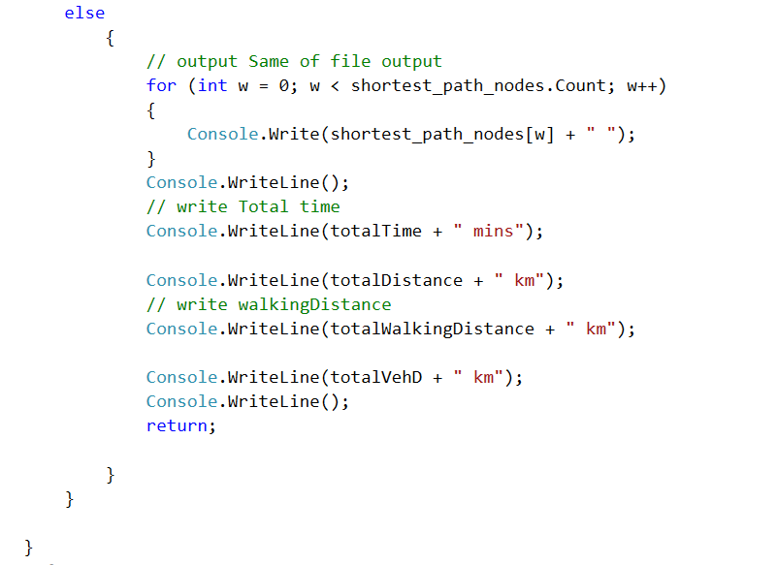

(*_*)Here WE Discuss Class Shortest_Path Line BY line (*_*)

class shortest_path

{

public string ourOutput_fileName;

🡺Complexity:o(1).

List<int> shortest_path_nodes1;

🡺Complexity:o(1).

List<int> shortest_path_nodes2;

🡺Complexity:o(1).

public List<int> shortest_path_nodes;

🡺Complexity:o(1).

List<int> Available_Starting_Intersections;

🡺List contain all the Available_Starting_Intersections of a certain query

🡺Complexity:o(1).

List<int> Available_Ending_Intersections;

🡺List contain all the Available_Starting_Intersections of a certain query

🡺Complexity:o(1).

double[] time;

🡺array for storing the shortest time to reach each intersection for a cretain query

🡺Complexity:o(1).

double[] time_End;

🡺Complexity:o(1).

double[] distance;

🡺 array for storing distance to reach each intersection for a cretain query

🡺Complexity:o(1).

double[] distance_End;

🡺Complexity:o(1).

int[] parent;

🡺Complexity:o(1).

🡺 array for storing the parent(best intersection to come from) of each intersection for a cretain query

int[] parent_End;

🡺Complexity:o(1).

public double totalTime;

🡺Complexity:o(1).

public double totalDistance;

🡺Complexity:o(1).

public double totalWalkingDistance;

🡺Complexity:o(1).

public double totalVehD;

🡺Complexity:o(1).

public double ExcuationTime_withOut_InOut = 0;

🡺Complexity:o(1).

◆🡻🡻The complexity of function(Calculate_ShortestPath)=o(body)=o(E`log V`).

public void Calculate_ShortestPath(Graph G, queries Q,int i)

🡺calc and construct the shortest path of each query

{

Stopwatch timer_without = Stopwatch.StartNew();

🡺initializing the time , distance , and parent arrays for this query

🡺Complexity:o(1).

int number_of_intersection_plus_2 = G.Number_Of_Intersection + 2;

🡺for speed

🡺Complexity:o(1).

time = new double[number_of_intersection_plus_2];

🡺Complexity:o(1).

time_End = new double[number_of_intersection_plus_2];

🡺Complexity:o(1).

distance = new double[number_of_intersection_plus_2];

🡺Complexity:o(1).

distance_End = new double[number_of_intersection_plus_2];

🡺Complexity:o(1).

parent = new int[number_of_intersection_plus_2];

🡺Complexity:o(1).

parent_End = new int[number_of_intersection_plus_2];

🡺Complexity:o(1).

shortest_path_nodes1 = new List<int>();

🡺Complexity:o(1).

shortest_path_nodes2 = new List<int>();

🡺Complexity:o(1).

shortest_path_nodes = new List<int>();

🡺Complexity:o(1).

🡺 initializing the Available_Starting_Intersections and vailable_Ending_Intersections lists for this query

Available_Starting_Intersections = new List<int>();

🡺Complexity:o(1).

Available_Ending_Intersections = new List<int>();

🡺 initial times

🡺Complexity:o(1).

⍟◆🡻Complexity of loop =number of iterations * o(body of loop)--🡪here=V*o(1)=o(V).

for (int j = 0; j < number_of_intersection_plus_2; ++j)

{

time[j] = 1e15; time_End[j] = 1e15;

🡺Complexity:o(1).

}

int number_of_intersection = G.Number_Of_Intersection;

🡺for speed ;

🡺Complexity:o(1).

⍟◆🡻Complexity of loop =number of iterations * o(body of loop)--🡪here=V*o(1)=o(V).

for (int j = 0; j < number_of_intersection; ++j)

{

double distance_toSource = Math.Sqrt(Math.Pow(Q.Start_X_Coordinate[i] - G.intersections[j].Item1, 2)

+ Math.Pow(Q.Start_Y_Coordinate[i] - G.intersections[j].Item2, 2));

🡺Complexity:o(1).

🡺checking for every intersection on the map if it can be included in (Available_Starting_Intersections or Available_Ending_Intersections) of this query

if (distance_toSource * 1000 <= Q.R[i])

{

Available_Starting_Intersections.Add(j);

🡺Complexity:o(1).

if (time[j] > distance_toSource / 5)

{

🡺time to arrive from (X,Y) cordinates to source node

time[j] = distance_toSource / 5;

🡺Complexity:o(1).

🡺distance from (X,Y) cordinates to source

distance[j] = distance_toSource;

🡺Complexity:o(1).

🡺parent of source equal to (X,Y) cordinates

parent[j] = G.Number_Of_Intersection;

🡺Complexity:o(1).

}

🡺find the shortest path for this starting node and changing the values of time array,distance array and parent array;

}

double distance_from_distination_To_j = (Math.Sqrt(Math.Pow(G.intersections[j].Item1 - Q.Destination_X_Coordinate[i], 2)

+ Math.Pow(G.intersections[j].Item2 - Q.Destination_Y_Coordinate[i], 2)));

🡺Complexity:o(1).

if (distance_from_distination_To_j * 1000 <= Q.R[i])

{

Available_Ending_Intersections.Add(j);

🡺Complexity:o(1).

🡺checke if time of distination more than new time by using new u node >> update

if (time_End[j] > (distance_from_distination_To_j / 5))

{

🡺 time to arrive from (X,Y) cordinates to source node

time_End[j] = (distance_from_distination_To_j / 5);

🡺Complexity:o(1).

🡺distance from (X,Y) cordinates to source

distance_End[j] = distance_from_distination_To_j;

🡺Complexity:o(1).

🡺parent of source equal to (X,Y) cordinates

parent_End[j] = G.Number_Of_Intersection + 1;

🡺Complexity:o(1).

}

}

}

int end_point = dijkstra_Two_Way(G, Q, i);

🡺Complexity:o(E`log V`).

construct_two_way_dijkstra_path(G, end_point);

🡺Complexity:o(V`).

totalTime = (time[end_point] + time_End[end_point])*60;

🡺Complexity:o(1).

totalDistance = distance[end_point] + distance_End[end_point];

🡺Complexity:o(1).

totalWalkingDistance = distance[shortest_path_nodes[0]] + distance_End[shortest_path_nodes[shortest_path_nodes.Count -1 ]];

🡺Complexity:o(1).

totalVehD = totalDistance - totalWalkingDistance;

🡺Complexity:o(1).

totalTime = Math.Round(totalTime, 2);

🡺Complexity:o(1).

totalDistance = Math.Round(totalDistance, 2);

🡺Complexity:o(1).

totalWalkingDistance = Math.Round(totalWalkingDistance, 2);

🡺Complexity:o(1).

totalVehD = Math.Round(totalVehD, 2);

🡺Complexity:o(1).

timer_without.Stop();

🡺Complexity:o(1).

ExcuationTime_withOut_InOut += timer_without.ElapsedMilliseconds;

🡺Complexity:o(1).

// #################################################

// parameter flag = false to write output in console , true to write in file

Write_Out_put(ourOutput_fileName , false );

🡺Complexity:o(1).

//##################################################

◆🡻🡻The complexity of function(constract_two_way_dijkstra_path)=o(body)=o(v`).

public void construct_two_way_dijkstra_path(Graph G, int real_end_index)

{

🡺construct the first half of the path (path from source to real_end_index)

🡺 nodes added in reversed order

int temp = real_end_index;

🡺Complexity:o(1).

⍟◆🡻Complexity of loop =number of iterations * o(body of loop)--🡪here=V`*o(1)=o(V`).

while (temp != G.Number_Of_Intersection)

{

shortest_path_nodes1.Add(parent[temp]);

🡺Complexity:o(1).

temp = parent[temp];

🡺Complexity:o(1).

}

🡺 construct the second half of the path (path from real_end_index to destination)

🡺nodes added in their right order

temp = real_end_index;

🡺Complexity:o(1).

⍟◆🡻Complexity of loop =number of iterations * o(body of loop)--🡪here=V`*o(1)=o(V`).

while (temp != G.Number_Of_Intersection + 1)

{

shortest_path_nodes2.Add(parent_End[temp]);

🡺Complexity:o(1).

temp = parent_End[temp];

🡺Complexity:o(1).

}

🡺 combine the first half and the second half of the path

int count1 = shortest_path_nodes1.Count;

🡺Complexity:o(1).

⍟◆🡻Complexity of loop =number of iterations * o(body of loop)--🡪here=V`*o(1)=o(V`).

for (int i = count1 - 2 ; i >= 0; i--)

shortest_path_nodes.Add(shortest_path_nodes1[i]);

🡺Complexity:o(1).

shortest_path_nodes.Add(real_end_index);

🡺Complexity:o(1).

int count2 = shortest_path_nodes2.Count;

🡺Complexity:o(1).

⍟◆🡻Complexity of loop =number of iterations * o(body of loop)--🡪here=V`*o(1)=o(V`).

for (int i = 0; i < count2-1 ; i++)

shortest_path_nodes.Add(shortest_path_nodes2[i]);

🡺Complexity:o(1).

}

◆🡻🡻The complexity of function(dijkstra_Two_Way)=o(body)=o(E`LOG V`).

public int dijkstra_Two_Way(Graph G, queries Q, int index)

{

double res = 1e17;

🡺Complexity:o(1).

int real_end_index = -1;

🡺Complexity:o(1).

bool[] visted = new bool[G.Number_Of_Intersection + 2];

🡺Complexity:o(1).

⍟◆🡻Complexity of loop =number of iterations * o(body of loop)--🡪here=V*o(1)=o(V).

for (int i = 0; i < G.Number_Of_Intersection + 2; i++) visted[i] = false;

Priority_Queue PQ = new Priority_Queue(time);

🡺Complexity:o(1).

Priority_Queue PQ_End = new Priority_Queue(time_End);

🡺Complexity:o(1).

PQ.buildHeap();

🡺Complexity:o(V).

PQ_End.buildHeap();

🡺Complexity:o(V).

⍟◆🡻Complexity of loop =number of iterations * o(body of loop)--🡪here=o(E`log V`).

while (true)

{

int u = PQ.extractMin();

🡺Complexity:o(log V).

int num_of_neighbours_of_u = G.Nodes_edges[u].Count;

🡺Complexity:o(1).

🡺for speed

⍟◆🡻Complexity of loop =number of iterations * o(body of loop)--🡪here=E`*o(log V`)=o(E`log V`).

for (int j = 0; j < num_of_neighbours_of_u; j++)

{

🡺retrive index of adjecent (المجاورة) vertex of minimum node (u)

int Current_index = G.Nodes_edges[u][j].Item1;

🡺Complexity:o(1).

🡺 time from u to one of the neighbours

double time_to_neighbour = G.Nodes_edges[u][j].Item2 / G.Nodes_edges[u][j].Item3;

🡺Complexity:o(1).

if (time[u] + time_to_neighbour < time[Current_index])

{

time[Current_index] = time[u] + time_to_neighbour;

🡺Complexity:o(1).

PQ.heap_update_key(Current_index, time[u] + time_to_neighbour);

🡺Complexity:o(log V`).

distance[Current_index] = distance[u] + G.Nodes_edges[u][j].Item2;

🡺Complexity:o(1).

parent[Current_index] = u;

🡺Complexity:o(1).

}

}

🡺checking if this node u may be on the shortest path between source and destination

if (time[u] + time_End[u] < res)

{

res = time[u] + time_End[u];

🡺Complexity:o(1).

real_end_index = u;

🡺Complexity:o(1).

}

if (visted[u] == true) { break; }

🡺Complexity:o(1).

visted[u] = true;

🡺Complexity:o(1).

int u_End = PQ_End.extractMin();

🡺Complexity:o(log V`).

int num_of_neighbours_of_u_End = G.Nodes_edges[u_End].Count;

🡺Complexity:o(1).

🡺for speed

for (int j = 0; j < num_of_neighbours_of_u_End; j++)

{

🡺retrive index of adjecent (المجاورة) vertex of minimum node (u)

int Current_index = G.Nodes_edges[u_End][j].Item1;

🡺Complexity:o(1).

🡺 time from u to one of the neighbours

double time_to_neighbour = G.Nodes_edges[u_End][j].Item2 / G.Nodes_edges[u_End][j].Item3;

🡺Complexity:o(1).

if (time_End[u_End] + time_to_neighbour < time_End[Current_index])

{

time_End[Current_index] = time_End[u_End] + time_to_neighbour;

🡺Complexity:o(1).

PQ_End.heap_update_key(Current_index, time_End[u_End] + time_to_neighbour);

🡺Complexity:o(log V`).

distance_End[Current_index] = distance_End[u_End] + G.Nodes_edges[u_End][j].Item2;

parent_End[Current_index] = u_End;

🡺Complexity:o(1).

}

}

🡺checking if this node u_End may be on the shortest path between source and destination

if (time[u_End] + time_End[u_End] < res)

{

res = time[u_End] + time_End[u_End];

🡺Complexity:o(1).

real_end_index = u_End;

}

if (visted[u_End] == true) { break; }

🡺Complexity:o(1).

visted[u_End] = true;

🡺Complexity:o(1).

}

return real_end_index;

🡺Complexity:o(1).

}

◆🡻🡻The complexity of function(Write_Out_Put)=o(body)=o(V).

public void Write_Out_put (string File_Name , bool flag )

{

if (flag)

{

StreamWriter obj = new StreamWriter(File_Name + ".txt" , true);

🡺Complexity:o(1).

⍟◆🡻Complexity of loop =number of iterations * o(body of loop)--🡪here=V*o(1)=o(V).

for (int j = 0; j < shortest_path_nodes.Count; j++)

{

obj.Write(shortest_path_nodes[j] + " ");

🡺Complexity:o(1).

}

obj.WriteLine();

🡺Complexity:o(1).

// write Total time

obj.WriteLine(totalTime + " mins");

🡺Complexity:o(1).

obj.WriteLine(totalDistance + " km");

🡺Complexity:o(1).

// write walkingDistance

obj.WriteLine(totalWalkingDistance + " km");

🡺Complexity:o(1).

obj.WriteLine(totalVehD + " km");

🡺Complexity:o(1).

obj.WriteLine();

🡺Complexity:o(1).

obj.Close();

🡺Complexity:o(1).

}

else

{

// output Same of file output

⍟◆🡻Complexity of loop =number of iterations * o(body of loop)--🡪here=V*o(1)=o(V).

for (int w = 0; w < shortest_path_nodes.Count; w++)

{

Console.Write(shortest_path_nodes[w] + " ");

🡺Complexity:o(1).

}

Console.WriteLine();

🡺Complexity:o(1).

// write Total time

Console.WriteLine(totalTime + " mins");

🡺Complexity:o(1).

Console.WriteLine(totalDistance + " km");

// write walkingDistance

🡺Complexity:o(1).

Console.WriteLine(totalWalkingDistance + " km");

🡺Complexity:o(1).

Console.WriteLine(totalVehD + " km");

🡺Complexity:o(1).

Console.WriteLine();

🡺Complexity:o(1).

return;

}

}

}

*Now We Finish discussion of Class graph (*_*)

*Let’s start with class Priority_Queue 🡻

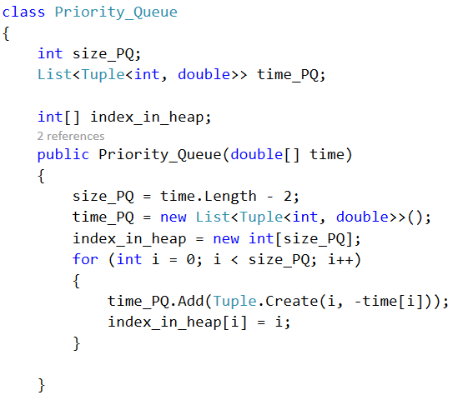

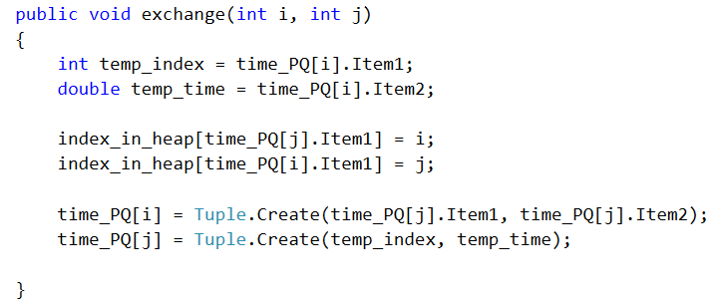

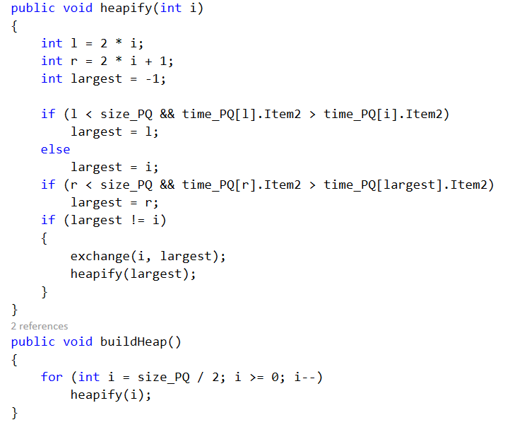

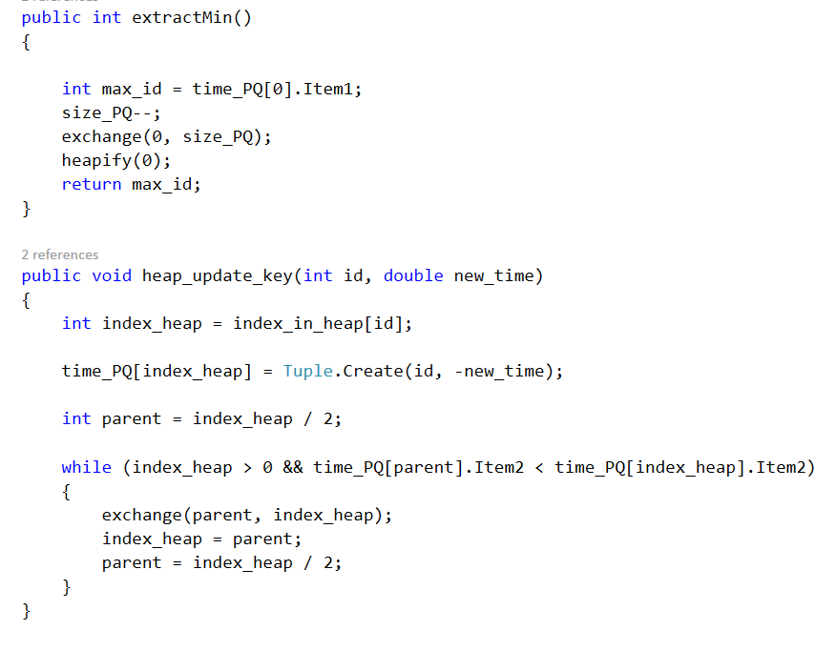

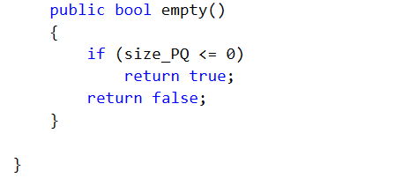

*Here We Analysis Class Priority_Queue Line by Line (*_*).

🡻🡻🡻🡻

class Priority_Queue

{

int size_PQ;

List<Tuple<int, double>> time_PQ;

🡺Complexity:o(1).

Dictionary<int, int> index_in_heap;

🡺Complexity:o(1).

public Priority_Queue(double[] time)

{

size_PQ = time.Length - 2;

🡺Complexity:o(1).

time_PQ = new List<Tuple<int, double>>();

🡺Complexity:o(1).

index_in_heap = new Dictionary<int, int>();

🡺Complexity:o(1).

⍟◆🡾🡾Complexity of loop = number of iterations * o(body)::here =size of queue*o(1)=o(size of queue).

for (int i = 0; i < size_PQ; i++)

{

time_PQ.Add(Tuple.Create(i, -time[i]));

🡺Complexity:o(1).

index_in_heap[i] = i;

🡺Complexity:o(1).

}

}

◆🡺The complexity of function(exchange)=o(1).

public void exchange(int i, int j)

{

int temp_index = time_PQ[i].Item1;

🡺Complexity:o(1).

double temp_time = time_PQ[i].Item2;

🡺Complexity:o(1).

index_in_heap[time_PQ[j].Item1] = i;

🡺Complexity:o(1).

index_in_heap[time_PQ[i].Item1] = j;

🡺Complexity:o(1).

time_PQ[i] = Tuple.Create(time_PQ[j].Item1, time_PQ[j].Item2);

🡺Complexity:o(1).

time_PQ[j] = Tuple.Create(temp_index, temp_time);

🡺Complexity:o(1).

}

◆🡾The complexity of function(heapify)=o(log v).

public void heapify(int i)

{

int l = 2 * i;

🡺Complexity:o(1).

int r = 2 * i + 1;

🡺Complexity:o(1).

int largest = -1;

🡺Complexity:o(1).

🡾complexity of if &else condition=o(body)=o(1).

if (l < size_PQ && time_PQ[l].Item2 > time_PQ[i].Item2)

largest = l;

🡺Complexity:o(1).

else

largest = i;

🡺Complexity:o(1).

🡾 complexity of if condition=o(body)=o(1).

if (r < size_PQ && time_PQ[r].Item2 > time_PQ[largest].Item2)

largest = r;

🡺Complexity:o(1).

🡾 complexity of if condition=o(body)=o(1).

if (largest != i)

{

exchange(i, largest);

🡺Complexity:o(1).

heapify(largest);

🡺Complexity:o(log v).

}

}

◆🡾The complexity of function(buildHeap)=o(size of queue /2*log (n)).

public void buildHeap()

{

⍟◆🡾🡾Complexity of loop = number of iterations * o(body)::here =size of queue /2 *o(log v).

for (int i = size_PQ / 2; i >= 0; i--)

heapify(i);

🡺Complexity:o(log n).

}

◆🡾The complexity of function(extractMin)=o(log v).

public int extractMin()

{

int max_id = time_PQ[0].Item1;

🡺Complexity:o(1).

size_PQ--;

🡺Complexity:o(1).

exchange(0, size_PQ);

🡺Complexity:o(1).

heapify(0);

🡺Complexity:o(log v).

return max_id;

🡺Complexity:o(1).

}

◆🡾The complexity of function(heap_update_key)=o(log v).

public void heap_update_key(int id, double new_time)

{

int index_heap = index_in_heap[id];

🡺Complexity:o(1).

time_PQ[index_heap] = Tuple.Create(id, -new_time);

🡺Complexity:o(1).

int parent = index_heap / 2;

🡺Complexity:o(1).

🡾complexity of while condition=#of iterations*o(body)=o(log v).

while (index_heap > 0 && time_PQ[parent].Item2 < time_PQ[index_heap].Item2)

{

exchange(parent, index_heap);

🡺Complexity:o(1).

index_heap = parent;

🡺Complexity:o(1).

parent = index_heap / 2;

🡺Complexity:o(1).

}

}

◆🡾The complexity of function(empty)=o(1).

public bool empty()

{

🡾complexity of if condition=o(body)=o(1).

if (size_PQ <= 0)

return true;

🡺Complexity:o(1).

return false;

🡺Complexity:o(1).

}

}

*Now We Finish discussion of Class priority_Queue(*_*)

*Let’s Start With Class CheckCorrectness(*_*)

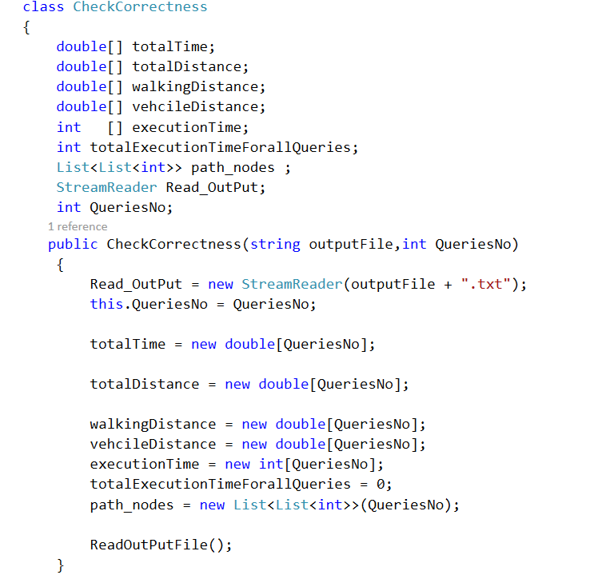

🡪complexity=O(V)

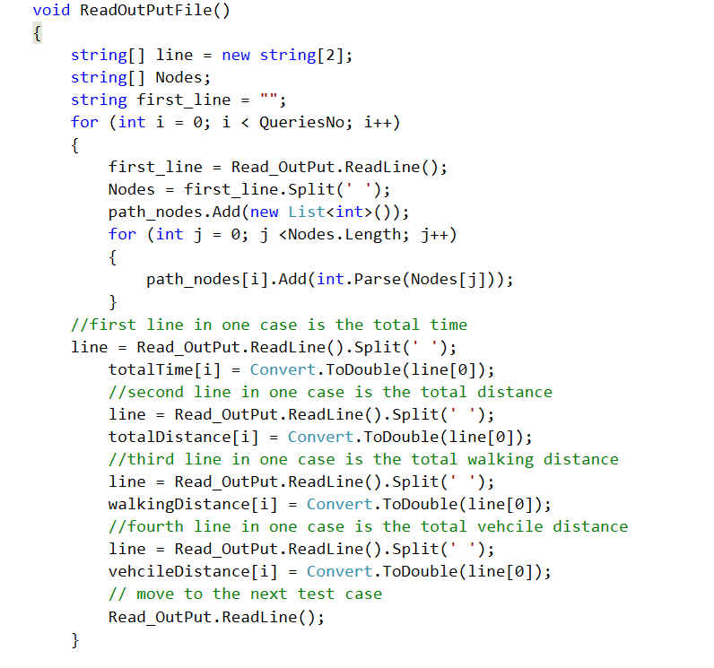

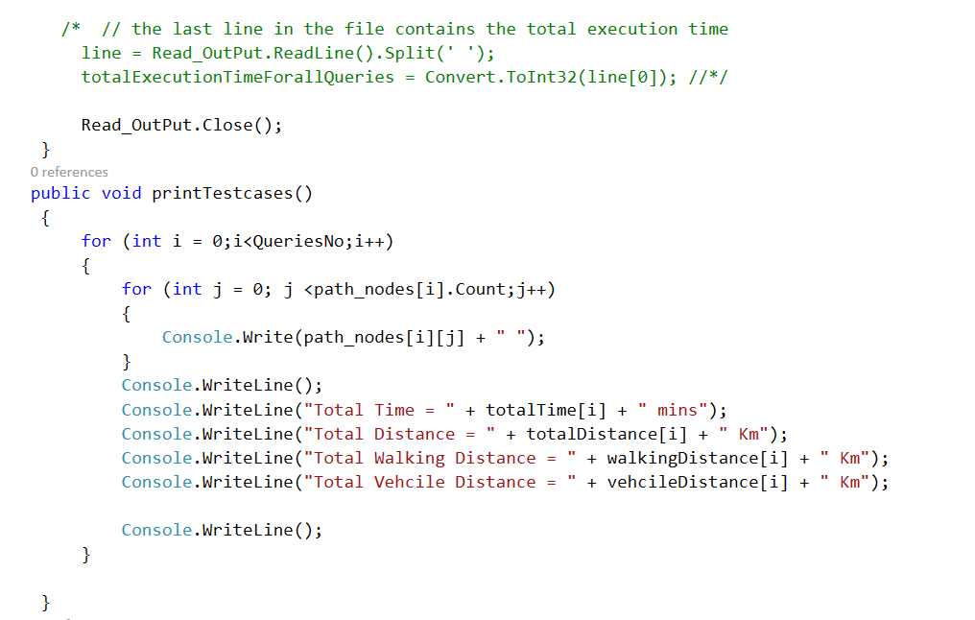

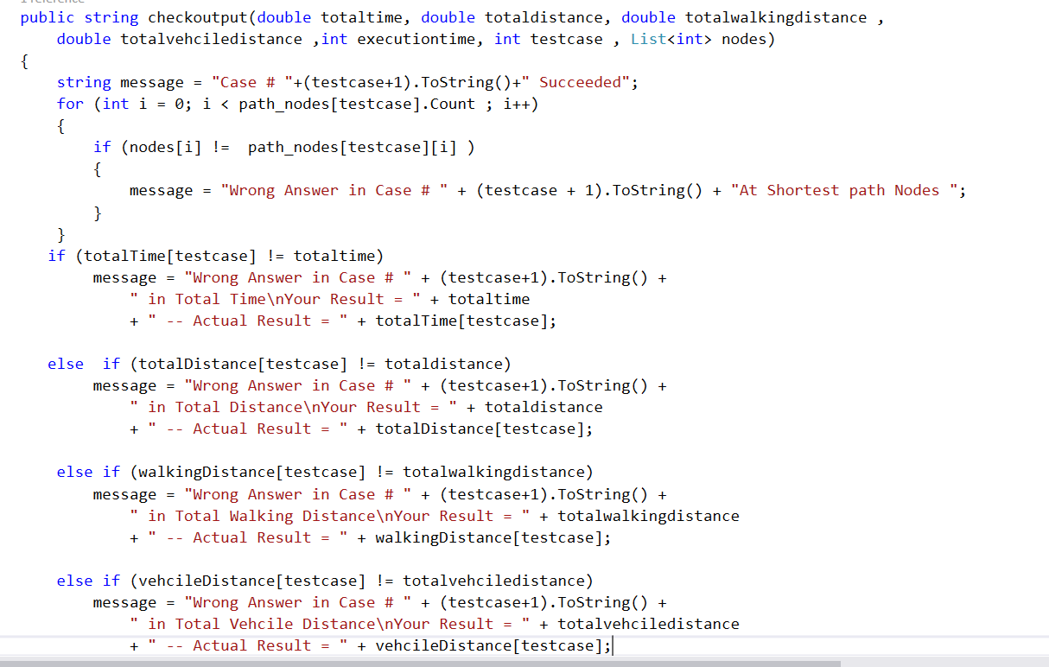

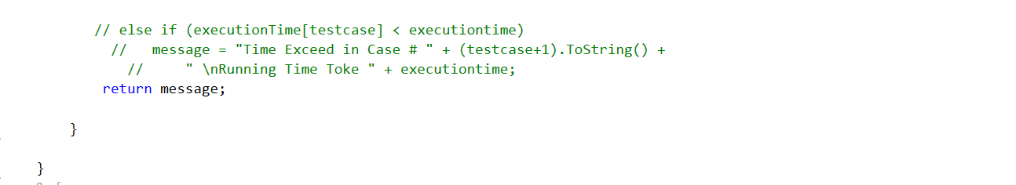

(*_*)🡻🡻Analysis🡻🡻 (*_*)

🡪complexity=O(Path_ndes).

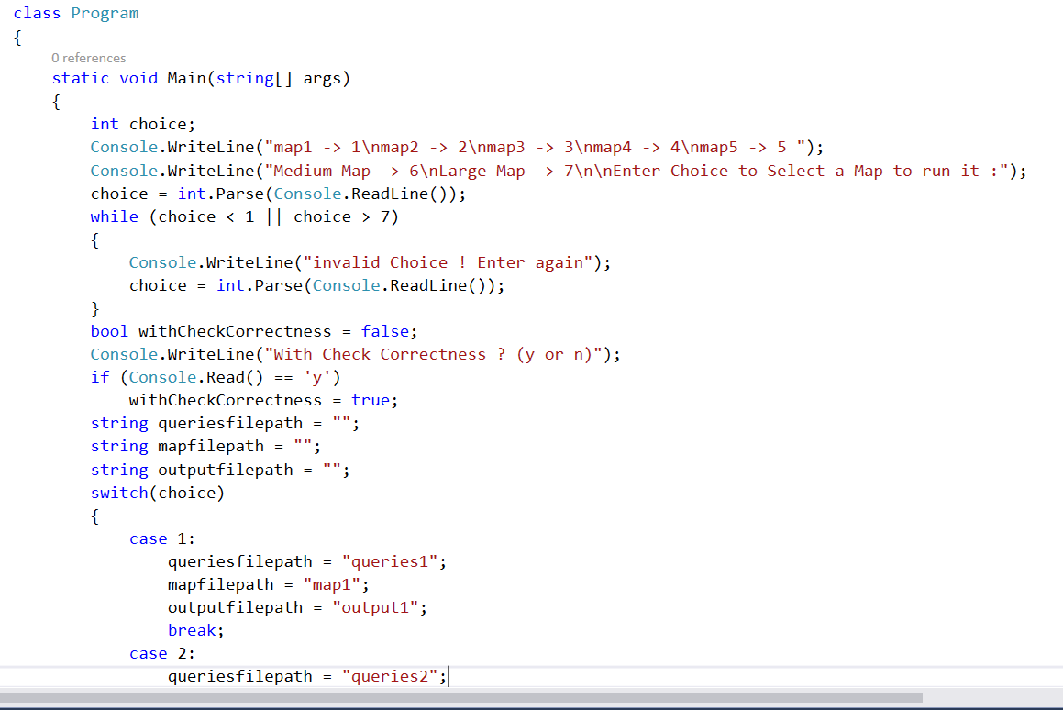

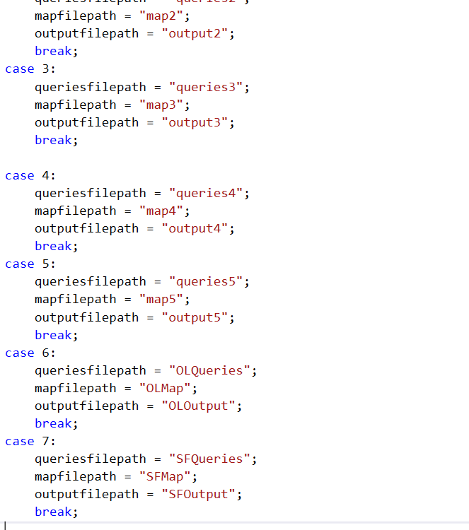

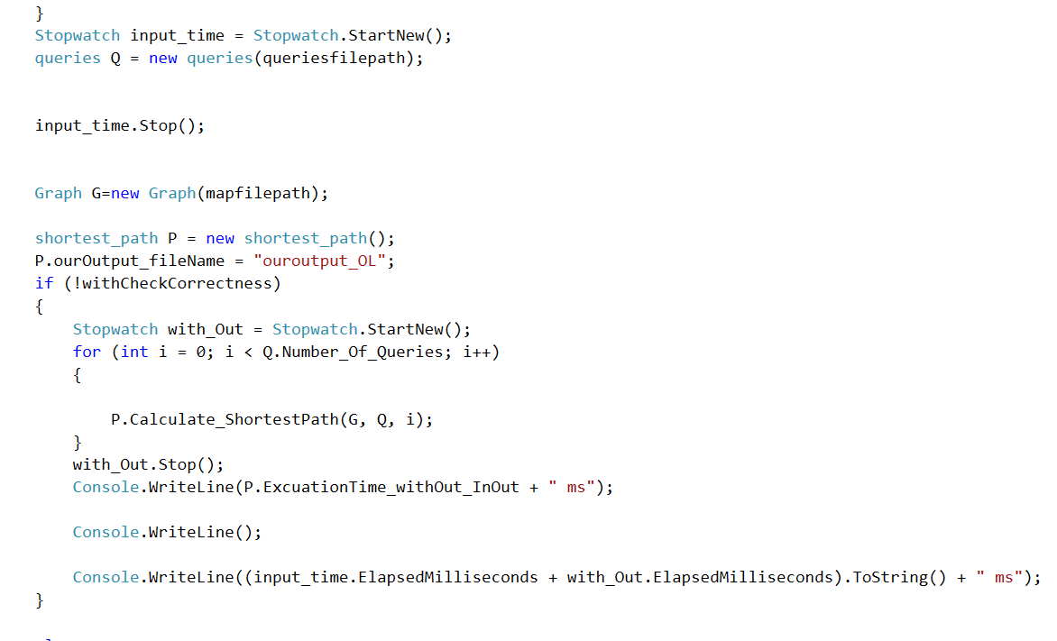

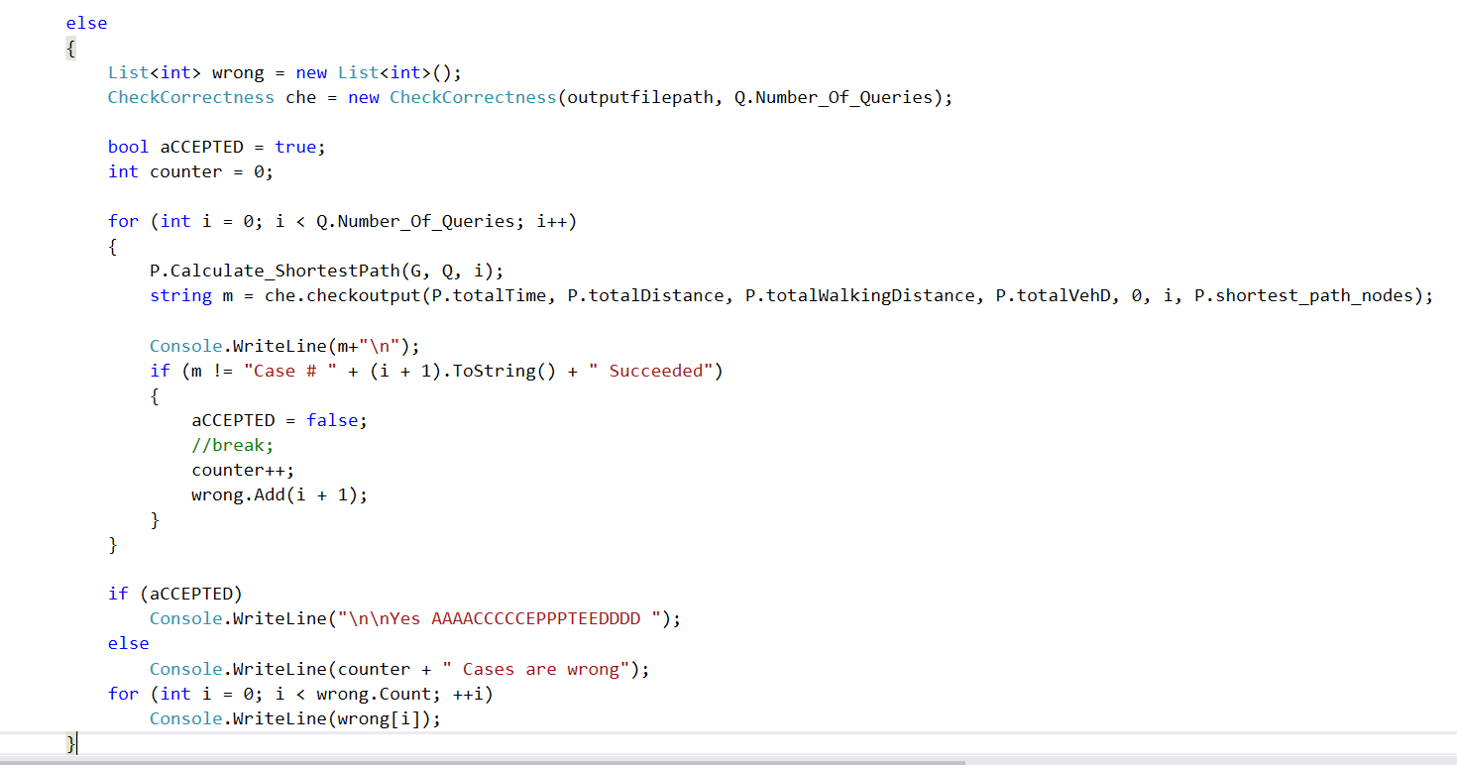

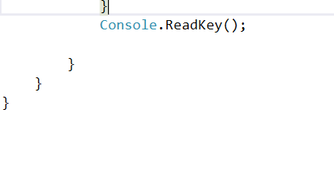

class Program

{

static void Main(string[] args)

{

int choice;

Console.WriteLine("map1 -> 1\nmap2 -> 2\nmap3 -> 3\nmap4 -> 4\nmap5 -> 5 ");

Console.WriteLine("Medium Map -> 6\nLarge Map -> 7\n\nEnter Choice to Select a Map to run it :");

choice = int.Parse(Console.ReadLine());

while (choice < 1 || choice > 7)

{

Console.WriteLine("invalid Choice ! Enter again");

choice = int.Parse(Console.ReadLine());

}

bool withCheckCorrectness = false;

Console.WriteLine("With Check Correctness ? (y or n)");

if (Console.Read() == 'y')

withCheckCorrectness = true;

string queriesfilepath = "";

string mapfilepath = "";

string outputfilepath = "";

switch(choice)

{

🡺Complexity:o(1).

case 1:

queriesfilepath = "queries1";

mapfilepath = "map1";

outputfilepath = "output1";

break;

case 2:

queriesfilepath = "queries2";

mapfilepath = "map2";

outputfilepath = "output2";

break;

case 3:

queriesfilepath = "queries3";

mapfilepath = "map3";

outputfilepath = "output3";

break;

case 4:

queriesfilepath = "queries4";

mapfilepath = "map4";

outputfilepath = "output4";

break;

case 5:

queriesfilepath = "queries5";

mapfilepath = "map5";

outputfilepath = "output5";

break;

case 6:

queriesfilepath = "OLQueries";

mapfilepath = "OLMap";

outputfilepath = "OLOutput";

break;

case 7:

queriesfilepath = "SFQueries";

mapfilepath = "SFMap";

outputfilepath = "SFOutput";

break;

}

Stopwatch input_time = Stopwatch.StartNew();

queries Q = new queries(queriesfilepath);

input_time.Stop();

Graph G=new Graph(mapfilepath);

shortest_path P = new shortest_path();

P.ourOutput_fileName = "ouroutput_OL";

if (!withCheckCorrectness)

{

Stopwatch with_Out = Stopwatch.StartNew();

⍟◆🡾🡾Complexity of loop = number of iterations * o(body)::here =o(E`log V`).

for (int i = 0; i < Q.Number_Of_Queries; i++)

{

P.Calculate_ShortestPath(G, Q, i);

}

with_Out.Stop();

Console.WriteLine(P.ExcuationTime_withOut_InOut + " ms");

Console.WriteLine();

Console.WriteLine((input_time.ElapsedMilliseconds + with_Out.ElapsedMilliseconds).ToString() + " ms");

}

🡺Complexity:o(1).

else

{

List<int> wrong = new List<int>();

CheckCorrectness che = new CheckCorrectness(outputfilepath, Q.Number_Of_Queries);

bool aCCEPTED = true;

int counter = 0;

for (int i = 0; i < Q.Number_Of_Queries; i++)

{

P.Calculate_ShortestPath(G, Q, i);

🡺Complexity:o(E`log V`).

string m = che.checkoutput(P.totalTime, P.totalDistance, P.totalWalkingDistance, P.totalVehD, 0, i, P.shortest_path_nodes);

🡺Complexity:o(1).

Console.WriteLine(m+"\n");

if (m != "Case # " + (i + 1).ToString() + " Succeeded")

{

aCCEPTED = false;

//break;

counter++;

🡺Complexity:o(1).

wrong.Add(i + 1);

🡺Complexity:o(1).

}

}

if (aCCEPTED)

Console.WriteLine("\n\nYes AAAACCCCCEPPPTEEDDDD ");

🡺Complexity:o(1).

else

Console.WriteLine(counter + " Cases are wrong");

🡺Complexity:o(1).

for (int i = 0; i < wrong.Count; ++i)

Console.WriteLine(wrong[i]);

🡺Complexity:o(1).

}

Console.ReadKey();

🡺Complexity:o(1).

}

}

}

(*_*)Thank_You(*_*)