Team Names :

Wael Mohamed abdEl moaty

Mahmoud hamed Mohamed

Assma Sobhy mostafa

Gehad Khaled Sayed

Assma Hamed Mohamed

Project Description

* The scene recognition is an area of visual recognition where recognizes and identifies scene of the image. The scene recognition identifies what the image as a whole is about, or where it is taken, like if it's a picture of sea, image of zoo, photo of a party, and so on. It doesn't classify a certain object in the picture, but tries to recognize the whole scene of the picture.
* The dataset for the project consists of 10 classes :-
  + Airport\_inside
  + Bakery
  + Bedroom
  + Greenhouse
  + Gym
  + Kitchen
  + Operating\_room
  + Poolinside
  + Restaurant
  + Toystore

The project is a contest On Kaggle

**Kaggle** is a community and site for hosting machine learning competitions. Competitive machine learning can be a great way to develop and practice your skills, as well as demonstrate your capabilities

Using Google Colab as IDE for Python Note Book :

**Google Colab** is a free cloud service and now it supports free GPU! You can: improve your Python programming language coding skills.

Using Keras Deep learning Frame work :

**Keras** is a neural network library while **TensorFlow** is the open source library for a number of various tasks in machine learning. **TensorFlow** provides both high-level and low-level APIs while **Keras** provides only high-level APIs. ... **Keras** is built in Python which makes it way more user-friendly than **TensorFlow**

We used transfer learning in our project :

T**ransfer learning** is a research problem in machine **learning** that focuses on storing knowledge gained while solving one problem and applying it to a different but related problem..

# We use  Fine-tuning using pre-trained models

models that pre-trained in huge data set called imageNet

ImageNet is a dataset of images that are organized according to the [WordNet](https://wordnet.princeton.edu/" \t "_blank) hierarchy. WordNet contains approximately 100,000 phrases and ImageNet has provided around 1000 images on average to illustrate each phrase.

## Strategies for Fine tuning:

#### **-** Linear SVM on top of bottleneck features

#### **-** Just Replace and train the last layer

#### **-** Train only last few layers

#### **-** Freeze, Pre-train and Finetune(FPT)

We will focus on strategy number 1 but without “older method “ by link output features with Another model with conv1D

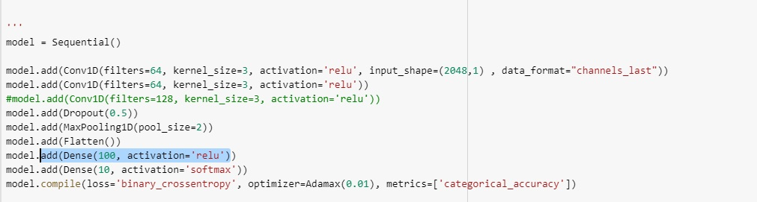

Our first pre-trained model is : VGG 16

**VGG16** (also called OxfordNet) is a convolutional neural network architecture named after the Visual Geometry Group from Oxford, who developed it. It was used to win the ILSVR (ImageNet) competition in 2014

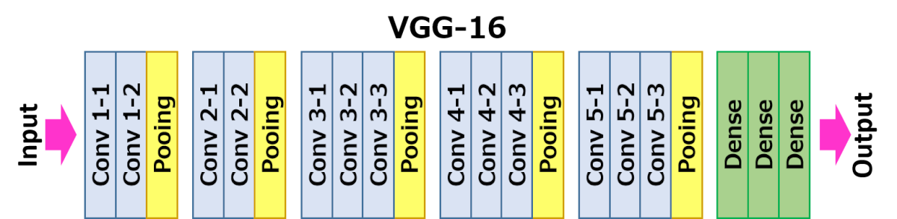

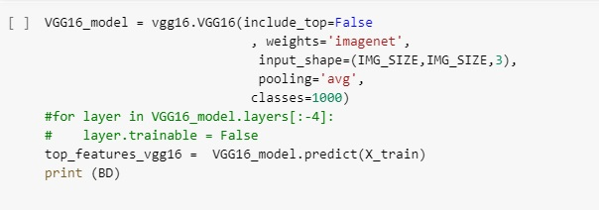

Now we train our model by this features :

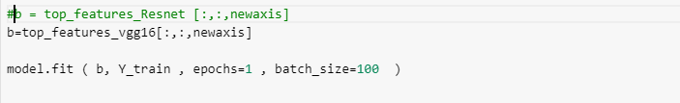

Achieved Accuracy :87% on Kaggle

Second model used : Resnet 152

**ResNet**, short for Residual Networks is a classic neural network used as a backbone for many computer vision tasks. This model was the winner of ImageNet challenge in 2015.

**Residual connections** are the same thing as 'skip **connections**'. They are used to allow gradients to flow through a network directly, without passing through non-linear activation functions

Resnet 152 Architecture :

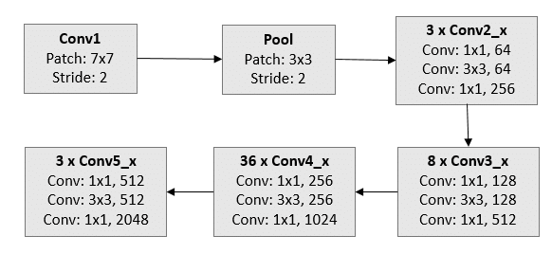

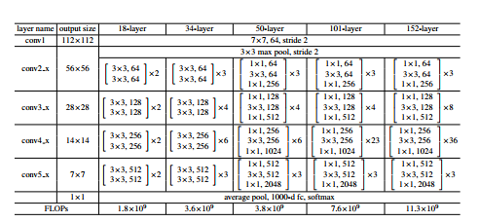

Now we train our model by this features :

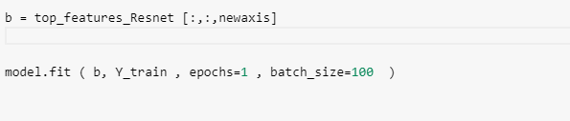

Achieved accuracy on Kaggle 93%