Aystro
Applied Computer Vision for Automated Retail Shelf Auditing
A Field Training Report
Trainee: Mahmoud Firas Fannoun
Host Organization: Aystro
Training Period: 27 July 2026 – 6 August 2026
Date of Submission: 8 August 2026

Abstract
This report documents the technical concepts acquired and the work undertaken during a two-week field training period at Aystro, focused on computer vision systems for automated retail shelf auditing. The work comprised two complementary strands: an analytical strand, in which an existing object detection dataset of 213 shelf photographs containing 4,641 manually annotated bounding boxes was audited and a revised system architecture derived; and an implementation strand, in which a cross-platform data collection application was developed to support field capture, automated analysis, and human verification of model output.
The report examines the detect-then-recognize architectural pattern, in which spatial localization is deliberately decoupled from identity classification, and documents a structural limitation of similarity-based visual classification: because the embedding model resizes every crop to a fixed square before encoding it, aspect ratio is discarded and containers of identical labelling but differing physical proportion become indistinguishable. This limitation was resolved by fusing bounding-box geometry, already produced by the detection stage, with the visual signal — an approach implemented and verified in the delivered application.

1. Introduction and Problem Context
Object detection is a foundational task in computer vision that answers two coupled questions about an image: where an object is located (localization) and what that object is (classification). In retail shelf auditing, the practical objective is to convert a photograph of a store shelf into structured commercial data — how many units of each product are present, how they are arranged, and what share of the visible shelf each brand occupies. This requires both answers simultaneously, since a count without positions cannot describe shelf layout, and positions without identities cannot describe inventory.
The dataset examined at the outset of the training had been annotated according to manufacturer brand, assigning each bounding box a class such as coca-cola or pepsi. This labelling scheme, while intuitive, exposed a set of structural problems that formed the analytical core of the training period and are examined in the sections that follow.
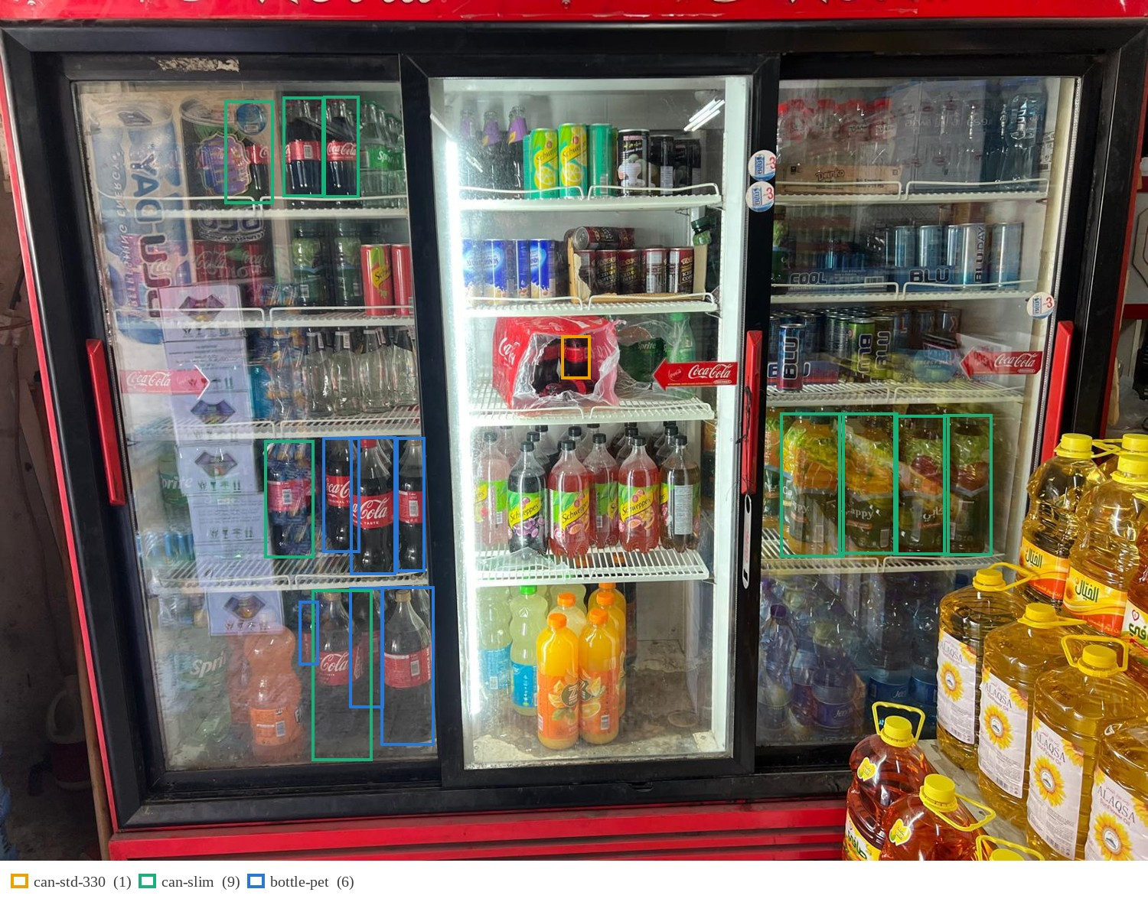
Figure 1. A field capture from the dataset with its relabelled bounding boxes overlaid; colour denotes packaging format. Beyond the density of the audit scene, the image shows two limitations examined later: many products carry no annotation at all (Section 4), and several boxes are assigned a format their contents contradict, the geometry having been degraded by glass reflection and occlusion (Section 7).
2. Methodology and Scope of Work
The training followed an investigative rather than a purely implementational approach. An existing annotated dataset was audited, its limitations diagnosed, a revised architecture derived and validated for feasibility against the production platform, and a supporting field application developed and tested.
2.1 Dataset Audit
The existing project export was analysed programmatically. It comprised 213 shelf photographs partitioned into training (173), validation (24), and test (16) splits, containing 4,641 manually drawn bounding boxes across six manufacturer classes: coca-cola, cappy, xl_energy, sprite, fanta, and pepsi. The project had grown incrementally, beginning with coca-cola and xl_energy before the remaining four brands were introduced — an expansion pattern that itself exemplifies the catalogue growth problem examined in Section 3.
Class distribution analysis revealed pronounced imbalance: the largest class accounted for 42.2% of all annotations while the smallest accounted for 2.8%, a ratio of approximately 15:1. This concentration provides a direct statistical account of the low recall observed on sparsely represented brands.
2.2 Geometric Relabelling
A relabelling scheme based on physical packaging format rather than brand was derived. For each annotation, the aspect ratio was computed from the stored box coordinates and mapped to one of four format classes — can-std-330, can-slim, bottle-pet, and unknown-package — using empirically determined ratio bands. Annotations were regenerated programmatically in Pascal VOC XML format and migrated to a separate project.
2.3 Ambiguity Flagging
Rather than assuming that every box admits a confident format assignment, each annotation was assessed for evidential reliability during relabelling and flagged where compromised. Of the 4,641 annotations, 194 (4.2%) were flagged as truncated — the object intersecting the frame boundary or extending beyond a close-up view — and 1,954 (42.1%) were flagged as difficult, denoting occlusion, oblique perspective, or specular interference sufficient to render the derived geometry unreliable.
That over two-fifths of the corpus required an ambiguity flag is itself a principal empirical finding of the training. It establishes that ambiguity in field imagery is structural rather than exceptional, and consequently that a deployed system must incorporate a verification mechanism by design rather than treat correction as an exceptional recovery path.
2.4 Platform Feasibility Assessment
The proposed architecture was evaluated block-by-block against the component catalogue of Roboflow Workflows to confirm that each stage could be realised natively within the platform. The findings are reported in Section 9.
2.5 Application Development
A cross-platform data collection application was implemented in Flutter to support structured field capture, automated analysis, and human verification. Its architecture and the reasoning behind it are described in Section 10.
3. The Catalogue Expansion Problem
A single-stage detector that classifies each product directly by its identity inherits a serious maintenance liability: the retail catalogue is not static. New stock-keeping units (SKUs) enter the market continuously, and under a monolithic design each addition requires retraining the entire detection model — expensive in computation, in annotation effort, and in time, and degrading a system that was previously working correctly for all existing products.
A second, statistical problem was observed in the dataset directly. When a fixed corpus of 213 images is partitioned across many brand classes, each class receives only a small share of the available examples. The model consequently learns well on densely represented classes and performs poorly on the remainder, producing the low recall — products present on the shelf but never detected — observed in the existing model.
The project's own history illustrates the mechanism directly: the earliest trained model version was fitted on 27 images, before most classes existed, and remained the workflow default long after the catalogue had grown beyond it. Coverage of the newer brands was therefore governed not by any deficiency of the detection method but by which model version the pipeline happened to invoke.
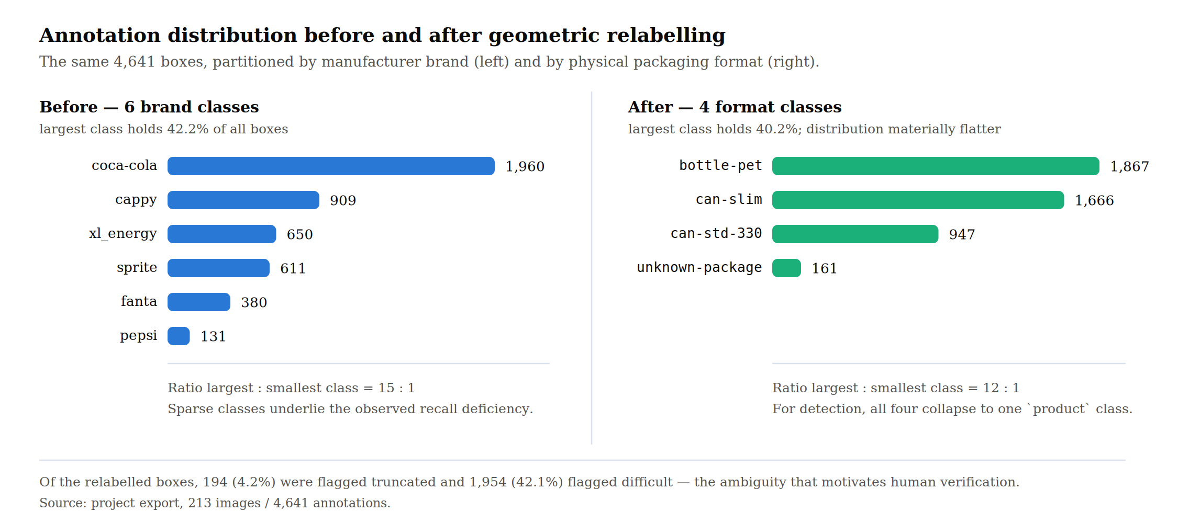
Figure 2. Annotation distribution before and after geometric relabelling. The same 4,641 boxes are partitioned by manufacturer brand (left) and by physical packaging format (right).
4. Class-Agnostic Detection
The response to both problems is to strip the detection stage of identity information entirely. In a class-agnostic detector, every product is assigned a single generic class — product — regardless of brand, flavour, or packaging, and the model is trained to answer only the question of whether a product is present at a given location.
This yields two distinct benefits. Statistically, the entire corpus contributes to a single class rather than being fragmented, substantially increasing the effective training signal without collecting a single additional image. Architecturally, the detection layer becomes stable: holding no knowledge of product identity, it is not invalidated by the introduction of a new SKU and need not be retrained.
An important practical qualification was established during the training: relabelling existing annotations to a generic class corrects mislabelled boxes, but cannot recover products that were never annotated at all. Missing annotations remain a separate data-completeness task, and no reorganisation of the label space substitutes for them.
5. Recognition by Embedding Similarity
Once localization is decoupled, identity must be resolved separately. The approach studied replaces conventional supervised classification with embedding-based retrieval: each detected region is cropped and passed through a vision-language model — CLIP — which maps the image into a high-dimensional numerical vector. Classification is performed by finding the nearest neighbour among a reference gallery of clean, known product images.
The decisive property of this approach is that adding a new product requires only adding its reference image to the gallery; no retraining occurs. This transforms catalogue maintenance from a model-training operation into a data-entry operation, which is the central reason the pattern is favoured in production retail systems.
6. The Geometric Limitation of Visual Similarity
A significant limitation of embedding-based recognition was identified during the training, and its mechanism established precisely. CLIP resizes every crop to a fixed square input — 224 by 224 pixels — before encoding it. This operation discards aspect ratio by construction: a tall narrow container and a shorter wider one arrive at the encoder having been stretched to the same shape. The model is therefore not merely insensitive to physical proportion; the information has been removed before inference begins.
The consequence is acute for products that differ only in packaging format. A standard 330 ml can measures approximately 66 mm in diameter by 115 mm in height, a ratio of about 1.74; a sleek 330 ml can measures approximately 53 mm by 145 mm, a ratio of about 2.7. The two hold identical contents and carry identical branding, so proportion is the only reliable distinguishing signal — and it is precisely the signal the embedding cannot see.
This was confirmed empirically. On a shelf photograph holding both formats side by side, the visual classifier assigned all ten cans to a single class, while the detector's own bounding boxes separated the two clusters cleanly: standard cans measured between 1.72 and 1.82, and sleek cans between 2.30 and 2.58, with an empty band between them. A decision threshold of 2.05 sits within that empty band, so neither cluster lies near it.
The resolution adopted recognises that the required discriminating information has already been produced by the detection stage. The aspect ratio of the bounding box is a direct geometric consequence of the container's physical form, and is approximately invariant to camera distance, since zooming scales both dimensions proportionally and leaves their ratio unchanged. Neither signal suffices alone: the visual embedding determines which product the object is, while bounding-box geometry determines which physical format it takes.
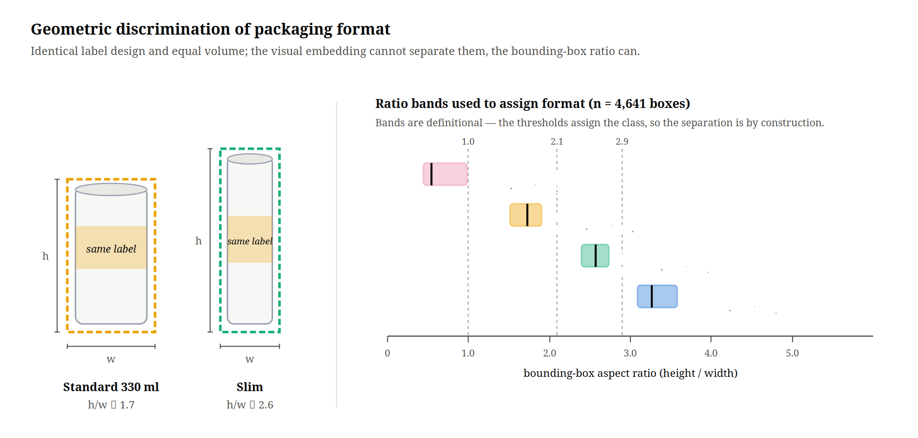
Figure 3. Geometric discrimination of packaging format. Left: two containers of identical labelling and equal volume but differing proportion — the measured separation on which the rule rests. Right: the ratio bands used to assign format across all 4,641 annotations. The bands are definitional rather than discovered: the thresholds assign the class, so their separation is a property of the scheme and not evidence for it.
7. Data Quality Factors in Uncontrolled Imagery
Because the aspect-ratio signal derives from the geometry of the annotated box, its reliability depends directly on the fidelity of that box to the real object. Several failure modes were catalogued during the training, each degrading this fidelity in a distinct way.
Truncation. Objects intersecting the frame boundary, and close-up photographs in which the container extends beyond the visible area, produce partial boxes. The measured height is then a lower bound rather than a measurement, and a sleek can may read as standard. This mode is not merely theoretical: it accounted for 4.2% of the corpus and required an explicit guard in the implemented decision rule.
Perspective distortion. A container photographed from an oblique angle or from above projects onto the image plane with altered proportions, so the same physical product can yield materially different aspect ratios across viewpoints.
Occlusion and dense packing. Products arranged in tight rows partially obscure one another, making boundaries ambiguous and occasionally causing a single box to enclose portions of two adjacent units.
Specular reflection. The reflective metal surfaces of beverage cans scatter light and blur perceived edges, reducing the precision with which boundaries can be placed.
Inherited annotation error. Where an original box was drawn loosely or tightly relative to the true product outline, any geometric quantity derived from it inherits that error unchanged.
A methodological principle follows directly: when geometric evidence is compromised, the correct outcome is an explicit deferral rather than a low-confidence guess, since a wrong label propagates silently into downstream commercial reporting. This principle was implemented literally — the geometric rule declines to judge any box touching the frame edge, leaving the classifier's original label in place — and it motivated the human verification interface described in Section 10.
8. Hierarchical Pipeline Architecture
The concepts above compose into a three-stage architecture in which each stage narrows the decision space presented to the next.
Stage One, class-agnostic detection, locates every product on the shelf under a single generic class, producing bounding boxes, unit counts, spatial positions, and the geometric measurements required later. Stage Two, manufacturer classification, matches each cropped region to a manufacturer by embedding similarity; this layer is small and stable, since the set of manufacturers in a market changes far more slowly than the set of products, making it well suited to a training-free approach. Stage Three, product and format classification, operates within the narrowed candidate set established by Stage Two: a trained classifier resolves the specific brand variant while bounding-box geometry resolves the packaging format.
Restricting comparison to one manufacturer's catalogue rather than the entire market materially reduces visual confusion between candidates. It should be noted that all stages after the first are classification operations: the pipeline is detect, then classify, then classify — not repeated detection. Localization is computed once and reused, since spatial coordinates do not change between stages.
A representative class hierarchy illustrates the separation of concerns. Stage One assigns product; Stage Two assigns coca-cola; Stage Three assigns the full SKU identifier, where the visual classifier supplies the brand variant and the geometric rule supplies the format distinction.
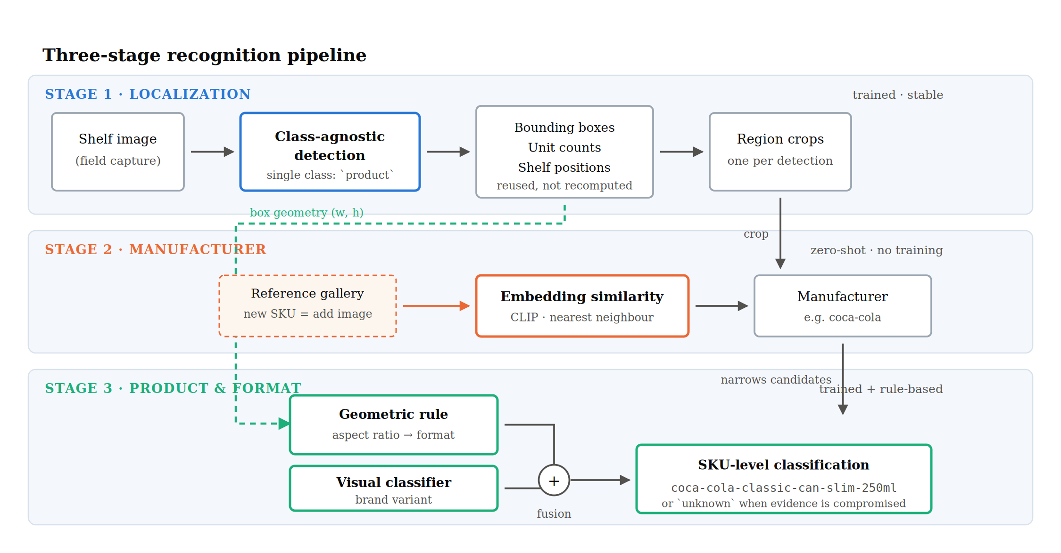
Figure 4. Block diagram of the three-stage pipeline, showing the flow from raw shelf image through class-agnostic detection, region cropping, manufacturer classification, and the fusion of visual and geometric evidence at SKU level.
9. Platform Implementation
The proposed architecture was mapped onto Roboflow Workflows, the platform in operational use. Verification against the platform documentation confirmed that every required component exists natively, with a single exception.
Table 1. Mapping of pipeline stages onto native platform components.
Pipeline function | Platform component | Training required
Class-agnostic detection | Object Detection Model | Yes
Region extraction | Dynamic Crop | No
Manufacturer classification | CLIP Comparison | No (zero-shot)
Product / variant classification | Single-Label Classification Model | Yes
Format discrimination by geometry | Dynamic Python Block | No (rule-based)

The geometric decision rule is the only component without a ready-made equivalent. It is implemented through a Dynamic Python Block, which permits custom logic to consume the outputs of preceding blocks — reading bounding-box dimensions and applying the aspect-ratio threshold separating packaging formats. This represents a small quantity of code rather than an additional trained model. In the delivered application the same rule is implemented client-side, demonstrating that the fusion step is portable across execution contexts.
The workflow additionally exposes runtime parameters — confidence threshold, intersection-over-union threshold, class-agnostic non-maximum suppression, maximum detection count, and model version — which the application surfaces to the operator, so that detection behaviour can be tuned in the field without redeployment.
10. Field Data Collection Application
A recurring theme of the analysis is that model output on uncontrolled imagery cannot be treated as final: ambiguous cases arise structurally, not incidentally. A cross-platform application was therefore developed in Flutter to serve three roles — standardising field capture at the point of collection, running the analysis pipeline against the captured image, and interposing human verification between model inference and committed data.
The delivered application comprises 60 Dart source files totalling approximately 10,800 lines, organised into six layers, and is accompanied by 20 test files totalling approximately 4,100 lines.
Table 2. Composition of the delivered application by architectural layer.
Layer | Modules | Responsibility
Screens | 12 | Authentication, capture, review, administration, visit flow
Services | 14 | Detection, camera, authentication, market and visit persistence
Models | 13 | Detections, bounding boxes, shape rules, share-of-shelf, user profiles
Widgets | 17 | Detection overlays, editors, adaptive layout, result panels
Config / Theme | 4 | Runtime configuration and presentation tokens

10.1 Structured Capture
The application implements a role-differentiated flow. Company administrators define and manage the set of markets under audit and review team access requests; field representatives select a market, capture shelf imagery through a dedicated camera interface with selectable aspect ratio, and persist the result against that market as part of a recorded visit. Binding every image to a known market at capture time ensures that collected data carries the contextual metadata required for downstream commercial analysis, rather than arriving as unattributed photographs.
10.2 Human-in-the-Loop Verification
A detection editor allows the operator to review model-produced detections and correct them before submission. This component addresses the failure modes of Section 7 operationally: where truncation, occlusion, or perspective renders an automatic classification unreliable, the operator resolves it rather than allowing a low-confidence label to propagate. The corrections additionally constitute a supervised signal suitable for subsequent retraining, so routine field use generates training data as a by-product of normal operation.
10.3 Commercial Measurement
The application converts verified detections into a share-of-shelf measure: for each class, the bounding-box areas are summed and divided by the total detected area across all classes. The measure is deliberately simple and is documented as a relative facing-space proxy rather than a true occupancy measurement, since overlapping boxes are not de-duplicated. Stating that limitation explicitly, rather than presenting the figure as exact, is itself part of the design.
10.4 Cross-Platform Delivery
The interface was implemented responsively for both mobile and desktop viewports, with attention to theme contrast and legibility, reflecting the operational reality that capture occurs on handheld devices in variable store lighting while review and administration occur on desktop.
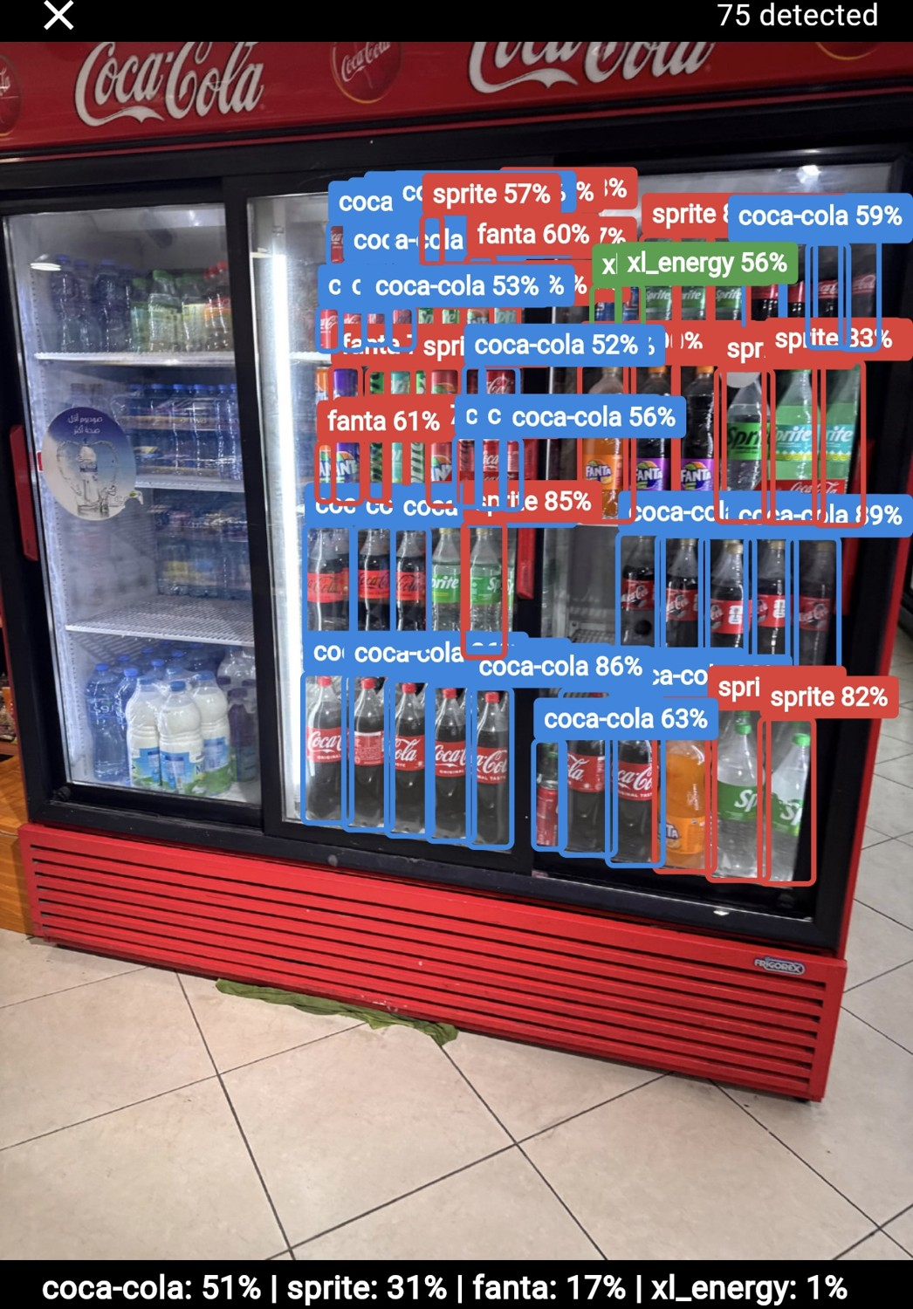
Figure 5. The application reviewing a live capture: 75 detections returned for a single cooler, with the share-of-shelf summary computed beneath. The crowding of labels is itself informative — it is the dense-packing regime of Section 7, and the reason an operator-facing editor rather than an automatic commit is the appropriate design.
11. Results and Outcomes
Table 3. Effect of the relabelling and class-collapse on the training corpus.
Measure | Before | After
Shelf images | 213 | 213
Bounding boxes | 4,641 | 4,641
Classification classes | 6 (brand) | 4 (format)
Detection classes | 6 | 1 (product)
Largest : smallest class | 15 : 1 | 12 : 1
Annotations per detection class | 774 (mean) | 4,641

The most consequential quantitative outcome is the sixfold increase in the number of annotations contributing to a single detection class, achieved without collecting additional imagery. Under the original scheme the detector received a mean of 774 examples per class, with the sparsest brand supported by only 131; under the class-agnostic scheme the full corpus of 4,641 boxes supports the single detection objective.
The relabelling assigned formats by ratio band — unknown-package below 1.0, can-std-330 between 1.0 and 2.1, can-slim between 2.1 and 2.9, and bottle-pet above 2.9 — yielding class medians of 0.54, 1.73, 2.57, and 3.26. It should be stated plainly that these bands do not themselves validate the approach: the thresholds define the classes, so their separation is guaranteed by construction. The evidence that box geometry is a usable discriminative signal comes instead from the independent side-by-side measurement reported in Section 6, where the two can formats separated into disjoint measured clusters while the visual classifier assigned them a single class. Inspection of the relabelled images also showed the rule mislabelling partially occluded bottles as cans, which is the error mode Section 7 predicts and a further reason the format assignment requires verification before use.
The tangible deliverables of the training period were: a geometrically relabelled annotation set derived programmatically from the original brand-labelled corpus; a documented three-stage system architecture with a verified component-level mapping onto the production platform; and a functioning cross-platform field application supporting structured capture, automated analysis, human verification, and share-of-shelf reporting.
12. Challenges Encountered
The principal difficulties of the period were not algorithmic but evidential — establishing what the data and the tooling were actually doing, as opposed to what they were assumed to be doing.
The first was annotation ambiguity at scale. Over two-fifths of the corpus required an ambiguity flag, and each flagged box demanded a judgement that no threshold could make automatically. Relabelling 4,641 boxes by physical format also revealed that a purely geometric rule inherits every defect of the box it reads: a partially occluded bottle produces a short box and is misread as a can. Distinguishing genuine format differences from artefacts of capture consumed a substantial share of the period, and the resulting label set still contains errors of this kind.
The second was diagnosing behaviour that configuration, not modelling, was causing. Poor coverage of the newer brands initially appeared to be a detection failure. It was in fact governed by a default model version trained on 27 images, long superseded but still invoked by the workflow. Similarly, the failure to separate can formats looked like insufficient training data until the mechanism was identified — the embedding model resizes crops to a fixed square and discards aspect ratio before inference. In both cases the visible symptom pointed away from the actual cause.
A third, more practical difficulty was tooling friction during the dataset migration. Bulk annotation upload through the platform API proved to have no per-image overwrite path, so a single malformed request left one image with an empty annotation that could not be corrected programmatically. Working within the constraints of a hosted platform — rather than assuming full control over the data store — was itself part of the learning.
13. Next Steps and Support Required
The immediate technical priority is to train the class-agnostic detector on the collapsed label set and measure it properly. To date the expected improvement rests on a statistical argument — a sixfold increase in annotations per detection class — and not on a measured result. A held-out evaluation reporting per-class recall and mean average precision, compared against the current brand-classed detector, is required before the architecture can be claimed to work rather than merely to be well-motivated.
Beyond that, three pieces of work follow in order: completing the annotations for products never labelled at all, which no reorganisation of the label space can substitute for; assembling the reference gallery that Stage Two depends on; and implementing the Stage Three fusion inside the platform workflow so the rule verified client-side runs server-side as well.
Progress on these depends on inputs the training period could not supply from within. Most consequential is a product reference set — clean single-product images for each SKU in scope, together with a catalogue giving physical dimensions, since the geometric thresholds are currently calibrated on two can formats and would need extending per format encountered. Also needed is guidance on the accuracy that constitutes production readiness, as the correct operating point for a shelf audit — and therefore how readily the system should defer to human verification — is a commercial judgement rather than a technical one. Finally, additional field imagery spanning store types, shelf configurations, and lighting conditions would materially improve generalisation; the current corpus, at 213 images, is small relative to the variability the deployed system will meet.
14. Reflection on Learning Outcomes
The most consequential lesson of the training was that the decisive question in an applied vision system is frequently not which model performs best, but how responsibility should be divided between components. Considerable time was initially directed toward improving classification accuracy within a single-stage design before it became apparent that the accuracy ceiling was imposed by the architecture rather than by the model.
A second lesson concerned the value of identifying a model's representational boundary rather than attempting to overcome it by training. Establishing not merely that CLIP failed to distinguish the two can formats, but why — that the square resize discards aspect ratio before encoding — converted an apparently stubborn accuracy problem into a solved one, and did so with a rule of a few lines rather than additional data collection.
A third lesson emerged from the annotation work: the effort required to produce reliable annotations at scale is routinely underestimated, and design decisions that reduce annotation burden — such as collapsing many classes into one — can improve system outcomes more than algorithmic refinements. Relatedly, discovering that a stale default model version was governing live behaviour was a reminder that in deployed systems, configuration is as consequential as modelling, and considerably easier to overlook.
15. Conclusions
The principal insight of the training period is architectural rather than algorithmic: maintainability in a domain with a continuously expanding catalogue is determined less by the accuracy of any single model than by how responsibilities are partitioned between components. Isolating the volatile part of the problem — product identity — from the stable part — object presence — allows the system to absorb catalogue growth through data updates rather than model retraining.
A second conclusion concerns the complementarity of evidence types. Learned visual representations and explicit geometric measurements fail and succeed under different conditions; a system fusing both is materially more robust than one relying on either alone. Recognising the boundary of what a learned representation can encode, and supplying the missing information by other means, proved more productive than attempting to train the limitation away.
Finally, the training demonstrated that data quality constrains the achievable ceiling of any architecture, and that an operational system should therefore be designed to expect ambiguity rather than to assume its absence. That over two-fifths of the annotations required an ambiguity flag makes the case quantitatively. The verification interface developed during the period embodies the resulting principle: rather than treating human correction as a fallback for model failure, it treats it as a permanent component of the data pipeline and a continuing source of supervised training signal.

References
[1] Radford, A., Kim, J. W., Hallacy, C., et al. (2021). Learning Transferable Visual Models From Natural Language Supervision. Proceedings of the 38th International Conference on Machine Learning (ICML).
[2] Goldman, E., Herzig, R., Eisenschtat, A., Goldberger, J., & Hassner, T. (2019). Precise Detection in Densely Packed Scenes. IEEE Conference on Computer Vision and Pattern Recognition (CVPR).
[3] Ren, S., He, K., Girshick, R., & Sun, J. (2015). Faster R-CNN: Towards Real-Time Object Detection with Region Proposal Networks. Advances in Neural Information Processing Systems (NeurIPS).
[4] Redmon, J., Divvala, S., Girshick, R., & Farhadi, A. (2016). You Only Look Once: Unified, Real-Time Object Detection. IEEE Conference on Computer Vision and Pattern Recognition (CVPR).
[5] Schroff, F., Kalenichenko, D., & Philbin, J. (2015). FaceNet: A Unified Embedding for Face Recognition and Clustering. IEEE Conference on Computer Vision and Pattern Recognition (CVPR).
[6] Deng, J., Guo, J., Xue, N., & Zafeiriou, S. (2019). ArcFace: Additive Angular Margin Loss for Deep Face Recognition. IEEE Conference on Computer Vision and Pattern Recognition (CVPR).
[7] Everingham, M., Van Gool, L., Williams, C. K. I., Winn, J., & Zisserman, A. (2010). The PASCAL Visual Object Classes (VOC) Challenge. International Journal of Computer Vision, 88(2), 303–338.
[8] Lin, T.-Y., Maire, M., Belongie, S., et al. (2014). Microsoft COCO: Common Objects in Context. European Conference on Computer Vision (ECCV).
[9] Oquab, M., Darcet, T., Moutakanni, T., et al. (2023). DINOv2: Learning Robust Visual Features without Supervision. Transactions on Machine Learning Research (TMLR).
[10] Roboflow. Workflows Documentation. https://inference.roboflow.com/workflows/ (accessed August 2026).

