Aystro
Separating Localisation from Identification in Automated Retail Shelf Auditing
An applied study in scalable computer-vision system architecture
Author: Mahmoud Firas Fanoun
Host organisation: Aystro
Research period: 27 July – 18 August 2026
Submitted: 18 August 2026

Abstract
This study examines an architectural question in applied computer-vision systems: how the responsibilities of locating an object and identifying it should be divided between a system's components, and what that division costs or saves in accuracy and in scalability. The application domain is automated retail shelf auditing, where a photograph of a commercial shelf is converted into a structured product inventory and per-brand share of shelf.
Two approaches are compared. The first (v1) is a single object-detection layer whose classes are the brands themselves — one model answering both questions at once. The second (v2) is a multi-stage architecture that separates them: a class-agnostic detector locates products without any knowledge of identity, followed by independent, conditionally routed classifiers that determine brand, then variant, then packaging material. Both were evaluated under the same protocol, on the same model architecture, from the same source photographs.
Every accuracy figure in this study is measured at a single fixed confidence threshold of 0.70 — not at each class's own optimal threshold, since one system cannot run a different threshold per class. The multi-stage approach outperformed the single-layer one on all six detection metrics: 93.33% mAP@50 against 88.62%, 76.49% mAP@50-95 against 70.09%, and 80.7% recall against 74.0% — and it did so even though the single-layer approach was evaluated on magnified tiles, which is the easier condition for detection. Its per-class breakdown exposes signal starvation directly: a 6.35-point spread across its represented classes, and total collapse on an unrepresented one.
The computational complexity of the variant-classification layer was also reduced from O(N×K) to O(N) by introducing conditional routing, measured directly as a 65% reduction in processing time with identical labels on the measured photograph. The marginal cost of adding a new brand to the catalogue is approximately four minutes of GPU time, measured four separate times. The unifying result is that every measured weakness in the system traces to a specific, countable sample shortfall — genuine data scarcity in some cases, a test-split artefact in others — rather than to any deficiency in the architecture or the choice of model.

1. Introduction
1.1 The applied problem
A brand's presence on the shelf — how many units are displayed and what fraction of the visible space they occupy — is commercial intelligence that manufacturers and retailers pay to obtain. Today it is collected manually by representatives who tour stores and record what they see: slow, expensive to scale, and inconsistent in quality because it depends on the attention of the person doing it.
Automating it requires the system to distinguish each displayed product from its neighbour individually — knowing that a brand is present is not enough, its units must be counted. This is where localisation becomes necessary: not as a deliverable in its own right, but as the means by which visually identical instances are separated from one another so that counting becomes possible at all.
1.2 Hypothesis
The study begins from the observation that the two questions — where, and what — have fundamentally different characteristics. Localisation is stable: “is there a displayed object here?” is a general visual question whose answer does not change as the product catalogue changes, and which can be learned from any set of products. Identity is volatile: a market's catalogue changes continuously as products enter and leave and new flavours are introduced.
The hypothesis is that coupling these two concerns inside a single model imposes a double cost. An economic cost, because every change to the catalogue requires retraining the entire model; and a statistical cost, because a limited training signal is divided across multiple classes, starving each of them.
1.3 Contributions
1. Measured empirical evidence that separating localisation from identification improves detection performance from the same source photographs, with the mechanism of that improvement documented through the per-class breakdown.
2. A conditional-routing architecture that makes the cost of the variant-classification layer independent of catalogue breadth — O(N) instead of O(N×K) — with a direct measurement of its effect on latency.
3. A repeated measurement of the marginal cost of catalogue expansion under the proposed architecture.
4. A design result in active learning: a demonstration that confidence-threshold sampling is structurally incapable of capturing confident errors, and a proposed alternative criterion.
2. Problem formulation
Let a shelf photograph contain N displayed products. The system is required to produce a structured inventory: a unit count for each distinct label, from which each brand's share of the displayed space is derived. The target label is compound, built from independent axes of the form: {brand}-{package}-{variant}-{size}.
“Variant” here is an umbrella term for any distinction within a single brand, whatever its basis — flavour or taste (fanta-orange, cappy-mango), formulation (coca-zero, coca-diet: the same drink at a different sugar content), or product line (xl-classic, xl-red). The general term is deliberate, because the basis is not uniform across brands: Fanta's distinction is purely a flavour one, whereas Coca-Cola's is not a flavour at all. Naming the axis “flavour” would misdescribe half the connected brands.
The first three axes — brand, variant, and packaging material — were completed in this study. The size axis is the planned next step and is discussed in Section 10.
Note that localisation does not appear in this output. It is an internal requirement, not a final deliverable: its function is to separate adjacent products from one another so that counting is valid, and to isolate regions of the image so that each can serve as input to a downstream classification layer. This distinction is central to the study, because it is what makes relieving localisation of the burden of identity possible in the first place.
The first approach (v1). A single detector learns a function mapping the image directly to a set of (region, brand) pairs. The cost of adding a new brand here is a full retrain — a function of the size of the whole catalogue, not of the size of the addition.
The second approach (v2). A class-agnostic detector produces regions under a single generic class, followed by independent classification functions operating on the cropped regions. The cost of adding a brand here is training one small classifier, independent of the rest of the system.
The second approach raises a problem of its own: if K variant classifiers exist and each runs on every region, the number of invocations is O(N×K) even though only one invocation in K is ever useful. Section 4 addresses this.
3. Methodology
3.1 Evaluation protocol
Both approaches were evaluated under conditions unified as far as possible: the same model architecture (rfdetr-large), so no difference can be attributed to capacity; the same source photographs, as each project holds the same 227 raw images; and the same evaluation tool, run against a held-out test split in both cases. All figures are read directly from the platform's tooling; none is estimated, and where no measurement exists the text says so explicitly.
One difference could not be unified, and is stated plainly because it bears on the interpretation of the results: the preprocessing pipelines of the two versions differ substantially.
Table 1. The two preprocessing pipelines. The difference in image count comes from augmentation, not from additional source data.
Item | v1 (version 20) | v2 (version 2)
Images after preprocessing | 1,191 | 384
Train / valid / test | 982 / 112 / 97 | 316 / 34 / 34
Static crop | central quarter only | none
Tiling | 2×2 | none

Each evaluation image in v1 therefore represents roughly one sixteenth of the area of the original photograph, at a linear magnification of about 4×, whereas v2 is evaluated on complete images. This difference has three consequences for interpretation.
First, the gap in training-image count (1,191 against 384) is not a difference in source data but in the augmentation pipeline; the source is the same.
Second, tiling magnifies objects relative to the frame, which is an easier setting for detection, not a harder one. Any advantage the multi-stage approach shows in this comparison is therefore achieved despite its counterpart being evaluated under the easier condition — making the result conservative rather than inflated.
Third, performance broken down by object size cannot validly be compared between the two versions, because the small/medium/large buckets are defined relative to the image being evaluated; a “small” object in a magnified tile is physically far smaller than its counterpart in a full image. These figures are therefore presented in Section 5.1 as a characterisation of the current system alone, not as a comparison.
3.2 Behavioural verification
A methodological principle was adopted whose importance was established empirically: no claim about the system's behaviour is accepted unless verified by an actual inference call on a real image. More than once it emerged that inspecting the configuration gave an impression of correctness while actual behaviour differed, and that training metrics alone did not reveal this.
3.3 Data auditing
Where performance was weak on a particular class, direct visual auditing of the training data was adopted as the first diagnostic instrument, before any model tuning. A repeatable method was developed for this: crops of the class under examination are downloaded and arranged into contact-sheet grids ordered by a cheap but informative signal — aspect ratio separates cans from bottles, dominant hue separates flavours — making human judgement possible over whole ranges at once rather than image by image. In every case examined, this method traced the weakness to the data rather than to the model.
4. Proposed architecture
The architecture narrows the decision space stage by stage, so that each layer is small, independent, and replaceable without disturbing what precedes it.
Stage 1 — detection (class-agnostic). Product regions are located under a single generic class. This model carries no knowledge of identity, and therefore requires no retraining as the catalogue changes, however far it expands.
Stage 2 — brand. Each region is cropped and classified by manufacturer. This layer is relatively stable, because the set of brands in a market changes far more slowly than the set of products. It is the critical layer, because its decision determines the path of everything downstream.
Stage 3 — variant (flavour, formulation, or product line, depending on the brand; see Section 2), conditionally routed. If the identified brand has its own variant classifier, the routing step invokes that classifier alone; a region not belonging to a connected brand passes through no variant classifier at all. Four brands are connected in this pattern.
Stage 4 — packaging material, unconditional. A single shared classifier (can / plastic / glass) runs on every region, because material is a physical property independent of the manufacturer — so any brand added in future benefits from it immediately, with no additional training.
A merge step then selects the most specific label available (the variant if present, otherwise the plain brand) and combines it with the packaging material. The essential architectural property is that the routing in Stage 3 decouples a classifier's execution from the mere availability of its input — which is what makes growth independent of K, as Section 5.5 shows.
Note that the axes are independent by design: packaging material does not depend on brand, whereas variant does. This independence is what permits the size axis to be added later as a fourth layer without disturbing anything before it.
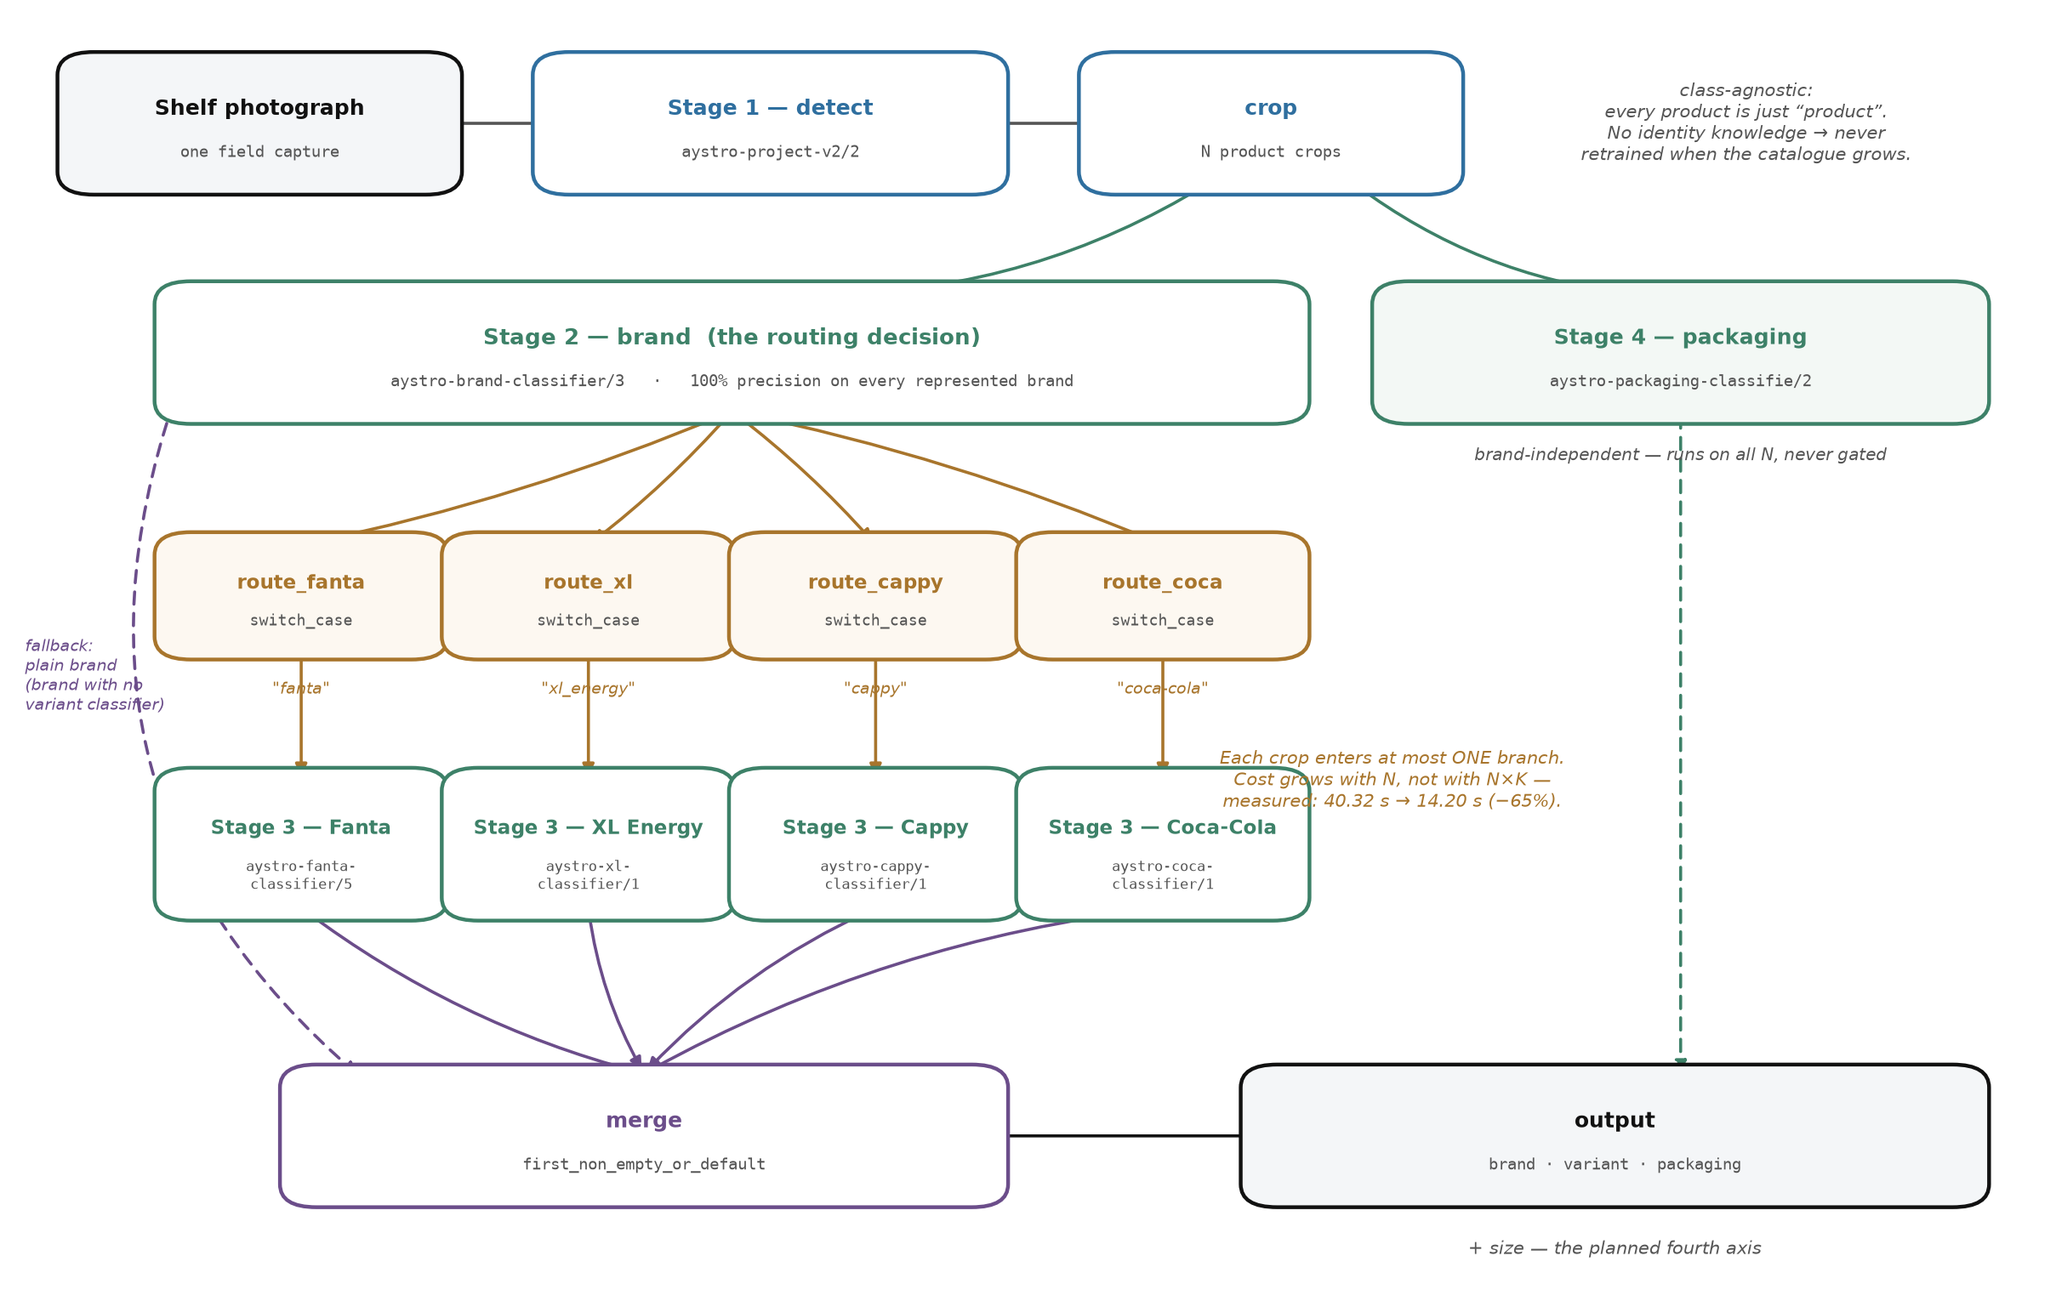
Figure 1. The architecture as actually deployed, read from the live workflow specification. The essential difference from conventional staged architectures is the routing steps (in orange): they decouple the execution of the variant classifiers from the mere availability of their input, which is what Section 5.5 measures.
5. Experimental results
5.1 Detection: single-layer against multi-stage
The accuracy of any classification system is measured at a declared confidence threshold, and this study adopts a single fixed threshold of 0.70 for every classification figure it reports — for both detectors and all six classifiers. The choice is methodological, not cosmetic: the evaluation tool computes for each class its own “optimal threshold” (ranging here from zero to 0.91), and reporting each class at its own threshold yields high numbers that describe no single system, since a running pipeline cannot apply a different threshold per class. The fixed threshold describes what actually happens when the system runs as one unit, and it is the stricter choice — the figures below are lower than their optimal-threshold counterparts, deliberately.
Table 2. Both detectors on a held-out test split, with the same evaluation tool and the same model architecture. Precision, recall and F1 at a 0.70 threshold for both; the mAP metrics are threshold-independent, being computed across all thresholds.
Metric | v1 (single, 6 classes) | v2 (multi, 1 class) | Difference
mAP@50 | 88.62% | 93.33% | +4.71
mAP@50-95 | 70.09% | 76.49% | +6.40
mAP@75 | 80.43% | 87.57% | +7.14
Precision | 91.6% | 92.0% | +0.40
Recall | 74.0% | 80.7% | +6.70
F1 | 81.6% | 85.9% | +4.30

The multi-stage approach leads on all six metrics, from the same source photographs, and despite the single-layer approach being evaluated on magnified tiles — the easier condition for detection (Section 3.1). The measured gap is therefore most likely a lower bound on the true gap rather than an exaggeration of it.
The widest margin is in recall: 80.7% against 74.0%, a gap of 6.7 points. This is the more important metric in this domain, because a product that is never detected corrupts the inventory with no way to recover it later, whereas a spurious detection is corrected by the human reviewer. Precision is near-identical (92.0% against 91.6%), meaning the recall gain was not bought by conceding precision, as the usual trade would have it.
As a characterisation of the current system alone — not a comparison, for the reason given in Section 3.1 — its performance across object sizes is 92.31% for small, 94.47% for medium, and 96.98% for large objects. It therefore sustains high performance across the whole size range, a practical requirement in shelf photography where product dimensions vary widely within a single frame.
5.2 Per-class signal starvation
The per-class breakdown of the single-layer approach exposes the mechanism of the statistical constraint the hypothesis predicted. It is presented here alongside the annotation distribution of the same project, so that the effect can be set against its direct cause.
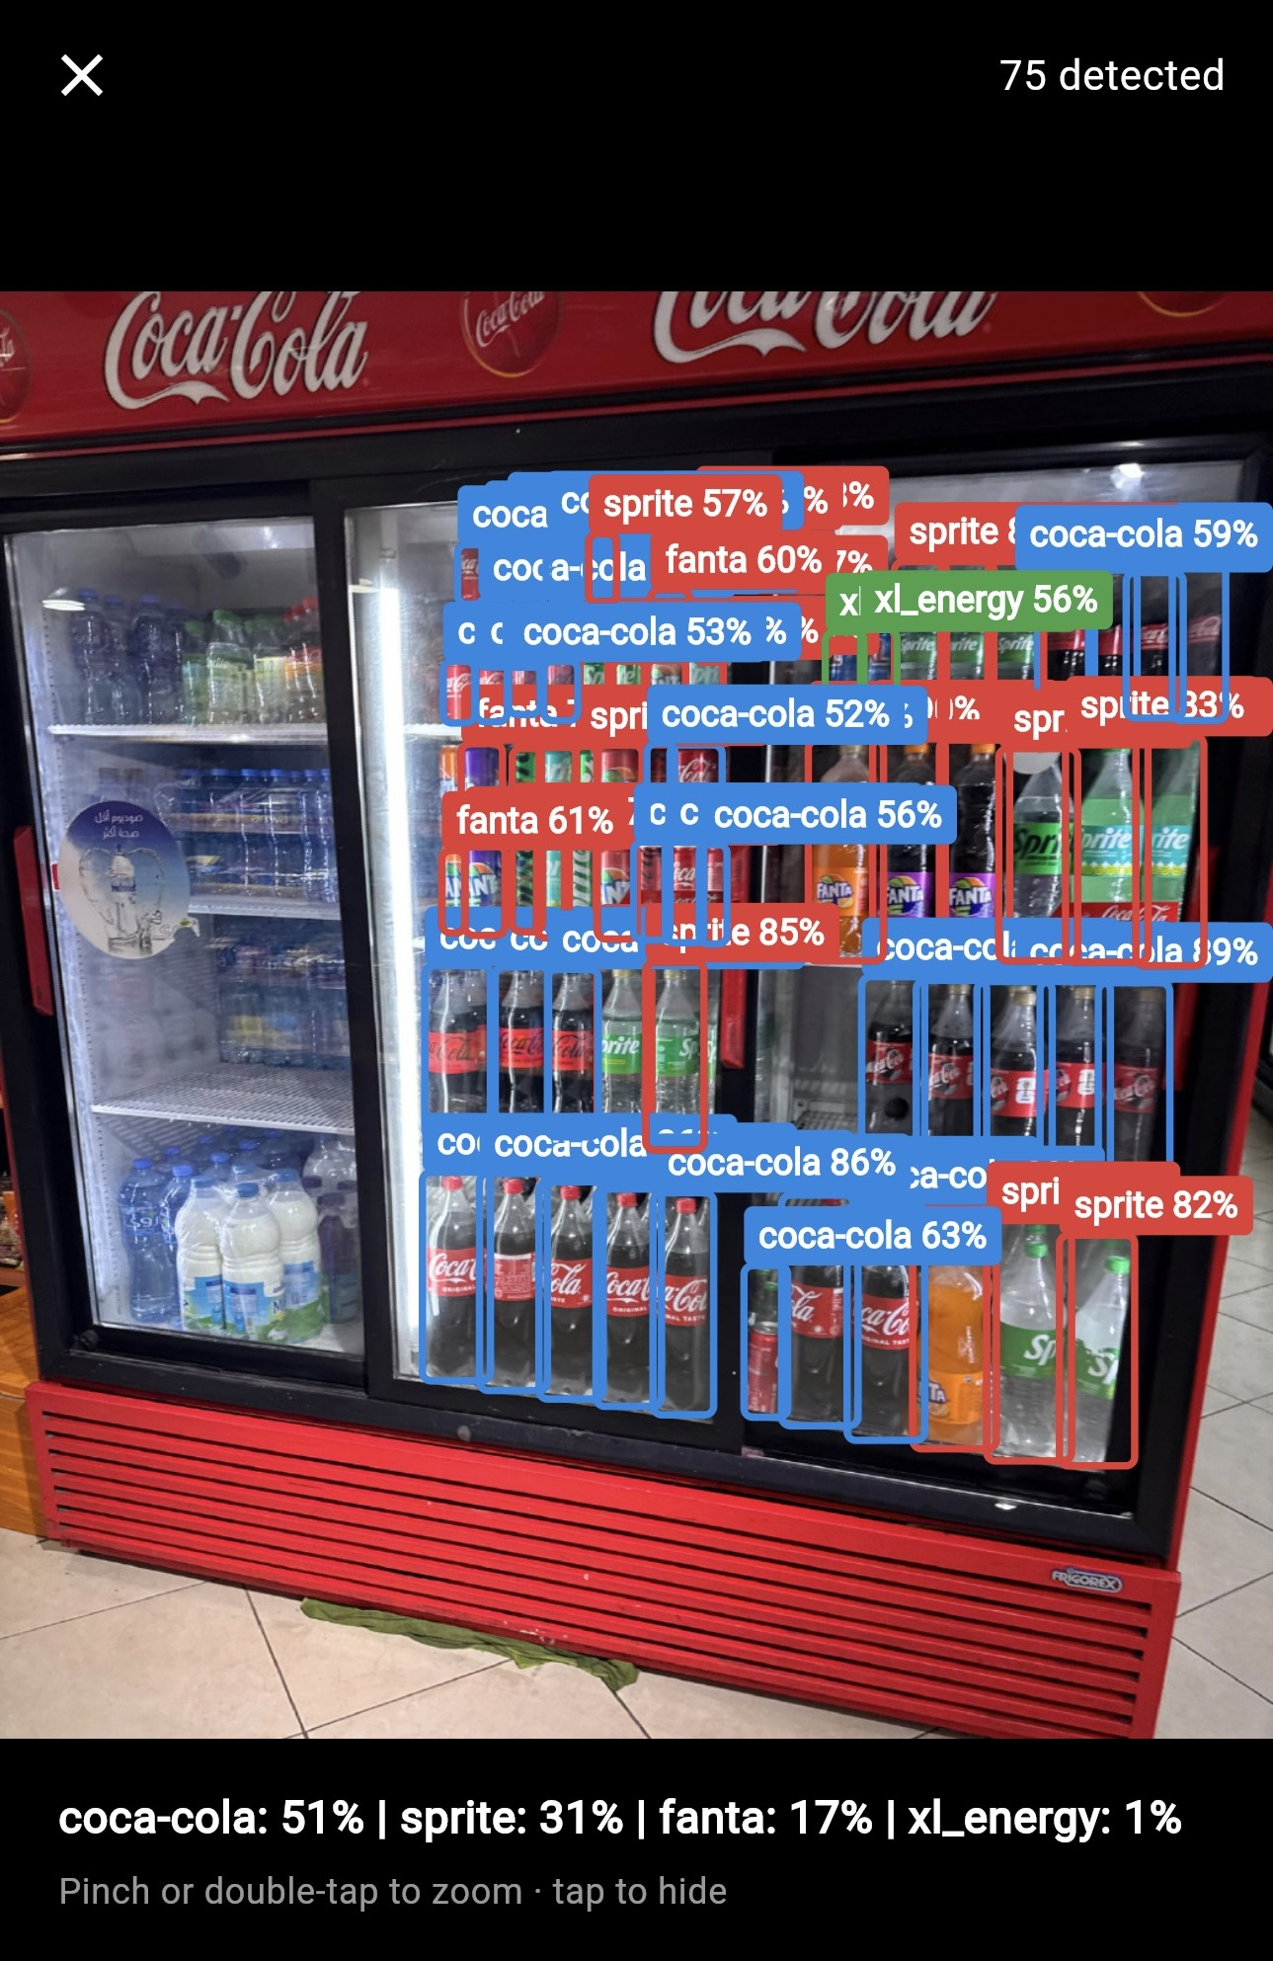
Figure 2. The single-layer approach on a real shelf: 75 detections, every label at brand level only — this approach's ceiling by construction, since its classes are the brands themselves. The share-of-shelf figures beneath are computed at the same level. The domain conditions described in Section 7 are also visible here: high display density, mutual occlusion, and reflections off the glass.
Table 3. Per-class performance of the single-layer detector against each class's share of the annotation budget. Total: 4,879 annotations.
Class | Annotations | mAP@50
coca-cola | 2,079 | 89.27%
cappy | 948 | 85.62%
xl_energy | 661 | 91.97%
sprite | 651 | 88.29%
fanta | 409 | 87.98%
pepsi | 131 | — (0% at every threshold)

Performance varies by 6.35 points between the strongest represented class and the weakest, and the pepsi class collapses entirely for lack of any representation in the test split. This is signal starvation exactly: a limited training signal divided six ways produces uneven performance bounded by its weakest class, not its strongest.
The annotation distribution deserves careful reading, because it does not say what it might be assumed to say. Among the represented classes the relationship between annotation count and performance is not monotonic: xl_energy, with 661 annotations, outperforms coca-cola with 2,079 — so tripling the data does not necessarily buy accuracy. The correct reading is that there is a floor of representation: above it, performance settles into a narrow band not governed by volume alone; below it, the class collapses outright. At a 2.7% share, pepsi is the only class beneath that floor — and the only one that collapsed.
The architectural implication is that the problem is not data scarcity in aggregate but its division. Splitting the budget six ways is what pushed the weakest class below the floor of representation; had the same signal been directed entirely at one class, no class would have been beneath the floor at all. That is precisely what the next approach does.
The multi-stage approach instead concentrates the entire signal into a single class scoring 93.33% — higher than any individual class in the single-layer approach — and defers discrimination to downstream layers operating on cropped, rescaled regions, that is, with far more visual detail than the detector has available on the full image. The implication is that the separation does not improve detection by accident: it improves it because it relieves the detector of a task for which it does not have sufficient visual detail, and assigns that task to a layer that does.
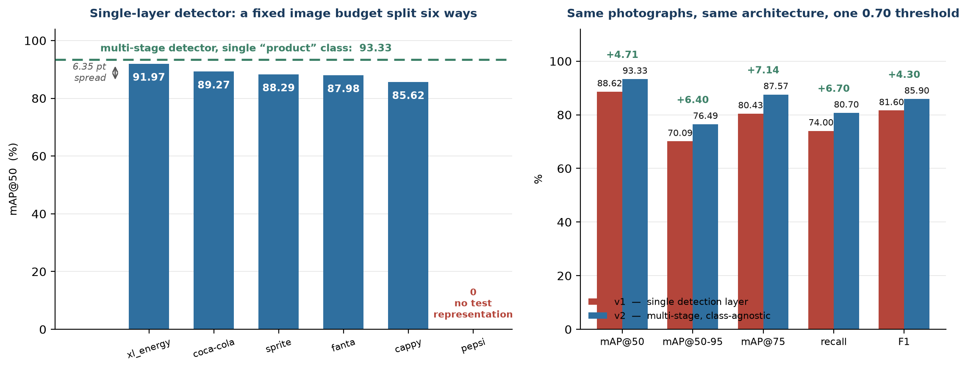
Figure 3. Left: per-class performance of the single-layer detector; the dashed line is the class-agnostic detector's single class. Right: headline metrics for both approaches, same evaluation tool.
5.3 Classification-layer performance
Table 4. The six classification layers at a 0.70 threshold. The per-class average weighs every class equally, the per-instance average weighs every test instance equally; what the difference means is discussed in Section 5.4.
Classifier | Precision | Recall (per-class avg) | Recall (per-instance avg)
Brand | 100% | 89.1% | 83.0% (39/47)
Fanta (flavour) | 100% | 88.9% | 94.4% (17/18)
Packaging | 95.9% | 74.4% | 93.8% (151/161)
XL Energy (variant) | 66.7% | 66.7% | 96.6% (28/29)
Coca-Cola (variant) | 66.7% | 55.6% | 93.3% (28/30)
Cappy (flavour) | 50.0% | 31.2% | 39.1% (9/23)

Table 5. The brand layer at a 0.70 threshold. Precision is 100% for every represented class. Total: 47 instances.
Class | Test instances | Correct | Recall
xl_energy | 20 | 16 | 80.0%
cappy | 14 | 12 | 85.7%
coca-cola | 10 | 8 | 80.0%
fanta | 2 | 2 | 100%
sprite | 1 | 1 | 100%
pepsi | 0 | — | —

Precision reached 100% for every brand with actual field photography behind it, even at the strict threshold. This is an architecturally decisive result: the decision on which everything downstream depends does not, in practice, err — when this classifier issues a verdict, it is correct. No error in the later layers can therefore be attributed to misrouting, which is a necessary condition for any conclusion about those layers' performance to be valid.
Table 6. Variant and packaging layers at a 0.70 threshold. Classes with no test representation are omitted.
Classifier | Classes (instances: correct) | Test total
Fanta | orange (12:12), redapple (3:3), grape (3:2) | 18
Packaging | plastic (88:84), can (70:66), glass (3:1) | 161
XL Energy | classic (24:24), red (4:4), sugarfree (1:0) | 29
Coca-Cola | classic (26:26), zero (3:2), diet (1:0) | 30
Cappy | orange (6:3), grape (4:3), lemon (4:1), mix (3:0), apple (2:0), mango (2:2), peach (1:0), strawberry (1:0) | 23

The fixed threshold exposes a distinction invisible at optimal thresholds, and it is among the most useful things this analysis produced: some weak classes are not wrong but merely unconfident. The xl-sugarfree class scores 100% precision and 100% recall at a 0.40 threshold, then falls to zero at 0.70 — the model knows it and gets it right, but at a confidence lying between the two thresholds. The same holds for cappy-strawberry and cappy-apple, and partially for cappy-lemon (50% recall at 0.40 against 25% at 0.70).
This is fundamentally different from coca-diet and glass, which fail at every threshold without exception. The former case is “learned but not trustworthy for automatic decisions” and is addressed by more examples to consolidate confidence; the latter is “not learned at all” and needs data simply to exist. A single table at each class's own optimal threshold cannot separate the two — it shows both as succeeding or failing depending on the class — whereas reading performance across two thresholds can.
Inspecting the confusion matrices at this threshold reveals a striking property: across the brand, Fanta, XL, Coca and Cappy classifiers there is not a single confusion between one class and another in the entire test set. Every error is an abstention — the model failed to reach the threshold and stayed silent — rather than a misclassification. In the brand layer, for instance: 47 instances, 39 correct, 8 abstentions, zero confusions.
This property has direct operational value: the system does not call a Coca-Cola a Sprite; it is either right or silent. An abstention is a tractable error, referred to human review and corrected there, whereas a confident misclassification propagates into the report without arousing suspicion. The sole exception is the packaging classifier, the only one that shows genuine confusion (can with plastic eight times, glass to plastic twice) and never abstains — and also the only one operating on a physical property rather than a commercial identity.
5.4 How statistically reliable these figures are
The figures above require an explicit caveat, and omitting it would make the report misleading however carefully each number was measured: the test splits are very small, and many of the 100% figures rest on single instances.
Table 7. Wilson 95% confidence intervals for four classes, all scoring 100%. The same number, carrying entirely different meanings.
Class | Correct/instances | Recall | 95% interval
sprite (brand) | 1/1 | 100% | 20.7% – 100%
xl-red | 4/4 | 100% | 51.0% – 100%
fanta-orange | 12/12 | 100% | 75.7% – 100%
coca-classic | 26/26 | 100% | 87.1% – 100%

The sprite class scores 100% on a single test image, and the true interval for its performance runs from 20.7% to 100% — that is, the number carries almost no information. By contrast coca-classic, on 26 instances, has an interval of 87.1%–100%, which is a statement with content. The two figures are identical on the page and fundamentally different in substance, and nothing distinguishes them except the instance count — which is why it is stated in every table in this study.
Small samples have a second effect, visible in the two recall columns of the table in Section 5.3: the per-class average weighs a class holding one instance as heavily as a class holding 24. XL's 66.7% is the clearest illustration — it means “two classes out of three”, and the third holds a single instance; had that one image cleared the threshold, the figure would read 100%. A number that swings by a third on the strength of one image is volatility, not measurement — while by the per-instance average, 28 of the 29 actual products in the test set were classified correctly (96.6%).
Both averages are valid, but they answer different questions. The per-class average asks “how does the system handle the average class?”, exposing and penalising data gaps; the per-instance average asks “how does it handle the average product on a shelf?”, which is what a client actually experiences. The prose of this study reports the former because it is the more conservative, and the latter is shown alongside it so the former is not misread.
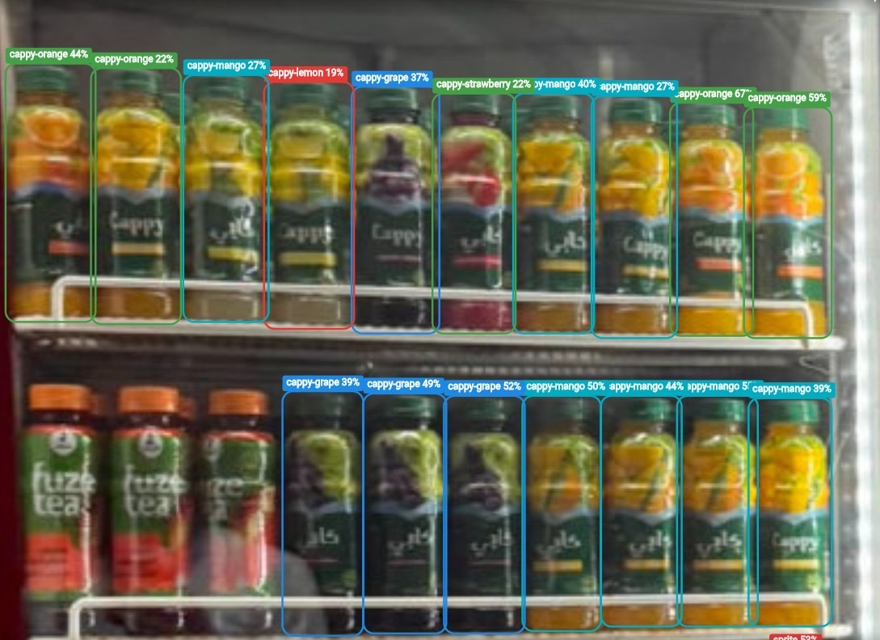
Figure 4. The multi-stage architecture on a real Cappy shelf: labels here are at flavour level (orange / mango / grape / lemon / strawberry) rather than brand level — this is what the routed variant layer produces, and it is directly comparable with the preceding figure. What matters most in it is that the confidences shown range from 19% to 67% — most of them below the 0.70 threshold this study adopts. This is exactly the case the section quantifies: the flavour is visually distinguished and usually correct, but below the confidence that would license an automatic decision — which is why the classifier scores 50% precision and 31.2% recall at that threshold, and why active learning was directed at it (Section 6).
The conclusion is that no measured weakness in the system is attributable to the architecture or the choice of model; all of them trace back to a specific, countable sample shortfall — and Section 9 separates which of these are genuine data scarcity and which are merely split artefacts. This is a decisive practical distinction: either kind is addressed by a procedure of known cost, whereas an architectural deficiency requires redesign.
5.5 Computational complexity
In the unrouted design every variant classifier runs on every region, making the number of invocations O(N×K). On a test photograph containing 60 products, one brand's classifier ran on all sixty regions even though only 12 belonged to it — 48 wasted invocations out of every 60. With conditional routing each region passes through at most one classifier, so growth becomes O(N), independent of K.
The direct measurement — running both versions back to back on the same photograph through the same call path — showed processing time falling from 40.32 seconds to 14.20 seconds, a 65% reduction, with all sixty labels literally identical between the two runs on that photograph. The agreement is an acceptance condition rather than a detail: a speed-up that changes the result is a defect, not an improvement. The measurement is stated at its actual limits — one test photograph, taken when only a single classifier was connected — not as a general guarantee.
Routing, however, is today no longer merely a performance optimisation but a correctness requirement. Once every classifier was set to always return its top-1 guess (Section 7 explains why), each variant classifier produces an answer for any region it receives — so running all four classifiers unrouted would let the merge step pick up the Fanta classifier's guess on a Sprite crop. The unrouted design is no longer a slower alternative; it is a wrong one.
The effect compounds as the catalogue widens. K grew from one to four during the research period. Using the measured distribution of the same photograph's regions (20 + 12 + 8 for brands with classifiers, 12 for a brand without one, and 8 unclassified), the unrouted design at K = 4 would require 60 × 4 = 240 invocations, whereas routing requires 20 + 12 + 8 = 40 — a reduction of 83%. This figure is derived arithmetically from a measured distribution rather than timed directly like the two preceding ones.
The significance is that the shape of growth itself has changed: under the unrouted design every brand added in future would have imposed a cost on every region of every image, whereas today it adds a cost that does not accumulate. Measuring this while K was still one was far cheaper than discovering it after K had become four.
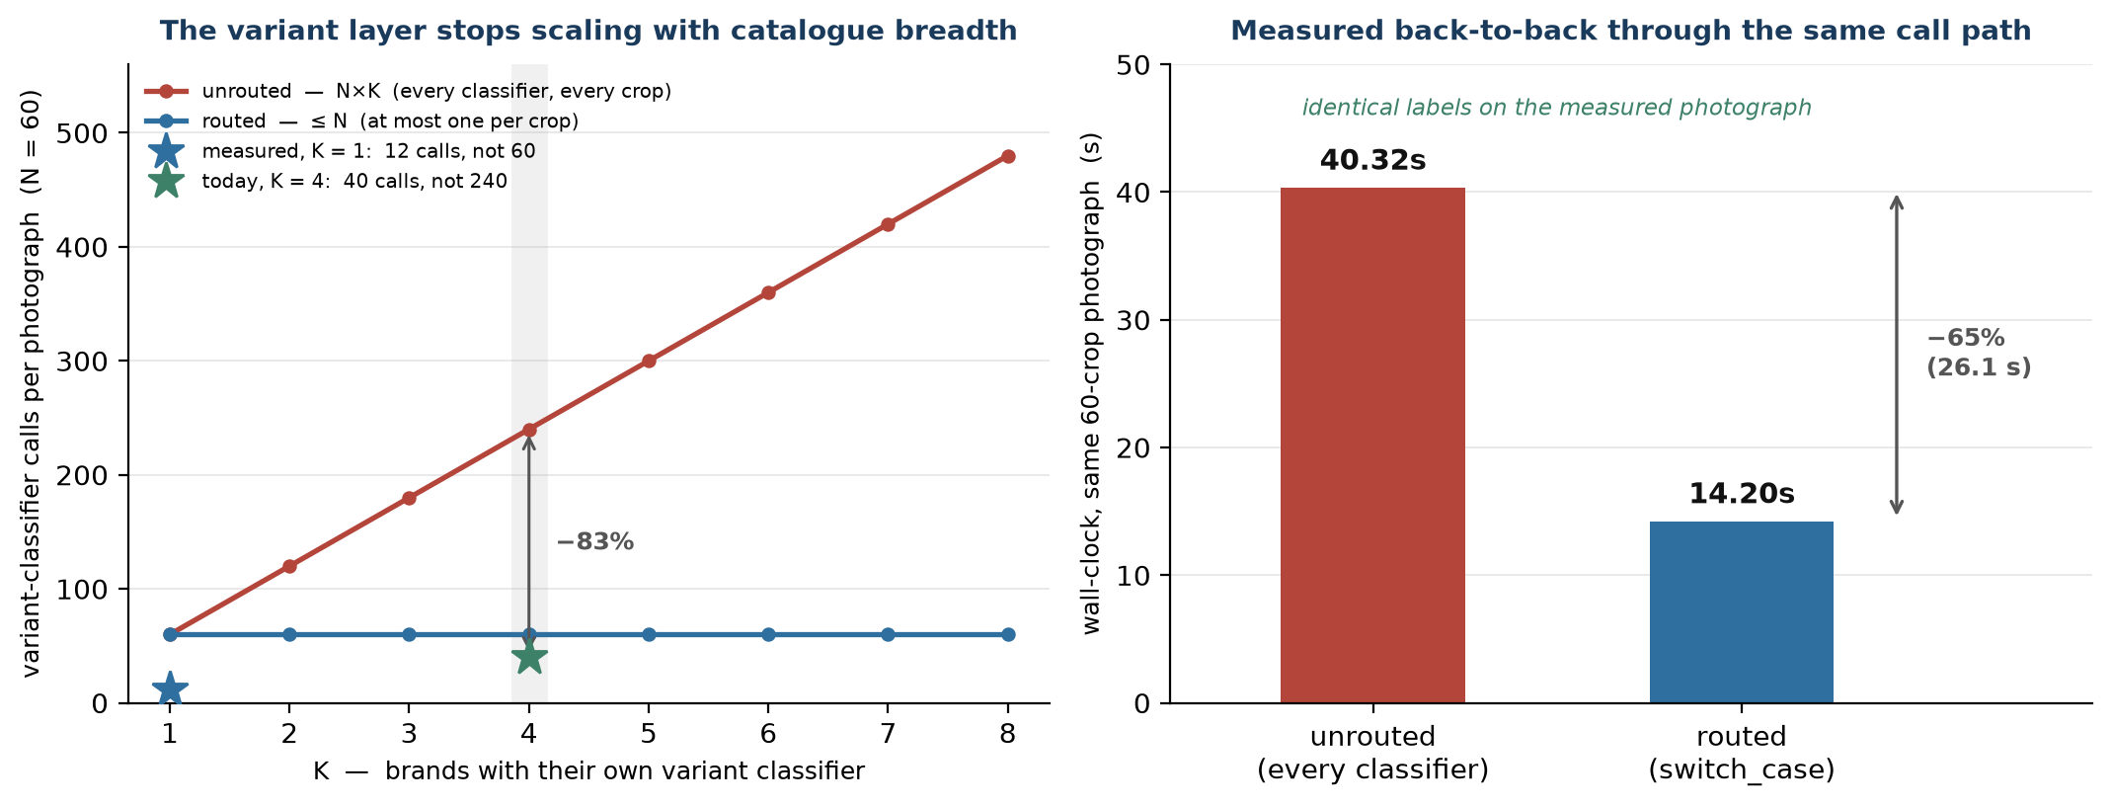
Figure 5. Left: variant-classifier invocations per photograph as a function of the number of brands with their own classifier; the two stars are the actual measurements. Right: measured time on the same photograph before and after routing.
5.6 Training cost and the marginal cost of growth
Table 8. Training cost of the seven models in production, computed from recorded training times at the published rate.
Model | Training time | Credits
Class-agnostic detector | 44.2 min | 1.47
Packaging classifier | 8.2 min | 0.27
Coca-Cola variant classifier | 5.1 min | 0.17
Brand classifier | 4.3 min | 0.15
XL Energy variant classifier | 4.0 min | 0.13
Cappy flavour classifier | 3.6 min | 0.12
Fanta flavour classifier | 3.3 min | 0.11
Total | 72.7 min | 2.42

Seven models at a total training cost of under an hour and a quarter of GPU time. The detector alone accounts for 61% of it, while the marginal cost of adding a variant classifier is roughly four minutes.
This is the architecture's central claim, and it was measured four times rather than once. On each occasion the work was the same: labelling a few hundred already-available regions, training one classifier, and connecting it to a routing step — with no change to the detector or the brand layer. Repeating the pattern four times is what turns “the marginal cost is low” from an inference drawn from a single case into an established observation.
For comparison, the equivalent cost under the single-layer approach is retraining the whole detector (44.2 minutes), together with the attendant risk of unintended regression in classes that were previously working correctly. No dollar figure is given here deliberately, because prices change independently of this report and should be verified at source when needed.
It was also established that inference is billed per image submitted to the pipeline rather than per internal model invoked — meaning that shelf density costs time, not money, which is precisely what Section 5.5 measures.
6. Active learning: a design result
A mechanism was built to convert field usage into training data, addressing the constraint established in Section 5.3: that the system's ceiling is set by data scarcity rather than model capacity.
The first design followed common practice: upload those regions where the classifier's confidence falls below a threshold, on the assumption that these are the most likely to be wrong. Empirical observation refuted this. After two classifiers improved, their confidence rose above 98% and they effectively stopped submitting any samples for review, while genuine errors continued to appear in use.
Analysis reveals a structural deficiency rather than a calibration problem. A confidence gate, by definition, captures uncertainty, not error — and these are not the same thing. A model that errs with high confidence — operationally the most dangerous case, because it propagates into reports without arousing suspicion — lies outside what such a gate can see, however its threshold is tuned. The fault is in the criterion itself, not in its value.
The adopted alternative replaces the confidence condition with a route-membership condition: every region the system actually routed to a given classification branch is uploaded, regardless of confidence. This increases the volume of data collected, a deliberate cost during an active correction phase, but it makes confident errors visible to human review instead of letting them pass silently.
One rule was preserved throughout: regions are uploaded unlabelled, and the system is never trained on its own guess without human review — which prevents the self-reinforcing drift that affects active-learning systems fed on their own output, entrenching their errors rather than correcting them.
7. Field application
Models alone do not constitute an operable system. Automated output on uncontrolled photographs cannot be treated as final — the ambiguity in them is structural, not exceptional — and so a cross-platform application was developed serving three research functions.
First, standardising capture conditions at the point of collection, reducing the variation the model has not learned (distance, angle, framing).
Second, interposing a human reviewer between the model's output and any figure reported as fact. Review here is part of the design rather than a fallback: wherever occlusion or camera angle makes a classification unreliable, a person settles it.
Third, closing the data loop: every human correction is a supervised signal fit for retraining, so ordinary field usage produces training data as a by-product — which is what makes Section 6 practicable.
An operational decision follows from this third function: what is shown to the reviewer is not necessarily what is counted in the report. The 0.70 threshold used for measurement defines what qualifies as a trustworthy automatic verdict, but hiding everything below it from the reviewer's screen would deny them sight of precisely the cases they are meant to correct — the cases the system most needs (Section 5.3). Predictions below the threshold are therefore shown for review but not counted automatically, since what is never seen cannot be corrected.
8. Challenges encountered
First: data scarcity is the binding constraint, not model capacity. This is the clearest thing the study established quantitatively. When performance is weak on a given class, the intuitive reading is always “the model needs more training” — and it proved repeatedly to be wrong. A visual audit of all 301 regions of one brand showed 95% of them to be a single variant, with no confirmed example of the others. A similar audit showed 90% of another brand's examples to be bottles rather than cans — meaning the model had learned that brand as a bottle. No amount of training produces discrimination between categories whose images do not exist.
Second: the measurement problem itself. The hardest part of the period was not building models but knowing what the system actually does, as against what it appears to do. High metrics establish that a model has learned what it was trained on, not that what it was trained on is correct; these are different questions. This imposed the principle of Section 3.2 as a necessary condition for every conclusion in the study, not as excess caution.
Third: the availability of measurement tooling as a research constraint. Automated evaluation of the classifiers was unavailable during part of the study period, so no accuracy figures for the classification layers could be reported during that time. The study committed to not substituting estimated figures for them. This is recorded because it illustrates that some research constraints are not technical but concern access to tools.
Fourth: verifying automated work on large data. Labelling more than 1,400 images required distributing the work across parallel processes, and the study established that an automated process's own report is no substitute for inspecting the resulting data directly; this direct inspection was adopted as a rule for every large labelling operation.
9. Limitations
1. The test splits are improperly small — the gravest limitation in this study, and the one that precedes all others because it bears on the reliability of every figure in it.
Table 9. Actual split proportions. The conventional test share is around 20%.
Project | Train | Valid | Test | Test share
Brand classifier | 1,534 | 105 | 47 | 2.8%
Coca-Cola | 720 | 30 | 30 | 3.8%
XL Energy | 612 | 58 | 29 | 4.1%
Fanta | 238 | 43 | 18 | 6.0%
Detector v2 | 316 | 34 | 34 | 8.9%
Cappy | 161 | 46 | 23 | 10.0%

The consequence is that classes rich in data reached the test set with one or two instances. The clearest example is sprite: the project holds 374 images of it, of which exactly one landed in the test split and 373 in training. Its “100%” is therefore not a performance certificate but an artefact of the split.
2. From this follows an essential distinction between two kinds of weakness that had been conflated under the single description of “data scarcity”. The first is a split deficiency rather than a data one (sprite, fanta at brand level, xl-red): the data exists in full within the project but the split withheld it from the test set, and the remedy is regenerating a version with a balanced split and retraining — minutes of computation, blocked solely on training credits. The second is genuine scarcity (coca-diet with 5 source images, glass with 25 images in the whole corpus, the thin Cappy flavours, and pepsi, unrepresented in detector and classifier alike): no split and no retraining produces these — only field photography does. Conflating the two inflates the apparent size of the work outstanding, since a substantial part of what looks like a data gap is a procedural one, closable by a single retraining run.
3. The differing preprocessing pipelines of the two compared versions (Section 3.1). Its effect is mitigated by two things: the difference works against the stated conclusion, and the size-resolved comparison was dropped as invalid. Unifying the pipeline in a later evaluation would close this point definitively.
4. Two independent splits. The projects generate their splits separately even though they share the source photographs, which weakens the comparison in principle.
5. The system was not evaluated end to end — the most important missing measurement in the study.
“End to end” means treating the whole system as a single black box: it is given a shelf photograph it has never seen, and its final output — the complete compound label for every product — is compared against a human labelling of the same photograph; Section 5 instead measured each layer in isolation. The difference matters for two reasons: the accuracy of a chain is a product rather than an average (three steps at 90% each yield roughly 73%), and each layer was measured on clean, manually labelled input while in production it receives the previous layer's output — a crop that may be shifted, clipped, or occluded. The brand layer's 100% answers “how often is it right on ideal crops?”, not “how often is it right on our detector's crops?”.
The distinction is practical rather than theoretical: the only figure that may honestly be given to a client is the end-to-end one, and it will necessarily be lower than every figure in Section 5. The cost of closing the gap is human rather than computational — fully labelling thirty to fifty shelf photographs by hand, with no training and no credits required.
10. Future work and what is needed
10.1 Requiring no external input
First, and cheapest for the return: regenerating the six classifier versions with a balanced split (70/20/10) and retraining them, closing Limitation 1. The brand classifier alone would move from 47 test instances to roughly 340, and sprite would gain dozens of instances instead of one — turning the figures in Section 5.3 from suggestive into statistically meaningful. The computational cost is about four minutes per classifier, under half an hour for the whole set; the only obstacle is the availability of training credits.
Next, an end-to-end evaluation on a manually labelled test set, to measure error accumulation across the chain (Limitation 5) — scientifically the highest-priority item, and one that needs no credits at all. Then re-evaluating both detectors under a unified preprocessing pipeline, to close Limitation 3. Then harvesting the first batch of active-learning data, reviewing it, and retraining on it — the first practical test of whether the loop described in Section 6 closes. Every future split should be stratified, guaranteeing each class a minimum test share — randomness applied to an unbalanced set is what produced the situation of Limitation 1 in the first place.
10.2 The open axis: adding size to the compound label
The fourth and final axis of the target label (Section 2) is package size — distinguishing a half-litre container from its 1.5-litre counterpart. It is technically the hardest of the axes, because absolute size cannot be inferred from an image alone without a scale reference.
The first step is not technical but investigative: establishing whether size is ambiguous in this market at all — since many combinations (brand + variant + package type) may be sold in only one size, in which case size can be looked up from a reference table rather than inferred visually, a cheap step that may eliminate most of the hard cases before anything is built. For the ambiguous cases that remain, the candidate approach is geometric comparison against a reference object of known size in the same image, falling back to a visual size classifier if that proves inadequate — and either requires a validation set before it can be trusted.
10.3 What is needed from outside the team
First, a targeted field photography round — the real constraint on progress. It is not an engineering item, and the evaluation has turned it from a general request into a list of measured priorities.
Table 10. Data gaps ordered by measured priority rather than by estimate.
Gap | Measured state | Priority
Coca-Cola Diet | 0% / 0% — 5 source images | Critical
Glass-packaged products | 33.3% recall — 3 instances | Critical
Six Cappy flavours | no representation | High
Coca-Cola Zero | 66.7% recall | High
Pepsi | unrepresented in detector and classifier | High
Two thin XL variants | no representation | Medium

Alongside it, a size validation set of 50 to 100 images in which the true size is known with certainty, since no size-estimation approach can be evaluated without one — it is a precondition for the axis described in Section 10.2, not a complement to it.
Second, continuity of access to training and evaluation resources, since the availability of measurement tooling is what made this study's results possible.
Third, guidance the technical team cannot issue on its own, and the most important thing requested here: what accuracy threshold counts as production-ready in this domain? The question has become concrete now that figures exist. The brand layer at 100% precision is ready by any standard, and a classifier at 56% is ready by none. But what about the intermediate cases? Is a class at 66.7% recall acceptable in a report delivered to a client? Should it be presented with a caveat? Or withheld until its data improves?
The answer directly determines engineering behaviour: how far the system should lean toward referring a decision to human review rather than settling it automatically. That is a commercial judgement about what the client accepts and what the service agreement bears, not a technical question — and it will shape the next round of tuning work.
11. Conclusion
This study tested the hypothesis that separating localisation from identification in applied computer-vision systems improves both accuracy and scalability. The results support the hypothesis with measured evidence.
First, the multi-stage approach outperformed the single-layer one on every mean-precision metric and on recall, from the same source photographs, and despite its counterpart being evaluated under the easier condition. The per-class breakdown reveals the mechanism: a limited training signal divided six ways produces performance bounded by its weakest class rather than its strongest, whereas separation concentrates that signal into one class and defers discrimination to a layer with far more visual detail available to it.
Second, the shape of growth deserves measurement as much as accuracy does. The difference between O(N×K) and O(N) does not show up in a single image, but it determines whether the system remains practical after ten brands or collapses under its own weight. The marginal cost of catalogue expansion — roughly four minutes of GPU time, measured four times — is the practical translation of that gain, and is the commercially decisive metric rather than any individual model's accuracy.
Third, data quality — and the quality of its measurement — bounds the ceiling of any architecture. This is now measured rather than inferred: every individual weakness traces to a countable sample shortfall, part genuine photography scarcity and part a split artefact repairable by retraining, and none traces to a flaw in the design. The two most important items in the next phase are therefore fixing the splits and a photography round — not an engineering item.
What has been achieved — a more accurate detector from the same source photographs, six working and measured classification layers, a routing architecture demonstrated four times, a live active-learning loop, at a total training cost of under an hour and a quarter — constitutes an empirically established foundation to build on, not a finished product. The limitations in Section 9 are specific and of known cost, and none of them points to a flaw in the underlying design.

