**SUPPLEMENTAL MATERIAL**

**Data (GitHub and Dryad)**

Sample of 100 trees from the McGuire et al. (1) posterior distribution

Average dichromatism and dichromatism of each patch for 237 species

PCA scores from 14 morphological measurements for males and females of 117 species

Weight-corrected tail length dimorphism for 172 species

PCA scores of male song properties for 262 species

Simulation of dimorphism: External text file.

**Supplemental methods**

*Morphological dimorphism*

We compared the calculation of Morphological Dimorphism (MD) using two approaches; first, as the Euclidean distance between males and females in the multidimensional space defined by the 14 PCs for each species (our chosen method in the main text); and second, by weighting this Euclidean distance by the proportion of variance explained by each PC axis. We evaluated which of the two approaches better approximated a simulated dataset of dimorphic traits under different parameters (see Supplemental Material for R script). We found that both methodologies yielded similar results, therefore, we chose the first approach for simplicity.

*AVONET and combined dataset models*

To determine if increased sampling within the “Bee” clade (Fig. 1) would change our results and interpretations, we ran two additional set of models. The first model used only the AVONET (2) complete morphology dataset for hummingbirds. After filtering those species without data for both sexes, those not included in the phylogeny, and those without altitude, habitat structure, and body mass data, this model contained 78 species, including 17 species of the “Bee” clade. All measurements were divided by the cubic root of the body mass and dimorphism was calculated in the same way as our morphological dimorphism (see main text). For the model testing the association between morphological dimorphism and tail length dimorphism, the tail length measurement was excluded from the PCA distance matrix as in our own dataset.

The combined data set added 16 species present in the AVONET dataset and absent in ours. For a total of 123 species, with 17 of species of the “Bee” clade. We kept only the four measurements that were common in both datasets: total culmen beak length, bill height, folded wing length, and tail length. Since the body mass data we collected was not available for the additional species, we corrected for the cubic root of body mass using the Colwell et al. database for all species. After correcting for size, dimorphism was calculated in the same way as our morphological dimorphism (see main text).

*Song complexity*

Prior to the calculation of song parameters, we curated our acoustic database and checked for species with reported loss of song in Clark et al. (3). Most species with evolutionary loss of song belong to the Bee clade, specifically *Popelaria* spp, *Calliphlox amethystina*, *Philodice mitchellii*, *Chaetocercus burmeisteri*, *Chaetocercus mulsant*, *Chaetocercus bombus*, *Chaetocercus berlepschi*, *Calothorax enicura*, *Archilochus alexandri*, *Archilochus colubris*, *Selasphorus scintilla*, *Selasphorus flammula*, *Selasphorus platycercus*, *Selasphorus rufus*, *Selasphorus sasin*, *Selasphorus calliope*. Out of these species, *Calliphlox amethystina*, *Selasphorus sasin*, *Selasphorus calliope*, y *Selasphorus flammula* were the only species in our dataset. Therefore, we decided to exclude the first three species only, because the song of *S. flammula* has been described and recorded several times by two of us (MAS and FGS).

Four parameters describing song complexity were calculated for each recording: element types, as the number of unique elements in a song; acoustic space, as the minimum spanning tree connecting all elements of a song in the overall hummingbird acoustic space; element transition diversity, a measure of sequence predictability calculated as the ratio of the number of transitions between different element types to the transitions between the same element type; and between-song variation, as the mean pairwise distance of the element sequence between songs from the same recording using the optimal matching algorithm for sequence comparison (4) in the R package *TraMineR* (5). To reduce dimensionality and to obtain a single measure of song complexity, we employed a PCA on all four song complexity parameters. PC1 (62.9% of total variance) loaded strongly and negatively on all properties except for element transition diversity, which loaded strongly on PC2 (8.8%). We kept PC1 as a measure of song complexity (Fig. 1; Table S2).

Element acoustic spaces were calculated as the first two principal components from a PCA on 22 acoustic parameters measured in the R package *warbleR* (6). Species acoustic spaces were quantified in the R package *PhenotypeSpace* (7) and minimum spanning trees quantified with the R package *vegan* (8). Between-song variation was imputed for the two species in which only a single song per recording was obtained (*Chalcostigma herrani* and *Coeligena phalerata*). Imputation was conducted with an iterative PCA algorithm (9) in the R package *missMDA* (10).

**Supplemental tables**

**Table S1.** Morphology PCA summary and loadings.

|  |  |  |  |  |  |  |  |  |  |  |  |  |  |  |
| --- | --- | --- | --- | --- | --- | --- | --- | --- | --- | --- | --- | --- | --- | --- |
|  | **PC1** | **PC2** | **PC3** | **PC4** | **PC5** | **PC6** | **PC7** | **PC8** | **PC9** | **PC10** | **PC11** | **PC12** | **PC13** | **PC14** |
| Standard deviation | 2.71 | 1.46 | 1.29 | 0.94 | 0.89 | 0.84 | 0.59 | 0.29 | 0.13 | 0.10 | 0.06 | 0.04 | 0.03 | 0.02 |
| Proportion of Variance | 0.53 | 0.15 | 0.12 | 0.06 | 0.06 | 0.05 | 0.02 | 0.01 | 0.00 | 0.00 | 0.00 | 0.00 | 0.00 | 0.00 |
| Cumulative Proportion | 0.53 | 0.68 | 0.80 | 0.86 | 0.92 | 0.97 | 0.99 | 1.00 | 1.00 | 1.00 | 1.00 | 1.00 | 1.00 | 1.00 |
|  | **PC1** | **PC2** | **PC3** | **PC4** | **PC5** | **PC6** | **PC7** | **PC8** | **PC9** | **PC10** | **PC11** | **PC12** | **PC13** | **PC14** |
| Bmass | 0.34 | 0.07 | 0.06 | -0.13 | 0.16 | -0.27 | 0.18 | -0.09 | -0.74 | -0.38 | -0.13 | 0.04 | 0.00 | -0.01 |
| ExpCul | 0.22 | 0.34 | -0.41 | 0.06 | -0.13 | 0.36 | 0.19 | 0.00 | -0.04 | 0.00 | 0.24 | 0.65 | 0.00 | -0.06 |
| TotCul | 0.24 | 0.33 | -0.38 | 0.04 | -0.12 | 0.34 | 0.20 | -0.03 | 0.02 | -0.01 | -0.24 | -0.67 | 0.00 | 0.06 |
| CommWidth | 0.33 | 0.12 | -0.08 | -0.13 | 0.14 | -0.23 | -0.27 | -0.79 | 0.29 | 0.07 | 0.01 | 0.03 | 0.01 | 0.00 |
| BillHeight | 0.29 | 0.23 | -0.16 | -0.11 | 0.13 | -0.08 | -0.76 | 0.48 | -0.02 | 0.00 | -0.05 | 0.00 | -0.01 | 0.00 |
| FoldWingLength | 0.34 | -0.11 | 0.21 | -0.08 | 0.07 | 0.06 | 0.17 | 0.10 | -0.02 | 0.65 | -0.55 | 0.20 | -0.04 | -0.03 |
| WingLength | 0.35 | -0.09 | 0.20 | -0.07 | 0.08 | 0.05 | 0.11 | 0.11 | -0.03 | 0.23 | 0.54 | -0.17 | 0.61 | 0.23 |
| WingWidth | 0.35 | -0.18 | 0.08 | 0.03 | 0.08 | -0.01 | 0.11 | 0.10 | 0.04 | 0.10 | 0.46 | -0.18 | -0.71 | -0.22 |
| WShapeRatio | -0.13 | 0.42 | 0.43 | -0.43 | -0.01 | 0.21 | 0.01 | -0.03 | 0.02 | -0.03 | 0.05 | 0.04 | -0.29 | 0.55 |
| WAspectRatio | 0.01 | 0.47 | 0.55 | 0.15 | -0.10 | 0.13 | -0.04 | -0.03 | 0.02 | -0.06 | 0.02 | -0.06 | 0.15 | -0.63 |
| WingTap | 0.20 | 0.10 | 0.21 | 0.81 | -0.14 | -0.11 | -0.07 | -0.02 | 0.01 | -0.06 | -0.06 | 0.05 | -0.09 | 0.43 |
| WingLoad | -0.12 | 0.47 | -0.17 | -0.01 | 0.08 | -0.70 | 0.35 | 0.22 | 0.19 | 0.19 | 0.07 | -0.02 | 0.00 | 0.00 |
| WingArea | 0.34 | -0.14 | 0.13 | -0.12 | 0.10 | 0.00 | 0.24 | 0.23 | 0.57 | -0.57 | -0.21 | 0.12 | 0.08 | 0.01 |
| TailLength | 0.17 | -0.11 | 0.03 | -0.23 | -0.92 | -0.25 | -0.06 | 0.02 | -0.01 | -0.01 | 0.00 | 0.00 | 0.00 | 0.00 |

**Table S2.** Acoustic PCA summary and loadings. Acoustic parameters are element types (elm.types), sequence complexity (c.sq.complx), acoustic space (acous.spc.mst), and between song variation with imputed values (btwn.song.var.IMP).

|  |  |  |  |  |
| --- | --- | --- | --- | --- |
|  | PC1 | PC2 | PC3 | PC4 |
| Standard deviation | 1.58 | 1.01 | 0.53 | 0.43 |
| Proportion of Variance | 0.63 | 0.26 | 0.07 | 0.05 |
| Cumulative Proportion | 0.63 | 0.88 | 0.95 | 1.00 |
|  | PC1 | PC2 | PC3 | PC4 |
| elm.types | -0.52 | 0.38 | -0.76 | 0.05 |
| c.sq.complx | -0.20 | -0.92 | -0.33 | -0.04 |
| acous.spc.mst | -0.59 | 0.02 | 0.37 | -0.72 |
| btwn.song.var.IMP | -0.58 | -0.05 | 0.42 | 0.69 |

**Table S3.** BPMMs results for the altitude and habitat models. 95% confidence interval was computed as High-Density Interval from the pooled distribution of 100 models each using a phylogenetic tree from the posterior distribution. Habitat is a categorical variable organized as: 1, understory; 2, mixed; 3, open. A colon denotes interaction. Significance was assessed by whether the 95% confidence interval touched zero or not. The combined dataset in morphological dimorphism refers to the AVONET dataset combined with our own for common measurements (See supplementary methods for details). Tail dimorphism squared refers to the square root size correction. Tail dimorphism cubic refers to a cubic root size correction used to evaluate the effect of the size correction method on results.

|  |  |  |  |
| --- | --- | --- | --- |
| **Dichromatism ~ MidAlt * Habitat** | | | |
| Trait | post.median | l-95% CI | u-95% CI |
| (Intercept) | -0.117 | -0.801 | 0.561 |
| MidAlt | -0.337 | -0.740 | 0.060 |
| Habitat2_mixed | -0.050 | -0.391 | 0.303 |
| Habitat3_open | -0.108 | -0.485 | 0.262 |
| MidAlt:Habitat2_mixed | 0.417 | 0.007 | 0.832 |
| MidAlt:Habitat3_open | 0.446 | 0.020 | 0.871 |
| **Morphological dimorphism ~ MidAlt * Habitat** | | | |
| Trait | post.median | l-95% CI | u-95% CI |
| (Intercept) | -0.171 | -0.998 | 0.645 |
| MidAlt | -0.599 | -1.097 | -0.090 |
| Habitat2_mixed | 0.188 | -0.254 | 0.615 |
| Habitat3_open | 0.053 | -0.437 | 0.533 |
| MidAlt:Habitat2_mixed | 0.798 | 0.293 | 1.292 |
| MidAlt:Habitat3_open | 0.319 | -0.214 | 0.858 |
| **Morphological dimorphism (AVONET) ~ MidAlt * Habitat** | | | |
| Trait | post.median | l-95% CI | u-95% CI |
| (Intercept) | -0.274 | -1.076 | 0.543 |
| MidAlt | 0.383 | -1.432 | 2.163 |
| Habitat2_mixed | 0.345 | -0.513 | 1.212 |
| Habitat3_open | 0.237 | -0.622 | 1.102 |
| MidAlt:Habitat2_mixed | -0.367 | -2.136 | 1.526 |
| MidAlt:Habitat3_open | -0.558 | -2.352 | 1.291 |
| **Morphological dimorphism (Combined dataset) ~ MidAlt * Habitat** | | | |
| Trait | post.median | l-95% CI | u-95% CI |
| (Intercept) | -0.379 | -1.080 | 0.322 |
| MidAlt | -0.112 | -0.738 | 0.509 |
| Habitat2_mixed | 0.272 | -0.274 | 0.800 |
| Habitat3_open | 0.227 | -0.339 | 0.806 |
| MidAlt:Habitat2_mixed | -0.009 | -0.655 | 0.640 |
| MidAlt:Habitat3_open | -0.199 | -0.858 | 0.455 |
| **Song complexity ~ MidAlt * Habitat** | | | |
| Trait | post.median | l-95% CI | u-95% CI |
| (Intercept) | 0.139 | -0.358 | 0.627 |
| MidAlt | -0.172 | -0.644 | 0.291 |
| Habitat2_mixed | -0.392 | -0.767 | -0.019 |
| Habitat3_open | -0.251 | -0.652 | 0.150 |
| MidAlt:Habitat2_mixed | 0.016 | -0.498 | 0.518 |
| MidAlt:Habitat3_open | 0.334 | -0.162 | 0.839 |
| **Tail dimorphism (Squared) ~ MidAlt * Habitat** | | | |
| Trait | post.median | l-95% CI | u-95% CI |
| (Intercept) | -0.275 | -1.078 | 0.498 |
| MidAlt | -0.100 | -0.601 | 0.400 |
| Habitat2_mixed | 0.137 | -0.296 | 0.566 |
| Habitat3_open | 0.143 | -0.314 | 0.592 |
| MidAlt:Habitat2_mixed | -0.016 | -0.545 | 0.493 |
| MidAlt:Habitat3_open | -0.064 | -0.596 | 0.477 |
| **Tail dimorphism (Cubic) ~ MidAlt * Habitat** | | | |
| Trait | post.median | l-95% CI | u-95% CI |
| (Intercept) | -0.245 | -1.067 | 0.594 |
| MidAlt | -0.083 | -0.567 | 0.397 |
| Habitat2_mixed | 0.155 | -0.258 | 0.579 |
| Habitat3_open | 0.138 | -0.302 | 0.578 |
| MidAlt:Habitat2_mixed | -0.025 | -0.522 | 0.463 |
| MidAlt:Habitat3_open | -0.084 | -0.595 | 0.445 |

**Table S4.** Results of PGLS models between sex differences in body mass, folded wing length, and wing length and altitude and habitat structure. Wing measurements were corrected for size by dividing by the cubic root of body mass. Sex differences were calculates as the log10 difference between female and male values and then scaled to unit variance. Models were run with a Pagel’s correlation structure with initial value of 1 to account for phylogenetic signal.

|  |  |  |  |  |
| --- | --- | --- | --- | --- |
| **Bmass ~ MidAlt * Habitat** | | |  |  |
|  | Value | Std.Error | t-value | p-value |
| (Intercept) | -0.132 | 0.506 | -0.260 | 0.795 |
| MidAlt | 0.103 | 0.193 | 0.535 | 0.594 |
| Habitat2_mixed | 0.136 | 0.179 | 0.764 | 0.447 |
| Habitat3_open | 0.070 | 0.226 | 0.310 | 0.757 |
| MidAlt:Habitat2_mixed | 0.100 | 0.167 | 0.596 | 0.552 |
| MidAlt:Habitat3_open | -0.228 | 0.215 | -1.058 | 0.292 |
|  |  |  |  |  |
| **FoldWingLength ~ MidAlt * Habitat** | | |  |  |
|  | Value | Std.Error | t-value | p-value |
| (Intercept) | 0.071 | 0.377 | 0.188 | 0.851 |
| MidAlt | 0.044 | 0.254 | 0.174 | 0.862 |
| Habitat2_mixed | -0.327 | 0.218 | -1.503 | 0.136 |
| Habitat3_open | 0.166 | 0.242 | 0.688 | 0.493 |
| MidAlt:Habitat2_mixed | -0.166 | 0.257 | -0.649 | 0.518 |
| MidAlt:Habitat3_open | -0.069 | 0.270 | -0.256 | 0.798 |
|  |  |  |  |  |
| **WingLength ~ MidAlt * Habitat** | | |  |  |
|  | Value | Std.Error | t-value | p-value |
| (Intercept) | -0.040 | 0.405 | -0.100 | 0.921 |
| MidAlt | 0.172 | 0.247 | 0.696 | 0.488 |
| Habitat2_mixed | -0.007 | 0.214 | -0.033 | 0.974 |
| Habitat3_open | 0.221 | 0.241 | 0.920 | 0.360 |
| MidAlt:Habitat2_mixed | -0.504 | 0.244 | -2.063 | 0.042 |
| MidAlt:Habitat3_open | -0.238 | 0.262 | -0.908 | 0.366 |

**Table S5.**  BPMMs using the dichromatism of each patch as response variable, and mid altitude and habitat as predictors. 95% confidence interval was computed as High-Density Interval from the pooled distribution of 100 models each using a phylogenetic tree from the posterior distribution. Significance was assessed by whether the 95% confidence interval touched zero or not.

|  |  |  |  |
| --- | --- | --- | --- |
| **Crown Dichromatism ~ MidAlt * Habitat** | | | |
| Trait | post.median | l-95% CI | u-95% CI |
| (Intercept) | 0.069 | -0.495 | 0.617 |
| MidAlt | -0.298 | -0.735 | 0.139 |
| Habitat2_mixed | -0.037 | -0.408 | 0.347 |
| Habitat3_open | -0.228 | -0.630 | 0.166 |
| MidAlt:Habitat2_mixed | 0.416 | -0.056 | 0.877 |
| MidAlt:Habitat3_open | 0.373 | -0.098 | 0.833 |
|  |  |  |  |
| **Gorget Dichromatism ~ MidAlt * Habitat** | | | |
| Trait | post.median | l-95% CI | u-95% CI |
| (Intercept) | -0.379 | -1.035 | 0.260 |
| MidAlt | -0.223 | -0.615 | 0.173 |
| Habitat2_mixed | -0.045 | -0.386 | 0.295 |
| Habitat3_open | 0.081 | -0.288 | 0.443 |
| MidAlt:Habitat2_mixed | 0.230 | -0.173 | 0.643 |
| MidAlt:Habitat3_open | 0.222 | -0.194 | 0.641 |
|  |  |  |  |
| **Belly Dichromatism ~ MidAlt * Habitat** | | | |
| Trait | post.median | l-95% CI | u-95% CI |
| (Intercept) | 0.011 | -0.586 | 0.621 |
| MidAlt | -0.433 | -0.846 | -0.005 |
| Habitat2_mixed | -0.184 | -0.540 | 0.174 |
| Habitat3_open | -0.236 | -0.614 | 0.151 |
| MidAlt:Habitat2_mixed | 0.535 | 0.085 | 0.963 |
| MidAlt:Habitat3_open | 0.481 | 0.037 | 0.921 |
|  |  |  |  |
| **Mantle Dichromatism ~ MidAlt * Habitat** | | | |
| Trait | post.median | l-95% CI | u-95% CI |
| (Intercept) | -0.089 | -0.614 | 0.476 |
| MidAlt | 0.049 | -0.398 | 0.497 |
| Habitat2_mixed | 0.221 | -0.162 | 0.602 |
| Habitat3_open | 0.095 | -0.314 | 0.484 |
| MidAlt:Habitat2_mixed | 0.031 | -0.441 | 0.528 |
| MidAlt:Habitat3_open | 0.098 | -0.383 | 0.572 |
|  |  |  |  |
| **Rump Dichromatism ~ MidAlt * Habitat** | | | |
| Trait | post.median | l-95% CI | u-95% CI |
| (Intercept) | -0.018 | -0.528 | 0.531 |
| MidAlt | -0.150 | -0.591 | 0.303 |
| Habitat2_mixed | 0.100 | -0.282 | 0.488 |
| Habitat3_open | -0.051 | -0.463 | 0.343 |
| MidAlt:Habitat2_mixed | 0.104 | -0.380 | 0.599 |
| MidAlt:Habitat3_open | 0.236 | -0.241 | 0.720 |

**Table S6.** BPMMs results for the comparisons between pairs of dimorphic traits, including altitude and habitat structure as covariates. Total_dim refers to morphological dimorphism (using all 14 morphological measurements). Tail_dim refers to tail dimorphism of the longest male rectrix corrected for size. 95% confidence interval was computed as High-Density Interval from the pooled distribution of 100 models each using a phylogenetic tree from the posterior distribution. Significance was assessed by whether the 95% confidence interval touched zero or not. Habitat is a categorical variable organized as: 1, understory; 2, mixed; 3, open. A colon denotes interaction.

|  |  |  |  |
| --- | --- | --- | --- |
| **Dichromatism ~ Total_Dim + Total_Dim:MidAlt + Total_Dim:Habitat** | | | |
| Trait | post.median | l-95% CI | u-95% CI |
| (Intercept) | -0.267 | -0.959 | 0.381 |
| Total_Dim | 0.239 | -0.181 | 0.656 |
| Total_Dim:MidAlt | -0.060 | -0.214 | 0.093 |
| Total_Dim:Habitat2_mixed | -0.001 | -0.496 | 0.506 |
| Total_Dim:Habitat3_open | -0.317 | -0.826 | 0.212 |
|  |  |  |  |
| **Dichromatism ~ Total_Dim + Total_Dim:MidAlt + Total_Dim:Habitat (AVONET)** | | | |
| Trait | post.median | l-95% CI | u-95% CI |
| (Intercept) | 0.018 | -0.704 | 0.748 |
| Total_Dim | 1.168 | -0.298 | 2.614 |
| Total_Dim:MidAlt | -0.123 | -0.319 | 0.076 |
| Total_Dim:Habitat2_mixed | -0.957 | -2.447 | 0.529 |
| Total_Dim:Habitat3_open | -0.975 | -2.466 | 0.539 |
|  |  |  |  |
| **Dichromatism ~ SongComplexity + SongComplexity:MidAlt + SongComplexity:Habitat** | | | |
| Trait | post.median | l-95% CI | u-95% CI |
| (Intercept) | -0.097 | -0.739 | 0.542 |
| SongComplexity | 0.238 | 0.015 | 0.449 |
| SongComplexity:MidAlt | 0.107 | -0.038 | 0.253 |
| SongComplexity:Habitat2_mixed | -0.052 | -0.356 | 0.243 |
| SongComplexity:Habitat3_open | -0.090 | -0.390 | 0.213 |
|  |  |  |  |
| **Dichromatism ~ SongComplexity + SongComplexity:MidAlt + SongComplexity:Habitat (removing outliers)** | | | |
| Trait | post.median | l-95% CI | u-95% CI |
| (Intercept) | -0.097 | -0.753 | 0.550 |
| SongComplexity | 0.271 | -0.019 | 0.566 |
| SongComplexity:MidAlt | 0.101 | -0.045 | 0.249 |
| SongComplexity:Habitat2_mixed | -0.034 | -0.430 | 0.342 |
| SongComplexity:Habitat3_open | -0.122 | -0.474 | 0.240 |
|  |  |  |  |
| **Dichromatism ~ Tail_Dim + Tail_Dim:MidAlt + Tail_Dim:Habitat** | | | |
| Trait | post.median | l-95% CI | u-95% CI |
| (Intercept) | -0.149 | -0.777 | 0.482 |
| Tail_Dim | 0.258 | -0.806 | 1.335 |
| Tail_Dim:MidAlt | -0.120 | -0.261 | 0.023 |
| Tail_Dim:Habitat2_mixed | -0.052 | -1.146 | 1.053 |
| Tail_Dim:Habitat3_open | -0.132 | -1.220 | 0.948 |
|  |  |  |  |
| **Morphological dimorphism ~ SongComplexity + SongComplexity:MidAlt + SongComplexity:Habitat** | | | |
| Trait | post.median | l-95% CI | u-95% CI |
| (Intercept) | -0.013 | -0.874 | 0.867 |
| SongComplexity | -0.175 | -0.496 | 0.163 |
| SongComplexity:MidAlt | -0.103 | -0.278 | 0.072 |
| SongComplexity:Habitat2_mixed | 0.094 | -0.340 | 0.520 |
| SongComplexity:Habitat3_open | -0.111 | -0.515 | 0.302 |
|  |  |  |  |
| **Morphological dimorphism ~ SongComplexity + SongComplexity:MidAlt + SongComplexity:Habitat (AVONET)** | | | |
| Trait | post.median | l-95% CI | u-95% CI |
| (Intercept) | -0.106 | -0.493 | 0.249 |
| SongComplexity | 0.102 | -0.344 | 0.575 |
| SongComplexity:MidAlt | 0.109 | -0.170 | 0.392 |
| SongComplexity:Habitat2_mixed | -0.300 | -0.940 | 0.352 |
| SongComplexity:Habitat3_open | 0.525 | -0.102 | 1.150 |
|  |  |  |  |
| **Tail_Dimorphism ~ SongComplexity + SongComplexity:MidAlt + SongComplexity:Habitat** | | | |
| Trait | post.median | l-95% CI | u-95% CI |
| (Intercept) | -0.181 | -0.734 | 0.406 |
| SongComplexity | -0.041 | -0.298 | 0.225 |
| SongComplexity:MidAlt | -0.155 | -0.290 | -0.021 |
| SongComplexity:Habitat2_mixed | -0.069 | -0.436 | 0.295 |
| SongComplexity:Habitat3_open | 0.259 | -0.078 | 0.604 |
|  |  |  |  |
| **Tail dimorphism ~ Total_Dim + Total_Dim:MidAlt + Total_Dim:Habitat** | | | |
| Trait | post.median | l-95% CI | u-95% CI |
| (Intercept) | -0.167 | -0.538 | 0.174 |
| Total_Dim | 0.263 | -0.250 | 0.781 |
| Total_Dim:MidAlt | 0.143 | 0.050 | 0.235 |
| Total_Dim:Habitat2_mixed | 0.554 | 0.014 | 1.098 |
| Total_Dim:Habitat3_open | 0.523 | 0.003 | 1.054 |
|  |  |  |  |
| **Tail dimorphism ~ Total_Dim + Total_Dim:MidAlt + Total_Dim:Habitat (AVONET)** | | | |
| Trait | post.median | l-95% CI | u-95% CI |
| (Intercept) | -0.053 | -0.616 | 0.498 |
| Total_Dim | 0.289 | -0.649 | 1.276 |
| Total_Dim:MidAlt | -0.008 | -0.167 | 0.151 |
| Total_Dim:Habitat2_mixed | -0.112 | -1.112 | 0.883 |
| Total_Dim:Habitat3_open | -0.217 | -1.224 | 0.788 |

**Table S7.** BPMMs between dichromatism of each patch and male song complexity. A colon denotes interaction. 95% confidence interval was computed as High-Density Interval from the pooled distribution of 100 models each using a phylogenetic tree from the posterior distribution. Significance was assessed by whether the 95% confidence interval touched zero or not.

|  |  |  |  |
| --- | --- | --- | --- |
| **Crown Dichromatism ~ SongComplexity + SongComplexity:MidAlt + SongComplexity:Habitat** | | | |
| Trait | post.median | l-95% CI | u-95% CI |
| (Intercept) | -0.033 | -0.466 | 0.408 |
| SongComplexity | 0.353 | 0.107 | 0.604 |
| SongComplexity:MidAlt | 0.091 | -0.072 | 0.257 |
| SongComplexity:Habitat2_mixed | -0.392 | -0.726 | -0.048 |
| SongComplexity:Habitat3_open | -0.157 | -0.504 | 0.196 |
|  |  |  |  |
| **Gorget Dichromatism ~ SongComplexity + SongComplexity:MidAlt + SongComplexity:Habitat** | | | |
| Trait | post.median | l-95% CI | u-95% CI |
| (Intercept) | -0.253 | -0.818 | 0.323 |
| SongComplexity | 0.266 | 0.031 | 0.491 |
| SongComplexity:MidAlt | 0.055 | -0.098 | 0.208 |
| SongComplexity:Habitat2_mixed | -0.126 | -0.435 | 0.194 |
| SongComplexity:Habitat3_open | -0.177 | -0.500 | 0.143 |
|  |  |  |  |
| **Belly Dichromatism ~ SongComplexity + SongComplexity:MidAlt + SongComplexity:Habitat** | | | |
| Trait | post.median | l-95% CI | u-95% CI |
| (Intercept) | -0.094 | -0.670 | 0.506 |
| SongComplexity | 0.024 | -0.211 | 0.259 |
| SongComplexity:MidAlt | 0.008 | -0.147 | 0.159 |
| SongComplexity:Habitat2_mixed | 0.217 | -0.110 | 0.535 |
| SongComplexity:Habitat3_open | -0.154 | -0.483 | 0.173 |
|  |  |  |  |
| **Mantle Dichromatism ~ SongComplexity + SongComplexity:MidAlt + SongComplexity:Habitat** | | | |
| Trait | post.median | l-95% CI | u-95% CI |
| (Intercept) | 0.035 | -0.346 | 0.466 |
| SongComplexity | -0.055 | -0.307 | 0.192 |
| SongComplexity:MidAlt | 0.263 | 0.101 | 0.426 |
| SongComplexity:Habitat2_mixed | 0.302 | -0.043 | 0.640 |
| SongComplexity:Habitat3_open | 0.262 | -0.091 | 0.613 |
|  |  |  |  |
| **Rump Dichromatism ~ SongComplexity + SongComplexity:MidAlt + SongComplexity:Habitat** | | | |
| Trait | post.median | l-95% CI | u-95% CI |
| (Intercept) | 0.037 | -0.432 | 0.581 |
| SongComplexity | -0.058 | -0.318 | 0.197 |
| SongComplexity:MidAlt | 0.105 | -0.060 | 0.273 |
| SongComplexity:Habitat2_mixed | 0.122 | -0.221 | 0.484 |
| SongComplexity:Habitat3_open | 0.157 | -0.206 | 0.513 |

**Supplemental figures**

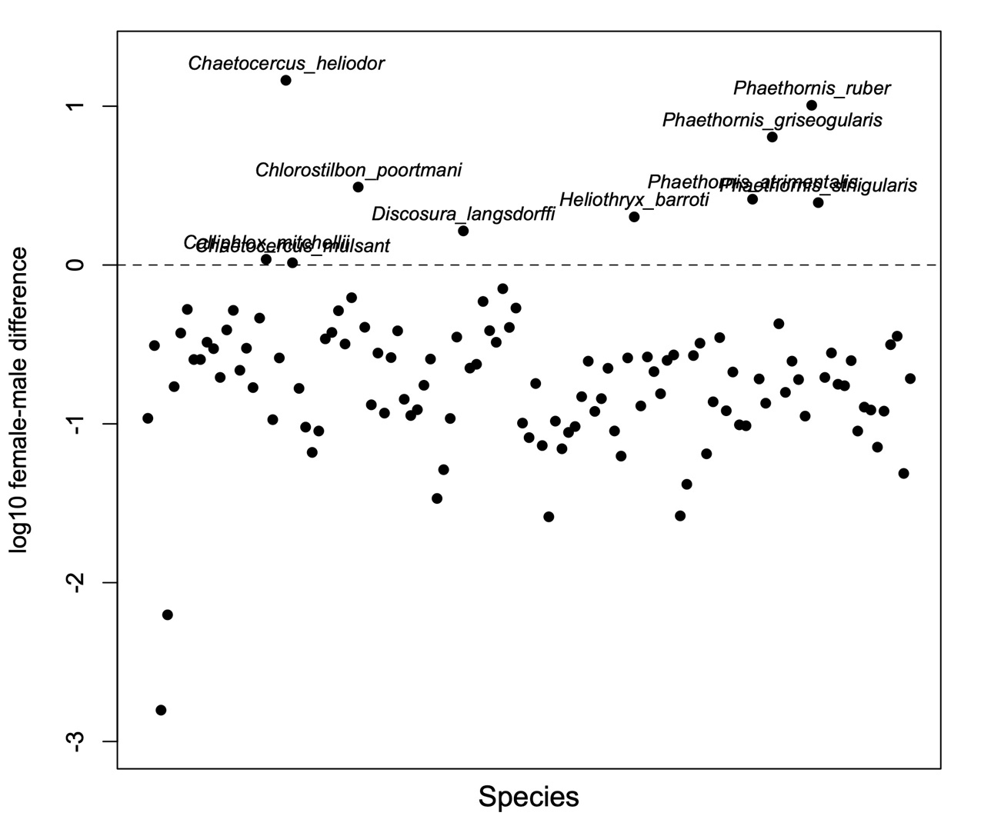

**Figure S1.** Sum of all log10 differences between female and male morphological measurements. Positive values indicate cases where females are larger (i.e., female-biased dimorphism), while negative values indicate species where the male is the larger sex (i.e., male-biased dimorphism). Each dot corresponds to a species and the dotted line represents the divide between male-biased (> 0) and female-biased (< 0) in the vertical axis. 107 of the species included (91.5%) are male-biased dimorphic, 10 species (8.5%) are female-biased dimorphic. Names of species with female-biased dimorphism are shown. *Calliphlox mitchellii, Chaetocercus mulsant* and *C. heliodor* belong to the “Bee” clade.

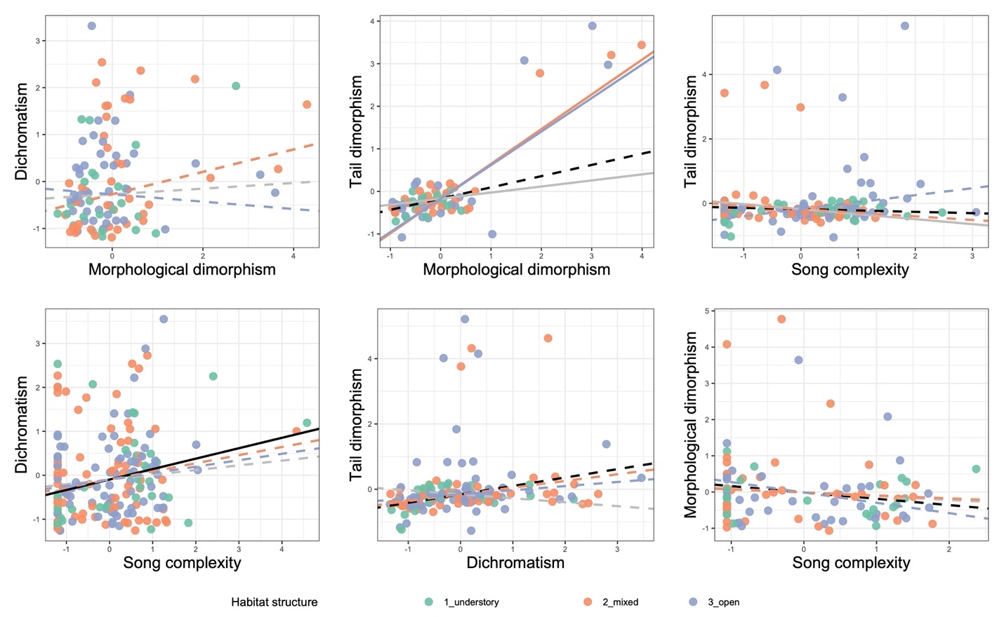

**Figure S2.** Scatterplots showing the relationships between all pairs of dimorphic traits. Each dot represents a species and are coloured according to their corresponding habitat structure. Lines represent relationships estimated from BPMMs: regardless of other covariates (black), interaction with altitude (grey), and interaction with habitat structure relative to the understory. Vertical and horizontal axes are scaled to unit variance.

**Supplemental references**

1. McGuire JA, Witt CC, Remsen JV, Corl A, Rabosky DL, Altshuler DL, et al. Molecular Phylogenetics and the Diversification of Hummingbirds. Current Biology. 2014 Apr;24(8):910–6.

2. Tobias JA, Sheard C, Pigot AL, Devenish AJM, Yang J, Sayol F, et al. AVONET: morphological, ecological and geographical data for all birds. Coulson T, editor. Ecology Letters. 2022 Mar;25(3):581–97.

3. Clark CJ, McGuire JA, Bonaccorso E, Berv JS, Prum RO. Complex coevolution of wing, tail, and vocal sounds of courting male bee hummingbirds. Evolution. 2018 Mar;72(3):630–46.

4. Studer M, Ritschard G. What matters in differences between life trajectories: a comparative review of sequence dissimilarity measures. J R Statist Soc A. 2016;179(Part 2):481–511.

5. Gabadinho A, Ritschard G, Mueller NS, Studer M. Analyzing and Visualizing State Sequences in R with TraMineR. Journal of Statistical Software. 2011;40(4):1–37.

6. Araya-Salas M, Smith-Vidaurre G. warbleR: an r package to streamline analysis of animal acoustic signals. Methods in Ecology and Evolution. 2017;8(2):184–91.

7. Araya-Salas M, Odom K. PhenotypeSpace: and R package to quantify and compare phenotypic trait spaces. 2022.

8. Dixon P. VEGAN, a package of R functions for community ecology. Journal of Vegetation Science. 2003;14(6):927–30.

9. Josse J, Husson F. Handling missing values in exploratory multivariate data analysis methods. Journal de la société française de statistique. 2012;153(2):79–99.

10. Josse J, Husson F. **missMDA** : A Package for Handling Missing Values in Multivariate Data Analysis. J Stat Soft [Internet]. 2016 [cited 2022 Jan 3];70(1). Available from: http://www.jstatsoft.org/v70/i01/