**Song analysis protocol** *(updated on may-24, 2022)*

This protocol explains the steps to conduct an objective assessment of the vocal behavior of several hummingbird species. The information for the recordings containing hummingbird songs is available in 2 data sheet files in google drive: "Species account.xlsx" and "Recording metadata.xlsx". "Recording metadata.xlsx" has all the common metadata information for all available recordings (e.g. location, date, time, library). "Species account.xlsx" contains information about the analysis (e.g. # recs analyzed, who analyzed it and when). In addition the “Song Analysis Virtual Lab Notebook” must be used to log daily work progress, hours worked and any issue with the species or specific sound files.

Please follow the instructions as close as possible to ensure the data would be comparable across species regardless of who did the analysis. There is also a “Analysis notes” file in google drive. Additional information about can be added there with much more detail.

**Analysis workflow**

1. Choose a species assigned to you (“Assigned to” column in “Species account.xlsx” file).
2. Look up the species in “<https://neotropical.birds.cornell.edu>” to get an example of the species typical song (if is available)
3. Look at the name of the sound files that belong to that species in the “recording metadata.xlsx” spreadsheet (again in the “Updated species name” column). Note that some species names have been updated so the species name in the sound file name might not match the species name in the spreadsheets. Is better to use the recording ID for searching for a particular sound file.
4. Open Raven (to do this in linux if the icon is not in the sidebar, go to this "Desktop / Link to Raven-1.5.0.0035 / Selections" double-click the "Raven" icon)
5. In Raven you should open the sound files: Ctrl + O (or go to file → open sound files)
   1. Go to the folder with the recordings (in linux "home/recordings/")
   2. Review the files that correspond to the species to be analyzed, try to choose based on the following criteria (**in order of priority**):
      1. Recordings that have songs (not calls, set in column vocalization type. If no songs are available check “call” recordings)
      2. Those of better quality (avoid those of Xeno-Canto when possible,uncompressed files are better. These files do not have any letter in their name code)
      3. Which are from different geographical areas (e.g. different countries)
      4. Avoid using recordings from same recordist/location/date when possible as they are likely to belong to the same individual
6. When you open the file a "Configure New Sound Window" window appears, in the "Window Preset" window, choose the "hummingbirds" option and then click "OK" (if this window does not open when loading a file you must go to View → Window Preset and select "hummingbirds")
7. Examine the recording to try to determine:
   1. if the quality allows you to work with that recording
   2. if it corresponds to a song or a call (we will only analyze songs). You can check the “Vocalization type” column in "Recording metadata.xlsx" for this, but note that they are often mislabeled (many people call hummingbird songs “calls”). Several clues can be used to determine if a vocalizations matches our song definition:
      1. If it has a complex structures (several elements with distinct shapes) For instance: “a-b-c-a-b-c”
      2. Or, if is simple but the timing is consistent (eg. Long billed hermit songs: “a -- a -- a -- a” instead of “a-a------aa----a-a---a”)
      3. If its an undirected signal (not produced towards a nearby individual). However, notice that some bee hummingbirds produce complex songs only during dive displays which are always produced in the presence of females. We will count this vocalizations as songs as those are the most complex vocalizations they produce. As a rule of thumb, any complex vocalization will be taken as the song, however, species with only simple vocalizations that could either be a song or a call the safest assumption would be to assume they are calls.
      4. If it’s clear that the bird was broadcasting from a fixed point (e.g. perch).
      5. This can be visualized in a dichotomous key as follows:

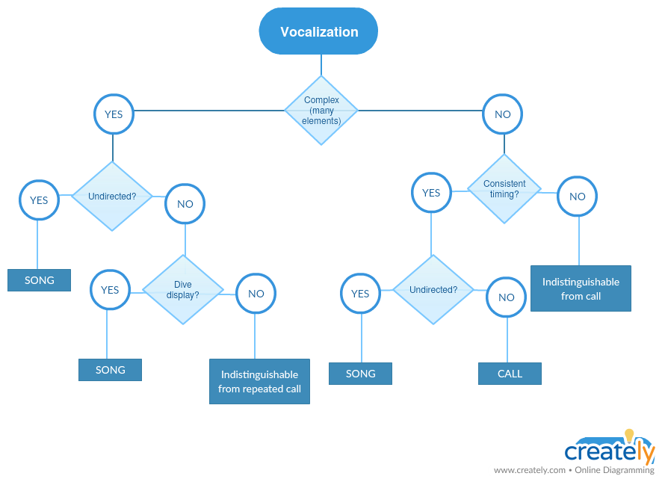

If there is not enough information to figure out some of this features (e.g. short recording) you may have to ignore that recording.

*NOTE: Some species seem to have multiple song types (both simple and complex songs). If this seems to be the case it’s most important that the complex songs are selected. If there are not that many complex songs, you can also select some simple songs and make a note of this.*

1. If there is something wrong with the recording (e.g. doesn’t have vocalizations, is too short, too noisy, or the file was not found, etc) add the information to the “Additional info” column in "Recording metadata.xlsx".
2. If it’s a bad recording, add note about it in the metadata

We will analyze recordings in 2 different ways: 1) selecting individual elements and 2) selecting complete songs. The goal of doing this is to have an overview of the variation in the species song. Thus, we should analyze different recordings for the 2 types of analysis (i.e. do not analyze both full songs and individual elements within the same recording). Try to analyze recordings that are geographically as far away as possible. If they are from the same site, could be included only if they show different song structures:

**Selecting individual elements**

1. If the recording corresponds to a song:
   1. Determine the sequence of elements of which the song is composed. **A song can be defined by the repetition of a sequence of elements (even if the sequence is a single element) and/or by long silences (much greater than the silences between elements within a song). Sequence repetitions can be variable in the composition and number of repeats of individual elements.** Again, you could check the [Neotropical Birds website](https://neotropical.birds.cornell.edu/Species-Account/nb/home) for song examples (although not all species are represented).

*Example*

Let say we have a vocalization like this:

*abcdab abcdab abcdab abcdab abcdab abcdab abcdab abcdab a bcdab*

In this example every sequence of 6 elements that is separated from others by a wide gap will be called a song. You will have to choose 5 of those. Something like this (green means analyzed):

*abcdab abcdab abcdab abcdab abcdab abcdab abcdab abcdab a bcdab*

* 1. Ensure that they belong to a single individual
  2. Select the beginning and end of each of the elements for **at least** 2 songs (if available). Songs do not have to be consecutive. If there are more songs available in the recordings and they vary considerably you can try to measure more songs.
  3. Make selections on the spectrogram by adjusting both time and frequency. If the songs have a lot of harmonics the high frequency can extend more (high frequency accuracy is not relevant when there are many harmonics).
  4. Set the beginning and end (the margins of the selection box) right at the beginning and end of the element, trying not to include the reverberations at the end of the element
  5. Avoid making selections where the elements overlap other sounds
  6. If the recording was made on 2 channels, make the selections only on the first channel (the one above).
  7. Once you commit the selection (pressing “Enter”), each element must be tagged with the song to which it belongs (Raven will ask for the tag each time a new selection is entered). The label must be a number for the song and a letter for the element (eg "1a" for element "a" in song "1"). Different elements should be labeled with different letters (so elements that look the same should be labeled with the same letter)
  8. Save the selection in the default folder suggested by Raven. When you try to close the audio file Raven will ask if they want to save the selection, just click OK and keep the suggested file name unchanged.

2. Find another recording of the same species and repeat steps 3 to 6.

3. Try to have selections of 5 different recordings per species.

**Selecting complete (“full”) songs (DONT DO THIS)**

1. Complete song selections are those covering the entire song. These must be selected in the remaining recordings (those not used for element selection). If there are no recordings left skip this part.

2. Complete songs will be selected on at least 5 recordings (and a maximum of 10 recordings or those that are available). The selections should not be very precise. Use only the song tag for this selections (e.g. 1, 2, etc).

3. If the songs of different individuals have a very different structure (for example, some seem to have a single element while others have songs with multiple elements) it can be checked if this corresponds to geographical variation by searching the metadata of the recording in the database "Recording metadata.xlsx found in google drive. **This is not crucial**, although if it’s revised the information should be entered in "Comments" in "Species account.xlsx".

4. Once you are done with the species:

1. enter the information in "Species account.xlsx" in google drive. You must describe the song structure (number of elements, if they are recombined).
2. If no song were found in the available recordings add a 0 (zero) the “# recordings” columns in the "Species account.xlsx" spreadsheet.

5. Start with a new species

**At the end of the analysis session:**

1. Copy the selection files to "/Dropbox/Projects/Hummingbird song evolution/Selections". In Linux selections should be copied from "Desktop/Link to Raven-1.5.0.0035/Selections/Selections". In Windows the folder is found in “C:\Program Files (x86)\Raven Pro 1.5\Selections”
2. Make sure all the information for the analyzed species is included in the "Species account.xlsx" spreadsheet.
3. If additional comments are needed for the analysis (like when some files are not found) add them to the “Analysis notes” file in google drive (need to add your name and date before any note)
4. Again “Song Analysis Virtual Lab Notebook” must be used to log daily work progress, hours worked and any issue with the species or specific sound files.

*PD: If there is something inconsistent or poorly explained in this protocol add a comment on top of it*

**Examples**

1. *Single song repertoire:*

This refers to songs composed by a single element that is repeated over and over again. In this case each sound represents an element and a song and should be labeled 1a, 2a, 3a, etc:

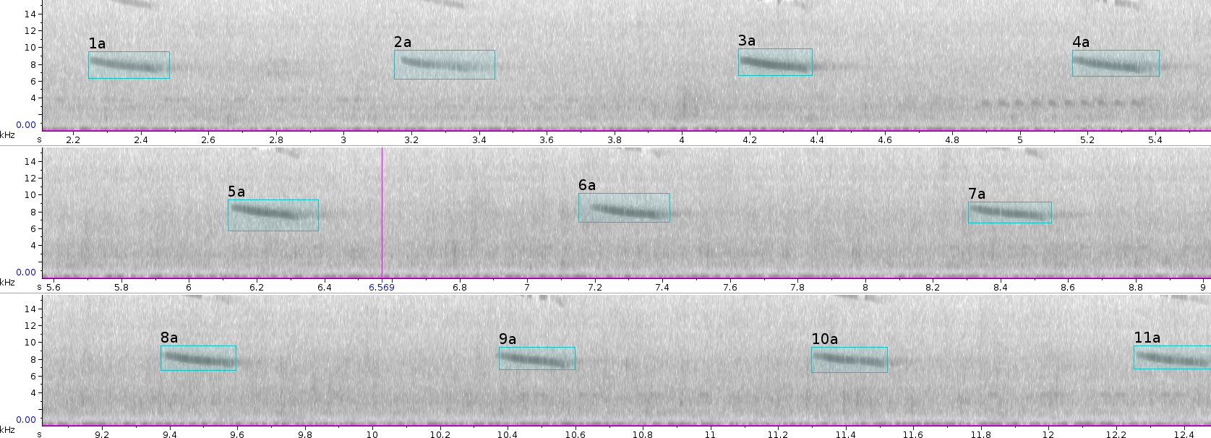

*For “full song” selections in single song repertoire species we should include several elements (ideally 5) in the same selection box.*

