Questions

1. Do groups remain cohesive during flight? (distances between individuals in 5s clips and 50 frames)
2. Does flying cohesively facilitate roost finding? (roost entry)
3. Do bats coordinate calling during flight? (call rate, time partitioning and transitions)

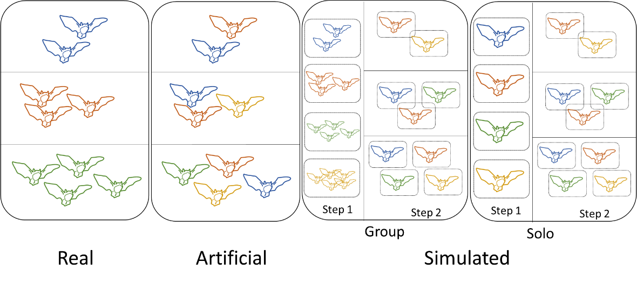

Figure 1. Types of flights generated for experiments. Real and artificial trials occurred when several individuals, either from the same (real) or from different (artificial) groups, flew together in the flight cage (group membership shown in different colors). Simulated group trials occurred by first allowing bats to fly as a group (step 1); then, data from different individuals were extracted and randomly merged to simulate groups of different sizes (step 2). For simulated solo trials, we first allowed individuals to fly alone (step 1), and then generated simulated group data by randomly mixing results of individual flights (step 2).

**Question 1. Do groups remain cohesive during flight?**

Coordination i

1) Flight trajectories (real) (<https://www.dropbox.com/scl/fo/5h6s4edp7s49orkqlbm7g/h?rlkey=jbt7itdyivr6898y5qared7oa&dl=0>)

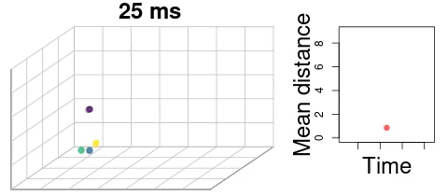

2) Distance among individuals (real, group simulated)

5 second clips:

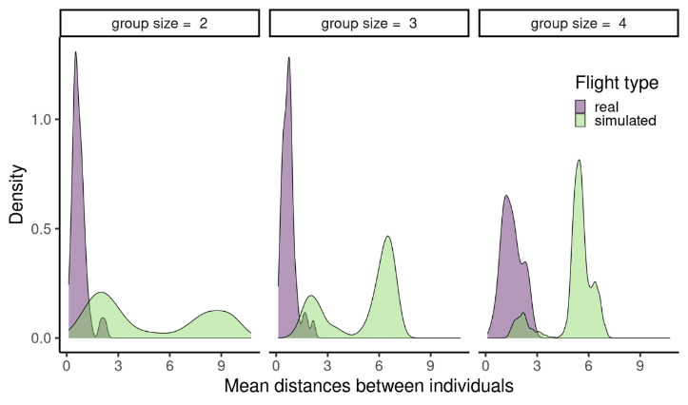

50 frames: non-significant trend towards shorter distances among natural vs artificial

For each real group flight, create a single simulated flight with the same number of individuals and run a regression model. Re do that several times and average the posterior distributions across models

3) Measure group cohesion (50 frames per bat; real, artificial) (<https://rpubs.com/marcelo-araya-salas/805868>) (<https://rpubs.com/marcelo-araya-salas/794158>)

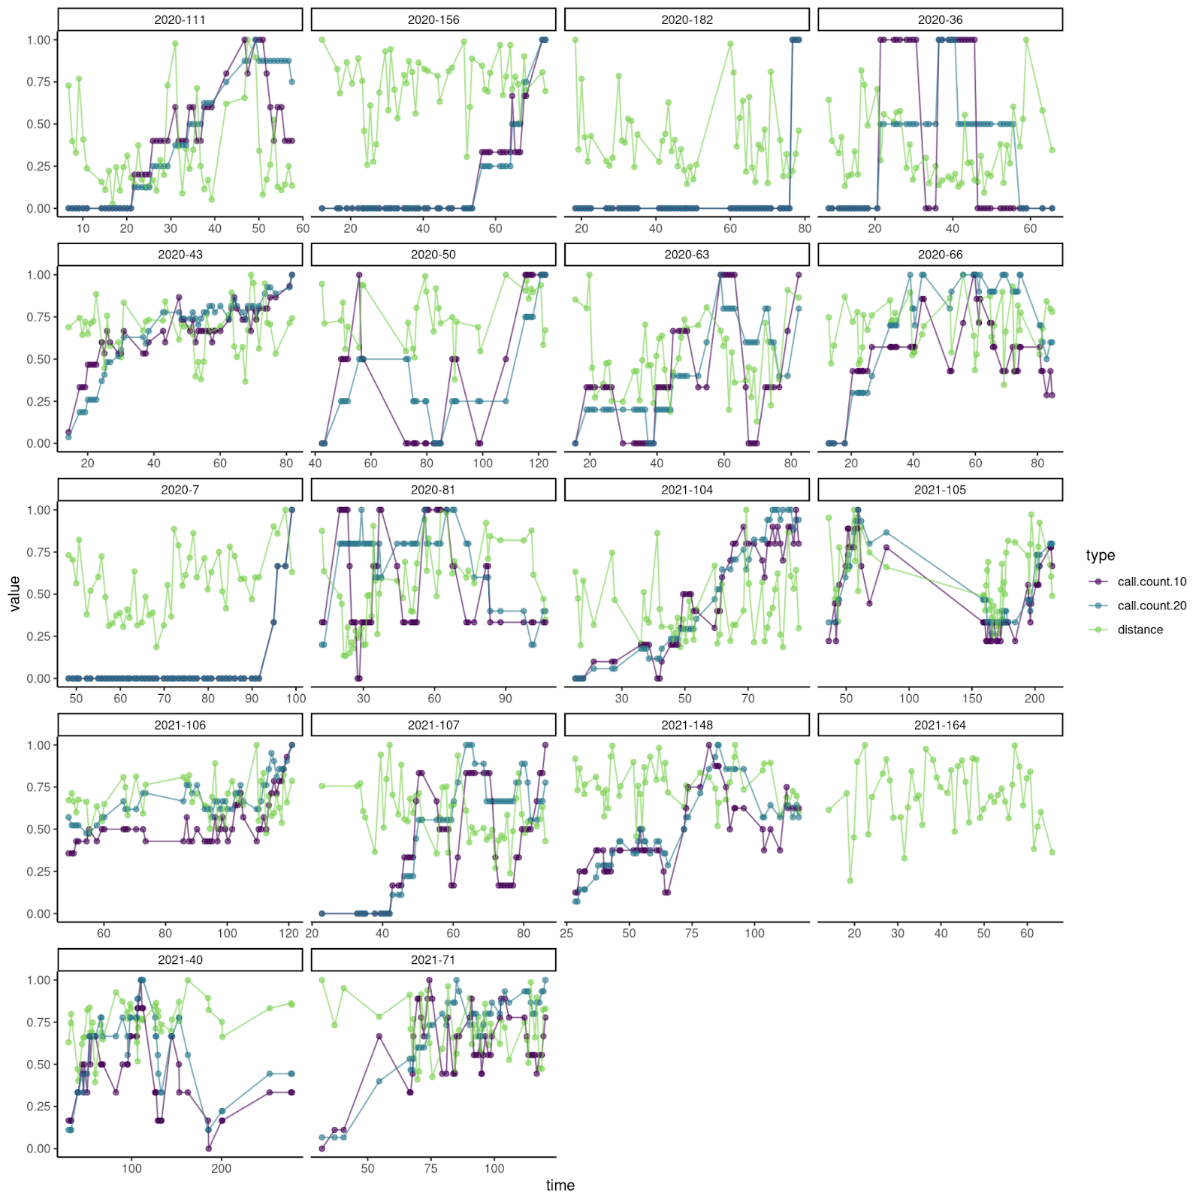

Run regression using all values of distance and call rate using group type (artificial and real) and call rate as predictors (interaction?) and distance as response (model time autocorrelation and log normal distribution and monotonic effect for group size)

**Question 2. Does flying cohesively facilitate roost finding? (análisis preliminares: <https://rpubs.com/marcelo-araya-salas/887208>)**

1) Time needed to enter (real, artificial, group simulated, solo simulated)

2) Cohesive entrance to roost (real, artificial, group simulated, solo simulated)

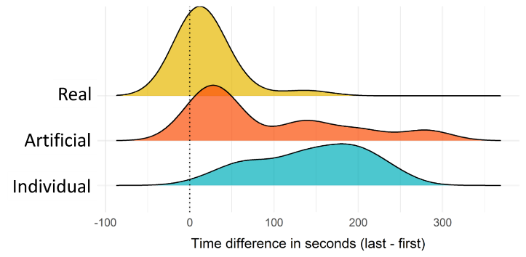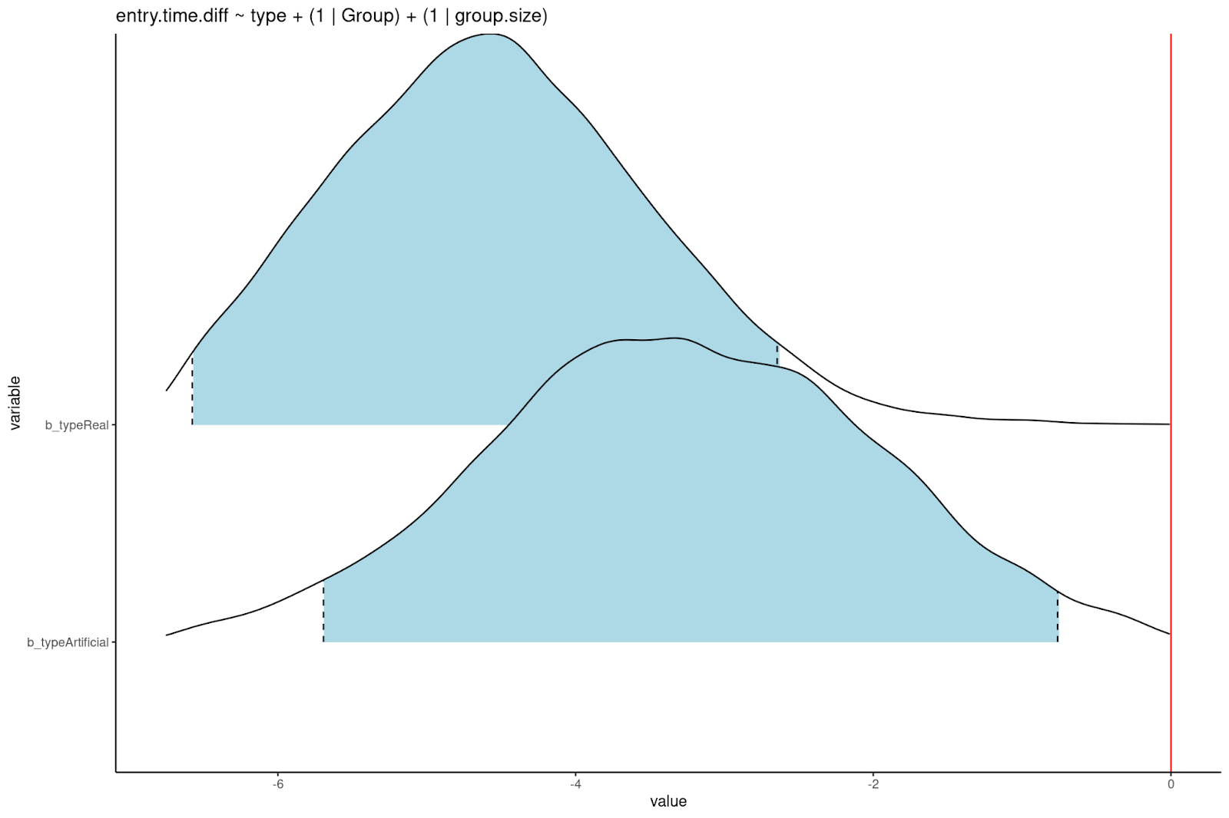

check https://rpubs.com/marcelo-araya-salas/887208

For each real group flight, create a single simulated flight with the same number of individuals (using both individual flight data from solo and group flights) and run a regression model. Re do that several times and average the posterior distributions across models.

**Does flying cohesively facilitate roost finding? (roost entry)**

**(file:///home/m/Dropbox/Projects/flight_coordination_in_Thyroptera/scripts/roost_entry_coordination.html)**

We measured the cohesion of group roost entry by calculating the time interval between the first and last individual entering the roost. Roost entry cohesion was similar between natural and artificial groups (EFFECT SIZE HERE). However, both groups show higher cohesion than that expected by chance when simulating group flight roost entries from individuals flights (RUN SEVERAL TIMES WITH DIFFERENT data set AND AVERAGED MODELS).

**Do bats coordinate calling during flight?  (https://rpubs.com/marcelo-araya-salas/1000978)**

We found that individual call rate decreases during group flight compared to solo flight in both natural (effect size and 95% CrI: -129 (-1.55 -  -1.04)) and artificial groups (-1.520 (-1.813 - -1.223)). This pattern is mediated by group size in artificial groups but not in natural groups, with larger groups showing lower individual calling rates (-0.312 (-0.532 - -0.092), Fig X).

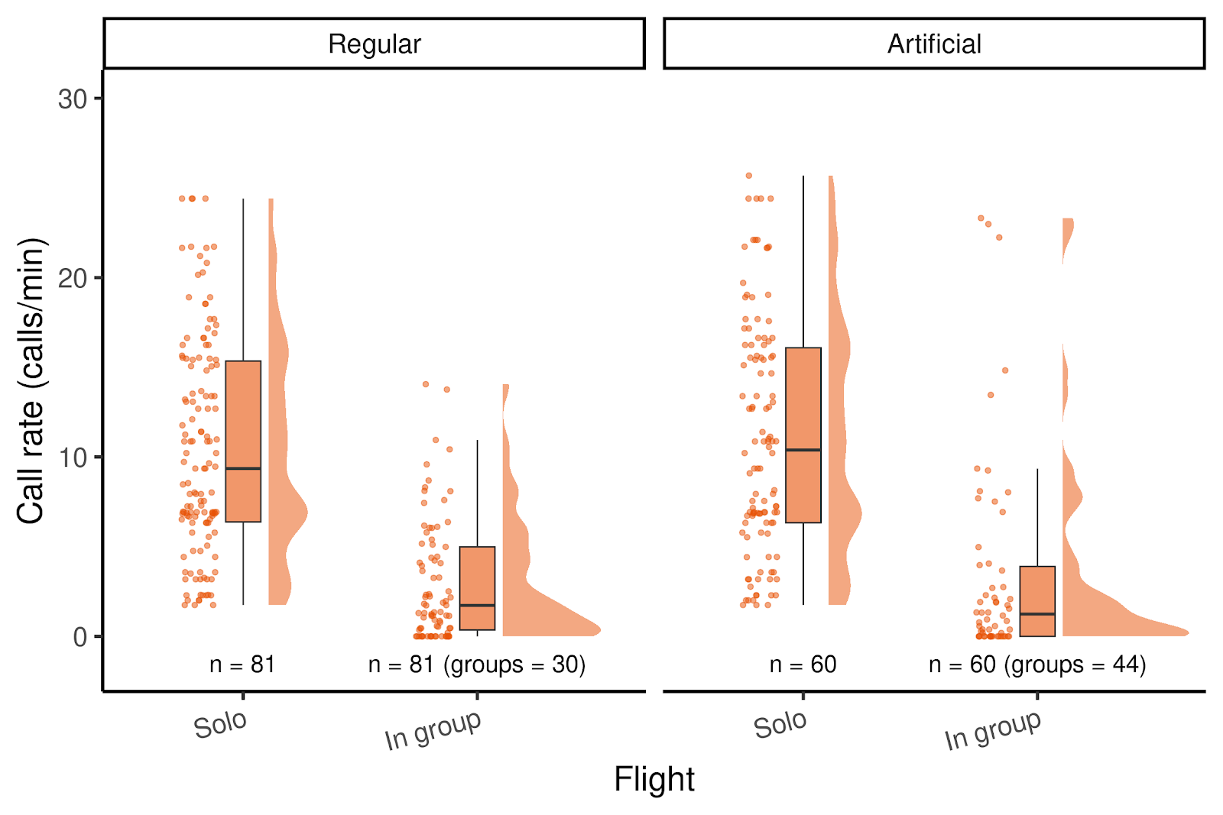

*Fig X. Raincloud plot showing the jittered individual data points, boxplots (median, interquartile range and overall range) and half violin plots of individual call rate by flight type (in group or solo) and group type (natural or artificial, panels).*

The decrease in individual call rates during group flights resulted in an overall group call rate that was indistinguishable from call rates observed in solo flights (Fig Y). This was true for both natural (0.292 ( -0.019 - 0.604)) and artificial groups (0.166  (-0.159 - 0.487)).

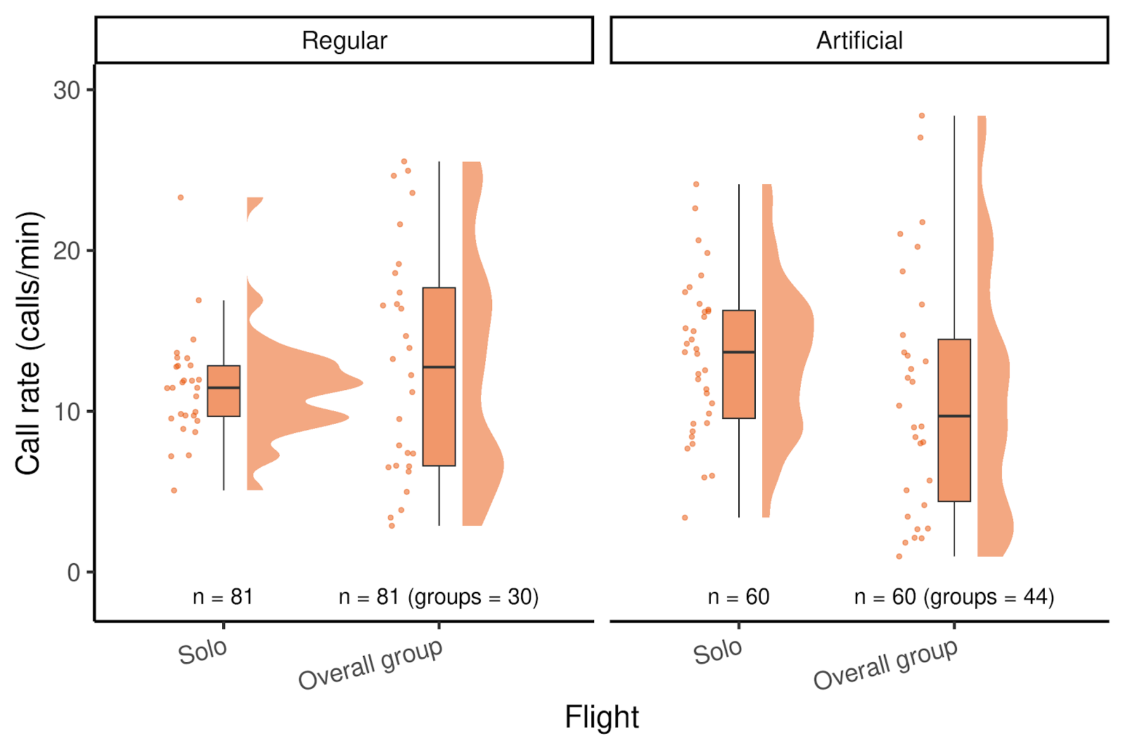

*Fig Y. Raincloud plot showing the jittered individual data points, boxplots (median, interquartile range and overall range) and half violin plots of individual and group call rates by group type (natural or artificial, panels).*

We also evaluated whether group flight calls were broadcasted in order to prevent clustering of calls over time by comparing the observed mean time difference to the closest call to the distribution expected by change based on a randomization procedure. The combined p-value across experiments suggest that calls in group flights are spaced more than expected by chance in artificial (p = 0.017) but not in natural groups (p = 0.24), suggesting that calls in natural groups tend to be more clustered. However the differences in coordination score was small between the two group types (FIG in suppl. mat).

4) Transition networks (real, artificial, solo/group simulated?)