Article

Foraging, Fear and Behavioral Variation in a Traplining Hummingbird

Katarzyna Wojczulanis-Jakubas 1,* and Marcelo Araya-Salas 2

|  |
| --- |
| **Citation:** Wojczulanis-Jakubas, K.; Araya-Salas, M. Foraging, Fear and Behavioral Variation in a Traplining Humingbird. *Animals* **2023**, *13*, x. https://doi.org/10.3390/xxxxx  Academic Editor(s):  Received: date  Revised: date  Accepted: date  Published: date    **Copyright:** © 2023 by the authors. Submitted for possible open access publication under the terms and conditions of the Creative Commons Attribution (CC BY) license (https://creativecommons.org/licenses/by/4.0/). |

1 Department of Vertebrate Ecology and Zoology, University of Gdansk, Gdansk, Poland; katarzyna.wojczulanis-jakubas@ug.edu.pl

2 Centro de Investigación en Neurociencias, Universidad de Costa Rica, San Pedro, San José, Costa Rica

**\*** Correspondence: Author: katarzyna.wojczulanis-jakubas@ug.edu.pl

**Abstract:** Traditionally, foraging behavior has been explained as the response to a trade-off between energetic gain from feeding resources and potential costs from concomitant risks. However, increasing number of studies has shown that this view fails to explain an important fraction of the variation in foraging across a variety of taxa. One potential mechanism that may account for this variation is that various behavioral traits associated with foraging may have different fitness consequences and that may further depend on environmental context. Here, we explored this mechanism by evaluating foraging efficiency of Long-billed Hermit hummingbirds (*Phaethornis longirostris)* with regard to three behavioral traits: a) exploration (number of feeders used during the foraging visit), b) risk avoidance (latency to start feeding) and c) arousal (amount of movements during the foraging visit) in conditions of two different levels of perceived risk (low – control, and high – experimental, with a threatening bullet ant model). Foraging efficiency decreased in response to threatening conditions. However, behavioral traits explained additional variation in foraging efficiency in a condition-dependent manner. More exploration was associated with higher foraging efficiency in control conditions, but this was reversed when exposed to a threat. Regardless of conditions, arousal was positively associated with foraging efficiency while risk avoidance was negatively related. Importantly, exploratory behavior and risk avoidance were quite repeatable behaviors suggesting that they may be related to intrinsic traits of individuals. Our findings highlight the importance of taking into account additional behavioral dimensions to better understand foraging strategies of individuals.

**Keywords:** risk allocation hypothesis; risk avoidance; exploratory behavior; arousal; repeatability

1. Introduction

A variety of ecological factors has been identified as major determinants in shaping foraging strategies of animals (i.e. resource exploitation). Of those the most commonly evoked are the amount and distribution of available food resources [1,2] and animal motivation (both in the sense of marginal value theorem [3] and/or body condition [4]), but predation pressure is also frequently considered [5,6] The intensity of a prey vigilance increases with the level of risk predation (probability of predator presence), affecting its foraging efficiency. As the risk allocation hypothesis imposes, a prey allocates time for foraging inversely proportionately to the predation pressure [5–7]. Thus, in a given food resources–predation landscape, a fixed foraging strategy is expected to evolve [8]. However, increasing number of studies demonstrates a high variation in foraging strategies [9–11], which is hard to explain using only food- and predation-based arguments [4].

Variation in foraging strategies of individuals remains an intriguing topic [1,12–16]. Existing evidence demonstrates not only the variation *per se* but consistent inter-individual differences in the average level of a behavior displayed across a range of contexts (Carere and Maestripieri 2013) and in response to environmental variation (Nussey et al. 2007; Dingemanse et al. 2009). Within a species/population, individuals usually represent a full continuum of a given behavioral display, with two polar-opposite phenotypes (e.g. high and low exploratory behavior) and various intermediate forms in between. Importantly, fitness advantages of contrasting behaviors may differ in various contexts, sometimes dramatically [18]. For example, highly exploratory behavior can be advantageous in conditions of resource competition but disadvantageous in a higher predation pressure environment [18–21]. Despite growing number of studies showing high behavioral variability in foraging performance in animals, it is still not entirely recognized what could be fitness consequences of this variation.

The fitness payoff of a behavior under different scenarios is likely to be a main source maintaining the observed variation in foraging strategy [11,18,22]. Under variable conditions, a diversity of behavioral strategies can be maintained if a different performance results in different cost and benefits for different contexts. If so, performance may vary as a function of interactions between social and/or ecological selective forces, which can help to reveal the complex interplay of intrinsic and extrinsic factors shaping behavioral variability [23–26].

Here, we examined the fitness consequences of various behavioral strategies during foraging in wild ranging hummingbirds. This avian group is known for their extreme metabolism with a high need for energy intake that makes them constantly motivated to forage [27]. As such, they are expected to be under strong selection for maximizing foraging efficiency, which can have a considerable effect on the fitness. This is particularly significant for trap-lining foraging species, move around in a route-like fashion across the habitat to visit dispersed flower patches [28,29]. Such a free foranging strategy entails a period of high vulnerability of foraging individuals, exploited by a wide range of predators [30–35], which in turn, results in a trade-off between efficient foraging and risk avoidance. The differential payoffs in the selective landscape given by these two factors are expected to shape foraging strategies of the hummingbirds.

In this study we studied the foraging behavior of the Long-billed Hermit hummingbird (LBH, *Phaethornis longirostris*). The species is arelatively large size hummingbird of humid neo-tropical lowlands. It exhibits a lekking mating system in which males sing and display from traditional areas inside the forest for mate attraction, during an eight month breeding season (Stiles & Wolf 1979). Unlike many hummingbirds, hermits do not defend a patch of flowers but visit widely scattered flowers in a foraging route (i.e. trap-lining). Aggressive interactions related to disputes over lek territories are common [29]. Floaters can be found singing from perches of territorial males while the latter are absent foraging. Territorial ownership is typically regained after an aggressive interaction with intruders, suggesting a selective pressure to reduce foraging time and increase territory attendance. Indeed, more efficient foraging males are more likely to own a lek territory [29].

To examine the payoffs of different behavioral strategies under a trade-off between food resource exploitation and risk avoidance, we considered the issue in the context of low and high level of perceived threat. We also analyzed the issue in regard to three behavioral axes, commonly linked to the exploitation of food resources: a) exploration (number of foraging spots (i.e. feeders) used during the foraging visit), b) risk avoidance (latency to approach the foraging spot to forage), and c) arousal (amount of movements during the foraging event) [1,18,19,36,37]. We hypothesized that foraging efficiency (expressed as the amount of time spend on feeding in respect to the total time of the visit at the feeder), may be lower at threatening conditions. We also hypothesized that foraging efficiency is further modulated by the three behavioral traits (exploration, risk avoidance and arousal), expecting that high values on these traits will negatively affect foraging efficiency.

2. Methods

2.1. Fieldwork

We carried out the study at La Selva Biological Station, Costa Rica (10 o23’ N, 84o10’ W) between May and June 2015. We captured and marked 21 individuals with foam tags (total weight of 0.02 g, which is ~0.3 % of LBH body mass, 6g) with unique color combinations, attached to the bird’s back and chest with nontoxic eyelash glue (Araya-Salas et al. 2018). To evaluate foraging efficiency of marked individuals and quantify it in low and high risk context, we conducted a field experiment using hummingbird feeders. Commercial feeders (Perky model Pet #209B, 900 ml) were modified to have a single opening for accessing “nectar”. Three feeders were arranged in a line (separated by ca 10 cm distance from each other, Fig. 1) and filled with a fresh nectar (~30% sugar-water). The set-up was located in a distance of ca 100 m from the lek border. The feeders (filled with nectar filled/changed daily) were exposed in the field for two weeks before the onset of experiments, to habituate birds to feeders. All marked birds were observed on the lek after being caught, either defending territory or as floaters (i.e. all of them survived the capturing and marking procedure and behaved normally at the lek area). Location of the feeders did not overlap with foraging area of captured individual. .

**Figure 1.** Scheme of the foraging visit – the total time spent by focal bird at the feeders area with at least one feeding event. Time-points crucial for the data analysis denoted with black circles and labelled with letters to denote particular events, being components of the foraging visit: **a)** onset of the foraging visit (appearance in the feeder area, usually hovering in front of the feeder); **b)**, **d)** and **f)** onsets of consecutive feeding events (i.e. inserting the bill into the flower-hole of the feeder; **c)** and **e)** end of the respective feeding events (i.e. removal of the bill from the flower-hole of the feeder); **g)** end of the foraging visit (i.e. the end of the very last feeding event during the foraging visit). Multiple feedings intervals are possible (1-26, mean: 4.9).

The experiment session consisted of two consecutive phases performed on the same day, in the low (first phase, control) and high risk contexts (second phase, experimental). Birds were allowed to forage on the nectar spontaneously and their behavior was recorded by a commercial camera (continuous recording mode; model: Fujifilm HS30); camera set up on a tripod in a distance of ca 10 m from the feeders (zoomed on the feeders area). During the second phase, we glued a dead bullet ant (*Paraponera clavata*; found dead in the forest) to each of the three feeders (at 2 cm from the flower-hole) to simulate a threat. Although the ant is not a predator of hummingbirds, presence of large insects on flowers often scares various hummingbird species (e.g. Carr and Golinski 2020), including Long-billed Hermits (MAS., pers. obs, Supplementary Online Materials: videos 1 and 2). Importantly, attached bullet ants did not completely scare birds off, allowing the quantification of their foraging behavior in these circumstances. Hence attaching the bullet ant to the feeders was expected to resemble situations of increased risk of being injured while still exploiting the feeding resource.

We performed three complete experiment sessions (with two phases) and two incomplete sessions (with control phase only, due to weather conditions), all within two weeks (with 2-3 days between sessions). The two complete (two phases) and two incomplete sessions (control phase only) were conducted in the mornings when the foraging activity peak occurs (Stiles & Wolf, 1979), and only a single complete experiment session was performed in the afternoon, when the activity is lower. Since the time of the day, which we considered in the present study, did not affect foraging efficiency considerably (generalized mixed effect model: foraging efficiency ~ hour (fixed effect; numeric) + birdID (random effect); estimate: -0.009 ± SE 0.005, t = -1.74, df = 137.97, P = 0.08), we did not consider it in further analyses. Furthermore, since the entire experiment session was completed within a relatively short window of time (up to three hours), and both phases were completed during the same time window we don’t expect time to bias comparisons of the control and experimental phases.

The duration of control phases, including those from incomplete sessions, varied from 0.5 to 3 hours. Owing to regular visits of birds in these control conditions (ranging from 1 to 12 per hour per individual), we could record multiple visits of focal individuals, on average of 6 visits per individual (range 2-18). For experimental phases, we kept recording until all visitors observed during the preceding control phase returned to the feeders, resulting in an average of 3 visits per individual during this phase (range: 1-7). The control phase was performed always before the experimental one as doing so we could ensure recruitment of individuals to both phases. The presence of the bullet ant on their very first encounter with the feeders in a given day might preclude birds to explore the resource. To mitigate the potentially negative effect of bullet ant exposure on the frequency of visits, we performed the sessions with 2-3 days gap in between. For all these practical reasons, we could not randomize treatments and controls phases. A potential confounding effect that might bias our results due to the lack of randomization is habituation. Under this scenario familiarity with the experimental set up will result in foraging efficiency trend over time, regardless of treatment. To address this concern, we analyzed individual foraging efficiency over consecutive visits using data from control phases (see Supplementary Online Materials). We found that foraging efficiency change over time only for one individual, and that happened after a considerable number of visits. Furthermore, in this case foraging efficiency improved over time. If this pattern would have affected the observed difference in efficiency between treatments we would expect higher efficiency in the high risk phase which was always conducted after the control phase. However, this was not the case (Supplementary Online Materials: Fig. S1 and S2). Consequently, we treated all the visits of particular individuals as independent data points but obviously controlling for their identity in further analyses.

2.2. Videos analysis

We screened the video recordings with VLC software (www.videolan.org), to locate and cut out video fragments with foraging visits of focal birds. Events of two or more individuals (Long-billed Hermits or a different species) visiting the feeders at the same time were uncommon and were excluded from analysis as interactions disrupted their regular foraging behavior. A foraging visit was considered whenever a bird inserted the bill into a feeder at least once. For each bird’s visit we established key time-points (black circles on Fig. 1), with 0.1 seconds precision, using Cowlog software [38]. Based on these time-points we calculated the duration of latency to forage, defined as the interval between appearance in the feeder area (when started to hover in front of the feeder in a distance of around 0.5 m) and the onset of foraging (time from *a* to *b* on Fig. 1); the duration of feeding interval/s (time from *b* to *c* on Fig. 1; on average 4.9 events, with a range of 1-26); duration of feeding break/s (time from *c* to *d* on Fig. 1); the duration of total foraging (time from *b* to *g*, Fig. 1) and the duration of total foraging visit (time from *a* to *g* on Fig. 1). For each visit we also noted which and how many times each of the three feeders were used by the focal bird.

To quantify bird movements around the feeders, we took advantage of the line-arrangement of the feeders that greatly restricted birds activity into two axis. That simplified further analyses, as operating in two-dimensional space we could establish Cartesian coordinates of a bird position for each video frame using the software Tracker version 5.1.5 (physlets.org/tracker). Based on those coordinates we calculated distances between each two bird’s positions using Pythagorean theorem.

2.3. Parameters

We calculated foraging efficiency as the ratio of the total duration of foraging (sum of the duration of all feeding intervals) to the total duration of the foraging visit. To characterize foraging strategies we measured three behavioral features that have been linked to intrinsic individual characteristics in other species and have been shown to affect foraging: exploration, risk avoidance and arousal [1,18,19,36,37]. As a proxy for **exploration** we utilized the rate of visited feeder; the number of feeders divided by the total duration of the visit, as the absolute number of feeder changes is likely to be a function of time spend at the feeders. As a proxy for **risk avoidance** we used latency to start to forage (the very first use of the feeder during the visit); as defined above (time from *a* to *b* on Fig. 1). For both parameters, the higher the value, the stronger was the exhibited behavior. As **arousal** we considered the coefficient of variance in spatial distances covered by an individual during the whole foraging visit, divided by the number of visited feeders. Birds changing the position frequently (of high value of the coefficient) were assumed to exhibit higher arousal.

2.4. Data analysis

All the analyses were performed in R [39]. Since all parameters had skewed distribution, we log-transformed them prior to analyses (Supplementary Online Materials: Fig. S2). To examine how consistent birds are in their behavior during the foraging, we estimated the repeatability of all the examined parameters (foraging efficiency, exploration, risk avoidance, and arousal) using the *rptR* package [40]. To do this we used behavioral features measured during the low risk (control) treatment only, which represented undisturbed conditions, and for which we recorded multiple visits per individual. When estimating repeatability, we considered behavioral traits as single response variables and birds identity as varying intercept factor (i.e random effect) [40].

To assess variation in foraging efficiency (response variable) as a function of risk level and intrinsic behavioral features (exploration, latency and arousal as predictors) we applied a Bayesian generalized linear mixed model with individuals as a random effect. We fitted three models representing alternative hypotheses explaining variation in foraging efficiency. The first model represents a more traditional view of foraging behavior in which efficiency is only affected by the level of risk. The second model included an interaction among behavioral traits and risk level, which represents a more nuanced scenario in which the interplay between risk level and intrinsic behavioral differences determines foraging efficiency. There was only little collinearity between predictors (VIF for each of the parameters in the model <1.5 also correlation coefficient ranged from -0.21 to -0.10; Supplementary Online Materials: Fig. S3). We run this model with a single predictor for intrinsic behavioral trait (separately considering arousal, exploration and risk avoidance) as well as in a form of a global model, with all behavioral predictors included. The two approaches yield qualitatively similar results, therefore we presented here only the outcome of the global model. while the outcome of the single behavior-predictor models are presented in Supplementary Online Materials: Table S1, Table S2, Fig. S4). Finally, we fitted an intercept-only model representing the scenario in which the proposed predictors do not affect efficiency. All the three alternative models were compared using model selection based on the deviance information criteria (DIC) [41]. Models were fitted using the R package *MCMCglmm* [42].

3. Results

Repeatabilitywas moderate but significant for all the behavioral traits except for arousal (Fig. 2). When predicting foraging efficiency, the model including all intrinsic behavioral traits and their interaction with the risk predation context performed significantly better than a simpler model including only risk context (Table 1). All parameters and their interaction were significant in this model except for risk avoidance (Table 2). Overall, foraging efficiency was lowered in the higher risk context (Fig. 3) and the effect of intrinsic behavioral features on the foraging efficiency was context dependent (Table 2). The most dramatic effect was found in respect to exploratory behavior, which was positively related to foraging efficiency in low risk context but the opposite pattern was observed in the higher risk context (Fig. 4). Arousal was positively related to foraging efficiency and this was particularly pronounced when birds faced higher risk (Fig. 4). Risk avoidance overall tended to decrease foraging efficiency but that was not significant and did not differ between risk levels (Fig. 4).

**Table 1.** Ranking of models explaining foraging efficiency of Long-billed Hermits, ordered by delta Deviance Information Criterion (DIC; Akaike’s Information Criterion AIC yields to same conclusions).

|  |  |  |  |  |  |  |  |
| --- | --- | --- | --- | --- | --- | --- | --- |
| Predictors | df | DIC | ΔDIC | weight DIC | AIC | ΔAIC | weight AIC |
| md_all_interactions | 10 | -400.0909 | 0.00 | 1 | -396.3073 | 0.00 | 0.99 |
| md_arousal_exploration | 8 | -388.2385 | 11.85 | 0 | -386.2831 | 10.02 | 0.01 |
| md_arousal_risk_avoidance | 8 | -378.9807 | 21.11 | 0 | -376.8184 | 19.49 | 0.00 |
| md_arousal | 6 | -363.3410 | 36.75 | 0 | -363.2509 | 33.06 | 0.00 |
| md_risk_avoidance_exploration | 8 | -350.1568 | 49.93 | 0 | -348.8140 | 47.49 | 0.00 |
| md_exploration | 6 | -345.7716 | 54.32 | 0 | -346.4065 | 49.90 | 0.00 |
| md_risk_avoidance | 6 | -315.2258 | 84.87 | 0 | -315.0929 | 81.21 | 0.00 |
| md_context | 4 | -308.6036 | 91.49 | 0 | -310.7995 | 85.51 | 0.00 |
| md_null | 3 | -296.3098 | 103.78 | 0 | -299.8347 | 96.47 | 0.00 |

**Table 2.** Effects of behavioral variables and experimental context (low/high risk) on foraging efficiency of Long-billed Hermits (N individuals = 12, N data points = 192). Common intercept = 0.4548, effects are slope estimates derived from the fist top Bayesian MCMC generalized linear model (Table 1). Significant effects denoted in bold.

|  |  |  |  |  |
| --- | --- | --- | --- | --- |
| Predictor | Effect size | CI 2.5% | CI 97.5% | pMCMC |
| contextHigh risk | -0.1409 | **-0.2732** | **-0.0132** | 0.0322 |
| arousal | 0.0684 | **0.0275** | **0.1083** | 0.0006 |
| exploration | 0.3686 | **0.1244** | **0.6167** | 0.0023 |
| risk_avoidance | -0.0327 | -0.0663 | 0.0023 | 0.0641 |
| contextHigh risk:arousal | 0.2445 | **0.1541** | **0.3436** | 0.0001 |
| contextHigh risk:exploration | -0.8355 | **-1.1641** | **-0.4925** | 0.0001 |
| contextHigh risk:risk_avoidance | -0.0270 | -0.0793 | 0.021 | 0.2918 |

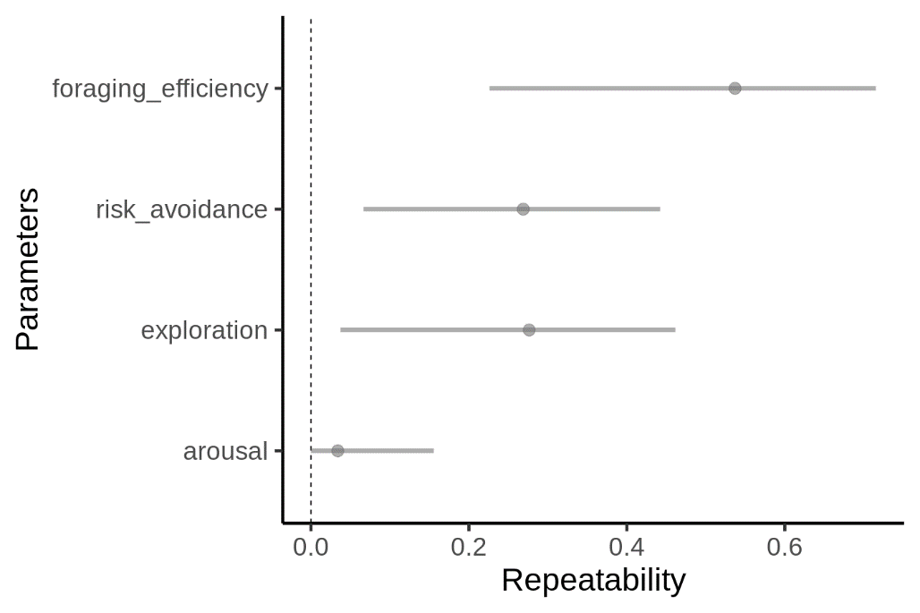

**Figure 2.** Repeatability estimates of foraging efficiency and behavioral parameters in the Long-billed Hermit measured in control conditions, analyzed with linear mixed-effects models (Nakagawa and Schielzeth 2010). Dots represent the value of repeatability coefficient, and bars 95% confidence intervals.

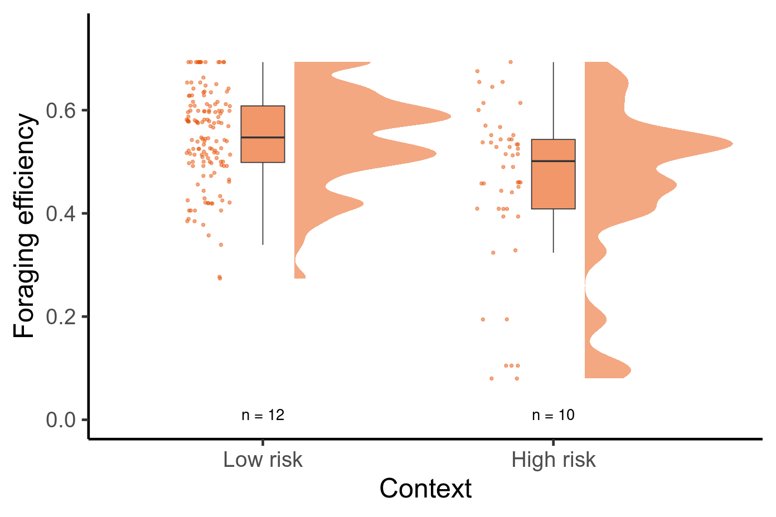

**Figure 3.** Foraging efficiency in the context of low and high levels of perceived risk. Data points, boxplot (with median and inter-quartile range) and data distribution are presented.

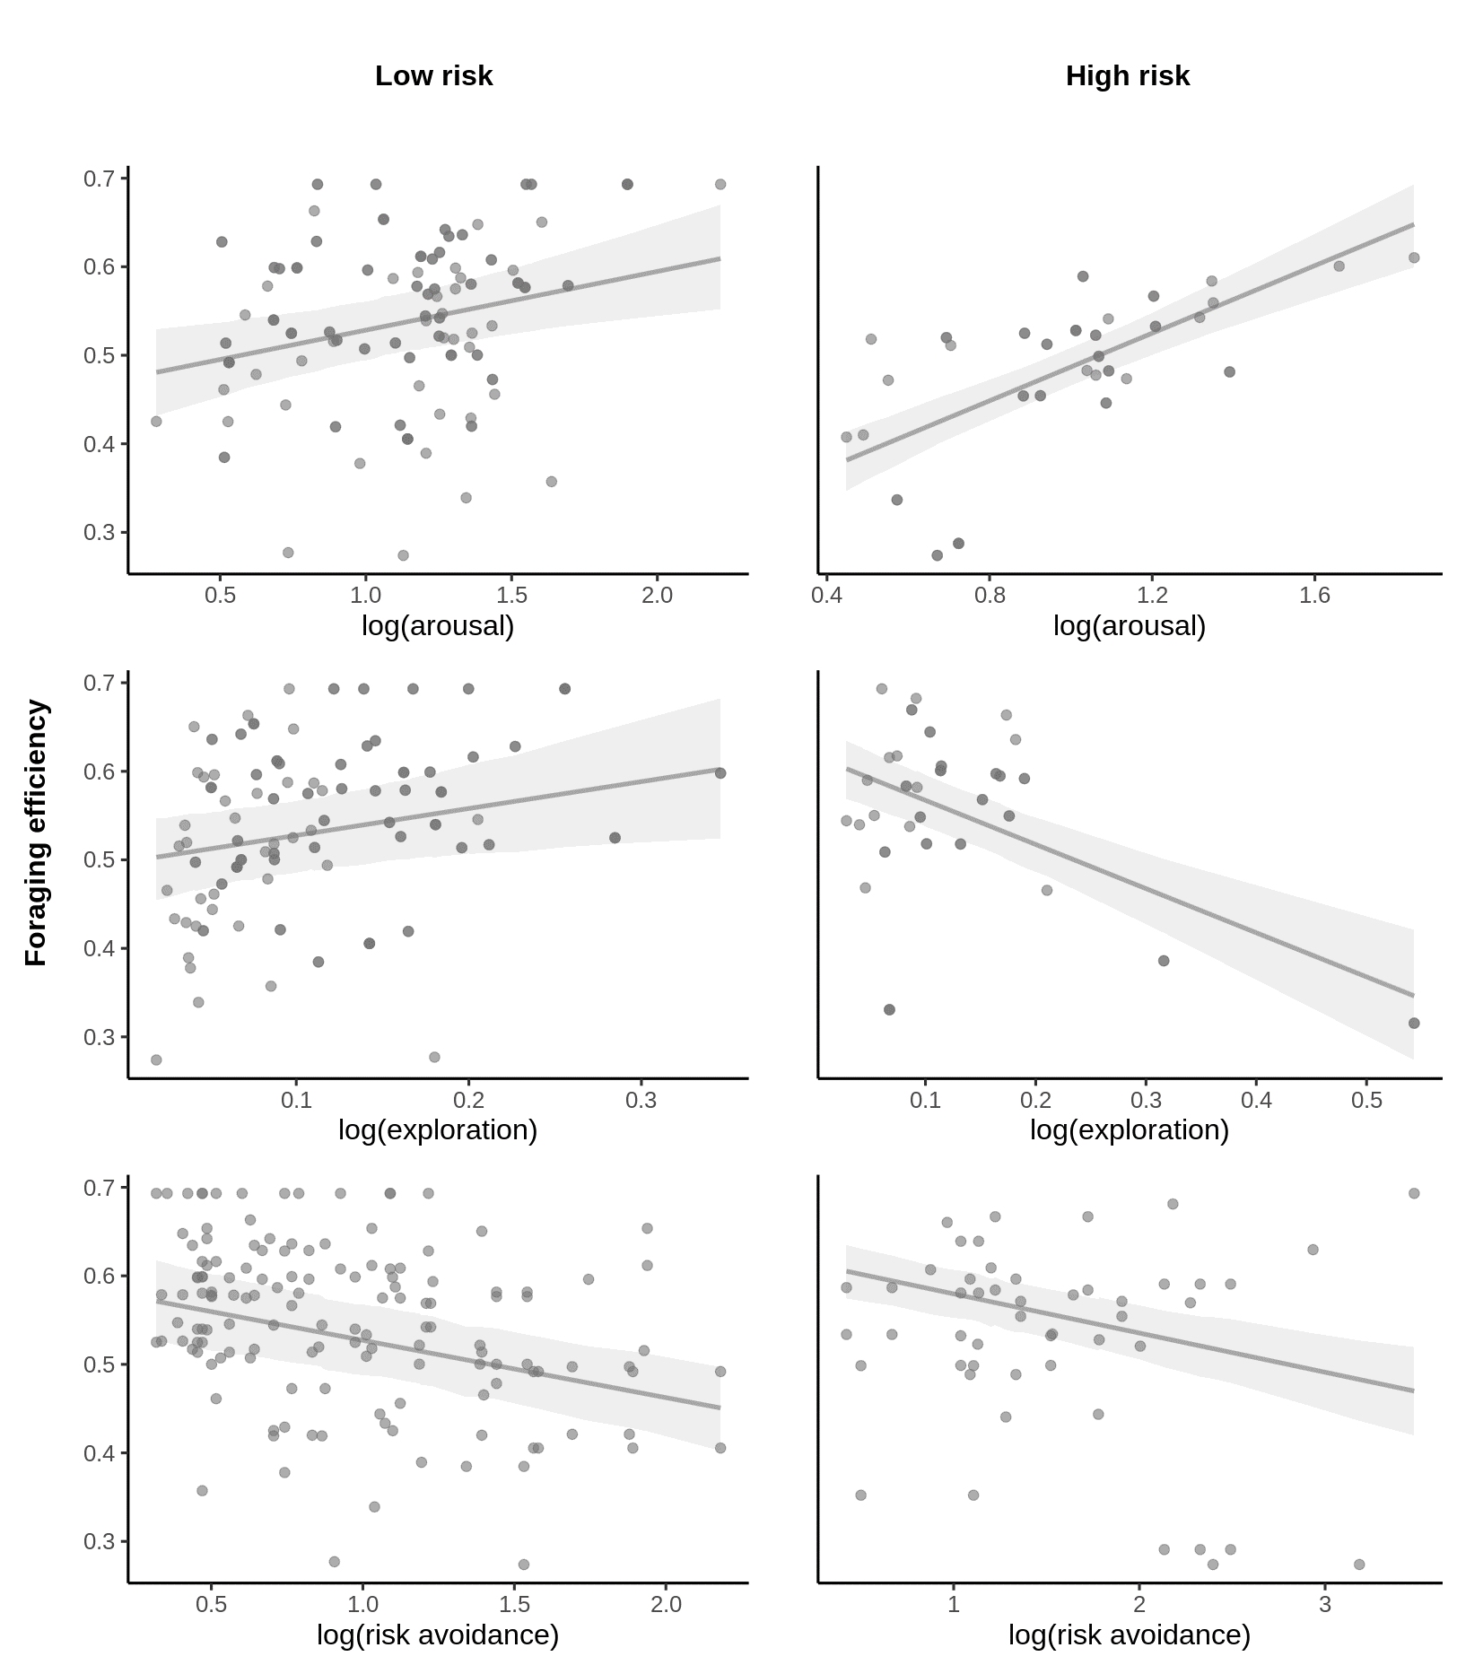

**Figure 4.** Foraging efficiency of Long-billed Hermits in regard to their behavioral performance (exploration, risk avoidance and arousal) in the context of low and high levels of perceived risk of predation. Regression lines presented with 95% confidence intervals (shadow area).

4. Discussion

As we could expect under the risk allocation hypothesis [5,6] foraging efficiency of Long-billed Hermits decreased in response to threatening conditions. However, behavioral performance related to exploration, risk avoidance and arousal, additionally affected the foraging efficiency, and interestingly, it was affected in a condition-dependent manner. These results suggest that a range of strategies, instead of a single fixed strategy, should be considered when modelling foraging behavior in a different contexts. The results also highlight the importance of behavioral variability in shaping evolution of foraging strategy.

Despite not being a specific prey target, hummingbirds may be opportunistically hunted by a wide range of predators, including insects [31,33–35,43]. That imposes a considerable predation risk and favors evolution of vigilance behavior. Indeed, we found that experimental exposure of an ant, potentially representing just a risk of being bitten (but not eaten), was enough for LBHs to exhibit some behavioral changes. Importantly, despite of the risk, birds did forage although with a lower efficiency. This places LBHs in a group of species representing so call paradox of risk-allocation hypothesis - in conditions of a frequent predator presence, prey might need to forage actively even though a threat (either potential or real predator) is present [5,6,44] In that context, it is worth to evoke one of assumptions of the risk allocation hypothesis, which is ‘living on the edge’ in terms of meeting energy demands [5,7]. This assumption seems to be rarely met in most of animal species used to test the hypothesis so far ([44]). Hummingbirds, given their extreme metabolism rate, could be a rare example when the assumption is actually true.

In control conditions individuals exhibiting more exploratory behavior had also overall higher efficiency during the foraging visit. The opposite pattern was observed for the experimental conditions. A simple reason for this shift could be that the time spend when switching feeders was longer under risk conditions, which increased the duration of the visit, probably associated with the need to analyze “*de novo*” the risk situation. Importantly, individuals were consistent over the time in their exploration which could indicate that this behavior is related to personality [19,22,45,46]. If the exploratory behavior was indeed a personality trait, and that trait had different fitness consequences in regard to predation, the predation pressure is likely to shape distribution of exploration phenotypes in the population. Unfortunately, examining bird behavior in limited time and contextual space we are not able to test this prediction currently. Nevertheless, to encourage future studies, we highlight potential role of threats in the environment in the evolution of personality [22,47,48].

There was a clear tendency that risk avoidance behavior negatively affects foraging efficiency. In the global model, that we presented in the main text, it was not significant but the effect was apparent in a single trait model (Table S2, Supplementary Online Materials). That indicates that in the most extreme scenario, individuals exhibiting high risk aversion may tend to jeopardize their survival in terms of energy intake, while individuals with low risk aversion, although benefiting from high foraging efficiency, would be more likely to be predated. If the risk avoidance was related to birds personality, the relationship between that and foraging efficiency would contribute in the selection of given behavioral phenotype in given predation risk level. Consistently, frequent changes and/or unpredictable level of risk predation in the environment would maintain variability in this behavioral phenotype [18]. Again, we cannot boldly conclude here about birds personality but the results are intriguing and encourage to explore this research avenue in the future.

To maximize fitness, hummingbirds should adaptively allocate both the exploratory and risk avoidance behaviors. Here we considered the issue in respect to a given species but interpreting our study in a broader context we could speculate that exploratory and risk avoidance should be differently allocated in hummingbirds that differ in foraging strategy, like trappliners and territorials. The two groups are likely to experience different risk of predation, and so behaviors like exploration and risk avoidance could also differ. Weighting the relative effect of these intrinsic behavioral features can allow us to more accurately understand the evolutionary factors shaping foraging performance [49–51].

An increasing foraging efficiency with an increase in arousal may be counterintuitive at first glance, as time allocated to movements potentially limits the time for foraging. However, arousal was not a repeatable trait, thus bird’s arousal may simply reflect its nutritional state, thus it may vary considerably between different days and even visits. Then, more active individuals could be the more effective during the foraging, owing to their good body condition or high motivation to forage.

Both exploratory and risk avoidance behavior were quite repeatable for individuals. Although more study are needed to properly examine how stable this repeatability is over different contexts and a longer period, our results suggest that these two behaviors could be related to birds personality [22,52,53]. In a constantly changing environment, varying fitness consequences of given behavioral phenotype would maintain variation in animals personality [18]. If indeed the exploratory and risk avoidance behavior are at least partially heritable traits, this can be expected to play an important role in the evolution of behavioral phenotypes under diverse conditions of predation pressure. Hummingbirds stand as a useful model for the study of animal behavioral syndromes and their interaction with critical natural history features in the wild.

**5. Conclusions**

Although with lower efficiency, Long-billed Hermits foraged despite an elevated level of risk in the environment. This make them a good model species for studies on the risk allocation hypothesis, where propensity to forage is measured in the context of predator presence. Our results show not only that foraging efficiencyof an individual **is** affected by a threat presence but also that the efficiency depends on behavioral performance of the individual. More exploration was associated with higher foraging efficiency in no-risk conditions but it was lower when birds were exposed to a risk. Regardless of conditions, arousal was positively associated with foraging efficiency while risk avoidance was related negatively. Importantly, exploratory behavior and risk avoidance were quite repeatable behaviors suggesting that they may be related to intrinsic traits of individuals. Our findings highlight the importance of taking into account additional behavioral dimensions to better understand foraging strategies of individuals.

**Supplementary Materials:** The following supporting information can be downloaded at: www.mdpi.com/xxx/s1, **Figure S1.** Relationship between foraging efficiency and consecutive visits at feeders area during the control phases of the experiment (all individuals considered); **Figure S2.** Autocorrelation analysis plots for six time series (four individuals) of foraging efficiency during consecutive visits at feeders area during the control phases of the experiment. The titles denote individual identity and number of control session. Solid vertical lines denote correlation coefficient for particular lag of the time series, and dashed horizontal lines delimit the range of their significance; **Figure S3.** Distribution of foraging efficiency and behavioral parameters in the study population of the long-billed hermits, raw (A) and log-transformed (B) data; **Figure S4.** Correlation coefficients between the three behavioral variables; **Figure S5.** Comparison ofestimates from single predictor models and the global model; **Table S1.** Ranking of models explaining foraging efficiency of Long-billed Hermits, ordered by delta Deviance Information Criterion (DIC; Akaike’s Information Criterion AIC yields to same conclusions). Best model for each parameters is bolded; **Table S2.** Effects of behavioral variables and predation context on foraging efficiency of long-billed hermits. Effects are model slope estimates derived from Bayesian MCMC generalized linear model. Only models that improved fit compared to the null models are presented. Source code of the statistical analyses can be found at https://github.com/maRce10/foraging_efficiency_in_long_billed_hermit_hummingbirds

**Author Contributions:** Authors equally conceived the study, contributed to data collection, data analysis and manuscript writing.

**Funding:** This research was funded by National Geographic Society, grant number 9169-12 and British Ornithological Union.

**Institutional Review Board Statement:** All activities (birds marking, feeding, and video recording/observations) were performed with the greatest care. The capturing and marking procedure did not have apparent effect on birds survival, as all the individuals where observed in the lek and/or at the feeders area after the capturing. The foam with the birds were marked was of negligible weight (0.02 g, which constitutes ~0.3% of average body mass (6g) of LBH). The study was reviewed and authorized by the Costa Rican Ministerio del Ambiente y Energia (063-2011-SINAC), and performed in accordance with their guidelines and regulations.

**Data Availability Statement:** Dataassociated with the manuscript included as supplementary materials.

**Acknowledgments:** The study was supported by Small Research Grant of British Ornithological Union (to KWJ), the National Geographic Society (CRE grant no. 9169-12 to MAS), a Research Initiation Grant from New Mexico State University (to MAS), the College of Arts and Sciences and the Biology Department at New Mexico State University (to MAS) and the Organization for Tropical Studies (to MAS). We thank Elizabeth Rogers, Judith Smith and Virgilio Lopez III for assistance in field work, and Yuki Brooknevskaya for an overall encouragement during the working on the manuscript.

**Conflicts of Interest:** Authors declare not conflict of interest.

Reference

1. Herborn, K.A.; Heidinger, B.J.; Alexander, L.; Arnold, K.E. Personality Predicts Behavioral Flexibility in a Fluctuating, Natural Environment. *Behav. Ecol.* **2014**, *25*, 1374–1379, doi:10.1093/beheco/aru131.

2. Morrison, M.M.; Raplph, C.J.; Verner, J.; Jehl, J.R.J. *Avian Foraging: Theory, Methodology and Applications*; 1990; Vol. 13; ISBN O-935868-47-X.

3. Charnov, E.L. Optimal Foraging, the Marginal Value Theorem. *Theor. Popul. Biol.* **1976**, *9*, 739–752.

4. Bautista, L.M.; Tinbergen, J.; Kacelnik, A. To Walk or to Fly? How Birds Choose among Foraging Modes. *Proc. Natl. Acad. Sci. U. S. A.* **2001**, *98*, 1089–1094, doi:10.1073/pnas.98.3.1089.

5. Lima, S.L.; Bednekoff, P.A. Temporal Variation in Danger Drives Antipredator Behavior: The Predation Risk Allocation Hypothesis. *Am. Nat.* **1999**, *153*, 649–659, doi:10.1086/303202.

6. Houston, A.I.; Mcnamara, J.M.; Hutchinson, J.M.C.; Trans, P.; Lond, R.S. General Results Concerning the Trade-off between Gaining Energy and Avoiding Predation. *Philos. Trans. R. Soc. London. Ser. B Biol. Sci.* **1993**, *341*, 375–397, doi:10.1098/rstb.1993.0123.

7. Verdolin, J.L. Meta-Analysis of Foraging and Predation Risk Trade-Offs in Terrestrial Systems. *Behav. Ecol. Sociobiol.* **2006**, *60*, 457–464, doi:10.1007/s00265-006-0172-6.

8. Krebs, J.R. Optimal Foraging, Predation Risk and Territory Defence. *Ardea* **1980**, *68*, 83–90, doi:10.5253/arde.v68.p83.

9. Patrick, S.C.; Bearhop, S.; Grémillet, D.; Lescroël, A.; Grecian, W.J.; Bodey, T.W.; Hamer, K.C.; Wakefield, E.; Le Nuz, M.; Votier, S.C. Individual Differences in Searching Behaviour and Spatial Foraging Consistency in a Central Place Marine Predator. *Oikos* **2014**, *123*, 33–40, doi:10.1111/j.1600-0706.2013.00406.x.

10. Camprasse, E.C.M.; Cherel, Y.; Bustamante, P.; Arnould, J.P.Y.; Bost, C.A. Intra-and Inter-Individual Variation in the Foraging Ecology of a Generalist Subantarctic Seabird, the Gentoo Penguin. *Mar. Ecol. Prog. Ser.* **2017**, *578*, 227–242, doi:10.3354/meps12151.

11. Moldoff, D.E.; Westneat, D.F. Foraging Sparrows Exhibit Individual Differences but Not a Syndrome When Responding to Multiple Kinds of Novelty. *Behav. Ecol.* **2017**, *28*, 732–743, doi:10.1093/beheco/arx014.

12. Dingemanse, N.J.; Kazem, A.J.N.; Reale, D.; Wright, J. Behavioural Reaction Norms: Animal Personality Meets Individual Plasticity. *Trends Ecol. Evol.* **2009**, *25*, 81–89, doi:10.1016/j.tree.2009.07.013.

13. Alonzo, S.H. Integrating the How and Why of Within-Individual and among-Individual Variation and Plasticity in Behavior. *Curr. Opin. Behav. Sci.* **2015**, *6*, 69–75.

14. Toscano, B.J.; Gownaris, N.J.; Heerhartz, S.M. Personality , Foraging Behavior and Specialization: Integrating Behavioral and Food Web Ecology at the Individual Level. *Oecologia* **2016**, doi:10.1007/s00442-016-3648-8.

15. Bell, A.M.; Hankison, S.J.; Laskowski, K.L. The Repeatability of Behaviour: A Meta-Analysis. *Anim. Behav.* **2009**, *77*, 771–783, doi:10.1016/j.anbehav.2008.12.022.

16. Nussey, D.H.; Wilson, A.J.; Brommer, J.E. The Evolutionary Ecology of Individual Phenotypic Plasticity in Wild Populations. *J. Evol. Biol.* **2007**, *20*, 831–844, doi:10.1111/j.1420-9101.2007.01300.x.

17. Carere, C.; Maestripieri, D. *No Animal Personalities*; Carere, C., Maestripieri, D., Eds.; The University of Chicago Press, 2013;

18. Smith, B.R.; Blumstein, D.T. Fitness Consequences of Personality: A Meta-Analysis. *Behav. Ecol.* **2008**, doi:10.1093/beheco/arm144.

19. Réale, D.; Reader, S.M.; Sol, D.; McDougall, P.T.; Dingemanse, N.J. Integrating Animal Temperament within Ecology and Evolution. *Biol. Rev.* **2007**, *82*, 291–318, doi:10.1111/j.1469-185X.2007.00010.x.

20. Quinn, J.L.; Cole, E.F.; Bates, J.; Payne, R.W.; Cresswell, W. Personality Predicts Individual Responsiveness to the Risks of Starvation and Predation. *Proc. R. Soc. B* **2012**, *279*, 1919–1926, doi:10.1098/rspb.2011.2227.

21. Dall, S.R.X.; Houston, A.I.; McNamara, J.M. The Behavioural Ecology of Personality: Consistent Individual Differences from an Adaptive Perspective. *Ecol. Lett.* **2004**, *7*, 734–739, doi:10.1111/j.1461-0248.2004.00618.x.

22. Dingemanse, N.J.; Réale, D. Natural Selection and Animal Personality. *Behaviour* **2005**, *142*, 1165–1190.

23. Bergeron, P.; Montiglio, P.O.; Réale, D.; Humphries, M.M.; Gimenez, O.; Garant, D. Disruptive Viability Selection on Adult Exploratory Behaviour in Eastern Chipmunks. *J. Evol. Biol.* 2013, *26*, 766–774.

24. Roth, A.M.; Dingemanse, N.J.; Nakagawa, S.; McDonald, G.C.; Løvlie, H.; Robledo-Ruiz, D.A.; Pizzari, T. Sexual Selection and Personality: Individual and Group-Level Effects on Mating Behaviour in Red Junglefowl. *J. Anim. Ecol.* **2021**, *90*, 1288–1306, doi:10.1111/1365-2656.13454.

25. Le Cœur, C.; Thibault, M.; Pisanu, B.; Thibault, S.; Chapuis, J.L.; Baudry, E. Temporally Fluctuating Selection on a Personality Trait in a Wild Rodent Population. *Behav. Ecol.* **2015**, *26*, 1285–1291, doi:10.1093/beheco/arv074.

26. Mouchet, A.; Cole, E.F.; Matthysen, E.; Nicolaus, M.; Quinn, J.L.; Roth, A.M.; Tinbergen, J.M.; van Oers, K.; van Overveld, T.; Dingemanse, N.J. Heterogeneous Selection on Exploration Behavior within and among West European Populations of a Passerine Bird. *Proc. Natl. Acad. Sci. U. S. A.* **2021**, *118*, 1–6, doi:10.1073/pnas.2024994118.

27. Suarez, R.K. Hummingbird Flight: Sustaining the Highest Mass-Specific Metabolic Rates among Vertebrates. *Experientia* **1992**, *48*, 565–570, doi:10.1007/BF01920240.

28. Stiles, F.G.; Wolf, L.L. Ecology and Evolution of Lek Mating Behavior in the Long-Tailed Hermit Hummingbird. *Ornithol. Monogr.* **1979**, *27*, 78, doi:http://dx.doi.org/10.2307/40166760.

29. Araya-Salas, M.; Gonzalez-Gomez, P.; Wojczulanis-Jakubas, K.; López, V.; Wright, T.F. Spatial Memory Is as Important as Weapon and Body Size for Territorial Ownership in a Lekking Hummingbird. *Sci. Rep.* **2018**, *8*, doi:10.1038/s41598-018-20441-x.

30. Stiles, F.G. Possible Specialization for Hummingbird-Hunting in the Tiny Hawk. *Auk* **1978**, *95*, 550–553.

31. Nyffeler, M.; Maxwell, M.R.; Remsen, J. V. Bird Predation by Praying Mantises: A Global Perspective. *Wilson J. Ornithol.* **2017**, *129*, 331–344, doi:10.1676/16-100.1.

32. Owen, J.L.; Cokendolpher, J.C. Tailless Whipscorpion (Phrynus Longipes) Feeds on Antillean Crested Hummingbird (Orthorhyncus Cristatus). *Wilson J. Ornithol.* **2006**, *118*, 422–423, doi:10.1676/05-062.1.

33. Sazima, I. Lightning Predator: The Ferruginous Pygmy Owl Snatches Flower-Visiting Hummingbirds in Southwestern Brazil. *Rev. Bras. Ornitol.* **2015**, *23*, 12–14.

34. Zenzal, T.J.; Fish, A.C.; Jones, T.M.; Ospina, E.A.; Moore, F.R. Observations of Predation and Anti-Predator Behavior of Rubythroated Hummingbirds During Migratory Stopover. *Southeast. Nat.* **2013**, *12*, N21–N25, doi:10.1656/058.012.0416.

35. Lorenz, S. Carolina Mantind (Stagmomantis Carolica) Captures and Feeds on a Broad-Tailed Hummingbird (Selasphorus Platycercus). *Bull. Texas Ornithol. Soc.* **2007**, *40*, 1–40.

36. Quinn, J.L.; Cole, E.F.; Bates, J.; Payne, R.W.; Cresswell, W. Personality Predicts Individual Responsiveness to the Risks of Starvation and Predation. *Proc. R. Soc. B Biol. Sci.* **2012**, *279*, 1919–1926, doi:10.1098/rspb.2011.2227.

37. Couchoux, C.; Cresswell, W. Personality Constraints versus Flexible Antipredation Behaviors: How Important Is Boldness in Risk Management of Redshanks (Tringa Totanus) Foraging in a Natural System? *Behav. Ecol.* **2012**, *23*, 290–301, doi:10.1093/beheco/arr185.

38. Pastell, M. CowLog – Cross-Platform Application for Coding Behaviours from Video. *J. open Res. Softw.* 2016, *25*, 1–4.

39. R Core Team R: A Language and Environment for Statistical Computing. R 2019.

40. Stoffel, M.A.; Nakagawa, S.; Schielzeth, H. RptR: Repeatability Estimation and Variance Decomposition by Generalized Linear Mixed-Effects Models. *Methods Ecol. Evol.* **2017**, *8*, 1639–1644, doi:10.1111/2041-210X.12797.

41. Meyer, R. Deviance Information Criterion ( DIC ) . *Wiley StatsRef Stat. Ref. Online* **2016**, 1–6, doi:10.1002/9781118445112.stat07878.

42. Hadfield, J.D. MCMCglmm: MCMC Methods for Multi-Response GLMMs in R. *J. Stat. Softw.* **2010**, *33*, 1–22.

43. Owen, J.L.; Cokendolpher, J.C. Tailless Whipscorpion (Phrynus Longipes) Feeds on Antillean Crested Hummingbird (Orthorhyncus Cristatus). *Wilson J. Ornithol.* **2006**, *118*, 422–423, doi:10.1676/05-062.1.

44. Ferrari, M.C.O.; Sih, A.; Chivers, D.P. The Paradox of Risk Allocation: A Review and Prospectus. *Anim. Behav.* **2009**, *78*, 579–585, doi:10.1016/j.anbehav.2009.05.034.

45. Montiglio, P.; Sih, A.; Mathot, K.J.; Wolf, M.; Dingemanse, N.J. Animal Personality and State – Behaviour Feedbacks: A Review and Guide for Empiricists. *Trends Ecol. Evol.* **2015**, *30*, 50–60, doi:10.1016/j.tree.2014.11.004.

46. Dingemanse, N.J.; Kazem, A.J.N.; Wright, J.; Biologiques, S. Evolutionary and Ecological Approaches to the Study of Personality. **2010**, 3937–3946, doi:10.1098/rstb.2010.0222.

47. Nácarová, J.; Veselý, P.; Fuchs, R. Effect of the Exploratory Behaviour on a Bird’s Ability to Categorize a Predator. *Behav. Processes* **2018**, *151*, 89–95, doi:10.1016/j.beproc.2018.03.021.

48. Exnerová, A.; Svádová, K.H.; Fučíková, E.; Drent, P.; Štys, P. Personality Matters: Individual Variation in Reactions of Naive Bird Predators to Aposematic Prey. *Proc. R. Soc. B Biol. Sci.* **2010**, *277*, 723–728, doi:10.1098/rspb.2009.1673.

49. Tello-Ramos, M.C.; Hurly, T.A.; Healy, S.D. Traplining in Hummingbirds: Flying Shortdistance Sequences among Several Locations. *Behav. Ecol.* **2015**, *26*, 812–819, doi:10.1093/beheco/arv014.

50. Ohashi, K.; Thomson, J.D. Efficient Harvesting of Renewing Resources. *Behav. Ecol.* **2005**, *16*, 592–605, doi:10.1093/beheco/ari031.

51. Gill, F.B. Trapline Foraging by Hermit Hummingbirds: Competition for an Undefended, Renewable Resource. *Ecology* **1988**, *69*, 1933–1942, doi:10.2307/1941170.

52. Sih, A.; Bell, A.; Johnson, J.C. Behavioral Syndromes : An Ecological and Evolutionary Overview. *Trends Ecol. Evol.* **2004**, *19*, 372–378, doi:10.1016/j.tree.2004.04.009.

53. Cleasby, I.R.; Nakagawa, S.; Schielzeth, H. Quantifying the Predictability of Behaviour: Statistical Approaches for the Study of between-Individual Variation in the within-Individual Variance. *Methods Ecol. Evol.* **2015**, *6*, 27–37, doi:10.1111/2041-210X.12281.

**Disclaimer/Publisher’s Note:** The statements, opinions and data contained in all publications are solely those of the individual author(s) and contributor(s) and not of MDPI and/or the editor(s). MDPI and/or the editor(s) disclaim responsibility for any injury to people or property resulting from any ideas, methods, instructions or products referred to in the content.