A cultural atlas of vocal variation: Yellow-naped Amazon contact calls exhibit discreet call types throughout range

BY

Molly K Dupin

Christine R Dahlin

Timothy F Wright

ABSTRACT
The endangered yellow-naped amazon, Amazona auropalliata, is a vocal learning species that inhabits the dry forest Central America from Mexico to Costa Rica. Populations in Costa Rica have been shown to exhibit geographic variation in their contact calls, known as vocal dialect, but no data exists regarding vocal variation trends in populations outside this portion of the range. In order to ensure successful conservation planning, cultural traits such as vocal dialect should be evaluated across the species’ range. We recorded yellow-naped amazon contact calls at 47 different sites across the range between 2016 and 2019 and evaluated them for the presence of vocal dialects. We visually classified 14 contact call variants and validated our classifications comparing it to similarities obtained by spectrographic cross-correlation. We observed regional separation of variants; while neighboring populations exhibited dissimilar calls, geographically distant populations gave similar calls, likely a result of geographic isolation and cultural drift. Our results also indicate that vocal dialect is a range-wide trend characteristic of yellow-naped amazons. We recommend that unsampled populations be evaluated for vocal dialects, and that reintroduced or translocated individuals be carefully monitored for signs of social distress or failure to assimilate.

TABLE OF CONTENTS
ABSTRACT iii
INTRODUCTION 1
MATERIALS AND METHODS 6
Data Collection 6
Sampling Sites 6
Figure 1. 8
Data Processing 9
Visual Assessment of Call Variants 9
Statistical Analyses 11
RESULTS 13
Contact Calls and Quality Assessment 13
Call Variants Across the Range 14
Figure 2 15
Spectrographic Cross-Correlations 16
Figure 3. 19
Principal Component Analysis of Spectral Measures 20
Figure 4. 24
DISCUSSION 25
Global Patterns 25
Figure 5. 27
REFERENCES 33

INTRODUCTION
Cultural traits in wild animals have been observed across an array of behavioral contexts including foraging, navigation, and vocal communication. Some species exhibit traits that persist through multiple generations in a population. In this case, learning cultural traits from conspecifics, also known as cultural transmission (Whiten, 2019), can work in parallel with genetic inheritance as an alternate means of information transfer over time (Aplin, 2019; Whiten, 2017). For example, in 1965 Kawai observed wild Japanese macaques washing sweet potatoes on Koshima Islet, a behavior which was transmitted over many generations and required learning by juveniles (Kawai, 1965). Another popular example of animal culture is milk-bottle opening by tits in Great Britain (Sherry & Galef, 1984).

Vocal production learning (hereafter vocal learning) is a well-studied cultural trait that is known to occur in humans, songbirds, cetaceans, elephants, and some bats, but few other taxa; it is defined as the ability to replicate a sound produced by a conspecific or another species (Bradbury & Balsby, 2016; Tyack, 2020). In vocal learning species, naïve individuals generally acquire information from parents or elders, and match their behavior to that learned template (Whitehead, 2010); however, imperfect learning can lead to changes in the behaviors of a population, an phenomenon known as cultural drift (Podos & Warren, 2007). When acted upon in conjunction with geographic or reproductive isolation, cultural drift in the context of learned vocalizations sometimes produces a distinct mosaic pattern of geographic variation in acoustic signals, known as vocal dialects (Wright, Dahlin, & Salinas-Melgoza, 2008; Martins, Rodrigues, & de Araujo, 2018). In 1964, Marler and Tamura were the first to identify dialects in a non-human animal, the White-crowned Sparrow, Zonotrichia leucophrys (Marler & Tamura, 1964). They hypothesized that dialects were a result of limited dispersal between populations. In contrast, a study by Soha et al. showed no genetic correlation with acoustic variation in the subspecies, Z. leucophrys pugentensis, suggesting post-dispersal learning of dialects (Soha, Nelson, & Parker, 2004). Several other studies support Soha’s findings that geographically distinct dialects in passerines are not correlated with gene flow (Nicholls, Austin, Moritz, & Goldizen, 2006; Yoktan et al., 2011).

Since their identification by Marler and Tamura, vocal dialects have been identified in a much wider array of taxa, including whales (Deecke, Ford, & Spong, 2000), hummingbirds (Wiley, 1971), seals (Casey, Reichmuth, Costa, & Le Boeuf, 2018), bats (Boughman & Wilkinson, 1998), and parrots (Wright, 1996). While this vocal phenomenon is now more broadly acknowledged, the function and maintenance of dialects are still not well understood. This has created a conservation blind spot for organizations working with populations that demonstrate geographic variation in acoustic signaling. A species which exhibits multiple dialects could pose a problem when attempting to bolster small populations with individuals from larger ones; for example, individuals with non-matching dialects could fail to assimilate, preventing them from forming social bonds, attracting and acquiring mates, or reproducing (Laiolo, 2010; Podos & Warren, 2007). Consequently, this failure would reduce the fitness of the affected individuals and therefore the overall rate of population growth (Laiolo, 2010). Vocal dialects could also be problematic for conservationists in the context of reintroducing captive-bred individuals, particularly if released birds exhibit a different dialect than the host population. Thus, a thorough understanding of cultural traits exhibited a species plays an important role in conservation; this is particularly relevant for all taxa which demonstrate cultural transmission of vocal dialect, including cetaceans, bats, and parrots.

Yellow-naped amazons, Amazona auropalliata, are large, Neotropical parrots that have been experiencing dramatic population decline for several decades (Wright, Lewis, Lezama-Lopez, Smith-Vidaurre, & Dahlin, 2019).z Populations occur within lowland, seasonally dry tropical forests along both the Pacific and Caribbean coasts of Central America, ranging from southern Mexico to northern Costa Rica (Wright et al., 2019). In 1996, Wright documented the first known evidence of vocal dialect presence in Costa Rican populations of yellow-naped amazons (Wright, 1996). In 2005, Wright et al. resampled contact calls in Costa Rica and found that the acoustic variation discovered in 1996 exhibited both geographic and temporal stability.

Subsequent studies conducted by Wright et al. also revealed dramatic population declines for yellow-naped amazon populations in Costa Rica (Wright et al., 2019). Their data, collected in 2016, contributed to a 2017 change in status for yellow-naped amazons from threatened to endangered by BirdLife International (2017). The main causes of decline in this species are thought to be habitat destruction and poaching for the pet trade (Wright et al., 2019). A recent paper by Dupin et al. (2020) expanded on previously published population data by Wright et al. (2019) to incorporate populations in Nicaragua, Honduras, Guatemala, and Mexico. Their report recommends in situ conservation methods for this species, such as nest protection and enforcement of poaching repercussions; however, it is possible that with persistent declines, ex situ methods would need to be implemented, such as captive breeding and reintroduction.

Seasonally dry tropical forests of Central America have undergone extreme denudation as a result of agricultural expansion over the last several decades (Chazdon et al., 2011). Consequently, yellow-naped amazon habitat has become progressively more fragmented, a pattern which could have detrimental genetic and cultural effects. As geographic distance between populations grows, gene flow and social interaction can become non-existent, resulting in reproductive or social isolation (Laiolo & Tella, 2007; Simberloff, 1995). While extensive dialect and population studies have been performed in the southern portion of the yellow-naped amazon range, no data exists regarding the vocal patterns of this species in its northern range.

We hypothesized that vocal dialects are a trait that is a general characteristic of yellow-naped amazons. To answer this question, we recorded contact calls from the yellow-naped amazon in Costa Rica, Nicaragua, Honduras, Guatemala, and Mexico from 2016-2019. We expected to see a mosaic pattern of geographic variation in the contact calls of yellow-naped amazons, where calls within populations are more similar in their acoustic structure than between populations (Wright & Dahlin, 2018). Spectrographic cross-correlation (SPCC) plots, which illustrate the distribution of calls in two-dimensional acoustic space, were used as a means of assessing the similarity of variants. If contact calls were geographically distributed in a mosaic pattern, then the SPCC analyses would indicate dissimilarity between sites. Our principal component analysis should mirror these results. We also used a mantel-based spectrographic autocorrelation to evaluate the relationship between geographic location and similarity of contact call acoustic structure. We predicted variants would show dissimilarity between neighboring sites.

Alternatively, variation in yellow-naped amazon contact calls could be graded, or clinal. In this case, we expected to see the acoustic structure of calls progressively diverge from one end of the range to the other (Lee, Podos, & Sung, 2019). SPCC and PCA analyses would depict neighboring variants as being more similar, while geographically separated variants would appear more dissimilar. Calls would show a linear decrease in similarity, such that increasing geographic distance would be associated with acoustic dissimilarity.

MATERIALS AND METHODS

Data Collection
We recorded the contact calls of male and female unmarked yellow-naped amazons occurring in and around the same roost sites surveyed by Dupin et al. (2020) during 2016, 2018, and 2019. We recorded calls during the morning and evening, after individuals had left or as they arrived at the night roost. Contact calls are the most frequently emitted acoustic signal in this species, particularly in and around the roost where we opportunistically recorded birds during morning and evening choruses (Wright, 1996). We recorded flyovers and perched calls as this species is known to use contact calls in both contexts (Wright, 1996). We aimed to record a minimum of 10 calls from six different birds at each site. Calls were recorded using a Sennheiser (ME67, Wedemark, Germany) shotgun microphone and a Marantz (PMD660, Sagamihara, Japan) digital recorder at sampling rate of 22.05 kHz and an amplitude resoltuion of 16 bits. Individuals were differentiated in recordings via detailed dictation by the individual doing the recording.

Sampling Sites
We sampled contact calls from yellow-naped amazons during June and July of 2016, 2018, and 2019; both are months that fall outside of the species’ breeding season (Matuzak & Brightsmith, 2007). In 2016, we surveyed 25 sites in Costa Rica for yellow-naped amazons and 19 in Nicaragua, and in 2018 we sampled 11 sites in southern Mexico. During 2019 we resampled 2 sites and sampled an additional 3 new sites in Mexico, as well as 5 sites in Guatemala, and 7 sites in the Bay Islands, Honduras; one site in the Bay Islands was a private location which remains undisclosed at the owners request. In total, we surveyed 72 sites across the yellow-naped amazon range (Figure 1).
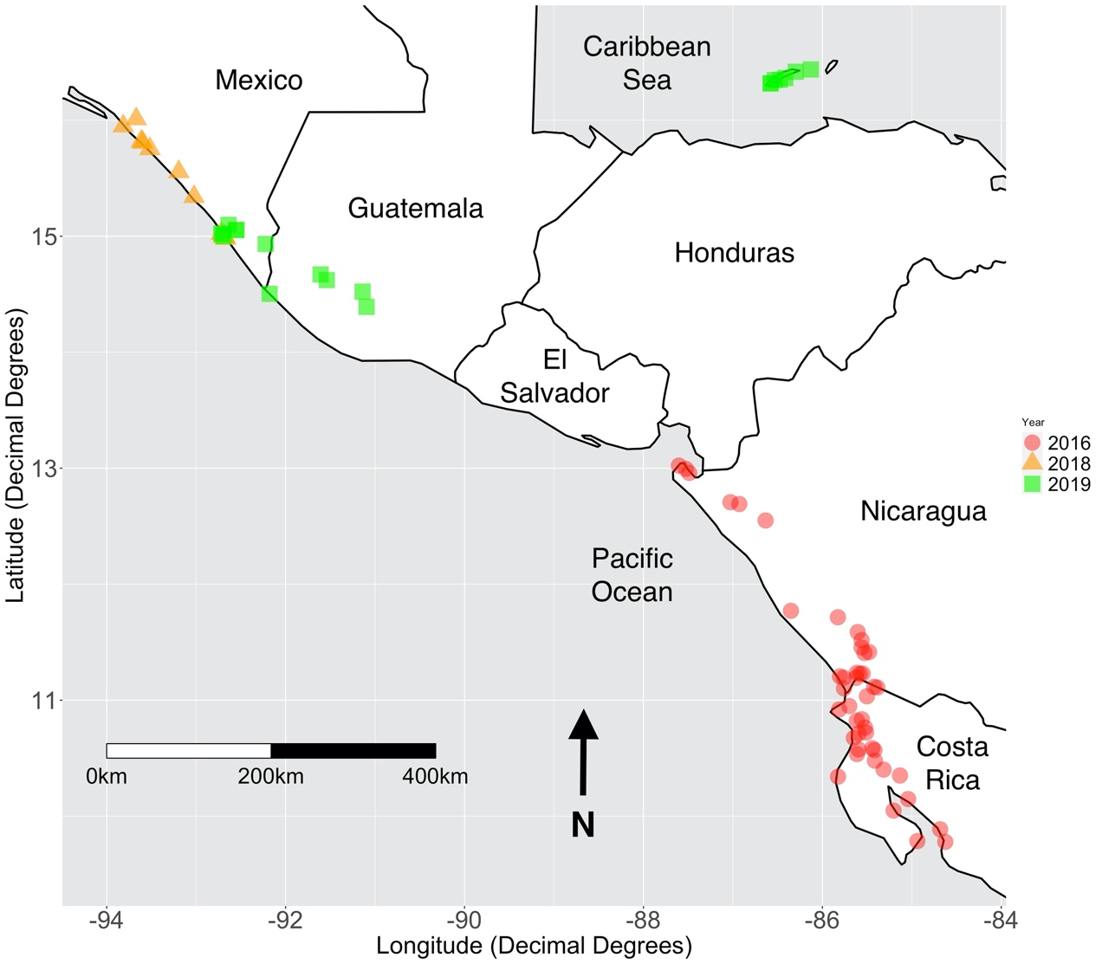
(b)

Figure 1. (a) A map of all sites sampled during 2018 and 2019. Sites from the Wright et al. study (Wright et al., 2019) conducted in 2016 are also included. The color and shape of each point corresponds to the year the site was sampled. (b) A species range polygon for the yellow-naped amazon provided by BirdLife (BirdLife International and Handbook of the Birds of the World, 2019).

Data Processing
Contact calls were processed digitally and visualized using the sound analysis program Raven Pro version 1.5. Calls from each field site were selected for analysis after a visual assessment of the original sound files and identification of one or more local variants. Contact calls in yellow-naped amazons are typically short (0.2 - 0.5 seconds), monosyllabic, have a dominant frequency around 2 kHz, and are repeated in long strings by birds while perched and in flight; thus, call variants across the range were identified as homologous by looking for these patterns. After all contact calls within each file were identified, the highest quality calls were selected by highlighting the call from start to finish using the cursor in Raven. In 2016, calls were highlighted in the original sound file before being copied and pasted into a blank window and saved as a new sound file. This procedure produced a sound file for each individual contact call. In 2018 and 2019, we selected calls within raw sound files and saved those selections within the original sound file, generating a .txt file selection table in Raven. Each 2018 and 2019 original sound file was therefore accompanied by a annotation table which detailed the start and end time of each selected and saved within it. We used the start and end times from the annotation table files and individual contact call sound files in our metadata sheet which we used for subsequent analyses.

Visual Assessment of Call Variants
We visually assessed all of the calls from 2016, 2018, and 2019 by creating spectrograms, or visual representations of sound frequency, for all the annotated calls. We used this combined dataset to create a spectrographic catalogue of all calls from each year using the catalog function from the warbleR (citation) package in R (citation, code available supplementarily). We used a window length of 512, overlap between consecutive windows was set to 85%, and our lowest and highest frequencies were 0.5kHz and 2.5kHz, respectively. We chose these frequency limits to filter out low and high frequency background noise such as cicadas and other bird species. Calls were organized in the catalog by site.

Each contact call was categorized as being of low, medium, or high signal quality by a single observer (MKD). Low quality calls were those that had high levels of noise interference, overlap with another call, and/or had no visible harmonic bands in the signal; calls of medium quality had some visible bands but lacked higher-frequency harmonics and might contain some noise interference. High quality calls had multiple, dark bands and no noise interference. We also evaluated each spectrogram for the presence of overlap with calls, and whether or not a 2.5 kHz upper frequency limit excluded any overlapping signal or background noise. All low-quality calls were removed from the dataset along with calls that overlapped with another signal. Calls that presented with noise even after the bandpass filter was implemented were examined individually to determine whether that noise would interfere with analysis. If noise did not overlap significantly with the call or was mostly excluded as a result of the bandpass filter, it was retained.

After our visual assessment, we evaluated the number of remaining calls per bird at each site, and the number of birds at each site. Birds with less than 3 calls and sites with less than 3 birds were removed from the dataset. We adjusted the start and end times of the remaining calls using the seltailor function from the warbleR (citation) package in R (code provided in electronic supplement). Each call was then categorized based on its acoustic structure; calls with noticeably different acoustic structures were categorized as a distinct call variant and named arbitrarily. This method is subjective, but has proven to be useful as a tool to assess overall degree of difference between variants, as described by Wright and colleagues in their previous studies on yellow-naped amazons (Wright, 1996; Wright et al., 2008).

Statistical Analyses
All calls were sorted by country for the following analyses to aid in visual assessment of results. We conducted a spectrographic cross-correlation (SPCC) using the cross_correlation function from the package warbleR in R. Our window length was set at 512, overlap was set at 85%, and we used a 0.5kHz and 2.5 kHz limit on the lower and upper frequencies. The function generates a correlation matrix that we used to create classic metric multidimensional scaling plots as well as Kruskal non-metric multidimensional scaling plots. The classic MDS plots were created by using the ggplot function to plot all points from the first two dimensions of the cross-correlation matrix in acoustic space. We also created Kruskal non-metric MDS plots (hereafter, kernel plots) using the function isoMDS from the package MASS in R. The kernel plots we produced showed the distribution of each call using contour lines, where the closer lines represent a higher density of calls. The smallest circles indicate high concentrations of calls in one area of acoustic space; we refer to these as centroids. In addition to creating plots for each country, we also generated cumulative plots for each analysis to assess whether variation appeared to be random or clinal. All code used for SPCC and MDS plots was modelled on code by Smith-Vidaurre et al. available online via GitHub (Smith-Vidaurre, Araya-Salas, & Wright, 2020).

We used a principal component analysis as an alternative approach to measure similarity between call variants across the range. We accomplished this by first using the spectro_analysis function from the warbleR package in RStudio to measure acoustic parameters across calls, and then using the prcomp function from the stats package to apply the principal component analysis (PCA). We plotted the first 2 principal components for each region as a ground-truthing method to validate the approach. We used the function leveneTest() in R test to assess for equal variances, and the function shapiro.test() to evaluate the normality of our dataset. We performed Welch’s ANOVA on principle components 1 and 2 from our PCA output to evaluate for differences among variants. To determine which variant comparisons showed significant differences, we conducted a Games-Howell post-hoc analysis on our ANOVA results using the posthocTGH() function in R.

RESULTS

Contact Calls and Quality Assessment
We surveyed 72 locations in Mesoamerica where yellow-naped amazons are known to occur or have occurred historically. We observed this species at 56 of those sites, and recorded individuals at 47 sites. In 2016 our team was able to sample contact calls at 22 locations in Costa Rica and 9 in Nicaragua; we recorded birds at 10 sites in Mexico between 2018 and 2019. In 2019 we sampled birds at 2 sites in Guatemala and 4 in the Bay Islands of Honduras. We identified and selected 2,561 yellow-naped amazon contact calls from our field recordings and removed 116 of those during quality assessment due to the presence of noise overlap or low signal quality. In total, 26 birds were removed from the remaining dataset due to retention of fewer than three contact calls. Eight birds were removed from Mexico 2018/2019, 4 from Guatemala, 1 from the Bay Islands, Honduras, 2 from Nicaragua, and 11 from Costa Rica. Three sites from Costa Rica (Enseñada, Pelon Bajura, and Palo Verde) were removed as a result of having fewer than 3 birds. None of the other countries surveyed had sites removed during quality assessment.

We retained 2,338 yellow-naped amazon contact calls from our original dataset for analysis. We classified 21.5% of calls as medium quality, and 78.5% of calls as high quality. Mexico represented 23.3% of contact calls in the final dataset and 1.5% of calls were from Guatemala. Contact calls from the Bay Islands, Honduras made up 9.3% of the dataset, 23% are from Nicaraguan individuals, and 43% are from birds in Costa Rica.

Call Variants Across the Range
Our visual classification of yellow-naped amazon contact calls yielded 14 different call variants across the species range (Figure 2). We identified 4 variants in Mexico and 2 variants in Guatemala. In the Bay Islands Honduras, recorded individuals exhibited 2 distinct variants. Previously, Wright et al. reported 3 call variants in Costa Rica during a 1994 survey and the same 3 variants and a new subvariant during a second survey in 2005 (Wright, 1996; Wright et al., 2008); our visual analysis of contact calls collected from these same regions during 2016 indicate that birds in Nicaragua give 4 different variants, one of which was previously reported at the northern border of Costa Rica, and birds in Costa Rica give 2 different variants, both of which were reported in the previous surveys. Sixteen percent of the 243 birds in our dataset exhibited more than 1 contact call variant (previously referred to as “bilingual” birds). Overall, these observations were rare, and primarily concentrated in Costa Rica (N = 36), although bilingual birds were also recorded in Mexico (N = 2) and Guatemala (N = 1). None of the birds in our dataset from Nicaragua or Honduras were bilingual.

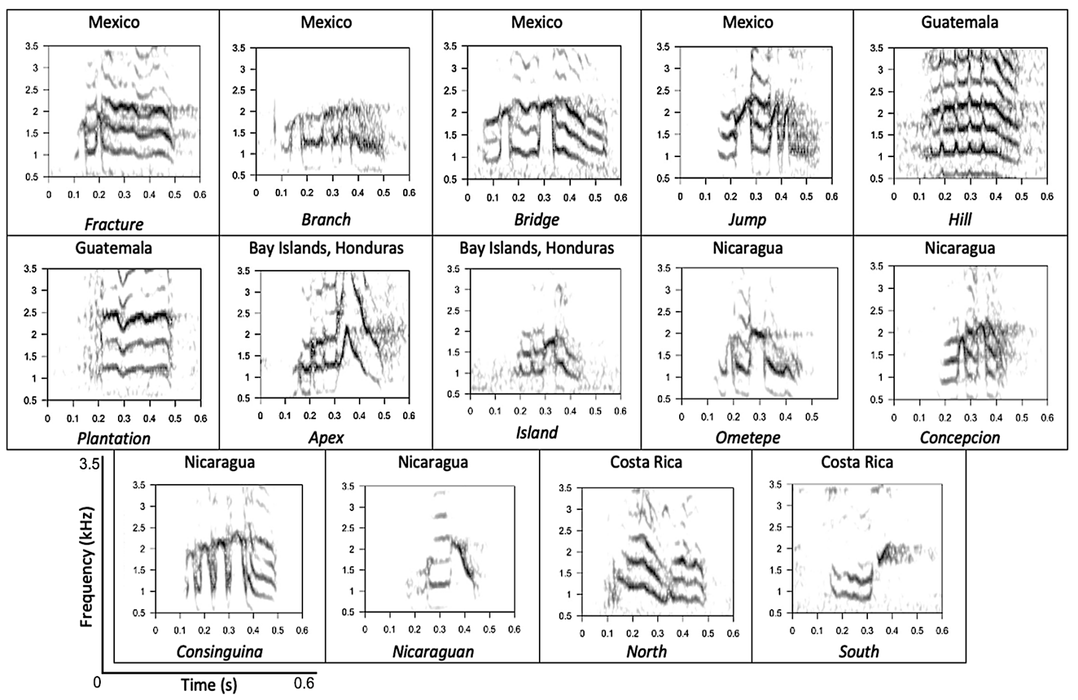

Figure 2. Spectrograms of each identified call variant with the country of origin listed above and the call variant name listed below the image. All images are shown on a 0.6 second timescale at 3.5 kHz frequency.

Spectrographic Cross-Correlations
SPCC analyses for each country supported some, but not all of our call classifications for the yellow-naped amazon contact call variants identified across the range (Figure 3). Plots of contact calls recorded in Mexico showed an intermediate level of clustering among the 4 identified variants, with some grouping together more strongly than others. For example, variants Branch and Jump each show strong clustering, but they are both completely overlapped by both the Bridge and Fracture variants. Each variant demonstrated a degree of geographic separation, as only one call type was exhibited at each site, with the exception of the Roberto Barrios. Two of the 8 birds recorded at this site gave both Fracture and Jump variants.

The 2 variants identified in Guatemala, Plantation and Hill, exhibited weak clustering when plotted in acoustic space, and both call types overlapped significantly. Kernel plots for these variants also illustrated more than one central concentration of calls for each type. When examining the geographic patterns of call variants in Guatemala, it appears that each variant was given at only one site; however, it should be noted that one bird which was excluded from our analyses called using both variants at the northernmost site, Los Tarrales.

SPCC plots of the Island and Apex variants identified in the Bay Islands, Honduras showed distinct clustering of call types with no overlap. The Island call variant was observed strictly on the eastern end of the island Roatan, and the eastern Bay Islands region. The Apex variant was constrained to the western regions of the island Roatan, and both variants were separated by a large geographic space where no yellow-naped amazons were observed.

When we examined the SPCC plots for the 4 call variants identified in Nicaragua, we observed relatively strong grouping each, although they all exhibited some degree of overlap with another variant. The Consinguina call type exhibited the least amount of overlap, while Nicaraguan, Concepcion, and Ometepe variants overlapped significantly with one another; however, kernel plots indicated none of the central concentrations of the call types overlapped. Populations sampled in northern Nicaragua all exhibited the same call type, while 3 different variants were observed at sites on and around Ometepe.

Wright et al. (2008) originally identified 3 call variants in Costa Rica, 2 of which were observed again in 2016 (North and South). SPCC plots for the Costa Rica call variants showed poor clustering and strong overlap between the two variants. Although the North calls appear to be contained to one geographic area (Figure 3), the South call type occurs almost to the northern boundary of Costa Rica.

When all identified variants from across the range were plotted in acoustic space, it was difficult to visually detect separate distributions as they showed a large degree of overlap. We mapped all of the acoustic variants as they occurred across the range and noticed that geographic overlap of call types is much less prevalent in the northern half.
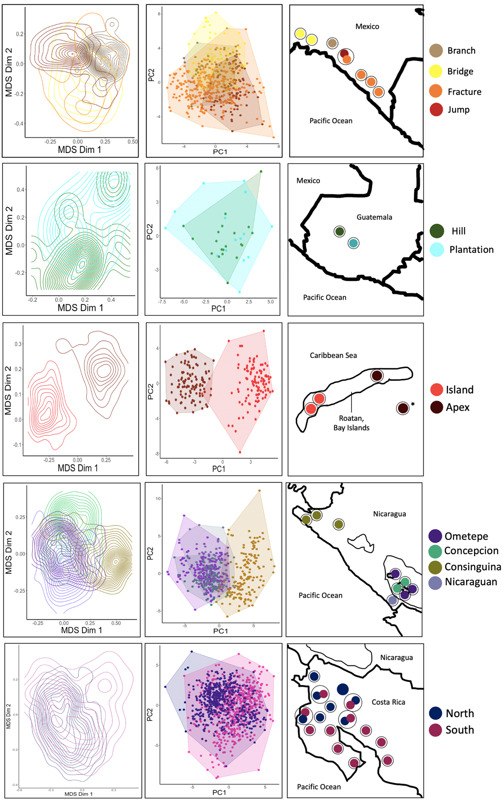
Mexico
Guatemala
Honduras
Nicaragua
Costa Rica
SPCC
PCA
Geographic map
Legend
Figure 3. A multi-panel image with four columns showing SPCC plots, PCA plots, a geographic map, and a legend, in that order. Rows represent the sampled countries, arranged in order from north to south. The geographic map for Honduras depicts the call type for the undisclosed location using an asterisk (*). Black circles represent a single site.

Principal Component Analysis of Spectral Measures
We used PCA on spectral measures as an alternative measure of validation for our visually classified contact call variants. The first 5 loadings from our analysis accounted for 77.38% of cumulative variation (Figure 3). PC1 represented 26.69% of explained variation and primarily accounted for differences in frequency variables such as mean dominant frequency, and mean frequency (in kHz). PC2 explained 17.60% of variation and represented differences in temporal variables such as signal duration and duration of the call in the 75th quantile.

Plots of PC1 and PC2 for variants in each country generally reflected the patterns exhibited in the corresponding SPCC plots. When we plotted the first 2 PC variables for Mexico, the Bridge and Jump variants clustered together strongly. The Branch variant also clustered out well but overlapped significantly with Branch. Branch, Bridge, and Jump were each overlapped significantly by the Fracture variant. The PC plot of variants identified in Guatemala, Hill and Plantation, indicated significant overlap and a wide spread of each in acoustic space. The 2 call types we identified in the Bay Islands, Apex and Island, remained distinct from one another in the PC plot with the exception of 1 outlier. Call variants identified in Nicaragua exhibited varying degrees of overlap; Consinguina exhibited less than the other 3 variants, Ometepe, Nicaraguan, and Concepcion, which show strong overlap of one another. The 2 call variants given in Costa Rica did not exhibit distinction from one another when we plotted the first 2 PC loadings. The PC plot for all call variants identified across the range showed complete overlap of call types with no distinguishable separation.

The results of our ANOVA on PC1 and PC2 indicated significant differences between call variants for both PC1 (F = 294.07, df = 299.41, p = < 2.2⁻¹⁶) and PC2 (F = 53.263.82, df = 300.35, p = < 2.2⁻¹⁶). To gain a better understanding of which variant comparisons were significantly different, we conducted a Games-Howell post-hoc analysis on the first 2 PCs.

The post-hoc analyses on call variants identified in Mexico (Branch, Fracture, Jump, and Bridge) indicated that comparisons of each variant had significantly different frequency parameters (p < 0.05), with the exception of Bridge and Branch (t = 0.2975, df = 111.1, p = 1). Examination of PC2 post-hoc results show that Fracture and Branch were not significantly different (t = 2.515, df = 55.77, p = 0.42). The comparison of call variants Jump and Branch (t = 1.295, df = 73.06, p = 0.99), and Bridge and Jump (t = 3.143, df = 161., p = 0.1) also lacked statistical significance.

Post-hoc analyses of variants identified in Guatemala showed no significant difference in their mean PC1 (t = 0.0248, df = 20.75, p = 1) or PC2 (t = 0.0725, df = 21.03, p = 1) values. These results mirror the patterns we observed in the SPCC plots for this country. We visually and aurally reexamined both call variants thoroughly, and we believe that they should remain separate due to their structural and audible distinctiveness.

In the Bay Islands, Honduras, post-hoc analyses of our ANOVA results for PC1 indicated that both variants had significant differences in their frequencies (t = 37.63, df = 214.6, p = < 0.01); however, the ANOVA on PC2 showed no significant temporal differences (t = 0.6481, df = 214.8, p = 1).

All call variants identified in Nicaragua showed significant differences in mean PC1 values apart from the comparison between Nicaragua and Concepcion (t = 1.346, df = 193.8, p = 0.99). When we examined differences in mean PC2 values detected with the Games-Howell post- hoc analysis, Nicaraguan and Concepcion call variants again showed no statistical distinction (t = 2.759, df = 198.6, p = 0.25). The Nicaraguan and Consinguina comparison for PC2 revealed no statistical difference between the call types (t = 2.158, df = 215.1, p = 0.66), nor did the Ometepe and Concepcion comparison (t = 0.6267, df = 194.6, p = 1).

The Games-Howell post-hoc results for Costa Rica indicated that the two call types, North and South, were not significantly different with respect to mean PC1 values (t = 0.6412, df = 838.6, p = 1). The PC2 comparison of North and South did show significant differences.

The Mantel-based spatial autocorrelogram illustrated 3 distinct patterns in our data. First, within 250 km yellow-naped amazon contact calls mostly exhibit significant similarity based on spectrogram cross-correlation, although there do exist 2 outlier points indicating significant dissimilarity (Figure 4). The second pattern we identified was the general, significant dissimilarity in calls between 250 and 500 km; beyond 500 km there is an almost equal distribution of significant similarity and dissimilarity, with an increasingly neutral significance as geographic distance increases.

Spatial Correlation Significance Values
Significance of Correlation Value for Acoustic Similarity

Figure 4. A Mantel-based spatial autocorrelogram depicting the acoustic similarity of calls against increasing geographic distance. Spatial Correlation Values indicate the significance of each point, with a cutoff value of 0.05.

DISCUSSION
Yellow-naped amazon populations in Costa Rica have been reported to exhibit geographic variation in their contact calls for more than 20 years. In this study, we provide the first published evidence that vocal dialects are a range-wide trend observed in this species. A study by Dupin et al. (2020) found that wild populations of this species exhibited regional, geographic separation; we found multiple variants within each region, all of which exhibited discreet differences which we were able to detect visually. In total, we identified 14 contact call variants given by wild yellow-naped amazons across their range. Our SPCC and PCA analyses validated some, but not all of our visual classifications when we compared variants by country. We noticed that most variants exhibited some degree of structural similarity regardless of the degree of geographic separation, suggesting that vocal dialect in this species exhibits a mosaic pattern. SPCC and PCA plots of all call variants support this observation, revealing extreme overlap in acoustic space.

Global Patterns
In 1996, Wright identified 3 audibly and spectrogaphically distinct contact call variants present in Costa Rican populations (Wright, 1996), and later confirmed the geographic and temporal stability of those same variants (Wright, Rodriguez, & Fleischer, 2005). Our visual assessment of 2,338 contact calls collected from yellow-naped amazons across their range revealed the presence of 14 distinct call variants. Results from SPCC analyses and PCA support many of our visual classifications; however, several variants that exhibited high acoustic similarity required reevaluation. Variants in this species appear to be regionally spaced, and populations show increasing acoustic similarity as geographic distance increases. We observed several commonly used structural patterns across all yellow-naped amazon contact call variants, including the presence of gaps within the call, frequency shifts, and differences in duration. Rather than clinal or graded variation of call types, dialects in this species appear to be products of modifications to a basic call structure (Figure 5) that are distributed across the range in a mosaic pattern.

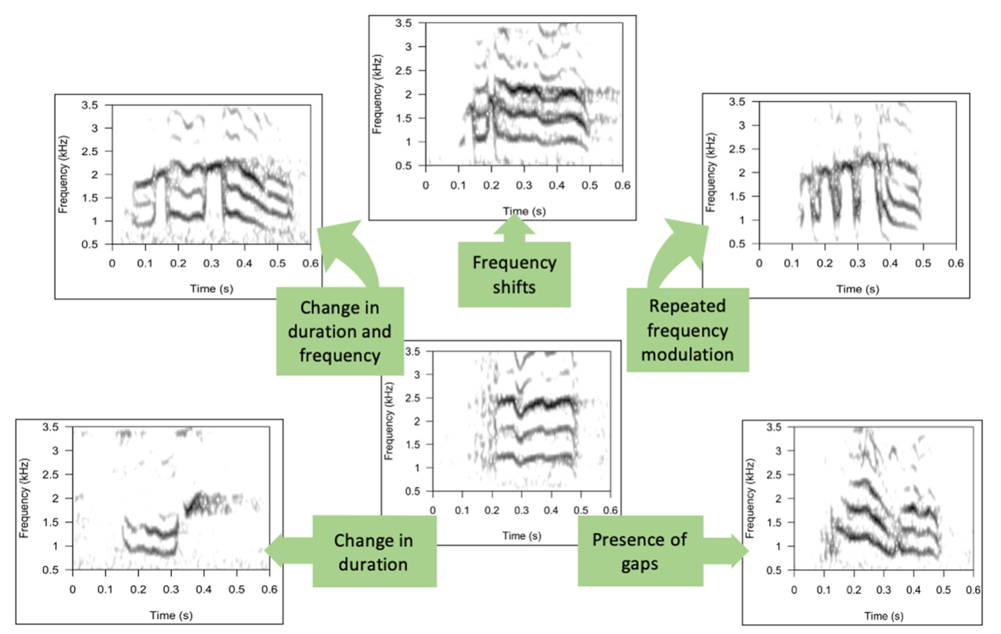
Figure 5. An image using spectrograms to depict the common ways in which yellow-naped amazon contact calls can structurally vary.

In addition to the yellow-naped amazon, several other parrot species have been found to exhibit distinct dialects including the Australian ringneck parrot, Barnardius zonariu (Baker, 2000); Galah, Eolophus roseicapillus (Baker, 2003); Australian Palm Cockatoo, Probosciger aterrimus (Keighley, Langmore, Zdenek, & Heinsohn, 2017); Cuban Parrot, Amazona leucocephala (J. Reynolds, Hayes, & Wiley, 2010); and invasive populations of the Monk parakeet, Myiopsitta monachus (but see (Smith-Vidaurre et al., 2020) for evidence of different patterns in native populations) (Buhrman-Deever, Rappaport, & Bradbury, 2007). There is little understanding as to why parrot species exhibit vocal dialects, but several hypotheses have been formed to explain their function. Podos and Warren (2007) postulate that female preference for local call types is a driver of acoustic divergence. In this case, female sexual preference for males with a local trait would result in some level of genetic divergence between populations (Wilkins, Seddon, & Safran, 2013). A study by Wright and Wilkinson reported no genetic correlation with yellow-naped amazon contact calls, stating instead that individuals exhibited high dispersal across dialect boundaries (Wright & Wilkinson, 2001). Parrots may also exhibit vocal dialect as a badge or signal of group affiliation and familiarity (Sewall, Young, & Wright, 2016). Alternatively, geographic variation as seen in dialects could be a consequence of genetic drift, when individuals learning calls make copying errors (Podos & Warren, 2007).

We observed that neighboring call types exhibit subtle differences in acoustic structure as opposed to whole-structure change. Variants separated by geographic differences greater than 250 km exhibited weaker differences in acoustic structure. These results, in conjunction with our observation of common patterns in the acoustic structure of variants from across the range suggest that the cultural drift hypothesis seems to be a suitable explanation for call variation in this species.

Regional Patterns and Implications for Cultural Evolution
Several variants we visually identified across the range did not correspond to our SPCC and PCA results. In some cases, SPCC plots and PCA measures contradicted each other; however, it should be noted that the function we used to create our cross-correlation matrix, xcorr() from the package warbleR, compares call spectrograms by assessing similarity when overlapped (Araya-Salas & Smith-Vidaurre, 2017); thus, depending on the manner in which calls align, it is possible for visually dissimilar variants to exhibit spectrographic similarity when compared. Although SPCC is considered an efficient measurement of acoustic similarity, it is important to consider its limitations, and the quality of the recordings used in analyses (Bradbury, Cortopassi, & Clemmons, 2001).

The remaining populations of wild yellow-naped amazons exhibit regional separation, with few or no detectable parrots between populated areas (Dupin et al., 2020). When we analyzed spectrograms of call variants within each region, we noticed that calls were structured more similarly within regions than between them. SPCC and PCA plots for each country also showed varying degrees of within-region similarity for variants in Mexico, Guatemala, Nicaragua, and Costa Rica. This pattern of structural homologies within regions is likely a result of variants forming from a common origin through evolution by cultural drift.

Though we were able to sample the majority of the native yellow-naped amazon range, there are several regions we were unable to survey due to limited time and manpower. The regions were unable to sample include the country of El Salvador, the southeastern Caribbean region of Honduras, and the northwestern Caribbean region of Nicaragua. Although we were not able to record birds in these areas, we believe that our data is still an accurate representation of the vocal variation which exists across the range. It is likely that some healthy populations remain in the large, unsampled regions of Nicaragua and Honduras where tropical dry forest is dense and relatively inaccessible. In contrast, a study by Herrera and colleagues in El Salvador suggest there are likely fewer than 250 yellow-naped amazons remaining in this country, which has been largely deforested (2020).

There appears to be a particular geographic pattern of variants across the range. In southern Nicaragua and Costa Rica, populations of yellow-naped amazons are more fluid, with less geographic space in between each site. Some variants appear to be restricted to a certain geographic area, while others appear randomly throughout the region with no clear pattern. In the northern-most country of Mexico, yellow-naped amazons are much more sparsely distributed, which may explain why call types exhibit almost no geographic overlap. The spread we observed in Costa Rica could be a result of a previous translocation study by Salinas-Melgoza and Wright (2012), although there were few individuals used and most of them flew back to their original location. Temporal studies conducted on populations in Costa Rica suggest that geographic shifts in variant stability may be a result of cultural drift or differences in migration (Wright et al., 2008). Without further data exploring temporal trends in other parts of the range, we cannot be sure whether these possibilities also apply to the northern portions of the range. Future yellow-naped amazon dialect studies should focus on evaluating the temporal and geographic stability of variants, as understanding how dialects change over time would enhance the ability of conservation organizations to implement effective management plans.

Several birds in our dataset exhibited more than one call variant. In most cases, bilingualism occurred such that there appeared a dominant call type, and another type which a bird would emit once or twice. Wright reported the infrequent occurrence of bilingual birds in Costa Rica during his 1994 survey, and Wright et al. observed them infrequently in Costa Rica during their 2005 survey (Wright, 1996; Wright et al., 2005). Bilingual birds present an interesting alternative standpoint to conservation of species with vocal variation, as their occurrence suggests that naïve individuals may be able to succeed when released into a population with an unfamiliar dialect by adapting the foreign call type into their repertoire. In a translocation study on yellow-naped amazons, one juvenile individual remained in the translocated area, and showed adaptation to the local call type, while the adults that remained had a tendency to segregate out with individuals giving a more similar call type (Salinas-Melgoza & Wright, 2012). This pattern suggests that call types may be learned by juveniles post-dispersal, and that adult individuals may not be able, or want to learn the new call type (Salinas-Melgoza & Wright, 2012). Together, the results from this single study indicate that there may be a window in which released individuals could assimilate more easily into a population with a foreign dialect. There is very little evidence of non-conforming dialects influencing post-release success; translocation studies using juveniles and adults, or captive behavioral studies would provide useful information in this regard. Additionally, there is very little published data examining the effects of vocal dialect on post-release success of captive-bred individuals; however, Puerto Rican parrots bred in captivity have developed distinctly different call types that persist post-release, with translocated individuals adapting new call types to their repertoires (Martinez & Logue, 2020). Historical populations of this species were not documented to exhibit vocal dialects, and post-release call convergence suggests that dialects may not persist as wild populations continue to grow.

Summary and Future Directions
Neighboring variants of yellow-naped amazon contact calls exhibited similarities in their acoustic structure which suggest differentiation due to learning errors. Our observations of structural dissimilarities in populations separated by large geographic spaces indicates limited dispersal between populations. Thus, the results from this study show that yellow-naped amazon dialects are because of cultural drift in conjunction with geographic isolation. Salinas-Melgoza and Wright (2012) reported strong philopatric tendencies in this species, which is likely how dialects are maintained. Future studies on yellow-naped amazon populations should incorporate measurement of philopatry and validation of post-dispersal learning.

Although similarity in nearby populations could further complicate conservation plans like reintroduction, juvenile yellow-naped amazons exhibit post-dispersal learning and therefore represent an opportunity to circumnavigate potential conflict between adults due to non-conforming calls (Salinas-Melgoza & Wright, 2012). We do not recommend stopping or delaying any future conservation actions, or those in progress, as rapid population decline in this species warrants immediate action (Dupin et al., 2020). Rather, we suggest that any reintroduced or translocated individuals should be carefully monitored for signs of inability to assimilate or socialize. This study provides the first range-wide survey of vocal dialects in yellow-naped amazons, showing mosaic patterns throughout the range. These patterns may be vulnerable to cultural disruption, as seen in Costa Rica and should be considered in conservation planning.

ACKNOWLEDGMENTS
We are very grateful to the colleagues that aided in the collection field data between 2016 and 2019: Alyssa Trimeloni, Dr. Grace Smith-Vidaurre, Dominique Hellmich, Lorena Cabada-Gomez, Carlos Campos, Dr. James Gilardi, Sam Williams and the Macaw Recovery Network, Eric Anderson, Edith Belen Jimenez Diaz, Cristina Contreras Meda, Candelario Giron Montes, Martín Lezama Lopez, and Cara Dunbar. We would also like to extend a thank you to the following organizations which facilitated in data collection via permission to record on their land: Area de Conservación Guanacaste, La Biosfera de la Encrucijada, and Finca Patrocinio and One Earth Organization. Also, thank you to Theodore Muka, Sophia Lasche, and Adam Hopper for providing feedback and editing.

REFERENCES
Aplin, L. M. (2019). Culture and cultural evolution in birds: a review of the evidence. Animal Behaviour, 147, 179-187. doi: 10.1016/j.anbehav.2018.05.001
Araya-Salas, M., & Smith-Vidaurre, G. (2017). warbleR: an r package to streamline analysis of animal acoustic signals. Methods in Ecology and Evolution, 8(2), 184-191. doi: 10.1111/2041-210x.12624
Baker, M. C. (2000). Cultural diversification in the flight call of the Ringneck Parrot in Western Australia. Condor, 102(4), 905-910. doi: 10.1650/0010-5422(2000)102[0905:cditfc]2.0.co;2
Baker, M. C. (2003). Local similarity and geographic differences in a contact call of the Galah (Cacatua roseicapilla assimilis) in Western Australia. Emu, 103(3), 233-237. doi: 10.1071/mu02035
BirdLife International and Handbook of the Birds of the World. (2019). Bird species distribution maps of the world. Version 2019.1. Available at http://datazone.birdlife.org/species/requestdis .
Boughman, J. W., & Wilkinson, G. S. (1998). Greater spear-nosed bats discriminate group mates by vocalizations. Animal Behaviour, 55, 1717-1732. doi: 10.1006/anbe.1997.0721
Bradbury, J. W., & Balsby, T. J. S. (2016). The functions of vocal learning in parrots. Behavioral Ecology and Sociobiology, 70(3), 293-312. doi: 10.1007/s00265-016-2068-4
Bradbury, J. W., Cortopassi, K. A., & Clemmons, J. R. (2001). Geographical variation in the contact calls of orange-fronted Parakeets. Auk, 118(4), 958-972. doi: 10.1642/0004-8038(2001)118[0958:gvitcc]2.0.co;2
Buhrman-Deever, S. C., Rappaport, A. R., & Bradbury, J. W. (2007). Geographic variation in contact calls of feral North American populations of the Monk Parakeet. Condor, 109(2), 389-398. doi: 10.1650/0010-5422(2007)109[389:gvicco]2.0.co;2
Casey, C., Reichmuth, C., Costa, D. P., & Le Boeuf, B. (2018). The rise and fall of dialects in northern elephant seals. Proceedings of the Royal Society B-Biological Sciences, 285(1892). doi: 10.1098/rspb.2018.2176
Chazdon, R. L., Harvey, C. A., Martínez-Ramos, M., Balvanera, P., Stoner, K. E., Schondube, J. E., . . . Flores-Hidalgo, M. (2011). Seasonally dry tropical forest biodiversity and conservation value in agricultural landscapes of Mesoamerica. In R. Dirzo, H. S. Young, H. A. Mooney & G. Ceballos (Eds.), Seasonally Dry Tropical Forests (pp. 195-219). Washington, D.C.: Island Press.
Deecke, V. B., Ford, J. K. B., & Spong, P. (2000). Dialect change in resident killer whales: implications for vocal learning and cultural transmission. Animal Behaviour, 60, 629-638. doi: 10.1006/anbe.2000.1454
Dupin, M. K., Dahlin, C. R., & Wright, T. F. (2020). Range-wide population census of the endangered yellow-naped amazon (Amazona auropalliata). Diversity, 12(10). doi: https://doi.org/10.3390/d12100377
Herrera, N., Lara, K., & Funes, C. (2020). Estado poblacional de la Lora Nuca Amarilla ( Amazona auropalliata ) en El Salvador. Zeledonia, 24(1).
International, B. (2017). Amazona auropalliata. The IUCN Red List of Threatened Species 2017: e.T22686342A118961453.
J. Reynolds, M. B., Hayes, W. K., & Wiley, J. W. (2010). Geographic variation in the flight call of the cuban parrot (Amazona leucocephala) and its taxonomic relevance. Journal of Caribbean Ornithology, 23(1).
Kawai, M. (1965). Newly-acquired Pre-cultural Behavior of the Natural Troop of Japanese Monkeys on Koshima Islet. Primates(1).
Keighley, M. V., Langmore, N. E., Zdenek, C. N., & Heinsohn, R. (2017). Geographic variation in the vocalizations of Australian palm cockatoos (Probosciger aterrimus). Bioacoustics-the International Journal of Animal Sound and Its Recording, 26(1), 91-108. doi: 10.1080/09524622.2016.1201778
Laiolo, P. (2010). The emerging significance of bioacoustics in animal species conservation. Biological Conservation, 143(7), 1635-1645. doi: 10.1016/j.biocon.2010.03.025
Laiolo, P., & Tella, J. L. (2007). Erosion of animal cultures in fragmented landscapes. Frontiers in Ecology and the Environment, 5(2), 68-72. doi: 10.1890/1540-9295(2007)5[68:eoacif]2.0.co;2
Lee, J. H., Podos, J., & Sung, H. C. (2019). Distinct patterns of geographic variation for different song components in Daurian Redstarts Phoenicurus auroreus. Bird Study, 66(1), 73-82. doi: 10.1080/00063657.2019.1614144
Marler, P., & Tamura, M. (1964). Culturally Transmitted Patterns of Vocal Behavior in Sparrows. Science, 146(365), 1483-&. doi: 10.1126/science.146.3650.1483
Martinez, T. M., & Logue, D. M. (2020). Conservation practices and the formation of vocal dialects in the endangered Puerto Rican parrot, Amazona vittata. Animal Behaviour, 166, 261-271. doi: 10.1016/j.anbehav.2020.06.004
Martins, B. A., Rodrigues, G. S. R., & de Araujo, C. B. (2018). Vocal dialects and their implications for bird reintroductions. Perspectives in Ecology and Conservation, 16(2), 83-89. doi: 10.1016/j.pecon.2018.03.005
Matuzak, G. D., & Brightsmith, D. J. (2007). Roosting of Yellow-naped Parrots in Costa Rica: estimating the size and recruitment of threatened populations. Journal of Field Ornithology, 78(2), 159-169. doi: 10.1111/j.1557-9263.2007.00099.x
Nicholls, J. A., Austin, J. J., Moritz, C., & Goldizen, A. W. (2006). Genetic population structure and call variation in a passerine bird, the satin bowerbird, Ptilonorhynchus violaceus. Evolution, 60(6), 1279-1290.
Podos, J., & Warren, P. S. (2007). The evolution of geographic variation in birdsong. Advances in the Study of Behavior, Vol 37, 37, 403-458. doi: 10.1016/s0065-3454(07)37009-5
Salinas-Melgoza, A., & Wright, T. F. (2012). Evidence for Vocal Learning and Limited Dispersal as Dual Mechanisms for Dialect Maintenance in a Parrot. Plos One, 7(11). doi: 10.1371/journal.pone.0048667
Sewall, K. B., Young, A. M., & Wright, T. F. (2016). Social calls provide novel insights into the evolution of vocal learning. Animal Behaviour, 120, 163-172. doi: 10.1016/j.anbehav.2016.07.031
Sherry, D. F., & Galef, B. G. (1984). Cultural transmission without imitation: Milk bottle opening by birds. Animal Behavior, 32(3).
Simberloff, D. (1995). Habitat fragmentation and population extinction of birds. Ibis, 137, S105-S111. doi: 10.1111/j.1474-919X.1995.tb08430.x
Smith-Vidaurre, G., Araya-Salas, M., & Wright, T. F. (2020). Individual signatures outweigh social group identity in contact calls of a communally nesting parrot. Behavioral Ecology, 31(2), 448-458. doi: 10.1093/beheco/arz202
Soha, J. A., Nelson, D. A., & Parker, P. G. (2004). Genetic analysis of song dialect populations in Puget Sound white-crowned sparrows. Behavioral Ecology, 15(4), 636-646. doi: 10.1093/beheco/arh055
Tyack, P. L. (2020). A taxonomy for vocal learning. Philosophical Transactions of the Royal Society B-Biological Sciences, 375(1789). doi: 10.1098/rstb.2018.0406
Whitehead, H. (2010). Conserving and managing animals that learn socially and share cultures. Learning & Behavior, 38(3), 329-336. doi: 10.3758/lb.38.3.329
Whiten, A. (2017). A second inheritance system: the extension of biology through culture. Interface Focus, 7(5). doi: 10.1098/rsfs.2016.0142
Whiten, A. (2019). Cultural Evolution in Animals. Annual Review of Ecology, Evolution, and Systematics, Vol 50, 50, 27-48. doi: 10.1146/annurev-ecolsys-110218-025040
Wiley, R. H. (1971). Song Groups in a Singing Assembly of Little Hermits. Condor, 73(1), 28-&. doi: 10.2307/1366121
Wilkins, M. R., Seddon, N., & Safran, R. J. (2013). Evolutionary divergence in acoustic signals: causes and consequences. Trends in Ecology & Evolution, 28(3), 156-166. doi: 10.1016/j.tree.2012.10.002
Wright, T. F. (1996). Regional dialects in the contact call of a parrot. Proceedings of the Royal Society B-Biological Sciences, 263(1372), 867-872. doi: 10.1098/rspb.1996.0128
Wright, T. F., & Dahlin, C. R. (2018). Vocal dialects in parrots: patterns and processes of cultural evolution. Emu, 118(1), 50-66. doi: 10.1080/01584197.2017.1379356
Wright, T. F., Dahlin, C. R., & Salinas-Melgoza, A. (2008). Stability and change in vocal dialects of the yellow-naped amazon. Animal Behaviour, 76, 1017-1027. doi: 10.1016/j.anbehav.2008.03.025
Wright, T. F., Lewis, T. C., Lezama-Lopez, M., Smith-Vidaurre, G., & Dahlin, C. R. (2019). Yellow-naped Amazon Amazona auropalliata populations are markedly low and rapidly declining in Costa Rica and Nicaragua. Bird Conservation International, 29(2), 291-307. doi: 10.1017/s0959270918000114
Wright, T. F., Rodriguez, A. M., & Fleischer, R. C. (2005). Vocal dialects, sex-biased dispersal, and microsatellite population structure in the parrot Amazona auropalliata. Molecular Ecology, 14(4), 1197-1205. doi: 10.1111/j.1365-294X.2005.02466.x
Wright, T. F., & Wilkinson, G. S. (2001). Population genetic structure and vocal dialects in an amazon parrot. Proceedings of the Royal Society B-Biological Sciences, 268(1467), 609-616. doi: 10.1098/rspb.2000.1403
Yoktan, K., Geffen, E., Ilany, A., Yom-Tov, Y., Naor, A., & Leader, N. (2011). Vocal dialect and genetic subdivisions along a geographic gradient in the orange-tufted sunbird. Behavioral Ecology and Sociobiology, 65(7), 1389-1402. doi: 10.1007/s00265-011-1149-7

