1 Understanding cultural evolution in hummingbird leks through the

2 fossilized birth-death process

3 Marcelo Araya-Salas (marcelo.araya@ucr.ac.cr)1,2*†
4 Beatriz Willink (beatriz.willink@zoologi.su.se)3,4*
5 Alejandro Rico-Guevara (colibri@uw.edu)5

6 2025-03-04

7 1 Centro de Investigación en Neurociencias, Universidad de Costa Rica
8 2 Lab of Ornithology, Cornell University
9 3 Department of Zoology, Stockholm University, Stockholm 106-91, Sweden
10 4 Department of Biological Sciences, National University of Singapore, Singapore 117558, Singapore
11 5 Department of Biology, University of Washington
12 * Both authors contributed equally
13 † To whom correspondence should be addressed

14

15 Keywords: acoustic sequences, Long-billed Hermit, model adequacy, node dating, phylogenetics, posterior
16 predictive simulation, sequence alignment

17 Abstract

18 Introduction
19 The idea that culture changes and diversifies over time in a manner analogous to organic evolution and
20 phylogenetic diversification can be traced back to Darwin, who noted that “the formation of different languages
21 and of distinct species, and the proofs that both have been developed through a gradual process, are curiously
22 parallel” (Darwin 1871). The term culture can be used broadly to refer to socially transmitted information
23 that influences behavioural patterns within animal groups (Laland and Hoppitt 2003). While human language,
24 beliefs, norms and material artefacts are well-known cultural domains, many forms of culture exist among
25 other animals, such as vocal dialects (Catchpole and Slater 2003; Aplin 2019), navigation routes (Laland
26 and Williams 1997; Jesmer et al. 2018), and tool use traditions (Whiten et al. 2005; Luncz and Boesch
27 2014). In the last century, the formal modelling of cultural change as evolution, whether in humans or
28 non-human animals, has been conducted by drawing analogies between cultural and population genetic
29 processes (Cavalli-Sforza and Feldman 1981; Boyd and Richerson 1985), or between cultural and phylgenetic
30 diversification (Gray et al. 2007; Mesoudi 2017). However, unlike genetic evolution, in which the most
31 fundamental units of transmission (nucleotides) are essentially universal, cultural evolution implies disparate
32 units of transmission across taxa and in different social contexts (e.g. tool design vs. language). In order to
33 address the long-standing question of whether cultural change is truly akin to evolution, we require means to
34 systematically assess the power of evolutionary methods, across the great variety of cultural forms that have
35 emerged in the history of animals.
36 Some learnt behaviours can be described as sequences of ethological units. For example, visual displays can
37 be encoded as a string of stereotyped motor patterns (Ligon et al. 2018; Araya-Salas et al. 2019) and bird
38 and whale songs are typically structured as sequences of repeated and hierarchically nested sounds (Payne
39 and McVay 1971; Rivera-Cáceres et al. 2016; Kershenbaum et al. 2016; Garland et al. 2017). Encoding
40 behaviour as a sequence facilitates the adoption of phylogenetic approaches that take molecular data as their
41 main input. Such approaches have been developed within a strong theoretical framework that continues
42 to grow and increasingly accommodates biological realism (Yang and Rannala 2012). Substitution models
43 applied to molecular sequence evolution are routinely combined with clock models and tree priors, such as
44 the birth-death process, to understand the temporal dynamics of lineage diversification and turnover (Morlon
45 2014; Bromham et al. 2018) Analogously, clock models, tree priors and substitution models may be used
46 to elucidate the temporal dynamics of cultural diversification, when culture can be adequately modeled as
47 behavioural sequences composed of discrete units. Estimating the absolute fit of such models to cultural data
48 is crucial to evaluate the utility of phylogenetic approaches for our understanding of cultural evolution and
49 diversification.

50 Cultural evolution poses special challenges to the application of phylogenetic models. Most implementations of
51 phylogenetic models on molecular data start with a sequence alignment. Alignments represent assumptions of
52 homology between characters in matched positions along a sequence, but are typically treated as observations
53 for phylogenetic inference (Lutzoni et al. 2000; Redelings and Suchard 2005; Lunter et al. 2005). Numerous
54 methods of sequence alignment have therefore been developed to capture the main features of molecular
55 evolution, and in some cases to explicitly model substitution events (Yang and Rannala 2012; Chatzou et al.
56 2016). Nonetheless, the accurate reconstruction of homology in sequence alignments is a pervasive challenge
57 in molecular phylogenetics (Warnow 2021), that is only exacerbated when borrowing phylogenetic tools for
58 the study of behavioural sequences (Caetano and Beaulieu 2020). We clearly have a better understanding of
59 the basic rules that govern the rates of different nucleotide substitutions than we do for changes in the dance
60 moves of a courtship display or changes in the sequence of sounds of a mating call. A crucial question for
61 the nascent field of cultural phylogenetics (sensu Mesoudi 2017) is therefore whether alignment algorithms
62 developed for molecular data can be suitably modified to represent the processes behind cultural change.
63 Despite these challenges, culture also poses unmatched opportunities for the application of phylogenetic
64 inference. Culture can change very rapidly in comparison to molecular evolution (Perreault 2012), allowing
65 researchers to document lineage diversification events as they occur, and during the span of one or a few
66 academic lifetimes. Cultural phylogenetics can therefore capitalize on a relatively rich historical record,
67 that markedly contrasts the sparse fossil record of many organismal groups (Kidwell and Holland 2002).
68 Recently developed phylogenetic methods have shown that sampling ancestors of extant taxa and explicitly
69 incorporating these data in the diversification process allow for more accurate estimation of divergence times
70 (Gavryushkina et al. 2014, 2017; Zhang et al. 2016). This is accomplished by the fossilized birth-death process
71 (FBDP) (Heath et al. 2014; Gavryushkina et al. 2014), a model that jointly describes the probabilities of
72 lineage splitting, extinction and fossilization that give rise to the sampled taxa, whether extant or fossil. Of
73 course, the fossilization rate estimated in the FBDP may represent actual fossilization events, but can also
74 be used to describe serially sampled viral strains (Stadler and Yang 2013; Gavryushkina et al. 2014), or,
75 as in this case, historical records of behavioural patterns that are socially learnt and transmitted (Rama
76 2018; Ritchie and Ho 2019; Zhang et al. 2020). Thus, when culture evolves rapidly and learnt behaviours are
77 sampled serially, a vast record of ancestral lineages can bolster inferences of cultural diversification dynamics
78 through the FBDP.
79 Cultural phylogenetics research that builds on Bayesian estimation of origination, extinction and preservation
80 rates is recently growing, but remains restricted to specific domains of human culture (Gjesfjeld et al. 2016,
81 2020; Rama 2018; Ritchie and Ho 2019; Sagart et al. 2019; Zhang et al. 2020). Studies applying the FBDP

82 in particular have been focused on elucidating the history of diverse human language families (Rama 2018;
83 Sagart et al. 2019; Zhang et al. 2020). Thus, a great untapped potential remains for investigating cultural
84 diversification through the FBDP in non-human animals. Such an approach can help us determine whether
85 the analogy between organic evolution and cultural change holds for other cultural phenomena. Because bird
86 songs are often socially learnt and linearly composed of discrete subunits, they can be used to examine the
87 suitability of the FBDP as a phylogenetic model of cultural diversification.
88 The Long-billed Hermit (Phaethornis longirostris; Fig. 1a) produces songs that can be represented as sequences
89 of discrete sounds fused together into an unbroken signal (Fig. 1b; see ‘Methods’). Indeed, the most salient
90 differences among song types reside in the composition and sequential order of their sounds (Araya-Salas and
91 Wright 2013). Evidence of social learning in this species (sensu Ten Cate 2021), includes micro-geographic
92 song variation decoupled from genetic structure (Araya-Salas et al. 2019) and adult replacement of crystallized
93 songs (Araya-Salas and Wright 2013). Males sing a single song-type repertoire, which enables comparisons
94 of individual songs as homologous traits (as opposed to multiple song-type repertoires). Courtship occurs
95 within leks of 5-20 highly vocal males (Stiles and Wolf 1979), which facilitates longitudinal monitoring of all
96 song types within a lek. Moreover, song types can be shared by sub-groups of males within leks, with no
97 evidence of song type sharing across leks (Araya-Salas et al. 2019), suggesting that leks operate as relatively
98 isolated cultural systems. Such independence across leks provides an unmatched opportunity to investigate
99 the robustness of phylogenetic models across different iterations of an underlying cultural diversification
100 process.
101 Here, we used the FBDP to model cultural diversification in five leks of Long-billed Hermits, using historical
102 song surveys spanning up to five decades (Fig. 1c-d). We then investigated model reliability and absolute
103 fit of phylogenetic models, using posterior predictive simulation and comparing features of empirical song
104 sequences to sequences generated by models under the FBDP. We further asked how biologically informed
105 assumptions during sequence alignment impact model reliability and estimates of diversification dynamics.
106 Finally, we explored how the use and completeness of historical records (analogous to fossil records) affect
107 model reliability,parameter estimation and the fit of alternative clock models to long-billed hermit song data.


Figure 1. Socially transmitted songs in the Long-billed Hermit. a) A male Long-billed Hermit. b) Spectrograms of two songs from different males in the SUR lek, sampled in 2019. The colour arrow shows a pure tone and the another colour arrow show a vibratory sound. c) Locations of the study leks in the Caribbean lowlands of Costa Rica. d) Historical sampling of song records in each lek.

108 Methods

109 Data collection and song structure coding
110 Sound recordings of Long-billed Hermits were registered from 2008 to 2019, in five leks, distributed across
111 four sites in the Caribbean slope of Costa Rica: La Selva Biological Station (leks SUR and CCE), Finca las
112 Brisas (BR1), Hitoy Cerere Biological Reserve (HC1) and La Tirimbina Lodge (TR1) (Fig. 1c). We also
113 included historical recordings available for three of the studied leks at La Selva and Hitoy Cerere (Stiles and
114 Wolf 1979). Recordings were gathered with different equipment at different points in time (i.e. shotgun or
115 parabolic microphones, analog or digital recorders). Nonetheless, the spectrographic structure of the signals
116 (used for determining signal structure, see below) is not affected by the recording equipment in a detectable
117 manner.
118 Long-billed Hermit songs are composed of two basic sound types: tonal and vibratory sounds (trills). Pure
119 tones can vary in the degree of modulation (i.e. changes in frequency through time), while trills vary in the

120 number of oscillations per unit of time (i.e. rate) (Fig. 1b). We subdivided these two basic sound types into
121 six categories (Fig. S1): slow trill, medium-paced trill, fast trill, downward pure tone, upward pure tone and
122 flat pure tone. Songs were split into 20 equal-length segments, and each segment was assigned to one of these
123 six categories, based upon visual inspection of spectrograms (Fig. S1). The choice of 20 segments per song
124 captured a compromise between our ability do discriminate sound types, which increased with segment length,
125 and the probability that a single sound type occurred in each segment, which decreased with segment length
126 (Supporting Text 1). We validate this choice by assessing inter-observer repeatability of sound classification
127 (Supporting Text 2; Fig. S2).

128 Sequence alignment
129 Alignment of behavioural sequences is complicated by the challenge of establishing homology between
130 ethological segments or units (Caetano and Beaulieu 2020). Here, we implemented and compared three
131 alignment strategies based on two methods originally developed for multiple sequence alignment (MSA)
132 of molecular data. In alignments of nucleotide and protein sequences, gaps represent insertion or deletion
133 mutations, so that characters at gapped sites lack homology across the data set. Commonly used MSA
134 methods differ in their treatment of insertion and deletion events in ways that can impact homology inferences
135 in cultural as well as in molecular characters (Löytynoja 2012). MAFFT (Katoh et al. 2002; Katoh and
136 Standley 2013) uses a progressive alignment algorithm with a default gap-opening penalty (1.53) and no gap
137 extension penalty by default, in versions > 6.626. The L-INS-i method follows the progressive alignment
138 by iterative refinement, based on consistency and weighted sum-of-pairs scores. In MAFFT versions >
139 7.371 user-defined alphabets and scoring matrices can be implemented in addition of nucleotide and amino
140 acid alternatives. MAFFT is therefore a flexible program to align behavioural sequences in which changes
141 analogous to multi-site insertions and deletions have occurred, and which are composed by a variable number
142 of characters and character states. In our first alignment strategy, which we hereafter refer to as ‘MAFFT-
143 agnostic’, we used the MAFFT L-INS-i method with default gap penalties and a customized scoring matrix
144 in which all transitions between alternative character states were equally likely.
145 Our second alignment strategy also used the MAFFT L-INS-i method and default gap penalties, but we
146 made the assumption that when hummingbirds modify pre-existing songs they are more likely to replace a
147 trill by a different type of trill and a tone by a different type of tone than to change from vibratory to pure
148 sounds or vice versa. We implemented this assumption by enforcing a higher cost of mismatches between
149 sound categories than within either trills or pure tones. To determine an appropriate difference in mismatch
150 scores, we made two further assumptions, namely that cultural evolution is independent between leks and

151 also between individuals within leks (see Discussion). If insertions and deletions of song segments occur
152 independently among individuals, alignment length should increase as sequences are more distantly related
153 (Löytynoja 2012). We would thus expect longer alignments in data sets composed of sequences from different
154 leks than in data sets composed of sequences from the same lek, as these sequences have a more recent
155 common ancestor. Following this logic, we selected mismatch scores for substitutions within and between
156 sound categories (trill vs. pure tone) that maximize the alignment length for pools of sequences from different
157 leks relative to the alignment length for the same number of sequences originating from the same lek. We
158 hereafter refer to this alignment strategy as ‘MAFFT-optimal’.
159 For our third alignment strategy, we used the phylogenetically informed alignment program PRANK (Löytynoja
160 and Goldman 2005, 2008). PRANK also uses a progressive algorithm but handles the placement of insertions
161 and deletions differently, by using outgroup information in the subsequent alignment step. PRANK thus
162 uses the sequence phylogeny to differentiate insertions from deletions, and thereby avoids site overmatching
163 by penalizing insertions in a single stage of the alignment (Löytynoja and Goldman 2005). Unlike MAFFT,
164 PRANK is an evolutionary aware program in that insertions, deletions and substitutions are modelled
165 explicitly on a phylogenetic tree. However, PRANK does not support customized alphabets and substitution-
166 rate matrices. To use PRANK, we assumed that pure tones can be treated as ambiguous between upward
167 and downward tones, and medium-speed trills can similarly be treated and ambiguous between fast and
168 slow trills. We therefore used IUPAC ambiguity codes for DNA nucleotides to rename song segments, with
169 tones as purines and trills as pyrimidines. As per PRANK’s defaults we used a TN93 nucleotide substitution
170 model with empirical base frequencies and transition/transversion rate ratio (κ) = 2. Therefore, as in the
171 ‘MAFFT-optimal’ alignment, the ‘PRANK-TN93’ alignment explicitly assumed a higher transition rate
172 within vibratory and tonal sound categories than between them. For this alignment, we used the default
173 gap-opening rate and extension probabilities (0.025 and 0.75 respectively), and we omitted the -F option that
174 fixes inferred insertions but increases sensitivity to guide-tree accuracy.

175 Phylogenetic analysis
176 All phylogenetic analyses were conducted in RevBayes v. 1.0.12 and v. 1.1.0 , a computation environment
177 that uses probabilistic graphical models for Bayesian inferences in phylogenetics and evolution (Höhna et
178 al. 2016). Our phylogenetic model was a fossilized birth-death process (FBDP) which describes the joint
179 prior distribution of the tree topology, divergence times and lineage sampling times before the present (Heath
180 et al. 2014). In the FBDP, extant taxa and lineages sampled before the present are part of the same
181 macroevolutionary process. For many applications of the FBDP, extinct and ancestral taxa can only be

182 sampled through fossils. However, in the case of fast-evolving songs that are culturally transmitted among
183 individuals, historical records of songs are equivalent to fossil data. Historical records contain the character
184 sequences of songs that existed in the past and may be ancestral to extant songs or may represent lineages
185 that have gone extinct. As in the FBDP with fossil data, the probability that a historical song is an ancestor
186 of extant songs depends on the rates of lineage turnover and the rate of recovery of historical records. This
187 recovery rate is the rate at which ancestral songs are sampled from the lineage diversification process and
188 it is a random variable drawn from a prior distribution, such as the birth and death rates of a traditional
189 birth-death model. Sampling ancestors as part of the same evolutionary process as we have done here
190 improves estimation of diversification and clock rates (Gavryushkina et al. 2014) and sampling character
191 data from ancestors further improves estimates of divergence times in simulated data (Luo et al. 2020).
192 Our data set of historical records of songs in hummingbird leks has three advantages in comparison to most
193 fossil data sets used in phylogenetic analyses. First, there is no stratigraphic uncertainty. We can be certain
194 that historical songs occurred in the year when they were recorded. Second, there are no partial fossils.
195 Songs recorded in the past are just as complete as the most recent ones, creating no additional ambiguity
196 in character states of historical songs. Third, the historical record is relatively rich. In all leks, there are
197 multiple years sampled consecutively, and in two leks (SUR and CCE) historical records go back to 1969 (Fig.
198 1d). Because leks are small and hummingbirds are actively displaying their calls (Stiles and Wolf 1979), we
199 can assume detection is nearly perfect and thus there is no missing taxa in any of the sampled years.
200 A possible complication in our analysis is that long gaps without sampling are interspaced in the three leks
201 with deeper historical records (HC1, CCE and SUR). The temporal distribution of these ancestral samples is
202 not unlike that of fossils, which are typically aggregated in discrete strata of exposed rocks (Holland 2016).
203 The FBDP is robust to some forms of bias in fossil sampling, including non-continuous recovery (Heath et
204 al. 2014). Nonetheless, to better understand the effects of deep, yet discontinuous historical sampling, we
205 conducted all analyses for these leks both with the complete data set, including long gaps without lineage
206 sampling, and with the more recent and continuously sampled data. Finally, to investigate the general impact
207 of sampling historical records on phylogenetic inference of song diversification, we the conducted an additional
208 set of analyses, including only terminal tips (i.e. songs observed in the last year of sampling). For these
209 analyses without historical records, we used the three leks (BR1, SUR and TR1) that had 3 or more distinct
210 songs in their last year of sampling.
211 Another potential issue arises from the years with highly frequent sampling, in which identical songs could be
212 sampled at multiple time points. This is uncommon for fossil data, as it would entail the discovery of fossils
213 with the same character state combination in multiple horizons. Here, we focus on the results of analyses in

214 which all historical occurrences are considered in the evolutionary process, including identical songs sampled
215 in consecutive years. However, we also conducted all analyses accounting only once for each unique song, at
216 its earliest occurrence.
217 Phylogenetic analyses were conducted with all three alignment strategies (MAFFT-agnostic, MAFFT-optimal
218 and PRANK-TN93) for each lek. We used an exponential prior with rate parameter = 10 for the speciation,
219 extinction and historical sampling rates, and a broad uniform prior, bounded between 1000 and 0 years, on
220 the root age of all leks. Song sequences were assumed to evolve under a generalised time-reversible (GTR)
221 model with exchangeability rates and stationary frequencies drawn from a flat Dirichlet prior. Site-rate
222 heterogeneity was modelled with a discretised gamma distribution with four rate categories and with equal
223 shape and scale parameters, in turn drawn from an exponential prior with rate = 10.
224 We tested both global and relaxed clocks for song evolution. Branch rates under the global clock were drawn
225 from an exponential prior with rate = 10. Branch rates under the relaxed clock were uncorrelated and drawn
226 from an exponential prior, with mean in turn drawn from an exponential hyperprior with rate = 10. We
227 compared clock models using marginal likelihood approximation via the stepping stone algorithm (Xie et
228 al. 2010). Clock-model comparisons were conducted for each lek (BR1, CCE, HC1, SUR, TR1), alignment
229 (MAFFT-agnostic, MAFFT-optimal, PRANK-TN93), historical dataset (oldest records included, recent
230 records only, no fossils) and use of historical records per song (using all, using earliest). For diversification
231 dynamics, tree comparisons and tests of model reliability (see below), we present results under the preferred
232 clock model.
233 We conducted two independent MCMC runs for each analyses, with 150 000 iterations and an additional 15
234 000 of burn-in and parameter tuning every 200. To improve mixing, we used the Metropolis-Coupled MCMC
235 sampler with three heated chains and default swapping parameters. To avoid autocorrelation in the posterior
236 we saved samples every 100th iteration. We assessed MCMC performance using the package coda v. 0.19-4
237 (Plummer et al. 2006) in R v. 4.0.4 (R Core Team 2021). We checked for convergence between independent
238 runs visually and using the Gelma-Rubin potential scale-reduction factor (psrf). We assumed convergence if
239 psrf < 1.05 for all variables, as well as the multivariate estimate. We also inspected autocorrelations between
240 draws (targeted below 0.1) and effective sample sizes (targeted above 200) for all model variables. We plotted
241 trees for visual inspection using the package ggtree (Yu et al. 2017) and our general results using the package
242 ggplot2 (Wickham 2016) in R.

243 Model reliability
244 We used predictive data simulations to test for absolute model fit, also implemented in RevBayes (Höhna et
245 al. 2018) . During parameter inference, a Stochastic-Variable-Monitor stored the stochastic variable values
246 for each posterior sample. Then, these values were used to simulate new data sets based on the inference
247 model. We specified a thinning of 2 iterations for the stochastic variable trace, thus simulating 3 000 datasets
248 for the ‘large’ leks (CCE, SUR) and 1 500 datasets for the ‘small’ leks (BR1, HC1, TR1).
249 We present data-based test statistics comparing simulated to empirical datasets, as tests of absolute model
250 fit. We calculated 10 such statistics: 1) the number of invariant sites in the alignment, 2) the number of
251 segregating sites in the alignment, 3) the maximum length of invariant blocks, 4) the maximum length of
252 variable blocks, 5) the number of invariant blocks, 6) the maximum pairwise difference between two sequences
253 in an alignment, 7) the minimum pairwise difference between two sequences in an alignment, and three
254 measurements of genetic diversity: 8) Watterson’s θ, an estimate of “population mutation rate” (Watterson
255 1975), 9) Tajima’s D, a measurement of whether a population evolves neutrally (Tajima 1989), 10) π, the
256 average number of pairwise differences in the alignment, used to calculate Tajima’s D, and a measure of
257 character diversity. For more details about these statics and how they are calculated see Höhna et al. (2018).
258 For each test, we report a posterior predictive effect size (PPES) and a two-tailed posterior predictive p-value
259 (Höhna et al. 2018). The PPES of each statistic corresponds to the difference between the median of the
260 posterior distribution of simulated data sets and the empirical value, normalized by the SD of the posterior
261 distribution (Höhna et al. 2018). The two-tailed posterior predictive p-value is calculated by first obtaining
262 a lower- and upper-tail p-value and multiplying the smaller of the one-tailed p-values by two. The lower
263 one-tailed p-value is the proportion of simulated data sets in which the value for the test statistic is lower
264 than or equal to the observed value. The upper one-tailed test is the proportion of simulated data sets in
265 which the value for the test statistic is greater than or equal to the observed value. Especially with small
266 data sets, it is possible that test statistics in mutliple simulated data sets are exactly equal to test statistics
267 in the empirical data. In these cases the smaller of the two one-tailed p-values could be greater than 0.5. In
268 these cases, the posterior predictive p-value was set to 1.

269 Treespace and parameter sensitivity
270 We explored tree topology congruence of different models by comparing topological distances between high
271 posterior probability trees. Topologies were compared with the Robinson-Foulds distance (Robinson and
272 Foulds 1981) with the R package phangorn v.2.11.1 (Schliep 2011). Topological distances were projected
273 in a bidimensional space using Classic Multidimentional Scalling in order to quantify topological space.

274 Only tree tips pairwise shared between trees were considered when calculating distances. We estimated
275 the overall spread of the topological space (i.e. space size) for different models as a metric of within-model
276 topological congruence. Topological space size was quantified as the 95% kernel density area. We also
277 calculated between-model topological congruence as the overlap of the topological space of a model to the
278 spaces from other models. Space overlap was estimated as the intersection-over-union of the two 95% kernel
279 density spaces (i.e. proportion of the joint area of two spaces that was shared). Topological congruence
280 descriptors were calculated using the R package PhenotypeSpace v.0.1.0 (Araya-Salas and Odom 2022).
281 The effect of different model specifications on these two topological space descriptors was evaluated using
282 Bayesian lineal regression models with each descriptor as the response variable (modeled with a gaussian
283 distribution), model alignment strategy, use of historical data, historical record completeness, and clock
284 model as predictors and lek as a varying intercept effect (i.e. random effect). Regression models were run in
285 Stan (Carpenter et al. 2017) through the R platform (R Core Team 2021) using the package brms v.2.22.0
286 (Bürkner 2017). We also computed multiple comparisons of alignment strategies (similar to post hoc tests in
287 frequentist statistics) using the joint posterior distribution of the model parameters. We present effect size
288 point estimates as median posterior estimates, and report 95% highest posterior density intervals (HPDIs)
289 as a measure of uncertainty. We evaluated the predictive performance of all models, measured by the LOO
290 Information Criterion (LOOIC; Vehtari et al. 2017), by comparing each model against its correspondent
291 null model (i.e., a model with no fixed effects). Models were compared using the expected log predictive
292 density (ELPD). Models were run on three chains for 2500 iterations, following a warm-up of 2500 iterations
293 using weakly informative priors. Effective sample size was kept above 3000 for all parameters. Potential
294 scale reduction factor was used to assess model convergence and kept below 1.05 for all parameter estimates.
295 Performance was checked visually by plotting the trace and distribution of posterior estimates for all chains.
296 We also plotted the autocorrelation of successive sampled values to evaluate independence of posterior samples.
297 Posterior predictive check plots were also used to inspect if model predictions aligned with the distribution
298 and variability of the observed data.
299 Finally, we asked if inferences of diversification dynamics and song evolution were influenced by the use of
300 different alignment strategies. To do this we compared the posterior distributions of parameter estimates
301 between the MAFFT-agnostic, MAFFT-optimal and PRANK-TN93 alignment strategies. For diversification
302 dynamics we compared speciation, extinction, and net diversification rates, as well as the age of the MRCA
303 of all songs (hereafter ‘root age’, including extinct lineages) and the age of the MRCA of only extant songs
304 (hereafter ‘crown age’, including song present in the last year of sampling). Following Muff et al. (2021), we
305 communicate our statistical results in the language of evidence.

306

307

308

309

310

311

312

313

314

315

316

317

318

319

Results
We used the FBDP to model cultural change and diversification in five independent leks of the Long-billed Hermit. These natural leks differ markedly in size and in the length and completeness of their historical sampling record (Fig. 1d; 2). MCMC model diagnostics reflect this disparity. The MCMC analysis of the smallest lek (BR1) under the global clock model was the only scenario in which all model parameters met out mixing (autocorrelation < 0.1) and convergence (psrf < 1.05) criteria (Table S1). In larger leks and more complex models (i.e. relaxed clock) more model parameters, especially branch rate parameters, failed the mixing, and to a lesser extent, the convergence criteria (Table S1). Nonetheless, in all but one analysis (SUR lek using the MAFFT-optimal alignment and all observations of all historical records and a global clock), estimation of the most relevant model parameters (likelihood, root age, crown age and diversification rates) converged between independent runs (Table S1). We therefore used these models to investigate absolute model fit, relative fit of alternative clock models, and the effects of alignment strategies and the historical record on topological convergence and diversification inferences. We return to the caveats in parameter estimation in the Discussion.


Figure 2. Maximum a posteriori (MAP) trees for each lek under a relaxed clock model and utilizing the entire historical song record and a phylogenetically informed alignment algorithm (PRANK). a) BR1, b) TR1, c) HC1, d) CCE, e) SUR.

320

321

322

323

324

325

326

327

328

329

330

331

332

333

Clock model selection
A relaxed clock model of song evolution (in which different song lineages evolve at different rates) was generally supported, but the strength of this support depended on the historical record and sampling strategy. When historical data was entirely excluded, there was no increase in ML by relaxing the clock model (Fig 3). However, the use of historical songs akin to fossils resulted in a higher fit of the relaxed model, particularly when all historical records, including identical song sequences sampled in consecutive years, were incorporated in the macroevolutionary process (Fig 3). While this trend was present in most leks and data sets, it tended to be stronger under the phylogenetically-informed PRANK-TN93 alignment, especially in the historically largest lek (SUR). Hereafter, we present the results of analyses using the relaxed clock model.
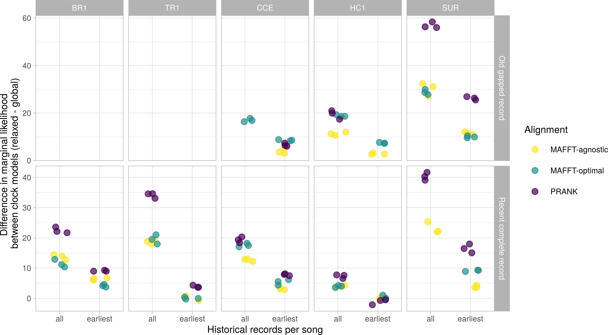
Figure 3. Relative fit of relaxed and global clock models in phylogenetic inference of song evolution under the FBDP. The fit of alternative clock models was compared in five leks (BR1, TR1, HC1, CCE, and SUR) using marginal likelihood approximation. Two leks (BR1 and TR1) lacked deep historical data (no sampling "including oldest records") and three leks contained enough extant songs to estimate clock model fit using a BDP (without historical data).

Model reliabilty
Simulated data under our inference models accurately reflected certain features of most empirical data sets. Namely, the number of segregating and invariant sites, the maximum length of variable and invariant blocks and the minimum pairwise distance between sequences were generally in agreement between simulated and empirical data (Table 1; Fig. 4; Fig. S3-S32). The two measures of song element diversity (Watterson’s θ

334 and π), analogous to population genetic diversity, were reliably modeled with the exception of about a third
335 of the PRANK alignments, and four MAFFT-agnostic alignments, in which simulated data underestimated
336 diversity (Fig. 5; Fig. S23-S29). Consequently, several of these alignments also resulted in relatively low
337 values of Tajima’s D in simulated data, consistent with our models overestimating the effect of drift (Fig.
338 S30-32). Finally, the the maximum pairwise distance between sequences was the data feature most often in
339 conflict between simulated and empirical data sets (Fig. 6), and overall underestimated in simulated data
340 (Fig. S20-S22).
341 Discrepancies between empirical and simulated data were found in all leks and alignment strategies (Fig.
342 S3-S32). For the same lek and historical record, PRANK-TN93 alignments tended to result in relatively high
343 song-element diversity (π), in both empirical and simulated data sets. Nonetheless, such high song diversity
344 was often underestimated, while the strength of drift in these alignments was overestimated, particularly in
345 the TR1 lek (Fig. 5; Fig. S27-32). Similarly, where estimates of the maximum pairwise distance between
346 songs were highest, mainly in PRANK-TN93 and MAFFT-optimal alignments, such song divergence tended
347 to be underestimated (Fig. 6; Fig. S20-22).
348 Table 1. Summary of absolute model fit statistics obtained by comparing properties of empirical data to
349 posterior predictive data simulations.

Alignment | Historical record | Mean PPE | SD | Min | Max | Percent P-value > 0.05
MAFFT-agnostic | Old gapped | 0.63 | 0.79 | 0 | 3.23 | 0.97
MAFFT-agnostic | Recent complete | 0.82 | 0.86 | 0 | 3.94 | 0.91
MAFFT-agnostic | None | 0.53 | 0.55 | 0 | 2.10 | 1.00
MAFFT-optimal | Old gapped | 0.95 | 0.84 | 0 | 3.09 | 0.95
MAFFT-optimal | Recent complete | 0.85 | 0.83 | 0 | 3.93 | 0.88
MAFFT-optimal | None | 1.05 | 0.74 | 0 | 2.89 | 0.96
PRANK-TN93 | Old gapped | 1.00 | 0.87 | 0 | 4.37 | 0.92
PRANK-TN93 | Recent complete | 0.81 | 0.88 | 0 | 4.06 | 0.93
PRANK-TN93 | None | 1.36 | 1.04 | 0 | 3.68 | 0.70

350 Treespace congruence
351 The spread of the topological space increased when including all historical records (effect size: 0.031,
352 uncertainty interval (UI): 0.023 - 0.040) and when including fossils (effect size: 0.012, UI: 0.005 - 0.019), but

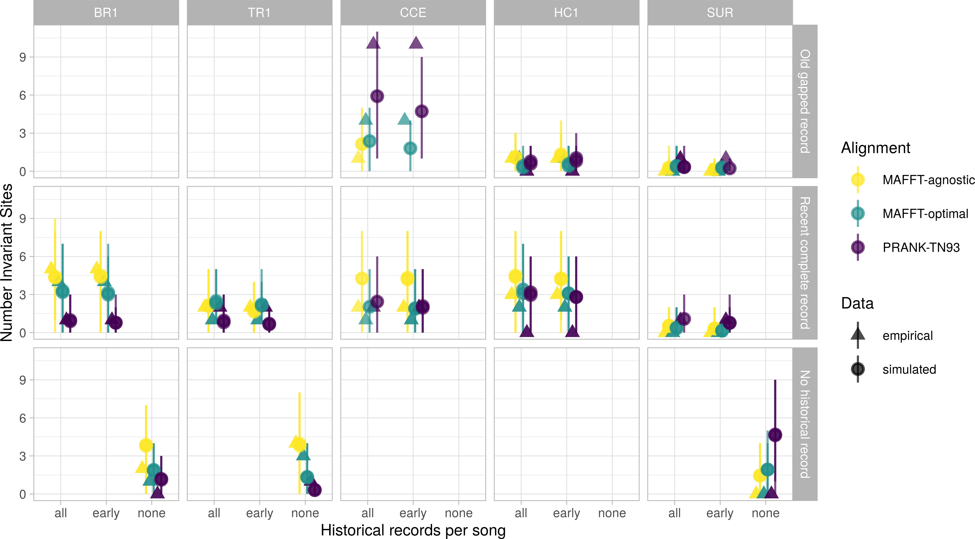
Figure 4. Number of invariant sites in empirical song data and posterior predictive data simulations (see Methods). For simulated data, we report the mean and 95% HPD interval of 1500 (BR1, TR1, HC1) or 3000 (CCE and SUR) simulations.
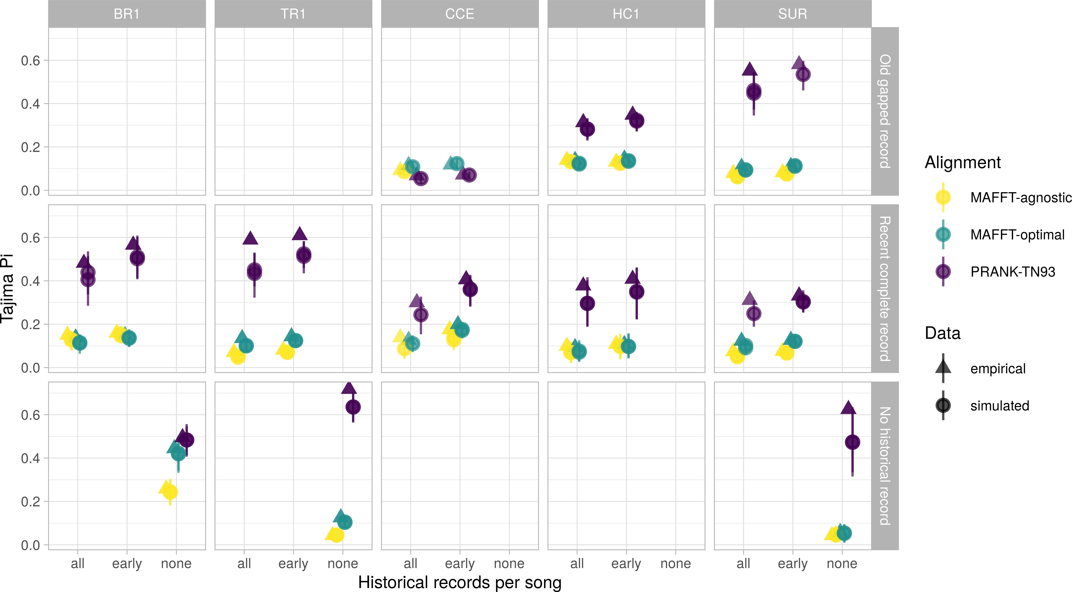
Figure 5. Song element diversity (π) in empirical song data and posterior predictive data simulations (see Methods). For simulated data, we report the mean and 95% HPD interval of 1500 (BR1, TR1, HC1) or 3000 (CCE and SUR) simulations.

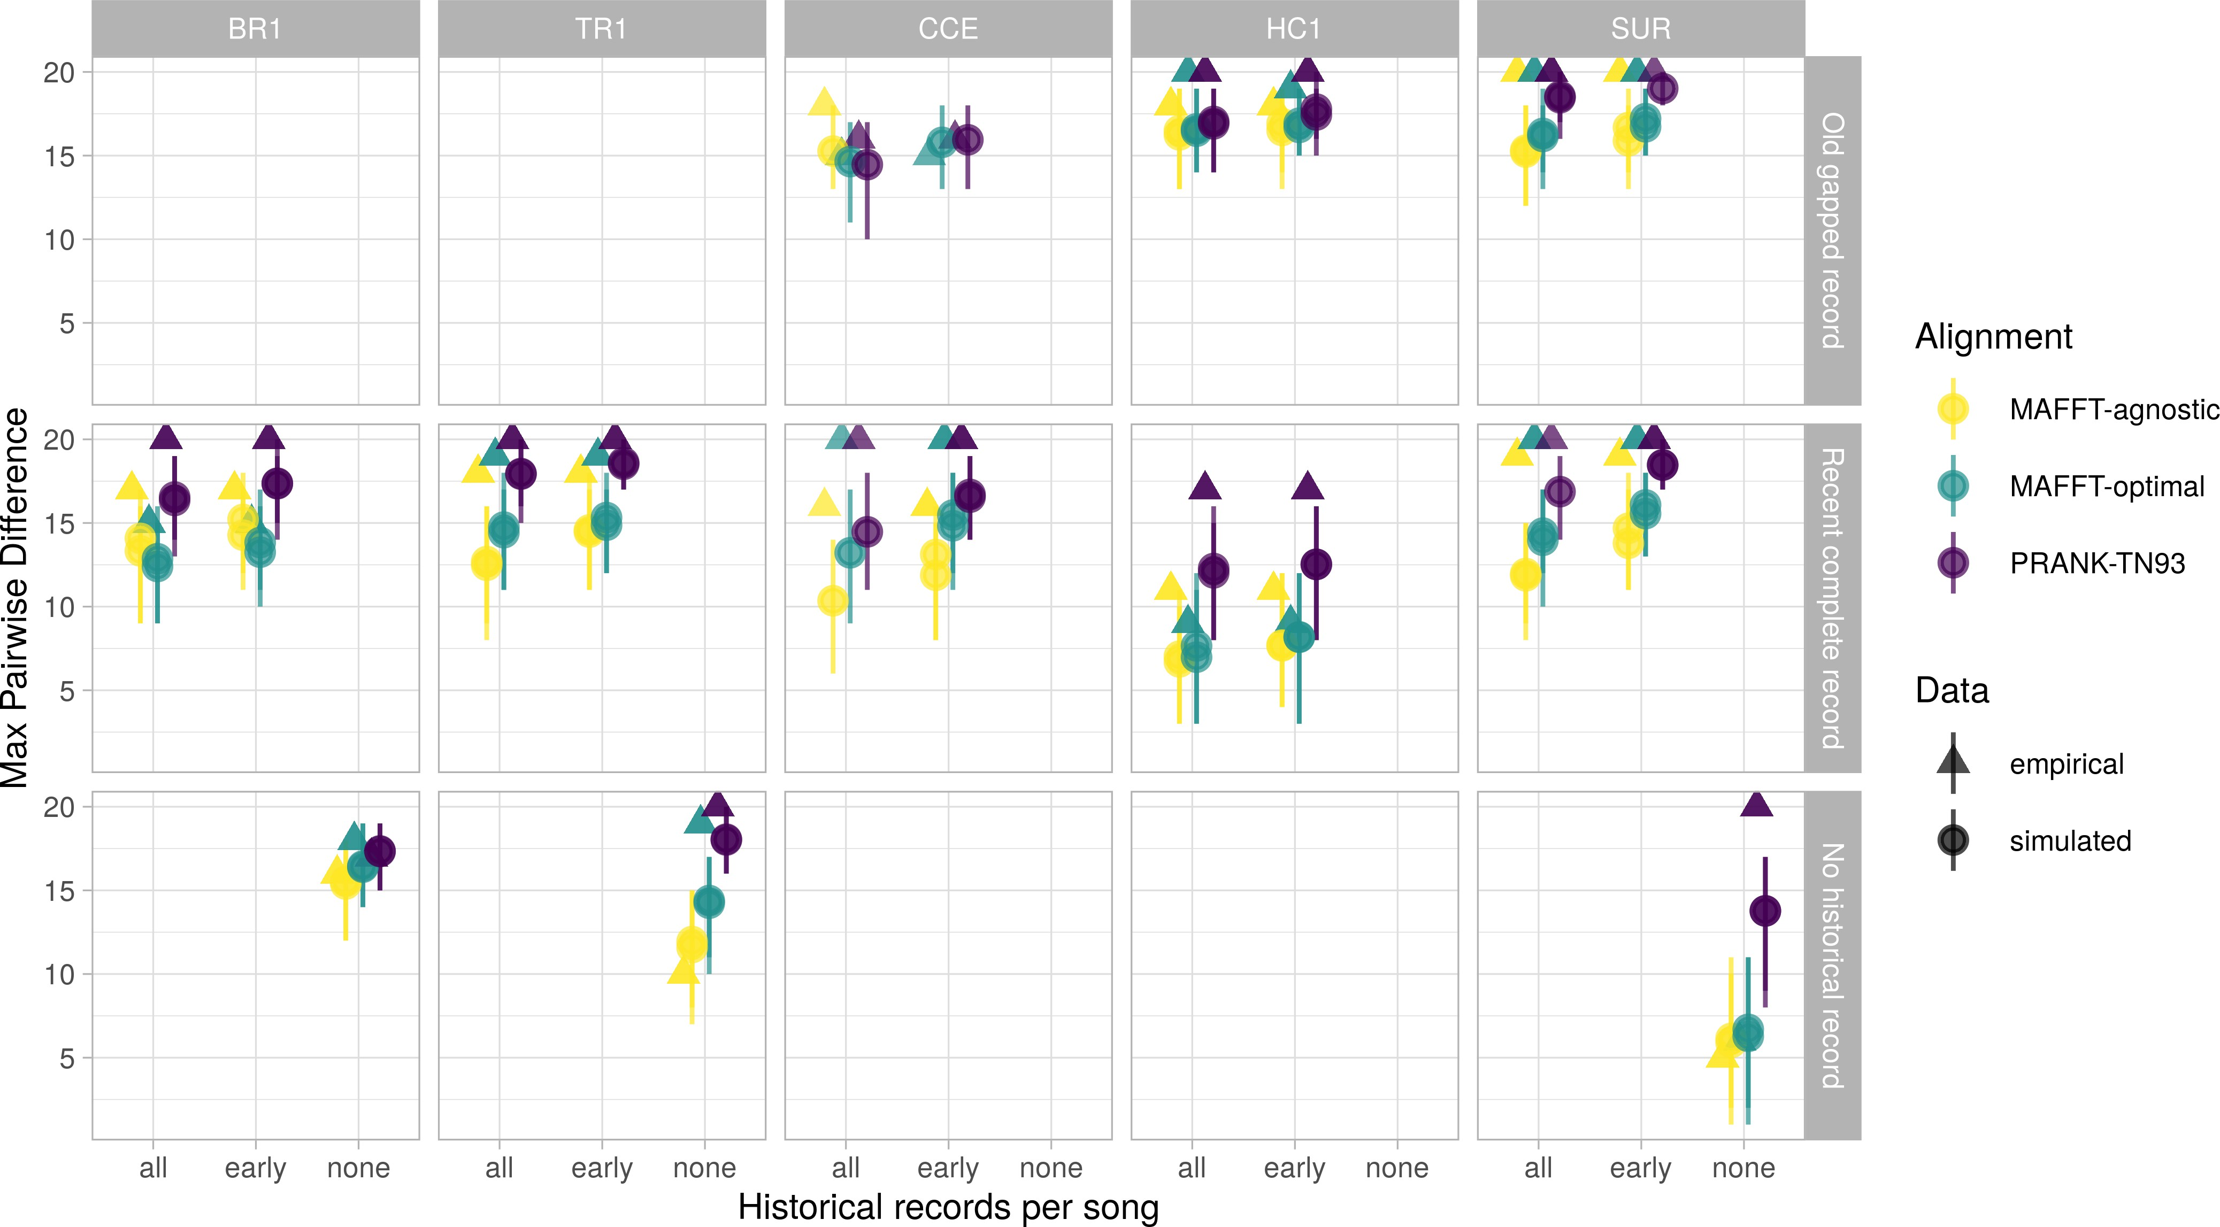
Figure 6. Maximum pairwise distance between songs in empirical song data and posterior predictive data simulations (see Methods). For simulated data, we report the mean and 95% HPD interval of 1500 (BR1, TR1, HC1) or 3000 (CCE and SUR) simulations.

353 was not affected by the use of different clock models (effect size: -0.002, UI: -0.009 - 0.005). For the alignment
354 strategy only the MAFFT-optimal alignment increased the spread of the topological space compared to
355 the PRANK-TN93 alignment (effect size: -0.009, UI: -0.018 - 0.000) no other differences in space size were
356 detected between alignment strategies (PRANK-TN93 VS MAFFT-agnostic, effect size: -0.005, UI:-0.014 -
357 0.003; MAFFT-optimal VS MAFFT-agnostic, effect size: 0.004, UI: -0.005 - 0.013). The dissimilarity of the
358 topological space between models increased by the inclusion of all historical records (effect size: 0.174, UI: 0.130
359 - 0.224) and fossils (effect size: 0.176, UI: 0.119 - 0.235), but not by the use of different clock models (effect
360 size: 0.030, UI: -0.015 - 0.076). The PRANK-TN93 alignment increased topological space dissimilarity when
361 compared to both MAFFT-optimal (effect size: 0.102, UI: 0.045 - 0.159) and MAFFT-agnostic alignments
362 (effect size: 0.110, UI: 0.043 - 0.180), but did not differ between the MAFFT alignments (effect size: 0.008,
363 UI: -0.049 - 0.067).

364 Diversification dynamics
365 Diversification rates and divergence times were sensitive to historical information. In the three leks in
366 which analyses without fossils could be conducted (BR1, TR1, SUR), fossil-free inference resulted in much
367 slower speciation and extinction rates and markedly uncertain root ages, in comparison to analyses including

368

369

370

371

372

373

374

375

376

377

378

379

380

381

382
historical songs (Fig. 7; S33-S35). For the three leks in which a long but gapped historical record could be contrasted with a shorter but complete record (CCE, HC1, and SUR), the inclusion of more ancient records resulted in older crown and root age estimates ( Fig. 7; S33-S35). In contrast, strong effects of alignment strategies were found in only two leks. In the largest lek (SUR), the PRANK-TN93 alignment led to a moderate decrease in speciation and extinction rate and a relatively strong increase in divergence times (Fig. 8). In the HC1 lek both the PRANK-TN93 and MAFFT-optimal alignments caused older crown age estimates (Fig. 8), compared to the MAFFT-agnostic alignment. Finally, sampling all historical occurrences, as opposed to only the earliest occurrence of each unique song, resulted in increased speciation and extinction rates and slightly more precise estimates of divergence times (Fig. 9; Fig. S36-S38).
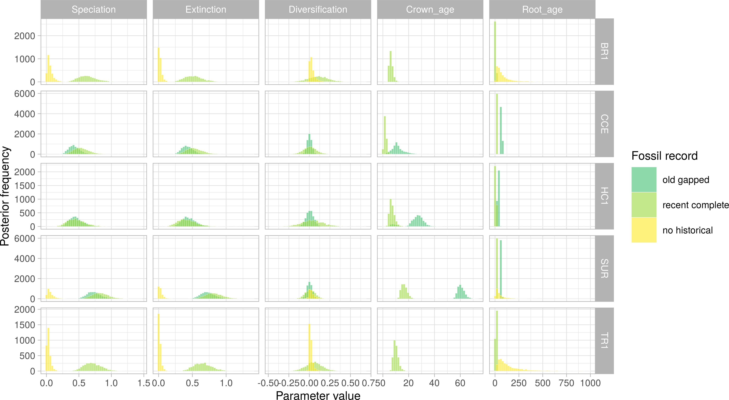
Figure 7. Age and diversification estimates under different sets of historical song records in five leks of the Long-billed Hermit. Histograms show posterior distributions of parameter estimates in models using a relaxed molecular clock and the PRANK-TN93 alignment strategy. For data sets including historical song records, all occurrences of such record are included in the analysis.

Discussion
Many researchers view cultural change as a process akin to organic evolution [REF]. However, a basic prediction of this parallel has largely evaded scrutiny. We typically do not know if evolutionary models and especially phylogenetic models applied to cultural change capture the most prominent features of this process, resulting absolute fit to cultural data [REF exceptions?]. Here, we address this question using the socially learnt songs of the Long-billed Hermit in multiple independent leks, and a phylogenetic model, the fossilized

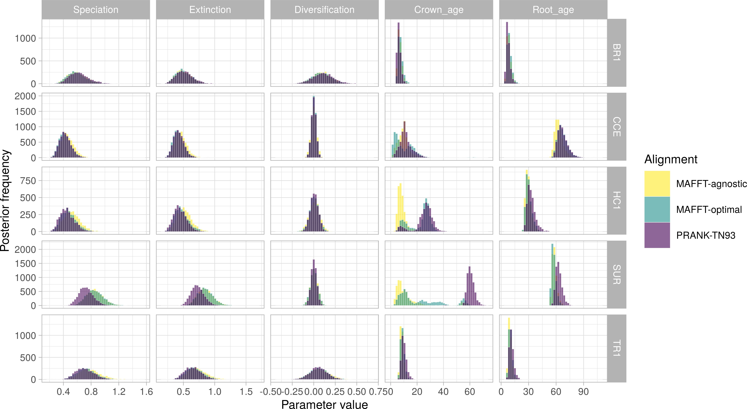
Figure 8. Age and diversification estimates under different alignment strategies in five leks of the Long-billed Hermit. Histograms show posterior distributions of parameter estimates in models using a relaxed molecular clock and all historical records. All available historical records are included in the analysis.
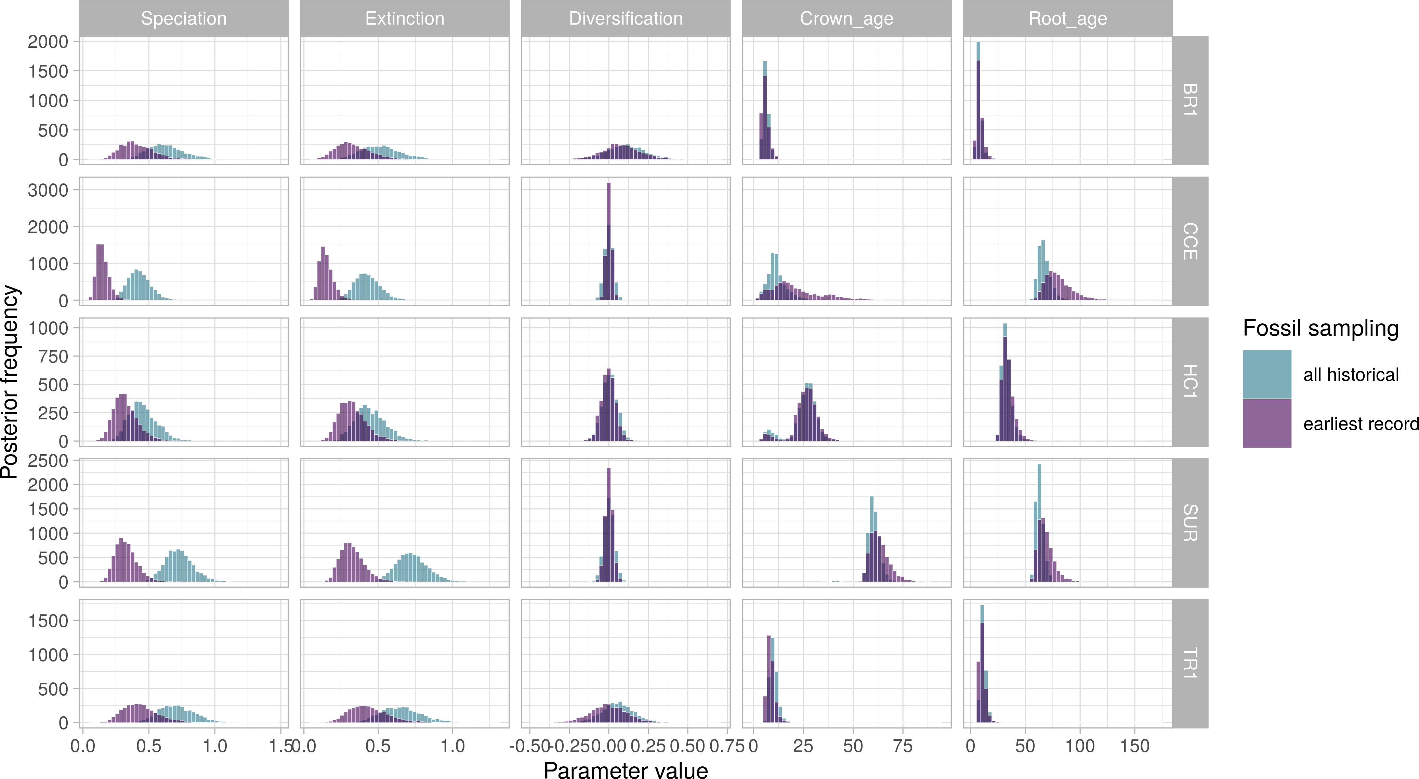
Figure 9. Age and diversification estimates of songs in five leks of the Long-billed Hermit. Histograms show posterior distributions of parameter estimates in models using a relaxed molecular clock and the PRANK-TN93 alignment strategy. We compare analyses using all occurrences of historical songs, including identical songs sampled serially, and analyses including each unique song at its earliest occurrence.

383 birth-death process, that is particularly suitable for serially-sampled data. We found that these phylogenetic
384 models are overall reliable, although they tend to underestimate song element diversity and song divergence
385 in some scenarios. We also asked how the historical song record, analogous to the fossil record, and alignment
386 strategies, ported from molecular phylogenetics, influence parameter estimation. In line with theoretical
387 expectations [REF Heath?], inclusion of historical data resulted in more precise root-age estimates (Fig.
388 7), a higher rate of lineage divergence (“speciation”) and extinction (Fig. 7). Our analyses with historical
389 song records also lent support for heterogeneous branch rates (Fig. 3). If available, older historical records
390 prompted deeper divergence times (Fig. 7). On the other hand, alignment strategies had very strong effects
391 on tree topology (Fig. ?), and weak to moderate effects on diversification dynamics (Fig. 8).
392 Posterior predictive simulations suggested that the FBDP is a plausible model for cultural change in the
393 Long-billed Hermit. Nearly 90% of posterior predictive effect sizes (PPEs) between empirical and simulated
394 data under the FBDP were below 2.00 (mean PPE = 0.84, sd = 0.85, min = 0, max = 4.37; Table 1).
395 Moreover, only one scenario, in which all historical records were excluded (SUR, PRANK-TN93 alignment),
396 produced consistent evidence for model inadequacy in data-based posterior predictive checks (Fig. S3-S32).
397 Even though tests of model adequacy are important safeguards against estimation biases (Carstens et al.
398 2022), tools for their implementation in Bayesian phylogenetics are relatively new [REFs incl Hohna 2018 and
399 some Duchene]. To our knowledge, these tools have been advocated [BEAST REf] but not yet utilized in
400 cultural phylogenetics [but see REFs for other models of cultural evolution]. When applied to molecular and
401 morphological phylogenetics, posterior predictive checks often reveal a wide range of model fits, depending on
402 the locus (or trait) and clade analyzed (Richards et al. 2018; May et al. 2021; Khouri et al. 2022). We were
403 therefore surprised to find that FBD models were similarly adequate in most of our data sets, ranging from
404 8 ‘taxa’ (TR1 without historical records) to 100 ‘taxa’ (SUR with all available records). Nonetheless, our
405 phylogenetic models failed to reproduce some diversity features of the data (π and Tajima’s D) in data sets in
406 which such diversity was relatively high. Interestingly, the main source of variation in song-element diversity
407 was not the lek identity or the use of historical data, but the alignment strategy (Fig. 5). Phylogenetically
408 informed PRANK-TN93 alignments were generally more compact (Table S1), thus increasing the average
409 number of mismatched positions in song alignments, and thus also increasing π and Tajima’s D, but reducing
410 model fit, compared to MAFFT strategies.
411 In addition to some measures of model adequacy, alignment strategies strongly influenced tree topology (Fig.
412 ?) and age estimates for the ancestor of extant taxa, in the two leks with deeper historical records (Fig. SUR
413 and CCE). In leks with historical records that spanned multiple decades (SUR, CCE, HC1), topologies based
414 on PRANK-TN93 data were markedly distinct from topologies based on phylogenetically naive MAFFT

415 alignments (Fig ?). In smaller leks with more shallow historical records (BR1 and TR1), the two alignment
416 strategies that enforced a lower substitution rate between vibratory and tonal sounds (PRANK-TN93 and
417 MAFFT-optimal) resulted in relatively similar topologies (Fig ?). In a recent study that compared alternative
418 MSA programs for ancestral protein sequence reconstruction, variations of PRANK and MAFFT algorithms
419 had the highest overall performance (Vialle et al. 2018). However, the two methods were affected in different
420 ways by the underlying substitution process and characteristics of the tree (Vialle et al. 2018). Because leks
421 evolve independently, diverse cultural substitution processes and varying tree topologies are also expected to
422 result in a mixture of alignment performance even within a single species. Our conflicting results between
423 alignment strategies thus underscore a foremost challenge for cultural phylogenetics with behavioral sequences:
424 establishing homology in sequence subunits.
425 In most phylogenetic analyses, a multiple sequence alignment is treated as an observation, and alignment
426 uncertainty is ignored (REF bali-phy for an exception). However, for phenotypic sequences establishing
427 homology can be a daunting challenge, even when characters are unambiguously coded [Caetano REF].
428 Furthermore, because culture can change independently of genetic evolution [REF], guiding phenotypic
429 sequence alignments with independently estimated molecular trees might be problematic. Comparing
430 alternative alignment strategies across multiple cultural data sets as we have done here, is a step towards
431 understanding the robustness of cultural phylogenetic analyses. However, as for phylogenetic models,
432 developing tools to assess the adequacy of alignment methods is crucial for a broader application of phylogenetic
433 approaches to cultural sequences. In the case of socially learnt bird songs, alignment methods can be informed
434 by a growing mechanistic understanding of learning, sound production and song function [REFs]. In humans,
435 alignment methods have been tailored to particular cultural domains and used to identify large-scale patterns
436 in melody evolution (Savage et al. 2022) and to resolve deep ancestral relationships between language
437 families (Jäger 2015). In addition to developing specific alignment approaches for different cultural domains,
438 phylogenetic methods that incorporate alignment uncertainty can be implemented to reduce biases in homology
439 hypotheses of behavioural sequences (Caetano and Beaulieu 2020).
440 Our analyses of socially learnt bird songs make three further assumptions, dictated by the phylogenetic
441 models we sought to apply. First, we discretised song spectrograms of variable duration (X - Xs) into 20
442 characters, each belonging to one of six categories. This conveniently allowed us to model song evolution
443 as a substitution process, and was justified by the distinctiveness sound categories and high repeatability
444 of character coding (Fig. Supporting text?). However, focusing on substitutions may obscure some and
445 perhaps important? cultural changes in song composition. When learning birds modify their song template
446 by extending or contracting particular segments, these changes will introduce indels in the alignment which

447 do not contribute to the modelled evolutionary process. We could use a sentence here about how

448 common these changes in song length are, both on LBH and other birds to then say something
449 about how big of an issue this could be.
450 Second, we assumed that song elements along a sequence evolve independently of one another. Mechanical,
451 cognitive and functional constraints on song sequence my falsify this assumption. For example, it is likely
452 that if a bird slows down the first trill of a series of consecutive trills, subsequent trills will also be replaced
453 as biological reason and REF here if there is one. Similarly, rapid alternations between tonal and
454 vibratory sounds may be strenuous [REF if this makes any sense], thus biasing substitution rates based
455 on the identity of nearby sites. The consequences of such site epistasis have been studied mainly in the
456 context of protein evolution, where structure and function generate coevolutionary dynamics among sites
457 [REFs]. In protein evolution, incorrectly assuming site independence can result in biased estimation of
458 site-wise substitution rates [REF], with potential consequences for ancestral sequence reconstruction, clock
459 rate estimation and topological inference. Properties of songs and other behavioral sequences that arise from
460 interactions between subunits may create transmission biases for particular subunit combinations [REF?],
461 potentially resulting in model mispecification of traditional substitution models. Evolutionary models that
462 relax the assumption of site independence may thus also be of applicability for cultural phylogenetics.
463 Finally, our study assumes that songs diversify in a tree-like manner, with no horizontal transfer. For the
464 Long-billed Hermit system, this means that juvenile males introduce changes on their learning templates,
465 independently of other songs that they may have heard in the same lek. We do not know if males of the
466 Long-billed Hermit indeed copy and potentially modify a sing song template, or if new songs can and are
467 often formed by combining elements from multiple templates. Maybe a sentence here about what we
468 do know about the learning process. Nonetheless, it is possible that cultural phylogenetic models are
469 robust to a degree of horizontal transfer, as suggested by the relatively high absolute fit of these models
470 to song data (Table 1). An early study based on cladistics showed that data sets across different cultural
471 domains had a similar fit to a tree-like diversification process as biological data sets [REF Collard]. Further
472 assessments of the robustness of cultural phylogenetics to observed levels of horizontal transfer and reticulate
473 evolution are warranted, as well as the exploration of recently developed methods that can accommodate
474 such processes [REF to that french paper].
475 Culture can change rapidly compared to morphology [REF]. Thus, cultural phylogenetics studies can often tap
476 on a relatively rich historical record, obtained from archeological preservation (in humans) or from longitudinal
477 studies. Historical records in our longitudinal sampling of Long-billed Hermit songs have some advantages
478 over traditional fossils, such as complete character sequences and no stratigraphic uncertainty. Our study also

479 shares some of the challenges of phylogenetic inference with fossils, like time-heterogeneous preservation. We
480 thus expected that historical song records would impact estimates of node ages and diversification rates to at
481 least the same extent as total-evidence approaches under the FBDP influence the same parameters in organic
482 lineages. We found that incorporating historical data resulted in more precise root age estimates, as seen
483 across total-evidence dating analyses under the FBDP [REFs to Total evidence]. Furthermore, by sampling
484 ancestral lineages that formed and went extinct before the present, the historical song record also accelerated
485 estimates of both speciation and extinction, but without effects on net diversification (Fig. 7). Our results
486 therefore suggest that unlike organic evolution, which typically follows a trend of increasing diversity over
487 time, social factors, such as sexual selection and kin recognition, may impose net-zero diversification in stable
488 cultural systems [REF?].
489 We were also interested in understanding how decisions on how to use available historical records would
490 impact estimation of node ages. We found that including older but sporadically sampled records resulted in
491 older estimates of crown and root ages for all leks with such data (CCE, HC1 and SUR; Fig. 7). In contrast,
492 accounting for all historical occurrences, including identical sequences sampled on different years, increased
493 only the precision of age estimates (crown and origin) in the two largest leks (CCE and SUR; Fig. 9). In
494 fact, the main consequence of using all historical occurrences was to increase support for a relaxed clock
495 model (Fig. 3), as clock rates must differ between branches separating identical songs and branches in which
496 substitutions occurred.
497 Simulation studies show that accounting for all possible fossil occurrences [REF OReily] and sampling fossils at
498 regular time intervals [REF 2020Sim] bolster the accuracy of phylogenetic inference of organic evolution under
499 the FBDP. These sampling practices, especially the latter, may be prohibitive for some organic clades. Here,
500 we based our analyses on pre-existing data, most of which was collected before the methods we used were even
501 developed. However, future cultural phylogenetics studies based on longitudinal data can incorporate these
502 best sampling strategies in their design, and more systematically assess how the availability and regularity of
503 historical records impact age estimates of cultural lineages.

504 Conclusions

505 Acknowledgements
506 . . . B.W. is funded by an International Postdoc Grant (2019-06444) from the Swedish Research Council
507 (Vetenskaprådet). . . UCR (VI) project. . .

508 Author contributions
509 B.W. and M.S.A. conceived the study. M.S.A. collected the data with support from A.R.G.. M.S.A.
510 and B.W. analyzed the data and wrote the manuscript with contributions from A.R.G..

511 References
512 Aplin L.M. 2019. Culture and cultural evolution in birds: A review of the evidence. Animal Behaviour.
513 147:179–187.
514 Araya-Salas M., Odom K. 2022. PhenotypeSpace: An r package to quantify and compare phenotypic trait
515 spaces.
516 Araya-Salas M., Smith-vidaurre G., Mennill D.J., Cahill J., Gonzalez-Gomez P.L., Wright T.F. 2019. Social
517 group signatures in hummingbird displays provide evidence of co-occurrence of vocal and visual learning.
518 Proceedings of the Royal Society B: Biological Sciences. 286.
519 Araya-Salas M., Wright T. 2013. Open-ended song learning in a hummingbird. Biology Letters. 9:20130625.
520 Boyd R., Richerson P.J. 1985. Culture and the Evolutionary Process. Chicago: The University of Chicago
521 Press.
522 Bromham L., Duchêne S., Hua X., Ritchie A.M., Duchêne D.A., Ho S.Y.W. 2018. Bayesian molecular dating:
523 Opening up the black box. Biological Reviews. 93:1165–1191.
524 Bürkner P.-C. 2017. Bayesian Distributional Non-Linear Multilevel Modeling with the R Package brms.
525 arXiv.:1705.11123.
526 Caetano D.S., Beaulieu J.M. 2020. Comparative analyses of phenotypic sequences using phylogenetic trees.
527 The American Naturalist. 195:E38–E50.
528 Carpenter B., Gelman A., Hoffman M.D., Lee D., Goodrich B., Betancourt M., Brubaker M., Guo J., Li P.,
529 Riddell A. 2017. Stan: A probabilistic programming language. Journal of Statistical Software. 76.
530 Carstens B.C., Smith M.L., Duckett D.J., Fonseca E.M., Thomé M.T.C. 2022. Assessing model adequacy
531 leads to more robust phylogeographic inference. Trends in Ecology & Evolution.
532 Catchpole C.K., Slater P.J.B. 2003. Bird song: Biological themes and variations. Cambridge: Cambridge
533 University Press.
534 Cavalli-Sforza L.L., Feldman M.W. 1981. Cultural transmission and evolution: A quantitative approach.
535 Princeton: Princeton University Press.
536 Chatzou M., Magis C., Chang J.-M., Kemena C., Bussotti G., Erb I., Notredame C. 2016. Multiple sequence
537 alignment modeling: Methods and applications. Briefings in Bioinformatics. 17:1009–1023.
538 Darwin C. 1871. The descent of man and selection in relation to sex. J. Murray.

539 Garland E.C., Rendell L., Lamoni L., Poole M.M., Noad M.J. 2017. Song hybridization events during
540 revolutionary song change provide insights into cultural transmission in humpback whales. Proceedings of
541 the National Academy of Sciences. 114:7822–7829.
542 Gavryushkina A., Heath T.A., Ksepka D.T., Stadler T., Welch D., Drummond A.J. 2017. Bayesian total-
543 evidence dating reveals the recent crown radiation of penguins. Systematic biology. 66:57–73.
544 Gavryushkina A., Welch D., Stadler T., Drummond A.J. 2014. Bayesian inference of sampled ancestor trees
545 for epidemiology and fossil calibration. PLoS Computational Biology. 10:e1003919.
546 Gjesfjeld E., Chang J., Silvestro D., Kelty C., Alfaro M. 2016. Competition and extinction explain the
547 evolution of diversity in American automobiles. Palgrave Communications. 2:1–6.
548 Gjesfjeld E., Silvestro D., Chang J., Koch B., Foster J.G., Alfaro M.E. 2020. A quantitative workflow for
549 modeling diversification in material culture. PloS one. 15:e0227579.
550 Gray R.D., Greenhill S.J., Ross R.M. 2007. The pleasures and perils of Darwinizing culture (with phylogenies).
551 Biological Theory. 2:360–375.
552 Heath T.A., Huelsenbeck J.P., Stadler T. 2014. The fossilized birth–death process for coherent calibration of
553 divergence-time estimates. Proceedings of the National Academy of Sciences. 111:E2957–E2966.
554 Höhna S., Coghill L.M., Mount G.G., Thomson R.C., Brown J.M. 2018. P3: Phylogenetic posterior prediction
555 in RevBayes. Molecular Biology and Evolution. 35:1028–1034.
556 Höhna S., Landis M.J., Heath T.A., Boussau B., Lartillot N., Moore B.R., Huelsenbeck J.P., Ronquist F. 2016.
557 RevBayes: Bayesian phylogenetic inference using graphical models and an interactive model-specification
558 language. Systematic Biology. 65:726–736.
559 Holland S.M. 2016. The non-uniformity of fossil preservation. Philosophical Transactions of the Royal Society
560 B: Biological Sciences. 371:20150130.
561 Jäger G. 2015. Support for linguistic macrofamilies from weighted sequence alignment. Proceedings of the
562 National Academy of Sciences. 112:12752–12757.
563 Jesmer B.R., Merkle J.A., Goheen J.R., Aikens E.O., Beck J.L., Courtemanch A.B., Hurley M.A., McWhirter
564 D.E., Miyasaki H.M., Monteith K.L., others. 2018. Is ungulate migration culturally transmitted? Evidence
565 of social learning from translocated animals. Science. 361:1023–1025.
566 Katoh K., Misawa K., Kuma K., Miyata T. 2002. MAFFT: A novel method for rapid multiple sequence
567 alignment based on fast Fourier transform. Nucleic acids research. 30:3059–3066.
568 Katoh K., Standley D.M. 2013. MAFFT multiple sequence alignment software version 7: Improvements in
569 performance and usability. Molecular Biology and Evolution. 30:772–780.
570 Kershenbaum A., Blumstein D.T., Roch M.A., Akçay C., Backus G., Bee M.A., Bohn K., Cao Y., Carter G.,
571 Cäsar C., Coen M., Deruiter S.L., Doyle L., Edelman S., Ferrer-i-Cancho R., Freeberg T.M., Garland

572 E.C., Gustison M., Harley H.E., Huetz C., Hughes M., Hyland Bruno J., Ilany A., Jin D.Z., Johnson
573 M., Ju C., Karnowski J., Lohr B., Manser M.B., Mccowan B., Mercado E., Narins P.M., Piel A., Rice
574 M., Salmi R., Sasahara K., Sayigh L., Shiu Y., Taylor C., Vallejo E.E., Waller S., Zamora-Gutierrez V.,
575 Akçay Ç., Backus G., Bee M.A., Bohn K., Cao Y., Carter G., Cäsar C., Coen M., Deruiter S.L., Doyle
576 L., Edelman S., Ferrer-i-Cancho R., Freeberg T.M., Garland E.C., Gustison M., Harley H.E., Huetz C.,
577 Hughes M., Hyland Bruno J., Ilany A., Jin D.Z., Johnson M., Ju C., Karnowski J., Lohr B., Manser
578 M.B., Mccowan B., Mercado E., Narins P.M., Piel A., Rice M., Salmi R., Sasahara K., Sayigh L., Shiu
579 Y., Taylor C., Vallejo E.E., Waller S., Zamora-Gutierrez V., Akçay C., Backus G., Bee M.A., Bohn K.,
580 Cao Y., Carter G., Cäsar C., Coen M., Deruiter S.L., Doyle L., Edelman S., Ferrer-i-Cancho R., Freeberg
581 T.M., Garland E.C., Gustison M., Harley H.E., Huetz C., Hughes M., Hyland Bruno J., Ilany A., Jin D.Z.,
582 Johnson M., Ju C., Karnowski J., Lohr B., Manser M.B., Mccowan B., Mercado E., Narins P.M., Piel A.,
583 Rice M., Salmi R., Sasahara K., Sayigh L., Shiu Y., Taylor C., Vallejo E.E., Waller S., Zamora-Gutierrez
584 V., Akçay Ç., Backus G., Bee M.A., Bohn K., Cao Y., Carter G., Cäsar C., Coen M., Deruiter S.L., Doyle
585 L., Edelman S., Ferrer-i-Cancho R., Freeberg T.M., Garland E.C., Gustison M., Harley H.E., Huetz C.,
586 Hughes M., Hyland Bruno J., Ilany A., Jin D.Z., Johnson M., Ju C., Karnowski J., Lohr B., Manser
587 M.B., Mccowan B., Mercado E., Narins P.M., Piel A., Rice M., Salmi R., Sasahara K., Sayigh L., Shiu Y.,
588 Taylor C., Vallejo E.E., Waller S., Zamora-Gutierrez V. 2016. Acoustic sequences in non-human animals:
589 A tutorial review and prospectus. Biological Reviews. 91:13–52.
590 Khouri Z., Gillung J.P., Kimsey L.S. 2022. The evolutionary history of mammoth wasps (Hymenoptera:
591 Scoliidae). BioRxiv.
592 Kidwell S.M., Holland S.M. 2002. The quality of the fossil record: Implications for evolutionary analyses.
593 Annual Review of Ecology and Systematics. 33:561–588.
594 Laland K.N., Hoppitt W. 2003. Do animals have culture? Evolutionary Anthropology: Issues, News, and
595 Reviews: Issues, News, and Reviews. 12:150–159.
596 Laland K.N., Williams K. 1997. Shoaling generates social learning of foraging information in guppies. Animal
597 Behaviour. 53:1161–1169.
598 Ligon R.A., Diaz C.D., Morano J.L., Troscianko J., Stevens M., Moskeland A., Laman T.G., Scholes E. 2018.
599 Evolution of correlated complexity in the radically different courtship signals of birds-of-paradise. PLOS
600 Biology. 16:e2006962.
601 Löytynoja A. 2012. Alignment Methods: Strategies, Challenges, Benchmarking, and Comparative Overview.
602 In: Anisimova M., editor. Evolutionary genomics: Statistical and computational methods, volume 1.
603 Totowa, NJ: Humana Press. p. 203–235.
604 Löytynoja A., Goldman N. 2005. An algorithm for progressive multiple alignment of sequences with insertions.

605 Proceedings of the National Academy of Sciences of the United States of America. 102:10557–10562.
606 Löytynoja A., Goldman N. 2008. Phylogeny-aware gap placement prevents errors in sequence alignment and
607 evolutionary analysis. Science. 320:1632–1635.
608 Luncz L.V., Boesch C. 2014. Tradition over trend: Neighboring chimpanzee communities maintain differences
609 in cultural behavior despite frequent immigration of adult females. American Journal of Primatology.
610 76:649–657.
611 Lunter G., Miklós I., Drummond A., Jensen J.L., Hein J. 2005. Bayesian coestimation of phylogeny and
612 sequence alignment. Bmc Bioinformatics. 6:1–10.
613 Luo A., Duchêne D.A., Zhang C., Zhu C.-D., Ho S.Y.W. 2020. A simulation-based evaluation of tip-dating
614 under the fossilized birth–death process. Systematic Biology. 69:325–344.
615 Lutzoni F., Wagner P., Reeb V., Zoller S. 2000. Integrating ambiguously aligned regions of DNA sequences
616 in phylogenetic analyses without violating positional homology. Systematic Biology. 49:628–651.
617 May M.R., Contreras D.L., Sundue M.A., Nagalingum N.S., Looy C.V., Rothfels C.J. 2021. Inferring the
618 total-evidence timescale of marattialean fern evolution in the face of model sensitivity. Systematic Biology.
619 70:1232–1255.
620 Mesoudi A. 2017. Pursuing Darwin’s curious parallel: Prospects for a science of cultural evolution. Proceedings
621 of the National Academy of Sciences. 114:7853–7860.
622 Morlon H. 2014. Phylogenetic approaches for studying diversification. Ecology Letters. 17:508–525.
623 Muff S., Nilsen E.B., O’Hara R.B., Nater C.R. 2021. Rewriting results sections in the language of evidence.
624 Trends in Ecology & Evolution.
625 Payne R.S., McVay S. 1971. Songs of humpback whales. Science. 173:585–597.
626 Perreault C. 2012. The pace of cultural evolution. PLoS One. 7:e45150.
627 Plummer M., Best N., Cowles K., Vines K. 2006. CODA: Convergence Diagnosis and Output Analysis for
628 MCMC. R News. 6:7–11.
629 R Core Team. 2021. R: A language and environment for statistical computing. Vienna, Austria: R Foundation
630 for Statistical Computing.
631 Rama T. 2018. Three tree priors and five datasets: A study of indo-european phylogenetics. Language
632 Dynamics and Change. 8:182–218.
633 Redelings B.D., Suchard M.A. 2005. Joint Bayesian estimation of alignment and phylogeny. Systematic
634 biology. 54:401–418.
635 Richards E.J., Brown J.M., Barley A.J., Chong R.A., Thomson R.C. 2018. Variation across mitochondrial
636 gene trees provides evidence for systematic error: How much gene tree variation is biological? Systematic
637 Biology. 67:847–860.

638 Ritchie A.M., Ho S.Y.W. 2019. Influence of the tree prior and sampling scale on bayesian phylogenetic
639 estimates of the origin times of language families. Journal of Language Evolution. 4:108–123.
640 Rivera-Cáceres K.D., Quirós-Guerrero E., Araya-Salas M., Searcy W.A. 2016. Neotropical wrens learn new
641 duet rules as adults. Proceedings of the Royal Society B: Biological Sciences. 283.
642 Robinson D.F., Foulds L.R. 1981. Comparison of phylogenetic trees. Mathematical Biosciences. 53:131–147.
643 Sagart L., Jacques G., Lai Y., Ryder R.J., Thouzeau V., Greenhill S.J., List J.-M. 2019. Dated language
644 phylogenies shed light on the ancestry of Sino-Tibetan. Proceedings of the National Academy of Sciences.
645 116:10317–10322.
646 Savage P.E., Passmore S., Chiba G., Currie T.E., Suzuki H., Atkinson Q.D. 2022. Sequence alignment of folk
647 song melodies reveals cross-cultural regularities of musical evolution. Current Biology. 32:1395–1402.
648 Schliep K.P. 2011. Phangorn: Phylogenetic analysis in R. Bioinformatics. 27:592–593.
649 Stadler T., Yang Z. 2013. Dating phylogenies with sequentially sampled tips. Systematic biology. 62:674–688.
650 Stiles F.G., Wolf L.L. 1979. Ecology and evolution of lek mating behavior in the long-tailed hermit
651 hummingbird. Ornithological Monographs. 27.
652 Tajima F. 1989. Statistical method for testing the neutral mutation hypothesis by DNA polymorphism.
653 Genetics. 123:585–595.
654 Ten Cate C. 2021. Re-evaluating vocal production learning in non-oscine birds. Philosophical Transactions of
655 the Royal Society B. 376:20200249.
656 Vialle R.A., Tamuri A.U., Goldman N. 2018. Alignment modulates ancestral sequence reconstruction accuracy.
657 Molecular Biology and Evolution. 35:1783–1797.
658 Warnow T. 2021. Revisiting Evaluation of Multiple Sequence Alignment Methods. Multiple sequence
659 alignment. Springer. p. 299–317.
660 Watterson G.A. 1975. On the number of segregating sites in genetical models without recombination.
661 Theoretical population biology. 7:256–276.
662 Whiten A., Horner V., De Waal F.B.M. 2005. Conformity to cultural norms of tool use in chimpanzees.
663 Nature. 437:737–740.
664 Wickham H. 2016. ggplot2: Elegant graphics for data analysis. Springer-Verlag New York.
665 Xie W., Lewis P.O., Fan Y., Kuo L., Chen M.-H. 2010. Improving marginal likelihood estimation for Bayesian
666 phylogenetic model selection. Systematic Biology. 60:150–160.
667 Yang Z., Rannala B. 2012. Molecular phylogenetics: Principles and practice. Nature Reviews Genetics.
668 13:303–314.
669 Yu G., Smith D., Zhu H., Guan Y., Lam T.T.-Y. 2017. ggtree: An R package for visualization and annotation
670 of phylogenetic trees with their covariates and other associated data. Methods in Ecology and Evolution.

671 1:28–36.
672 Zhang C., Stadler T., Klopfstein S., Heath T.A., Ronquist F. 2016. Total-evidence dating under the fossilized
673 birth–death process. Systematic Biology. 65:228–249.
674 Zhang H., Ji T., Pagel M., Mace R. 2020. Dated phylogeny suggests early neolithic origin of sino-tibetan
675 languages. Scientific reports. 10:1–8.

676 Supporting Material

677 Figure S1. Examples of songs and coding?

678 Supporting text 1
679 How do we arrive to 20 segments

680 Supporting text 2
681 Repeatability of sound classification
682 Figure S2. Main repeatability result.
683 Table S1. MCMC diganostics, add alignment legnth and no. of sequences to the table we have
684 Figures S3-S32. All model reliability results
685 Figures S33-S35. Histograms of age and diversification parameters per record type for all alignment strategies.
686 Figures S36-S38. Histograms of age and diversification parameters per sampling strategy for all alignment
687 strategies.

