Supplementary Figures
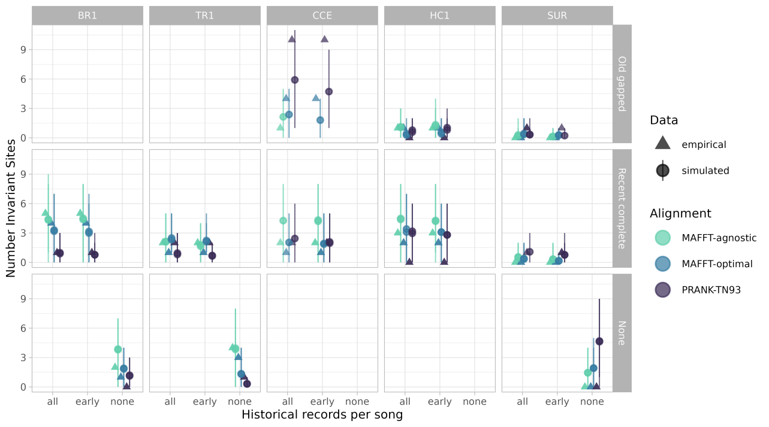
Figure S3. Number of invariant sites estimated from empirical and simulated data. Rows correspond to historical record configurations (Old gapped, Recent complete, and None), the x-axis indicates the treatment of repeated historical song observations (all occurrences, earliest occurrence only, or none), columns correspond to the five study leks (BR1, TR1, CCE, HC1, and SUR), colors indicate multiple sequence alignment strategies (MAFFT-agnostic, MAFFT-optimal, and PRANK-TN93), and symbols distinguish empirical (triangles) from simulated (circles) data. Error bars indicate 95% credible intervals.

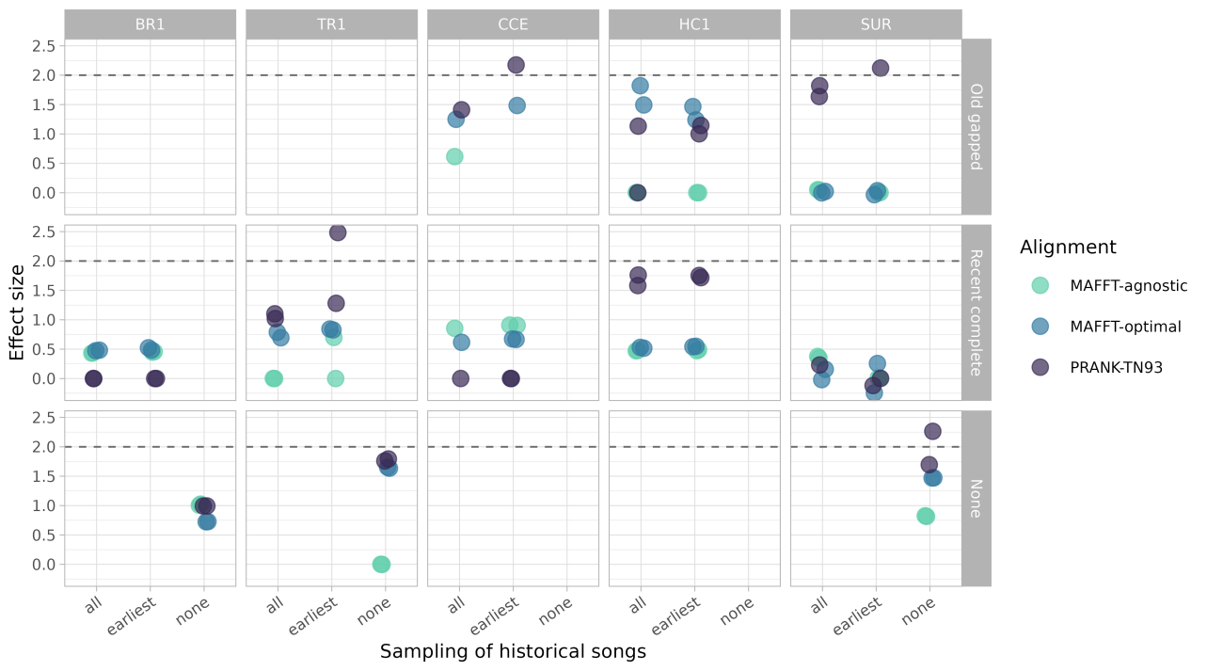
Figure S4. Effect sizes comparing empirical and simulated estimates of number of invariant sites. Rows correspond to historical record configurations (Old gapped, Recent complete, and None), the x-axis indicates the treatment of repeated historical song observations (all occurrences, earliest occurrence only, or none), columns correspond to the five study leks (BR1, TR1, CCE, HC1, and SUR), and colors indicate multiple sequence alignment strategies (MAFFT-agnostic, MAFFT-optimal, and PRANK-TN93). The dashed horizontal line indicates an effect size of 2.

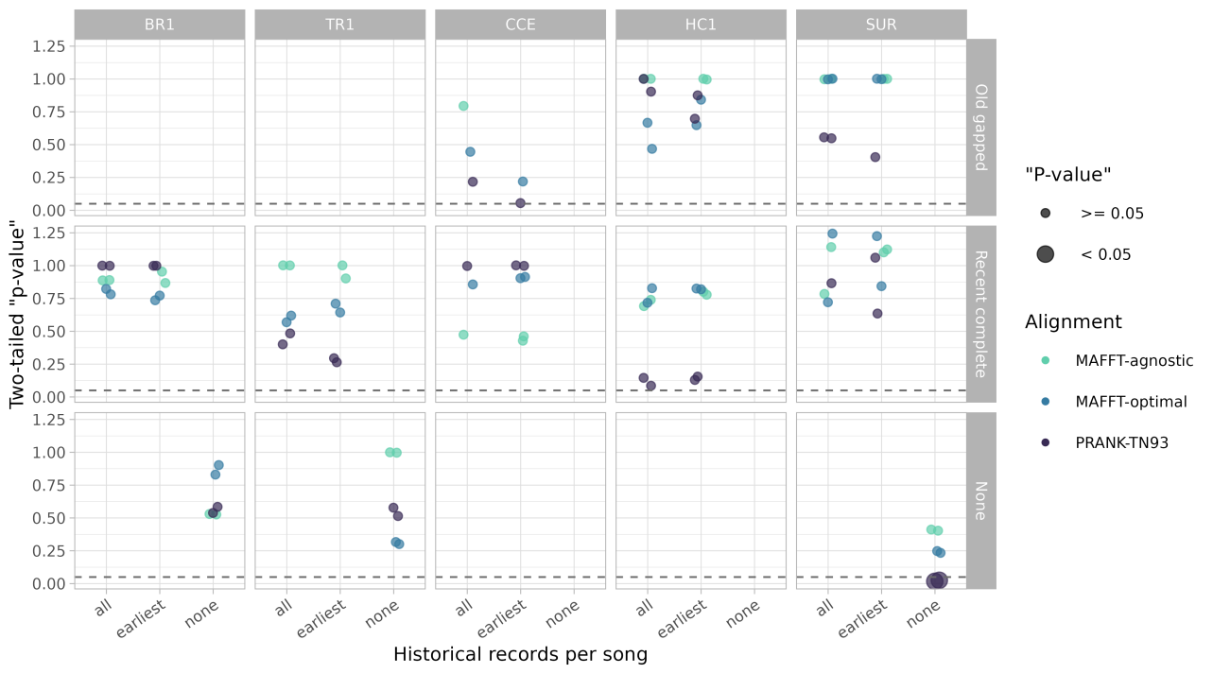
Figure S5. Two-tailed posterior predictive p-values comparing empirical and simulated estimates of number of invariant sites. Rows correspond to historical record configurations (Old gapped, Recent complete, and None), the x-axis indicates the treatment of repeated historical song observations (all occurrences, earliest occurrence only, or none), columns correspond to the five study leks (BR1, TR1, CCE, HC1, and SUR), colors indicate multiple sequence alignment strategies (MAFFT-agnostic, MAFFT-optimal, and PRANK-TN93), and point size indicates whether posterior predictive p-values are significant (< 0.05). The dashed horizontal line indicates p = 0.05.

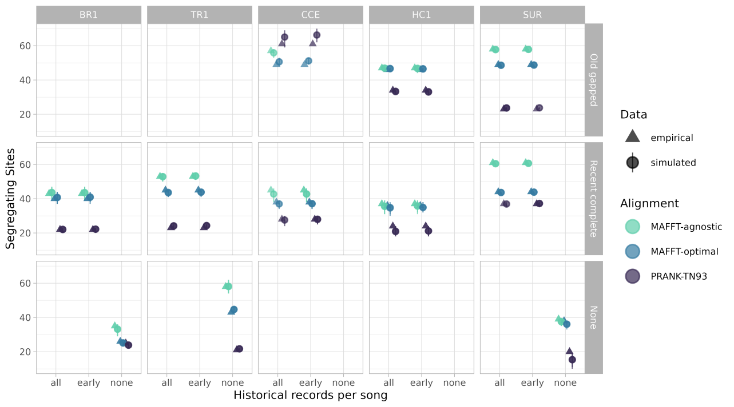
Figure S6. Number of segregating sites estimated from empirical and simulated data. Rows correspond to historical record configurations (Old gapped, Recent complete, and None), the x-axis indicates the treatment of repeated historical song observations (all occurrences, earliest occurrence only, or none), columns correspond to the five study leks (BR1, TR1, CCE, HC1, and SUR), colors indicate multiple sequence alignment strategies (MAFFT-agnostic, MAFFT-optimal, and PRANK-TN93), and symbols distinguish empirical (triangles) from simulated (circles) data. Error bars indicate 95% credible intervals.

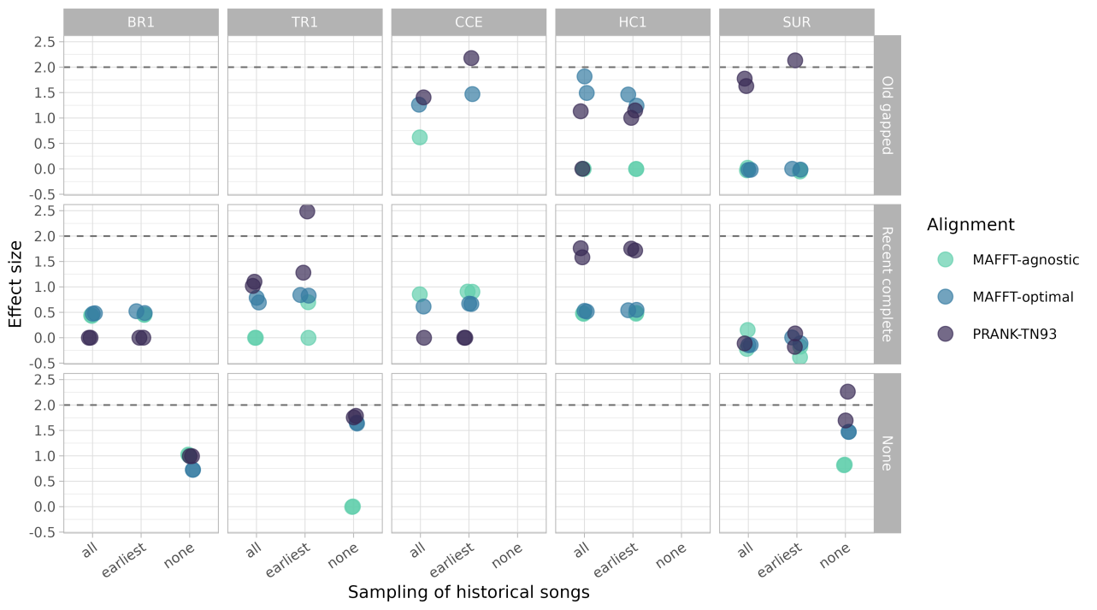
Figure S7. Effect sizes comparing empirical and simulated estimates of segregating sites. Rows correspond to historical record configurations (Old gapped, Recent complete, and None), the x-axis indicates the treatment of repeated historical song observations (all occurrences, earliest occurrence only, or none), columns correspond to the five study leks (BR1, TR1, CCE, HC1, and SUR), and colors indicate multiple sequence alignment strategies (MAFFT-agnostic, MAFFT-optimal, and PRANK-TN93). The dashed horizontal line indicates an effect size of 2.

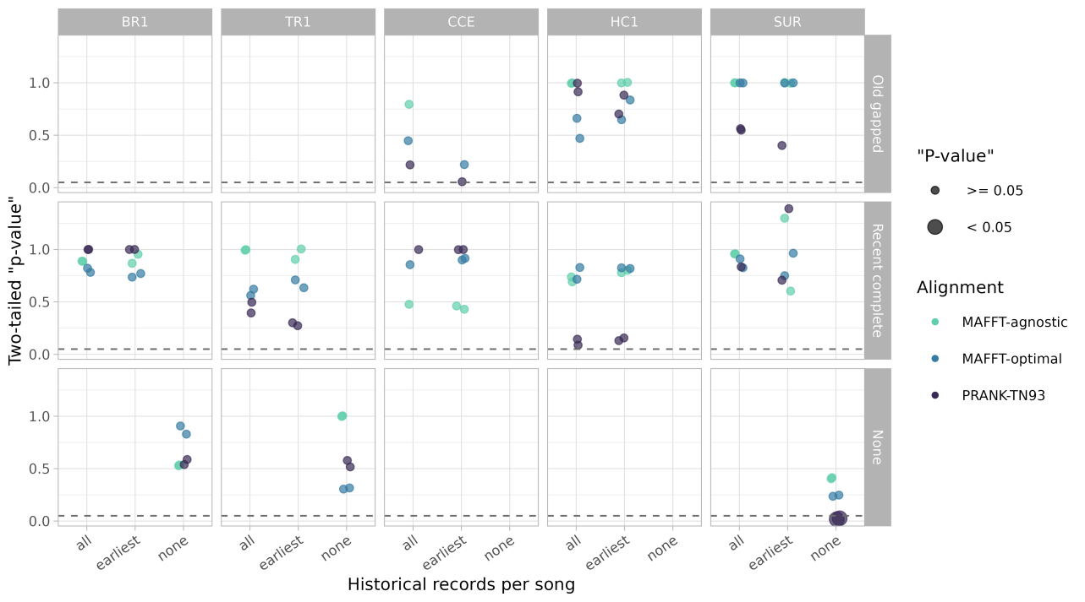
Figure S8. Two-tailed posterior predictive p-values comparing empirical and simulated estimates of segregating sites. Rows correspond to historical record configurations (Old gapped, Recent complete, and None), the x-axis indicates the treatment of repeated historical song observations (all occurrences, earliest occurrence only, or none), columns correspond to the five study leks (BR1, TR1, CCE, HC1, and SUR), colors indicate multiple sequence alignment strategies (MAFFT-agnostic, MAFFT-optimal, and PRANK-TN93), and point size indicates whether posterior predictive p-values are significant (< 0.05). The dashed horizontal line indicates p = 0.05.

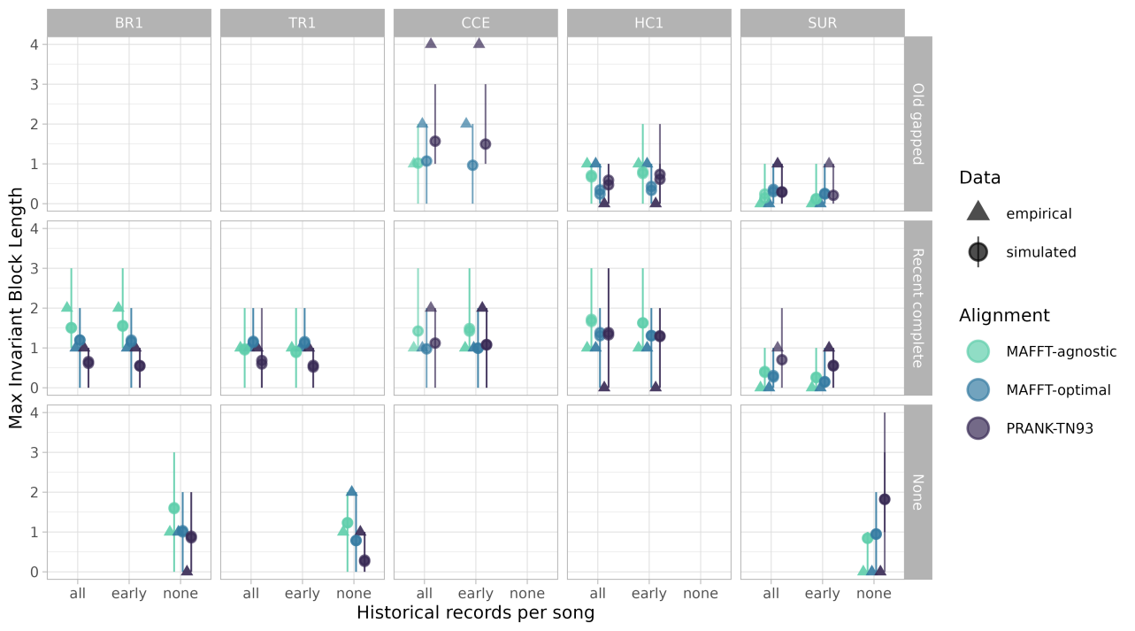
Figure S9. Maximum invariant block length estimated from empirical and simulated data. Rows correspond to historical record configurations (Old gapped, Recent complete, and None), the x-axis indicates the treatment of repeated historical song observations (all occurrences, earliest occurrence only, or none), columns correspond to the five study leks (BR1, TR1, CCE, HC1, and SUR), colors indicate multiple sequence alignment strategies (MAFFT-agnostic, MAFFT-optimal, and PRANK-TN93), and symbols distinguish empirical (triangles) from simulated (circles) data. Error bars indicate 95% credible intervals.

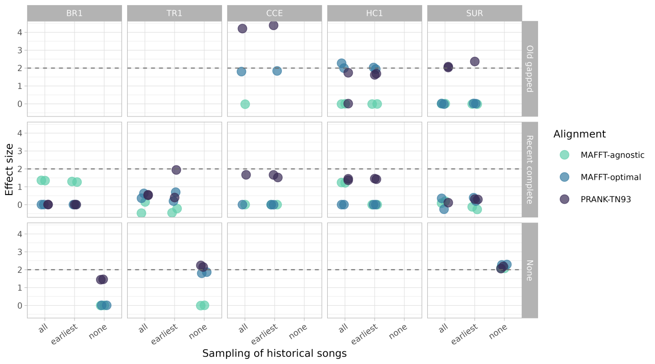
Figure S10. Effect sizes comparing empirical and simulated estimates of maximum invariant block length. Rows correspond to historical record configurations (Old gapped, Recent complete, and None), the x-axis indicates the treatment of repeated historical song observations (all occurrences, earliest occurrence only, or none), columns correspond to the five study leks (BR1, TR1, CCE, HC1, and SUR), and colors indicate multiple sequence alignment strategies (MAFFT-agnostic, MAFFT-optimal, and PRANK-TN93). The dashed horizontal line indicates an effect size of 2.

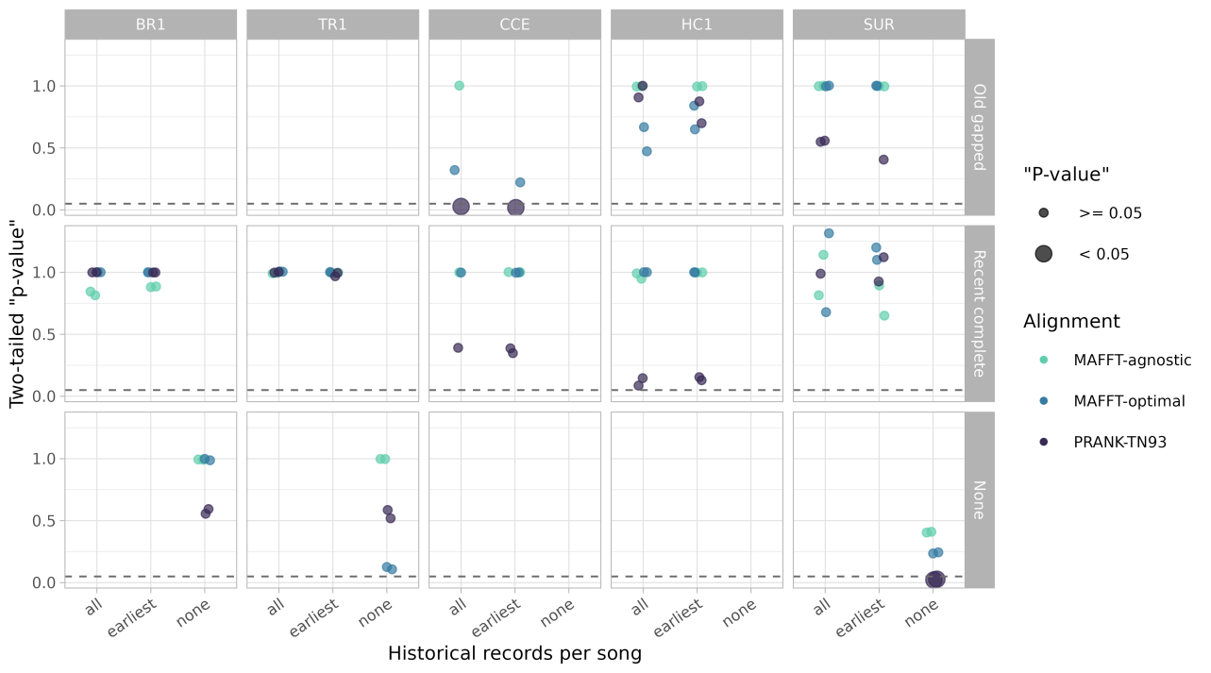
Figure S11. Two-tailed posterior predictive p-values comparing empirical and simulated estimates of maximum invariant block length. Rows correspond to historical record configurations (Old gapped, Recent complete, and None), the x-axis indicates the treatment of repeated historical song observations (all occurrences, earliest occurrence only, or none), columns correspond to the five study leks (BR1, TR1, CCE, HC1, and SUR), colors indicate multiple sequence alignment strategies (MAFFT-agnostic, MAFFT-optimal, and PRANK-TN93), and point size indicates whether posterior predictive p-values are significant (< 0.05). The dashed horizontal line indicates p = 0.05.

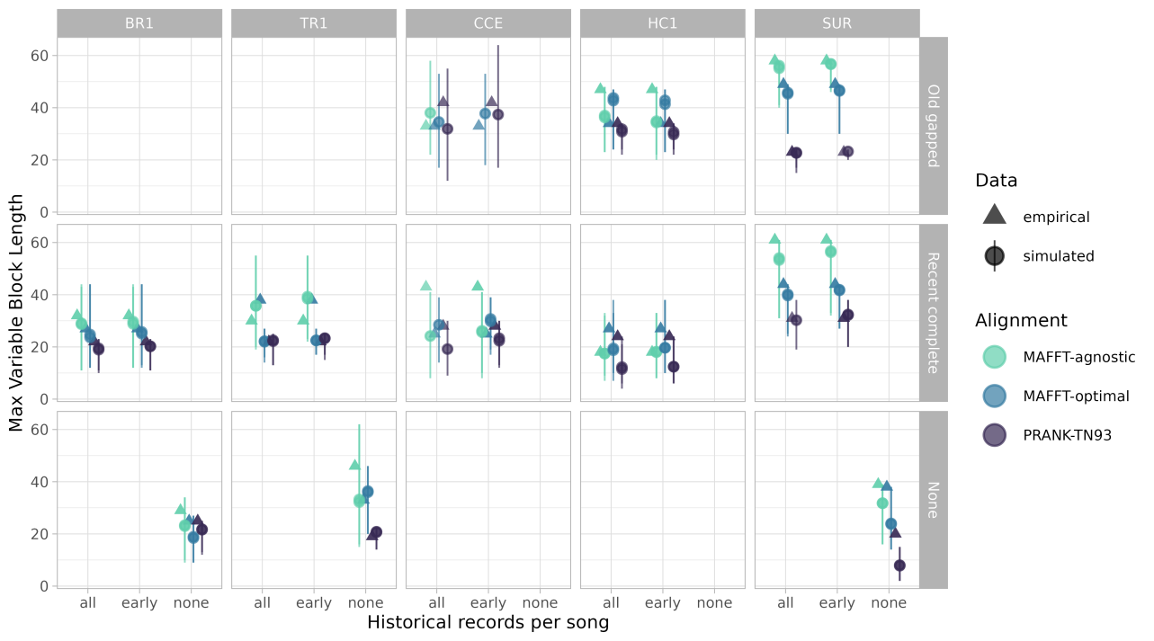
Figure S12. Maximum variable block length estimated from empirical and simulated data. Rows correspond to historical record configurations (Old gapped, Recent complete, and None), the x-axis indicates the treatment of repeated historical song observations (all occurrences, earliest occurrence only, or none), columns correspond to the five study leks (BR1, TR1, CCE, HC1, and SUR), colors indicate multiple sequence alignment strategies (MAFFT-agnostic, MAFFT-optimal, and PRANK-TN93), and symbols distinguish empirical (triangles) from simulated (circles) data. Error bars indicate 95% credible intervals.

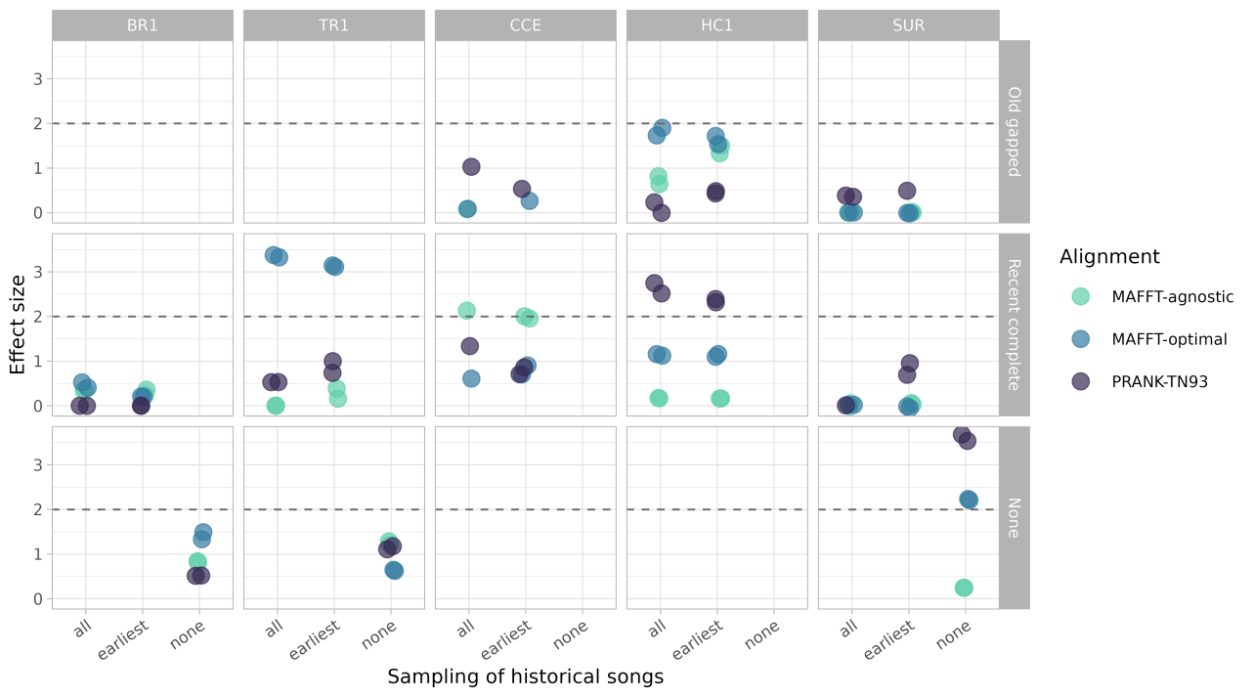
Figure S13. Effect sizes comparing empirical and simulated estimates of maximum variable block length. Rows correspond to historical record configurations (Old gapped, Recent complete, and None), the x-axis indicates the treatment of repeated historical song observations (all occurrences, earliest occurrence only, or none), columns correspond to the five study leks (BR1, TR1, CCE, HC1, and SUR), and colors indicate multiple sequence alignment strategies (MAFFT-agnostic, MAFFT-optimal, and PRANK-TN93). The dashed horizontal line indicates an effect size of 2.

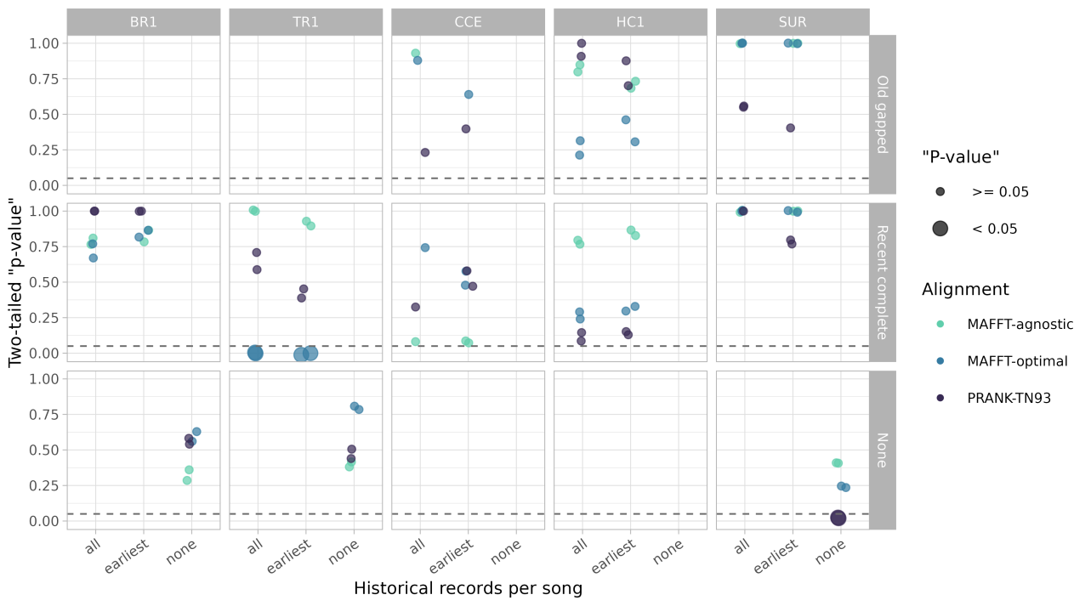
Figure S14. Two-tailed posterior predictive p-values comparing empirical and simulated estimates of maximum variable block length. Rows correspond to historical record configurations (Old gapped, Recent complete, and None), the x-axis indicates the treatment of repeated historical song observations (all occurrences, earliest occurrence only, or none), columns correspond to the five study leks (BR1, TR1, CCE, HC1, and SUR), colors indicate multiple sequence alignment strategies (MAFFT-agnostic, MAFFT-optimal, and PRANK-TN93), and point size indicates whether posterior predictive p-values are significant (< 0.05). The dashed horizontal line indicates p = 0.05.

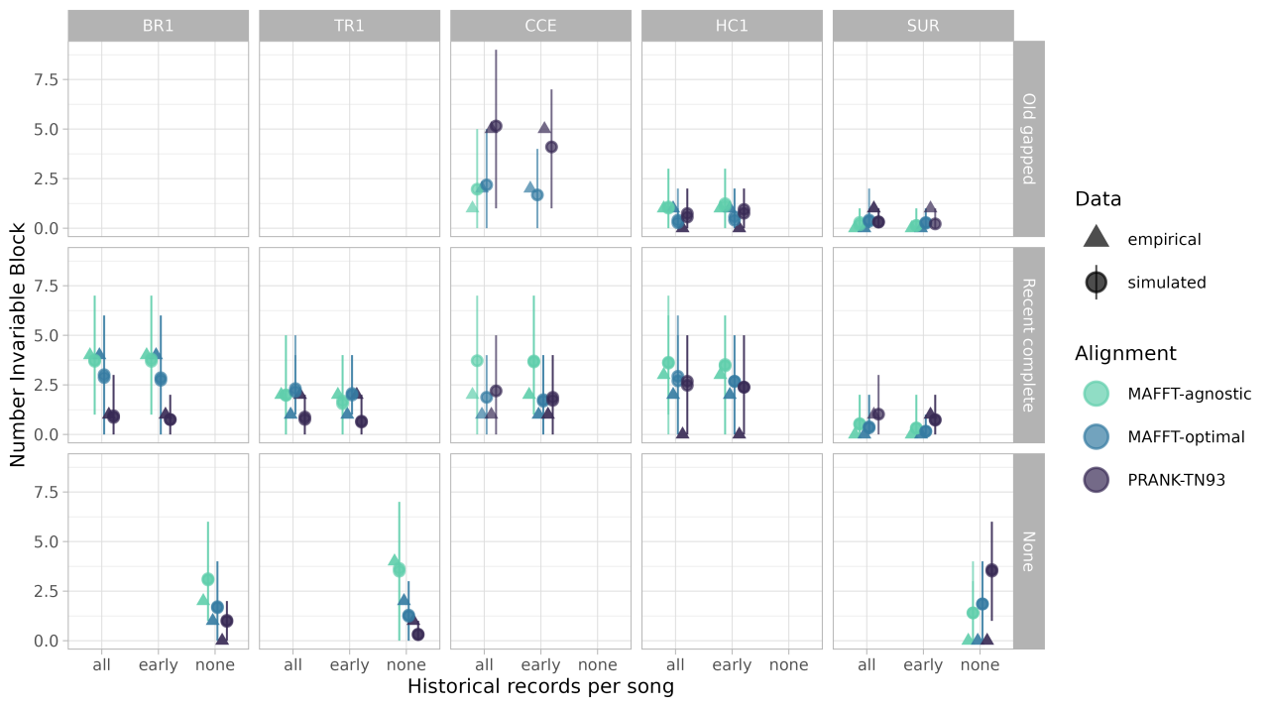
Figure S15. Number of invariant blocks estimated from empirical and simulated data. Rows correspond to historical record configurations (Old gapped, Recent complete, and None), the x-axis indicates the treatment of repeated historical song observations (all occurrences, earliest occurrence only, or none), columns correspond to the five study leks (BR1, TR1, CCE, HC1, and SUR), colors indicate multiple sequence alignment strategies (MAFFT-agnostic, MAFFT-optimal, and PRANK-TN93), and symbols distinguish empirical (triangles) from simulated (circles) data. Error bars indicate 95% credible intervals.

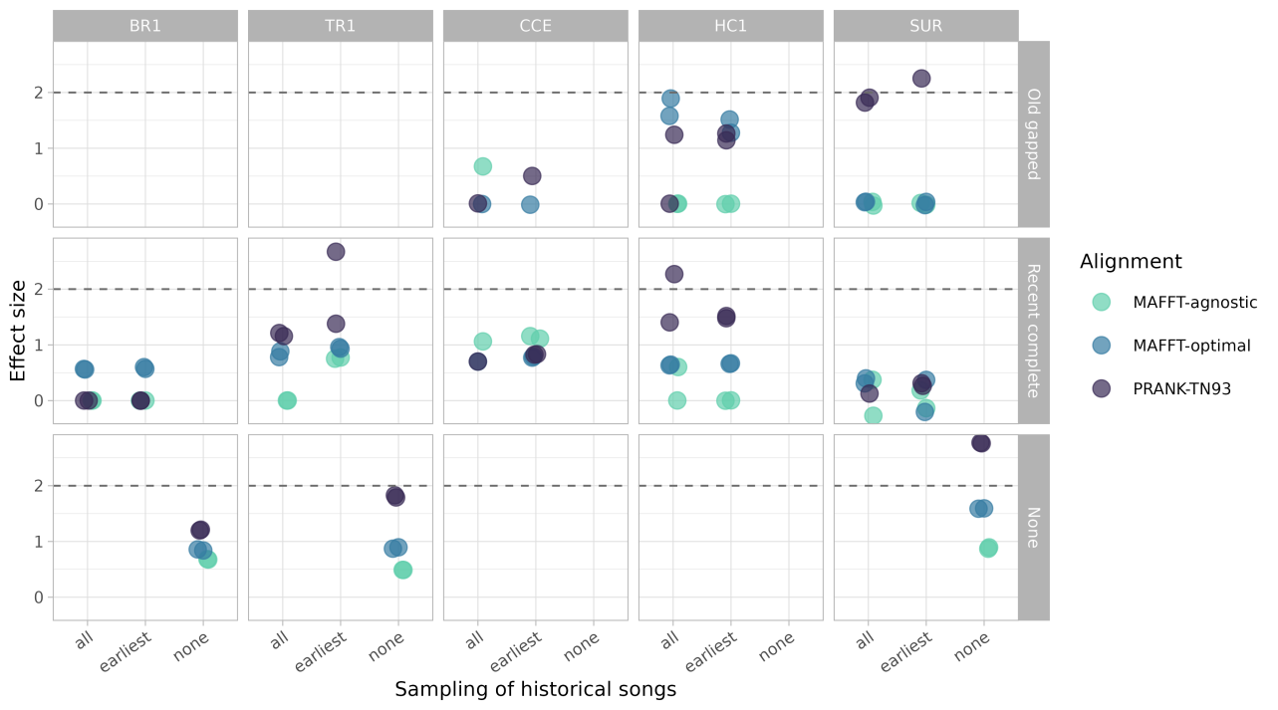
Figure S16. Effect sizes comparing empirical and simulated estimates of number of invariant blocks. Rows correspond to historical record configurations (Old gapped, Recent complete, and None), the x-axis indicates the treatment of repeated historical song observations (all occurrences, earliest occurrence only, or none), columns correspond to the five study leks (BR1, TR1, CCE, HC1, and SUR), and colors indicate multiple sequence alignment strategies (MAFFT-agnostic, MAFFT-optimal, and PRANK-TN93). The dashed horizontal line indicates an effect size of 2.

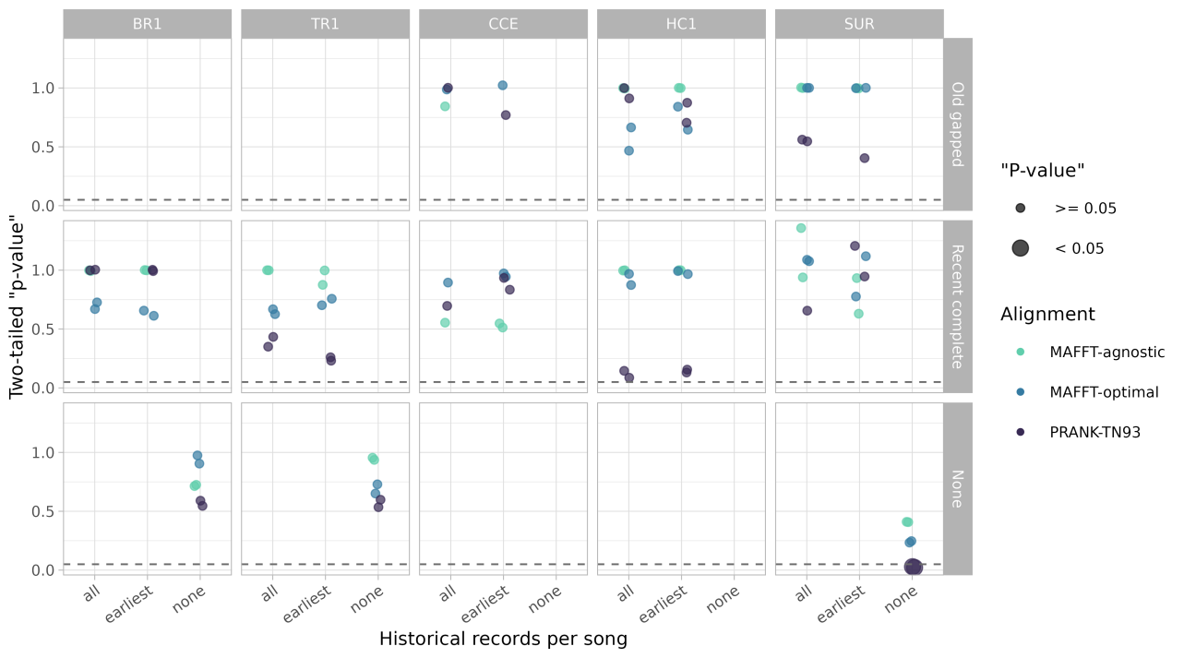
Figure S17. Two-tailed posterior predictive p-values comparing empirical and simulated estimates of number of invariant blocks. Rows correspond to historical record configurations (Old gapped, Recent complete, and None), the x-axis indicates the treatment of repeated historical song observations (all occurrences, earliest occurrence only, or none), columns correspond to the five study leks (BR1, TR1, CCE, HC1, and SUR), colors indicate multiple sequence alignment strategies (MAFFT-agnostic, MAFFT-optimal, and PRANK-TN93), and point size indicates whether posterior predictive p-values are significant (< 0.05). The dashed horizontal line indicates p = 0.05.

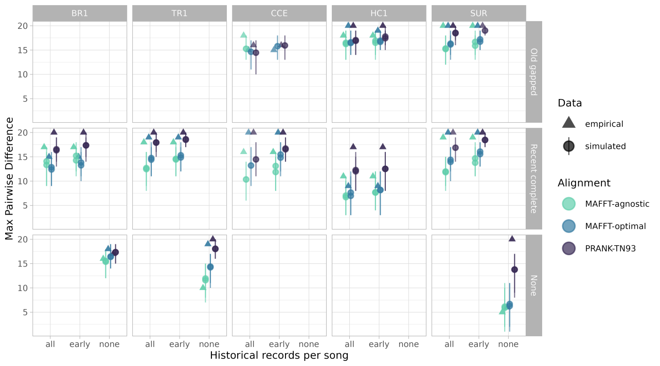
Figure S18. Maximum pairwise difference estimated from empirical and simulated data. Rows correspond to historical record configurations (Old gapped, Recent complete, and None), the x-axis indicates the treatment of repeated historical song observations (all occurrences, earliest occurrence only, or none), columns correspond to the five study leks (BR1, TR1, CCE, HC1, and SUR), colors indicate multiple sequence alignment strategies (MAFFT-agnostic, MAFFT-optimal, and PRANK-TN93), and symbols distinguish empirical (triangles) from simulated (circles) data. Error bars indicate 95% credible intervals.

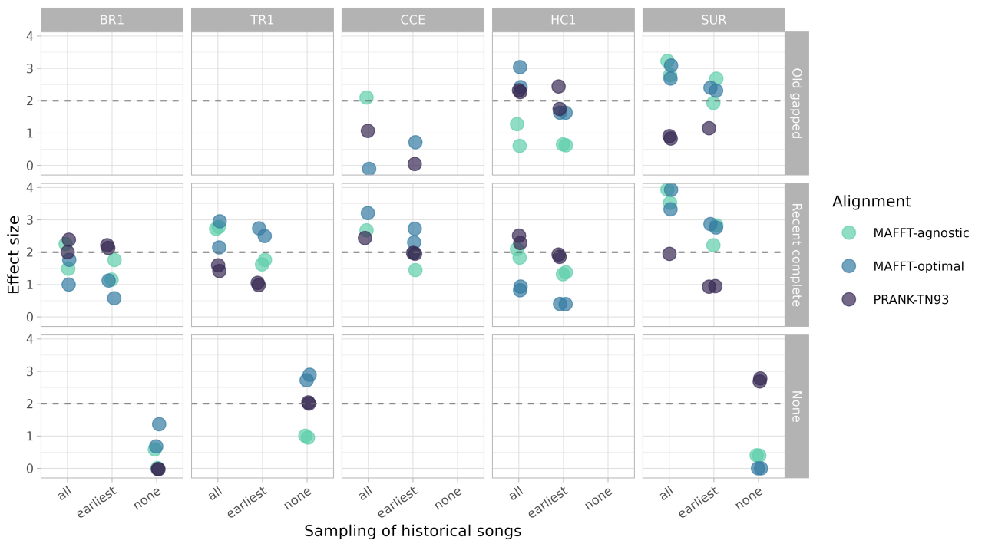
Figure S19. Effect sizes comparing empirical and simulated estimates of maximum pairwise difference. Rows correspond to historical record configurations (Old gapped, Recent complete, and None), the x-axis indicates the treatment of repeated historical song observations (all occurrences, earliest occurrence only, or none), columns correspond to the five study leks (BR1, TR1, CCE, HC1, and SUR), and colors indicate multiple sequence alignment strategies (MAFFT-agnostic, MAFFT-optimal, and PRANK-TN93). The dashed horizontal line indicates an effect size of 2.

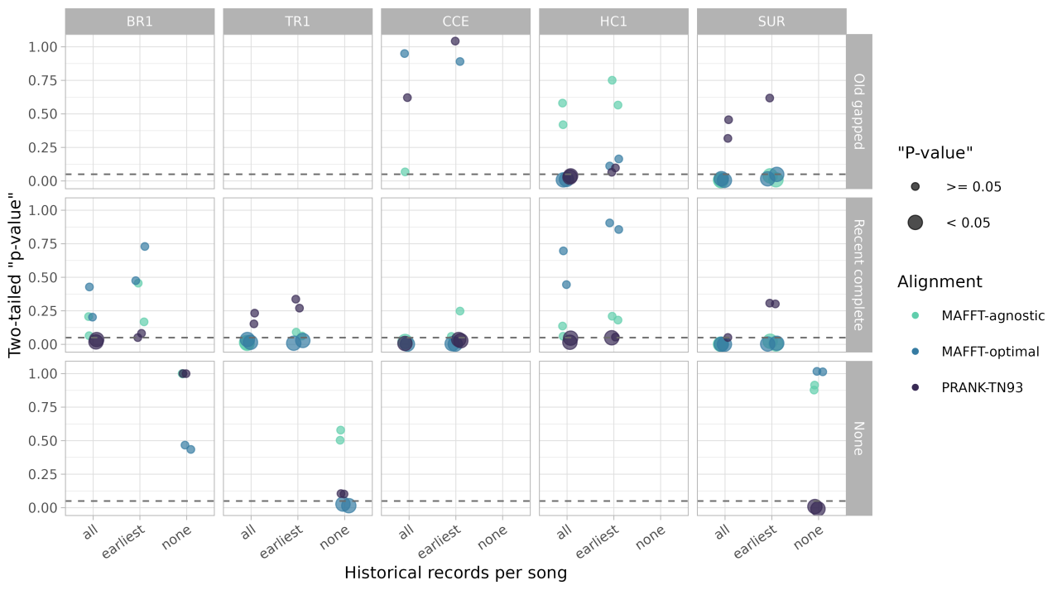
Figure S20. Two-tailed posterior predictive p-values comparing empirical and simulated estimates of maximum pairwise difference. Rows correspond to historical record configurations (Old gapped, Recent complete, and None), the x-axis indicates the treatment of repeated historical song observations (all occurrences, earliest occurrence only, or none), columns correspond to the five study leks (BR1, TR1, CCE, HC1, and SUR), colors indicate multiple sequence alignment strategies (MAFFT-agnostic, MAFFT-optimal, and PRANK-TN93), and point size indicates whether posterior predictive p-values are significant (< 0.05). The dashed horizontal line indicates p = 0.05.

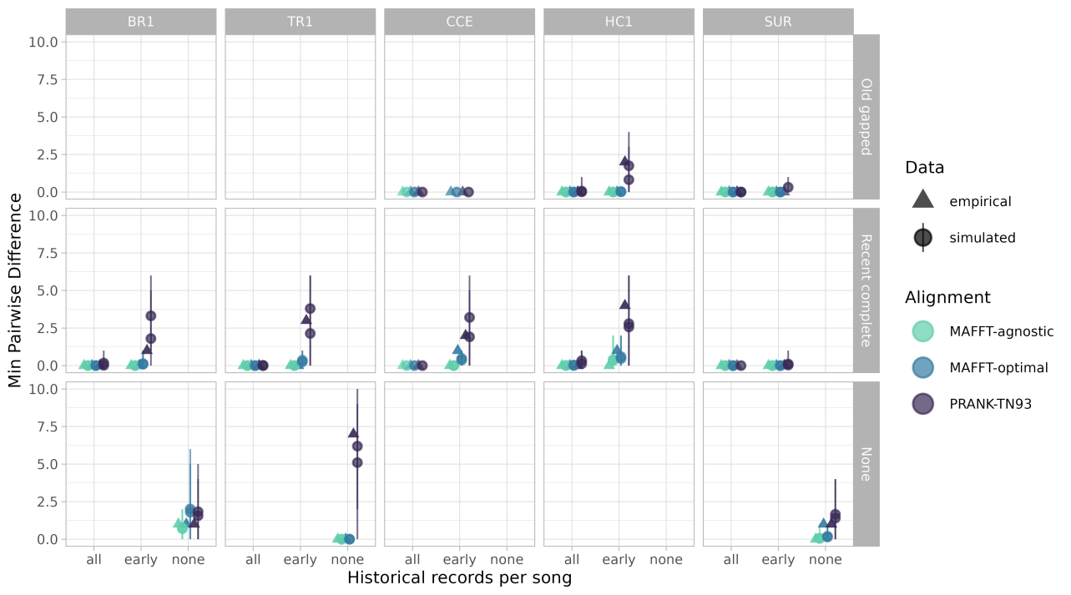
Figure S21. Minimum pairwise difference estimated from empirical and simulated data. Rows correspond to historical record configurations (Old gapped, Recent complete, and None), the x-axis indicates the treatment of repeated historical song observations (all occurrences, earliest occurrence only, or none), columns correspond to the five study leks (BR1, TR1, CCE, HC1, and SUR), colors indicate multiple sequence alignment strategies (MAFFT-agnostic, MAFFT-optimal, and PRANK-TN93), and symbols distinguish empirical (triangles) from simulated (circles) data. Error bars indicate 95% credible intervals.

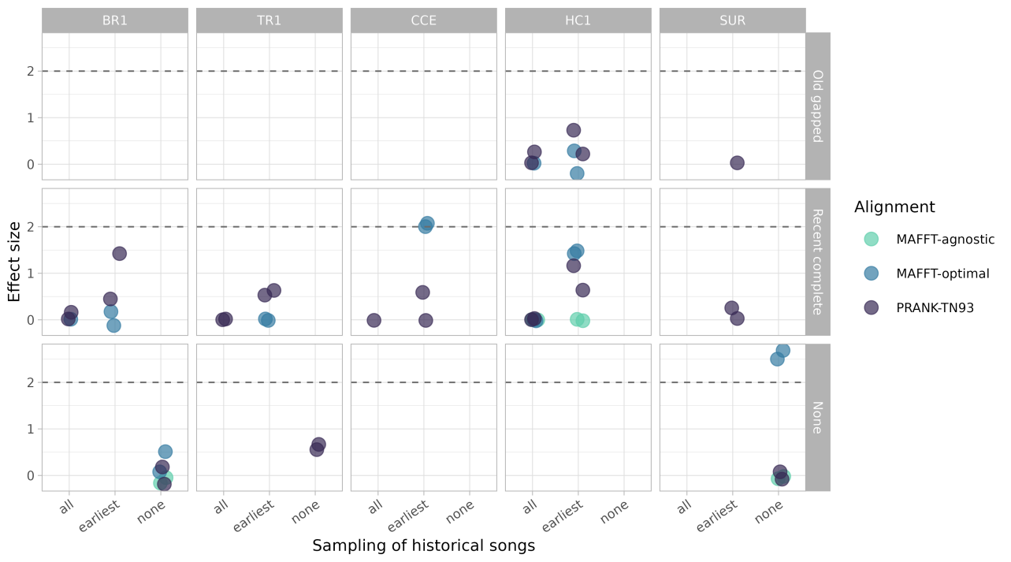
Figure S22. Effect sizes comparing empirical and simulated estimates of minimum pairwise difference. Rows correspond to historical record configurations (Old gapped, Recent complete, and None), the x-axis indicates the treatment of repeated historical song observations (all occurrences, earliest occurrence only, or none), columns correspond to the five study leks (BR1, TR1, CCE, HC1, and SUR), and colors indicate multiple sequence alignment strategies (MAFFT-agnostic, MAFFT-optimal, and PRANK-TN93). The dashed horizontal line indicates an effect size of 2.

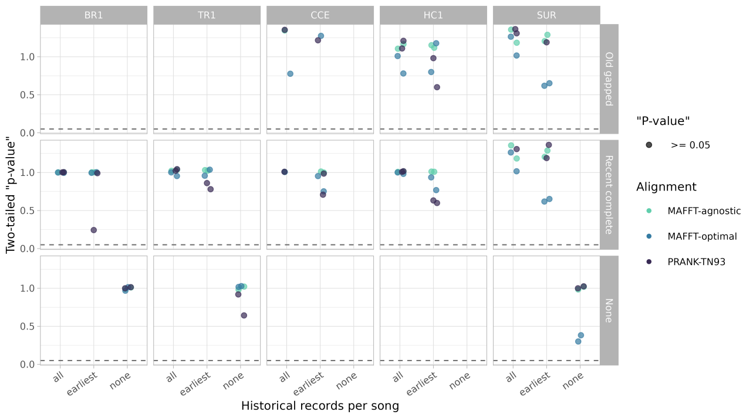
Figure S23. Two-tailed posterior predictive p-values comparing empirical and simulated estimates of minimum pairwise difference. Rows correspond to historical record configurations (Old gapped, Recent complete, and None), the x-axis indicates the treatment of repeated historical song observations (all occurrences, earliest occurrence only, or none), columns correspond to the five study leks (BR1, TR1, CCE, HC1, and SUR), colors indicate multiple sequence alignment strategies (MAFFT-agnostic, MAFFT-optimal, and PRANK-TN93), and point size indicates whether posterior predictive p-values are significant (< 0.05). The dashed horizontal line indicates p = 0.05.

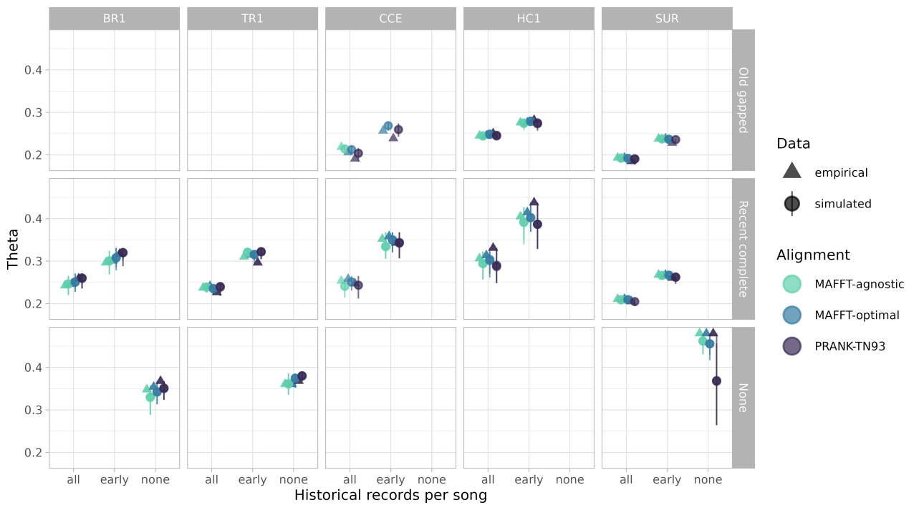
Figure S24. Theta estimated from empirical and simulated data. Rows correspond to historical record configurations (Old gapped, Recent complete, and None), the x-axis indicates the treatment of repeated historical song observations (all occurrences, earliest occurrence only, or none), columns correspond to the five study leks (BR1, TR1, CCE, HC1, and SUR), colors indicate multiple sequence alignment strategies (MAFFT-agnostic, MAFFT-optimal, and PRANK-TN93), and symbols distinguish empirical (triangles) from simulated (circles) data. Error bars indicate 95% credible intervals.

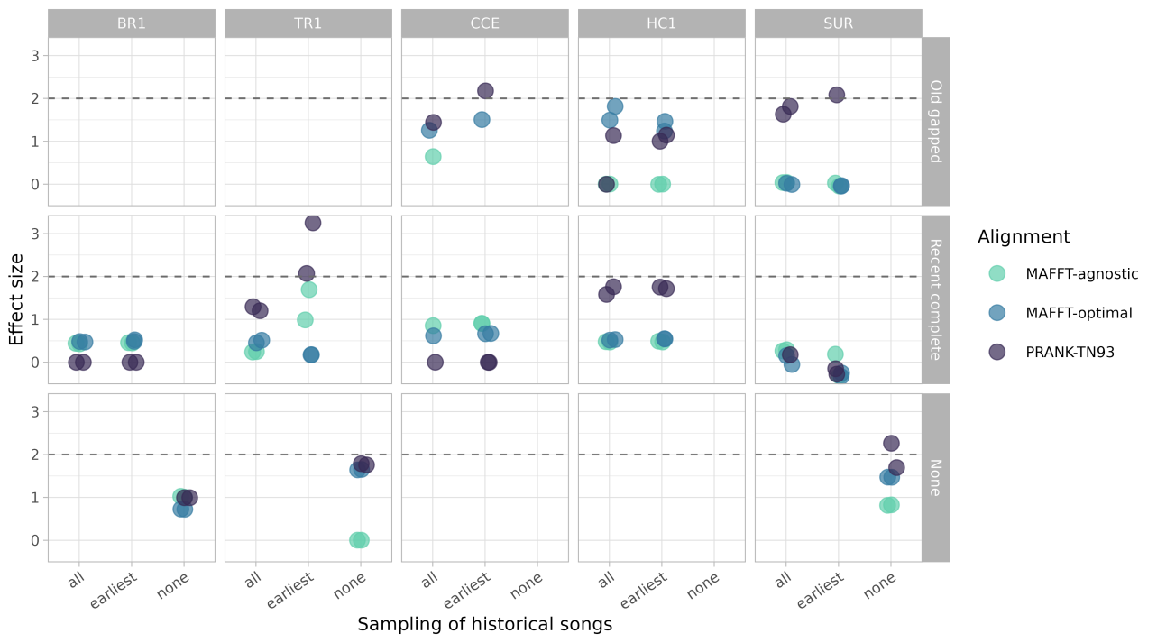
Figure S25. Effect sizes comparing empirical and simulated estimates of theta. Rows correspond to historical record configurations (Old gapped, Recent complete, and None), the x-axis indicates the treatment of repeated historical song observations (all occurrences, earliest occurrence only, or none), columns correspond to the five study leks (BR1, TR1, CCE, HC1, and SUR), and colors indicate multiple sequence alignment strategies (MAFFT-agnostic, MAFFT-optimal, and PRANK-TN93). The dashed horizontal line indicates an effect size of 2.

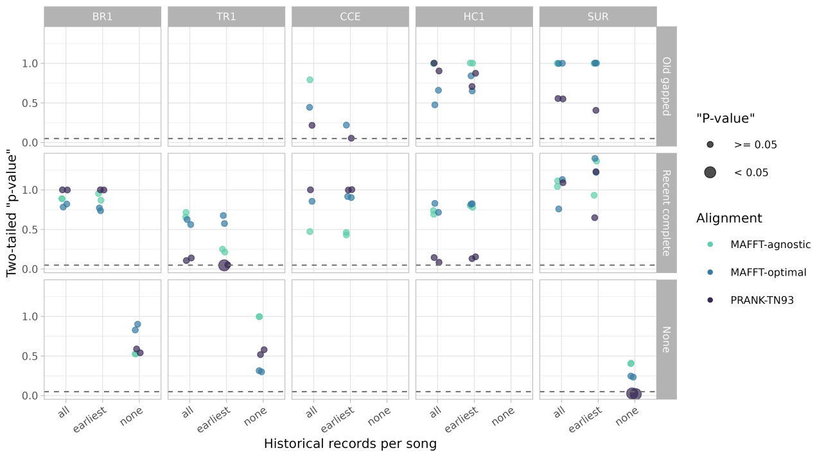
Figure S26. Two-tailed posterior predictive p-values comparing empirical and simulated estimates of theta. Rows correspond to historical record configurations (Old gapped, Recent complete, and None), the x-axis indicates the treatment of repeated historical song observations (all occurrences, earliest occurrence only, or none), columns correspond to the five study leks (BR1, TR1, CCE, HC1, and SUR), colors indicate multiple sequence alignment strategies (MAFFT-agnostic, MAFFT-optimal, and PRANK-TN93), and point size indicates whether posterior predictive p-values are significant (< 0.05). The dashed horizontal line indicates p = 0.05.

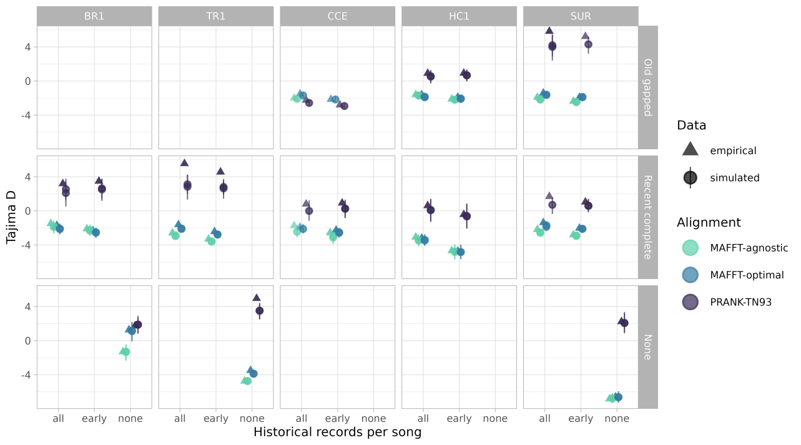
Figure S27. Tajima’s D estimated from empirical and simulated data. Rows correspond to historical record configurations (Old gapped, Recent complete, and None), the x-axis indicates the treatment of repeated historical song observations (all occurrences, earliest occurrence only, or none), columns correspond to the five study leks (BR1, TR1, CCE, HC1, and SUR), colors indicate multiple sequence alignment strategies (MAFFT-agnostic, MAFFT-optimal, and PRANK-TN93), and symbols distinguish empirical (triangles) from simulated (circles) data. Error bars indicate 95% credible intervals.

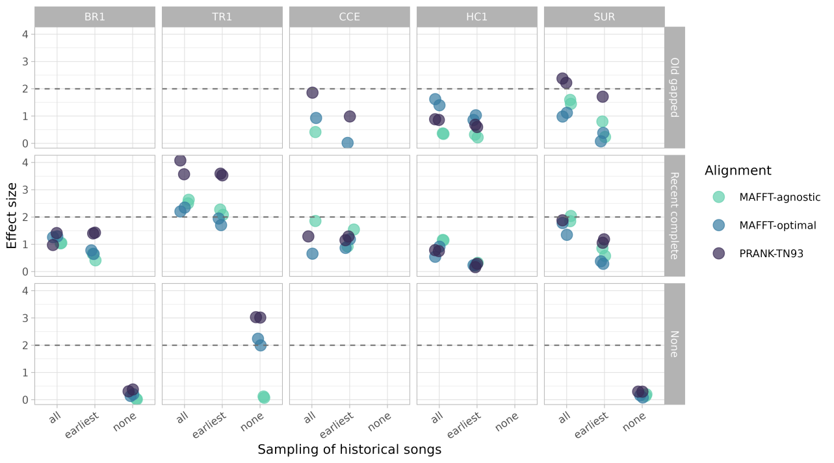
Figure S28. Effect sizes comparing empirical and simulated estimates of Tajima’s D. Rows correspond to historical record configurations (Old gapped, Recent complete, and None), the x-axis indicates the treatment of repeated historical song observations (all occurrences, earliest occurrence only, or none), columns correspond to the five study leks (BR1, TR1, CCE, HC1, and SUR), and colors indicate multiple sequence alignment strategies (MAFFT-agnostic, MAFFT-optimal, and PRANK-TN93). The dashed horizontal line indicates an effect size of 2.

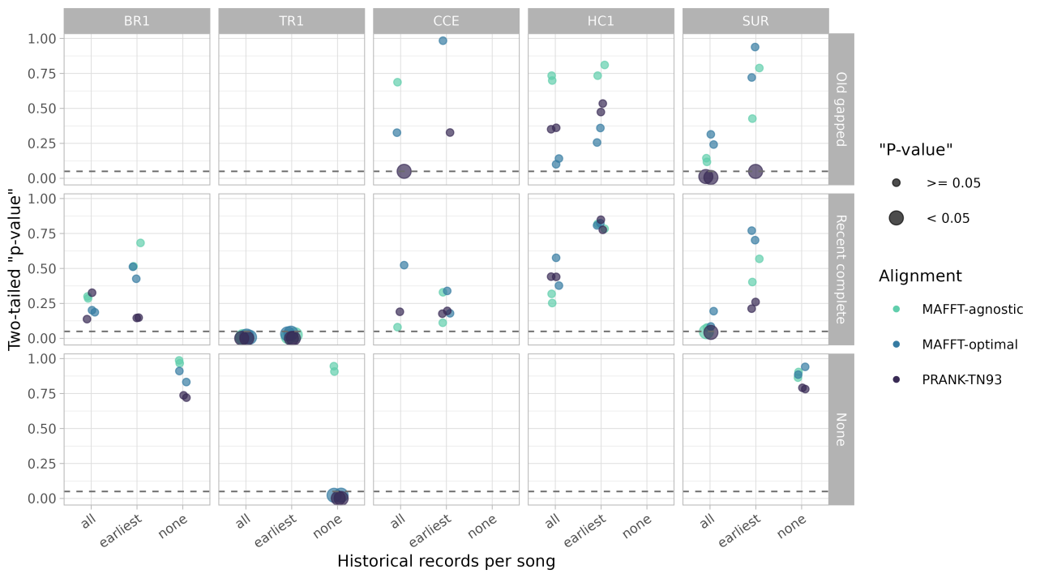
Figure S29. Two-tailed posterior predictive p-values comparing empirical and simulated estimates of Tajima’s D. Rows correspond to historical record configurations (Old gapped, Recent complete, and None), the x-axis indicates the treatment of repeated historical song observations (all occurrences, earliest occurrence only, or none), columns correspond to the five study leks (BR1, TR1, CCE, HC1, and SUR), colors indicate multiple sequence alignment strategies (MAFFT-agnostic, MAFFT-optimal, and PRANK-TN93), and point size indicates whether posterior predictive p-values are significant (< 0.05). The dashed horizontal line indicates p = 0.05.

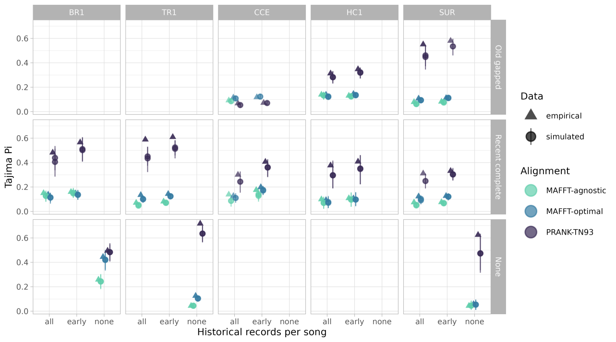
Figure S30. Nucleotide diversity (Tajima’s π) estimated from empirical and simulated data. Rows correspond to historical record configurations (Old gapped, Recent complete, and None), the x-axis indicates the treatment of repeated historical song observations (all occurrences, earliest occurrence only, or none), columns correspond to the five study leks (BR1, TR1, CCE, HC1, and SUR), colors indicate multiple sequence alignment strategies (MAFFT-agnostic, MAFFT-optimal, and PRANK-TN93), and symbols distinguish empirical (triangles) from simulated (circles) data. Error bars indicate 95% credible intervals.

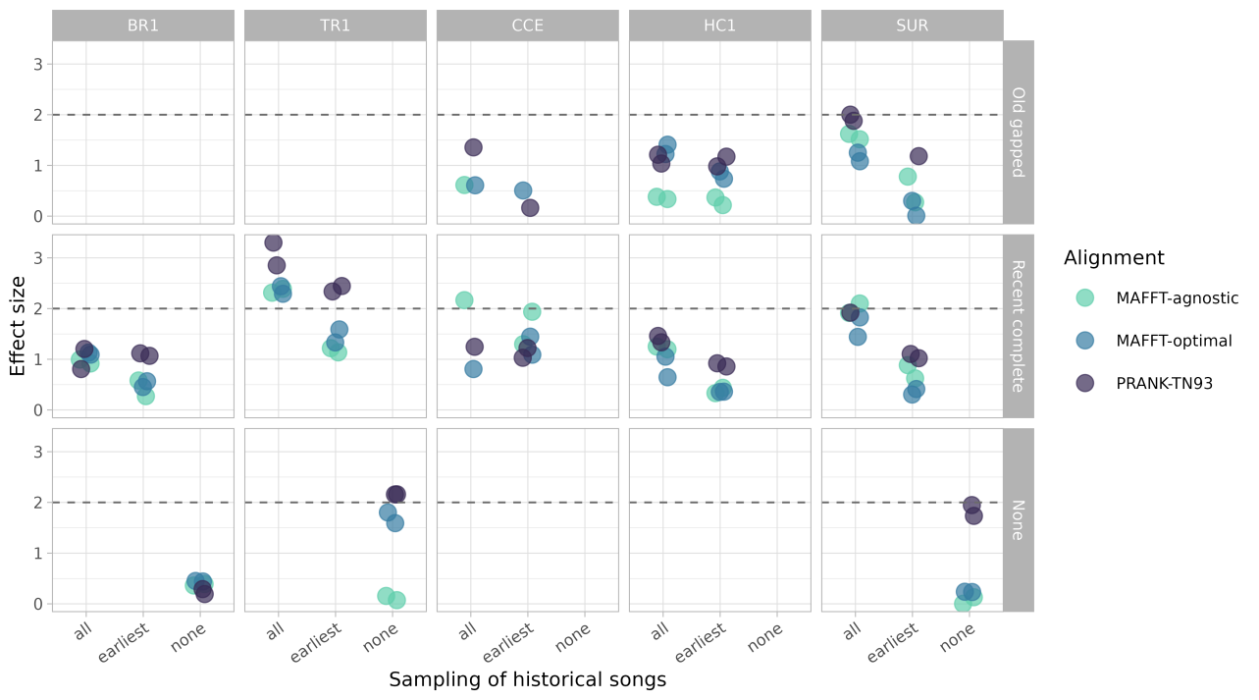
Figure S31. Effect sizes comparing empirical and simulated estimates of nucleotide diversity (Tajima’s π). Rows correspond to historical record configurations (Old gapped, Recent complete, and None), the x-axis indicates the treatment of repeated historical song observations (all occurrences, earliest occurrence only, or none), columns correspond to the five study leks (BR1, TR1, CCE, HC1, and SUR), and colors indicate multiple sequence alignment strategies (MAFFT-agnostic, MAFFT-optimal, and PRANK-TN93). The dashed horizontal line indicates an effect size of 2.

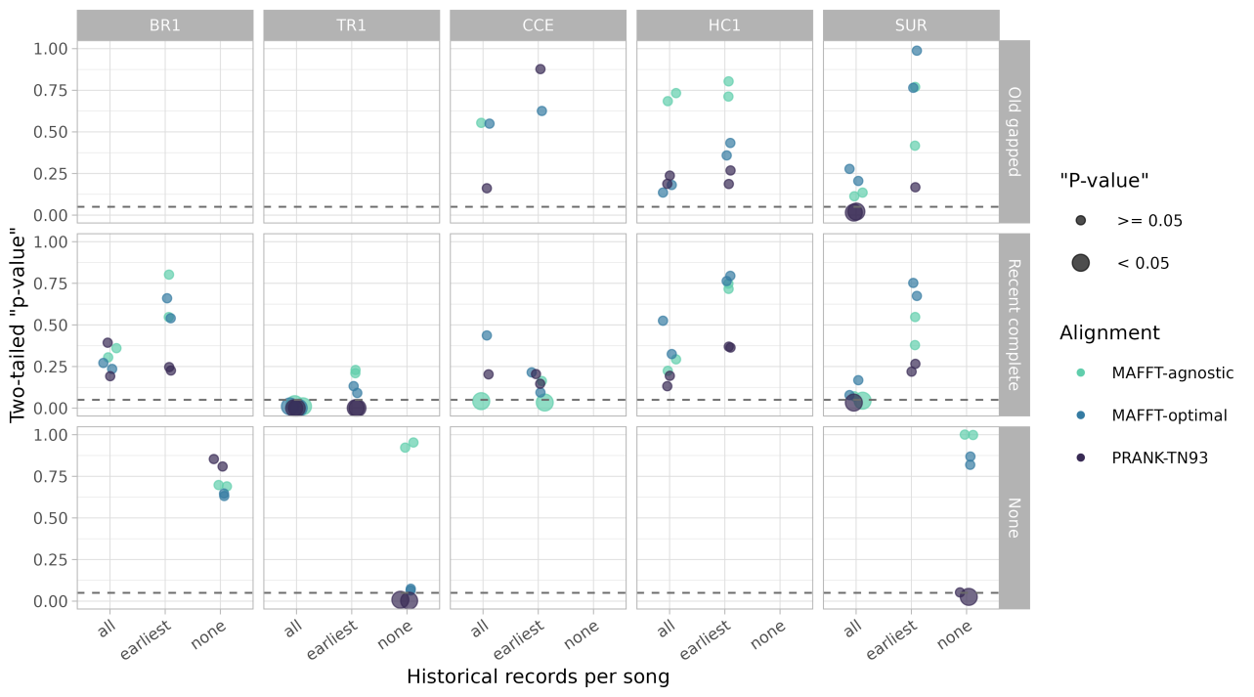
Figure S32. Two-tailed posterior predictive p-values comparing empirical and simulated estimates of nucleotide diversity (Tajima’s π). Rows correspond to historical record configurations (Old gapped, Recent complete, and None), the x-axis indicates the treatment of repeated historical song observations (all occurrences, earliest occurrence only, or none), columns correspond to the five study leks (BR1, TR1, CCE, HC1, and SUR), colors indicate multiple sequence alignment strategies (MAFFT-agnostic, MAFFT-optimal, and PRANK-TN93), and point size indicates whether posterior predictive p-values are significant (< 0.05). The dashed horizontal line indicates p = 0.05.

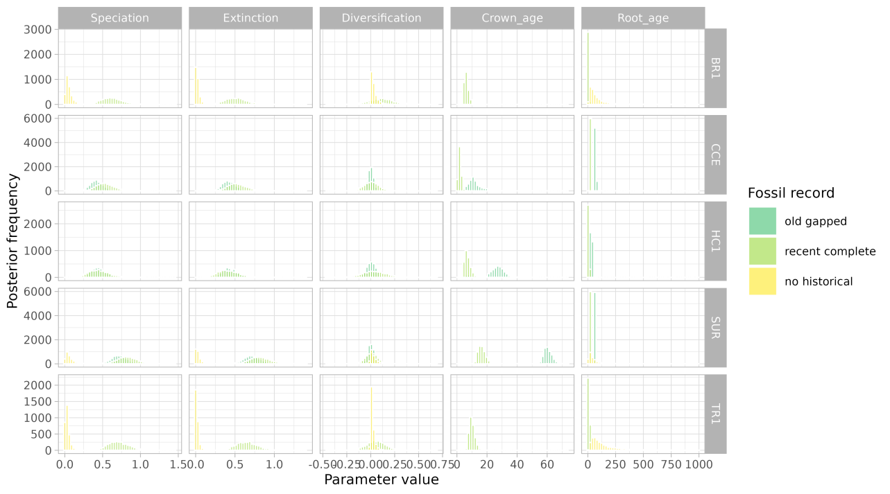
Figure S33. Overall posterior predictive p-values across historical record configurations, treatments of repeated historical song observations, study leks, and sequence alignment strategies.

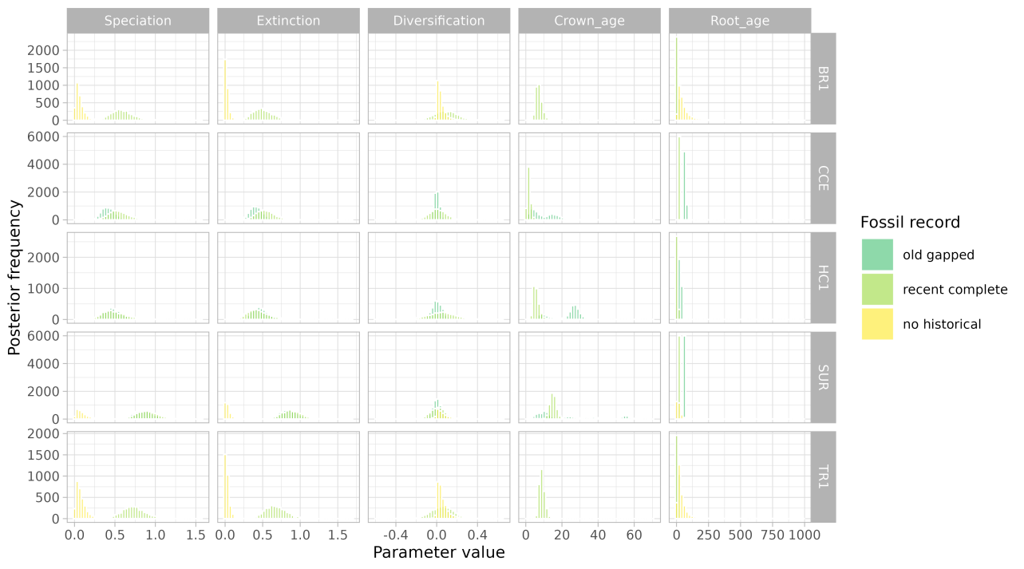
Figure S34. Posterior distributions of diversification parameters under alternative historical record configurations.

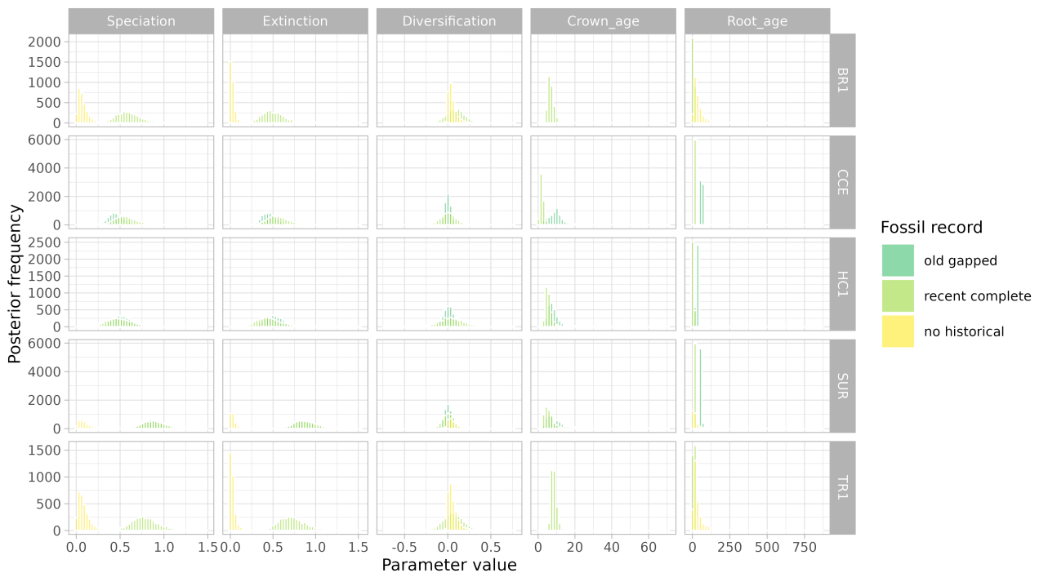
Figure S35. Posterior distributions of topological space descriptors under alternative historical record configurations.

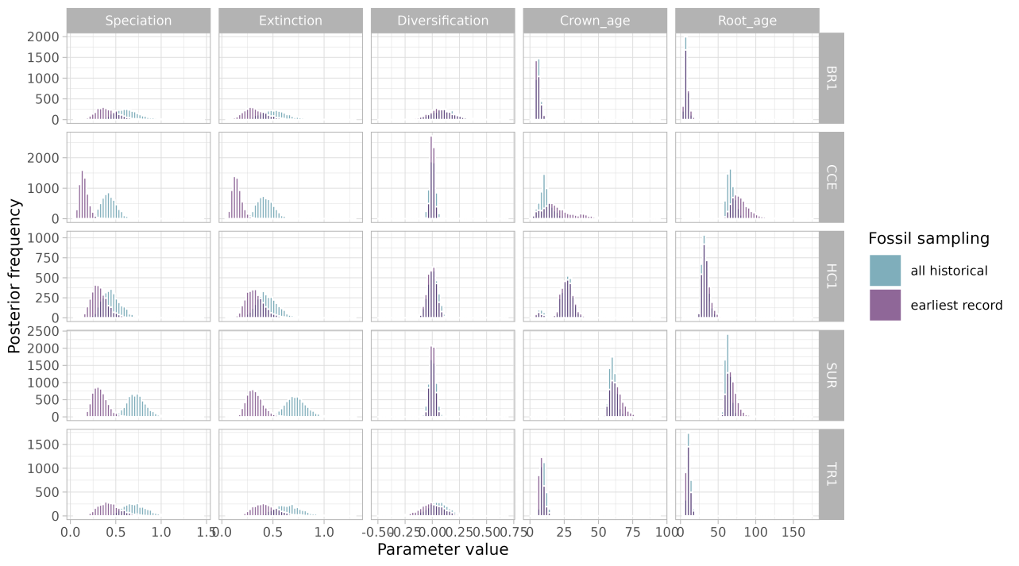
Figure S36. Posterior distributions of diversification parameters under alternative treatments of repeated historical song observations.

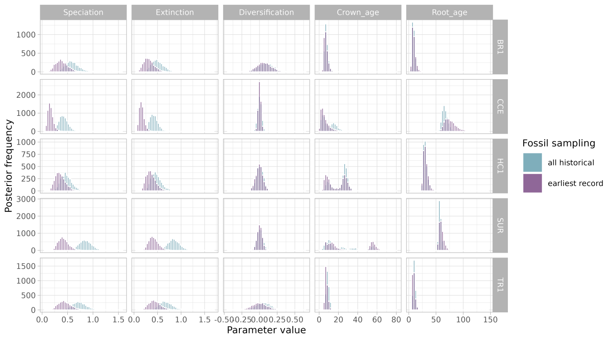
Figure S37. Posterior distributions of topological space descriptors under alternative treatments of repeated historical song observations.

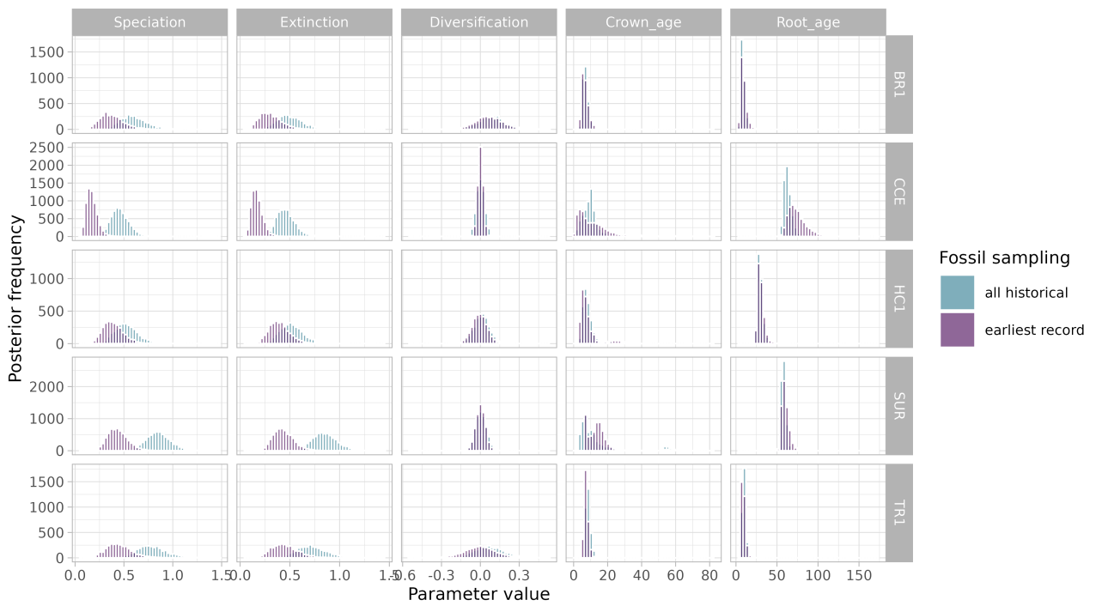
Figure S38. Posterior distributions of topological space descriptors across combinations of historical record configurations and treatments of repeated historical song observations.

