Understanding cultural evolution of songs in hummingbird leks through the fossilized birth-death process
Marcelo Araya-Salas ^{1,2*,†} (marcelo.araya@ucr.ac.cr)
Beatriz Willink ^{3,4*} (beatriz.willink@zoologi.su.se)
Alejandro Rico-Guevara ⁵ (colibri@uw.edu)
2026-07-04
1 Centro de Investigación en Neurociencias, Universidad de Costa Rica
2 Lab of Ornithology, Cornell University
3 Department of Zoology, Stockholm University, Stockholm 106-91, Sweden
4 Department of Biological Sciences, National University of Singapore, Singapore 117558, Singapore
5 Department of Biology, University of Washington
* Both authors contributed equally
† To whom correspondence should be addressed
Keywords: vocal learning, Long-billed Hermit, model adequacy, node dating, phylogenetics, posterior predictive simulation, sequence alignment

Abstract
Cultural traits can diversify through time in ways analogous to biological evolution, yet the extent to which phylogenetic models capture cultural change remains poorly understood. Here we apply a phylogenetic framework to socially learnt bird songs to investigate cultural diversification in the Long-billed Hermit (Phaethornis longirostris). Using longitudinal recordings spanning up to five decades across five hummingbird leks, we encoded songs as sequences of discrete sound segments and reconstructed their evolutionary history using Bayesian phylogenetic inference under a fossilized birth–death process. Historical song recordings were treated as ancestral samples analogous to fossils, allowing direct estimation of divergence times and diversification dynamics in cultural lineages. Higher pairwise song sequence similarity among song types from the same lek supported the view that leks operate as cohesive cultural units. We evaluated alternative sequence alignment strategies and assessed model adequacy using posterior predictive simulations. Phylogenetic models generally provided a good fit to the empirical song data, supporting the use of evolutionary approaches for analysing cultural sequences. Incorporating historical song records improved the precision of divergence-time estimates and increased inferred rates of song lineage turnover, while also providing stronger support for heterogeneous evolutionary rates among lineages. In contrast, alignment strategies had strong effects on inferred tree topologies but weaker effects on diversification parameters. Our results demonstrate that culturally transmitted bird songs can be analysed using phylogenetic models originally developed for biological evolution, and highlight the importance of historical records and alignment assumptions when inferring the dynamics of cultural diversification.

Introduction
The idea that culture changes and diversifies over time in a manner analogous to organic evolution and phylogenetic diversification can be traced back to Darwin, who noted that "the formation of different languages and of distinct species, and the proofs that both have been developed through a gradual process, are curiously parallel" (Darwin 1871). The term culture can be used broadly to refer to socially transmitted information that influences behavioural patterns within animal groups (Laland and Hoppitt 2003). While human language, beliefs, norms and material artefacts are well-known cultural domains, many forms of culture exist among other animals, such as vocal dialects (Catchpole and Slater 2003; Aplin 2019), navigation routes (Laland and Williams 1997; Jesmer et al. 2018), and tool use traditions (Whiten et al. 2005; Luncz and Boesch 2014). In the last century, the formal modelling of cultural change as evolution, whether in humans or non-human animals, has been conducted by drawing analogies between cultural and population genetic processes (Cavalli-Sforza and Feldman 1981; Boyd and Richerson 1985), or between cultural and phylogenetic diversification (Gray et al. 2007; Mesoudi 2017). However, unlike genetic evolution, in which the most fundamental units of transmission (nucleotides) are essentially universal, cultural evolution implies disparate units of transmission across taxa and in different social contexts (e.g. tool design vs. language). In order to address the long-standing question of whether cultural change is truly akin to evolution, we require means to systematically assess the power of evolutionary methods, across the great variety of cultural forms that have emerged in the history of animals.
Some learnt behaviours can be described as sequences of ethological units. For example, visual displays can be encoded as a string of stereotyped motor patterns (Ligon et al. 2018; Araya-Salas et al. 2019) and bird and whale songs are typically structured as sequences of repeated and hierarchically nested sounds (Payne and McVay 1971; Rivera-Cáceres et al. 2016; Kershenbaum et al. 2016; Garland et al. 2017). Encoding behaviour as a sequence facilitates the adoption of phylogenetic approaches that take molecular data as their main input. Such approaches have been developed within a strong theoretical framework that continues to grow and increasingly accommodates biological realism (Yang and Rannala 2012). Substitution models applied to molecular sequence evolution are routinely combined with clock models and tree priors, such as the birth-death process, to understand the temporal dynamics of lineage diversification and turnover (Morlon 2014; Bromham et al. 2018) Analogously, clock models, tree priors and substitution models may be used to elucidate the temporal dynamics of cultural diversification, when culture can be adequately modeled as behavioural sequences composed of discrete units. Estimating the absolute fit of such models to cultural data is crucial to evaluate the utility of phylogenetic approaches for our understanding of cultural evolution and diversification.
Cultural evolution poses special challenges to the application of phylogenetic models. Most implementations of phylogenetic models on molecular data start with a sequence alignment. Alignments represent assumptions of homology between characters in matched positions along a sequence, but are typically treated as observations for phylogenetic inference (Lutzoni et al. 2000; Redelings and Suchard 2005; Lunter et al. 2005). Numerous methods of sequence alignment have therefore been developed to capture the main features of molecular evolution, and in some cases to explicitly model substitution events (Yang and Rannala 2012; Chatzou et al. 2016). Nonetheless, the accurate reconstruction of homology in sequence alignments is a pervasive challenge in molecular phylogenetics (Warnow 2021), that is only exacerbated when borrowing phylogenetic tools for the study of behavioural sequences (Caetano and Beaulieu 2020). We clearly have a better understanding of the basic rules that govern the rates of different nucleotide substitutions than we do for changes in the dance moves of a courtship display or changes in the sequence of sounds of a mating vocalization. A crucial question for the nascent field of cultural phylogenetics (sensu Mesoudi 2017) is therefore whether alignment algorithms developed for molecular data can be suitably modified to represent the processes behind cultural change.
Despite these challenges, culture also poses unmatched opportunities for the application of phylogenetic inference. Culture can change very rapidly in comparison to molecular evolution (Perreault 2012), allowing researchers to document lineage diversification events as they occur, and during the span of one or a few academic lifetimes. Cultural phylogenetics can therefore capitalize on a relatively rich historical record, that markedly contrasts the sparse fossil record of many organismal groups (Kidwell and Holland 2002). Recently developed phylogenetic methods have shown that sampling ancestors of extant taxa and explicitly incorporating these data in the diversification process allow for more accurate estimation of divergence times (Gavryushkina et al. 2014, 2017; Zhang et al. 2016a). This is accomplished by the fossilized birth-death process (FBDP) (Heath et al. 2014; Gavryushkina et al. 2014), a model that jointly describes the probabilities of lineage splitting, extinction and fossilization that give rise to the sampled taxa, whether extant or fossil. Of course, the fossilization rate estimated in the FBDP may represent actual fossilization events, but can also be used to describe serially sampled viral strains (Stadler and Yang 2013; Gavryushkina et al. 2014), or, as in this case, historical records of behavioural patterns that are socially learnt and transmitted (Rama 2018; Ritchie and Ho 2019; Zhang et al. 2020). Thus, when culture evolves rapidly and learnt behaviours are sampled serially, a vast record of ancestral lineages can bolster inferences of cultural diversification dynamics through the FBDP.
Cultural phylogenetics research that builds on Bayesian estimation of origination, extinction and preservation rates is recently growing, but remains restricted to specific domains of human culture (Gjesfjeld et al. 2016, 2020; Rama 2018; Ritchie and Ho 2019; Sagart et al. 2019; Zhang et al. 2020). Studies applying the FBDP in particular have been focused on elucidating the history of diverse human language families (Rama 2018; Sagart et al. 2019; Zhang et al. 2020). Thus, a great untapped potential remains for investigating cultural diversification through the FBDP in non-human animals. Such an approach can help us determine whether the analogy between organic evolution and cultural change holds for other cultural phenomena. Because bird songs are often socially learnt and linearly composed of discrete subunits, they can be used to examine the suitability of the FBDP as a phylogenetic model of cultural diversification.
Bird songs provide a promising system for exploring the suitability of phylogenetic reconstruction methods for animal cultural traits because they are often socially learned and can be composed of sequences of discrete acoustic elements that can be analysed as ordered character strings. Individual Long-billed Hermits (Phaethornis longirostris; Fig. 1a) males exhibit a single song-type repertoire that repeat continuously while occupying their lek territories (Stiles and Wolf 1979; Araya-Salas and Wright 2013). The song consists of a continuous frequency-modulated sound (Fig. 2) and variation among song types arises primarily from differences in patterns of frequency modulation. These patterns of frequency-modulation can be classified into a small number of categories (Fig. 2; see Methods), which enables to encode song types as ordered character states that preserve their temporal organization. Evidence of social vocal production learning in this species (sensu Ten Cate 2021), includes micro-geographic song variation decoupled from genetic structure (Araya-Salas et al. 2019) and adult replacement of crystallized songs (Araya-Salas and Wright 2013). Importantly, the single song-type repertoire enables comparisons of individual songs as homologous cultural traits, unlike species in which individuals possess multiple element song-types or multiple song-type repertoires. Courtship occurs within leks of 5-20 highly vocal males (Stiles and Wolf 1979), which facilitates longitudinal monitoring of all song types within a lek. Moreover, song types are shared by sub-groups of males within leks (i.e. song neighborhoods), with no evidence of song type sharing across leks (Araya-Salas et al. 2019), suggesting that leks operate as relatively isolated cultural systems. Such independence across leks provides an unmatched opportunity to investigate the robustness of phylogenetic models across different iterations of an underlying cultural diversification process.
Here, we used the FBDP to model cultural diversification in five leks of Long-billed Hermits, using historical song surveys spanning up to five decades (Fig. 1c). We then investigated model reliability and absolute fit of phylogenetic models, using posterior predictive simulation and comparing features of empirical song sequences to sequences generated by models under the FBDP. We further asked how biologically informed assumptions during sequence alignment impact model reliability and estimates of diversification dynamics. Finally, we explored how the use and completeness of historical records (analogous to fossil records) affect model reliability, parameter estimation and the fit of alternative clock models to Long-billed Hermit song sequence data. Our results provide a formal test of the applicability of phylogenetic frameworks to model cultural evolution and highlight the critical role of historical data in shaping inferences about cultural diversification.
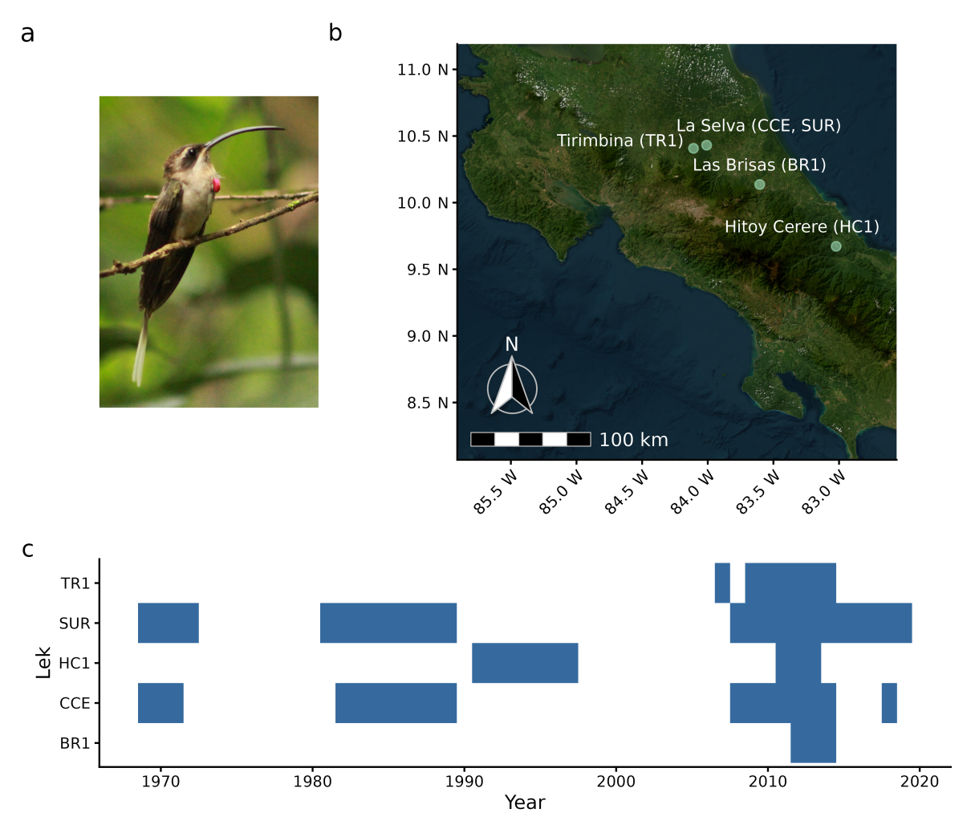
Figure 1. Study sites and historical sampling. a) A male Long-billed Hermit. b) Locations of the study leks in the Caribbean lowlands of Costa Rica. The leks found at each site are shown in parenthesis. c) Historical sampling of song records in each lek.

Methods

Data collection and song structure coding
Sound recordings of Long-billed Hermits were registered from 2008 to 2019, in five leks, distributed across four sites in the Caribbean slope of Costa Rica: La Selva Biological Station (leks SUR and CCE), Finca Las Brisas (BR1), Hitoy Cerere Biological Reserve (HC1) and Tirimbina Biological Reserve (TR1) (Fig. 1b). We also included historical recordings available for three of the studied leks at La Selva and Hitoy Cerere (Stiles and Wolf 1979). Recordings were gathered with different equipment at different points in time (i.e. shotgun or parabolic microphones, analog or digital recorders). Differences in recording equipment primarily affect the signal-to-noise ratio and the detectability of low-amplitude components of the signal. Because our analyses focus on the frequency contour of the dominant harmonics (see below), which are robust to such variation, differences among recording systems are unlikely to influence our acoustic analysis.
We classified the different sounds found within Long-billed Hermit songs according to their patterns of frequency modulation in the dominant harmonics. The classification first distinguished between two broad sound types: tonal sounds and trills, which are clearly observed in the spectrograms (Fig. 2) Within each sound type, we identified three subcategories. Trills were classified as slow, medium-paced or fast according to their oscillation rate, whereas tonal sounds were classified as upward, downward or flat according to the direction of frequency modulation (Fig. 2). This classification scheme yielded six discrete character states that enabled the representation of songs as ordered character strings for phylogenetic analysis. Songs were split into 20 equal-length segments, and each segment was assigned to one of the six character states based upon visual inspection of spectrograms (Fig. S1). The choice of 20 segments per song captured a compromise between our ability to discriminate sound categories, which increased with segment length, and the probability that a single sound type occurred within a segment, which decreased with segment length. We assessed the objectivity of sound classification by quantifying inter-observer agreement between two independent observers who classified a subset of songs. Agreement was quantified using Cohen's unweighted kappa coefficient, calculated with the kappa2 function in the R package irr (v0.84.1, Gamer et al. 2019).
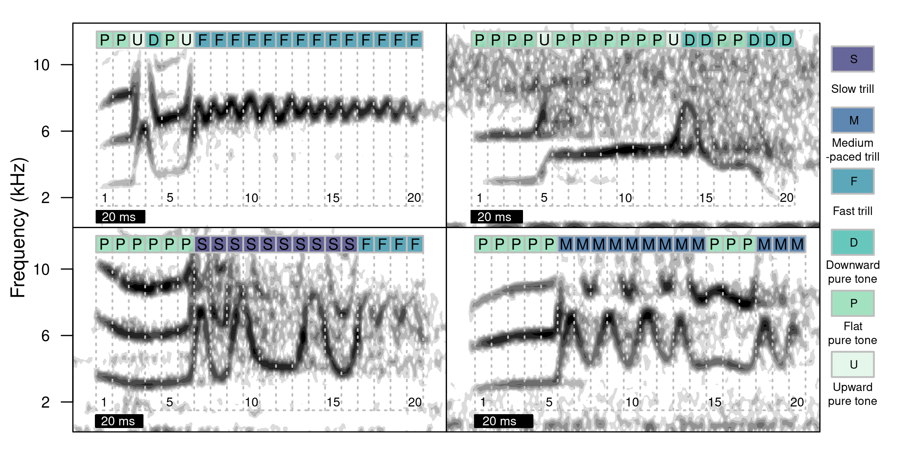
Figure 2. Spectrograms of four Long-billed Hermit songs from different song types. Each song was split into 20 equal-length segments, and each segment was assigned to one of six categories (shown on the left side) based on visual inspection of spectrograms.
To formally evaluate the assumption that leks operate as culturally cohesive units, we tested the prediction that song sequences were more similar among song types from the same lek and with less temporal separation (i.e. the time between their recorded occurrences) than among song types from different leks or with greater temporal separation. We quantified pairwise song sequence dissimilarity using Optimal Matching (OM) distances between all pairs of song sequences. Substitution costs were biologically informed, assigning lower penalties to substitutions within broad acoustic categories (pure tones or trills) than between categories, while insertion and deletion costs exceeded all substitution costs. Pairwise comparisons were restricted to songs recorded within the same study site, thereby allowing comparisons among leks that could potentially be visited by the same individuals. We modelled pairwise OM distance using a Bayesian linear regression model with a Gaussian response distribution, including whether songs originated from the same lek, the minimum temporal separation between recorded occurrences of the two song types, and their interaction as predictors. Because each song type appeared in multiple pairwise comparisons, we included a multi-membership varying-intercept effect for the pair of song types being compared, thereby accounting for the non-independence of pairwise observations involving the same song.

Sequence alignment
Alignment of behavioural sequences is complicated by the challenge of establishing homology between ethological units (Caetano and Beaulieu 2020). Here, we implemented and compared three alignment strategies based on two methods originally developed for multiple sequence alignment (MSA) of molecular data. In alignments of nucleotide and protein sequences, gaps represent insertion or deletion mutations, so that characters at gapped sites lack homology across the dataset. Commonly used MSA methods differ in their treatment of insertion and deletion events in ways that can impact homology inferences in cultural as well as in molecular characters (Löytynoja 2012). MAFFT (Katoh et al. 2002; Katoh and Standley 2013) uses a progressive alignment algorithm with a default gap-opening penalty (1.53) and no gap extension penalty by default, in versions > 6.626. The L-INS-i method follows the progressive alignment by iterative refinement, based on consistency and weighted sum-of-pairs scores. In MAFFT versions > 7.371 user-defined alphabets and scoring matrices can be implemented in addition of nucleotide and amino acid alternatives. MAFFT is therefore a flexible program to align behavioural sequences in which changes analogous to multi-site insertions and deletions have occurred, and which are composed by a variable number of characters and character states. In our first alignment strategy, which we hereafter refer to as 'MAFFT-agnostic', we used the MAFFT L-INS-i method with default gap penalties and a customized scoring matrix in which all transitions between alternative character states were equally likely.
Our second alignment strategy also used the L-INS-i algorithm implemented in MAFFT with default gap penalties, but incorporated biological assumptions about how Long-billed Hermit songs are culturally modified. Specifically, we assumed that when individuals modify pre-existing song types they are more likely to replace a trill with a different type of trill (i.e. change its pace) and a tonal sound with a different type of tonal sound (i.e. change it slope) than to switch between trills and tonal sounds. We implemented this assumption by specifying custom substitution costs that penalized mismatches between sound categories (trill vs. tonal sound) more strongly than mismatches within categories. To determine biologically realistic substitution costs, we developed an empirical optimization procedure designed that identified mismatch scores maximizing the difference between alignments of sequences from culturally related song types and alignments of sequences lacking cultural structure. This was achieved by comparing alignments of song sequences from song types recorded within the same lek with alignments of randomly assembled song sequences (hereafter simulated sequences). The rationale was that song types produced within a lek share cultural ancestry and therefore exhibit structural similarities, whereas randomly assembled song types should lack such resemblance. If insertion and deletion events accumulate through time as observed in molecular sequences (Löytynoja 2012), alignments of culturally related song types should require fewer inferred insertion–deletion events than alignments of unrelated sequences, resulting in shorter alignments with fewer gaps.
To generate a null expectation for unrelated sequences, we simulated song sequences that preserved key properties of the empirical data, including the distribution of segment types and segment lengths (number of segments), but were assembled randomly. For each candidate substitution matrix, we aligned both the empirical and simulated sequences using MAFFT and calculated the number of gaps introduced by the alignment. We then computed the difference in alignment length between empirical and simulated datasets and selected substitution costs that maximized this difference. We evaluated substitution costs for three classes of segment comparisons: identical segments, segments belonging to the same acoustic category, and segments belonging to different categories. Candidate substitution matrices were constructed such that similarity scores decreased monotonically across these classes, with the highest scores assigned to identical segments, intermediate scores assigned to substitutions within acoustic categories, and the lowest scores assigned to substitutions between different acoustic categories. The similarity scores that maximized the difference in alignment length between empirical and simulated song sequences were then used for sequence alignment. Score optimization was based on a dataset of 184 song sequences from 12 leks, including the focal five leks of the present study. We hereafter refer to this alignment strategy as 'MAFFT-optimal'.
For our third alignment strategy, we used the phylogenetically informed alignment program PRANK (Löytynoja and Goldman 2005, 2008). PRANK also uses a progressive algorithm but handles the placement of insertions and deletions differently, by using outgroup information in subsequent alignment steps. PRANK thus uses the sequence phylogeny to differentiate insertions from deletions, and thereby avoids site overmatching by penalizing insertions in a single stage of the alignment (Löytynoja and Goldman 2005). Unlike MAFFT, PRANK is an evolutionary aware program in that insertions, deletions and substitutions are modelled explicitly on a phylogenetic tree. However, PRANK does not support customized alphabets and substitution-rate matrices. To use PRANK, we assumed that tonal sounds can be treated as ambiguous between upward and downward tones, and medium-paced trills can similarly be treated as ambiguous between fast and slow trills. We therefore used IUPAC ambiguity codes for DNA nucleotides to rename song segments, with tonal sounds as purines and trills as pyrimidines. As per PRANK's defaults we used a TN93 nucleotide substitution model with empirical base frequencies and transition/transversion rate ratio (κ) = 2. Therefore, as in the 'MAFFT-optimal' alignment, the 'PRANK-TN93' alignment explicitly assumed a higher transition rate within trill and tonal sound categories than between them. For this alignment, we used the default gap-opening rate and extension probabilities (0.025 and 0.75 respectively), and we did not use the -F option which fixes inferred insertions but increases sensitivity to guide-tree accuracy.

Phylogenetic analysis
All phylogenetic analyses were conducted in RevBayes v. 1.0.12 and v. 1.1.0, a computation environment that uses probabilistic graphical models for Bayesian inference in phylogenetics and evolution (Höhna et al. 2016). Our phylogenetic model was a fossilized birth-death process (FBDP) which describes the joint prior distribution of the tree topology, divergence times and lineage sampling times before the present (Heath et al. 2014). In the FBDP, extant taxa and lineages sampled before the present are part of the same macroevolutionary process. For many applications of the FBDP, extinct and ancestral taxa can only be sampled through fossils. However, in the case of fast-evolving songs that are culturally transmitted among individuals, historical records of song types are equivalent to fossil data. Historical records contain song types that existed in the past and may be ancestral to extant song types or may represent lineages that have gone extinct. As in the FBDP with fossil data, the probability that a historical song type is an ancestor of extant song types depends on the rates of lineage turnover and the rate of recovery of historical records. This recovery rate is the rate at which ancestral song types are sampled from the lineage diversification process, and it is a random variable drawn from a prior distribution, analogous to the birth and death rates in a traditional birth-death model. Sampling ancestors as part of the same evolutionary process improves estimation of diversification and clock rates (Gavryushkina et al. 2014) and sampling character data from ancestors further improves estimates of divergence times in simulated data (Luo et al. 2020).
Our dataset of historical records of song types in hummingbird leks has three advantages over most fossil datasets used in phylogenetic analyses. First, there is no stratigraphic uncertainty. We can be certain that historical songs types occurred in the year when they were recorded. Second, there are no partial fossils. Songs recorded in the past are just as complete as the most recent ones, creating no additional ambiguity in their character states. Third, the historical record is relatively rich. In all leks, there are multiple years sampled consecutively, and in two leks (SUR and CCE) historical records go back to 1969 (Fig. 1c). Because leks are small and Long-billed Hermits are actively displaying their songs (Stiles and Wolf 1979), we can assume detection is nearly perfect and thus few or no song types were missed during the sampled years.
A possible complication in our analysis is that long gaps without sampling are interspersed in the three leks with deeper historical records (HC1, CCE and SUR). The temporal distribution of these ancestral samples is not unlike that of fossils, which are typically aggregated in discrete strata of exposed rocks (Holland 2016). The FBDP is robust to some forms of bias in fossil sampling, including non-continuous recovery (Heath et al. 2014). Nonetheless, to better understand the effects of deep, yet discontinuous historical sampling, we conducted all analyses for these leks both with the complete dataset, including long gaps without lineage sampling, and with the more recent and continuously sampled data. Finally, to investigate the general impact of sampling historical records on phylogenetic inference of song diversification, we the conducted an additional set of analyses using data from only terminal tips (i.e. songs types observed in the last year of sampling). For these analyses without historical records, we used the three leks (BR1, SUR and TR1) that had three or more distinct song types in their last year of sampling.
Another potential issue arises from the years with highly frequent sampling, in which identical song types could be sampled at multiple time points. This is uncommon for fossil data, as it would entail the discovery of fossils with the same character state combination in multiple horizons. Here, we focus on the results of analyses in which all historical occurrences are considered in the inference of the evolutionary process, including identical song types sampled in consecutive years. However, we also conducted all analyses accounting for each unique song type only at its earliest occurrence.
Phylogenetic analyses were conducted with all three alignment strategies (MAFFT-agnostic, MAFFT-optimal and PRANK-TN93) for each lek. We used an exponential prior with a rate = 10 for the speciation, extinction and historical sampling rates, and a broad uniform prior, bounded between 1000 and 0 years, on the root age of all leks. Song sequences were assumed to evolve under a generalised time-reversible (GTR) model with exchangeability rates and stationary frequencies drawn from a flat Dirichlet prior. Site-rate heterogeneity was modelled with a discretised gamma distribution with four rate categories and with equal shape and scale parameters, in turn drawn from an exponential prior with a rate = 10.
We tested both global and relaxed clocks for modeling song cultural diversification. Branch rates under the global clock were drawn from an exponential prior with rate = 10. Branch rates under the relaxed clock were uncorrelated and drawn from an exponential prior, with their mean drawn from an exponential hyperprior with rate = 10. We compared clock models using marginal likelihood approximation via the stepping stone algorithm (Xie et al. 2010). Clock-model comparisons were conducted for each lek (BR1, CCE, HC1, SUR, TR1), alignment (MAFFT-agnostic, MAFFT-optimal, PRANK-TN93), historical dataset (oldest records included, recent records only, no fossils) and use of historical records per song type (using all, using earliest). For diversification dynamics, tree comparisons and tests of model reliability (see below), we present results under the preferred clock model.
We conducted two independent MCMC runs for each analysis. For most leks, chains were run for 150,000 iterations following a burn-in of 50,000 iterations, with parameter tuning every 200 generations. For the two largest leks (SUR and CCE), longer runs were used to ensure convergence, consisting of 300,000 iterations following a burn-in of 100,000 iterations with tuning every 400 generations. To improve mixing, we used the Metropolis-Coupled MCMC sampler with three heated chains and default swapping parameters. To avoid autocorrelation in the posterior we saved samples every 100th iteration. We assessed MCMC performance using the package coda (v0.19.4.1, Plummer et al. 2006) in R (v4.0.4, R Core Team 2021). We checked for convergence between independent runs visually and using the Gelman-Rubin potential scale-reduction factor (psrf). We assumed convergence if psrf < 1.05 for all variables, as well as the multivariate estimate. We also inspected autocorrelations between draws (target < 0.1) and effective sample sizes (target > 200) for all model variables. We plotted trees for visual inspection using the package ggtree (Yu et al. 2017) and our summary using the package ggplot2 (Wickham 2016) in R.

Model reliability
We used predictive data simulations to test for absolute model fit, also implemented in RevBayes (Höhna et al. 2018a) v.1.2.2. During parameter inference, a Stochastic-Variable-Monitor stored the stochastic variable values for each posterior sample. Then, these values were used to simulate new datasets under the fitted model. We specified a thinning of two for the stochastic variable trace, thus simulating 3,000 datasets for the 'large' leks (CCE, SUR) and 1,500 datasets for the 'small' leks (BR1, HC1, TR1).
We present data-based test statistics comparing simulated and empirical datasets, as tests of absolute model fit. We calculated 10 such statistics: 1) the number of invariant sites in the alignment, 2) the number of segregating sites in the alignment, 3) the maximum length of invariant blocks, 4) the maximum length of variable blocks, 5) the number of invariant blocks, 6) the maximum pairwise difference between two sequences in an alignment, 7) the minimum pairwise difference between two sequences in an alignment, and three measurements of genetic diversity: 8) Watterson's θ, an estimate of the population mutation rate (Watterson 1975), 9) Tajima's D, a statistic used to test departures from neutral evolution (Tajima 1989), and 10) π, the average number of pairwise differences in the alignment, which is used to calculate Tajima's D and measures character diversity. For more details about these statistics and how they are calculated see Höhna et al. (2018a).
For each test, we report a posterior predictive effect size (PPES) and a two-tailed posterior predictive p-value (Höhna et al. 2018a). The PPES of each statistic corresponds to the difference between the median of the posterior distribution of simulated datasets and the empirical value, normalized by the standard deviation of the posterior distribution (Höhna et al. 2018a). The two-tailed posterior predictive p-value is calculated by first obtaining lower- and upper-tail p-values and multiplying the smaller of the one-tailed p-values by two. The lower one-tailed p-value is the proportion of simulated datasets in which the value for the test statistic is lower than or equal to the observed value. The upper one-tailed test is the proportion of simulated datasets in which the value for the test statistic is greater than or equal to the observed value. Especially with small datasets, it is possible that multiple simulated datasets produce the same test statistic as the empirical dataset. In these cases the smaller of the two one-tailed p-values could be greater than 0.5. When this occurred, the posterior predictive p-value was set to 1.

Treespace and parameter sensitivity
We explored tree topology congruence among different models by comparing topological distances between high posterior probability trees. Topologies were compared with the Robinson-Foulds distance (Robinson and Foulds 1981) with the R package phangorn v.2.11.1 (Schliep 2011). Topological distances were projected into a two-dimensional ordination representing topological space using Classic Multidimensional Scaling. Only tree tips shared by each pair of trees were considered when calculating distances. We estimated the overall spread of the topological space (i.e. space size) for different models as a metric of within-model topological congruence. Topological space size was quantified as the 95% kernel density area. We also calculated between-model topological congruence as the overlap of the topological space of each model and those from other models. Space overlap was estimated as the intersection-over-union of the two 95% kernel density areas (i.e. proportion of the joint area of two spaces that was shared). Topological congruence descriptors were calculated using the R package PhenotypeSpace v.0.1.0 (Araya-Salas and Odom 2022).
The effects of alignment strategy, historical sampling and clock model on these two topological space descriptors were evaluated using Bayesian linear regression models with each descriptor as the response variable (modelled with a Gaussian distribution), model alignment strategy, use of historical data, historical record completeness, and clock model as predictors and lek as a varying intercept effect (i.e. random effect). For the topological congruence model, we also included a multi-membership varying-intercept effect for the pair of models being compared, thereby accounting for the non-independence of pairwise comparisons involving the same phylogenetic model. We computed multiple comparisons of alignment strategies (similar to post hoc tests in frequentist statistics) using the joint posterior distribution of the model parameters. Regression models for topological space and song sequence similarity were run in Stan (Carpenter et al. 2017) through the R platform (R Core Team 2021) using the package brms v.2.22.0 (Bürkner 2017). We present effect size point estimates as median posterior estimates, and report 95% highest posterior density intervals (HPDIs) as a measure of uncertainty. Models were run on three chains for 2500 iterations following a warm-up of 2500 iterations using weakly informative priors. Effective sample size was kept above 3000 for all parameters. Potential scale reduction factor was used to assess model convergence and kept below 1.05 for all parameter estimates. Performance was checked visually by plotting the trace and distribution of posterior estimates for all chains. We also plotted the autocorrelation of successive sampled values to evaluate independence of posterior samples. Posterior predictive check plots were also used to inspect whether model predictions aligned with the distribution and variability of the observed data.
Finally, we asked if inferences of diversification dynamics and song cultural evolution were influenced by the use of different alignment strategies. To do this we compared the posterior distributions of parameter estimates among the MAFFT-agnostic, MAFFT-optimal and PRANK-TN93 alignment strategies. For diversification dynamics we compared speciation (i.e. song-type origination), extinction, and net diversification rates, as well as the age of the MRCA of all song types (hereafter 'root age', including extinct lineages) and the age of the MRCA of only extant song types (hereafter 'crown age', including songs present in the last year of sampling).

Results
We used the FBDP to model cultural change and diversification in five leks of the Long-billed Hermit. To do this we encoded song types as sequences of sound from six categories (Fig. 2). Classification was highly repeatable between the two observers (Cohen's κ = 0.926) who independently classifying the segments of 120 song types. A analysis of pairwise song sequence similarity supported the observed pattern that leks operate as cohesive cultural units. At zero temporal separation between recorded occurrences, song types from the same lek were more similar than song types from different leks (effect size: 0.031, uncertainty interval (UI): 0.022 to 0.039). Song sequence similarity decreased with temporal separation, and this decrease was stronger within leks than between leks (interaction effect size: -0.0006, UI: -0.0010 to -0.0002).
Leks differ markedly in size and in the length and completeness of their historical sampling records (Fig. 1d; 3). MCMC model diagnostics reflect this disparity. The MCMC analysis of the smallest lek (BR1) under the global clock model was the only scenario in which all model parameters met our mixing (autocorrelation < 0.1) and convergence (psrf < 1.05) criteria (Table S1). In larger leks and more complex models (i.e. relaxed clock) more model parameters, especially branch rate parameters, failed to meet the mixing, and to a lesser extent, the convergence criteria (Table S1). Nonetheless, in all but one analysis (SUR lek using the MAFFT-optimal alignment, all observations of all historical data and a global clock), estimation of the most relevant model parameters (likelihood, root age, crown age and diversification rates) converged between independent runs (Table S1). We therefore used these models to investigate absolute model fit, relative fit of alternative clock models, and the effects of alignment strategies and the historical record on topological convergence and diversification inferences. We return to the caveats in parameter estimation in the Discussion.
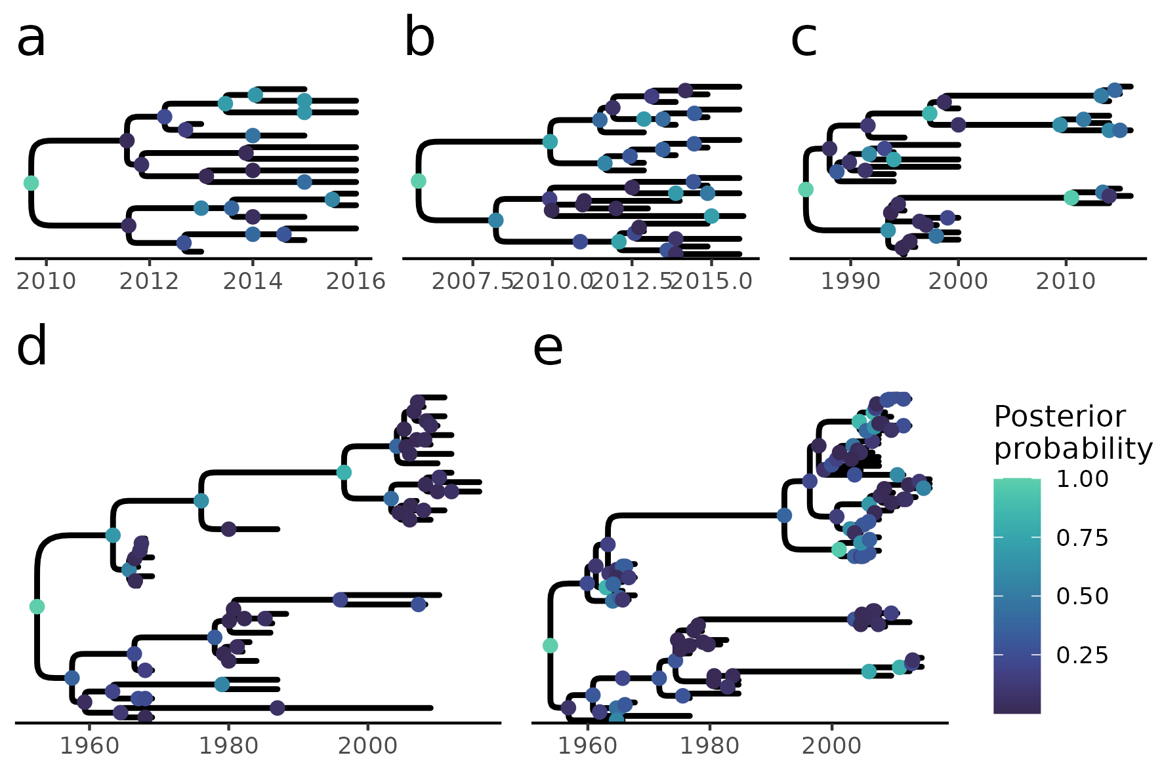
Figure 3. Maximum a posteriori (MAP) trees for each lek under a relaxed clock model and utilizing the entire historical song record and a phylogenetically informed alignment algorithm (PRANK). a) BR1, b) TR1, c) HC1, d) CCE, e) SUR.

Clock model selection
A relaxed clock model of song cultural evolution (in which different song lineages evolve at different rates) was generally supported, but the strength of this support depended on the historical record and sampling strategy. When historical data were entirely excluded, there was no increase in ML by relaxing the clock model (Fig. 4). However, the use of including historical data as ancestral samples resulted in greater support for the relaxed model, particularly when all historical data, including identical song types sampled in consecutive years, were incorporated in the macroevolutionary process (Fig. 4). While this trend was present in most leks and datasets, it tended to be stronger under the phylogenetically-informed PRANK-TN93 alignment, especially in the most extensively historically sampled lek (SUR). Hereafter, we present the results of analyses using the relaxed clock model.
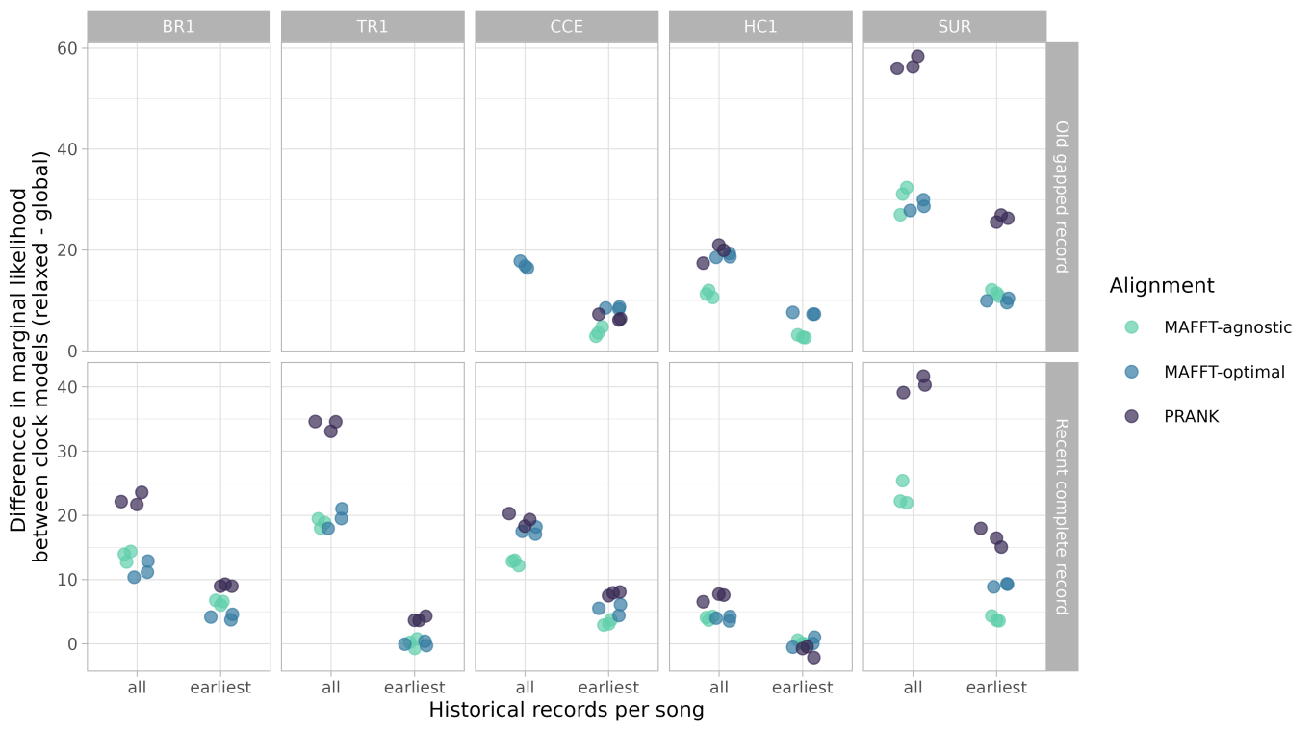
Figure 4. Relative fit of relaxed and global clock models in phylogenetic inference of song cultural evolution under the FBDP. The fit of alternative clock models was compared in five leks (BR1, TR1, HC1, CCE, and SUR) using marginal likelihood approximation. Two leks (BR1 and TR1) lacked deep historical data (no sampling "including oldest records") and three leks contained enough extant songs to estimate clock model fit using a BDP (without historical data).

Model reliability
Simulated data under our inference models accurately reflected certain features of most empirical datasets. Namely, the number of segregating and invariant sites, the maximum length of variable and invariant blocks and the minimum pairwise distance between sequences were generally in agreement between simulated and empirical data (Table 1; Fig. 5; Fig. S3-S32). The two measures of song segment diversity (Watterson's θ and π), analogous to population genetic diversity, were generally well reproduced by the models with the exception of about a third of the PRANK alignments, and four MAFFT-agnostic alignments, in which simulated data underestimated diversity (Fig. 6; Fig. S23-S29). Consequently, several of these alignments also resulted in relatively low values of Tajima's D in simulated data, consistent with our models overestimating the effect of drift (Fig. S30-32). Finally, the maximum pairwise distance between sequences was the data feature most often in conflict between simulated and empirical datasets (Fig. 7), and was overall underestimated in simulated data (Fig. S20-S22).

Table 1. Summary of absolute model fit statistics obtained by comparing properties of empirical data to posterior predictive data simulations.
Alignment | Historical record | Mean PPE | SD | Min | Max | Percent p-value > 0.05
MAFFT-agnostic | Old gapped | 0.63 | 0.79 | 0 | 3.23 | 0.97
MAFFT-agnostic | Recent complete | 0.82 | 0.86 | 0 | 3.94 | 0.91
MAFFT-agnostic | None | 0.53 | 0.55 | 0 | 2.10 | 1.00
MAFFT-optimal | Old gapped | 0.95 | 0.84 | 0 | 3.09 | 0.95
MAFFT-optimal | Recent complete | 0.85 | 0.83 | 0 | 3.93 | 0.88
MAFFT-optimal | None | 1.05 | 0.74 | 0 | 2.89 | 0.96
PRANK-TN93 | Old gapped | 1.00 | 0.87 | 0 | 4.37 | 0.92
PRANK-TN93 | Recent complete | 0.81 | 0.88 | 0 | 4.06 | 0.93
PRANK-TN93 | None | 1.36 | 1.04 | 0 | 3.68 | 0.70

Discrepancies between empirical and simulated data were found in all leks and alignment strategies (Fig. S3-S32). For the same lek and historical record, PRANK-TN93 alignments tended to result in relatively high song-segment diversity (π), in both empirical and simulated datasets. Nonetheless, such high song diversity was often underestimated, while the strength of drift in these alignments was overestimated, particularly in the TR1 lek (Fig. 6; Fig. S27-32). Similarly, where estimates of the maximum pairwise distance between songs were highest, mainly in PRANK-TN93 and MAFFT-optimal alignments, such song divergence tended to be underestimated (Fig. 7; Fig. S20-22).
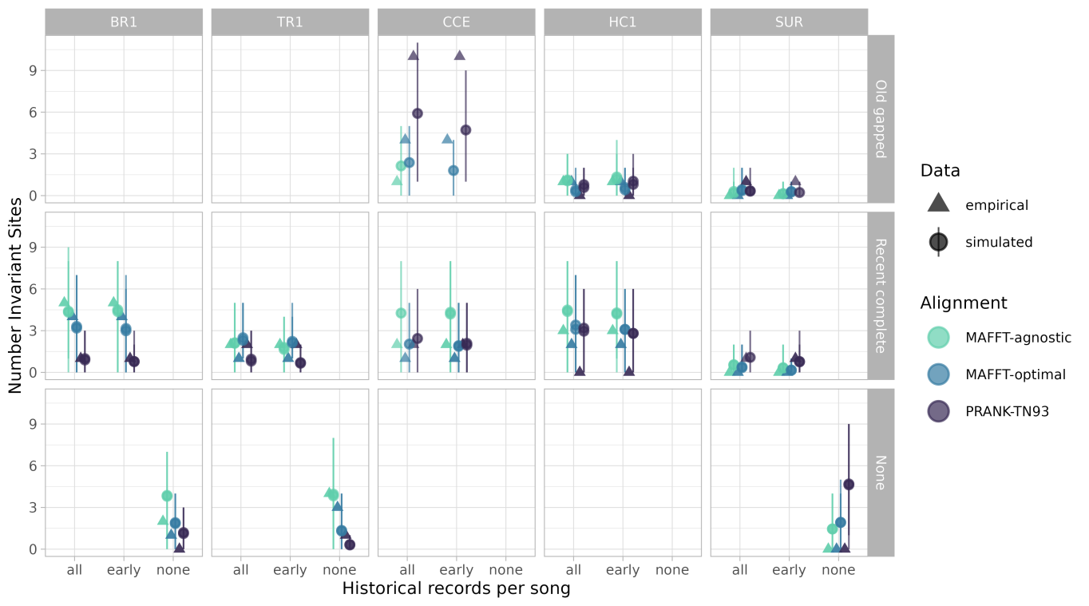
Figure 5. Number of invariant sites in empirical song data and posterior predictive data simulations (see Methods). For simulated data, we report the mean and 95% HPD interval of 1500 (BR1, TR1, HC1) or 3000 (CCE and SUR) simulations.
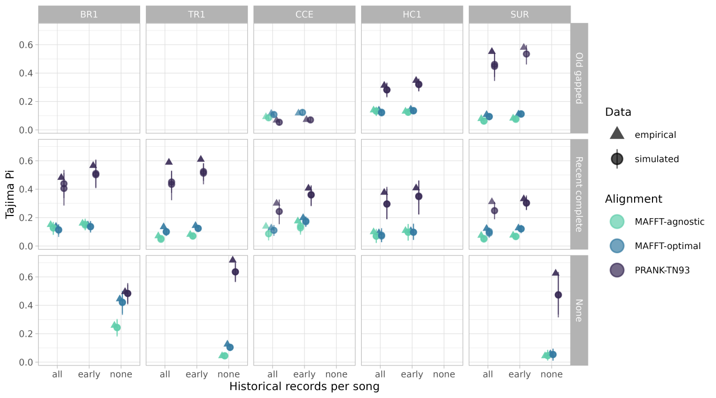
Figure 6. Song segment diversity (π) in empirical song data and posterior predictive data simulations (see Methods). For simulated data, we report the mean and 95% HPD interval of 1500 (BR1, TR1, HC1) or 3000 (CCE and SUR) simulations.
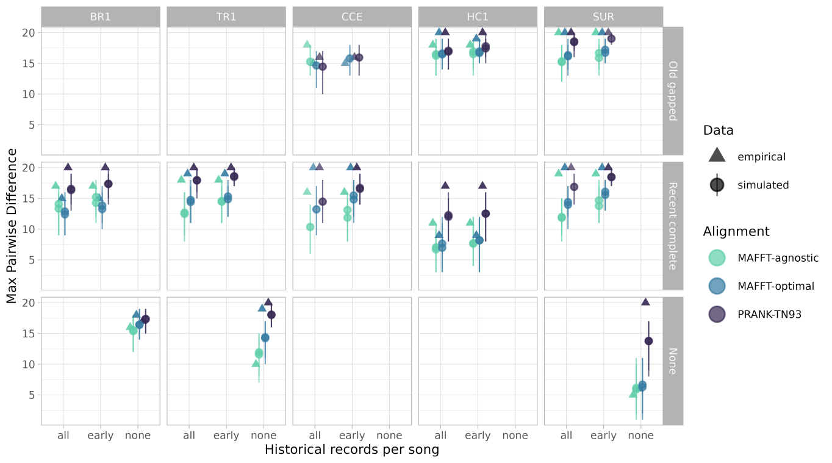
Figure 7. Maximum pairwise distance between songs in empirical song data and posterior predictive data simulations (see Methods). For simulated data, we report the mean and 95% HPD interval of 1500 (BR1, TR1, HC1) or 3000 (CCE and SUR) simulations.

Treespace congruence
The spread of the topological space increased when including all historical data (effect size: 0.031, UI: 0.023 - 0.040) and when including fossils (effect size: 0.012, UI: 0.005 - 0.019), but was not affected by the use of different clock models (effect size: -0.002, UI: -0.009 - 0.005). For the alignment strategy only the MAFFT-optimal alignment increased the spread of the topological space compared to the PRANK-TN93 alignment (effect size: -0.009, UI: -0.018 - 0.000) no other differences in topological space size were detected between alignment strategies (PRANK-TN93 vs. MAFFT-agnostic, effect size: -0.005, UI:-0.014 - 0.003; MAFFT-optimal vs. MAFFT-agnostic, effect size: 0.004, UI: -0.005 - 0.013). The dissimilarity of the topological space between models increased by the inclusion of all historical data (effect size: 0.174, UI: 0.130 - 0.224) and fossils (effect size: 0.176, UI: 0.119 - 0.235), but not by the use of different clock models (effect size: 0.030, UI: -0.015 - 0.076). The PRANK-TN93 alignment increased topological space dissimilarity when compared to both MAFFT-optimal (effect size: 0.102, UI: 0.045 - 0.159) and MAFFT-agnostic alignments (effect size: 0.110, UI: 0.043 - 0.180), but did not differ between the MAFFT alignments (effect size: 0.008, UI: -0.049 - 0.067).

Diversification dynamics
Diversification rates and divergence times were sensitive to historical information. In the three leks in which analyses without historical data could be conducted (BR1, TR1, SUR), inference excluding historical data resulted in much slower speciation and extinction rates and markedly more uncertain root ages, in comparison to analyses including historical data (Fig. 8; S33-S35). For the three leks in which a long but discontinuously sampled historical data could be contrasted with a shorter but complete record (CCE, HC1, and SUR), the inclusion of more ancient song types resulted in older crown and root age estimates (Fig. 8; S33-S35). In contrast, strong effects of alignment strategies were found in only two leks. In the largest lek (SUR), the PRANK-TN93 alignment led to a moderate decrease in speciation and extinction rates and a relatively strong increase in divergence times (Fig. 9). In the HC1 lek both the PRANK-TN93 and MAFFT-optimal alignments caused older crown age estimates (Fig. 9), compared to the MAFFT-agnostic alignment. Finally, sampling all historical occurrences, as opposed to only the earliest occurrence of each unique song, resulted in increased speciation and extinction rates and slightly more precise estimates of divergence times (Fig. 10; Fig. S36-S38).
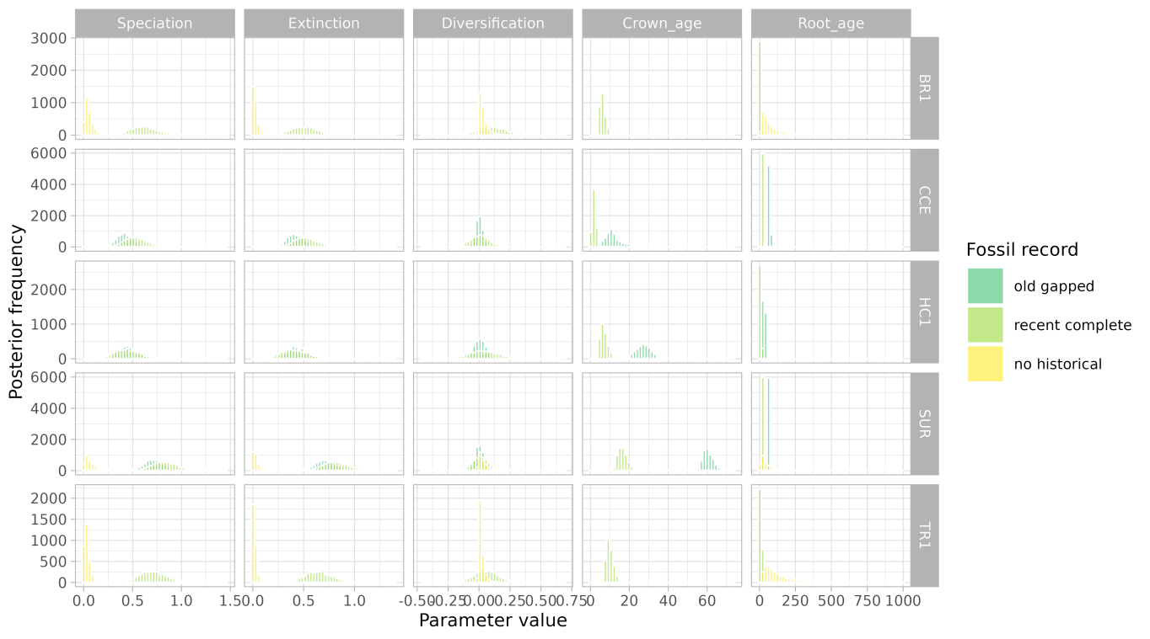
Figure 8. Age and diversification estimates under different sets of historical data in five leks of the Long-billed Hermit. Histograms show posterior distributions of parameter estimates in models using a relaxed molecular clock and the PRANK-TN93 alignment strategy. For analyses including historical data, all occurrences of historical song types are included.
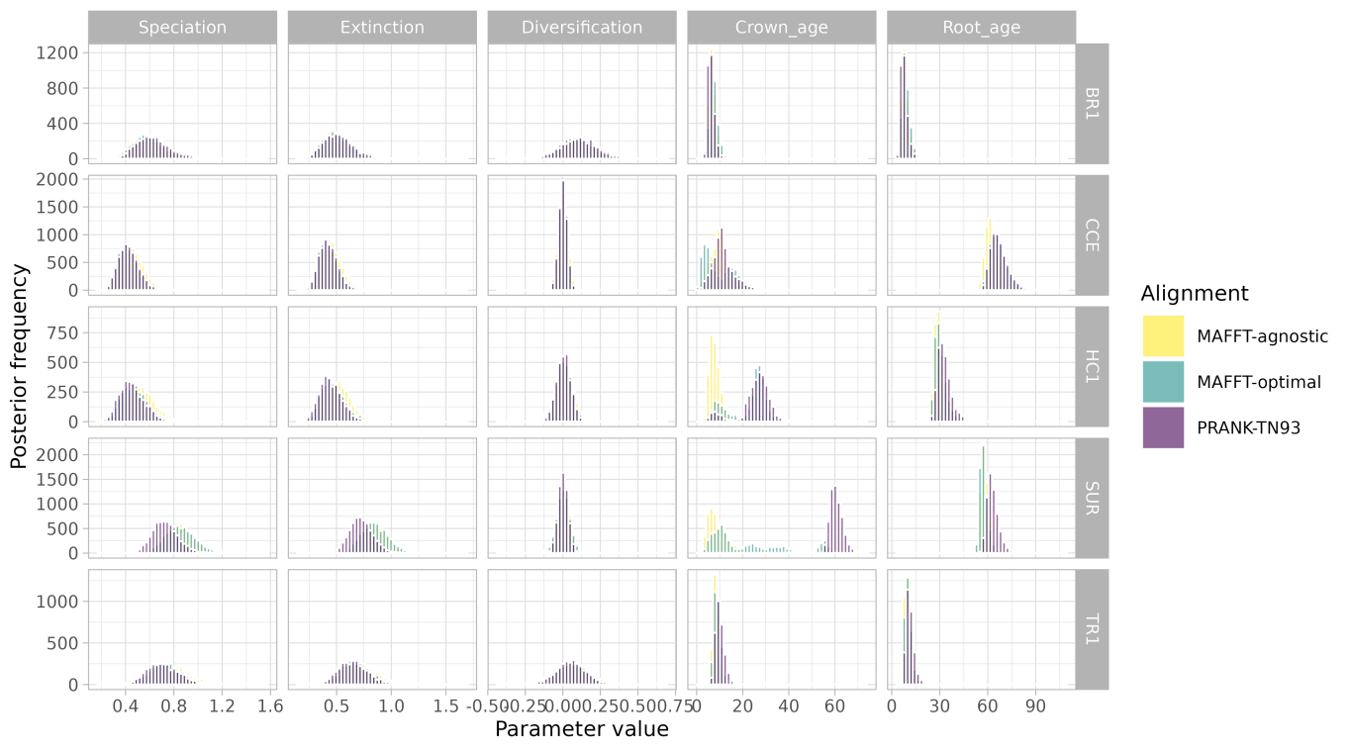
Figure 9. Age and diversification estimates under different alignment strategies in five leks of the Long-billed Hermit. Histograms show posterior distributions of parameter estimates in models using a relaxed molecular clock and all historical data. All available historical data are included in the analysis.
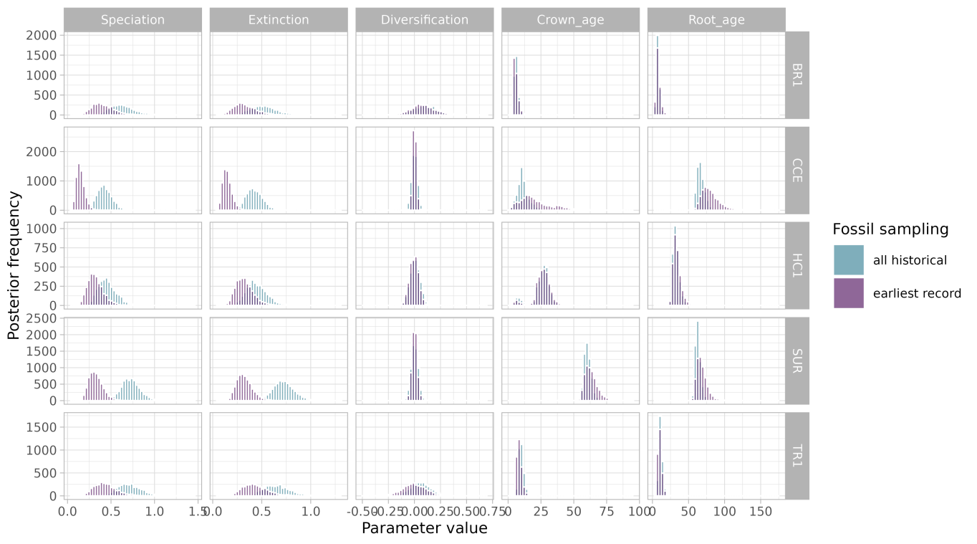
Figure 10. Age and diversification estimates of songs in five leks of the Long-billed Hermit. Histograms show posterior distributions of parameter estimates in models using a relaxed molecular clock and the PRANK-TN93 alignment strategy. We compare analyses using all occurrences of historical song types, including identical song types sampled serially, and analyses including each unique song type at its earliest occurrence.

Discussion
Many researchers view cultural change as a process akin to organic evolution (Guillo 2007; Lewens 2015; Bradie and Bouzat 2016). However, a basic prediction of this parallel has largely evaded scrutiny. We typically do not know whether evolutionary models and especially phylogenetic models applied to cultural change capture the most prominent features of this process (Mace and Holden 2005; Collard et al. 2008). Here, we address this question using the socially learnt songs of the Long-billed Hermit in multiple independent leks, and a phylogenetic model, the fossilized birth-death process, that is particularly suitable for serially-sampled data. We found that these phylogenetic models are overall reliable, although they tend to underestimate song segment diversity and song divergence in some scenarios. We also asked how the historical data, analogous to the fossil record, and alignment strategies, ported from molecular phylogenetics, influence parameter estimation. In line with theoretical expectations (Heath et al. 2014), including historical data resulted in more precise root-age estimates (Fig. 8), a higher rate of lineage divergence ('speciation') and extinction (Fig. 8). Our analyses with historical data also lent support for heterogeneous branch rates (Fig. 4). Including older historical data also resulted in deeper divergence times (Fig. 8). In contrast, alignment strategies had a strong effects on tree topology, but only weak to moderate effects on diversification dynamics (Fig. 9).
Posterior predictive simulations suggested that the FBDP is a plausible model for cultural change in the Long-billed Hermit. Nearly 90% of posterior predictive effect sizes (PPEs) between empirical and simulated data under the FBDP were below 2.00 (mean PPE = 0.84, sd = 0.85, min = 0, max = 4.37; Table 1). Moreover, only one scenario, in which all historical data were excluded (SUR, PRANK-TN93 alignment), produced consistent evidence for model inadequacy in data-based posterior predictive checks (Fig. S3-S32). Even though tests of model adequacy are important safeguards against estimation biases (Carstens et al. 2022), tools for their implementation in Bayesian phylogenetics are relatively new (Höhna et al. 2018b; Duchêne et al. 2019). To our knowledge, these tools have been advocated (Bouckaert et al. 2019) but not yet utilized in cultural phylogenetics. When applied to molecular and morphological phylogenetics, posterior predictive checks often reveal a wide range of model fits, depending on the locus (or trait) and clade analyzed (Richards et al. 2018; May et al. 2021; Khouri et al. 2022). We were therefore surprised to find that FBD models were similarly adequate in most of our datasets, ranging from 8 song sequences (TR1 without historical data) to 100 song sequences (SUR with all available data). Nonetheless, our phylogenetic models failed to reproduce some diversity features of the data (π and Tajima's D) in datasets in which such diversity was relatively high. Interestingly, the main source of variation in song-segment diversity was not the lek identity or the use of historical data, but the alignment strategy (Fig. 6). Phylogenetically informed PRANK-TN93 alignments were generally more compact (Table S1), increasing the average number of mismatched positions in song alignments, and consequently increasing π and Tajima's D, but reducing model fit, compared to MAFFT alignments.
In addition to some measures of model adequacy, alignment strategies strongly influenced tree topology and age estimates for the ancestor of extant song types, in the two leks with deeper historical records (SUR and CCE). In leks with historical records that spanned multiple decades (SUR, CCE, HC1), topologies based on PRANK-TN93 alignments were markedly distinct from topologies based on phylogenetically naive MAFFT alignments. In smaller leks with shallower historical data (BR1 and TR1), the two alignment strategies that enforced a lower substitution rate between trills and tonal sounds (PRANK-TN93 and MAFFT-optimal) resulted in relatively similar topologies. In a recent study that compared alternative MSA programs for ancestral protein sequence reconstruction, variations of PRANK and MAFFT algorithms had the highest overall performance (Vialle et al. 2018). However, the two methods were affected in different ways by the underlying substitution process and characteristics of the tree (Vialle et al. 2018). Because leks seem to evolve largely independently, differences in the processes of cultural modification of song types and varying tree topologies are also expected to result in a variation in alignment performance even within a single species. Our conflicting results between alignment strategies thus underscore one of the foremost challenge for cultural phylogenetics with behavioral sequences: establishing homology in sequence subunits. Interestingly, despite the strong influence of alignment strategy on tree topology, its effects on diversification dynamics were comparatively modest. This suggests that alignment uncertainty primarily affects hypotheses of historical relationships among song types, whereas estimates of diversification dynamics may be relatively robust.
In most phylogenetic analyses, a multiple sequence alignment is treated as an observation, and alignment uncertainty is ignored (but see Redelings 2021). However, for phenotypic sequences establishing homology can be a daunting challenge, even when characters are unambiguously coded (Caetano and Beaulieu 2020). Furthermore, because culture can change independently of genetic evolution (Laland et al. 2010), guiding phenotypic sequence alignments with independently estimated molecular trees might be problematic. Comparing alternative alignment strategies across multiple cultural datasets as we have done here, is a step towards understanding the robustness of cultural phylogenetic analyses. However, just as for phylogenetic models, developing tools to assess the adequacy of alignment methods is crucial for a broader application of phylogenetic approaches to cultural sequences. In the case of socially learnt bird songs, alignment methods can be informed by a growing mechanistic understanding of learning, sound production and perception (Podos et al. 2009; Cate 2021). In humans, alignment methods have been tailored to particular cultural domains and used to identify large-scale patterns in melody evolution (Savage et al. 2022) and to resolve deep ancestral relationships between language families (Jäger 2015). In addition to developing specific alignment approaches for different cultural domains, phylogenetic methods that incorporate alignment uncertainty can be implemented to reduce biases in homology hypotheses of behavioural sequences (Caetano and Beaulieu 2020).
Our analyses of socially learnt bird songs make three further assumptions, dictated by the phylogenetic models we sought to apply. First, we discretised songs of variable duration (0.08 - 0.13 s) into 20 characters, each belonging to one of six categories. This conveniently allowed us to model the cultural diversification of song types as a substitution process, and was justified by the distinctiveness of sound categories and high repeatability of character coding. However, focusing on substitutions may obscure some cultural changes in song composition. If learning birds modify their song template by extending or contracting particular segments, these changes will introduce indels in the alignment which do not contribute to the modelled evolutionary process.
Second, we assumed that song segments along a sequence evolve independently of one another. Mechanical, cognitive and functional constraints on song sequence my falsify this assumption. For example, it is likely that if a bird slows down the first trill of a series of consecutive trills, subsequent trills will also be replaced, because sequences containing consecutive trills with different pacing appear to be rare. Similarly, rapid alternations between tonal sounds and trills may be prevented by physiological constraints, thus biasing substitution rates based on the identity of nearby sites. The consequences of such site epistasis have been studied mainly in the context of protein evolution, where structure and function generate coevolutionary dynamics among sites (Pollock et al. 1999). In protein evolution, incorrectly assuming site independence can result in biased estimation of site-wise substitution rates (Sullivan and Swofford 2001; Baele 2012), with potential consequences for ancestral sequence reconstruction, clock rate estimation and topological inference (Roure and Philippe 2011; Nasrallah and Huelsenbeck 2013). Properties of songs and other behavioral sequences that arise from interactions between subunits (e.g., elements within multi-element songs or acoustic components within single elements) may create transmission biases for particular subunit combinations, potentially resulting in model mispecification of traditional substitution models. Evolutionary models that relax the assumption of site independence may thus also be of applicability for cultural phylogenetics.
Finally, our study assumes that songs diversify in a tree-like manner, with no horizontal transfer. For the Long-billed Hermit system, this means that juvenile males introduce changes to their learning templates independently of other song types they may have heard within or outside their lek. We do not know whether males learn by modifying a single song template or whether new song types can arise by combining segments from multiple templates. Nonetheless, our analysis of pairwise song sequence similarity provides independent support for the former scenario. Song types from the same lek were consistently more similar than song types from neighbouring leks, but accumulated sequence differences more rapidly through time. These results are consistent with a scenario in which new song types arise primarily through modification of existing song types within a lek rather than through frequent exchange among neighbouring leks. Interestingly, the only Long-billed Hermit male that has been observed establishing territories in two different leks adopted a song type from the new lek after moving (M.A.-S., pers. obs.), suggesting that social pressures favour conformity to the local song repertoire. However, these results do not completely rule out the use of song types from other leks as additional learning input, nor occasional horizontal transfer. Nonetheless, cultural phylogenetic models may be robust to moderate levels of horizontal transfer, as suggested both by the relatively high absolute fit of our models (Table 1) and by previous simulation studies. An early study based on cladistics showed that datasets across different cultural domains had a similar fit to a tree-like diversification process as biological datasets (Collard et al. 2006). Furthermore, cultural phylogenies appear robust to realistic levels of horizontal transfer (Greenhill et al. 2009). Further assessments of the robustness of cultural phylogenetics to observed levels of horizontal transfer and reticulate evolution are warranted, as well as exploration of recently developed methods that explicitly accommodate such processes (Baudet et al. 2015; Nakhleh 2017).
Culture often change rapidly compared to morphology (Bonner 1980; Whiten 2019). Thus, cultural phylogenetics studies can often tap on a relatively rich historical record, obtained from archeological preservation (in humans) or from longitudinal studies. Historical records in our longitudinal sampling of Long-billed Hermit songs have some advantages over traditional fossils, such as complete character sequences and no stratigraphic uncertainty. Our study also shares some of the challenges of phylogenetic inference with fossils, like time-heterogeneous preservation. We thus expected that historical song records would impact estimates of node ages and diversification rates to at least the same extent as total-evidence approaches under the FBDP influence the same parameters in organic lineages. We found that incorporating historical data resulted in more precise root age estimates, as commonly observed in total-evidence dating analyses under the FBDP (Ronquist et al. 2016; Zhang et al. 2016b; Barido-Sottani et al. 2023). Furthermore, by sampling ancestral lineages that formed and went extinct before the present, the historical song record also accelerated estimates of both speciation and extinction, but without effects on net diversification (Fig. 8). Our results therefore suggest that, unlike many biological radiations in which diversity accumulates through time, stable cultural systems may experience approximately balanced rates of cultural lineage origination and loss, potentially maintained by social processes such as conformity, sexual selection, and kin recognition (Baker and Cunningham 1985; Garland and McGregor 2020; Williams 2021).
We were also interested in understanding how decisions on how to use available historical records would impact estimation of node ages. We found that including older but sporadically sampled records resulted in older estimates of crown and root ages for all leks with such data (CCE, HC1 and SUR; Fig. 8). In contrast, accounting for all historical occurrences, including identical sequences sampled on different years, increased only the precision of age estimates (crown and origin) in the two largest leks (CCE and SUR; Fig. 10). In fact, the main consequence of using all historical occurrences was to increase support for a relaxed clock model, as clock rates must differ between branches separating identical songs and branches in which substitutions occurred.
Simulation studies show that accounting for all possible fossil occurrences (O'Reilly et al. 2018) and sampling fossils at regular time intervals (Luo et al. 2023) bolster the accuracy of phylogenetic inference of organic evolution under the FBDP. These sampling practices, especially the latter, may be prohibitive for some organic clades. Here, we based our analyses on pre-existing data, most of which was collected before the methods we used were even developed. However, future cultural phylogenetics studies based on longitudinal data can incorporate these best sampling strategies in their design, and more systematically assess how the availability and regularity of historical records impact age estimates of cultural lineages.
Our study demonstrates that phylogenetic models originally developed for biological evolution can be successfully adapted to investigate the diversification of culturally transmitted behaviours. By explicitly evaluating key assumptions—including the role of historical sampling, sequence alignment, and the independence of cultural lineages—we identify conditions under which these models produce robust evolutionary inferences. As historical behavioural datasets continue to expand, integrating phylogenetic methods with long-term records offers a powerful framework for reconstructing the tempo and mode of cultural evolution across a broad diversity of socially learned behaviours.

Acknowledgements
… B.W. is funded by an International Postdoc Grant (2019-06444) from the Swedish Research Council (Vetenskaprådet). … UCR (VI) project. …

Author contributions
B.W. and M.S.A. conceived the study. M.S.A. collected the data with support from A.R.G.. M.S.A. and B.W. analyzed the data and wrote the manuscript with contributions from A.R.G..

References
Aplin L.M. 2019. Culture and cultural evolution in birds: A review of the evidence. Animal Behaviour. 147:179–187.
Araya-Salas M., Odom K. 2022. PhenotypeSpace: An r package to quantify and compare phenotypic trait spaces.
Araya-Salas M., Smith-vidaurre G., Mennill D.J., Cahill J., Gonzalez-Gomez P.L., Wright T.F. 2019. Social group signatures in hummingbird displays provide evidence of co-occurrence of vocal and visual learning. Proceedings of the Royal Society B: Biological Sciences. 286.
Araya-Salas M., Wright T. 2013. Open-ended song learning in a hummingbird. Biology Letters. 9:20130625.
Baele G. 2012. Context-dependent evolutionary models for non-coding sequences: An overview. Evolutionary Biology. 39:1–19.
Baker M.C., Cunningham M.A. 1985. The biology of bird-song dialects. Behavioral and Brain Sciences. 8:85–100.
Barido-Sottani J., Żyła D., Heath T.A. 2023. Estimating the age of poorly dated fossil specimens and deposits using a total-evidence approach and the fossilized birth–death process. Systematic Biology. 72:466–481.
Baudet C., Donati B., Sinaimeri B., Crescenzi P., Gautier C., Sagot M.-F. 2015. Cophylogenetic reconciliation with transfers, losses, and duplications. Journal of Computational Biology. 22:1005–1024.
Bonner J.T. 1980. The evolution of culture in animals. Princeton, NJ: Princeton University Press.
Bouckaert R., Vaughan T.G., Barido-Sottani J., Duchêne S., Fourment M., Gavryushkina A., Heled J., Jones G., Kühnert D., De Maio N., Matschiner M., Mendes F.K., Müller N.F., Ogilvie H.A., Plessis L. du, Popinga A., Rambaut A., Rasmussen D., Siveroni I., Suchard M.A., Wu C.-H., Xie D., Zhang C., Stadler T., Drummond A.J. 2019. BEAST 2.5: An advanced software platform for bayesian evolutionary analysis. PLoS Computational Biology. 15:e1006650.
Boyd R., Richerson P.J. 1985. Culture and the Evolutionary Process. Chicago: The University of Chicago Press.
Bradie M., Bouzat J.L. 2016. Patterns and processes in cultural evolution. Evolutionary Biology. 43:307–315.
Bromham L., Duchêne S., Hua X., Ritchie A.M., Duchêne D.A., Ho S.Y.W. 2018. Bayesian molecular dating: Opening up the black box. Biological Reviews. 93:1165–1191.
Bürkner P.-C. 2017. Bayesian Distributional Non-Linear Multilevel Modeling with the R Package brms. arXiv.:1705.11123.
Caetano D.S., Beaulieu J.M. 2020. Comparative analyses of phenotypic sequences using phylogenetic trees. The American Naturalist. 195:E38–E50.
Carpenter B., Gelman A., Hoffman M.D., Lee D., Goodrich B., Betancourt M., Brubaker M., Guo J., Li P., Riddell A. 2017. Stan: A probabilistic programming language. Journal of Statistical Software. 76.
Carstens B.C., Smith M.L., Duckett D.J., Fonseca E.M., Thomé M.T.C. 2022. Assessing model adequacy leads to more robust phylogeographic inference. Trends in Ecology & Evolution.
Catchpole C.K., Slater P.J.B. 2003. Bird song: Biological themes and variations. Cambridge: Cambridge University Press.
Cate C. ten. 2021. Re-evaluating vocal production learning in non-oscine birds. Philosophical Transactions of the Royal Society B. 376:20200249.
Cavalli-Sforza L.L., Feldman M.W. 1981. Cultural transmission and evolution: A quantitative approach. Princeton: Princeton University Press.
Chatzou M., Magis C., Chang J.-M., Kemena C., Bussotti G., Erb I., Notredame C. 2016. Multiple sequence alignment modeling: Methods and applications. Briefings in Bioinformatics. 17:1009–1023.
Collard M., Shennan S.J., Buchanan B. 2008. Evolutionary biological methods and cultural data. In: Bentley R.A., Maschner H.D.G., Chippindale C., editors. Handbook of archaeological theories. AltaMira Press. p. 67–90.
Collard M., Shennan S.J., Tehrani J.J. 2006. Branching, blending, and the evolution of cultural similarities and differences among human populations. Evolution and Human Behavior. 27:169–184.
Darwin C. 1871. The descent of man and selection in relation to sex. J. Murray.
Duchêne S., Bouckaert R., Duchêne D.A., Vaughan T.G., Stadler T., Drummond A.J. 2019. Phylodynamic model adequacy using posterior predictive simulations. Systematic Biology. 68:358–372.
Gamer M., Lemon J., Singh I.F.P. 2019. Irr: Various coefficients of interrater reliability and agreement.
Garland E.C., McGregor P.K. 2020. Cultural transmission, evolution, and revolution in vocal displays: Insights from bird and whale song. Frontiers in Psychology. 11:544929.
Garland E.C., Rendell L., Lamoni L., Poole M.M., Noad M.J. 2017. Song hybridization events during revolutionary song change provide insights into cultural transmission in humpback whales. Proceedings of the National Academy of Sciences. 114:7822–7829.
Gavryushkina A., Heath T.A., Ksepka D.T., Stadler T., Welch D., Drummond A.J. 2017. Bayesian total-evidence dating reveals the recent crown radiation of penguins. Systematic biology. 66:57–73.
Gavryushkina A., Welch D., Stadler T., Drummond A.J. 2014. Bayesian inference of sampled ancestor trees for epidemiology and fossil calibration. PLoS Computational Biology. 10:e1003919.
Gjesfjeld E., Chang J., Silvestro D., Kelty C., Alfaro M. 2016. Competition and extinction explain the evolution of diversity in American automobiles. Palgrave Communications. 2:1–6.
Gjesfjeld E., Silvestro D., Chang J., Koch B., Foster J.G., Alfaro M.E. 2020. A quantitative workflow for modeling diversification in material culture. PloS one. 15:e0227579.
Gray R.D., Greenhill S.J., Ross R.M. 2007. The pleasures and perils of Darwinizing culture (with phylogenies). Biological Theory. 2:360–375.
Greenhill S.J., Currie T.E., Gray R.D. 2009. Does horizontal transmission invalidate cultural phylogenies? Proceedings of the Royal Society B: Biological Sciences. 276:2299–2306.
Guillo D. 2007. Is cultural evolution analogous to biological evolution? A critical review of memetics. Intellectica. 46:151–173.
Heath T.A., Huelsenbeck J.P., Stadler T. 2014. The fossilized birth–death process for coherent calibration of divergence-time estimates. Proceedings of the National Academy of Sciences. 111:E2957–E2966.
Höhna S., Coghill L.M., Mount G.G., Thomson R.C., Brown J.M. 2018b. P3: Phylogenetic posterior prediction in RevBayes. Molecular Biology and Evolution. 35:1028–1034.
Höhna S., Coghill L.M., Mount G.G., Thomson R.C., Brown J.M. 2018a. P3: Phylogenetic posterior prediction in RevBayes. Molecular Biology and Evolution. 35:1028–1034.
Höhna S., Landis M.J., Heath T.A., Boussau B., Lartillot N., Moore B.R., Huelsenbeck J.P., Ronquist F. 2016. RevBayes: Bayesian phylogenetic inference using graphical models and an interactive model-specification language. Systematic Biology. 65:726–736.
Holland S.M. 2016. The non-uniformity of fossil preservation. Philosophical Transactions of the Royal Society B: Biological Sciences. 371:20150130.
Jäger G. 2015. Support for linguistic macrofamilies from weighted sequence alignment. Proceedings of the National Academy of Sciences. 112:12752–12757.
Jesmer B.R., Merkle J.A., Goheen J.R., Aikens E.O., Beck J.L., Courtemanch A.B., Hurley M.A., McWhirter D.E., Miyasaki H.M., Monteith K.L., others. 2018. Is ungulate migration culturally transmitted? Evidence of social learning from translocated animals. Science. 361:1023–1025.
Katoh K., Misawa K., Kuma K., Miyata T. 2002. MAFFT: A novel method for rapid multiple sequence alignment based on fast Fourier transform. Nucleic acids research. 30:3059–3066.
Katoh K., Standley D.M. 2013. MAFFT multiple sequence alignment software version 7: Improvements in performance and usability. Molecular Biology and Evolution. 30:772–780.
Kershenbaum A., Blumstein D.T., Roch M.A., Akçay C., Backus G., Bee M.A., Bohn K., Cao Y., Carter G., Cäsar C., Coen M., Deruiter S.L., Doyle L., Edelman S., Ferrer-i-Cancho R., Freeberg T.M., Garland E.C., Gustison M., Harley H.E., Huetz C., Hughes M., Hyland Bruno J., Ilany A., Jin D.Z., Johnson M., Ju C., Karnowski J., Lohr B., Manser M.B., Mccowan B., Mercado E., Narins P.M., Piel A., Rice M., Salmi R., Sasahara K., Sayigh L., Shiu Y., Taylor C., Vallejo E.E., Waller S., Zamora-Gutierrez V. 2016. Acoustic sequences in non-human animals: A tutorial review and prospectus. Biological Reviews. 91:13–52.
Khouri Z., Gillung J.P., Kimsey L.S. 2022. The evolutionary history of mammoth wasps (Hymenoptera: Scoliidae). BioRxiv.
Kidwell S.M., Holland S.M. 2002. The quality of the fossil record: Implications for evolutionary analyses. Annual Review of Ecology and Systematics. 33:561–588.
Laland K.N., Hoppitt W. 2003. Do animals have culture? Evolutionary Anthropology: Issues, News, and Reviews. 12:150–159.
Laland K.N., Williams K. 1997. Shoaling generates social learning of foraging information in guppies. Animal Behaviour. 53:1161–1169.
Laland K., Odling-Smee J., Myles S. 2010. How culture shaped the human genome: bringing genetics and the human sciences together. Nature Reviews Genetics. 11:137–148.
Lewens T. 2015. Cultural evolution: Conceptual challenges. Oxford: Oxford University Press.
Ligon R.A., Diaz C.D., Morano J.L., Troscianko J., Stevens M., Moskeland A., Laman T.G., Scholes E. 2018. Evolution of correlated complexity in the radically different courtship signals of birds-of-paradise. PLOS Biology. 16:e2006962.
Löytynoja A. 2012. Alignment Methods: Strategies, Challenges, Benchmarking, and Comparative Overview. In: Anisimova M., editor. Evolutionary genomics: Statistical and computational methods, volume 1. Totowa, NJ: Humana Press. p. 203–235.
Löytynoja A., Goldman N. 2005. An algorithm for progressive multiple alignment of sequences with insertions. Proceedings of the National Academy of Sciences of the United States of America. 102:10557–10562.
Löytynoja A., Goldman N. 2008. Phylogeny-aware gap placement prevents errors in sequence alignment and evolutionary analysis. Science. 320:1632–1635.
Luncz L.V., Boesch C. 2014. Tradition over trend: Neighboring chimpanzee communities maintain differences in cultural behavior despite frequent immigration of adult females. American Journal of Primatology. 76:649–657.
Lunter G., Miklós I., Drummond A., Jensen J.L., Hein J. 2005. Bayesian coestimation of phylogeny and sequence alignment. Bmc Bioinformatics. 6:1–10.
Luo A., Duchêne D.A., Zhang C., Zhu C.-D., Ho S.Y.W. 2020. A simulation-based evaluation of tip-dating under the fossilized birth–death process. Systematic Biology. 69:325–344.
Luo A., Zhang C., Zhou Q.S., Ho S.Y.W., Drummond A.J. 2023. Impacts of taxon-sampling schemes on bayesian tip dating under the fossilized birth–death process. Systematic Biology. 72:781–797.
Lutzoni F., Wagner P., Reeb V., Zoller S. 2000. Integrating ambiguously aligned regions of DNA sequences in phylogenetic analyses without violating positional homology. Systematic Biology. 49:628–651.
Mace R., Holden C.J. 2005. A phylogenetic approach to cultural evolution. Trends in Ecology & Evolution. 20:116–121.
May M.R., Contreras D.L., Sundue M.A., Nagalingum N.S., Looy C.V., Rothfels C.J. 2021. Inferring the total-evidence timescale of marattialean fern evolution in the face of model sensitivity. Systematic Biology. 70:1232–1255.
Mesoudi A. 2017. Pursuing Darwin's curious parallel: Prospects for a science of cultural evolution. Proceedings of the National Academy of Sciences. 114:7853–7860.
Morlon H. 2014. Phylogenetic approaches for studying diversification. Ecology Letters. 17:508–525.
Nakhleh L. 2017. Phylogenetic networks: A review of methods to model and reconstruct reticulate evolution. Journal of Computational Biology. 24:208–224.
Nasrallah C.A., Huelsenbeck J.P. 2013. The phylogenetic consequences of ignoring epistasis. Systematic Biology. 62:436–448.
O'Reilly J.E., Puttick M.N., Pisani D., Donoghue P.C.J. 2018. Empirical and simulation studies of the effects of fossil sampling on tip-dating phylogenetics. Systematic Biology.
Payne R.S., McVay S. 1971. Songs of humpback whales. Science. 173:585–597.
Perreault C. 2012. The pace of cultural evolution. PLoS One. 7:e45150.
Plummer M., Best N., Cowles K., Vines K. 2006. CODA: Convergence Diagnosis and Output Analysis for MCMC. R News. 6:7–11.
Podos J., Lahti D.C., Moseley D.L. 2009. Vocal performance and sensorimotor learning in songbirds. In: Brockmann H.J., Roper T.J., Naguib M., Mitani J.C., Simmons L.W., Barrett L., editors. Advances in the study of behavior. Academic Press. p. 159–195.
Pollock D.D., Taylor W.R., Goldman N. 1999. Detecting coevolving positions in a molecule: A bayesian mutational mapping approach. Molecular Biology and Evolution. 16:401–414.
R Core Team. 2021. R: A language and environment for statistical computing. Vienna, Austria: R Foundation for Statistical Computing.
Rama T. 2018. Three tree priors and five datasets: A study of indo-european phylogenetics. Language Dynamics and Change. 8:182–218.
Redelings B.D. 2021. BAli-phy version 3: Model-based co-estimation of alignment and phylogeny. Bioinformatics. 37:3032–3034.
Redelings B.D., Suchard M.A. 2005. Joint Bayesian estimation of alignment and phylogeny. Systematic biology. 54:401–418.
Richards E.J., Brown J.M., Barley A.J., Chong R.A., Thomson R.C. 2018. Variation across mitochondrial gene trees provides evidence for systematic error: How much gene tree variation is biological? Systematic Biology. 67:847–860.
Ritchie A.M., Ho S.Y.W. 2019. Influence of the tree prior and sampling scale on bayesian phylogenetic estimates of the origin times of language families. Journal of Language Evolution. 4:108–123.
Rivera-Cáceres K.D., Quirós-Guerrero E., Araya-Salas M., Searcy W.A. 2016. Neotropical wrens learn new duet rules as adults. Proceedings of the Royal Society B: Biological Sciences. 283.
Robinson D.F., Foulds L.R. 1981. Comparison of phylogenetic trees. Mathematical Biosciences. 53:131–147.
Ronquist F., Lartillot N., Phillips M.J., Fourment M., Ochoterena H., Höhna S., Alekseyenko A.V., Ayres D.L., Darling A., Erkens R.H.J., Zhang C., Fang F., Janke A., Matari O., Rambaut A., Stoltz M., Talavera G., Wenneberg B., Wohlfeil S., Magee A.F. 2016. Closing the gap between rocks and clocks using total-evidence dating. Philosophical Transactions of the Royal Society B: Biological Sciences. 371:20150136.
Roure B., Philippe H. 2011. Site-specific time heterogeneity of the substitution process and its impact on phylogenetic inference. BMC Evolutionary Biology. 11:17.
Sagart L., Jacques G., Lai Y., Ryder R.J., Thouzeau V., Greenhill S.J., List J.-M. 2019. Dated language phylogenies shed light on the ancestry of Sino-Tibetan. Proceedings of the National Academy of Sciences. 116:10317–10322.
Savage P.E., Passmore S., Chiba G., Currie T.E., Suzuki H., Atkinson Q.D. 2022. Sequence alignment of folk song melodies reveals cross-cultural regularities of musical evolution. Current Biology. 32:1395–1402.
Schliep K.P. 2011. Phangorn: Phylogenetic analysis in R. Bioinformatics. 27:592–593.
Stadler T., Yang Z. 2013. Dating phylogenies with sequentially sampled tips. Systematic biology. 62:674–688.
Stiles F.G., Wolf L.L. 1979. Ecology and evolution of lek mating behavior in the long-tailed hermit hummingbird. Ornithological Monographs. 27.
Sullivan J., Swofford D.L. 2001. Should we use model-based methods for phylogenetic inference when we know that assumptions about among-site rate variation and nucleotide substitution pattern are violated? Systematic Biology. 50:723–729.
Tajima F. 1989. Statistical method for testing the neutral mutation hypothesis by DNA polymorphism. Genetics. 123:585–595.
Ten Cate C. 2021. Re-evaluating vocal production learning in non-oscine birds. Philosophical Transactions of the Royal Society B. 376:20200249.
Vialle R.A., Tamuri A.U., Goldman N. 2018. Alignment modulates ancestral sequence reconstruction accuracy. Molecular Biology and Evolution. 35:1783–1797.
Warnow T. 2021. Revisiting Evaluation of Multiple Sequence Alignment Methods. Multiple sequence alignment. Springer. p. 299–317.
Watterson G.A. 1975. On the number of segregating sites in genetical models without recombination. Theoretical population biology. 7:256–276.
Whiten A. 2019. Cultural evolution in animals. Annual Review of Ecology, Evolution, and Systematics. 50:27–48.
Whiten A., Horner V., De Waal F.B.M. 2005. Conformity to cultural norms of tool use in chimpanzees. Nature. 437:737–740.
Wickham H. 2016. ggplot2: Elegant graphics for data analysis. Springer-Verlag New York.
Williams H. 2021. Mechanisms of cultural evolution in the songs of wild bird populations. Frontiers in Psychology. 12:643343.
Xie W., Lewis P.O., Fan Y., Kuo L., Chen M.-H. 2010. Improving marginal likelihood estimation for Bayesian phylogenetic model selection. Systematic Biology. 60:150–160.
Yang Z., Rannala B. 2012. Molecular phylogenetics: Principles and practice. Nature Reviews Genetics. 13:303–314.
Yu G., Smith D., Zhu H., Guan Y., Lam T.T.-Y. 2017. ggtree: An R package for visualization and annotation of phylogenetic trees with their covariates and other associated data. Methods in Ecology and Evolution. 1:28–36.
Zhang C., Stadler T., Klopfstein S., Heath T.A., Ronquist F. 2016b. Total-evidence dating under the fossilized birth–death process. Systematic Biology. 65:228–249.
Zhang C., Stadler T., Klopfstein S., Heath T.A., Ronquist F. 2016a. Total-evidence dating under the fossilized birth–death process. Systematic Biology. 65:228–249.
Zhang H., Ji T., Pagel M., Mace R. 2020. Dated phylogeny suggests early neolithic origin of sino-tibetan languages. Scientific reports. 10:1–8.

Supporting Material

Supporting text 1
Repeatability of sound classification
Figure S2. Main repeatability result.
Table S1. MCMC diagnostics, add alignment length and no. of sequences to the table we have
Figures S3-S32. All model reliability results
Figures S33-S35. Histograms of age and diversification parameters per record type for all alignment strategies.
Figures S36-S38. Histograms of age and diversification parameters per sampling strategy for all alignment strategies.

