Appendix S2
Supplementary Figures
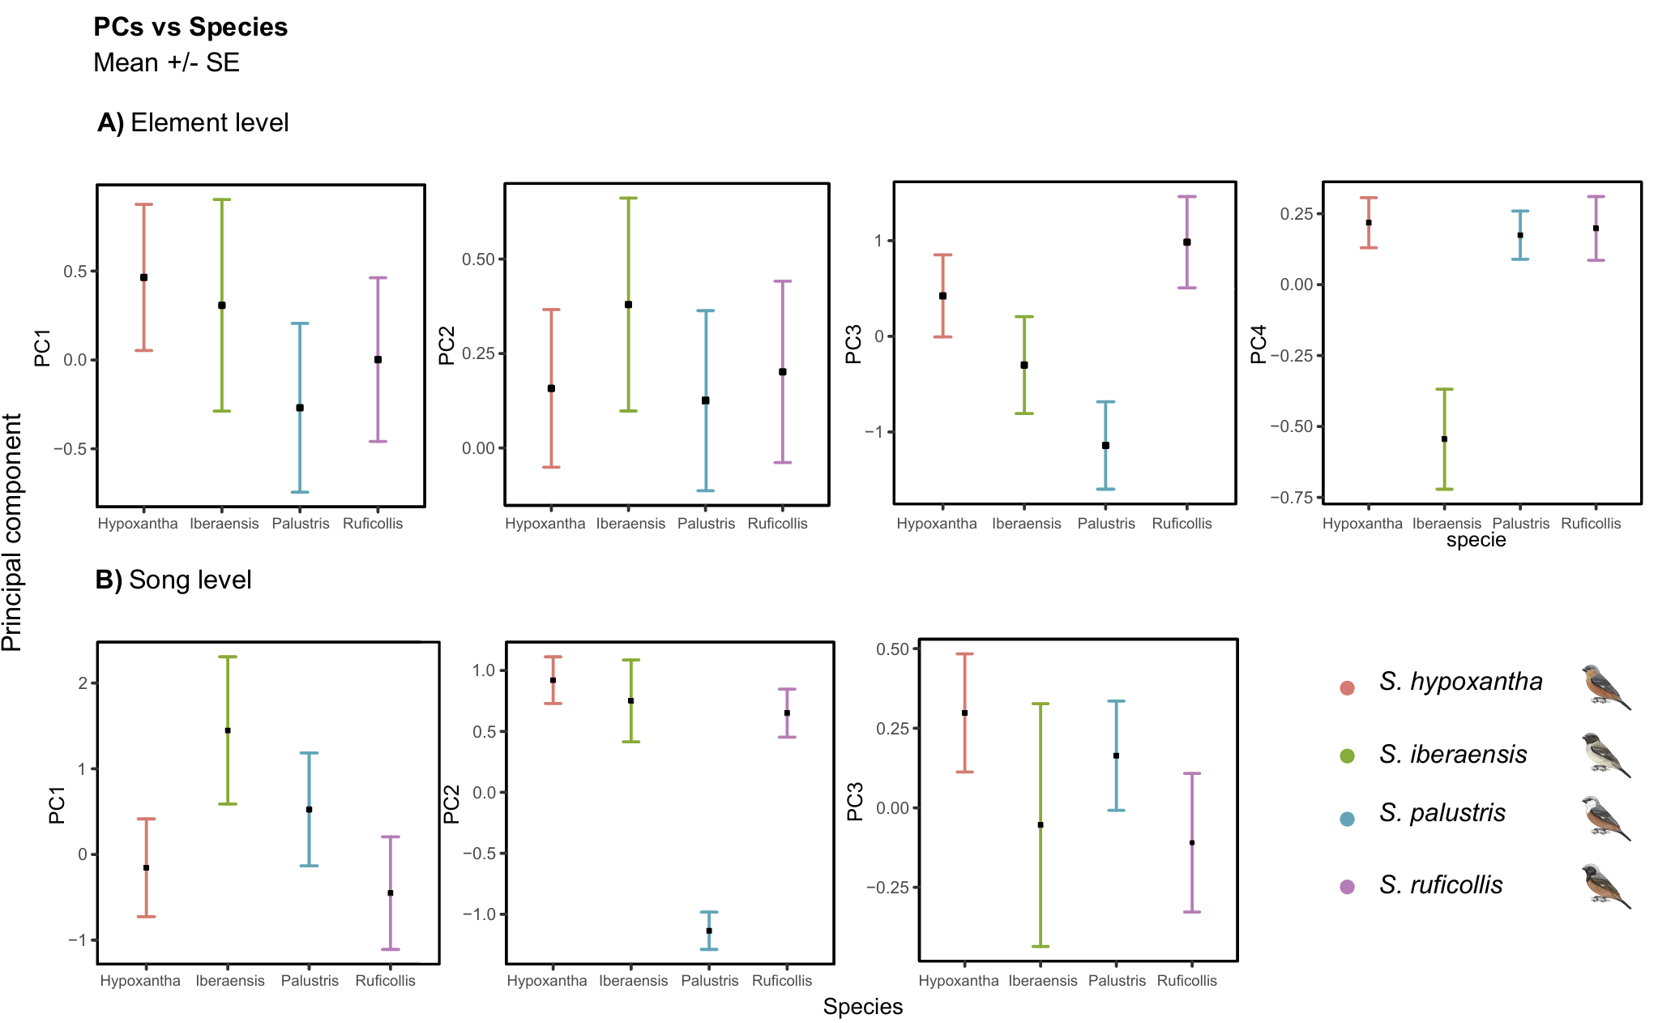
Supplementary Figure 1. Acoustic variation in complex songs of the four southern capuchinos. Mean scores (± SE) for each species on the retained PCs representing the acoustic variation estimated per element (A) and per song (B). The southern capuchino species are represented with different colors (references in the legend).

Supplementary Figure 2. Acoustic variation in complex songs of the southern capuchino populations. Mean scores (± SE) for each species on the retained PCs representing the acoustic variation of the populations estimated per element (A) and per song (B). The four southern capuchino species are represented with different colors (references in the legend). The localities where the species were recorded are identified with their abbreviations (EI, E, ER, MC, S). S. iberaensis and S. palustris were recorded only in Esteros del Iberá, and these populations are indicated by a combination of the species epithet and the locality abbreviation (ibe-EI, pal-EI).

