Implementing the Design

Introduction

This lab continues with the previous lab. You will perform static timing analysis. You will implement the design with the default settings and generate a bitstream.Then you will open a hardware session and program the FPGA. You will use on-board UART of the Nexys4 or the Basys3 board to validate your design.

Objectives

After completing this lab, you will be able to:

* Implement the design
* Generate various reports and analyze the results
* Run static timing analysis
* Generate bitstream and verify the functionality in hardware

Procedure

This lab is broken into steps that consist of general overview statements providing information on the detailed instructions that follow. Follow these detailed instructions to progress through the lab.

General Flow

Step 4:

Verify the Functionality

Step 3:

Generate the Bitstream

Step 2: Implement the Design

Step 1:   
Open a Vivado Project using IDE

1. Open a Vivado Project using IDE Step
   1. Launch Vivado and open the lab2 project. Save the project as lab3 in the *<2014_2_artix7_labs>* directory making sure that the create subdirectory option is selected. Set the flatten_hierarchy setting to rebuilt. Create new synthesis run naming it as synth_2.

|  |
| --- |
| References to **<2014_2_artix7_labs>** is a placeholder for the **c:\xup\fpga_flow\2014_2_artix7_labs** directory and **<2014_2_artix7_sources>** is a placeholder for the **c:\xup\fpga_flow\2014_2_artix7_sources** directory.  Reference to **<board>** means either the **Nexys4** or the **Basys3**. |

* + 1. Start the Vivado if necessary and open either the lab2 project (lab2.xpr) you created in the previous lab or the lab2 project in the labsolution directory using the **Open Project** link in the Getting Started page.
    2. Select **File > Save Project As …** to open the *Save Project As* dialog box. Enter **lab3** as the project name. Make sure that the *Create Project Subdirectory* option is checked, the project directory path is **<2014_2_artix7_labs>** and click **OK.**
    3. Click on the **Synthesis Settings** in the *Flow Navigator* pane.
    4. Make sure that the *flatten_hierarchy* is set to **rebuilt**, which allows the design hierarchy to be preserved for synthesis, and then rebuilt which is more useful for design analysis because many logical references will be maintained.

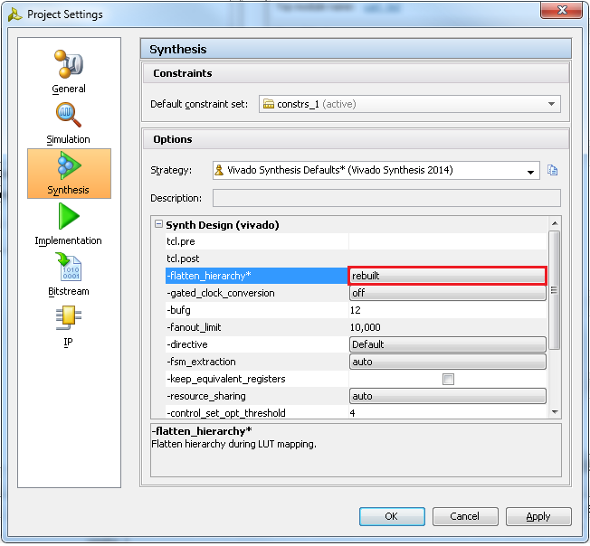

Figure 1. Setting hierarchy to rebuilt

* + 1. Click **OK**.

A Create New Run dialog box will appear asking you if a new run should be created. Click **Yes** and then **OK** to create the new run with **synth_2** name.

* 1. Synthesize the design. Generate the timing summary and analyze the design.
     1. Click on **Run Synthesis** under the *Synthesis* tasks of the *Flow Navigator* pane.

The synthesis process will be run on the uart_led.v and all its hierarchical files. When the process is completed a *Synthesis Completed* dialog box with three options will be displayed.

* + 1. Select the *Open Synthesized Design* option and click **OK** as we want to look at the synthesis output.
    2. Click on **Report Timing Summary** under the *Synthesized Design* tasks of the *Flow Navigator* pane.
    3. Leave all the settings unchanged, and click **OK** to generate a default timing report, *timing_1.*

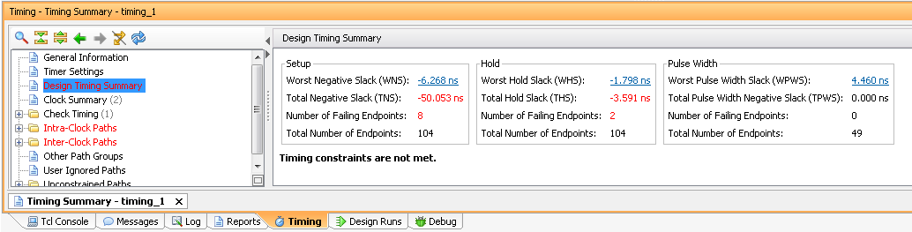

Figure 2. Timing report for the Nexys4

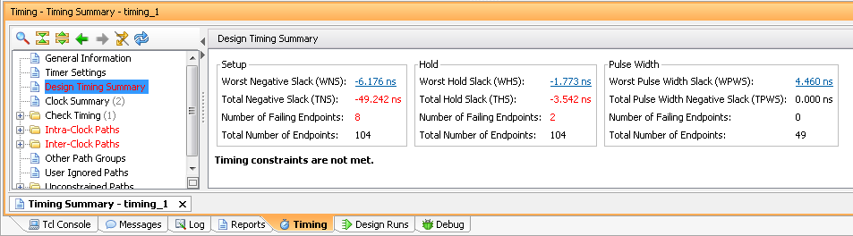

Figure 2. Timing report for the Basys3

* + 1. Click on the link beside the **Worst Negative Slack** (WNS) and see the 8 failing paths.
    2. Double-click on the Path 23 to see a detailed view of the path. The path report shows four sections: (i) Summary, (ii) Source Clock Path, (iii) Data Path, and (iv) Destination Clock Path.
    3. Select Path 23 in the timing summary panel, or the Path summary view, right-click, and select **Schematic**.

The schematic for the output data path will be displayed.

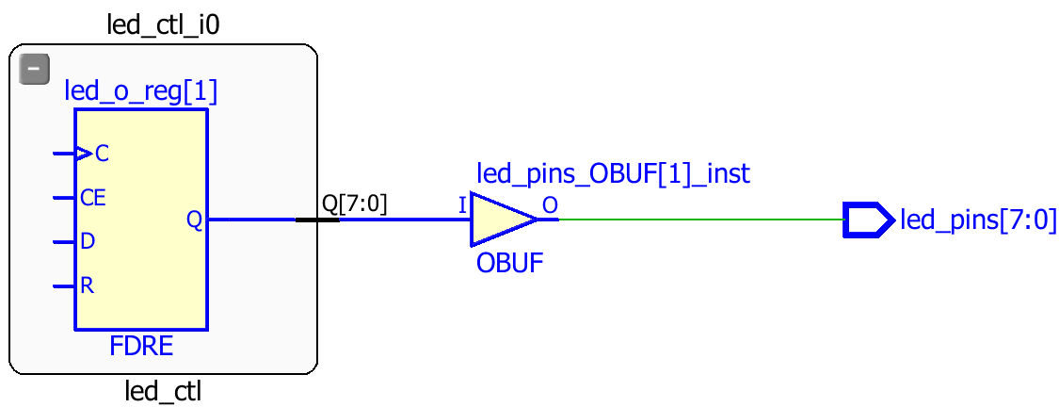

Figure 3. The output data path

* + 1. In order to see how the Source Clock Path is made up in schematic form, double-click on left end of the C pin of the FDRE in the schematic.

This will show the net between the BUFG and C port of the FDRE.

* + 1. Similarly, double-click on the left end of the BUFG to see the path between IBUF and BUFG.

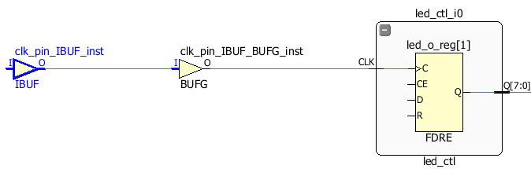

Figure 4. Source to clock port of the FDRE

* + 1. Finally, double-click on the input pin of IBUF to see the path between the clock input pin and the IBUF.

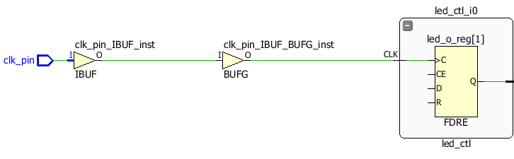

Figure 5. The schematic view of the source clock path

This corresponds to the Source Clock Path in the timing report.

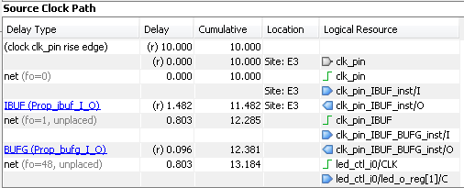

Figure 6. The source clock path for the Nexys4

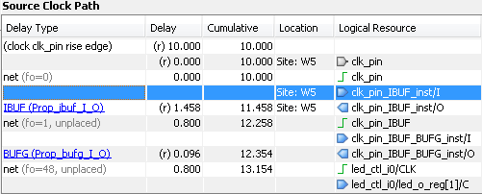

Figure 6. The source clock path for the Basys3

Since the virtual clock is slower (12 ns) than the clk_pin period (10 ns), the data path delay includes the clock period of the clk_pin clock source.

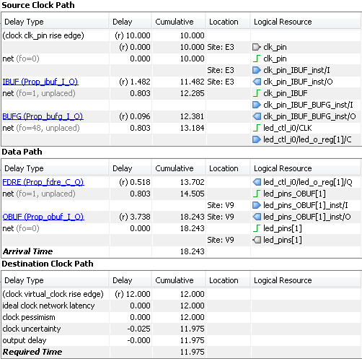

Figure 7. Worst failing path for the Nexys4

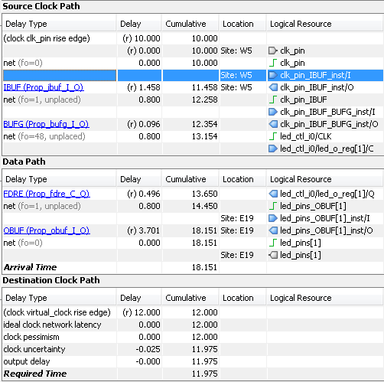

Figure 7. Worst failing path for the Basys3

* 1. Change the design constraint to constrain the virtual clock period to 10ns. Re-synthesize the design and analyze the results.
     1. Click **Edit Timing Constraints** under the Synthesized Design.

The Timing Constraints GUI will appear, showing the design has two create clocks, four inputs, and one output constraints. It also shows the constraints in the text form in the All Constraints section.

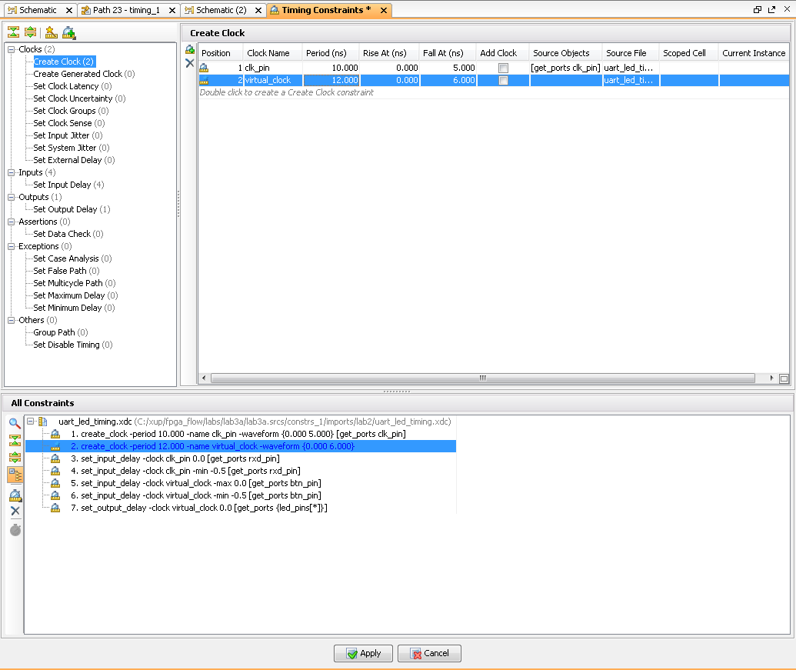

Figure 8. Timing Constraints showing 12 ns Virtual Clock period defined

* + 1. Click in the **Period** cell of the *virtual_clock* and change the period from **12** to **10** .
    2. Click **Apply**.

Note that since the timing constraint has changed, a warning message in the console pane is displayed to rerun the report.



* + 1. Click on **Rerun**.

Notice that setup timing violations are gone. However, there are still 2 failing paths for the Hold.

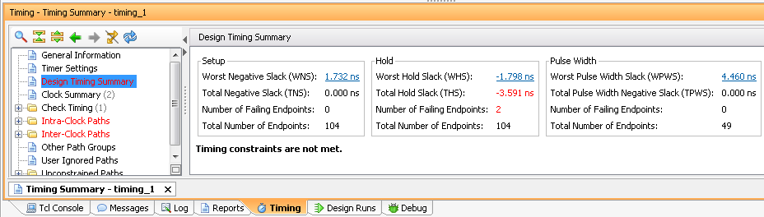

Figure 9. Setup timing met for the Nexys4

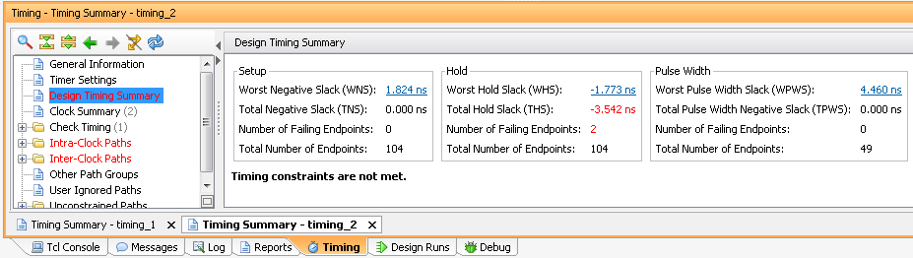

Figure 9. Setup timing met for the Basys3

* + 1. Click on the WHS link to see the paths.
    2. Double-click on the first path to see the timing compositions. Notice that the clock path delay does not include the entire clock period.
    3. Select **File > Save Constraints…**

Click **OK**.

Notice that the Synthesis Out-of-Date status is displayed on the top-right corner.

1. Implement the Design Step 2
   1. Run the implementation after saving the synthesis run. Perform the timing analysis.
      1. In the Design Runs tab, right-click on the synth_2 and select **Reset Runs**. Make sure the generated files are deleted. Click **Reset**.
      2. Click the **Closed Design** button in the status bar. If prompted, do not save anything.
      3. Click on the **Run Implementation** in the *Flow Navigator* pane.
      4. Click **OK** when prompted to run the synthesis first before running the implementation process.

When the implementation is completed, a dialog box will appear with three options.

* + 1. Select the *Open Implemented Design* option and click **OK**.
  1. View the amount of FPGA resources consumed by the design using Report Utilization.
     1. In the *Flow Navigator* pane, select Open Implemented Design > Report Utilization.

The Report Utilization dialog box opens.

* + 1. Click OK.

The utilization report is displayed at the bottom of the Vivado IDE. You can select any of the resources on the left to view its corresponding utilization.

* + 1. Select Slice LUTs to view how much and which module consumes the resource.

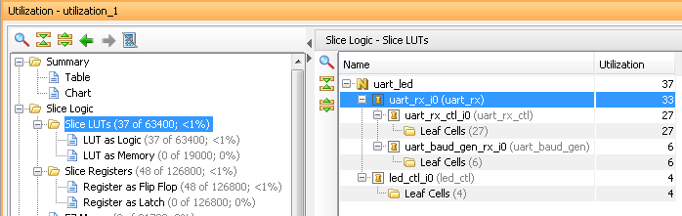

Figure 10. Resource utilization for the Nexys4

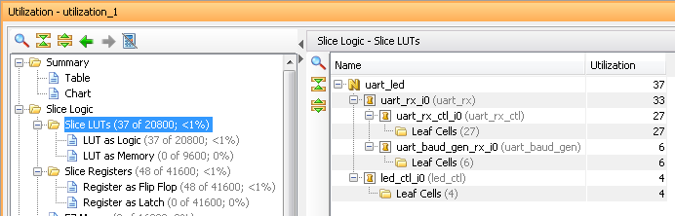

Figure 10. Resource utilization for the Basys3

* 1. Generate a timing summary report.
     1. In the Flow Navigator, under Implementation > Implemented Design, click Report Timing Summary

The Report Timing Summary dialog box opens.

* + 1. Leave all the settings unchanged and click **OK** to generate the report.

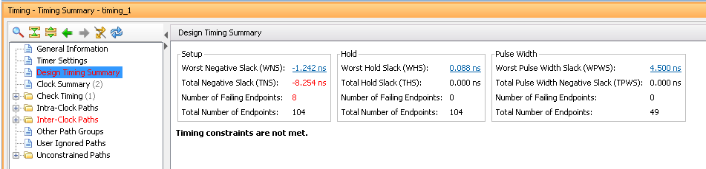

Figure 11. The timing summary report showing timing violations for the Nexys4

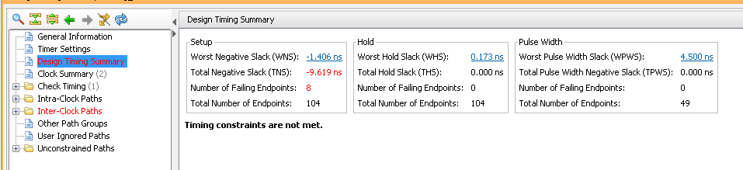

Figure 11. The timing summary report showing timing violations for the Basys3

* + 1. Click on the WNS link to see a detailed report to determine the failing path entries.
    2. Double-click on the first failing path to see why it is failing.

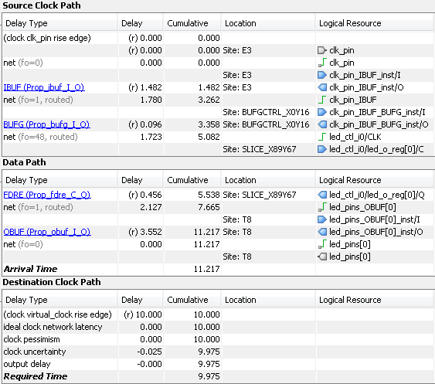

Figure 12. First failing path delays for the Nexys4

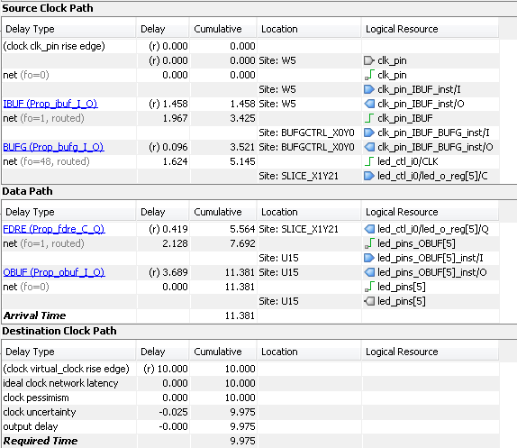

Figure 12. First failing path delays for the Basys3

Compared to delays from the synthesis report, the net delays are actual delays (rather than an estimated figure). The data path delay is longer than the destination clock path delay giving a negative slack (violation). The data path delay is 11.217 ns for the Nexys4, the destination clock path is 9.975 ns and the negative slack is -1.242 ns.

The figures are 11.381ns, 9.975 ns and -1.406 ns respectively for the Basys3.

At this point we can ignore this violation as the LED display change by a few nanoseconds won’t be observable by human eyes. We can also change the output delay by -2 ns and make the timings meet.

* + 1. Select **Implemented Design > Edit Timing Constraints** the *Flow Navigator* pane.
    2. Select the *Set Output Delay* entry in the left pane, and change the Delay Value to **-2.000** ns.
    3. Click **Apply**.
    4. Click **Rerun** link to re-run the timing report.

Observe that the timing violations of the Intra-clock paths are gone.

* + 1. Expand the **Intra-Clock Paths** folder on the left, expand *clk_pin*, and select the Setup group to see the list of 10 worst case delays on the right side.
    2. Double-click on the any path to see how that is made up of. Also right-click on it and select **Schematic.**

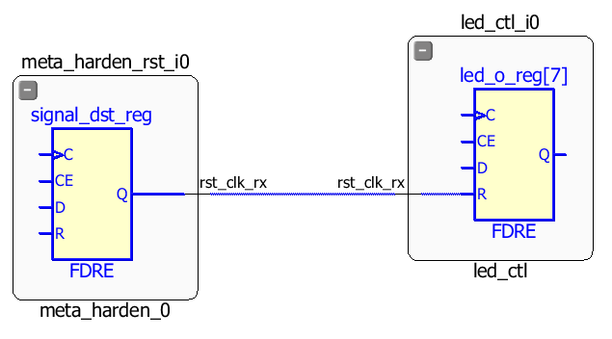

Figure 13. Schematic view of the a worst path delay

* + 1. Click on the **Device** tab and see the highlighted path in the view.

You will have to zoom-in to see the path.

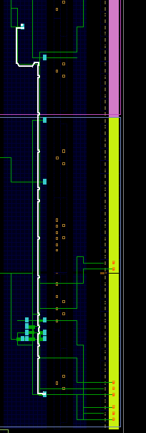

Figure 14. Path displayed in the Device view

* + 1. Select **Implemented Design > Report Clock Networks**.
    2. Click **OK**.

The Clock Networks report will be displayed in the Console pane showing two clock net entries.

* + 1. Select *clk_pin* entry and observe the selected nets in the Device view.

The clock nets are spread across multiple clock regions.

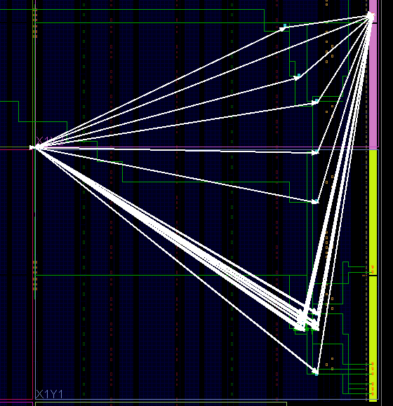

Figure 15. Clock nets for the Nexys4

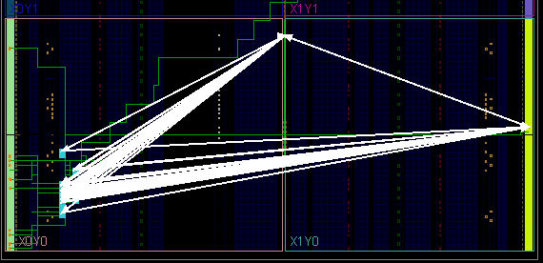

Figure 15. Clock nets for the Basys3

1. Generate the Bitstream Step 3
   1. Generate the bitstream.
      1. In the Flow Navigator, under Program and Debug, click Generate Bitstream.

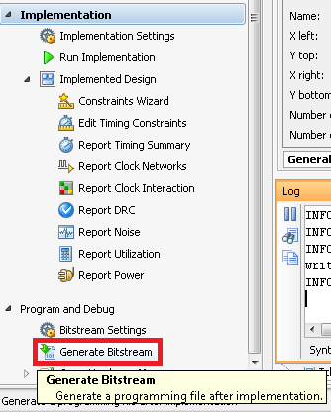

Figure 16, Generating the bitstream

* + 1. Click **Save** to save the constraints since the timing constraints had been changed and then click **Yes** to reset the runs and re-run all the processes.
    2. The write_bitstream command will be executed (you can verify it by looking in the Tcl console).
    3. Click **Cancel** when the bitstream generation is completed.

1. Verify the Functionality Step 4
   1. Connect the board and power it ON. Open a hardware session, and program the FPGA.
      1. Make sure that the micro-USB cable is connected to the JTAG PROG connector (next to the power supply connector). Make sure that the jumper on the board is set to select USB power (JP3 for the Nexys4 and JP2 for the Basys3).
      2. Select the *Open Hardware Manager* option and click **OK**.

The Hardware Manager window will open indicating “unconnected” status.

* + 1. Click on the **Open a new hardware target** link.

You can also click on the **Open recent target** link if the board was already targeted before.



Figure 17. Opening new hardware target

* + 1. Click **Next**  to see the Hardware Server Settings form.
    2. Click **Next** with the Target Hardware selected.

The JTAG cable which uses the digilent_plugin should be detected and identified as a hardware target. It will also show the hardware devices detected in the chain.

* + 1. Click **Next** and **Finish**.
    2. The Hardware Session status changes from Unconnected to the server name and the device is highlighted. Also notice that the Status indicates that it is not programmed.
    3. Select the device in the *Hardware Device Properties,* and verify that the **uart_led.bit** is selected as the programming file in the General tab.
  1. Start a terminal emulator program such as TeraTerm or HyperTerminal. Select an appropriate COM port (you can find the correct COM number using the Control Panel). Set the COM port for 115200 baud rate communication. Program the FPGA and verify the functionality.
     1. Start a terminal emulator program such as TeraTerm or HyperTerminal.
     2. Select an appropriate COM port (you can find the correct COM number using the Control Panel).
     3. Set the COM port for 115200 baud rate communication.
     4. Right-click on the FPGA entry in the Hardware window and select Program Device…
     5. Click on the Program button.

The programming bit file will be downloaded and the DONE light will be turned ON when the FPGA has been programmed.

* + 1. Type in some characters in the terminal emulator window and see the corresponding ASCII equivalent bit pattern displayed on the LEDs.
    2. Press and hold BTNU and see the the upper four bits are swapped with the lower four bits on the LEDs.
    3. When satisfied, close the terminal emulator program and power OFF the board.
    4. Select **File > Close Hardware Manager**. Click **OK**.
    5. Close the **Vivado** program by selecting **File > Exit** and click **OK**.

Conclusion

In this lab, you learned about many of the reports available to designers in the Vivado IDE. You had the opportunity to learn basic design analysis tools including the Schematic viewer, delay path properties and reports viewer, Device viewer, and selecting primitive parents. You also learned about the basic timing report options that are at your disposal. You verified the functionality in hardware by typing characters on the host machine and seeing the LED pattern changes.