Using the IP Catalog and IP Integrator

Introduction

In this lab you will use the IP Catalog to generate a clock resource. You will instantiate the generated clock core in the provided waveform generator design. You will also use IP Integrator to generate a FIFO core and then use it in the HDL design.

Objectives

After completing this lab, you will be able to:

* Include an IP in the project during the project creation
* Use IP Catalog to generate a clocking core
* Instantiate the generated clock
* Create a block design using IP Integrator
* Instantiate the block design
* Generate bitstream and verify the functionality in hardware

Procedure

This lab is broken into steps that consist of general overview statements providing information on the detailed instructions that follow. Follow these detailed instructions to progress through the lab.

Design Description

The design used in this lab is a programmable waveform generator, also known as a signal generator.

The waveform generator in this design is intended to be a “standalone” device that is controlled via a PC (or other terminal device) using RS-232 serial communication. The design described here implements the RS-232 communication channel, the waveform generator and connection to the external DAC, and a simple parser to implement a small number of “commands” to control the waveform generation.

The wave generator implements a look-up table of 1024 samples of 16 bits each in a RAM. The wave generator also implements three variables:

* nsamp: The number of samples to use for the output waveform. Must be between 1 and 1024.
* prescale: The prescaler for the sample clock. Must be 32 or greater.
* speed: The speed (or rate) for the output samples in units of the prescaled clock.

The wave generator can be instructed to send the appropriate number of samples once, cycling from 0 to nsamp-1 once and then stopping, or continuously, where it continuously loops the nsamp samples. When enabled, either once or continuously, the wave generator will send one sample to the DAC every (prescale x speed) clk_tx clock cycles. The contents of the RAM, as well as the three variables, can be changed via commands sent over the RS-232 link, as can the mode of the wave generator. The wave generator will generate responses for all commands.

There are three clock domains within this design: ***clk_rx***,***clk_tx***, and ***clk_samp***. The clock generator module instantiates all the clocking resources required for generating these three clocks. All three clocks are derived from a single clock input, coming in on ***clk_pin***. The frequency of the clock input depends on the oscillator available on the target board; for the Nexys4 it is 100MHz. The Basys3 has the same oscillator frequency.

The block diagram is as shown in **Figure 1**.



Figure 1. The design

General Flow

Step 5:

Generate and instantiate an IPI Block

Step 2: Generate & Instantiate Clock Generator Module

Step 4:

Generate the Bitstream & Verify the Functionality

Step 3:

Implement the Design

Step 1:   
Create a Vivado Project using IDE

1. Create a Vivado Project using IDE Step 1
   1. Launch Vivado and create a project targeting the XC7A100TCSG324-1 (Nexys4) or the XC7A35TCPG236-1 (Basys3) device and using the Verilog HDL. Use the provided Verilog source files, a device specific ip, and XDC files from the <*2014_2_artix7*_*sources>\lab4* directory.

|  |
| --- |
| References to **<2014_2_artix7_labs>** is a placeholder for the **c:\xup\fpga_flow\2014_2_artix7_labs** directory and **<2014_2_artix7_sources>** is a placeholder for the **c:\xup\fpga_flow\2014_2_artix7_sources** directory.  Reference to **<board>** means either the **Nexys4** or the **Basys3**. |

* + 1. Open Vivado by selecting **Start > All Programs > Xilinx Design Tools > Vivado 2014.2 > Vivado 2014.2**
    2. Click **Create New Project** to start the wizard. You will see *Create A New Vivado Project* dialog box. Click **Next**.
    3. Click the Browse button of the *Project location* field of the **New Project** form, browse to **<2014_2_artix7_labs>**, and click **Select**.
    4. Enter **lab4** in the *Project name* field. Make sure that the *Create Project Subdirectory* box is checked. Click **Next**.
    5. Select **RTL Project** option in the *Project Type* form, and click **Next**.
    6. Using the drop-down buttons, select **Verilog** as the *Target Language* and *Simulator Language* in the *Add Sources* form.
    7. Click on the **Add Files…** button, browse to the **<2014_2_artix7_sources>\lab4** directory, select all the Verilog files*,* click **OK**, and then click **Next**.
    8. In the *Add IP* form, click on the Add Directories… button, browse to the **<2014_2_artix7_sources>\lab4\ip\<board>** directory. Highlight the directory and click **Select**.
    9. Click **Next** to get to the *Add Constraints* form.
    10. You will see wave_gen_timing.xdc and both wave_gen_pins_<board>.xdc files have automatically been included. Select the XDC file not targeting the board and delete it by highlighting on it and clicking on the “X” to the left of the window. Click **Next.**
    11. In the *Default Part* form, using the **Parts** option and various drop-down fields of the **Filter** section, select the **XC7A100TCSG324-1** part for the Nexys4 or the **XC7A35TCPG236-1** part for the Basys3. Click **Next**.
    12. Click **Finish** to create the Vivado project.
  1. Correct the errors by adding file.
     1. You will notice four *Syntax Error Files* are being highlighted in the **Sources** pane.

If you check the messages Tab, you will see that these errors are due to missing files.

* + 1. Click on **Add Sources** in the *Flow Navigator* pane.
    2. Select *Add or Create Design Sources* and click **Next**.
    3. Click on the **Add Files…** button and browse to **<2014_2_artix7_sources>\lab4\.**
    4. In the *File Type* field, select **All Files**, and then select **clogb2.txt** file.
    5. Click **OK** and then **Finish**.

The error messages should go away.

* + 1. In the *Sources* pane, expand *Design Sources* and *wave_*gen if necessary, and double-click on the **clk_gen_i0** entry.

Scroll down the file and notice that around line 79 there is an instruction to instantiate a clock core.

1. Generate and Instantiate Clock Generator Module Step 2
   1. Launch the clocking wizard from the IP Catalog of Vivado and generate the clock core with input frequency of 100.00 MHz and two output clocks of 100.000 MHZ each.
      1. Click on **IP Catalog** in the *Flow Navigator* pane.

The IP Catalog will open in the auxiliary pane.

* + 1. Expand the **FPGA Features and Design > Clocking** sub-folders and double-click on the **Clocking Wizard** entry.

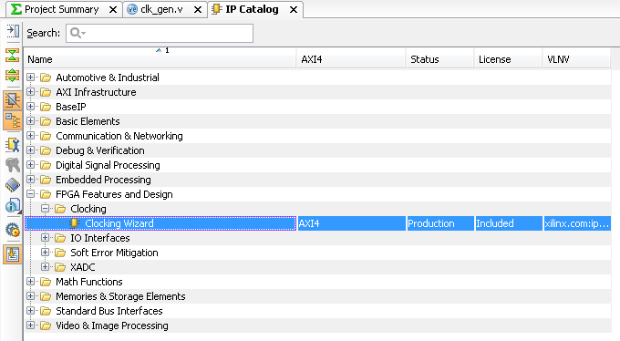

Figure 2. Accessing the clocking wizard

The clocking wizard will open.

* + 1. Change the core name to **clk_core**. Make sure that the *Primary* input clock frequency is **100.000** MHz and the primitive used is **MMCM**.

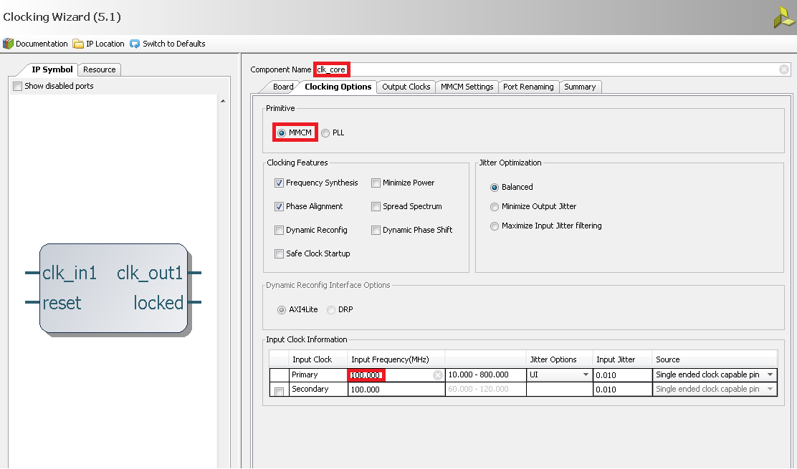

Figure 3. The clocking wizard

* + 1. Select the **Output Clocks** tab. Click on the check box to enable the second clock output.

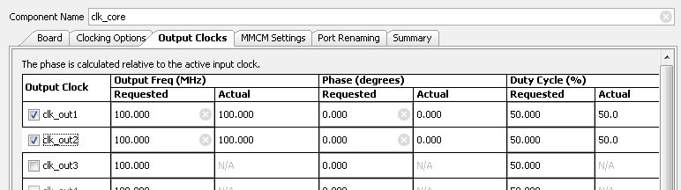

Figure 4. Setting output clocks

* + 1. Click on the **Summary** tab and check the information.

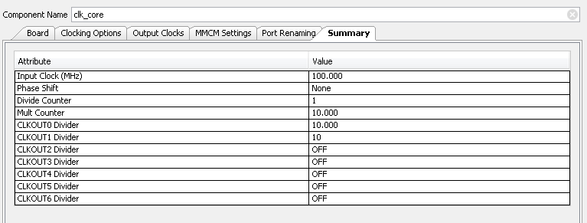

Figure 5. Summary page of the clock core being generated

* + 1. Click **OK** to see the *Generate Output Products* form.

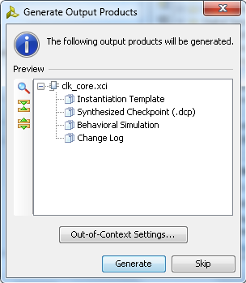

Figure 6. Generate output products form

* + 1. Click on **Generate** to generate the output products including the instantiation template.
  1. Instantiate the generated clock core.
     1. Select the **IP Sources** tab in the *Sources* pane.
     2. Expand the **IP (2)** branch. Notice the two IP entries. The char_fifo IP is the core that was included while creating project. The second core clk_core is the one that you have generated.
     3. Expand **clk_core > Instantiation Template** and double-click on **clk_core.veo** to see the instantiation template.
     4. Copy lines 71 through 80 and paste them at or around line 79 of the **clk_gen.v** file.
     5. Change the instance name and net names to as shown in the figure below to match the names of existing signals in the design.

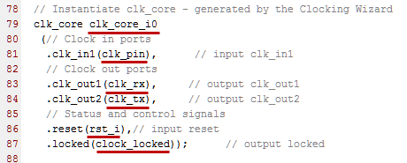

Figure 7. Assigning instance name and net conenctions

* + 1. Select File > Save File to save **clk_gen.v**
    2. Select the Hierarchy tab and expand the **wave_gen > clk_gen_i0** hierarchy and verify that clk_core.xci is in the hierarchy. The IP has a bordered yellow square icon next to it.

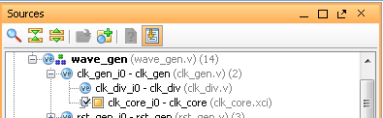

Figure 8. The clk_core instantiated and shown in the hierarchy

1. Implement the Design Step 3
   1. Implement the design.
      1. Click on the **Run Implementation** in the *Flow Navigator* pane.
      2. Click **OK** and run the synthesis first before running the implementation process.

When the implementation is completed, a dialog box will appear with three options.

* + 1. Select the *Open Implemented Design* option and click **OK**.
  1. View the amount of FPGA resources consumed by the design using Report Utilization.
     1. In the *Flow Navigator* pane, select Implemented Design > Report Utilization.

The Report Utilization dialog box opens.

* + 1. Click OK.
    2. Verify that the design is using the clock resource.

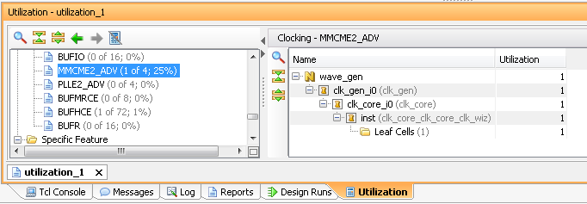

Figure 9. Clock resource utilization for the Nexys4

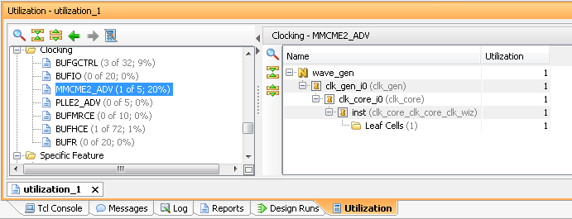

Figure 9. Clock resource utilization for the Basys3

1. Generate the Bitstream and Verify the Functionality Step 4
   1. Generate the bitstream.
      1. In the Flow Navigator, under Program and Debug, click Generate Bitstream.
      2. The write_bitstream command will be executed (you can verify it by looking in the Tcl console).
      3. Click **Cancel** when the bitstream generation is completed.
   2. Connect the board and power it ON. Open a hardware session, and program the FPGA.
      1. Make sure that the Micro-USB cable is connected to the JTAG PROG connector (next to the power supply connector). Make sure that the jumper on the board is set to select USB power (JP3 for the Nexys4 and JP2 for the Basys3).
      2. Select the *Open Hardware Manager* option and click **OK**.

The Hardware Manager window will open indicating “unconnected” status.

* + 1. Click on the **Open a new hardware target** link.

You can also click on the **Open recent target** link if the board was already targeted before. In this case skip to step 4-2-8.

* + 1. Click **Next**  to see the Vivado Hardware Server Settings form.
    2. Click **Next** with the Target Hardware selected.

The JTAG cable which uses the xilinx_tcf plugin, should be detected and identified as a hardware target. It will also show the hardware devices detected in the chain.

* + 1. Click **Next** and **Finish**.
    2. The Hardware Manager status changes from Unconnected to the server name and the device is highlighted. Also notice that the Status indicates that it is not programmed.
    3. Select the device and verify that the **wave_gen.bit** is selected as the programming file in the General tab.
  1. Start a terminal emulator program such as TeraTerm or HyperTerminal. Select an appropriate COM port (you can find the correct COM number using the Control Panel). Set the COM port for 115200 baud rate communication. Program the FPGA and verify the functionality.
     1. Start a terminal emulator program such as TeraTerm or HyperTerminal.
     2. Select the appropriate COM port (you can find the correct COM number using the Control Panel).
     3. Set the *COM* port for **115200** baud rate communication.
     4. Right-click on the FPGA entry in the Hardware window and select **Program Device…**
     5. Click on the **Program** button.

The programming bit file be downloaded and the DONE light will be turned ON indicating the FPGA has been programmed.

* + 1. Slide *Switch 0* to the **ON** position and type in some characters in the terminal window and see the character is echoed back. Setting Switch 0 to the ON position makes the design function as a loopback.
    2. Set *Switch 0* back to **OFF** position (down) so it is no longer in the loopback mode.
    3. Select **File > Send File …** in the Tera Term window.
    4. Browse to **<2014_2_artix7_sources>\lab4**, select **testpattern.txt** file, and click **Open**.

The file content will be send to the design. The file content is as follows:

*PFFFF < -- specifies the pre-scaling

*S0fff < -- specifies the speed value

*N000f < -- specifies the number of samples to play

*W00000000 < -- write first sample of value 0 at location 0000

*W00011111 < -- write second sample of value 0x1111 at location 0001

*W00022222

*W00033333

*W00044444

*W00055555

*W00066666

*W00077777

*W00088888

*W00099999

*W000AAAAA

*W000BBBBB

*W000CCCCC

*W000DDDDD

*W000EEEEE

*W000FFFFF

* + 1. The design understands various commands as listed in figure below. All values are in hexadecimal. All values and addresses are in hexadecimal.

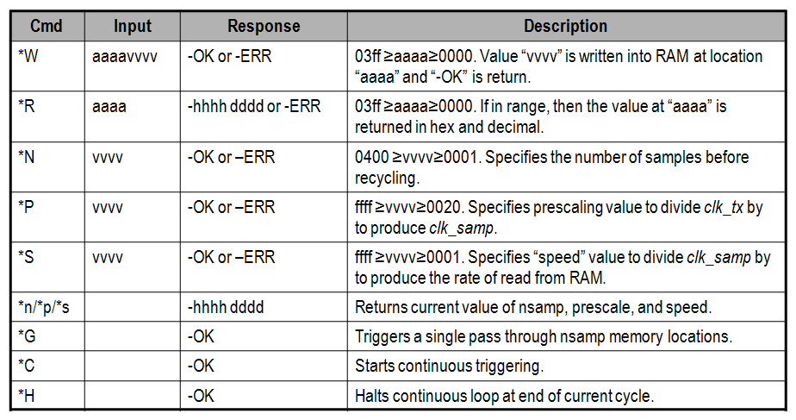

Figure 10. Commands

* + 1. Next type *G in the terminal window and observe the LED pattern changing slowly as written by the above file.
    2. You can type *s to see the sample value, *p to see the prescale value, and *n to see how many samples are being played back.
    3. You can also type *H to halt the play.

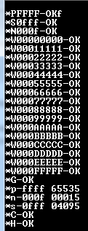

Figure 11. Terminal window display

* + 1. When satisfied, close the terminal emulator program and power OFF the board.
    2. Select **File > Close Hardware Manager**. Click **OK** to close it.

1. Generate and Instantiate an IPI Block Step 5
   1. Save the project as lab4_ipi. Remove the char_fifo IP from the design.
      1. Select **File > Save Project As…** and save it as **lab4_ipi** in the **<2014_2_artix7_labs>** directory making sure that the *Create Project Subdirectory* option is checked.
      2. Select the **IP Sources** tab in the *Sources* pane.
      3. Right-click on *char_fifo*, and select **Remove File from Project…**
      4. Click on the check-box of *Also delete the project local file/directory from disk*, and click **OK**.

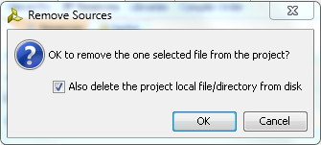

Figure 12. Removing an existing IP from the project

* + 1. Select **Hierarchy** tab in the *Sources* pane and observe that the char_fifo instance has a ? mark indicating that it is missing the source file.

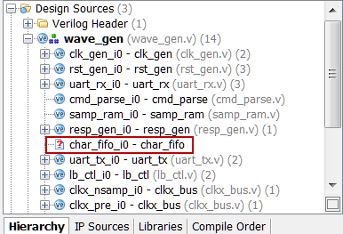

Figure 13. Removed source file

* + 1. Double-click on the **wave_gen.v** to open it in the editor window.
    2. Remove the instantiation of the char_fifo from the file around line 336.
    3. Select **File > Save File**.
  1. Create a block design naming it as char_fifo and add an instance of an FIFO Generator IP.
     1. Click on **Create Block Design** in the Flow Navigator block.
     2. Enter **char_fifo** as the block design name.

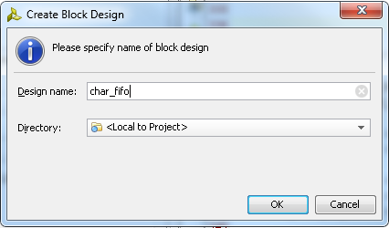

Figure 14. Naming the new block design

* + 1. Click **OK**.

The IP Integrator workspace opens and, in the information area, invites you to begin adding IP.

* + 1. In the Tcl Console, type the following command:

set_param bd.skipSupportedIPCheck true

This will enable the FIFO Generator to appear in the IP Integrator IP Catalog. This is required because by default the IP Catalog in the IP Block design will include just the processor based system IPs.

* + 1. Right-click in the IP Integrator design canvas and select Add IP.

The IP Integrator IP Catalog opens, displaying a list of IP available in the IP Integrator.

* + 1. Type FIFO in the search box at the top of the IP Integrator Catalog to see FIFO related available IPs.

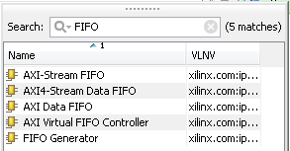

Figure 15. Searching for an IP in the IP Catalog

* + 1. Double-click FIFO Generator.

The FIFO is added to the IP Integrator design canvas.

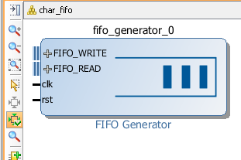

Figure 16. FIFO Generator instantiated

* 1. Customize the FIFO Generator IP instance.
     1. Double-click the FIFO Generator IP.

The FIFO Generator displays in the Re-customize IP dialog box.

* + 1. Make sure that the default Native option is selected for the interface type.
    2. Select Independent Clocks Block RAM from the Fifo Implementation drop-down list.

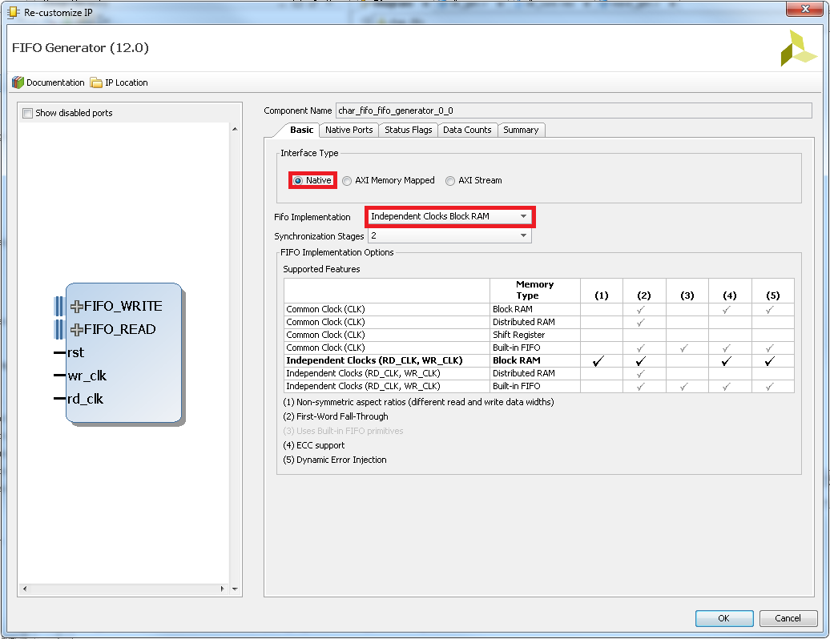

Figure 17. configuring BRAM for separate read and write clocks

* + 1. Select the Native Ports tab.

From the *Native Ports* tab you can configure the read mode, built-in FIFO options, data port parameters, and implementation options.

* + 1. Select First Word Fall Through as the read mode.
    2. Set the write width to be 8 bits**.**
    3. Click in the *Read Width* field to change it automatically to match the write width.
    4. Leave everything else at their default settings.

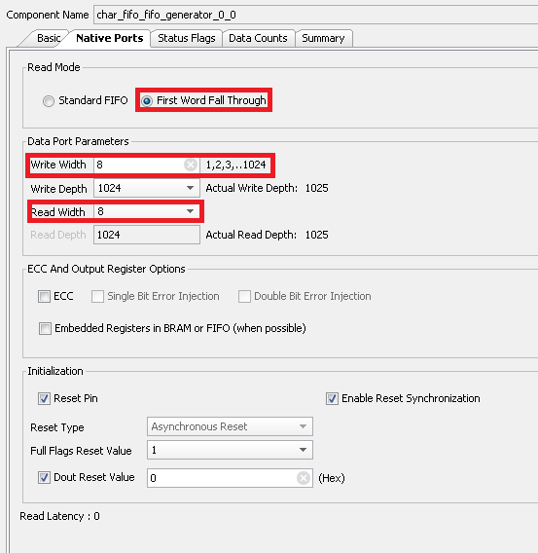

Figure 18. Configuring port width and read mode

* + 1. Browse through the settings of the Status Flags and Data Counts tabs.

These tabs configure other options for the FIFO Generator. For this design, leave everything at their default settings

* + 1. Select the Summary tab.

This tab displays a summary of all the selected configuration options, as well as listing resources used for this configuration.

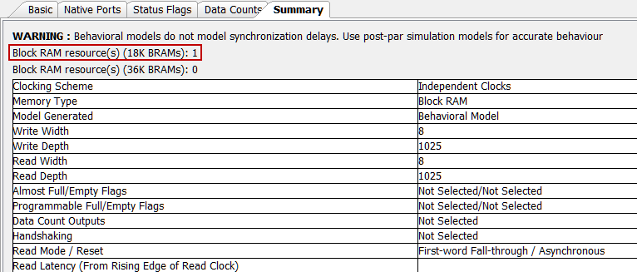

Figure 19. Summary page

* + 1. Verify that the information is correct. For this configuration you are using one 18K block RAM. Click OK.
  1. Make the ports external naming them as shown below.

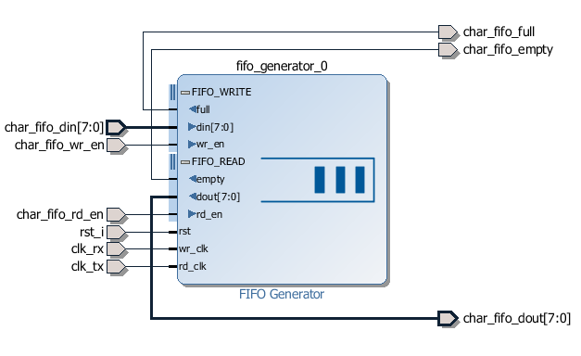

Figure 20. FIFO Generator IP fully generated and connected

* + 1. Expand the **FIFO_WRITE** and **FIFO_READ** interfaces.
    2. Select wr_clk and then press and hold the Ctrl key and select the rd_clk ports of the FIFO.

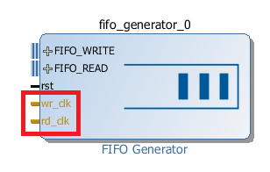

Figure 21. Selecting multiple ports

* + 1. With the ports highlighted, right-click and select Make External.

Two external connections are created for the selected FIFO ports. Notice that the external connections have the same name as the IP module port that they connect to. You can rename these connections by selecting them and changing the name in the External Port Properties window.

* + 1. Select the external connection port named clk_rx.
    2. In the External Port Properties window, in the Name field of the General tab, type the name clk_rx and press Enter. Similarly, select the external connection port named rd_clk and change its name to clk_tx.

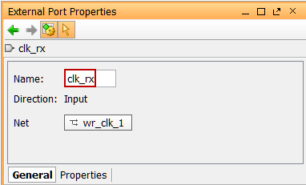

Figure 22. Changing the external port name

* + 1. You will need to expand FIFO_WRITE and FIFO_READ to see the signal names by clicking on the “+” symbols next to the bus names. While pressing the Ctrl key, click all of the remaining FIFO input and output ports and make them external.
    2. Change their names as listed below:
* din = char_fifo_din
* dout = char_fifo_dout
* empty = char_fifo_empty
* full = char_fifo_full
* rd_en = char_fifo_rd_en
* wr_en = char_fifo_wr_en
* rst = rst_i

When you have finished, your subsystem design should look like the figure below.

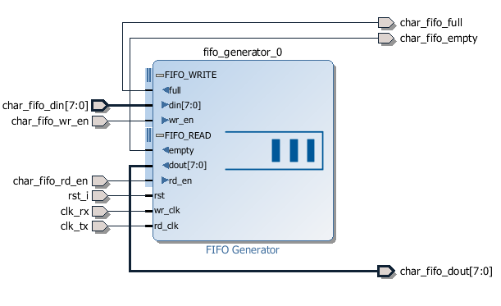

Figure 23. Renamed external ports

* + 1. Click on Refresh () icon from the vertical toolbar to see the above diagram.
    2. Select Tools > Validate Design.

You should see a message that validation was successful.

* 1. Generate the output product.
     1. In the IP Sources tab of the Sources window, select the char_fifo under the Block Designs.
     2. Right-click and select Generate Output Products.

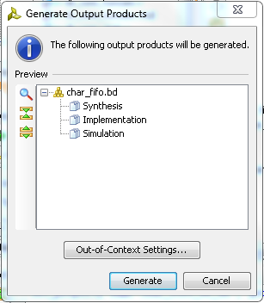

Figure 24. Generating the output products so the IP can be instantiated in the design

* + 1. Click Generate.

You should see the various IP output products displayed in the IP Sources tab of the Sources window.

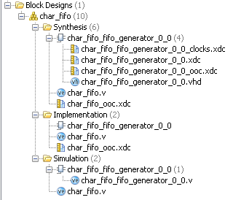

Figure 25. Generated output products

* 1. Instantiate the char_fifo IP in the project.
     1. From the *IP Sources* tab of the *Sources* window, select the char_fifo module.
     2. Right-click and select View Instantiation Template.

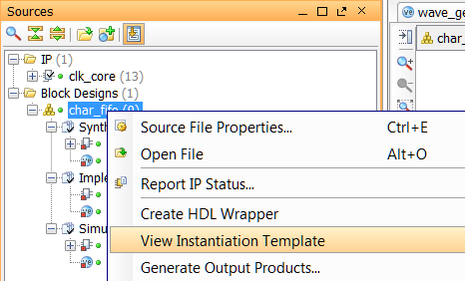

Figure 26. Generating an instantiation template

The char_fifo_wrapper.v instantiation template is opened in the text editor in the Vivado IDE.

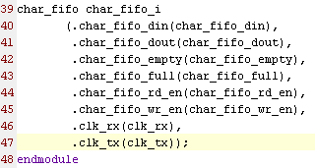

Figure 27. Part of the instantiation template

* + 1. Copy lines 39 through line 47, and paste them at or around line 334 in the wave_gen.v file.
    2. Save the Verilog file.
  1. Generate the bitstream and verify the functionality in hardware.
     1. Click on the **Run Implementation** in the *Flow Navigator* pane.

If prompted, click **Yes** to Save the project before proceeding.

* + 1. Click **OK** to re-run the synthesis process, followed by clicking **Save** to save the design.
    2. When completed, generate the resource utilization report and verify that one FIFO is being used.
    3. In the Flow Navigator, under Program and Debug, click Generate Bitstream.
    4. Open the hardware manager and verify the functionality of the design in the hardware.
    5. When done, close the **Vivado** program by selecting **File > Exit** and click **OK**.

Conclusion

In this lab, you learned how to add an existing IP during the project creation. You also learned how to use IP Catalog and generate a core. You then instantiated the core in the design, implemented the design, and verified the design in hardware. You also used the IP Integrator capability of the tool to generate a FIFO and then use it in the HDL design.