Xilinx Design Constraints

Introduction

In this lab you will use the uart_led design that was introduced in the previous labs. You will start the project with I/O Planning type, enter pin locations, and export it to the rtl. You will then create the timing constraints and perform the timing analysis.

Objectives

After completing this lab, you will be able to:

* Create a I/O Planning project
* Enter the pin locations and IO standards via Device view, Package Pins tab, and Tcl commands
* Create Period, Input Setup, and Output Setup delays
* Perform timing analysis

Procedure

This lab is broken into steps that consist of general overview statements providing information on the detailed instructions that follow. Follow these detailed instructions to progress through the lab.

Design Description

The design consists of a uart receiver receiving the input typed on a keyboard and displaying the binary equivalent of the typed character on the 8 LEDs. When a push button is pressed, the lower and upper nibbles are swapped. The block diagram is as shown in **Figure 1**.

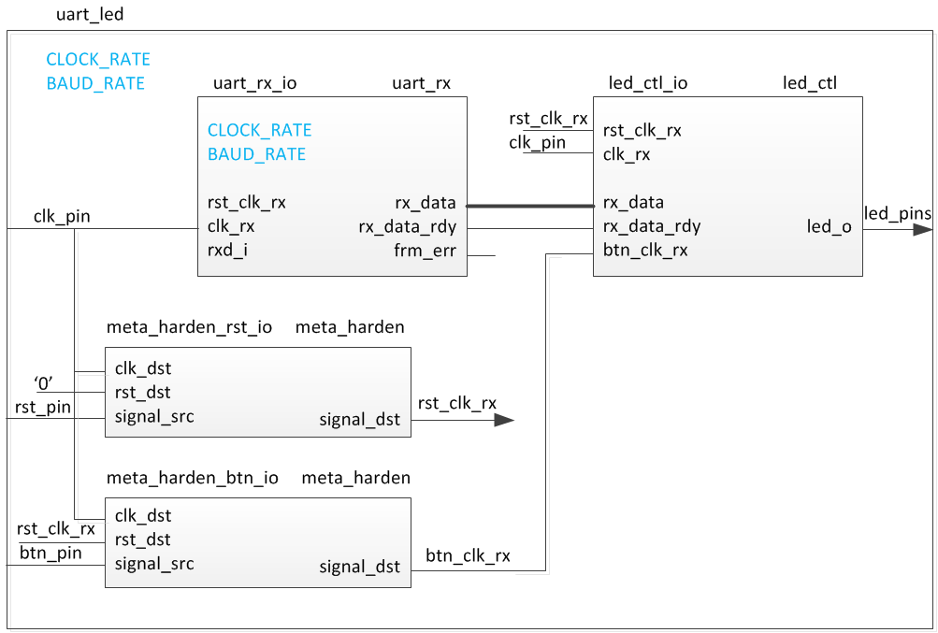

Figure 1. The design

General Flow

Step 5:

Generate the Bitstream and Verify (optional)

Step 2: Assign Various Pins and Source Files

Step 4:

Implement and Perform Timing Analysis

Step 3:

Synthesize and Enter Timing Constraints

Step 1:   
Create a Vivado I/O Planning Project

1. Create a Vivado I/O Planning Project Step 1
   1. Launch Vivado and create a I/O Planning project targeting the XC7A100TCSG324-1 (Nexys4) or the XC7A35TCPG236-1 (Basys3) device.

|  |
| --- |
| References to **<2014_2_artix7_labs>** is a placeholder for the **c:\xup\fpga_flow\2014_2_artix7_labs** directory and **<2014_2_artix7_sources>** is a placeholder for the **c:\xup\fpga_flow\2014_2_artix7_sources** directory.  Reference to **<board>** means either the **Nexys4** or the **Basys3**. |

* + 1. Open Vivado by selecting **Start > All Programs > Xilinx Design Tools > Vivado 2014.2 > Vivado 2014.2**
    2. Click **Create New Project** to start the wizard. You will see *Create A New Vivado Project* dialog box. Click **Next**.
    3. Click the Browse button of the *Project location* field of the **New Project** form, browse to **<2014_2_artix7_labs>**, and click **Select**.
    4. Enter **lab5** in the *Project name* field. Make sure that the *Create Project Subdirectory* box is checked. Click **Next**.
    5. Select **I/O Planning Project** option in the *Project Type* form, and click **Next**.
    6. Select **Do not import I/O ports at this time**, and click **Next**.
    7. In the *Default Part* form, using the **Parts** option and various drop-down fields of the **Filter** section, select the **XC7A100TCSG324-1** part for the Nexys4 or the **XC7A35TCPG236-1** for the Basys3. Click **Next**.
    8. Click **Finish** to create the Vivado project.

The device view window and package pins tab will be displayed.

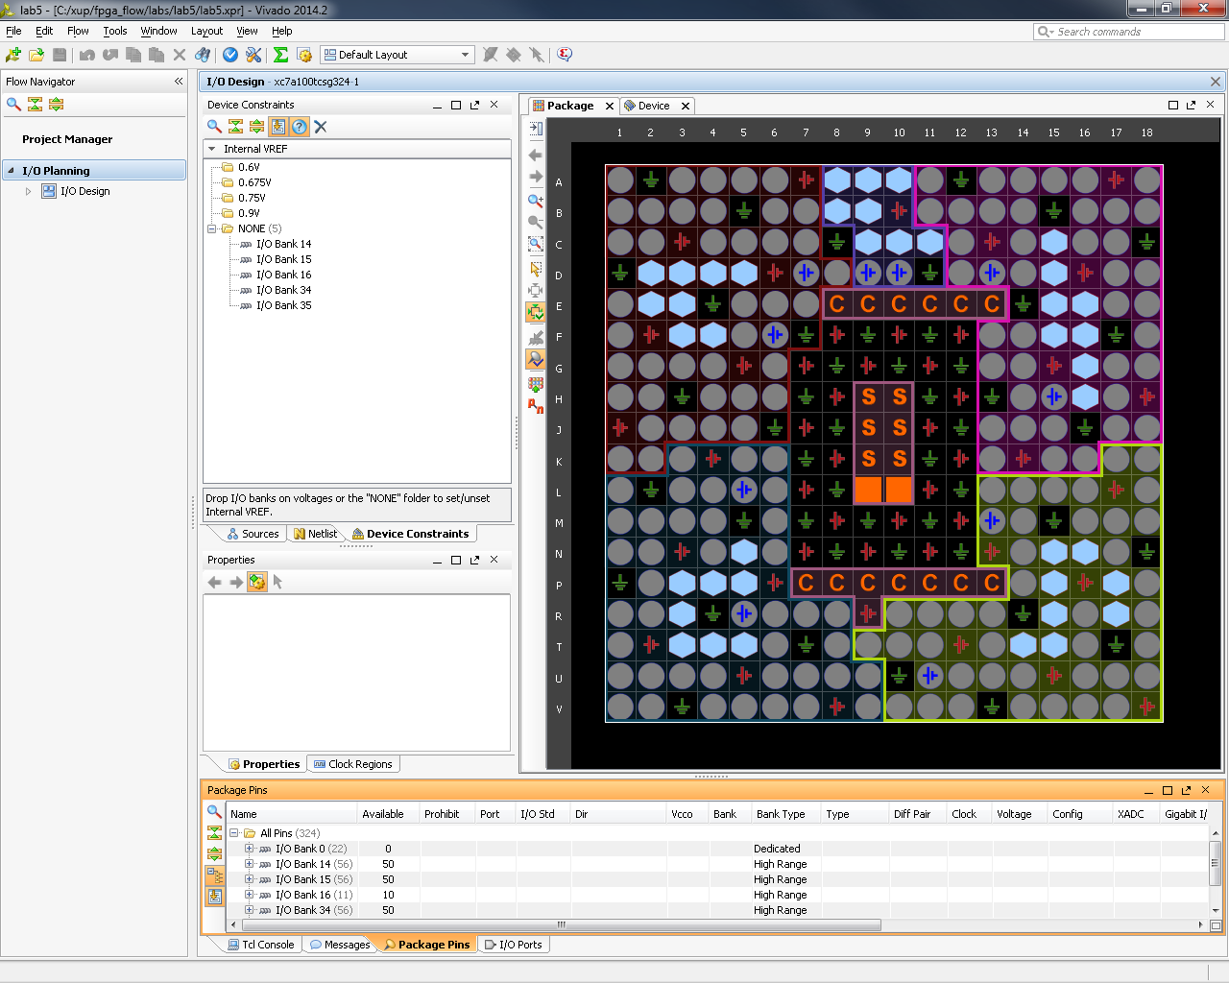

Figure 2. I/O Planning project’s default windows and views for the Nexys4

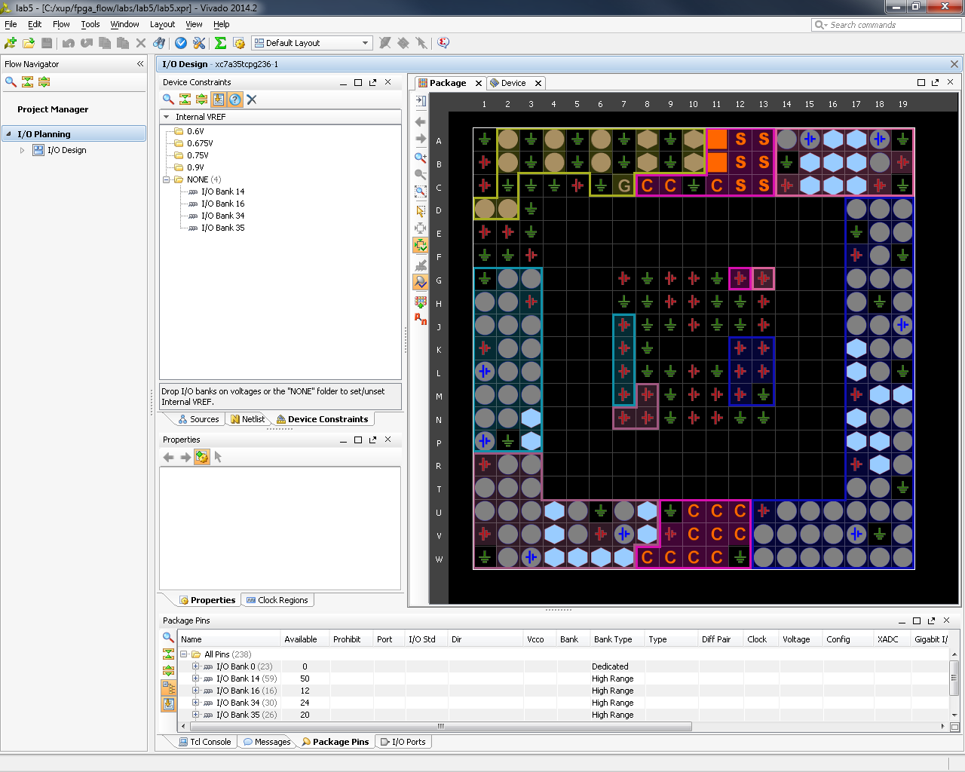

Figure 2. I/O Planning project’s default windows and views for the Basys3

1. Assign Various Pins and Add Source Files Step 2
   1. For the Nexys4, assign input pins clk_pin, btn_pin, rxd_pin, and rst_pin to E3, F15, C4, and E16 locations using the Device view and package pins.

For the Basys3, assign input pins clk_pin, btn_pin, rxd_pin, and rst_pin to W5, T18, B18, and U18 locations using the Device view and package pins.

* + 1. For the Nexys4, move the mouse over the Device view window and hover over it on the **E3** location.

For the Basys3, hover the mouse over **W5** in the Device view window.

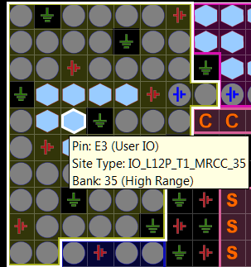

Figure 3. Locating E3 pin in the Device view for the Nexys4

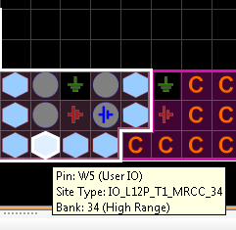

Figure 3. Locating W5 pin in the Device view for the Basys3

* + 1. When located, click on it.

The pin entry will be highlighted and displayed in the Package Pins tab.

* + 1. In the *Package* Pins pane, click in the Ports column of **E3** (Nexys4) or **W5** (Basys3) pin’s row, enter **clk_pin.**
    2. Click in the next column, *I/O Std*.

Notice that if the Tab key was pressed to move from the Port column to the I/O Std column, then LVCMOS18 is displayed in Red under the IO Standard column. It is shown in Red because of mismatch IO standard. If the I/O Std column was clicked, then the color will be shown in Black but the IO standard must be changed nonetheless.

* + 1. Click on the *LVCMOS18* entry to see a pop-up window. Scroll down and select **LVCMOS33** and then hit **Enter**. The LVCMOS33 is displayed in black. Keep the direction as input since clk_pin is an input port.
    2. Similarly, add the **btn_pin** input port at **F15** (Nexys4) or **T18** (Basys3) with *LVCMOS33* standard.
    3. Select **Edit > Find** or Ctrl-F to open the Find form. Select **Package Pins** in the *Find* drop-down field, type **\*C4** (for the Nexys4) or **\*B18** (for the Basys3) in the match criteria field, and click on **OK**.

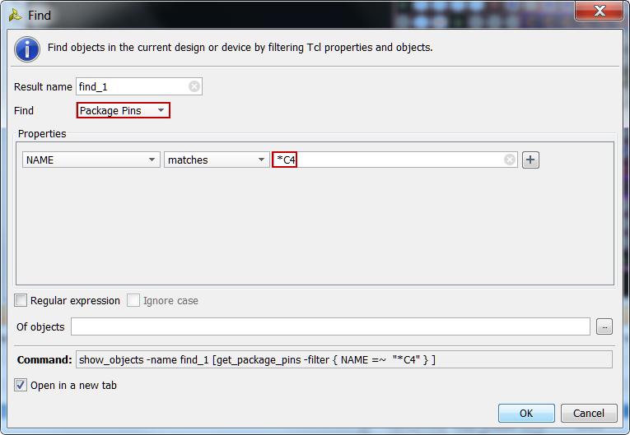

Figure 4. Finding a package pin for the Nexys4 (use B18 for the Basys3)

Notice that the pin is highlighted in the Device view and the corresponding entry is displayed in the Package Pins tab.

* + 1. Assign the name **rxd_pin** to the pin with *LVCMOS33* standard.
    2. Similarly add the **rst_pin** input by assigning it to the **E16** location with *LVCMOS33* standard. For the Basys3, assign it to **U18** with the LVCMOS33 standard.
  1. For the Nexys4, assign output pins led_pins[7] to led_pins[0] to locations U6, U7, T4, T5, T6, R8, V9, and T8. Creating them as a vector and assigning them using the Tcl command set_property. They all will be LVCMOS33.

For the Basys3, assign output pins led_pins[7] to led_pins[0] to locations V14, U14, U15, W18, V19, U19, E19 and U16. Creating them as a vector and assigning them using the Tcl command set_property. All the pins will be LVCMOS33.

* + 1. In the I/O Ports tab, click on the create I/O port button on the left vertical ribbon.

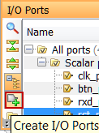

Figure 5. Create I/O Ports button

The Create I/O Ports form will be displayed.

* + 1. Type **led_pins** in the *Name* field, select *Output* direction, click on the check-box of **Create bus**, set the msb to **7**, and select **LVCMOS33** I/O standard, and click **OK**.

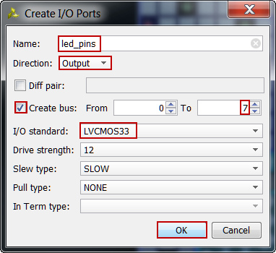

Figure 6. Creating I/O ports for the led_pins output

The led_pins entries will be created and displayed in the I/O Ports tab. Notice that the I/O standard and directions are already set, leaving only the pin locations to be assigned.

* + 1. Type the following commands in the console to assign the pin locations.

**For the Nexys4:**

set_property PACKAGE_PIN T8 [get_ports led_pins[0]]

set_property PACKAGE_PIN V9 [get_ports led_pins[1]]

set_property PACKAGE_PIN R8 [get_ports led_pins[2]]

set_property PACKAGE_PIN T6 [get_ports led_pins[3]]

set_property PACKAGE_PIN T5 [get_ports led_pins[4]]

set_property PACKAGE_PIN T4 [get_ports led_pins[5]]

set_property PACKAGE_PIN U7 [get_ports led_pins[6]]

set_property PACKAGE_PIN U6 [get_ports led_pins[7]]

**For the Basys3:**

set_property PACKAGE_PIN V14 [get_ports led_pins[7]]

set_property PACKAGE_PIN U14 [get_ports led_pins[6]]

set_property PACKAGE_PIN U15 [get_ports led_pins[5]]

set_property PACKAGE_PIN W18 [get_ports led_pins[4]]

set_property PACKAGE_PIN V19 [get_ports led_pins[3]]

set_property PACKAGE_PIN U19 [get_ports led_pins[2]]

set_property PACKAGE_PIN E19 [get_ports led_pins[1]]

set_property PACKAGE_PIN U16 [get_ports led_pins[0]]

* + 1. Select **File > Save Constraints**.

The Save Constraints form will be displayed.

* + 1. Enter **uart_led** in the *File name* field, and click **OK**.

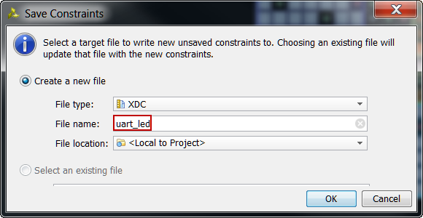

Figure 7. Accessing clocking wizard

The uart_led.xdc file will be created and added to the Sources tab.

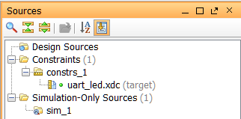

Figure 8. The uart_led.xdc file added to the source tree

* + 1. Expand the **I/O Planning > I/O Design** in the *Flow Navigator* pane.
    2. Click on **Report DRC** and click **OK**. Notice the design rules checker is run and one warning is reported. Ignore the warning.
    3. Click on **Report Noise** and click **OK**. Notice the noise analysis is done on the output pins only (led_pins) and the results are displayed.
    4. Click on **Migrate to RTL.**

The Migrate to RTL form will be displayed with Top RTL file field showing *c:/xup/fpga_flow/2014_2_artix7_labs/lab5/io_1.v* entry.

* + 1. Change *io_1.v* to **uart_led.v**, and click **OK**

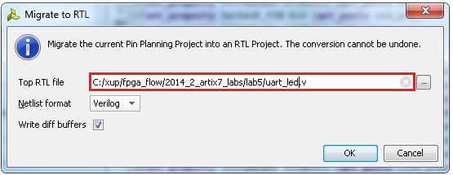

Figure 9. Assigning top-level file name

* + 1. Select the **Hierarchy** tab and notice that the *uart_led.v* file has been added to the project with top-level module name as **ios**. If you double-click the entry, you will see the module name with the ports listing.

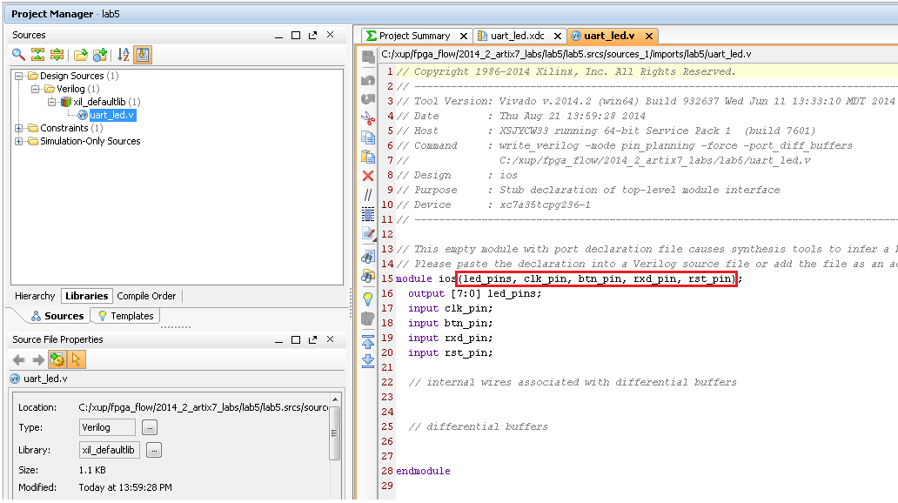

Figure 10. The top-level module content and the design hierarchy after migrating to RTL

* 1. Add the provided source files (from <2014_2_artix7_sources>\lab5) to the project. Copy the uart_led.txt (located in the <2014_2_artix7_sources>\lab5) content into the top-level source file.
     1. Click on **Add Sources** in the *Flow Navigator*.
     2. In the *Add Sources* form, select *Add or Create Design Sources*, and click **Next**.
     3. Click **Add Files…**
     4. Browse to **<2014_2_artix7_sources>\lab5** and select all *.v* files (led_ctrl, uart_rx, meta_harden, uart_baud_gen, uart_rx_ctl), and click **OK**.
     5. Click **Finish**.
     6. Using Windows Explorer, browse to **<2014_2_artix7_sources>\lab5** and open uart_led.txt using any text editor. Copy the content of it and paste it in uart_led.v (around line 19) in the Vivado project.
     7. Open the XDC file and comment out the following lines using the # mark for each line (or highlighting the lines and clicking on the block comment button “//”):

set_property direction IN [get_ports {clk_pin}]

set_property direction IN [get_ports {btn_pin}]

set_property direction IN [get_ports {rxd_pin}]

set_property direction IN [get_ports {rst_pin}]

set_property direction OUT [get_ports {led_pins[0]}]

set_property direction OUT [get_ports {led_pins[1]}]

set_property direction OUT [get_ports {led_pins[2]}]

set_property direction OUT [get_ports {led_pins[3]}]

set_property direction OUT [get_ports {led_pins[4]}]

set_property direction OUT [get_ports {led_pins[5]}]

set_property direction OUT [get_ports {led_pins[6]}]

set_property direction OUT [get_ports {led_pins[7]}]

* + 1. Select **File > Save File.**

1. Synthesize and Enter Timing Constraints Step 3
   1. Synthesize the design. Use the Constraints Wizard to specify a clock frequency and then use the Timing Constrains Editor to add input and output delays to the XDC file.
      1. Click on the **Run Synthesis** in the *Flow Navigator* pane.

When synthesis is completed a form with three options will be displayed.

* + 1. Select *Open Synthesized Design* and click **OK**.
    2. In the *Flow Navigator* pane (under Synthesized Design), click on the **Constraints Wizard**  button. This will open up the Constraints Wizard.
    3. Read the *Identify and Recommend Missing Timing Constraints* screen of the wizard to understand what the wizard does and click **Next**.
    4. Specify the frequency of the object “clk_pin” to be **100 MHz,** notice the Period, Rise At and Fall At are automatically populated. Also notice the Tcl command that can be previewed at the bottom of the wizard. Click **Next** to proceed.

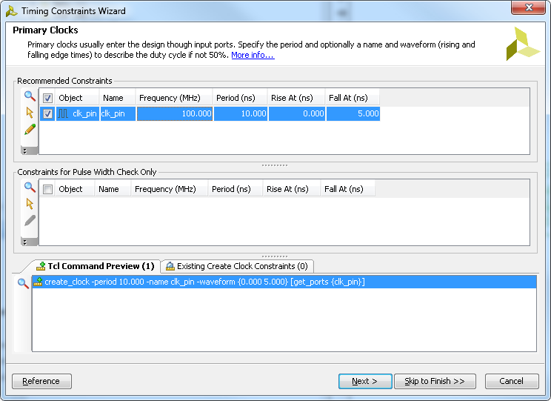

Figure 11. Constraints Wizard *clk_pin* parameters and Tcl command

* + 1. The wizard informs you there are no missing Generated Clocks, click **Next** to proceed.
    2. There are no missing Forwarded Clocks, click **Next** to proceed.
    3. There are no missing External Feedback Delays, click **Next** to proceed.
    4. The wizard identifies Input Delays needed for the pins: btn_pin, rst_pin and rxd_pin. Do the following:

1. Press Ctrl and select all three rows.
2. Enter the **tco_min** value to be **-0.5 ns** and everything else as **0 ns**. Click **Apply**.
3. Notice that under the Tcl Command Preview tab, 6 Tcl commands have been generated.
4. Click **Next**.

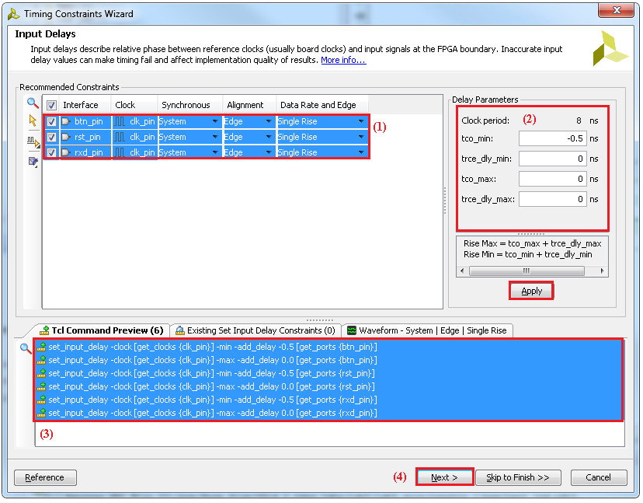

Figure 12. Specifying Input Delays for btn_pin, rst_pin and rxt_pin

* + 1. For Output Delays, specify all values (tsu, trce_dly_max, thd, trce_dly_min) to be **0 ns**. Click **Apply** and then click **Next**.
    2. There are no Combinatorial Delays identified, click **Next** to proceed.
    3. Click **Next** for the next few screens until the final Constraints Summary page. Read the description of each page.
    4. **Check** *On Finish –* **View Timing Constraints** and click **Finish** to close the wizard. The option will open the Timing Constraints Editor to show you the generated timing constraint.

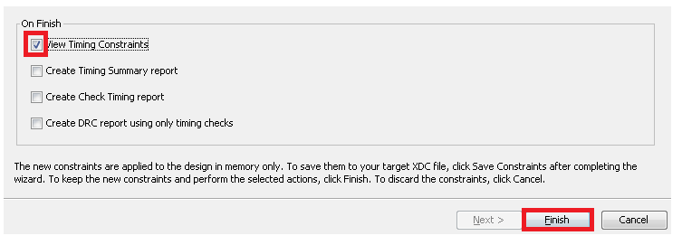

Figure 13, selecting View Timing constraints

* + 1. Note the wizard generated the clk_pin constraint for a 10 ns period (or 100 MHz). Notice in the All Constraints window, 9 constraints will be created.

There is no need to click Apply since the constraints have already been applied in the Constraints Wizard.

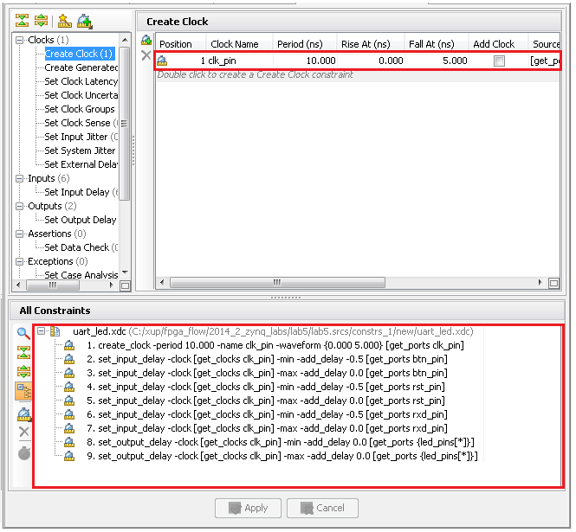

Figure 14. The constraints added after using the Constraints Wizard

* + 1. Select **File > Save Constraints** to save the changes to the target XDC. Click **OK** at the warning about synthesis going out of date.
    2. Open uart_led.xdc (if it was already opened, click Reload in the yellow status bar) and notice additional constraints were added to the last line of the file.
  1. Generate an estimated Timing Report showing both the setup and hold paths in the design.
     1. In the Flow Navigator, select Synthesized Design > Report Timing Summary.
     2. In the Options tab, select min_max from the Path delay type drop-down list.

.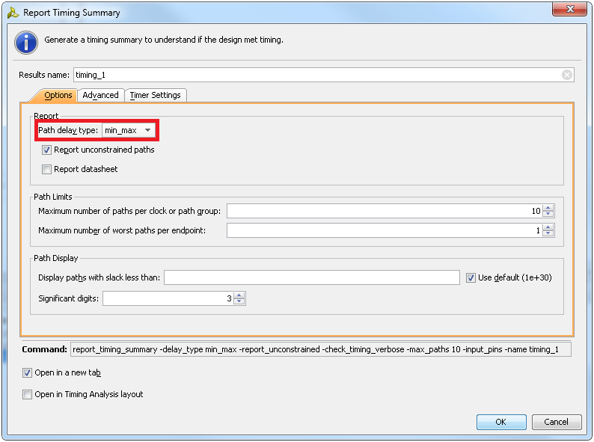

Figure 15. Performing timing analysis

* + 1. Click OK to run the analysis.

The Timing Results view opens at the bottom of the Vivado IDE.

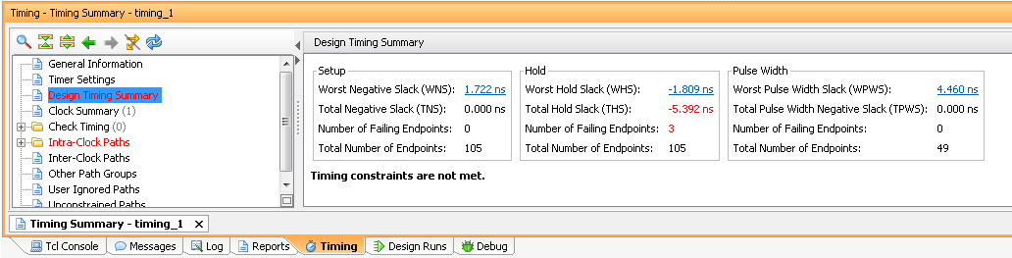

Figure 16. Timing summary for the Nexys4

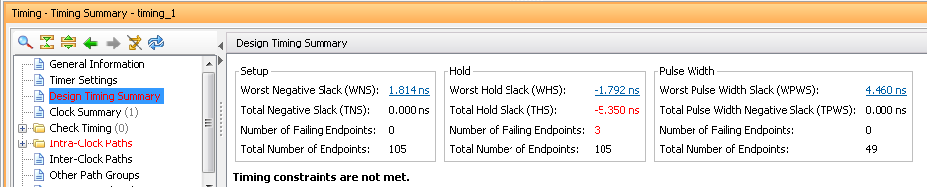

Figure 16. Timing summary for the Basys3

The *Design Timing Summary* report provides a brief worst Setup and Hold slack information and Number of failing endpoints to indicate whether the design has met timing or not.

Note that there are three timing failures under the hold check.

* + 1. Click on the link next to *Worst Hold Slack* (WHS) to see the list of failing paths.

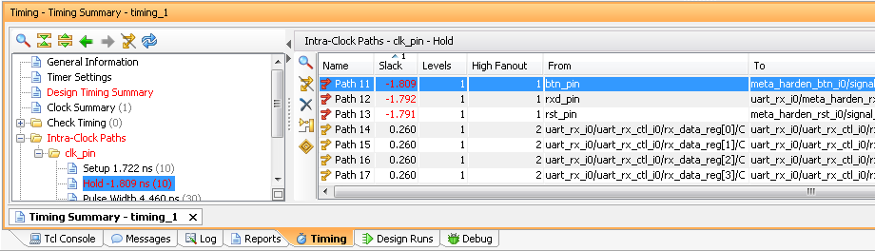

Figure 17. The list of paths showing hold violations for the Nexys4

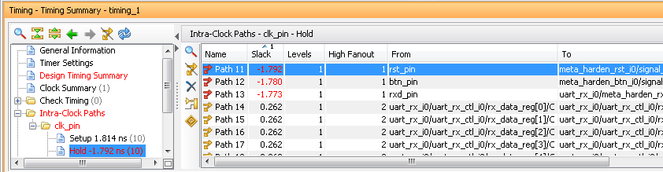

Figure 17. The list of paths showing hold violations for the Basys3

* + 1. Double-click on the Path 11 to see the actual path detail.

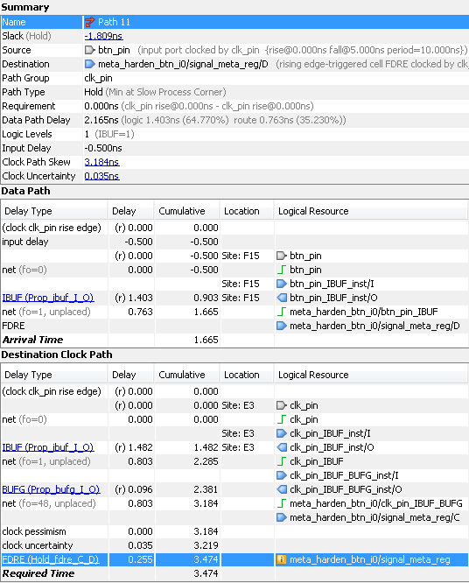

Figure 18. Failing hold path for the Nexys4

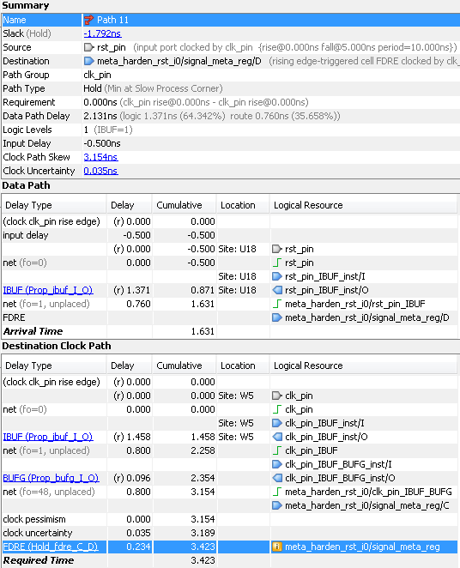

Figure 18. Failing hold path for the Basys3

* + 1. Select Path11, right-click and select Schematic.

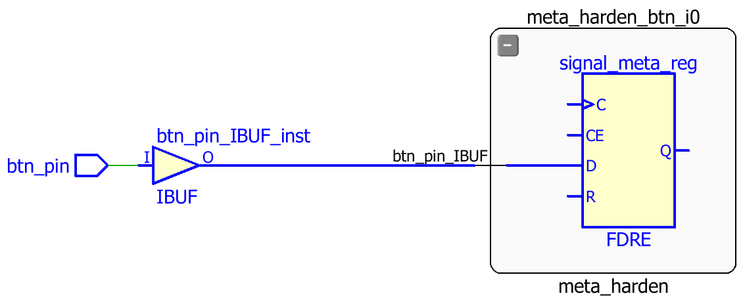

Figure 19. The schematic of the failing path

The three failing paths are of the btn_pin, rxd_pin and rst_pin.

1. Implement and Analyze Timing Summary Step 4
   1. Implement the design.
      1. Click on the **Run Implementation** in the *Flow Navigator* pane.
      2. Click **Yes** to run the synthesis first before running the implementation process.

When the implementation is completed, a dialog box will appear with three options.

* + 1. Select the *Open Implemented Design* option and click **OK**.
    2. Click Yes if you are prompted to close the synthesized design.
  1. Generate a timing summary report.
     1. In the Flow Navigator, under Implementation > Implemented Design, click Report Timing Summary.
     2. Click OK to generate the report using the default settings.

The Design Timing Summary window opens at the bottom in the Timing tab.

Note that failing timing paths are indicated in red.

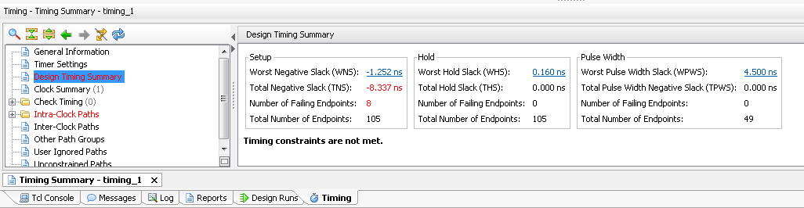

Figure 20. Failing setup paths for the Nexys4

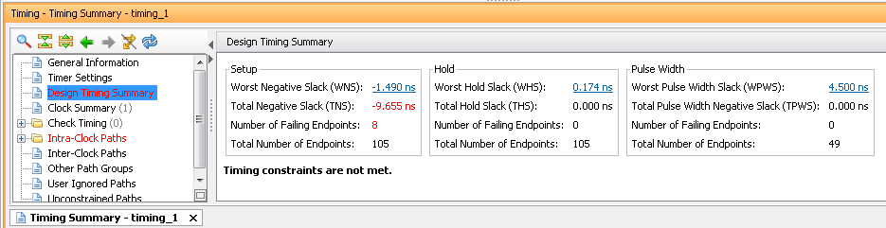

Figure 20. Failing setup paths for the Basys3

* + 1. Click on the WNS to see the failing paths.
    2. Double-click on the first failing path from the top and see the detailed analysis.

The output path delay can be reduced by placing the register in IOB.

* + 1. Apply the constraint by typing the following command in the Tcl console.

set_property IOB TRUE [get_ports led_pins[*]]

* + 1. Select **File > Save Constraints**. Click **OK** at the warning message.
    2. Click on **Run Implementation**.
    3. Click **Yes** to reset the synthesis run, perform the synthesis, and run implementation.
    4. Open the implemented design and observe that the number of failing paths in the Design Runs tab reported is 0.
    5. Click Report Timing Summary, and observe that there are no failing paths.

1. Generate the Bitstream and Verify the Functionality (Optional) Step 5
   1. Generate the bitstream.
      1. In the Flow Navigator, under *Program and Debug*, click Generate Bitstream.
      2. The write_bitstream command will be executed (you can verify it by looking in the Tcl console).
      3. Click **Cancel** when the bitstream generation is completed.
   2. Connect the board and power it ON. Open a hardware session, and program the FPGA.
      1. Make sure that the Micro-USB cable is connected to the JTAG PROG connector (next to the power supply connector). Make sure that is the board set to select USB power (JP3 on the Nexys4 and JP2 on the Basys3).
      2. Turn ON the power.
      3. Select the *Open Hardware Manager* option.

The Hardware Manager window will open indicating “unconnected” status.

* + 1. Click on the **Open a new hardware target** link.

You can also click on the **Open recent target** link if the board was already targeted before. In this case skip to step 5-2-8.

* + 1. Click **Next**  to see the Vivado Hardware Server Settings form.
    2. Click **Next** with the Target Hardware selected.

The JTAG cable which uses the xilinx_tcf should be detected and identified as a hardware target. It will also show the hardware devices detected in the chain.

* + 1. Click **Next** and **Finish**.
    2. The Hardware Manager status changes from Unconnected to the server name and the device is highlighted. Also notice that the Status indicates that it is not programmed.
    3. Select the device and verify that the **uart_led.bit** is selected as the programming file in the General tab.
  1. Start a terminal emulator program such as TeraTerm or HyperTerminal. Select an appropriate COM port (you can find the correct COM number using the Control Panel). Set the COM port for 115200 baud rate communication. Program the FPGA and verify the functionality.
     1. Start a terminal emulator program such as TeraTerm or HyperTerminal.
     2. Select an appropriate COM port (you can find the correct COM number using the Control Panel).
     3. Set the COM port for 115200 baud rate communication.
     4. Right-click on the FPGA entry in the Hardware window and select Programming Device…
     5. Click on the **Program** button.

The programming bit file be downloaded and the DONE light will be turned ON indicating the FPGA has been programmed.

* + 1. Verify the functionality as you did in the previous lab, by typing some characters into the terminal, and watching the corresponding values appear on the LEDs.
    2. When satisfied, close the terminal emulator program and power OFF the board.
    3. Select **File > Close Hardware Manager**. Click **OK** to close it.
    4. When done, close the **Vivado** program by selecting **File > Exit** and click **OK**.

Conclusion

In this lab, you learned how to create an I/O Planning project and assign the pins via the Device view, Package Pins tab, and the Tcl commands. You then exported to the rtl project where you added the provided source files. Next you created timing constraints and performed post-synthesis and post-implementation timing analysis.