**Ćwiczenie nr 4**

**Temat: Analiza układu synchronicznego.**

Zadaniem przedstawianego układu jest wykrycie wystąpienie po sobie kolejno trzech stanów wysokich. W przypadku gdy nastąpi taka sekwencja – stan układu pozostaje wysoki aż do pierwszego niskiego stanu wejścia. Stan niski na wejściu resetuje cały układ, który przechodzi w stan oczekiwania następnej sekwencję trzech stanów wysokich.

|  |  |  |  |  |  |  |  |  |  |  |  |  |
| --- | --- | --- | --- | --- | --- | --- | --- | --- | --- | --- | --- | --- |
| Funkcje wzbudzające: $$D_{1}=x\overline{y_{1}}+xy_{2}$$ $$D_{2}=xy_{1}+xy_{2}$$ | Tabela stanów – wyjść:   |  |  | | --- | --- | | stan | wartość | | S0 | 0 | | S1 | 0 | | S2 | 0 | | S3 | 1 | |  |

Tablica przejść i wzbudzeń:

|  |  |  |  |  |  |  |  |  |  |  |  |  |  |  |  |  |  |  |  |  |  |  |  |  |  |  |  |  |  |  |  |  |  |  |  |  |  |  |  |  |  |  |  |  |  |  |  |  |  |  |  |  |  |  |  |  |  |  |  |  |  |  |  |  |  |  |  |  |  |  |  |  |  |  |  |  |  |  |  |  |  |  |
| --- | --- | --- | --- | --- | --- | --- | --- | --- | --- | --- | --- | --- | --- | --- | --- | --- | --- | --- | --- | --- | --- | --- | --- | --- | --- | --- | --- | --- | --- | --- | --- | --- | --- | --- | --- | --- | --- | --- | --- | --- | --- | --- | --- | --- | --- | --- | --- | --- | --- | --- | --- | --- | --- | --- | --- | --- | --- | --- | --- | --- | --- | --- | --- | --- | --- | --- | --- | --- | --- | --- | --- | --- | --- | --- | --- | --- | --- | --- | --- | --- | --- | --- |
| |  |  |  |  |  |  |  |  |  | | --- | --- | --- | --- | --- | --- | --- | --- | --- | |  |  |  |  |  |  |  |  |  | | 0 | 0 | - | 0 | - | 0 | 0 | 0 | 0 | | 0 | 0 | - | - | 1 | 0 | 0 | 0 | 1 | | 0 | - | 1 | - | 1 | 0 | 0 | 1 | 1 | | 0 | - | 1 | 0 | - | 0 | 0 | 1 | 0 | | 1 | 0 | - | 1 | - | 0 | 1 | 0 | 0 | | 1 | 1 | - | - | 1 | 1 | 0 | 0 | 1 | | 1 | - | 0 | - | 0 | 1 | 1 | 1 | 1 | | 1 | - | 0 | 1 | - | 1 | 1 | 1 | 0 | | Funkcje wzbudzeń: |

|  |  |  |  |  |  |  |  |  |  |  |  |  |  |  |  |  |  |  |  |  |  |  |  |  |  |  |  |  |  |  |  |  |  |  |  |  |  |  |  |  |  |  |  |  |  |  |  |  |  |  |  |  |  |  |  |  |  |  |  |  |  |
| --- | --- | --- | --- | --- | --- | --- | --- | --- | --- | --- | --- | --- | --- | --- | --- | --- | --- | --- | --- | --- | --- | --- | --- | --- | --- | --- | --- | --- | --- | --- | --- | --- | --- | --- | --- | --- | --- | --- | --- | --- | --- | --- | --- | --- | --- | --- | --- | --- | --- | --- | --- | --- | --- | --- | --- | --- | --- | --- | --- | --- | --- |
| |  |  |  | | --- | --- | --- | |  | 0 | 1 | | 00 | 0 | 0 | | 01 | 0 | 1 | | 11 | - | - | | 10 | - | - |  |  |  |  | | --- | --- | --- | | \ | 0 | 1 | | 00 | 0 | 1 | | 01 | - | - | | 11 | - | - | | 10 | 0 | 1 | | |  |  |  | | --- | --- | --- | |  | 0 | 1 | | 00 | - | - | | 01 | - | - | | 11 | 1 | 0 | | 10 | 1 | 0 |  |  |  |  | | --- | --- | --- | |  | 0 | 1 | | 00 | - | - | | 01 | 1 | 1 | | 11 | 1 | 0 | | 10 | - | - | |

Do złożenia: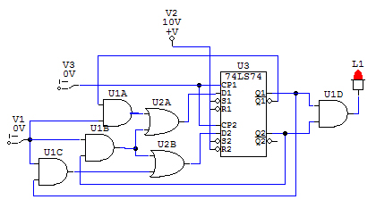

Układ gotowy: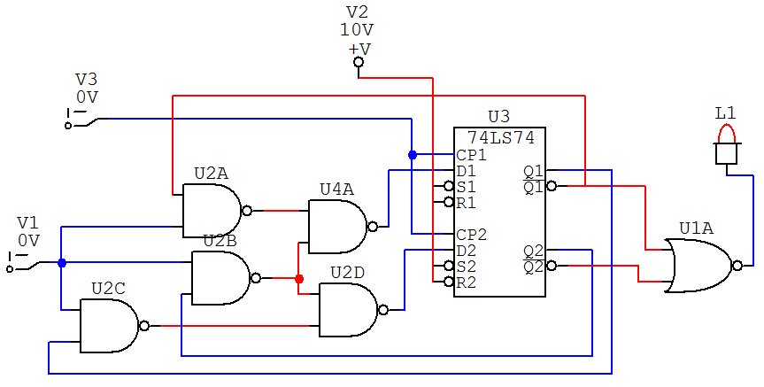

Wnioski:

Prezentowany układ działa zgodnie ze schematem zaprezentowanym na pierwszej stronie. Wyzwalanie stanu wysokiego powoduje przejście ze stanu s0 przez s1 i s2 do stanu s3. Wyzwolenie w którymkolwiek momencie stanu niskiego kieruje układ do s0. W przypadku trzykrotnego zadania stanu wysokiego układ przechodzi w stan wysoki aż do napotkania stanu niskiego.