**Ćwiczenie nr 5**

**Temat: Synteza układu synchronicznego.**

Celem ćwiczenia 5 jest znalezienie różnic pomiędzy analizą a syntezą układu synchronicznego. W tym celu należy zaprojektować synchroniczny o jednym wejściu i dwóch wyjściach. Układ ten ma przekazywać jedynki nieparzyste na wyjście Z1, a jedynki parzyste na wyjście Z2 („rozdzielacz jedynek”).

Układ Moore’a:

Graf przejść: Kodowanie stanów:

|  |  |  |
| --- | --- | --- |
| stan | y1 | y2 |
| s1 | 0 | 0 |
| s2 | 0 | 1 |
| s3 | 1 | 1 |
| s4 | 1 | 0 |

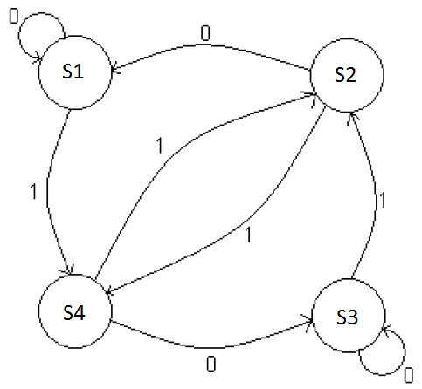

Tabela przejść: Tabela przejść i wzbudzeń:

|  |  |  |
| --- | --- | --- |
|  | x | |
| y1 y2 | 0 | 1 |
| s1 | s1 | s2 |
| s2 | s4 | s3 |
| s3 | s1 | s2 |
| s4 | s4 | s3 |

|  |  |  |  |  |  |  |
| --- | --- | --- | --- | --- | --- | --- |
| x | y1 | y2 | y2(t+1) | y1(t+1) | D1 | D2 |
| 0 | 0 | 0 | 0 | 0 | 0 | 0 |
| 0 | 0 | 1 | 0 | 1 | 1 | 0 |
| 0 | 1 | 0 | 0 | 0 | 0 | 0 |
| 0 | 1 | 1 | 0 | 1 | 1 | 0 |
| 1 | 0 | 0 | 1 | 0 | 0 | 1 |
| 1 | 0 | 1 | 1 | 1 | 1 | 1 |
| 1 | 1 | 0 | 1 | 0 | 0 | 1 |
| 1 | 1 | 1 | 1 | 1 | 1 | 1 |

Tabela D1: Tabela D2:

|  |  |  |
| --- | --- | --- |
| y1 y2 | 0 | 1 |
| 0 0 | 0 | 0 |
| 0 1 | 1 | 1 |
| 1 1 | 0 | 0 |
| 1 0 | 1 | 1 |

|  |  |  |
| --- | --- | --- |
| y1 y2 | 0 | 1 |
| 0 0 | 0 | 1 |
| 0 1 | 0 | 1 |
| 1 1 | 0 | 1 |
| 1 0 | 0 | 1 |

|  |  |  |
| --- | --- | --- |
| Przerzutnik "D" | | |
| Q(t) | Q(t+1) | D |
| 0 | 0 | 0 |
| 1 | 0 | 0 |
| 0 | 1 | 1 |
| 1 | 1 | 1 |

Funkcje:

$$F_{1}=\overline{y_{1}}y_{2}+y_{1}\overline{y_{2}}$$

$$F_{2}=x$$

Funkcje wyjść:

**Z1**  **Z2**

|  |  |
| --- | --- |
|  | **Z1** |
| 0 0 | 0 |
| 0 1 | 1 |
| 1 1 | 0 |
| 1 0 | 0 |

|  |  |
| --- | --- |
|  | **Z1** |
| 0 0 | 0 |
| 0 1 | 0 |
| 1 1 | 1 |
| 1 0 | 0 |

wertyy

$F_{21}=\overline{y_{1}}y_{2}$ $F_{22}=y_{1}y_{2}$

Realizacja AND-OR:

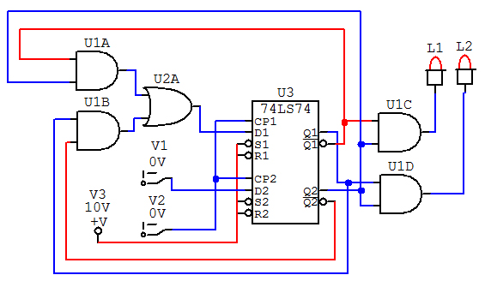

Realizacja na płycie:

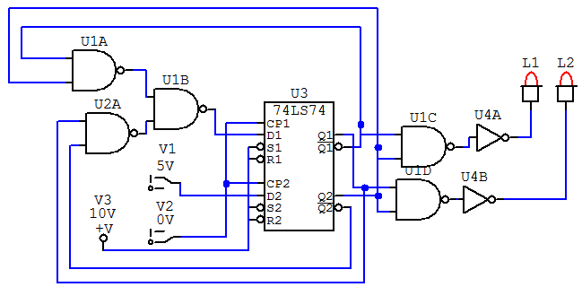

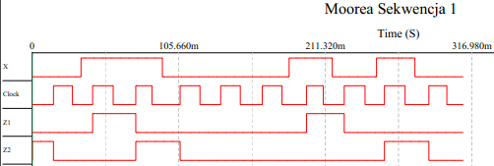

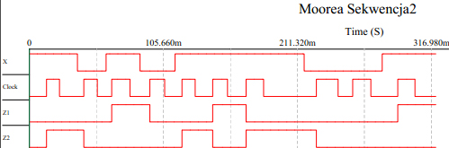Układ Mealy’ego:

Graf przejść:

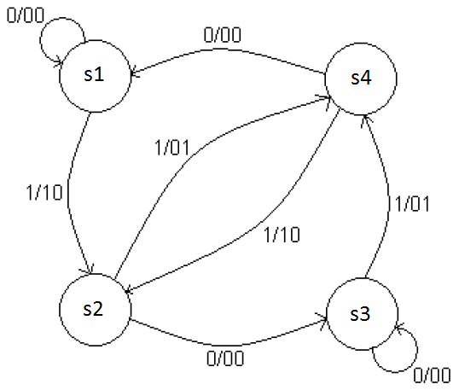

Tablica przejść i wzbudzeń: Tablica przejść J-K:

|  |  |  |  |  |  |  |  |  |  |  |  |  |  |  |  |  |  |  |  |  |  |  |  |  |  |  |  |  |  |  |  |
| --- | --- | --- | --- | --- | --- | --- | --- | --- | --- | --- | --- | --- | --- | --- | --- | --- | --- | --- | --- | --- | --- | --- | --- | --- | --- | --- | --- | --- | --- | --- | --- |
| |  |  |  | | --- | --- | --- | | / | 0 | 1 | | 00 | 00 | 01 | | 01 | 10 | 11 | | 11 | 00 | 01 | | 10 | 10 | 11 | | |  |  |  | | --- | --- | --- | |  | J | K | | 00 | 0 | - | | 01 | 1 | - | | 10 | - | 1 | | 11 | - | 0 | |

|  |  |  |  |  |  |  |  |  |  |  |  |  |  |  |  |  |  |  |  |  |  |  |  |  |  |  |  |  |  |  |  |  |  |  |  |  |  |  |  |  |  |  |  |  |  |  |  |  |  |  |  |  |  |  |  |  |  |  |  |  |  |
| --- | --- | --- | --- | --- | --- | --- | --- | --- | --- | --- | --- | --- | --- | --- | --- | --- | --- | --- | --- | --- | --- | --- | --- | --- | --- | --- | --- | --- | --- | --- | --- | --- | --- | --- | --- | --- | --- | --- | --- | --- | --- | --- | --- | --- | --- | --- | --- | --- | --- | --- | --- | --- | --- | --- | --- | --- | --- | --- | --- | --- | --- |
| |  |  |  | | --- | --- | --- | | / | 0 | 1 | | 00 | 0 | 0 | | 01 | 1 | 1 | | 11 | - | - | | 10 | - | - |  |  |  |  | | --- | --- | --- | | / | 0 | 1 | | 00 | - | - | | 01 | - | - | | 11 | 1 | 1 | | 10 | 0 | 0 | | |  |  |  | | --- | --- | --- | | / | 0 | 1 | | 00 | 0 | 1 | | 01 | - | - | | 11 | - | - | | 10 | 0 | 1 |  |  |  |  | | --- | --- | --- | | / | 0 | 1 | | 00 | - | - | | 01 | 1 | 0 | | 11 | 1 | 0 | | 10 | - | - | |

Funkcje wzbudzające:

$J_{1}=y_{2}$ $K_{1}=y_{2}$

$J_{2}=x$ $K_{2}=\overline{x}$

Funkcje wyjść:

|  |  |  |  |  |  |  |  |  |  |  |  |  |  |  |  |  |  |  |  |  |  |
| --- | --- | --- | --- | --- | --- | --- | --- | --- | --- | --- | --- | --- | --- | --- | --- | --- | --- | --- | --- | --- | --- |
| |  |  | | --- | --- | | / | **Z** | | 00 | 0 | | 01 | 1 | | 11 | 0 | | 10 | 0 | | |  |  | | --- | --- | | / | **Z** | | 00 | 0 | | 01 | 0 | | 11 | 1 | | 10 | 0 | $$F_{Z_{2}}=y_{1}y_{2}$$ |

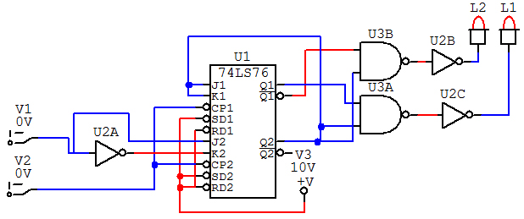

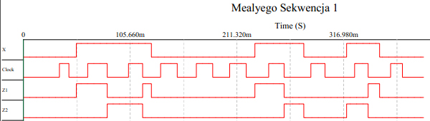

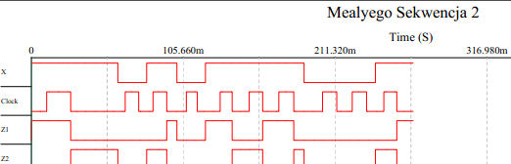

Wnioski:

Prezentowany układ działa zgodnie ze schematem zaprezentowanym na pierwszej stronie. Nieparzyste jedynki przekazywane są na wyjście Z1 a parzyste na Z2.