**MATERIALS:**

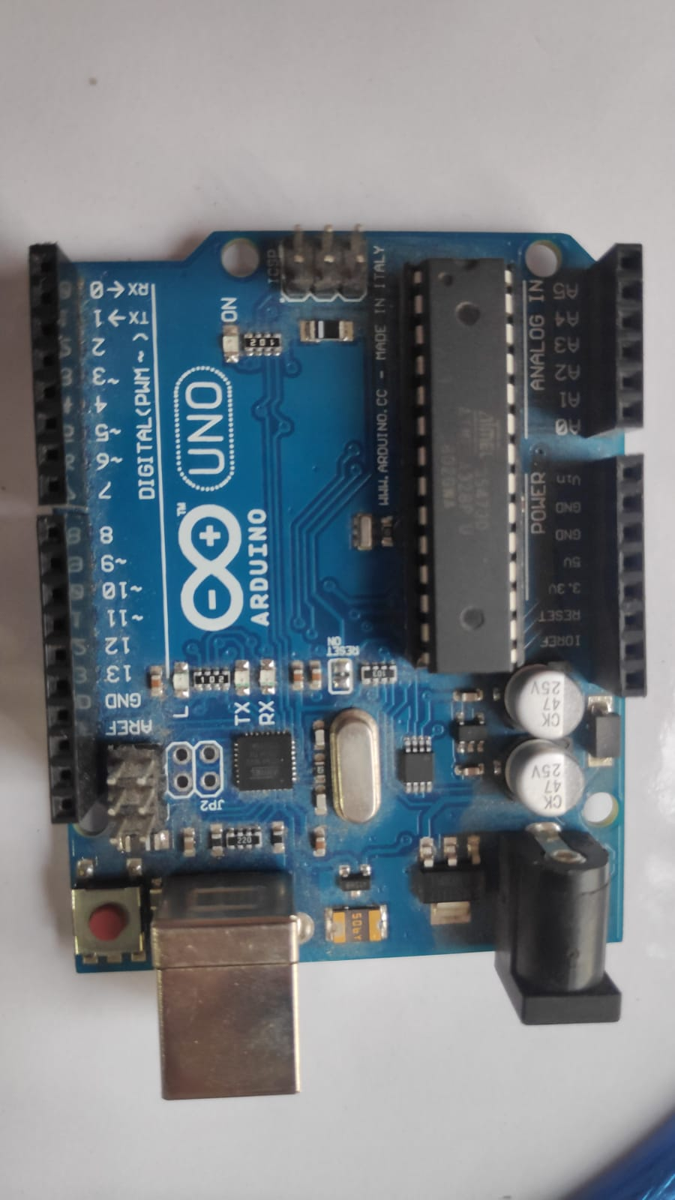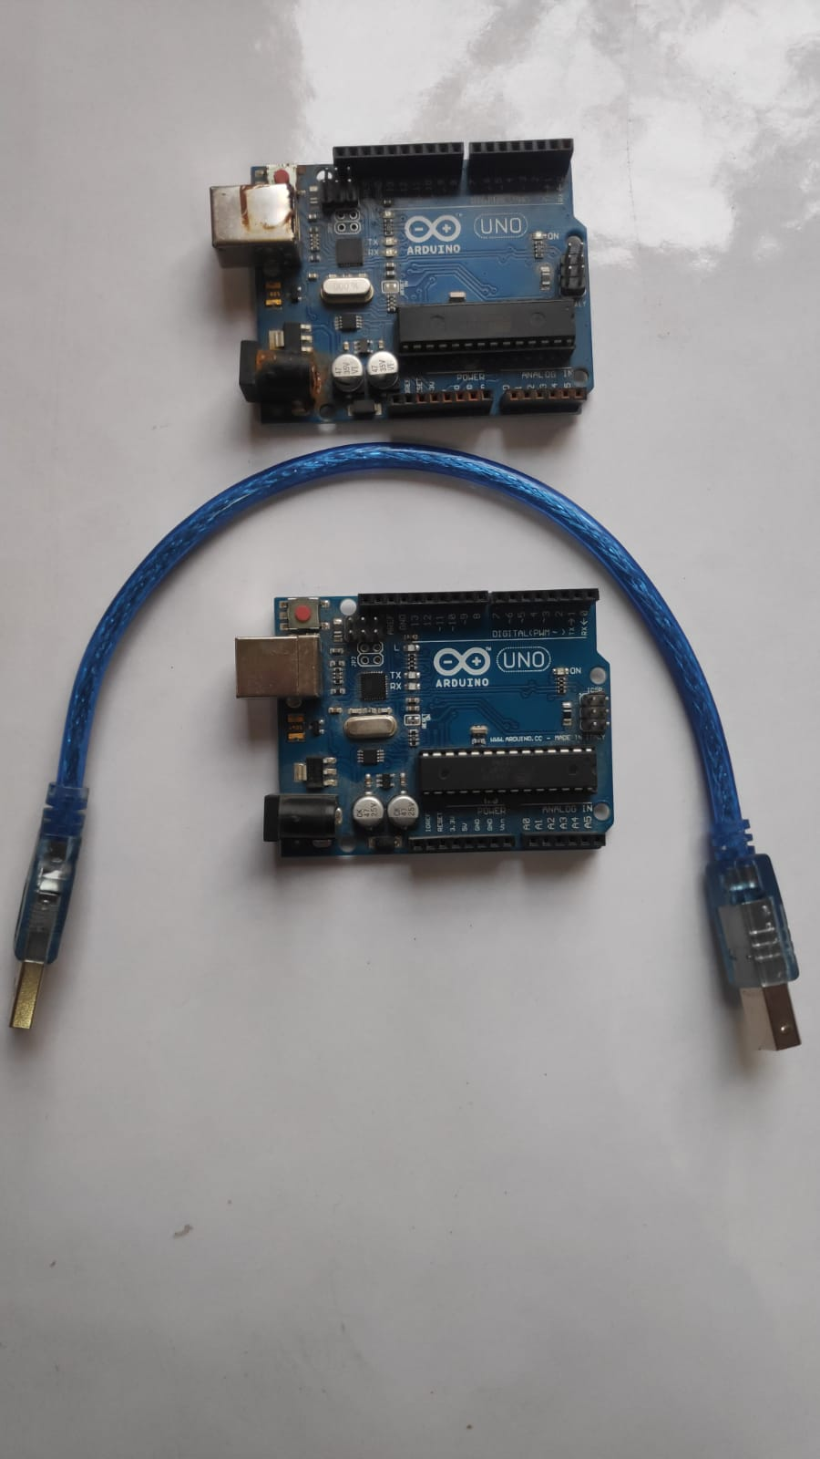

**ARDUINO BOARDS**

Arduino is an open-source electronics platform used for prototyping.

We use two of these microcontrollers on both the sites ( local control panel and tank) to enable control of other auxiliary actuators in our model.

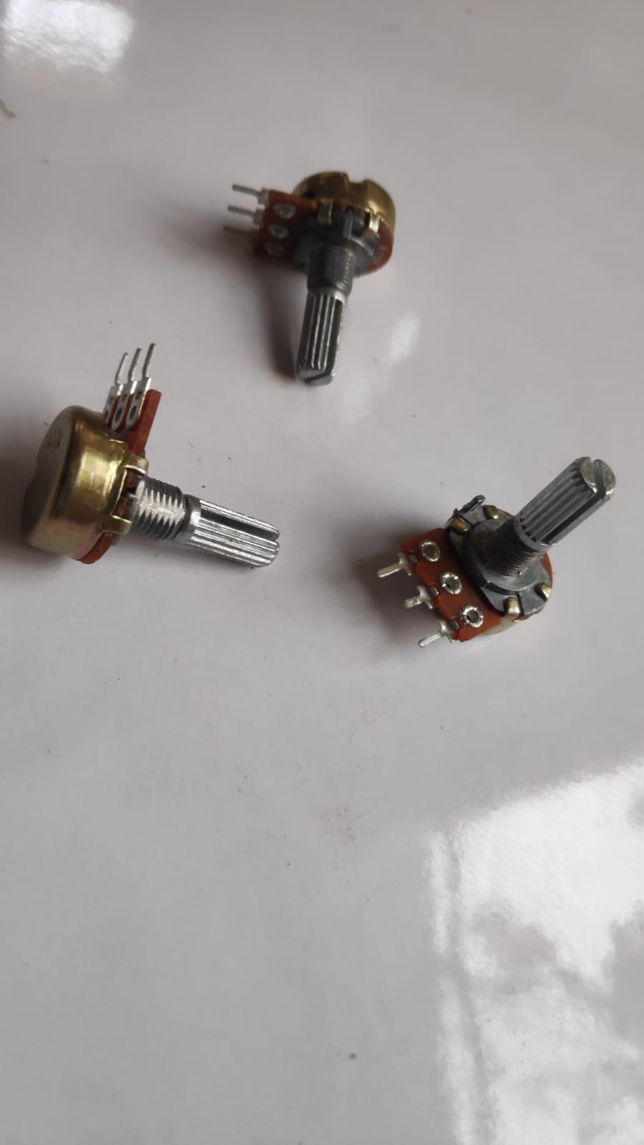

**POTENTIOMETERS**

A potentiometer is a type of position sensor. They are used to measure displacement in any direction.

**USAGE :**

We use them to control the servo motors in our model.

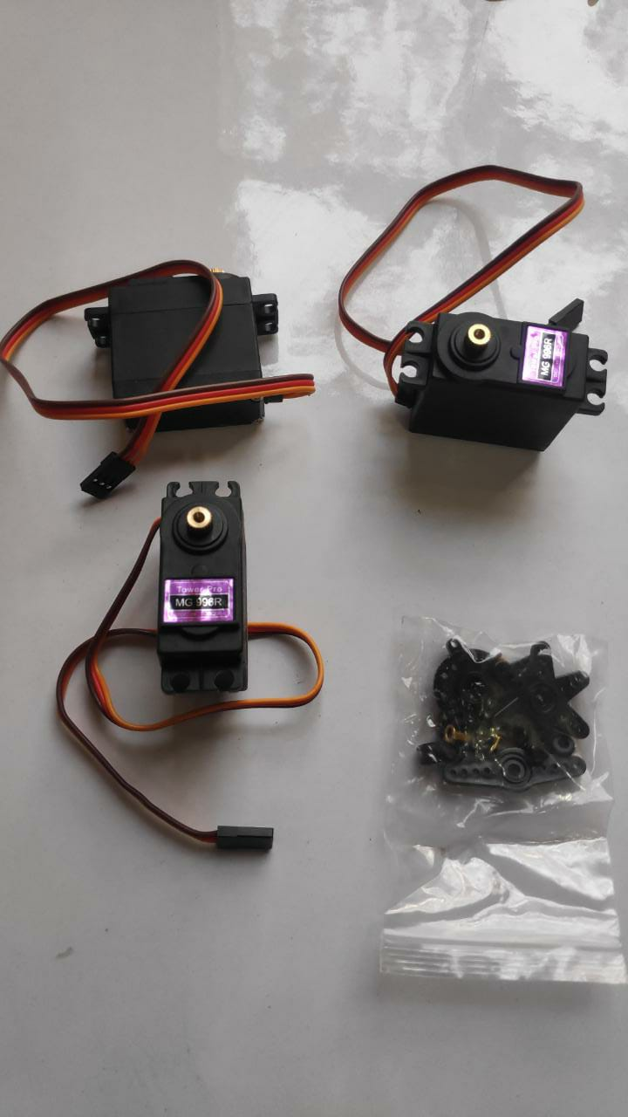

**SERVO MOTORS**

Servos are mainly used on angular or linear position and for specific velocity, and acceleration.

**USAGE:**

We use servo motors to control the Gun controller’s knobs in our model.

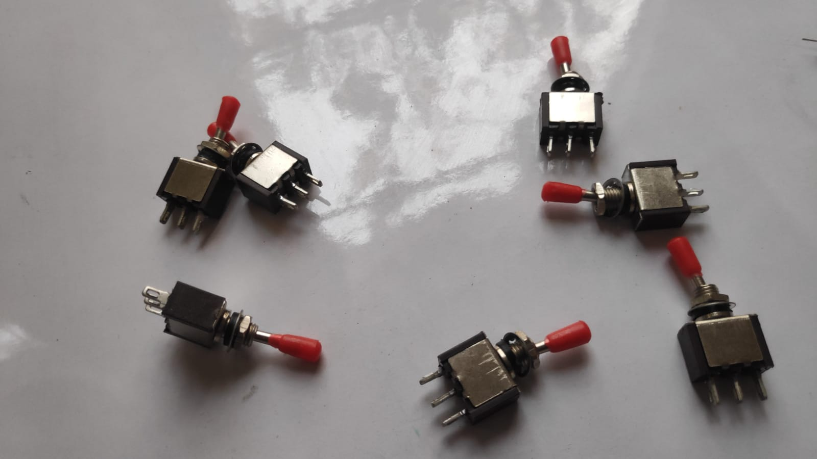

**TOGGLE SWITCH**

A toggle switch is a type of electrical switch that is actuated by moving a lever back and forth to open or close an electrical circuit.

**USAGE:**

We use them to toggle push pull solenoid in our model.

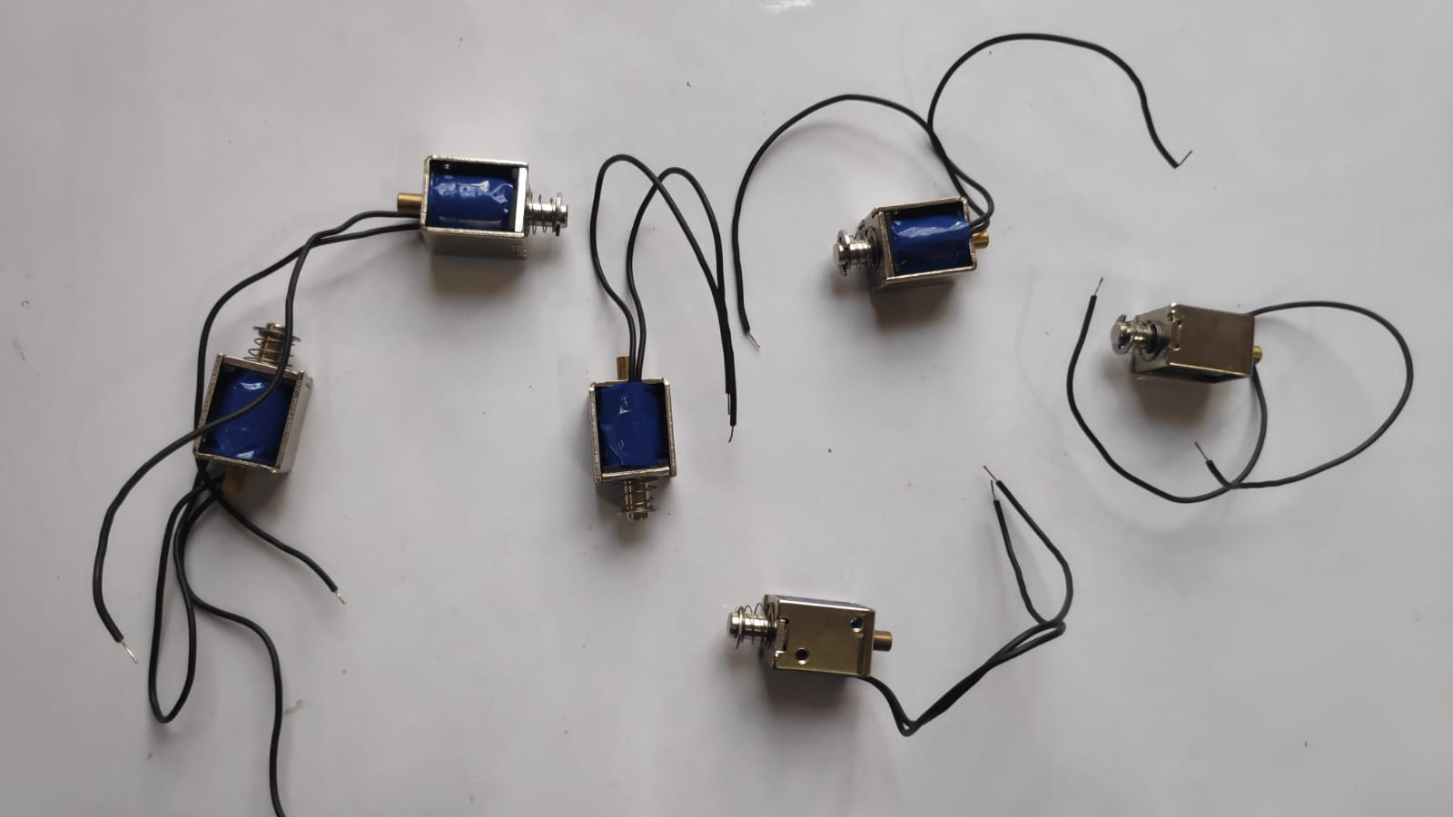

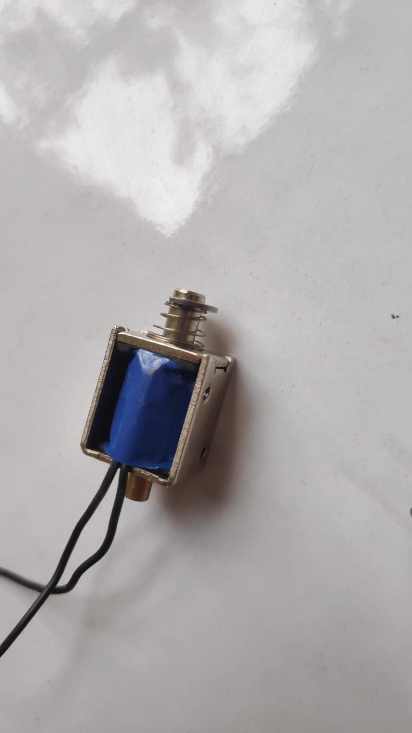

**PUSH PULL SOLENOID**

A push solenoid is an actuator that extends and retracts upon control signals

**USAGE:**

We use them to control switches on the gun controller.

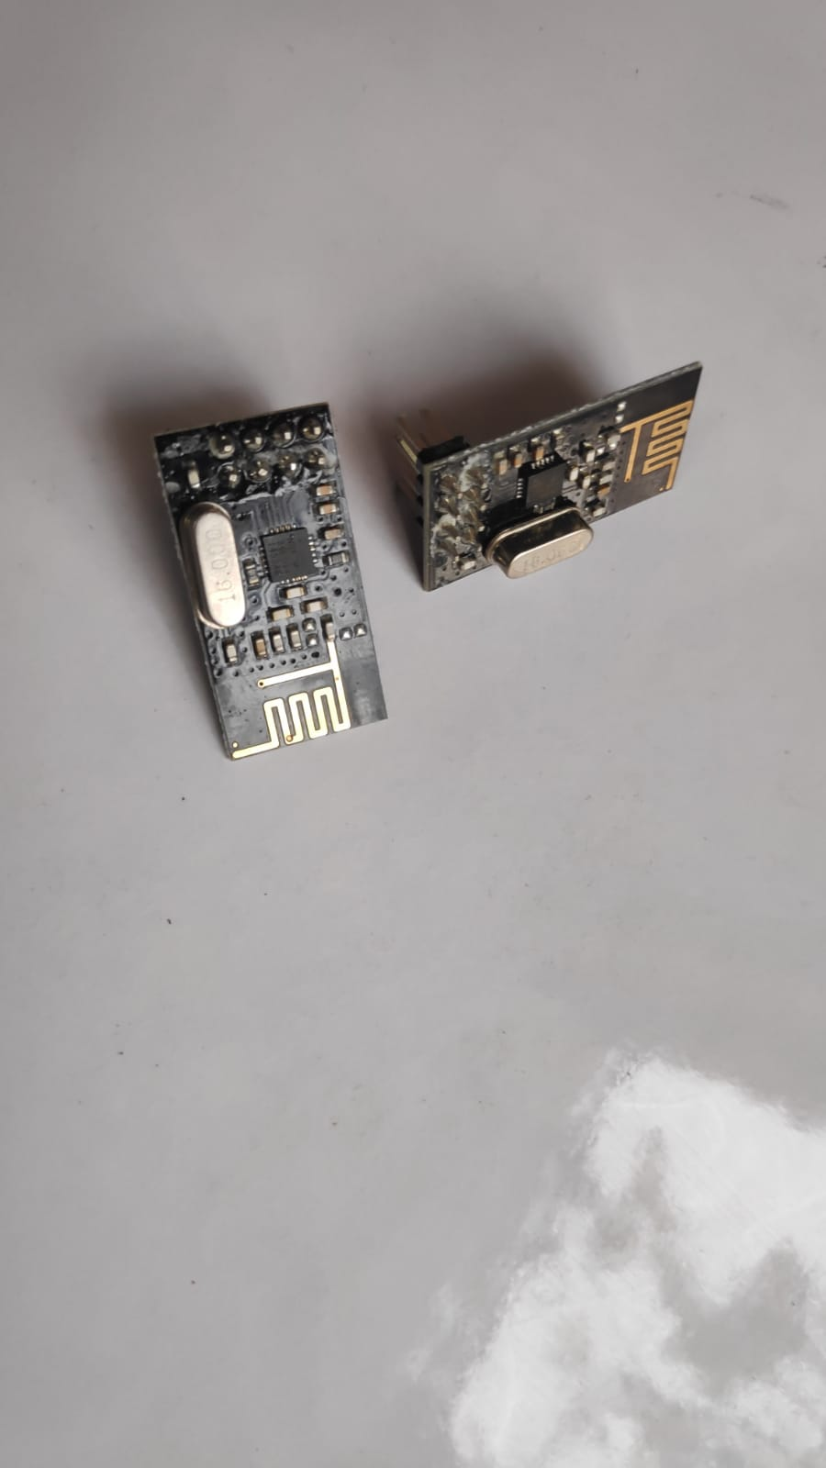

**nRF24L01 WIRELESS TRANCIEVER**

nRF24L01 is a single chip radio transceiver for the world wide 2.4 - 2.5 GHz ISM band.

**USAGE:**

We use them to enable wireless compatibility of Arduino(s).

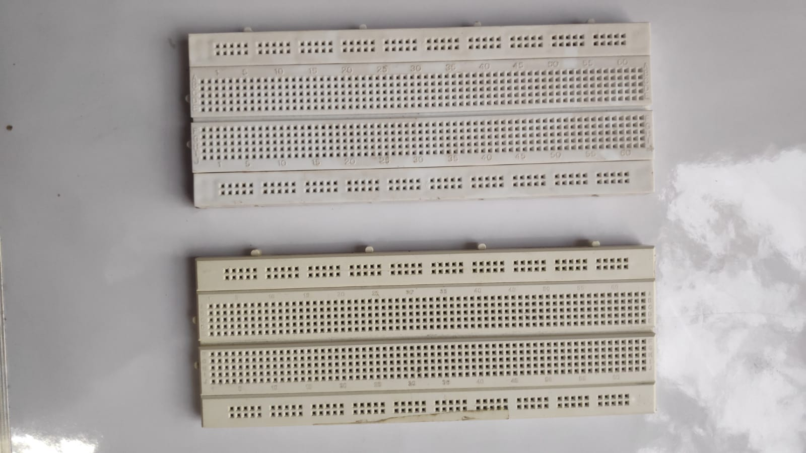

**BREADBOARD**

Breadboards are used **to hold electronic components** (transistors, resistors, chips, etc.) that are wired together. Used to develop prototypes of electronic circuits.

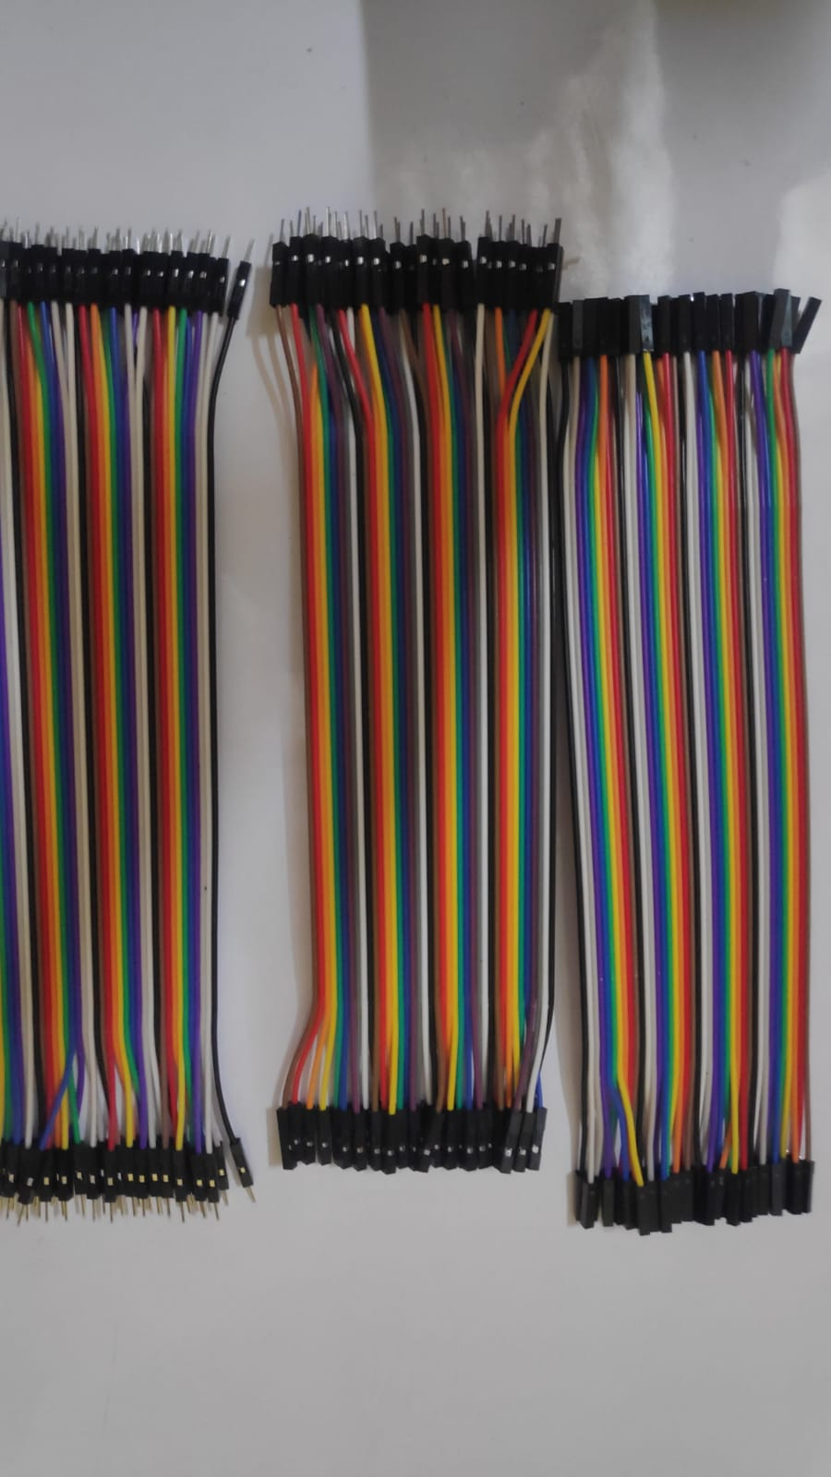

**JUMPER WIRES**

It is an electrical wire, or group of them in a cable, with a connector or pin at each end (or sometimes without them – simply "tinned"), which is normally used to interconnect the components of a breadboard or other prototype or test circuit

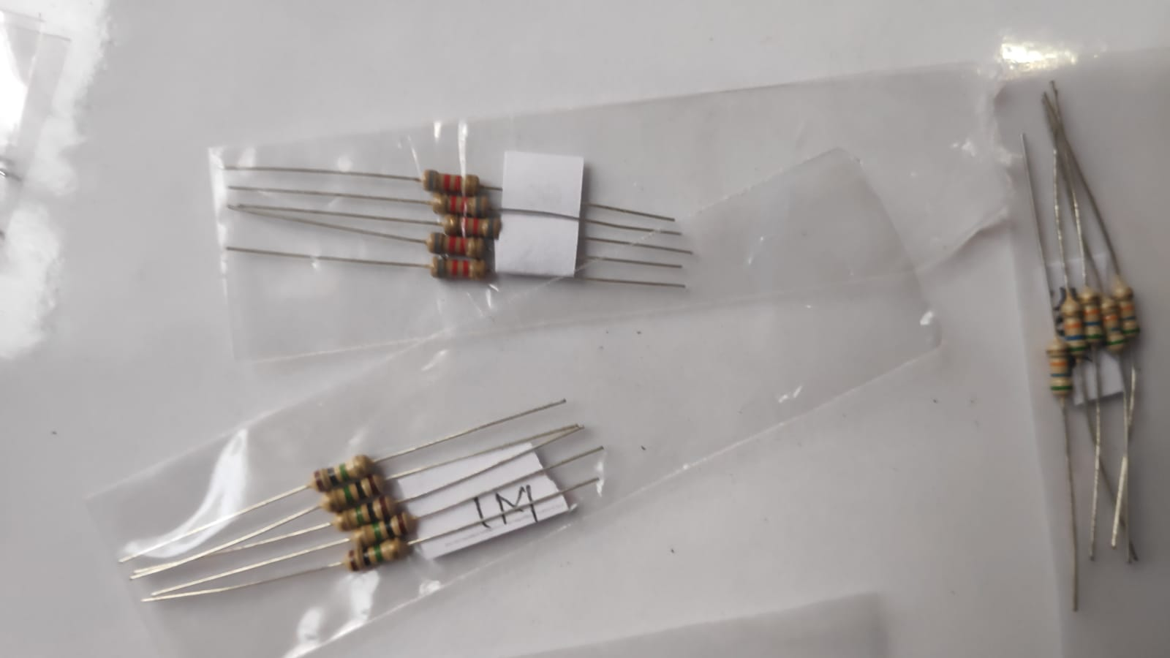

**RESISTOR**

A resistor is **a passive two-terminal electrical component that implements electrical resistance as a circuit element**. In electronic circuits, resistors are used to reduce current flow, adjust signal levels, to divide voltages, bias active elements, and terminate transmission lines, among other uses.

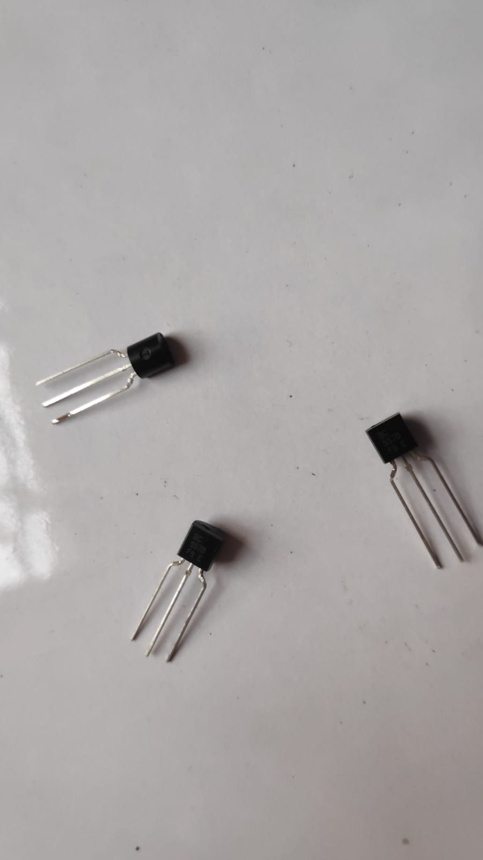

**TRANSISTOR**

A transistor is a semiconductor device used to amplify or switch electrical signals and power.

**USAGE:**

We use them to connect push pull solenoids with the Arduino board.