

Instagram Followers Marker

# The problem

One way to increase your presence on Instagram is by following a large number of accounts in the hope that some of them will follow you back. However, not all the accounts you follow will reciprocate, leading to an accumulation of accounts you're following.

When you're aiming to expand your desired account, it's essential to address the issue of having a high number of accounts you're following. To achieve a better balance between the accounts you follow and your followers, it becomes logical to unfollow some accounts.

The challenge arises when you wish to follow new accounts. It becomes difficult to determine whether you've previously followed a particular account or not.

# The solution

To solve this problem, the Instagram Followers Marker has been created. This will be a small Firefox plugin that labels Instagram accounts in a database. With this tool, you can mark an account when you unfollow it.

# Requirements

The Firefox plugin has the following requirements:

* One button to mark/unmark Instagram accounts integrated into the Instagram web
* Two categories of marking accounts. The first is the *marklist* and the second is *watchlist*
* The mark/unmark button should easily add the account in the *watchlist* using ctrl+click
* A database that stores the marked accounts
* Facility to view all accounts into the *marklist* and the *watchlist*
* A toolbar button. When it’s clicked will display the main menu in a popup
* Option to enable/disable: highlighting Instagram accounts, show/hide marker button, enable/disable ctrl+click saves profile in the watchlist
* Possibility to import/export the database in CSV format
* Maximize the height of the Instagram followed/followers sandbox

# User Interface

## Marker Button

The plugin will display a button on all Instagram accounts, allowing to add the accounts you wish to mark to the *watchlist*.

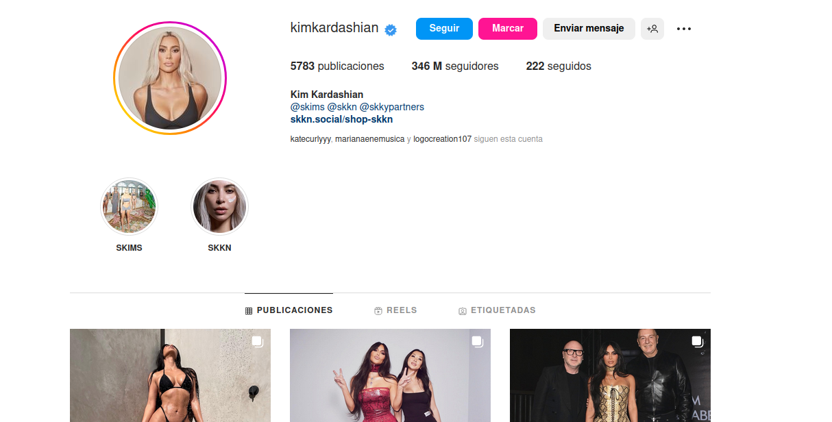

## Highlighting marked account

The plugin will highlight marked accounts with a pink color, effectively indicating accounts that you've previously marked due to your account following them. Both the marklist and watchlist will share this distinctive pink color.

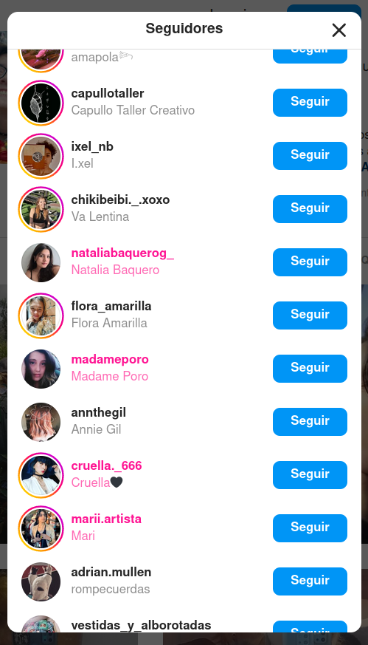

## Highlight in account pages

If the Instagram account page you've visited is in either the marklist or the watchlist, that account will be highlighted in pink.

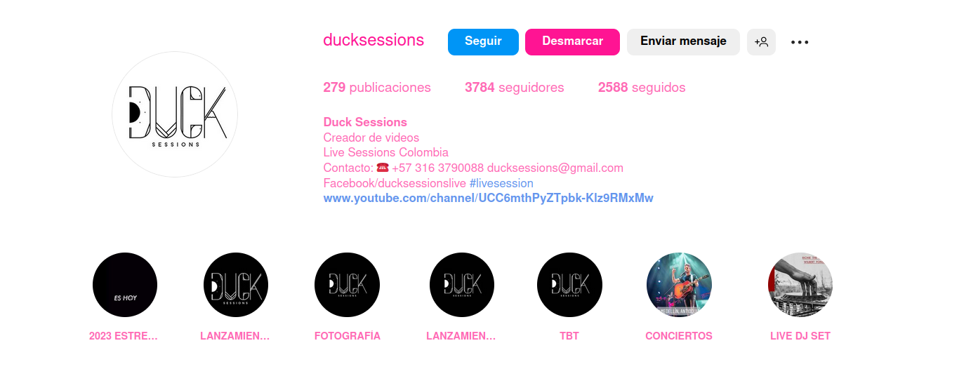

## Plugin main menu

The plugin will have a simple main menu. From there you will modify the options, show the Instagram accounts that’re stored in the *marklist*/*watchlist* and import/export the database.

