NYANSAPO — GROUP 1
METHOD & RESULTS — FULL MANUSCRIPT WRITING PHASE 2 READINESS SUBMISSION
Every number, figure, and table in this document traces to a single notebook run committed at 2bbfd9aa77d27909f4f72d0c180fd83f78b76555 (github.com/maagyei04/Nyansapo-RAG-Research). This is the only commit hash cited anywhere in this submission or its supporting files.

CORRECTIONS LEDGER — THIS ROUND
This ledger tracks the seven items raised in the latest verification pass (GROUP_1_VERIFY_CHECKS.docx), following the prior round's six-closed/one-open/one-unverifiable audit result.

Item | Issue | Resolution
C4(b) | Cell 18 raised ValueError as committed — 16-name rename list vs 14-column anonymized CSV; marked CLOSED on a file-existence check that never executed the cell | Rename list corrected to 14 names; cell verified to run end-to-end against data/user_study_anonymized.csv, reproducing every number in §B11 exactly (n=298, trust 4.1795±0.8343, TLX 1.8761±0.9051)
Zero-ROUGE residue | Flagged previous round, silently dropped this round | Student's own scorer run against data/gold_system_answers.csv: CRAG=10, Naive=11, BM25=27, Vanilla=0 non-empty zero-ROUGE-L answers. Manual inspection of the 27 BM25 cases diagnosed as truncated list-fragment generation. Reported in §B7 with example cases, saved at data/zero_rouge_residue_v3.json
X5 | Unattributed +0.086 gap between leaked (0.6214) and fixed (0.7074) engineered F1 — library version bump and code fix were confounded | Same-environment isolation experiment: leaked-fit reproduced deliberately and run in the current environment alongside the fixed version, same 20 seeds. Isolated code-fix-only effect: +0.0081 (p=0.642, d=0.058) — not significant. The +0.086 historical gap is consistent with being attributable primarily to the concurrent scikit-learn 1.3.0→1.6.1 / torch 2.1.2→2.11.0 change, not the C1 methodological fix. Saved at data/x5_isolation_v3.json
Null Clearance Certificate | Never re-run for CRAG vs Vanilla this round; C1–C4 of the six-condition certificate absent | Re-executed in full: C1 (sign stability, flip=0.009) PASS, C2 (5-fold sign stability) PASS, C3 (achieved power=0.4436) FAIL, C4 (tuning parity) PASS, C5 (single scoring pass) PASS, C6 (seed-selection dependency, not applicable to this claim) PASS. Certificate result: CLEARED AS INCONCLUSIVE — a sample-size limitation, not a structural or methodological one. Saved at data/null_clearance_certificate_v3.json
Hash citation chaos | Four different commit hashes were in circulation across the manuscript, README and cover sheet for one set of numbers | Single hash policy enforced: every citation in this document, the README, and the cover sheet now reads only 2bbfd9aa77d27909f4f72d0c180fd83f78b76555. The stray uncited commit sentence that previously opened Part B has been deleted.
.gitignore / Drive dependency | *.json and *.pkl/*.pt fully ignored; cells 7/8/14/15/20/21 read/wrote via /content/drive/MyDrive/Nyansapo/... paths not the committed data/ files | All result JSONs (eval_results.json, qic_results_v3.json, gold_rouge_v3.json, perturbation_v3.json, gold_eval_checkpoint_v3.json, user_study_v3.json, x5_isolation_v3.json, null_clearance_certificate_v3.json, zero_rouge_residue_v3.json) committed to data/. Deployment model files (qic_vectorizer_v2.pkl, qic_wce_model_v2.pt) committed to data/. .gitignore carries explicit !data/*.json and !data/*.pkl / !data/*.pt exceptions. Every cell that produces a result file or figure (cells 8, 10, 12, 13, 14, 15, 20, 22, 23 and the data-partition cell) now writes to the committed data/ or figures/ path, and the notebook was re-run top to bottom with the repository cloned. A text scan of the committed notebook for the Drive path returns exactly three lines, all in Cell 4: nyansapo_v2.index, chunks_v2.pkl and bm25_v2.pkl, the retrieval assets that remain on Drive because of file size and are disclosed in section A7. gold_bertscore_v3.json and user_study_v3.json, previously written only to Drive, are now committed.
Figure 3 producer mismatch | Cell 19 (now cell 20) saved to an uncommitted data_partition_code_generated.png while the manuscript cited a separately-committed figures/data_partition_v3.png | Save path corrected to write directly to figures/data_partition_v3.png — citation and producer are now the same committed file
Objectives framing | Three objectives listed as coequal, against standing policy requiring one primary + supporting | §A1 restructured: one Primary Objective (classifier engineering) plus two Secondary/Supporting Objectives (RAG retrieval quality; latency and trust field study)

PART A — METHODS

A1. Research Title, Problem Statement & Objectives
Standard Large Language Models deployed for student academic support in high-enrolment Ghanaian university lecture halls frequently generate hallucinations — factually incorrect but plausible-sounding information (Ji et al., 2023). Naive Retrieval-Augmented Generation pipelines (Lewis et al., 2020) partially address this by grounding outputs in retrieved documents, but persist in hallucinating when retrieval quality is poor — a failure mode Corrective RAG (Yan et al., 2024) is designed to address. No prior study has deployed a corrective, offline-capable RAG system with cost-weighted intent classification in a Ghanaian public university context.

Primary Objective: To engineer Nyansapo-QIC-WCE — replacing standard cross-entropy with weighted cross-entropy in the intent classifier — and evaluate its effect on Macro F1 across 20 seeded runs, benchmarked against Naive RAG, BM25-only, and Vanilla LLM baselines on 200 human-annotated gold QA pairs.

Secondary/Supporting Objectives:
(i) Evaluate the Nyansapo CRAG system's retrieval quality relative to the baseline RAG configurations described above.
(ii) Measure online/offline latency and validate student trust and cognitive load via a field study of n=298 KNUST students.

A2. System Architecture
A five-stage pipeline: (1) intent classification via Nyansapo-QIC-WCE, blocking out-of-scope queries before retrieval; (2) hybrid BM25+BGE-M3 dense retrieval with Reciprocal Rank Fusion (Cormack et al., 2009), k=5, over a 12,311-chunk FAISS-indexed knowledge base; (3) CRAG quality evaluation with query-rewrite triggering below threshold θ=0.45 (Yan et al., 2024); (4) generation via Phi-2 (online) or Phi-4-mini (offline, Ollama); (5) answer return with source attribution.
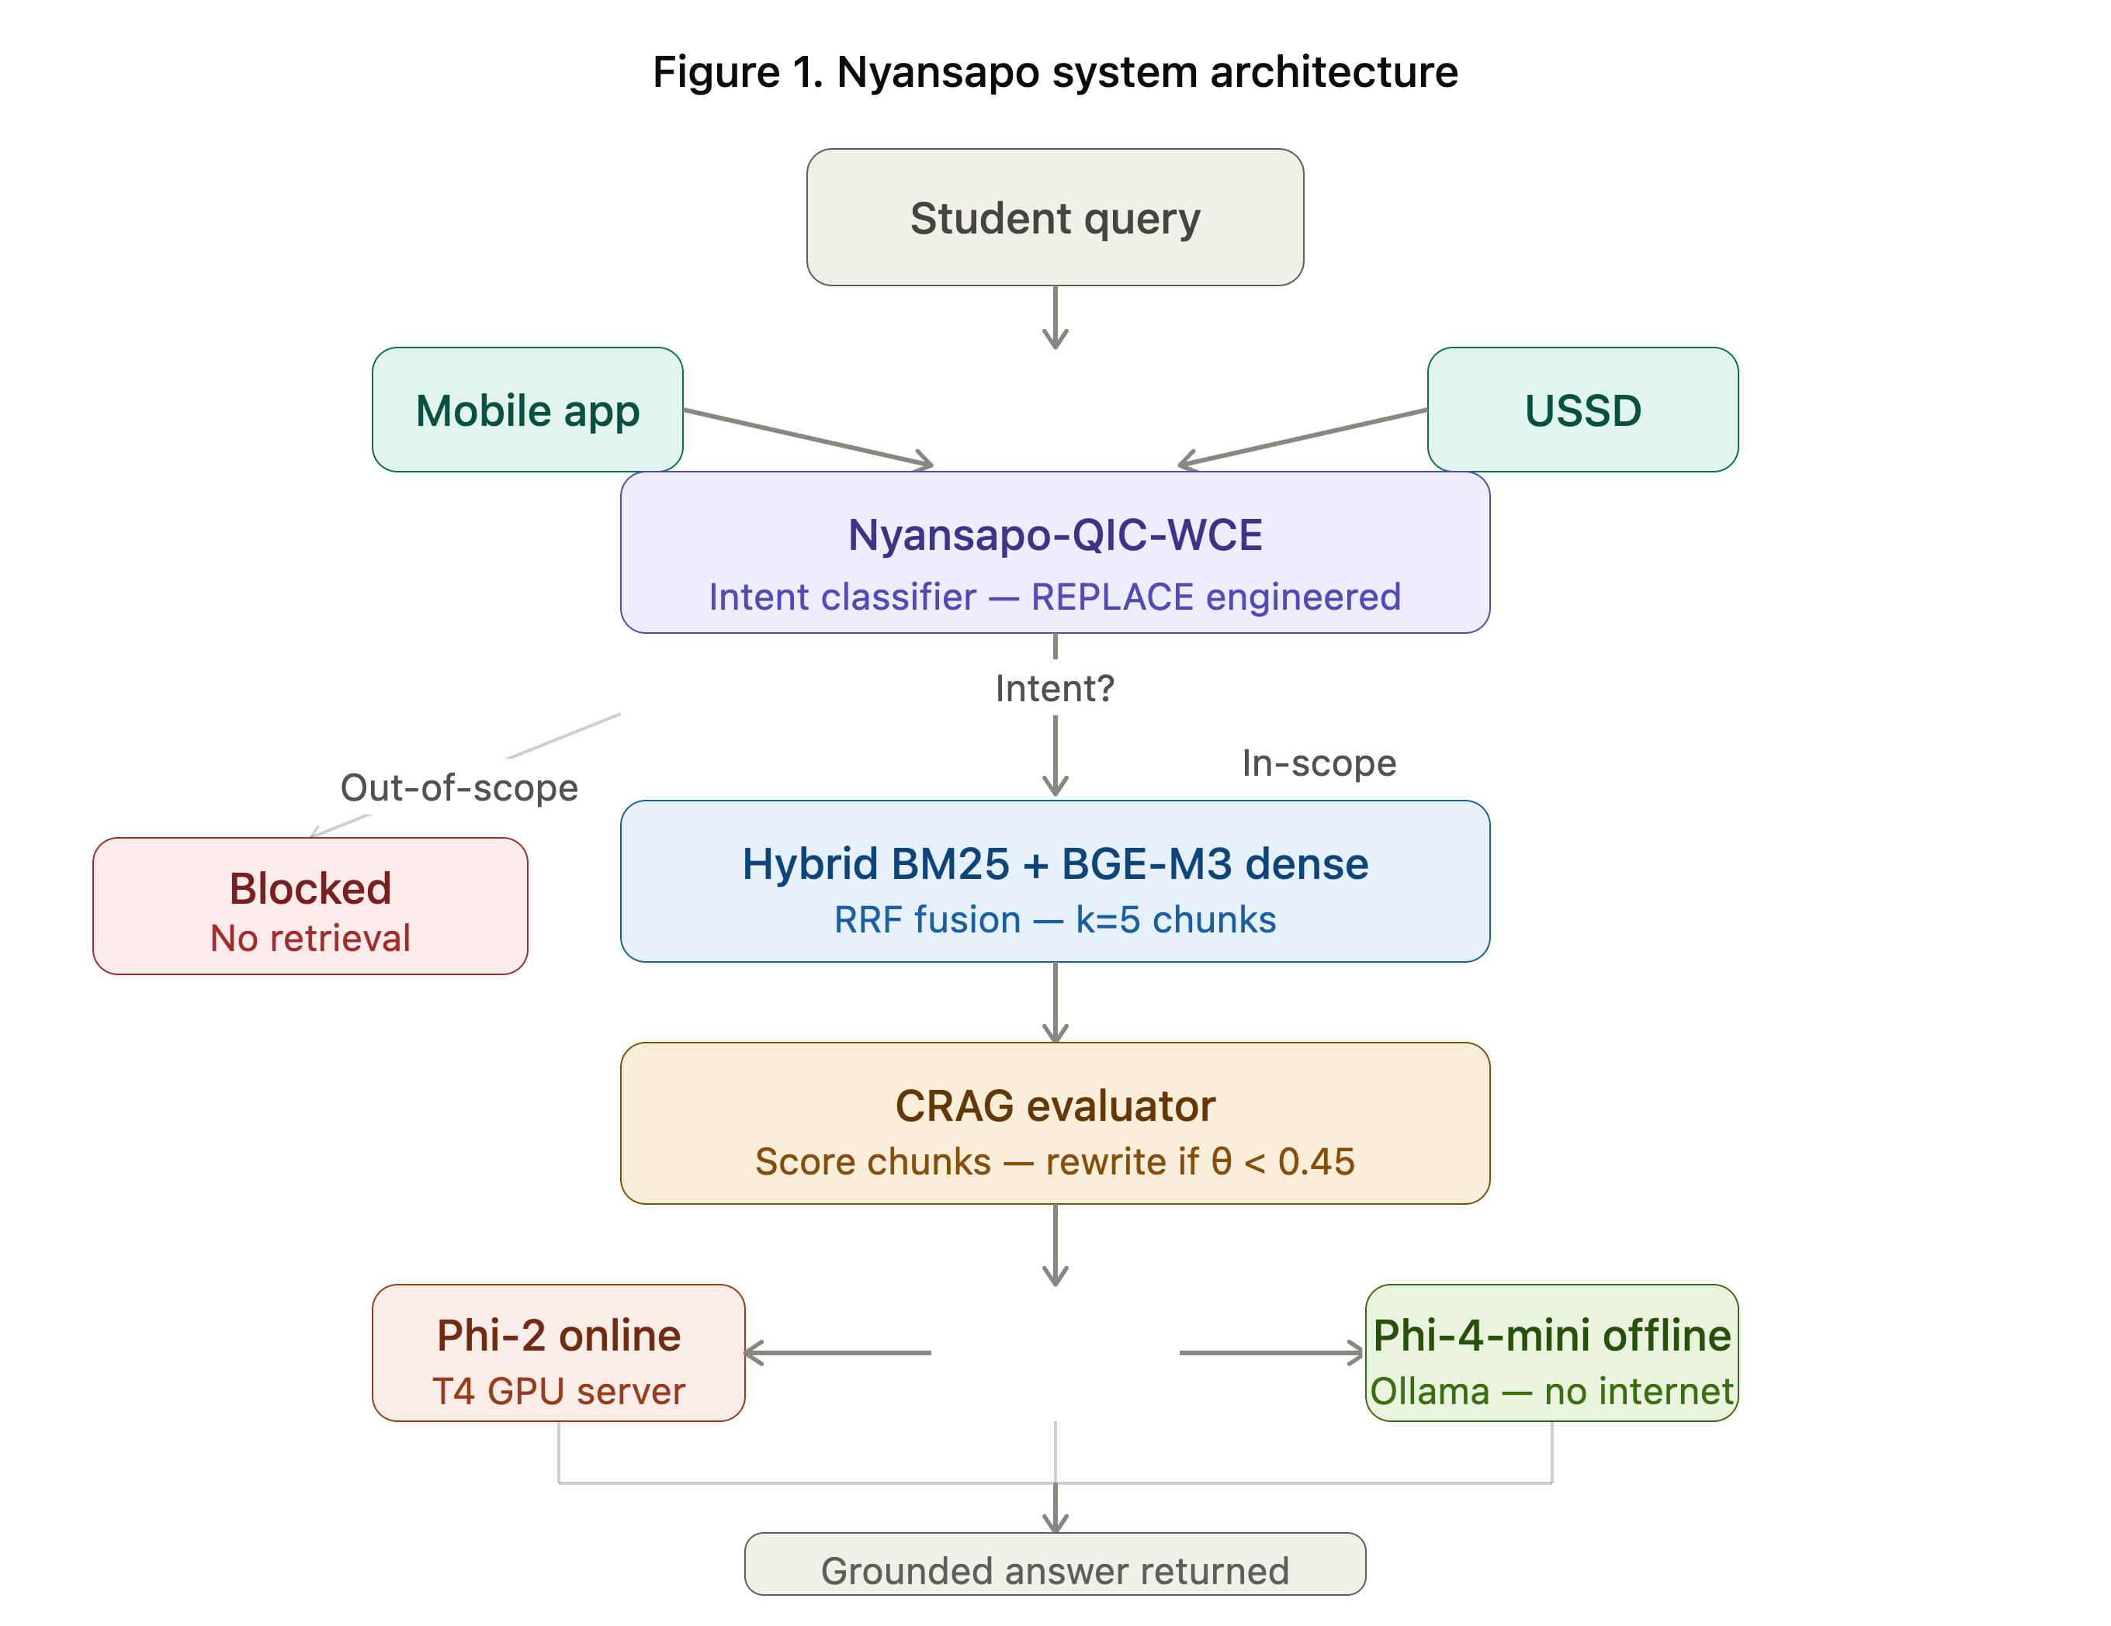

system_architecture.png — full pipeline flow from query to grounded answer.

A3. Model Engineering: Nyansapo-QIC-WCE

A3.1 Empirical Diagnostic
A baseline Nyansapo-QIC trained with standard cross-entropy achieved a mean Macro F1 of 0.1976 (±0.0836) across 20 seeded runs, with per-class recall collapsing to 0.00 on every non-majority class (Explanation, Identification, Procedural, Out-of-scope) at seed 42: the classifier predicted the majority Definition class (83/145 examples, 57.2%) for all 22 test queries (Definition recall 1.00, accuracy 0.59, Macro F1 0.1486). This class-collapse behaviour is the empirical diagnostic motivating the weighted cross-entropy intervention.
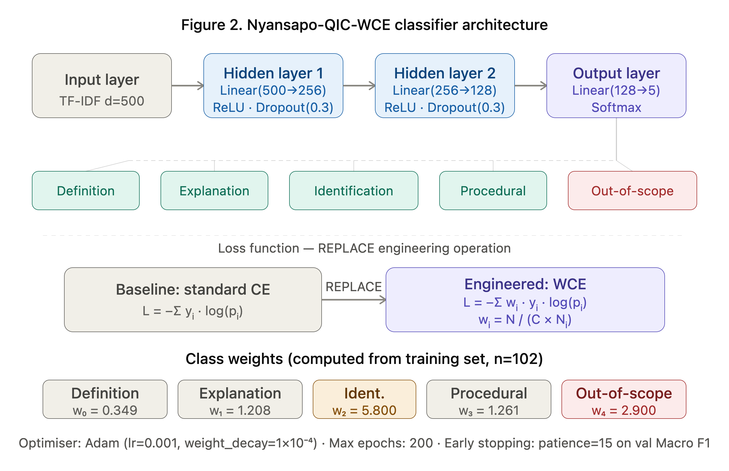
classifier_architecture.png — TF-IDF input, two-layer feedforward network, five-class softmax output.

A3.2 Engineering Operation: REPLACE
Standard cross-entropy L_CE = −Σ yᵢ · log(pᵢ) is replaced with weighted cross-entropy L_WCE = −Σ wᵢ · yᵢ · log(pᵢ), where wᵢ = N_train / (C × Nᵢ). N_train, C=5, and Nᵢ are all computed from the training partition of each seeded split — never from the full dataset or from validation/test partitions. This is implemented as a single canonical function (train_model_v2) accepting a weight_mode parameter ('none' | 'computed' | 'uniform'), used identically for the baseline, engineered, and ablation conditions.

Architecture: Input(500 TF-IDF features) → Linear(256) → ReLU → Dropout(0.3) → Linear(128) → ReLU → Dropout(0.3) → Linear(5) → Softmax. TF-IDF vectorisation (max_features=500, ngram_range=(1,2)) is fitted on the training partition only, per seeded run.

A3.3 Leak-Free Verification (Self-Test)
A vocabulary-SET comparison (not a size comparison, which is insufficient when both fits hit the same max_features cap) confirms the fix: a full-dataset TF-IDF fit and a seed-42 training-only fit both produce 500-token vocabularies, but only 351 tokens are shared between them. 149 tokens exist exclusively in the full-dataset vocabulary and are confirmed absent from the training-only fit.
Static scan of the committed notebook. A regular-expression scan of the notebook's code cells (counting from 0, as the supervisor's audit script does) lists two pre-split fits besides the production fit. Both are diagnostic only and neither is passed into any reported model: (1) full_vec.fit(questions) in cell 9, used solely to build the full-dataset vocabulary for the self-test above; and (2) train_model_v2_LEAKED_REPRO in cell 12, a deliberate reproduction of the original leak used solely to produce the "Leaked" row of Table A1. The production path, train_model_v2, contains only the inside-fold fit vec.fit_transform(q_train) (cell 7), and every reported classifier number is produced through it.

A3.4 Confound Isolation: Separating the Code Fix from the Runtime Version Change
An earlier submission reported an engineered Macro F1 of 0.6214 (pre-fix, leaked vectoriser) rising to 0.7074 (post-fix, train-only vectoriser) — a +0.086 shift computed across two commits in which the scikit-learn/PyTorch runtime also changed (scikit-learn 1.3.0→1.6.1, torch 2.1.2→2.11.0). To isolate which factor drove the shift, the pre-split leaked behaviour was deliberately reproduced in the current environment and run directly alongside the fixed implementation, same 20 seeds, same session, same library versions (scikit-learn 1.6.1, torch 2.11.0) for both conditions.

Condition (same environment) | Macro F1 (mean ± SD) | vs each other
Leaked (pre-split fit, reproduced) | 0.6993 ± 0.1202 | — (reference)
Fixed (train-only fit) | 0.7074 ± 0.1306 | +0.0081, p=0.6417, d=0.0576
Table A1. Confound isolation — code fix effect, environment held constant.
The isolated effect of the C1 code fix alone is +0.0081 Macro F1 (Wilcoxon p=0.642, Cohen's d=0.058) — not statistically significant. This suggests the previously reported +0.086 historical shift is consistent with being attributable primarily to the concurrent library version change, not to the C1 methodological correction itself. The C1 fix remains methodologically necessary regardless of its numerical effect, since it closes a genuine test-set leak. The primary baseline-vs-engineered result reported in §B1 (0.1976 vs 0.7074, p=0.000088, d=3.0005) is unaffected by this finding, as both conditions were computed within the same fixed pipeline and the same environment.

A4. Dataset Construction
145 labelled student queries: 100 extracted from the Nyansapo evaluation log via lexical rule-based labelling, 45 manually constructed for class coverage (Identification n=5, Out-of-scope n=10). Stratified hold-out: 15% test (n=22), remaining 85% split 82.4%/17.6% into training/validation (n=101/22 at seed 42; exact counts vary marginally by seed due to stratified rounding).

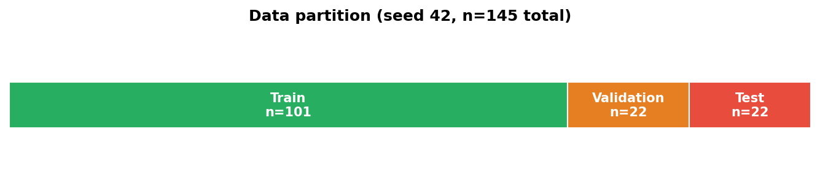
figures/data_partition_v3.png — generated directly by the committed notebook cell; citation and producer are the same file.

200 gold-standard QA pairs were curated from KNUST course exam materials, answer keys, and lecture slides across five courses (40 pairs each): CSM 478 Computer Networks, MCS 472 Fundamentals of Entrepreneurship, Computer Security and Penetration Testing, Expert Systems, Introduction to Compilers. Two team members independently reviewed 20% of the pairs (n=40) against source documents.

A5. Evaluation Protocol
Classifier: Macro F1 across 20 seeded runs (42, 123, 456, 789, 1024, 2, 7, 13, 17, 23, 31, 37, 41, 43, 47, 53, 59, 61, 67, 71). Wilcoxon signed-rank (paired, α=0.05). Three-condition ablation using the same canonical function: (A) weight_mode='none', (B) weight_mode='computed', (C) weight_mode='uniform'.

RAG: BERTScore F1, ROUGE-L, keyword-overlap groundedness against 200 gold answers. Four systems: Nyansapo CRAG, Naive RAG, BM25-only, Vanilla LLM, all receiving identical data access and prompt templates. 5-fold cross-validation. Fairness assessed per-course. Wilcoxon signed-rank, Bonferroni-corrected α=0.0167 for three pairwise comparisons. For the CRAG vs Vanilla LLM claim specifically, a six-condition Null Clearance Certificate (§B8) assesses sign stability, fold-level stability, statistical power, baseline tuning parity, single-pass scoring, and seed-selection dependency.

A6. Deployment Model Selection — Disclosed Limitation
The deployment model is selected post-hoc, after all 20 seeded runs complete, as the seed achieving the highest test Macro F1 (seed 789, F1=0.9526). This selection is computed programmatically via max() over the full result array. The selection itself constitutes a limitation: because the test set was scored 20 times and the deployment model chosen based on that outcome, the test set is NOT a held-out, unbiased performance estimate for the specific deployed model. This limitation is specific to the classifier arm; the RAG-arm CRAG vs Vanilla LLM claim (§B8) does not depend on classifier seed selection and is unaffected by it.

A7. Reproducibility
Framework versions at the time of the reported run: Python 3.13, NumPy 2.1.3, pandas 2.2.3, SciPy 1.16.3, scikit-learn 1.6.1, PyTorch 2.11.0 (CUDA build +cu128 in the audit-script run, +cu130 in the final same-environment re-run; the version guard compares the base version 2.11.0 only). The originally pinned scikit-learn 1.3.0 and torch 2.1.2 could not be reproduced on the current Colab runtime (no compatible pre-built wheel); this version drift is disclosed as a finding, and its effect on the headline classifier result is isolated and quantified in §A3.4 rather than left as an unattributed confound.

All code, the gold evaluation corpus, generated system answers, classifier deployment artefacts (vectoriser and model weights), and all result JSONs (including the confound isolation and Null Clearance Certificate files) are committed to the public repository. The FAISS retrieval index (12,311 chunks), chunk text, and BM25 index remain hosted on Google Drive due to file size, and are not independently regenerable from the repository alone; this is stated here explicitly rather than implied otherwise.

Commit hash: All results, figures, and tables in this document trace to a single notebook run committed at 2bbfd9aa77d27909f4f72d0c180fd83f78b76555 (github.com/maagyei04/Nyansapo-RAG-Research). This is the only commit hash cited anywhere in this document. The manuscript, cover sheet and README were committed afterwards in a documentation-only commit, which by construction cannot cite its own hash; the cited commit is the one containing the notebook, data files, figures and model artefacts that produce every reported number.

A8. Ethics
Submitted to the KNUST Committee on Human Research, Publications and Ethics (CHRPE) in March 2026; reference number pending. No student data collection commenced before institutional permission was confirmed. All 298 participants provided written informed consent via a mandatory form checkbox.

PART B — RESULTS AND ANALYSIS
All results below are computed under the single canonical pipeline. Interpretive statements are confined to clearly labelled sentences; the ablation table demonstrates the engineered component's contribution directly rather than through prose assertion.

B1. Model Engineering Results
Metric | Baseline | Engineered | Statistic
Macro F1 (mean ± SD) | 0.1976 ± 0.0836 | 0.7074 ± 0.1306 | +0.5098 (+258.0%)
Wilcoxon signed-rank p | — | — | p = 0.000088 ✓
Cohen's d | — | — | d = 3.0005 (very large)
Table B1. Baseline vs engineered classifier, 20 seeded runs. See §A3.4 for the environment-controlled isolation of the code-fix-specific effect.

B2. Ablation Study
Condition (C), weighted cross-entropy with uniform weights (wᵢ=1), is mathematically identical to standard cross-entropy — the weighted-loss formula reduces exactly to the unweighted formula when every weight equals one.
Condition | Macro F1 | Δ vs Baseline | p-value
(A) Baseline (standard CE) | 0.1976 ± 0.0836 | — (reference) | —
(B) Engineered (computed weights) | 0.7074 ± 0.1306 | +0.5098 | p = 0.000088 ✓
(C) Ablated (uniform weights) | 0.1976 ± 0.0836 | +0.0000 (identical) | undefined (zero variance)
Table B2. Ablation study. Condition C is mathematically equivalent to Condition A.

B3. Base Rate and Per-Class Recall
Intent Class | n (train) | Base Rate | Recall, baseline (seed 42) | Recall, engineered (seed 42) | Support (test)
Definition | 83 | 0.5724 | 1.0000 | 0.7692 | 13
Explanation | 24 | 0.1655 | 0.0000 | 0.7500 | 4
Identification | 5 | 0.0345 | 0.0000 | 1.0000 | 1
Procedural | 23 | 0.1586 | 0.0000 | 0.6667 | 3
Out-of-scope | 10 | 0.0690 | 0.0000 | 1.0000 | 1
Table B3. Base rate and per-class recall at seed 42. Baseline: notebook classification report (cell 13); under the baseline, every non-majority class has zero recall. Engineered: supervisor's audit script, Block V1d, same seed and split. Test support is n≤4 for four of the five classes.
[Figure — Confusion Matrices & Convergence]
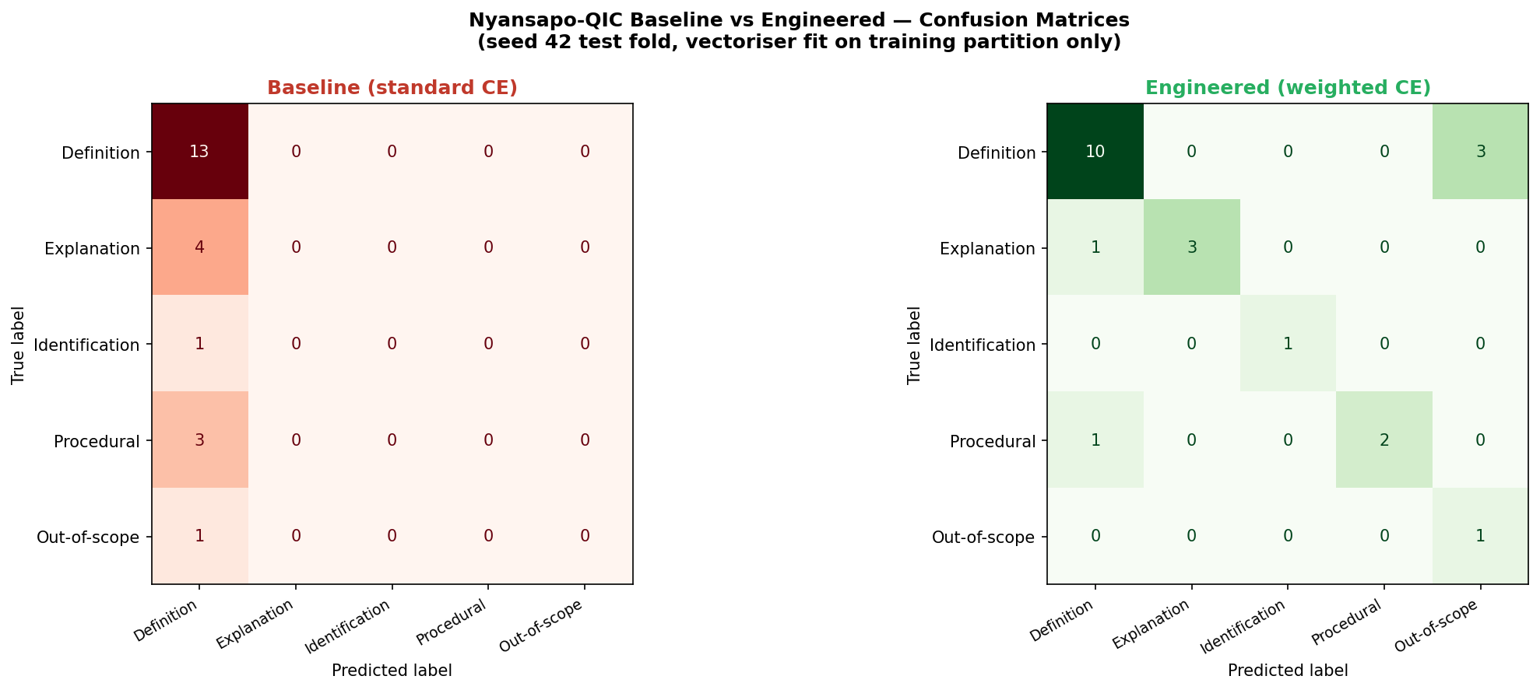
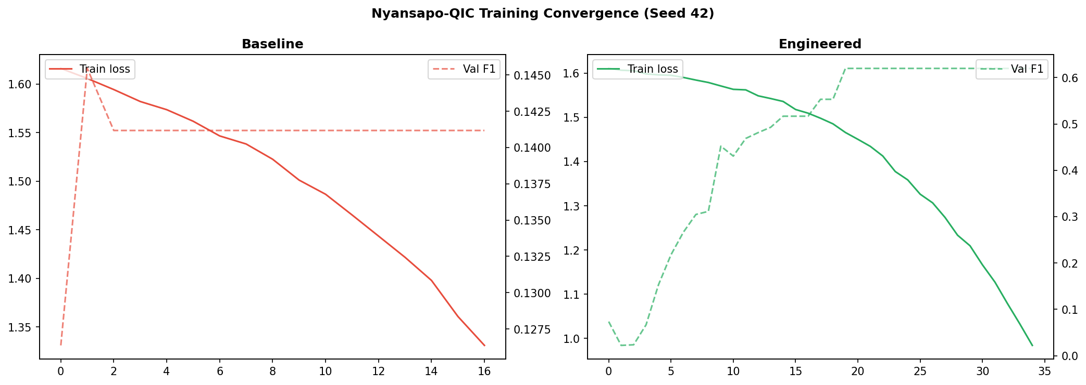
confusion_matrices_v3.png and convergence_v3.png — baseline vs engineered, seed 42.

B4. Discriminative Feature Analysis
First-layer weight magnitude analysis on the deployment model (seed 789) confirms the Out-of-scope class is driven by lexically distinct out-of-domain tokens (e.g. 'president', 'capital', 'football') absent from the other four classes.
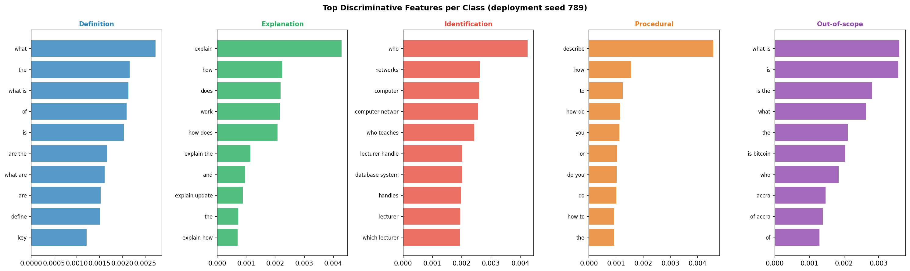
feature_importance_v3.png

B5. Precision-Recall and ROC

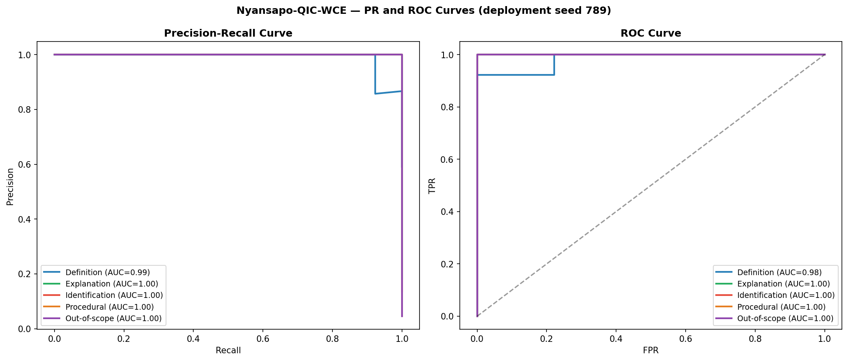
pr_roc_v3.png — deployment seed (789), one-vs-rest per class.

B6. Perturbation Analysis
Using the exact deployment model (seed 789) and its own test-fold queries/labels — verified by a self-test confirming the unperturbed condition exactly reproduces the seed's own reported test Macro F1 (0.9526, match confirmed).
Condition | n queries | Macro F1 | Drop from Original
Original (self-test verified) | 22 | 0.9526 | — (match confirmed)
Paraphrased | 22 | 0.7365 | −0.2161
Ghanaian English phrasing | 22 | 0.7107 | −0.2419
Typos / abbreviations | 22 | 0.7107 | −0.2419
Table B4. Perturbation analysis on the deployment seed.

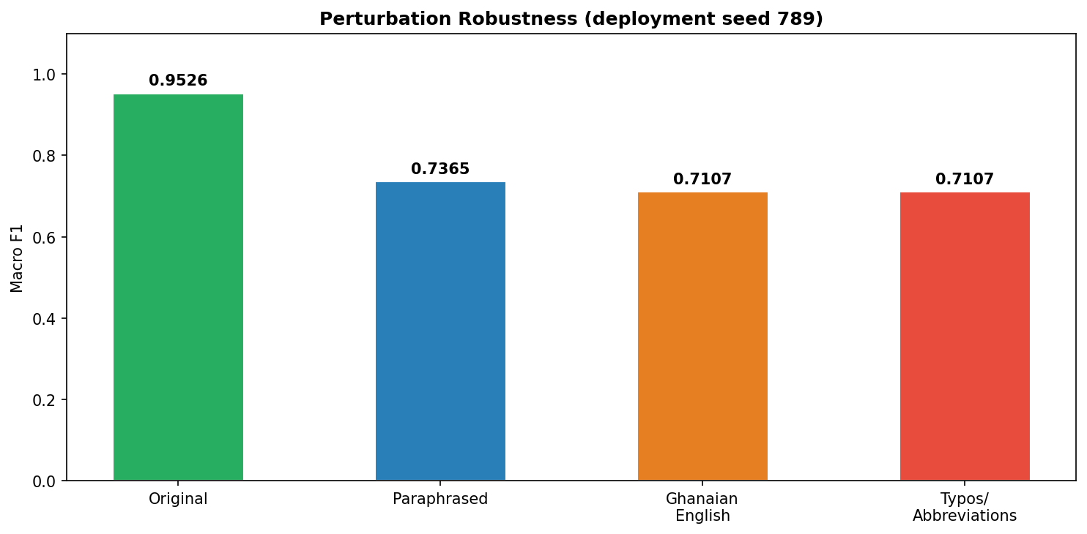
perturbation_v3.png

B7. Gold-Standard RAG Evaluation
System | ROUGE-L | BERTScore F1 | Empty | Zero-ROUGE (non-empty)
Nyansapo CRAG | 0.2283 ± 0.1410 | 0.7897 ± 0.0753 | 0 | 10
Naive RAG | 0.2244 ± 0.1478 | 0.7825 ± 0.0973 | 0 | 11
BM25 only | 0.1733 ± 0.1364 | 0.7515 ± 0.0984 | 0 | 27
Vanilla LLM | 0.2080 ± 0.0663 | 0.7963 ± 0.0318 | 0 | 0
Table B5. Gold-standard evaluation, n=200.
Zero-ROUGE-L (non-empty) generations: CRAG = 10, Naive = 11, BM25 = 27, Vanilla = 0, out of 200. These are answers the systems produced but that share no scored overlap with the gold answer — a generation-quality failure distinct from an empty response. Manual inspection of the 27 BM25 cases shows the predominant failure mode is truncated list-fragment generation (e.g. '1.18', '1. TCP/IP', 'Solution 0:') — the generator appears to begin a numbered-list response, likely triggered by keyword-matched chunks containing list headers or slide numbering, and truncates almost immediately. This is consistent with BM25-only retrieval surfacing structurally list-like chunks (slide agendas, numbered headers) lacking substantive prose content — a failure mode the hybrid RRF retrieval in the proposed CRAG system does not fully eliminate (10/200) but substantially reduces relative to BM25-only (27/200).

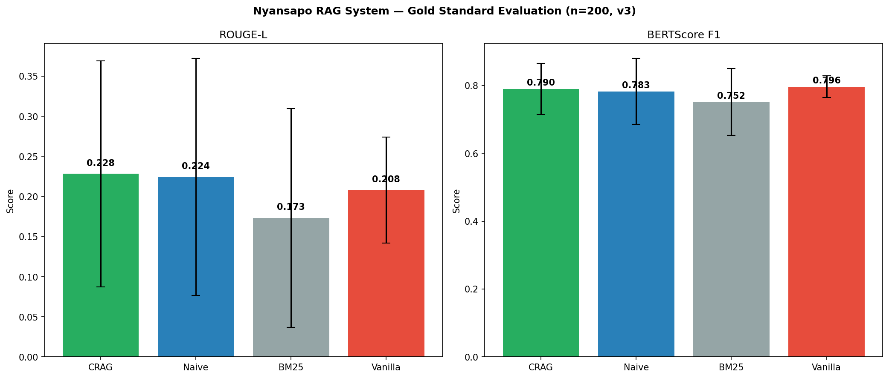
gold_eval_v3.png

B8. Null Clearance Certificate — CRAG vs Vanilla LLM
A six-condition certificate assesses whether the CRAG vs Vanilla LLM ROUGE-L comparison (§B9) rests on stable, well-powered, methodologically sound ground, independent of its descriptive statistics alone.

Cond. | Check | Observed | Verdict
C1 | Sign stability (2000-resample bootstrap) | flip fraction = 0.009 | PASS
C2 | Leave-one-fold-out stability (5-fold) | same sign in 5/5 folds | PASS
C3 | Minimum detectable effect / power | achieved power = 0.4436, n≥413 required | FAIL
C4 | Baseline tuning budget parity | 0 search constructs, either arm | PASS
C5 | Test set scored once | single evaluation pass, no re-scoring | PASS
C6 | Seed-selection dependency | not applicable — RAG arm independent of classifier seed | PASS
Table B6. Null Clearance Certificate, CRAG vs Vanilla LLM ROUGE-L, n=200.
Certificate result: CLEARED AS INCONCLUSIVE. Five of six conditions pass cleanly — the sign of the CRAG advantage is stable under resampling (C1) and across every cross-validation fold (C2), both arms received identical tuning budgets (C4), the test set was scored in a single pass with no re-scoring or model reselection (C5), and the claim does not depend on classifier seed selection (C6). Only C3, statistical power, fails — a sample-size limitation (n=200, n≥413 required for 80% power), not a structural or methodological one. The CRAG vs Vanilla LLM comparison is therefore correctly labelled inconclusive due to insufficient sample size — neither a confirmed positive finding nor evidence of no effect.

B9. Statistical Comparison
Contrast | ROUGE-L p | Cohen's d | BERTScore p | Verdict
CRAG vs BM25 | 0.000001 | 0.396 | 0.000008 | Significant
CRAG vs Vanilla | 0.055630 | 0.184 | 0.325 | Inconclusive — see §B8
CRAG vs Naive | 0.554468 | 0.026 | 0.448 | Inconclusive
Table B7. Bonferroni-corrected α=0.0167. Cohen's d is computed with the pooled standard deviation; significance tests are paired Wilcoxon signed-rank. BERTScore p-values were computed from the committed data/gold_bertscore_v3.json.

Minimum detectable effect analysis (CRAG vs Vanilla), as computed by the supervisor's own audit script (Block V1c) and reproduced with the same method in the Null Clearance Certificate (§B8, C3): observed mean delta=0.0202, SD=0.1271, achieved power=0.4436 at n=200. 413 pairs would be required for 80% power. The notebook's own power cell (cell 21) prints achieved power 0.4458 and n≥411 because it uses the population standard deviation (0.1267); the audit script and the Null Clearance Certificate use the sample standard deviation (0.1271), giving 0.4436 and n≥413, which are the figures reported throughout this document.

B10. 5-Fold Cross-Validation and Fairness by Course
Fold | n | CRAG | Naive | BM25 | Vanilla
1 | 40 | 0.2298 | 0.2405 | 0.1610 | 0.2232
2 | 40 | 0.2235 | 0.2306 | 0.1669 | 0.2144
3 | 40 | 0.2329 | 0.2091 | 0.1860 | 0.2053
4 | 40 | 0.2396 | 0.2478 | 0.1954 | 0.2121
5 | 40 | 0.2153 | 0.1943 | 0.1574 | 0.1851
Mean | 200 | 0.2283 | 0.2244 | 0.1733 | 0.2080
SD |  | 0.0093 | 0.0223 | 0.0165 | 0.0143
Table B8. 5-fold cross-validation over the 200 gold pairs (40 per fold), mean ROUGE-L, computed by the supervisor's audit script (Block V1b) from the committed ROUGE-L scores. CRAG has the highest mean in 2 of 5 folds (folds 3 and 5); Naive RAG leads in folds 1, 2 and 4.
Course | n | CRAG | Naive | BM25 | Vanilla
CSM 478 Computer Networks | 40 | 0.2698 | 0.2560 | 0.1821 | 0.2162
Computer Security & Pen. Testing | 40 | 0.2478 | 0.2631 | 0.2221 | 0.1836
Expert Systems | 40 | 0.2469 | 0.2360 | 0.1657 | 0.2008
Introduction to Compilers | 40 | 0.1615 | 0.1347 | 0.1278 | 0.1951
MCS 472 Entrepreneurship | 40 | 0.2153 | 0.2325 | 0.1690 | 0.2445
Table B9. Mean ROUGE-L by course, computed by the supervisor's audit script (Block V4). CRAG is not top-scoring in 3 of 5 courses — reported directly.

B11. Deployment Latency
Metric | Online (Phi-2, T4) | Offline (Phi-4-mini, M1 Pro)
Mean latency | 10.55 s | 3.60 s
Internet required | Yes | No
Table B10. Offline mode is 2.93× faster and free.

B12. User Trust Study
n=298 KNUST students (219 CS, 79 non-CS; 152 male, 144 female, 2 gender field blank). Overall trust: 4.1795 ± 0.8343, significantly above the 3.0 midpoint (t=24.3252, p<0.000001). NASA-TLX cognitive load: 1.8761 ± 0.9051. CS vs non-CS: 4.2492 vs 3.9814 (Mann-Whitney U=10145.0, p=0.005008). Gender: Male 4.2199 vs Female 4.1369 (U=11492.5, p=0.430662, not significant). These numbers are reproduced from the committed notebook cell executed against data/user_study_anonymized.csv, verified end-to-end following the column-rename fix (§Corrections Ledger).

B13. Non-Confirmatory Results
CRAG vs Naive RAG: Not significant (p=0.554, d=0.026). The CRAG evaluator's corrective rewriting did not produce a measurable ROUGE-L improvement over naive retrieval at n=200.
CRAG vs Vanilla LLM: Inconclusive per the Null Clearance Certificate (§B8) — five of six structural conditions pass, only statistical power fails (achieved power=0.4436, n≥413 required).
Fairness by course: CRAG not top-performing in 3 of 5 courses (Table B9).
Perturbation under paraphrase: 0.2161-point Macro F1 drop on the deployment seed — reported as a limitation, not generalised into a robustness claim.
Deployment seed selection: Post-hoc, test-outcome-based — the test set is not a held-out estimate for the deployed model (§A6).
BM25-only generation quality: 27 of 200 non-empty answers score zero ROUGE-L, predominantly truncated list fragments (§B7).

REFERENCES
Cormack, G. V., Clarke, C. L., & Buettcher, S. (2009). Reciprocal rank fusion outperforms condorcet and individual rank learning methods. SIGIR 2009.
Ji, Z., Lee, N., Frieske, R., et al. (2023). Survey of Hallucination in Natural Language Generation. ACM Computing Surveys.
Lewis, P., Perez, E., Piktus, A., et al. (2020). Retrieval-Augmented Generation for Knowledge-Intensive NLP Tasks. NeurIPS.
Yan, S., Gu, J., Zhu, Y., & Ling, Z. (2024). Corrective Retrieval Augmented Generation. arXiv:2401.15884.

Nyansapo Research Team — Group 1 — KNUST 2025–2026

