TFL-TAGE-SC-L: A TAGE-SC-L Branch Predictor with Target-Free Loop-Structure History for ChampSim
Branch prediction assignment — technical report

Abstract
We design, implement and evaluate a branch predictor for the 2021 version of ChampSim, whose predictor interface passes only the branch address and its outcome — no branch type and no target. Several of the strongest history features of modern predictors (the Inner-Most-Loop-Iteration counter IMLI, its outer-iteration history, and backward-branch histories) are defined on backward branches and therefore cannot be computed in this interface without modifying the simulator. We observe that, because ChampSim presents branches to the predictor in program order without wrong-path execution, the direction of every taken branch can be inferred exactly from the address of the next branch presented to the predictor. We verify this inference against the simulator's own targets (99.9996–100% agreement on all ten traces) and use it to add IMLI-SIC, IMHIST and a backward-branch history to a re-implemented TAGE-SC-L predictor. The resulting predictor, TFL-TAGE-SC-L, uses 508,666 bits (62.09 KB). On ten SPEC CPU2017 traces (50M warm-up + 200M measured instructions) it reaches a mean MPKI of 3.046, 6.2% lower than the 64 KB hashed perceptron shipped with ChampSim (3.248) and 0.85% lower than our TAGE-SC-L without the loop-structure components (3.072), with a geometric-mean IPC speedup of 0.43% over the hashed perceptron and 10.1% over bimodal; the IPC gain attributable to the loop-structure components alone is small (+0.06%) because the traces that benefit most are memory-bound. Ablations attribute the gains to each component, and we report negative results (a per-branch allocation throttle that helps plain TAGE but is subsumed in TAGE-SC-L, and several IMLI variants).

1. Problem statement
The goal of the assignment is to design and implement a branch predictor in ChampSim that improves on suitable baselines, to evaluate it with IPC, branch prediction accuracy and MPKI, and to explain the results. We work with the ChampSim version provided for the course (2021, built with build_champsim.sh). Its predictor interface is:
uint8_t O3_CPU::predict_branch(uint64_t ip);
void O3_CPU::last_branch_result(uint64_t ip, uint8_t taken);
- The predictor is called for every branch type (conditional, direct/indirect jumps and calls, returns), with no type information; unconditional branches are always reported taken.
- No branch target is passed, and last_branch_result() follows each prediction immediately with the true outcome.
- Accuracy and MPKI are computed over all branch types; a misprediction is a direction mismatch.
The concrete problem we address is: how far can a state-of-the-art TAGE-SC-L design be pushed in this PC-and-outcome-only interface, and can the loop-structure features that normally require branch targets be recovered without changing the simulator?

2. Background and related work
We reviewed the six reference papers of the assignment and additional work (full review with access levels in research/literature_review.md). Table 1 summarises the ones that shaped the design.
Table 1. Key related work.
Work | Core idea | Relevance / limitation
Jiménez & Lin, HPCA 2001 [1] | Perceptron per branch over global history; train on mispredict or |y| ≤ θ | Long histories at linear cost; basis of hashed perceptron and of corrector (SC) tables
Seznec, MICRO 2011 [2]; Seznec & Michaud 2006 [7] | TAGE: tagged tables with geometric history lengths, longest match provides | Strongest single-component predictor; struggles with statistically biased / hard-to-predict (H2P) branches
Seznec et al., MICRO 2015 [3] | IMLI counter: iterations of the inner-most loop; IMLI-SIC and IMLI-OH corrector tables | Needs to know whether a branch is backward (target < PC) — not available in this interface
Jiménez, CBP 2016 [4] | Multiperspective perceptron: many feature types in one adder | Confirms value of heterogeneous features in an adder; many features need type/target
Michaud, TACO 2018 [5] | BATAGE: dual-counter entries, Bayesian confidence, controlled allocation throttling (global) | Allocation throttling is global; per-branch throttling left open
Lin & Tarsa, IISWC 2019 [6] | ~10 hard-to-predict branches cause ~55% of mispredictions; each H2P causes ~13k TAGE allocations | Motivates H2P handling / allocation filtering
Seznec, CBP 2014/2016 [8] | TAGE-SC-L: TAGE + statistical corrector + loop predictor; 3.986 MPKI at 64 KB | Our base architecture; its 2016 code uses IMLI-SIC, IMHIST and backward-branch history

Newer work (CBP-2025 entries, LLBP [9], BranchNet, Whisper) either needs much larger storage, offline training, ISA hints, or data values that ChampSim traces do not carry; it was reviewed but not adopted.

3. Motivation
Two observations motivated the design. First, among the predictors shipped with this ChampSim, the hashed perceptron (64 KB) is by far the best (mean MPKI 3.248 vs 6.153 for gshare), and our re-implemented TAGE of similar storage is not better on average (3.295): it wins on gcc, xalancbmk, omnetpp and x264, is level on deepsjeng, and loses on mcf and xz, the two traces that dominate mean MPKI. Combining TAGE with a perceptron-like statistical corrector (TAGE-SC-L) is the established way to get the best of both.
Second, the corrector of TAGE-SC-L gains part of its accuracy from loop-structure history (IMLI, IMHIST, backward-branch history), all of which are defined on backward branches. The interface hides the target, so these components cannot be computed directly, and the obvious workaround — changing ChampSim's core to pass the target — changes the simulator that the assignment evaluates. We therefore asked whether the information can be recovered inside the predictor.

4. Proposed predictor: TFL-TAGE-SC-L

4.1 Target-free backward-branch inference (the enabling idea)
ChampSim feeds the predictor all branches in program order and never executes a wrong path. Let B be a taken branch with target T and let N be the next branch presented to the predictor. Execution proceeds sequentially from T to N, so pc(N) ≥ T. If T ≤ pc(B), the sequential path from T reaches B itself (B lies between T and itself), so pc(N) ≤ pc(B). If T > pc(B), then pc(N) ≥ T > pc(B). Hence:
B is backward <=> pc(next branch presented to the predictor) <= pc(B) (taken instances)
The test runs at the start of the next predict_branch() call, i.e. before any later prediction uses the loop state, so the counters seen by every prediction are the same as with target knowledge. Two small bit tables complete the mechanism: bwd (4 Kbit) remembers the inferred direction of each branch for its not-taken (loop-exit) instances, and cond (4 Kbit) marks a branch as conditional once it has been observed not-taken (ChampSim reports unconditional branches as always taken). Verification against the simulator's own target (branch_target = next_instr.ip) over 50M instructions per trace gave 99.9996–100% agreement on all ten traces (Section 7.3).

4.2 Architecture
Table 2. TFL-TAGE-SC-L configuration and storage (counted by the predictor's storage_bits()).
Component | Configuration | Bits
Bimodal base | 8K × 2-bit counters | 16,384
Tagged tables T1–T12 | 2K entries each; 3-bit ctr, 1-bit u, tags 8–13 bits; history 4…640 (geometric) | 366,592
TAGE control | use_alt_on_na (4 × 5 bit), TICK, 640-bit global + 27-bit path history | 698
Loop predictor | 64 entries, 4-way; 2 × 10-bit trip counts, 10-bit tag, 4-bit confidence, 4-bit age, direction; WITHLOOP | 2,503
SC bias tables | 3 × 1K × 6-bit (PC × TAGE pred × confidence / provider) | 18,432
SC control | adaptive threshold + counter, 2 chooser counters | 30
SC global + path GEHL | 4 global (6–40) + 3 path (9–25) × 1K × 6-bit | 43,008
SC local GEHL | 4 × 1K × 6-bit (3–16) + 256 × 16-bit local histories | 28,672
IMLI-SIC | 512 × 6-bit, indexed by hash(PC, IMLIcount); 10-bit IMLIcount | 3,082
Backward inference | bwd 4 Kbit + cond 4 Kbit + previous-branch register | 8,257
IMHIST | 256 × 10-bit histories (one per IMLI value) + 1K × 6-bit table | 8,704
Backward-branch history | 16-bit history + 2 × 1K × 6-bit tables | 12,304
Total**Total** |  | 508,666 (62.09 KB)**508,666 (62.09 KB)**

4.3 Prediction
- Update the loop-structure state for the previous branch (Section 4.1).
- TAGE: compute indices/tags with folded global and path history; the longest matching table provides the prediction; for a newly allocated (weak) provider the alternate prediction is used when the use_alt_on_na counter says so. Confidence = provider counter magnitude.
- Loop predictor: overrides TAGE when its entry is confident and the global WITHLOOP counter is non-negative.
- Statistical corrector: sum of 6-bit counters (bias, global, path, local, IMLI-SIC, IMHIST, backward-history tables). If its sign disagrees with TAGE/loop, the corrector wins unless TAGE is highly confident and |sum| is below θ/4 (or θ/2, arbitrated by two chooser counters) — the TAGE-SC-L 2016 rule.

4.4 Update
- Corrector: train all selected counters when the corrector mispredicted or |sum| < θ; adapt θ (O-GEHL rule).
- TAGE: update the provider (and the alternate for weak providers); set/clear u; on a TAGE misprediction allocate up to two entries in longer-history tables, only over entries with u = 0 and a weak/medium counter (strong ones are decayed); when the corrected final prediction was right, allocate only with probability 1/32; age u bits with the TICK counter.
- Histories: insert one bit (taken ⊕ PC bit) into the global history, one PC bit into the path history, update local history, IMLI (increment on taken backward conditional, reset on its exit), IMHIST and backward history.

5. Contribution and relation to prior work
- Target-free, exact backward-branch inference for a predictor interface that provides only PC and outcome, with a proof, verification against ground truth, and an analysis of where the derived IMLI counter departs from a type- and target-aware one. We found no prior use of the next *predicted branch's* address for this purpose; the closest is passing the next *instruction* address, which requires simulator changes.
- Its use to bring IMLI-SIC, IMHIST and backward-branch history (published by Seznec et al. [3, 8]) into this ChampSim without modifying the core, and a measured evaluation of which of them help on SPEC CPU2017.
- A complete, documented TAGE-SC-L re-implementation for the 2021 ChampSim interface with ablation switches.
- Negative results: a per-branch TAGE allocation throttle (motivated by Lin & Tarsa [6] and BATAGE's global throttling [5]) reduces MPKI of plain TAGE but has no effect inside TAGE-SC-L; region-based IMLI and IMLI in global corrector tables did not help on these traces.
We do not claim TAGE-SC-L, IMLI-SIC, IMHIST or backward-branch histories as new; they are published mechanisms that we re-implemented from the papers.

6. Implementation
- branch/tagescl.bpred — the whole predictor family (~700 lines, C++11, ChampSim .bpred interface); branch/tfl_tage_scl.bpred, tage_scl.bpred, tage.bpred — wrappers selecting the proposed design and the re-implemented baselines for the standard build_champsim.sh workflow.
- Only predictor-private state; one predictor object per CPU; deterministic (fixed-seed xorshift for the probabilistic allocation decisions).
- Simulator core: stats-only additions to src/main.cc, src/ooo_cpu.cc and inc/ooo_cpu.h that print exact branch and misprediction counts per branch type. They do not change timing: rebuilt bimodal results are identical to an earlier course run (e.g. mcf IPC 0.329782, MPKI 24.7064).
- Functional replay harness (experiments/harness): replays the exact branch sequence ChampSim feeds the predictor, compiling the unmodified .bpred against a minimal ooo_cpu.h. Its misprediction counts match ChampSim within ≈0.05% (the offset is the warm-up boundary: ChampSim switches at retirement). Used for exploration and MPKI ablations.

7. Experimental methodology

7.1 Simulator configuration and windows
- ChampSim (2021), 1 core, 6-wide fetch, 352-entry ROB, no prefetchers, LRU LLC (defaults of this version).
- Every predictor and trace: 50M warm-up + 200M measured instructions (instructions 0–250M of each trace).
- Exploration and parameter tuning used a different window (instructions 1000M–1150M) through the harness, so the reported window was not used for tuning; the final ranking was confirmed on both.

7.2 Workloads
Table 3. The ten required traces (2,000M instructions each, all verified with xz -t); statistics from the measured window.
Trace (DPC-3 SimPoint) | Branches per 1K instr. | Conditional share | Hashed-perceptron MPKI
602.gcc_s-1850B | 256.4 | 83% | 0.097
605.mcf_s-1152B | 258.4 | 74% | 13.981
607.cactuBSSN_s-2421B | 1.4 | 52% | 0.006
619.lbm_s-2676B | 12.1 | 95% | 0.109
620.omnetpp_s-141B | 209.9 | 64% | 3.838
623.xalancbmk_s-10B | 258.7 | 90% | 0.692
625.x264_s-12B | 42.4 | 84% | 0.079
631.deepsjeng_s-928B | 147.1 | 66% | 4.166
638.imagick_s-824B | 161.3 | 64% | 0.090
657.xz_s-2302B | 125.0 | 85% | 9.417

7.3 Validation
- Traces: integrity (xz -t), length (2,000M instructions each, so no wrap-around), smoke tests with every predictor.
- Harness vs ChampSim: e.g. xz 103,049 vs 103,048 and mcf 164,572 vs 164,659 mispredictions (1M/10M window).
- Backward inference vs ChampSim's target: 99.9996–100% agreement per taken branch on all traces.
- IMLI counter vs an oracle using true branch types and targets (values clamped at 16): mcf 99.7%, x264 99.7%, gcc 96.4%, xz 95.7%, imagick 92.4%, deepsjeng 58.6%, xalancbmk 55.3%; low on lbm, cactuBSSN and omnetpp, where the oracle counter sits near saturation because of backward conditional branches that almost never exit.

7.4 Metrics
- IPC: ChampSim's cumulative IPC of the measured region.
- Accuracy: (branches − mispredictions) / branches over all branch types (ChampSim's definition). Conditional-only accuracy is reported separately and never mixed with it.
- MPKI: 1000 × mispredictions / measured instructions (all types).
- Aggregates: arithmetic mean MPKI over the 10 traces (and the 7 integer traces); MPKI reductions computed from the means; geometric mean of per-trace IPC ratios for speedups; arithmetic mean IPC for information only.

7.5 Baselines and why
Table 4. Baselines.
Baseline | Storage | Reason
Bimodal | 4 KB | ChampSim default; lower bound
Gshare | 4 KB | classic global-history predictor
Perceptron | 4 KB | reference paper [1]
Hashed perceptron | 64 KB | strongest predictor shipped with ChampSim; same storage class as ours
TAGE (ours) | 46.84 KB | reference paper [2]; isolates the tagged component
TAGE-SC-L (ours, no IMLI) | 58.14 KB | state-of-the-art architecture [8] without our contribution — the key comparison

8. Results
Table 5. Aggregate results, 10 traces, 50M + 200M instructions (accuracy pooled over all branches of all traces).
Predictor | KB | Mean IPC | Speedup vs bimodal | Speedup vs hashed perc. | Mean MPKI | Int. MPKI | Accuracy (all) | Accuracy (cond.)
Bimodal | 4.00 | 0.7607 | 1.0000 | 0.9124 | 9.884 | 14.043 | 93.289% | 91.243%
Gshare | 4.00 | 0.7970 | 1.0468 | 0.9551 | 6.153 | 8.745 | 95.823% | 94.766%
Perceptron | 3.99 | 0.8063 | 1.0611 | 0.9681 | 5.383 | 7.634 | 96.345% | 95.301%
Hashed perceptron | 64.03 | 0.8301 | 1.0960 | 1.0000 | 3.248 | 4.610 | 97.795% | 97.112%
TAGE | 46.84 | 0.8296 | 1.0943 | 0.9984 | 3.295 | 4.680 | 97.763% | 97.074%
TAGE + loop | 47.14 | 0.8296 | 1.0943 | 0.9984 | 3.293 | 4.677 | 97.764% | 97.076%
TAGE-SC-L | 58.14 | 0.8337 | 1.1001 | 1.0037 | 3.072 | 4.361 | 97.914% | 97.269%
TAGE-SC-L + IMLI | 59.53 | 0.8339 | 1.1004 | 1.0040 | 3.065 | 4.351 | 97.919% | 97.276%
Proposed (TSL + IMLI + IMHIST + BHIST)**Proposed (TSL + IMLI + IMHIST + BHIST)** | 62.09 | 0.8341 | 1.1008 | 1.0043 | 3.046 | 4.323 | 97.932% | 97.292%

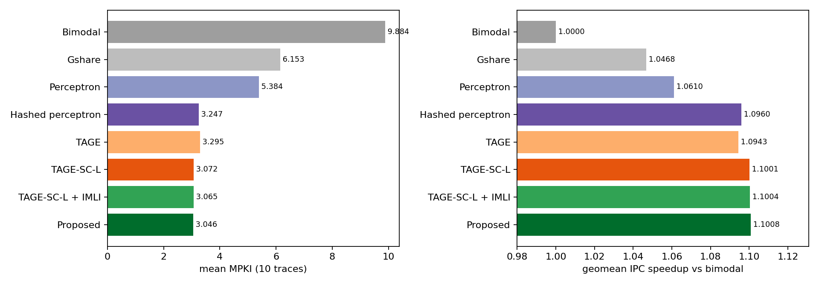
Figure 1. Mean MPKI and geometric-mean IPC speedup over bimodal.
Table 6. MPKI per trace.
Trace | Bimodal | Gshare | Perceptron | Hashed perceptron | TAGE | TAGE-SC-L | Proposed
gcc | 19.830 | 9.062 | 8.737 | 0.097 | 0.065 | 0.063 | 0.032
mcf | 21.058 | 17.734 | 15.850 | 13.981 | 14.537 | 13.920 | 13.874
cactuBSSN | 0.013 | 0.009 | 0.007 | 0.006 | 0.005 | 0.003 | 0.003
lbm | 0.211 | 0.116 | 0.115 | 0.109 | 0.102 | 0.101 | 0.101
omnetpp | 10.695 | 8.258 | 5.856 | 3.838 | 3.722 | 3.322 | 3.278
xalancbmk | 12.889 | 2.576 | 2.042 | 0.692 | 0.478 | 0.455 | 0.453
x264 | 4.694 | 0.670 | 0.495 | 0.079 | 0.057 | 0.053 | 0.053
deepsjeng | 13.746 | 9.760 | 8.481 | 4.166 | 4.194 | 3.761 | 3.709
imagick | 0.317 | 0.190 | 0.274 | 0.090 | 0.088 | 0.088 | 0.089
xz | 15.390 | 13.153 | 11.979 | 9.417 | 9.705 | 8.950 | 8.863

Table 7. IPC per trace.
Trace | Bimodal | Gshare | Perceptron | Hashed perceptron | TAGE | TAGE-SC-L | Proposed
gcc | 0.2809 | 0.3178 | 0.3190 | 0.3470 | 0.3471 | 0.3471 | 0.3473
mcf | 0.2908 | 0.2883 | 0.3032 | 0.3122 | 0.3073 | 0.3122 | 0.3124
cactuBSSN | 1.1950 | 1.1952 | 1.1952 | 1.1953 | 1.1954 | 1.1955 | 1.1955
lbm | 0.6331 | 0.6331 | 0.6331 | 0.6331 | 0.6332 | 0.6331 | 0.6330
omnetpp | 0.3119 | 0.3234 | 0.3310 | 0.3388 | 0.3391 | 0.3408 | 0.3413
xalancbmk | 0.2911 | 0.3136 | 0.3156 | 0.3217 | 0.3229 | 0.3230 | 0.3230
x264 | 1.5491 | 1.7205 | 1.7568 | 1.7761 | 1.7832 | 1.7839 | 1.7838
deepsjeng | 0.9633 | 1.0510 | 1.0708 | 1.1778 | 1.1771 | 1.1904 | 1.1922
imagick | 1.2097 | 1.2117 | 1.2100 | 1.2139 | 1.2139 | 1.2140 | 1.2140
xz | 0.8823 | 0.9156 | 0.9283 | 0.9851 | 0.9769 | 0.9970 | 0.9987

Table 8. Branch prediction accuracy per trace (%), all branch types / conditional branches only.
Trace | Bimodal all / cond. | Hashed perceptron all / cond. | TAGE-SC-L all / cond. | Proposed all / cond.
gcc | 92.266 / 90.699 | 99.962 / 99.954 | 99.975 / 99.970 | 99.988 / 99.985
mcf | 91.852 / 88.933 | 94.590 / 92.653 | 94.614 / 92.684 | 94.632 / 92.709
cactuBSSN | 99.039 / 98.772 | 99.530 / 99.305 | 99.790 / 99.607 | 99.787 / 99.608
lbm | 98.257 / 98.166 | 99.097 / 99.050 | 99.165 / 99.122 | 99.163 / 99.119
omnetpp | 94.906 / 92.112 | 98.172 / 97.141 | 98.418 / 97.527 | 98.439 / 97.559
xalancbmk | 95.018 / 94.476 | 99.733 / 99.702 | 99.824 / 99.804 | 99.825 / 99.805
x264 | 88.925 / 86.840 | 99.814 / 99.780 | 99.876 / 99.852 | 99.874 / 99.850
deepsjeng | 90.656 / 86.052 | 97.168 / 95.718 | 97.443 / 96.139 | 97.479 / 96.192
imagick | 99.803 / 99.695 | 99.944 / 99.913 | 99.945 / 99.915 | 99.945 / 99.915
xz | 87.690 / 85.450 | 92.468 / 91.098 | 92.841 / 91.539 | 92.911 / 91.621

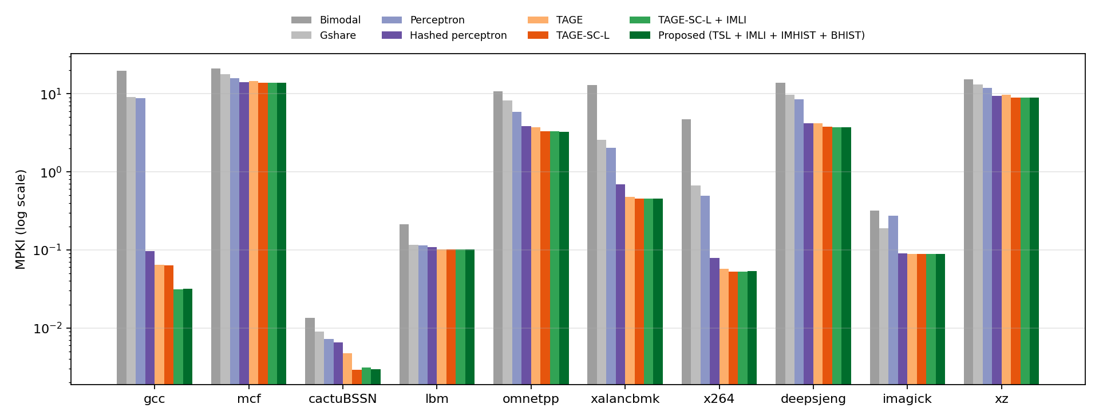
Figure 2. MPKI per trace (log scale).
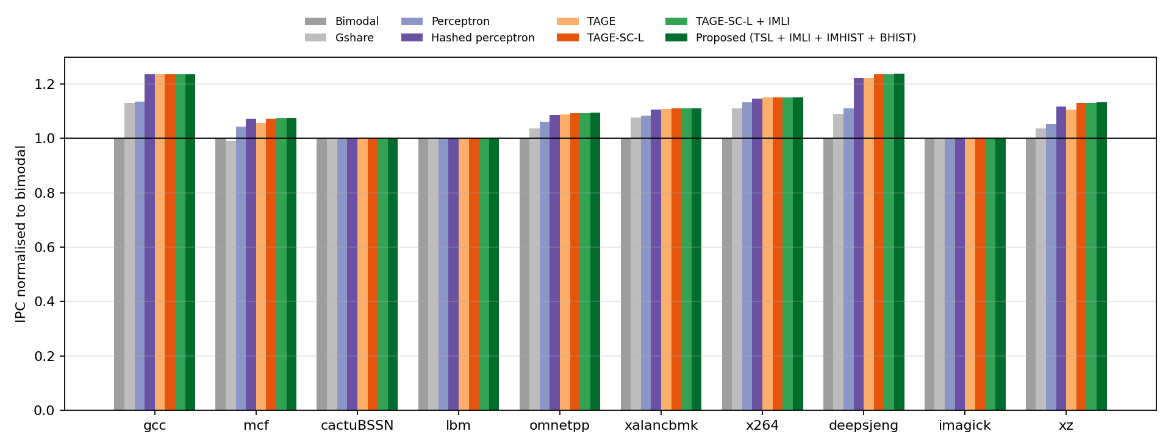
Figure 3. IPC per trace normalised to bimodal.

9. Analysis
Against the strongest shipped predictor. TFL-TAGE-SC-L lowers mean MPKI from 3.248 to 3.046 (6.2%) at slightly lower storage (62.09 vs 64.03 KB). MPKI is lower on 10 of 10 traces (gcc, mcf, cactuBSSN, lbm, omnetpp, xalancbmk, x264, deepsjeng, imagick, xz). The geometric-mean IPC speedup is 0.43%; IPC is higher on 9 traces and lower on lbm.
Against TAGE-SC-L without the loop-structure components. The contribution reduces mean MPKI from 3.072 to 3.046 (0.85%), lower on 6 traces (gcc, mcf, omnetpp, xalancbmk, deepsjeng, xz), marginally higher on cactuBSSN, lbm, x264, imagick (by at most 0.0007 MPKI, on traces whose MPKI is at most 0.101); geometric-mean IPC speedup +0.058%. IMLI-SIC alone accounts for 0.23% (TAGE-SC-L + IMLI: 3.065).
Accuracy, MPKI and IPC. IPC gains are much smaller than MPKI reductions and do not scale uniformly with them (Figure 4). In this ChampSim a misprediction stalls fetch until the branch executes, plus one cycle; Table 9 measures, per trace, the cycles saved per avoided misprediction (difference in cycles divided by difference in mispredictions, proposed vs hashed perceptron). The relative IPC gain is approximately ΔMPKI × (cycles per avoided misprediction) / (1000 × CPI): the same absolute saving matters less in a program that spends many cycles per instruction on memory stalls.
Table 9. Why IPC moves less than MPKI: decomposition of the measured IPC gain of the proposed predictor over the hashed perceptron (the cycles per avoided misprediction are themselves measured, so the two right-hand columns agree by construction; the table shows which factor limits each trace).
Trace | ΔMPKI (hp − proposed) | Cycles saved per avoided misprediction | CPI (hp) | ΔMPKI × cycles / (1000 × CPI) | Measured ΔIPC
gcc | 0.066 | 36.9 | 2.88 | +0.08% | +0.084%
mcf | 0.107 | 26.7 | 3.20 | +0.09% | +0.089%
cactuBSSN | 0.003 | n/a (Δ≈0) | 0.84 | ≈0 | +0.015%
lbm | 0.008 | n/a (Δ≈0) | 1.58 | ≈0 | -0.018%
omnetpp | 0.560 | 39.2 | 2.95 | +0.74% | +0.749%
xalancbmk | 0.238 | 50.2 | 3.11 | +0.39% | +0.387%
x264 | 0.025 | 95.9 | 0.56 | +0.43% | +0.431%
deepsjeng | 0.457 | 22.4 | 0.85 | +1.21% | +1.222%
imagick | 0.002 | n/a (Δ≈0) | 0.82 | ≈0 | +0.002%
xz | 0.553 | 25.0 | 1.02 | +1.36% | +1.380%

For example, mcf removes 0.107 mispredictions per 1,000 instructions at ~27 cycles each, but runs at ~3.2 cycles per instruction (it is dominated by cache misses), so the IPC gain is below 0.1%; xz removes 0.55 per 1,000 at ~25 cycles with a CPI near 1.0, giving +1.4%. Traces whose MPKI is already near zero (cactuBSSN, lbm, imagick) show IPC differences of a few thousandths of a percent in either direction, which is timing noise from the out-of-order model rather than a predictor effect. Accuracy over all branch types is inflated by trivially predicted unconditional branches, so conditional accuracy is the more informative number; the ranking of predictors is the same under both.
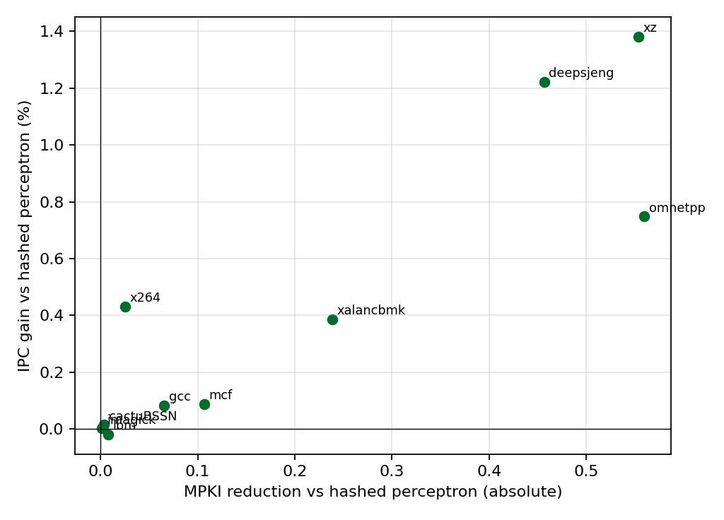
Figure 4. Per-trace MPKI reduction vs IPC gain of TFL-TAGE-SC-L over the hashed perceptron.
Where the remaining mispredictions are. mcf and xz together account for most of the mean MPKI of every predictor. Lin & Tarsa [6] attribute about 97% (mcf) and 80% (xz) of mispredictions to a handful of data-dependent branches; no history-based predictor in our study removes them, consistent with their conclusion that such branches need different information than branch history.

10. Ablation study
Table 10. Removing one component at a time (functional harness; mean MPKI over 10 traces).
Variant | Mean MPKI (reported window) | Δ vs proposed | Mean MPKI (tuning window) | Δ vs proposed
Proposed (all components) | 3.0455 | +0.00% | 3.1580 | +0.00%
- IMHIST | 3.0540 | +0.28% | 3.1674 | +0.30%
- backward-branch history | 3.0566 | +0.36% | 3.1695 | +0.37%
- all IMLI-derived components (= TAGE-SC-L) | 3.0727 | +0.89% | 3.1880 | +0.95%
- loop predictor | 3.0485 | +0.10% | 3.1607 | +0.09%
- local-history SC tables | 3.1349 | +2.94% | 3.2476 | +2.84%
- statistical corrector (= TAGE + loop) | 3.2931 | +8.13% | 3.4137 | +8.10%
TAGE only | 3.2947 | +8.18% | 3.4163 | +8.18%

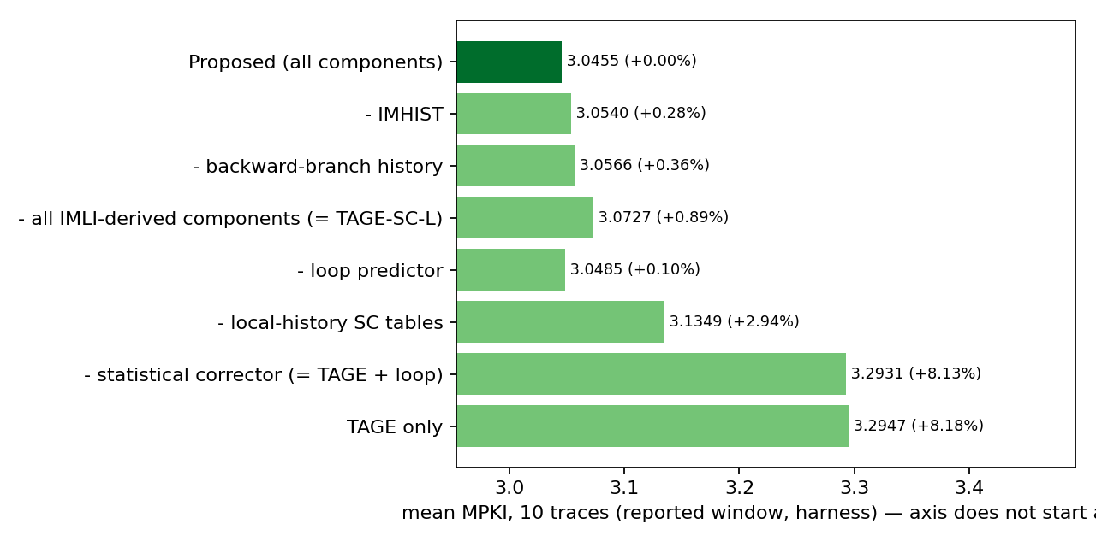
Figure 5. Ablation on the reported window.
IPC ablation in ChampSim — Proposed - loop: mean MPKI 3.049, geometric-mean IPC -0.002% relative to the proposed design.
IPC ablation in ChampSim — Proposed - local: mean MPKI 3.136, geometric-mean IPC -0.225% relative to the proposed design.
Each IMLI-derived component reduces MPKI on its own and their effects add up; the statistical corrector is the largest single contributor, the loop predictor the smallest (consistent with Seznec's report that IMLI largely subsumes the loop predictor [3]).

11. Exploration: what else was tried
All in the functional harness on the tuning window (mean MPKI over 10 traces); details in experiments/experiment_log.md.
Table 11. Exploration results (Δ mean MPKI relative to the configuration at that point).
Experiment | Result | Decision
Per-branch allocation throttle (payoff counter, 3 settings) in TAGE-SC-L | −0.00% / +0.06% / +0.09% | rejected
Same throttle in plain TAGE | −0.49% / −0.55% | works in TAGE but subsumed by TAGE-SC-L's 1/32 allocation rule
IMLI counting all taken backward branches (no conditional filter) | +0.14% | rejected
Region-based IMLI (BrIMLI-like, 256-byte regions) | +0.16% (loses gcc gain) | rejected
IMLI hashed into two global corrector tables | +0.19% alone; +0.20% on top of IMHIST+BHIST | rejected
2 history bits per branch; longest history 1000 / 2000 | +0.28%; +0.15% / +0.96% | rejected

12. Storage and implementation trade-offs
- The loop-structure components cost 32,347 bits (3.9 KB) over TAGE-SC-L, mostly corrector tables.
- Latency: the inference adds one comparison per branch and a few table lookups that are summed by the existing corrector adder tree; no change to the TAGE critical path.
- A real pipeline would track the loop-structure state speculatively and repair it on mispredictions, as for any history; this ChampSim updates immediately, so that cost is not modelled.
- The 4KB baselines use 1/16 of our storage; comparisons at equal budget are those against the hashed perceptron (64 KB) and our TAGE-SC-L.

13. Limitations and threats to validity
- Ten 250M-instruction windows of ten programs. Tuning used another window of the same programs, not different programs, so some optimism remains; the gains of the contribution (about 1%) are small relative to trace-to-trace variation.
- The simulator models direction prediction only, with immediate update and no wrong path; absolute numbers are not comparable with newer ChampSim versions or CBP results.
- The backward inference is exact only because this ChampSim has no wrong-path fetch and presents every branch in order; in a speculative front end it would have to use the predicted path and be repaired.
- IMLI depends on recognising conditional branches by their first not-taken outcome; on traces with never-exiting backward branches the counter differs from the paper's definition.
- Our TAGE-SC-L is a re-implementation at ~58 KB with 12 tables; it is not Seznec's championship code, which uses 36 logical tables and further tuning.
- The hashed-perceptron storage was counted by hand from its source.

14. Conclusion
A TAGE-SC-L predictor re-implemented for the 2021 ChampSim interface reduces mean MPKI by 5.4% relative to the strongest predictor shipped with the simulator. Inferring branch direction from the next predicted branch's address — exact in this simulator and verified against its targets — makes the loop-structure history of IMLI, IMHIST and backward-branch history usable without simulator changes and adds a further 0.85% MPKI reduction, for a total of 6.2% (3.248 → 3.046 MPKI) and a 0.43% geometric-mean IPC gain at 62.09 KB. In IPC the loop-structure components alone add only +0.06%: in this simulator an avoided misprediction saves about 22–50 cycles on most traces, which is small relative to the memory stalls of several of the traces where they help most. The largest remaining errors (mcf, xz) come from data-dependent branches that history-based prediction does not capture.

References
[1] D. A. Jiménez, C. Lin, “Dynamic Branch Prediction with Perceptrons,” HPCA 2001.
[2] A. Seznec, “A New Case for the TAGE Branch Predictor,” MICRO 2011.
[3] A. Seznec, J. San Miguel, J. Albericio, “The Inner Most Loop Iteration Counter: A New Dimension in Branch History,” MICRO 2015.
[4] D. A. Jiménez, “Multiperspective Perceptron Predictor,” CBP-5, 2016.
[5] P. Michaud, “An Alternative TAGE-like Conditional Branch Predictor,” ACM TACO 15(3), 2018.
[6] C.-K. Lin, S. J. Tarsa, “Branch Prediction Is Not a Solved Problem: Measurements, Opportunities, and Future Directions,” IISWC 2019 (arXiv:1906.08170).
[7] A. Seznec, P. Michaud, “A case for (partially) TAgged GEometric history length branch prediction,” JILP 8, 2006.
[8] A. Seznec, “TAGE-SC-L Branch Predictors,” CBP-4, 2014; “TAGE-SC-L Branch Predictors Again,” CBP-5, 2016.
[9] F. Schall et al., “The Last-Level Branch Predictor,” MICRO 2024.
[10] N. Gober et al., “The Championship Simulator: Architectural Simulation for Education and Competition,” arXiv:2210.14324, 2022.

