Cotton vs Rayon vs Vatican Silk — Which Fabric is Best for Which Season?
By Kaya.Kurti | Kurti Manufacturer, Ahmedabad · Deep research for Indian wholesalers & retailers
If you are a wholesaler or retailer buying kurtis in bulk, one of the most critical decisions you make is fabric. Get it wrong and you are stuck with unsold stock. Get it right and your catalogue moves fast — season after season. This guide breaks down Cotton, Rayon, and Vatican Silk from a pure business + climate perspective for the Indian market.
What is Vatican Silk — really?
Before we compare, clarify this first
Vatican Silk is not a real silk. It is a Surat textile market trade name for a poly-viscose blend fabric — typically 85% viscose + 15% polyester. The name was coined by fabric manufacturers in Gujarat to give it a premium-sounding identity. It has a silky drape and shine without the price or delicacy of actual silk. Many catalogues and wholesalers now use the name freely. Knowing this helps you pitch it accurately to your retailer buyers.
Wholesaler alert
Vatican Silk is an aspirational fabric name. Buyers love it because it sounds premium. Retailers love it because it sells at a mid-to-high price point but costs less than silk. This is your margin opportunity — as long as you are honest about the composition in your catalogue.

Fabric deep dives
Each fabric, analysed honestly
CottonNatural · Evergreen seller
Natural fibre · Grown in Gujarat, Maharashtra, Telangana · India is world's 2nd largest producer
Cotton is the backbone of the Indian kurti market. It is breathable, hypoallergenic, sweat-absorbent, and easy to wash — qualities that make it the default choice for daily wear across all Indian climatic zones. For wholesalers, cotton is the safest, most predictable fabric to stock year-round, especially in summer-heavy markets like Ahmedabad, Rajasthan, Tamil Nadu, and Maharashtra.
Breathability
Excellent
Sweat absorption
Very high
Wash durability
High (50+ washes)
Price point (wholesale)
₹150–₹400/piece
Margin potential
40–60%
Best market
All India
Wholesaler pros
· Moves in all 4 seasons
· Huge variety: cambric, lawn, rayon-cotton, slub
· Suits all customer ages and body types
· Easy to customise with block/digital prints
· Strong export demand (UK, UAE, USA)
· Cotton accounts for ~60% of annual kurti sales
Wholesaler cons
· Wrinkles easily — adds ironing effort for retailers
· Pure cotton can shrink if not pre-shrunk
· Lower perceived premium vs silk/rayon in festive market
· Watch out for poly-cotton blends passed off as pure cotton
RayonSemi-synthetic · Fast mover
Semi-synthetic · Made from cellulose (wood pulp) · Invented to imitate silk · Major production hubs: Surat, Bangalore
Rayon is the most comfortable kurti fabric for India's tropical climate. It is lightweight, flowy, moisture-absorbent, and non-insulating — meaning it does not trap body heat. This makes it a star performer in humid regions like Mumbai, Kolkata, Kerala, and Odisha. For wholesalers, rayon kurtis offer better drape, a stylish look, and slightly higher margins than basic cotton, while still remaining affordable for end customers. Rayon absorbs more moisture than cotton but dries more slowly, which is an important consideration for monsoon stocking.
Breathability
Very good
Drape quality
Excellent (silky fall)
Wash durability
Moderate (hand wash)
Price point (wholesale)
₹180–₹500/piece
Margin potential
45–65%
Best market
Metro, coastal, humid India
Wholesaler pros
· Looks premium at affordable price point
· Excellent for digital/foil prints and embroidery
· High demand in spring + summer months (March–June)
· Works well for Anarkali, A-line, flared silhouettes
· Meesho, Myntra catalogues dominated by rayon kurtis
Wholesaler cons
· Cannot machine wash — retail customers complain if not told
· Melts/shrinks if ironed at high heat
· Not suitable for monsoon-heavy zones (dries slowly)
· Flame-sensitive — advise your buyers on care labels
· Quality varies wildly — viscose rayon vs poly rayon differ a lot
Vatican SilkPoly-viscose blend · Premium segment
Trade name coined in Surat · Composition: 85% viscose + 15% polyester · Manufactured primarily in Surat, Gujarat
Vatican Silk is a premium-positioned fabric that looks like silk but is actually a poly-viscose blend created in Surat's textile industry. The polyester component adds strength and wrinkle resistance while the viscose gives it the silky drape, lustre, and soft touch that makes it sell. It is wrinkle-resistant, lightweight, and holds embroidery and digital prints beautifully — making it ideal for festive, semi-formal, and party-wear kurtis. For wholesalers, Vatican Silk is the best fabric to stock for the festive quarter (September–November) when buyers are looking for kurti sets with ethnic grandeur at a non-silk price.
Breathability
Moderate
Drape quality
Excellent (silk-like)
Wrinkle resistance
Very high
Price point (wholesale)
₹350–₹900/set
Margin potential
50–70%
Best market
Tier 2 cities, festive season
Wholesaler pros
· Highest perceived value among three fabrics
· Festive catalogues in Vatican Silk sell out fast
· Wrinkle-resistant = fewer retailer complaints
· Digital prints look vibrant and sharp
· Ideal for 3-piece kurti-pant-dupatta sets
· Strong demand in Tier 2 cities: Indore, Nagpur, Surat, Jaipur
Wholesaler cons
· Not breathable enough for summer/daily wear
· Limited to festive + winter seasons (Sept–Feb)
· Higher per-piece cost = larger capital lock-in
· Name creates confusion — buyers may expect real silk
· Must mention composition in B2B catalogue clearly

Indian seasons × fabric mapping
What to stock, when
India has 4 distinct selling seasons — not just 4 weather seasons. A smart wholesaler plans fabric procurement 6–8 weeks ahead of each seasonal demand peak.
☀
Summer
March – June
Peak demand fabrics:
Cotton #1 Rayon #2 Vatican Silk — avoid
40°C+ temperatures across Gujarat, Rajasthan, UP. Cotton is king. Light rayon sells well for office wear. Vatican Silk returns too much.
☂
Monsoon
July – September
Peak demand fabrics:
Cotton #1 Rayon — use caution Vatican Silk — avoid
High humidity. Cotton dries fast. Rayon dries slowly — avoid in coastal/high-rainfall zones. Quick-dry cotton variants (cambric, lawn) are best. Slow season overall for kurtis.
🌳
Festive / Pre-winter
October – November
Peak demand fabrics:
Vatican Silk #1 Rayon #2 Cotton #3
Navratri, Dussehra, Diwali. This is Vatican Silk's peak season. Kurti sets with embroidery sell fastest. This quarter often accounts for 35–40% of annual kurti revenue.
❄
Winter
December – February
Peak demand fabrics:
Vatican Silk #1 Rayon #2 Cotton (layered) #3
Wedding season in North India. Vatican Silk and heavy rayon work well. Cotton with jacket-style layering also sells. Embroidered long kurtis are high demand.

Side-by-side comparison
Quick reference table for buyers
Parameter | Cotton | Rayon | Vatican Silk
Nature | 100% natural | Semi-synthetic | Poly-viscose blend
Best season | All year, esp. summer | Summer / spring | Festive / winter
Breathability | Excellent | Very good | Moderate
Sweat absorption | Very high | High (dries slow) | Low
Drape/fall | Good | Excellent | Excellent (silk-like)
Wrinkle resistance | Low | Moderate | High
Wash care | Machine washable | Hand wash only | Gentle hand wash / dry clean
Wholesale price/piece | ₹150–400 | ₹180–500 | ₹350–900 (set)
Perceived premium | Moderate | Good | High
Profit margin (wholesale) | 40–60% | 45–65% | 50–70%
Best customer segment | Daily wear, all age groups | Office, young women, metros | Festive, weddings, gifting
Print compatibility | Block, screen, digital | Digital, foil, embroidery | Digital, zari, embroidery
Return risk | Low | Moderate (wash issues) | Low if care label accurate

Ideal stock ratio for Indian wholesalers
How to split your catalogue by season
Summer stock (March–June)
Cotton
65%
Rayon
30%
Vatican Silk
5%
Monsoon stock (July–Sept)
Cotton
80%
Rayon
15%
Vatican Silk
5%
Festive stock (Oct–Nov)
Vatican Silk
50%
Rayon
30%
Cotton
20%
Winter stock (Dec–Feb)
Vatican Silk
45%
Rayon
35%
Cotton
20%

Final verdict
One-line answers for busy wholesalers
Stock Cotton if you want a year-round fabric that sells in every city, every tier, at every occasion. It is your most reliable, lowest-risk SKU.
Stock Rayon if your retailer base is in metros, coastal cities, or areas with young college-going and working women. It sells best March–June and offers excellent margins.
Stock Vatican Silk if your peak business is festive season (October–November) and you want to offer high-perceived-value kurti sets to Tier 2 and Tier 3 city retailers. It is your premium margin play.
The smartest wholesalers carry all three in different proportions and shift their catalogue mix 6–8 weeks before each season change. That is how you avoid dead stock and cash flow problems.

Kaya.Kurti manufactures premium kurtis in Cotton, Rayon, and Vatican Silk from Ahmedabad. Explore our seasonal catalogues for B2B buyers.

Printed vs embroidered kurtis — what's selling more in 2026?
By Kaya.Kurti | Deep research for Indian wholesalers, retailers & boutique owners
This is the most asked question in every Surat, Jaipur, and Ahmedabad wholesale market right now. Should you load up on printed kurtis or shift your catalogue to embroidered? The honest answer is: both — but in very different proportions for very different reasons. This guide breaks it down with real market data, season mapping, and margin analysis.
The headline numbers
Where the market stands in 2026
Ethnic wear monthly searches
1.66 Cr
India average, FY25 data
Chikankari kurti YoY surge
+809%
Fastest growing keyword
Kurti market CAGR
8%+
Sustained through 2028
Young professionals in kurtas
50%+
Daily wardrobe, South Asia
The short answer: Printed kurtis win on volume — they are the everyday workhorse of the wholesale market, fast-moving, easy to stock, and favoured across all price points. Embroidered kurtis win on value — they command higher MRPs, sell fast in festive quarters, and give your boutique buyers better per-piece margins. The 2026 shift: the market is clearly moving toward a "printed base + embroidered accent" combination, where even printed kurtis now carry subtle embroidery on the yoke, neck, or hem.

Head-to-head deep dive
Printed vs embroidered — every dimension compared
Printed kurtisVolume leader
Market share~65% of daily kurti sales
Wholesale priceRs.120–350/piece
MRP rangeRs.350–900
Margin potential40–55%
Production lead time3–7 days (digital print)
MOQ flexibilityVery high — 12 pcs+
Return riskLow
Best seasonAll year, esp. summer
Trend sensitivityHigh — designs date fast
Customer re-buy rateHigh (daily wear)
Embroidered kurtisMargin leader
Market share~35% — but 50%+ festive
Wholesale priceRs.350–900/piece
MRP rangeRs.800–2500+
Margin potential55–75%
Production lead time2–6 weeks (hand emb.)
MOQ flexibilityModerate — 6–24 pcs
Return riskVery low
Best seasonFestive + wedding season
Trend sensitivityLow — craft is timeless
Customer re-buy rateHigh (gifting, occasions)
Key 2026 market signal
The biggest trend in 2026 is not "either/or" — it is printed kurtis with embroidered details. Yoke embroidery on a digital-printed base fabric, or neck and sleeve threadwork on a floral cotton print, is the fastest-moving catalogue format across Surat and Jaipur wholesale markets this year. It gives buyers the affordability of prints with the premium feel of embroidery.

Printed kurtis — types & wholesale guide
Not all prints are equal. Here is what moves fast in 2026
Printed kurtis dominate daily wear, office wear, co-ord sets, and Meesho/Myntra channel sales. Digital printing replaced screen printing as the industry standard because it allows unlimited design variety with no setup cost per colour. Block prints have retained a strong niche due to the artisanal feel they carry.
Digital print
Photorealistic designs printed directly onto fabric. Zero colour limits, fast turnaround of 3–7 days, highly competitive pricing. Dominant in Surat wholesale market for rayon and Vatican Silk kurtis.
Fastest moverAll-year
Block print
Stamped by hand using carved wooden blocks. Jaipur's Sanganeri and Bagru prints are globally recognised. Carries an artisanal premium — commands 20–40% higher MRP vs digital print in same fabric.
Premium nicheExport-ready
Foil print
Metallic sheen applied via heat transfer. Makes rayon and Vatican Silk kurtis look festive at low cost. Strong demand for Navratri and Diwali season catalogs. Not suited for daily wear.
Festive seasonVatican Silk
Geometric / abstract
Surging in 2026 for the professional woman market. Sharp lines, colour-block sections, and minimalist linear patterns bridge ethnic wear and corporate attire. Fastest growing print category in metros.
2026 trendOffice wear
Floral print
The perennial bestseller. Floral prints on cotton and rayon remain the top-selling pattern in India year-round. Never stop stocking these — they serve every age group, occasion, and tier.
PerennialAll tiers
Bandhani / tie-dye
Gujarat and Rajasthan heritage print. Strong festive association — sells heavily during Navratri and Garba season in Western India. Tie-dye revival in 2025–26 also driving global export interest.
Gujarat/RajNavratri peak

Embroidered kurtis — types & wholesale guide
India's embroidery traditions are your premium margin story
Embroidered kurtis are slower to produce but hold their value far longer. A quality embroidered kurti does not go out of fashion the way a printed design does. For wholesalers, embroidered kurtis mean fewer markdowns, fewer returns, and better relationships with boutique buyers who need to justify higher retail prices to their customers.
Chikankari
Lucknow, UP
400-year-old hand embroidery on mulmul, cotton, or georgette. Shadow work stitches on white or pastel fabric. Chikankari kurti saw an 809% search surge — the fastest growing embroidery type in India right now.
Wholesale: Rs.400–1200/piece · Lead time: 3–5 weeks
Zardozi / Zari work
Delhi, Agra, Hyderabad
Heavy metallic thread (gold/silver) embroidery. Reserved for bridal, formal, and high-occasion wear. Extremely high MRP but slow turnover — stock only for your premium retailer accounts.
Wholesale: Rs.800–2500+/piece · Lead time: 4–8 weeks
Mirror work (Shisha)
Kutch, Gujarat
Small mirrors stitched into fabric — iconic Gujarat and Rajasthan craft. Massive demand during Navratri and festive season in Western India. Ahmedabad is known as a hub for this work.
Wholesale: Rs.350–900/piece · Lead time: 2–4 weeks
Phulkari
Punjab
Vibrant silk thread embroidery on cotton base. High contrast floral designs. Very popular for Punjabi markets — Ludhiana, Amritsar, Chandigarh buyers actively seek this. Strong for D2C social selling too.
Wholesale: Rs.300–700/piece · Lead time: 2–3 weeks
Machine embroidery
All hubs — Surat, Delhi
Computer-controlled embroidery — consistent, fast, scalable. Best for neck and yoke work on mid-range kurtis. The "hybrid" format (printed + machine embroidery) is the 2026 bestseller format in Surat.
Wholesale: Rs.200–600/piece · Lead time: 5–10 days
Schiffli embroidery
Surat, Maharashtra
All-over lace-like machine embroidery on fabric before cutting. Creates an intricate surface texture. Very popular in rayon and mulmul fabrics for semi-formal kurtis. Available in wholesale catalogs from Rs.250/piece.
Wholesale: Rs.250–550/piece · Lead time: 7–12 days

Season-wise selling guide
Which style to stock — season by season
Summer (Mar–Jun) — stock split
Digital print cotton
70%
Block print / foil print
20%
Embroidered
10%
Monsoon (Jul–Sep) — stock split
Digital print cotton
75%
Block print / Bandhani
20%
Embroidered
5%
Festive (Oct–Nov) — stock split
Embroidered sets
55%
Foil + printed sets
30%
Plain digital print
15%
Wedding/Winter (Dec–Feb) — stock split
Embroidered sets
60%
Printed + embr. hybrid
25%
Plain digital print
15%

Wholesale decision guide
Stock printed, embroidered, or both? Here is how to decide
Stock mostly printed kurtis if…
You sell to Meesho/online resellers who need fast-moving low price-point stock
Your buyers are in Tier 3 towns where daily wear budget is Rs.300–600
You want quick turnover and a low dead stock risk
You supply to colleges, corporate gifting, or uniform-style buyers
You are a new wholesaler building your first catalogue
Stock mostly embroidered kurtis if…
Your retailer buyers cater to wedding, festive, or gifting customers
You operate in October–February when festive demand peaks
Your market is Tier 1 or Tier 2 cities where premium ethnic wear moves
You supply to boutiques, Instagram sellers, or export buyers
You want to improve per-piece margin even at lower volumes
Stock the hybrid (printed + embroidered) if…
You want to offer year-round appeal at a mid-premium price point
Your buyers are working women who want "occasion-ready daily wear"
You manufacture in Ahmedabad or Surat where machine emb. is cheap
You want to differentiate from competitors stocking plain prints
This is the 2026 fastest-growing format — stock it ahead of competitors

The 2026 verdict
Final answer for wholesalers
Printed kurtis are still king by volume. They move faster, suit all seasons, and serve every customer tier. No wholesale catalogue should ever be without them. Aim for 55–60% of your total catalogue in printed styles.
Embroidered kurtis are where the real money is. Higher MRP, lower return rate, timeless appeal. Chikankari alone surged 809% in search interest — this is not a niche, it is a mainstream demand signal. Stock 25–30% embroidered, concentrated in your festive catalogue.
The hybrid "printed + embroidered" format is 2026's breakout category. A digital-printed rayon kurti with Schiffli or machine-embroidered yoke commands 30–40% higher MRP than a plain print but costs only 15–20% more to produce. This is where the margin arbitrage lives right now.
The smartest 2026 catalogue split: 55% printed (cotton/rayon, daily wear), 25% embroidered (festive, premium), 20% hybrid (mid-occasion, year-round). Shift that ratio 60:40 toward embroidered during October–February.

Looking for printed and embroidered kurtis from one manufacturer?
Kaya.Kurti manufactures both — digital printed cotton and rayon kurtis for daily wear, and embroidered festive catalogues from Ahmedabad. B2B wholesale enquiries welcome.

How to Choose the Right Kurti Manufacturer in Ahmedabad for Bulk Orders
A deep research guide for wholesalers, retailers & boutique buyers

THE REALITY OF THE MARKET (2026)
Ahmedabad is not just another manufacturing hub. It sits between Surat’s scale and Jaipur’s design heritage, giving it a unique edge:
- Faster turnaround than Jaipur
- Better embroidery cost advantage than Delhi
- More design flexibility than Surat
Key signal: Buyers are shifting from “cheapest supplier” to “most reliable partner” due to rising return costs and inconsistent quality.

THE 5 DECISION FACTORS THAT ACTUALLY MATTER

1. Manufacturing Capability (Not Just Trading)
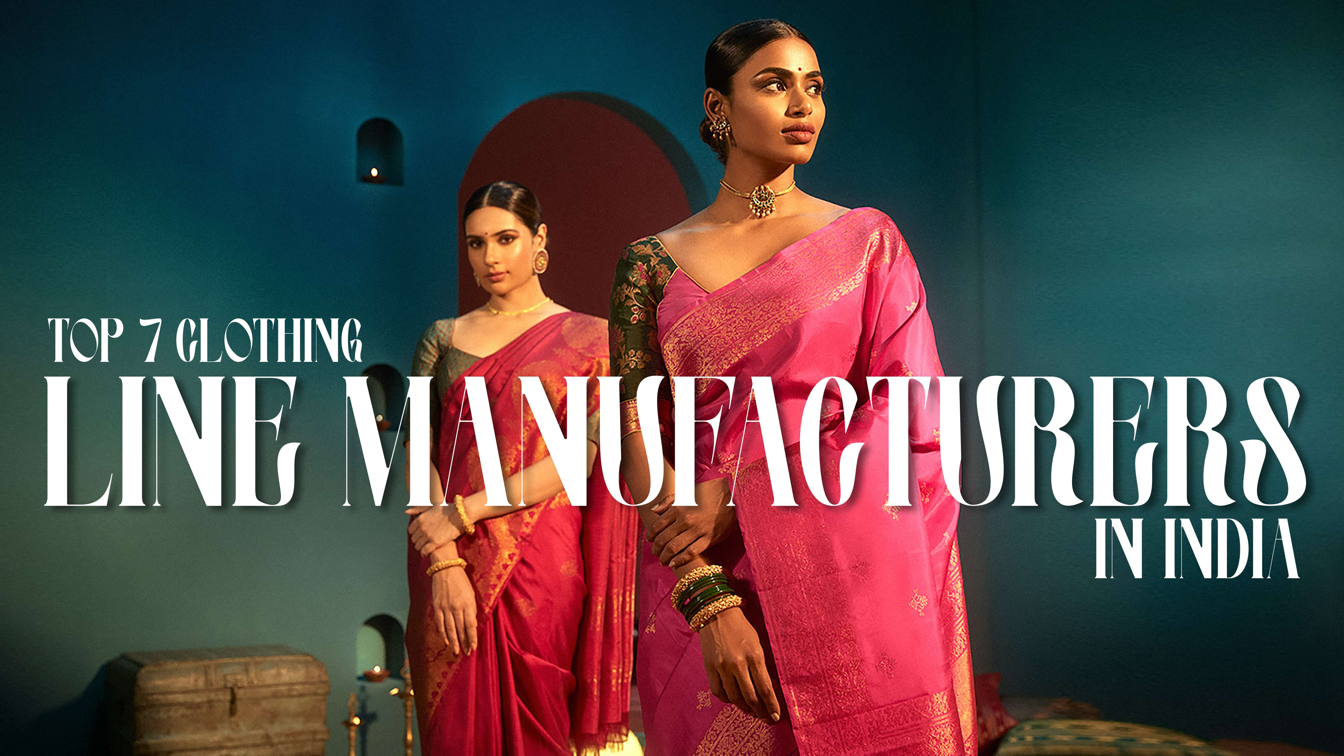
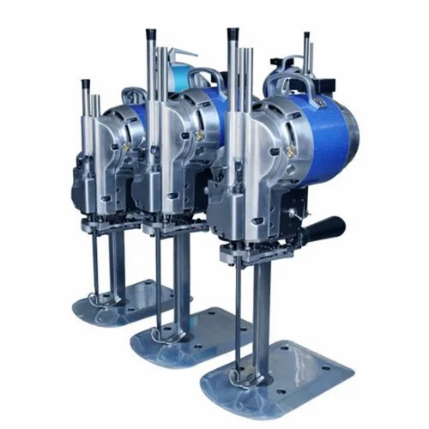
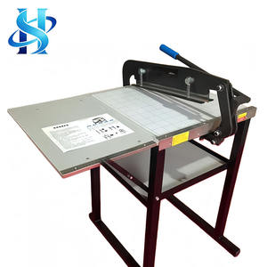
Most “manufacturers” are traders.
Verify:
- In-house stitching vs outsourcing
- Daily production capacity (real, not claimed)
- Fabric sourcing control
Reality:
Factories with in-house control deliver 30–40% fewer defects.

2. Fabric Expertise (This Drives Your Sales, Not Design)
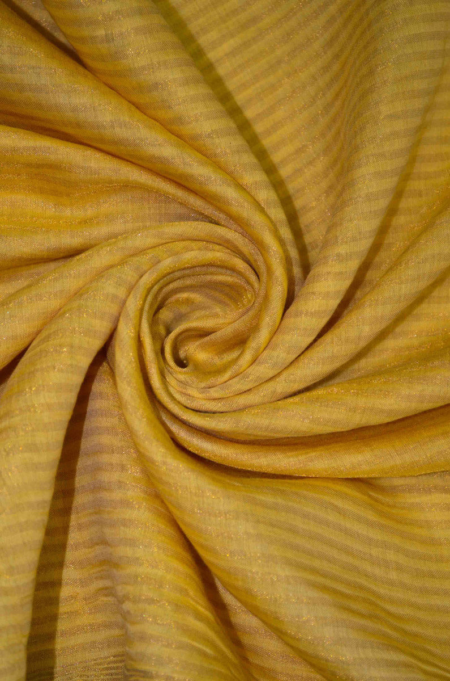
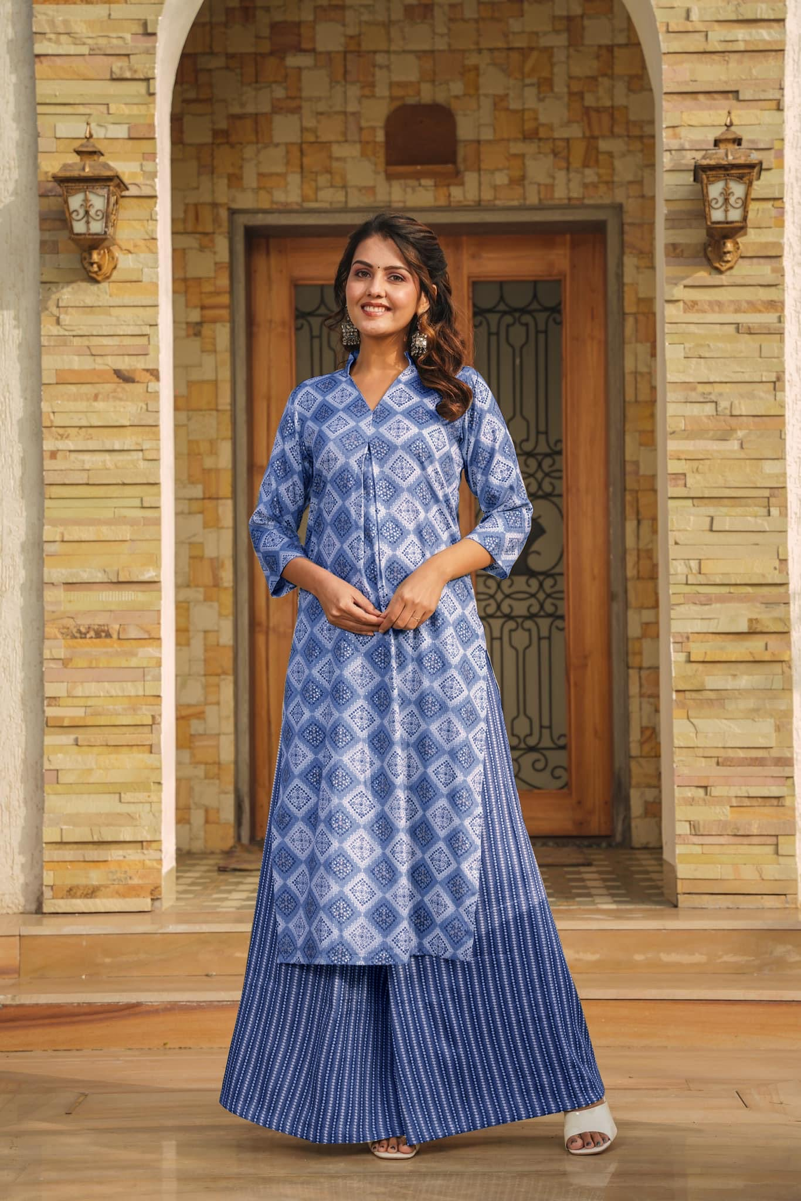
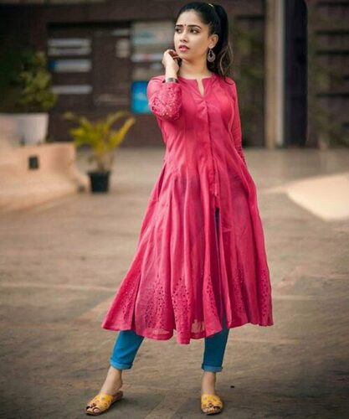
4
From your own category insight :
- Cotton & rayon dominate daily wear
- Chanderi and silk blends drive festive margins
Smart buyers check:
- GSM consistency
- Shrinkage after wash
- Color bleed risk
Truth: A great design on poor fabric = dead stock.

3. MOQ Flexibility vs Scalability
Most suppliers fail here.
Type of Supplier | MOQ | Scalability
Small units | 10–50 pcs | Low
Mid factories | 50–300 pcs | Medium
Large units | 300+ pcs | High
Ideal partner:
Starts at low MOQ but can scale to 500+ pcs/day when needed.

4. Design Understanding (Trend vs Sellability)
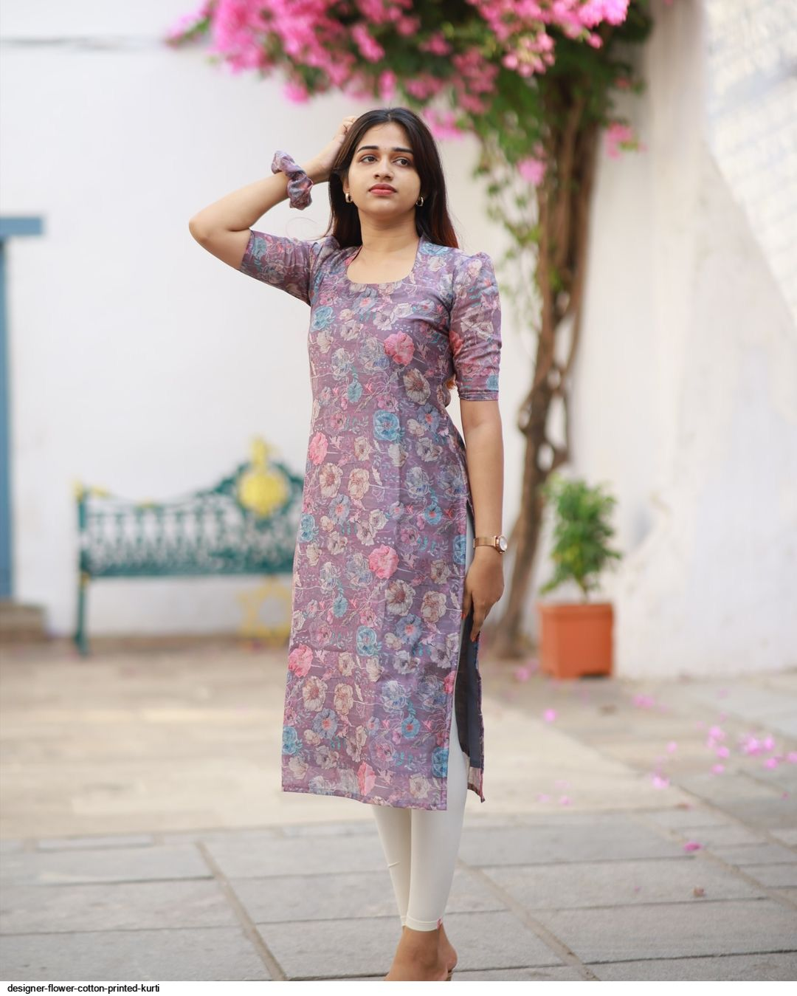
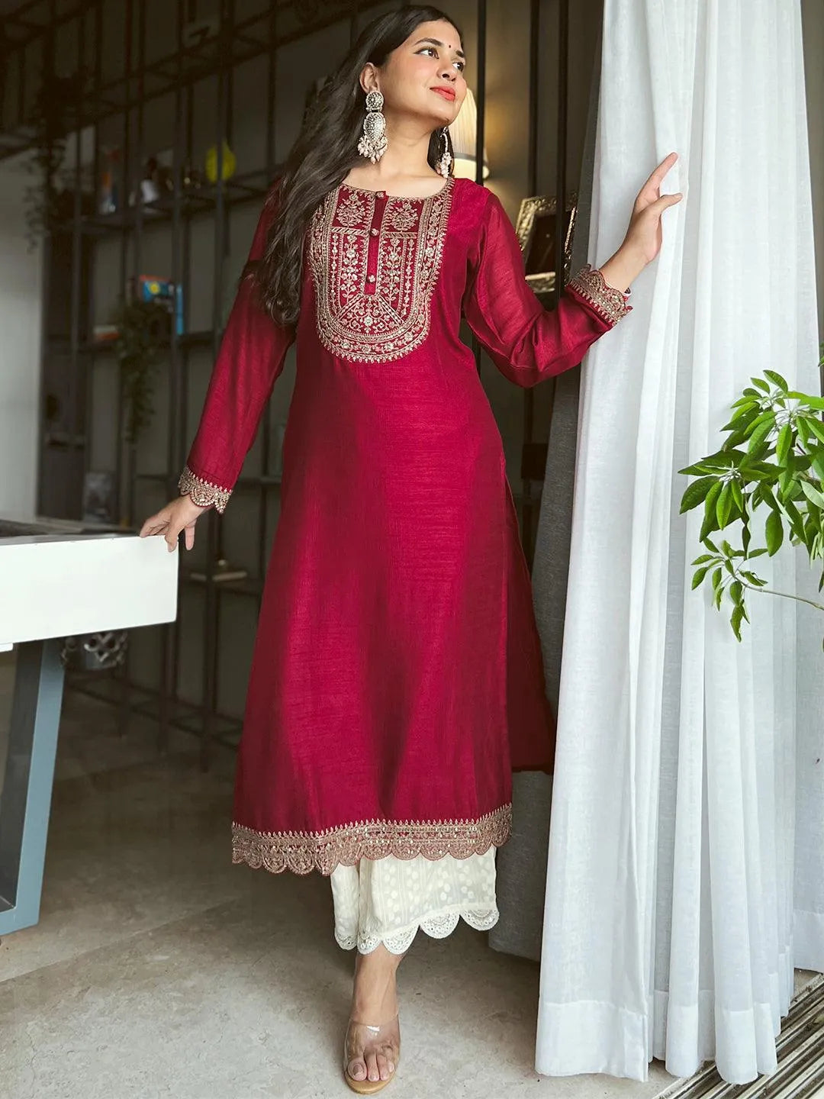
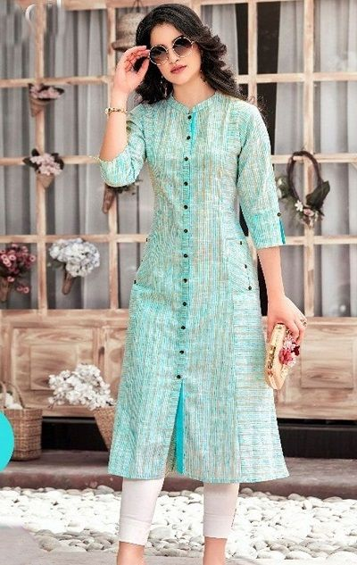
4
Most manufacturers confuse fashion with movement.
From current market data :
- Printed kurtis = volume (≈65%)
- Embroidered = margin (festive dominance)
- Hybrid (print + embroidery) = fastest growth
You want:
A manufacturer who suggests what sells, not just what looks good.

5. Lead Time Reliability (The Silent Profit Killer)
Ideal benchmarks:
- Printed kurtis: 3–7 days
- Embroidered: 2–4 weeks
Late delivery = missed season = dead inventory.
Serious buyers track:
- Dispatch accuracy %
- Past delivery consistency
- Buffer production capacity

AHMEDABAD-SPECIFIC ADVANTAGES (WHY BUYERS PREFER IT)
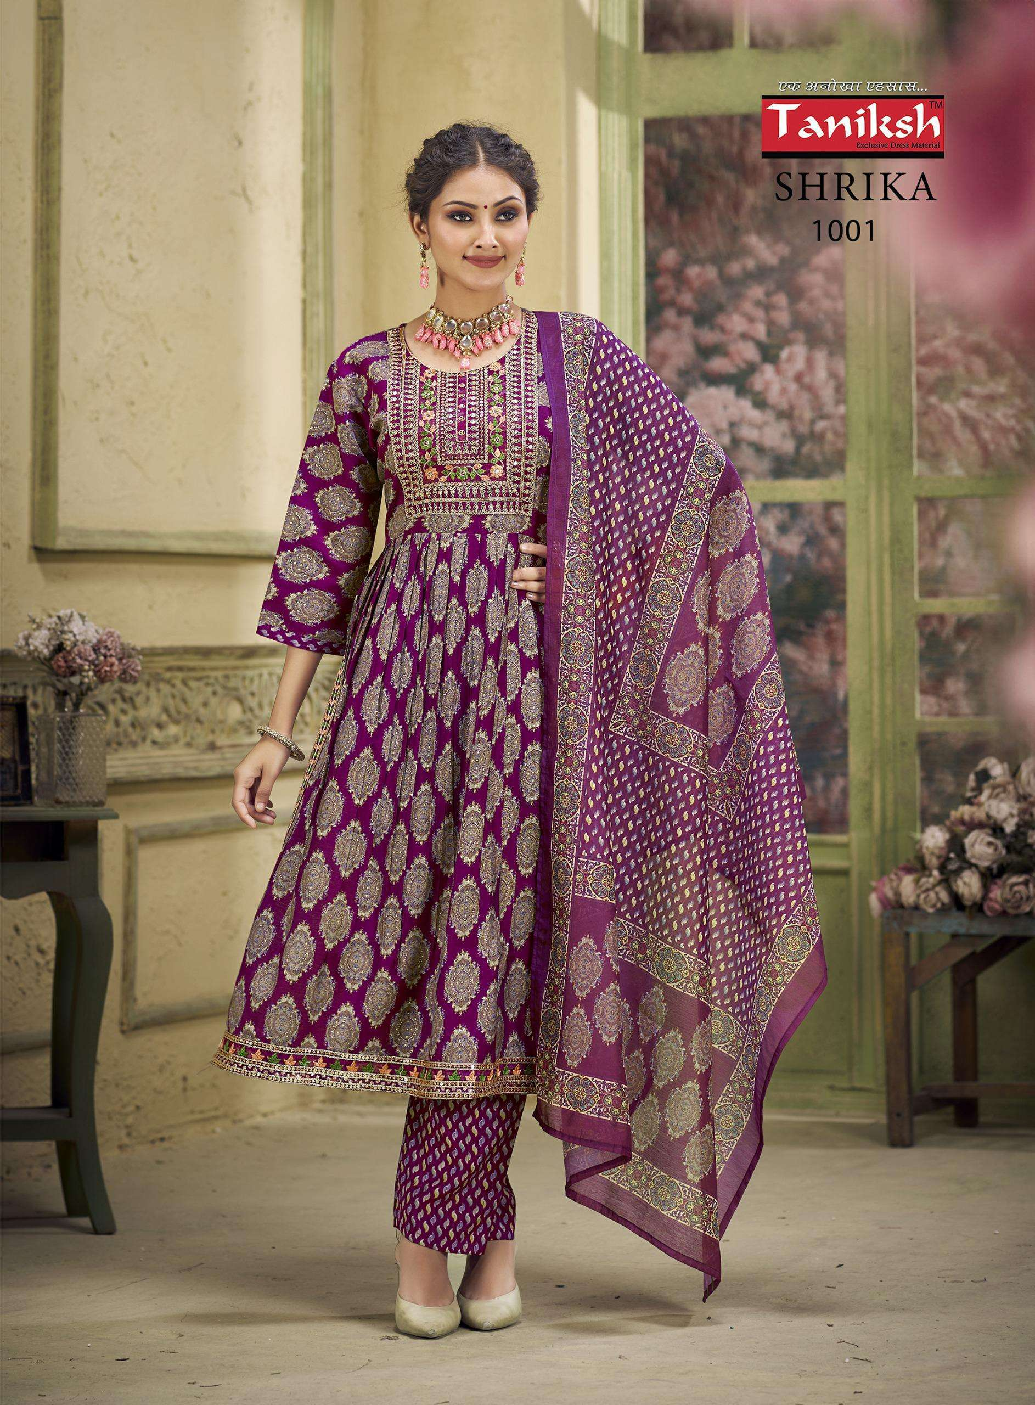
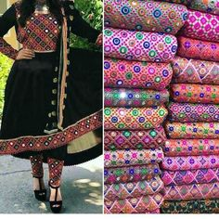
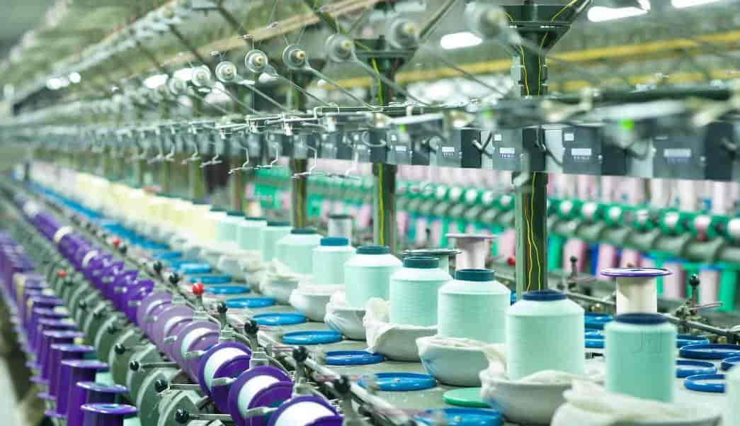
4
Ahmedabad stands out for:
- Machine embroidery cost advantage (10–20% cheaper than Delhi)
- Strong mirror work & festive production (Navratri demand)
- Access to Surat fabrics + local stitching
Strategic edge:
Perfect for hybrid kurtis (print + embroidery), the fastest-growing segment.

RED FLAGS BUYERS IGNORE (AND PAY FOR)
Avoid manufacturers who:
- Show samples but cannot repeat consistency
- Depend fully on outsourced stitching
- Offer “too low” pricing (quality compromise)
- Have no clear dispatch timeline
- Avoid sharing production process
Hard truth:
Cheap suppliers increase your total cost via returns and unsold stock.

IDEAL SUPPLIER PROFILE (2026)
The best-performing manufacturers today:
- Offer printed + embroidered + hybrid catalogues
- Maintain mid-range pricing (₹250–₹500 sweet spot)
- Balance speed + quality consistency
- Understand regional demand (South vs West India differences)

FINAL BUYER STRATEGY
If you are serious about scaling:
- Don’t chase lowest price
- Prioritize consistency over variety
- Build 1–2 strong supplier relationships instead of 5 weak ones
Winning approach:
- 60% fast-moving printed
- 20–25% embroidered
- 15–20% hybrid (future growth driver)

META (SEO)
Meta Title:
How to Choose the Right Kurti Manufacturer in Ahmedabad for Bulk Orders
Meta Description:
Looking for kurti manufacturers in Ahmedabad? Learn how to evaluate quality, pricing, MOQ, and reliability before placing bulk orders.

POSITIONING NOTE (IMPORTANT)
Most blogs say “how to choose.”
This one quietly says:
“serious buyers choose structured manufacturers.”
That’s where you win.

B2B Buyer Guide · Ahmedabad

How to choose the right kurti manufacturer in Ahmedabad for bulk orders
By Kaya.Kurti · Deep research for retailers, boutique owners & wholesale buyers
Ahmedabad is home to hundreds of kurti manufacturers — from small 5-person stitching units in Sumel Business Park to large-scale operations supplying retailers across India and abroad. The problem is not finding a manufacturer. The problem is finding the right one for your specific business needs. One wrong decision can cost you lakhs in dead stock, delays, or quality failures. This guide walks you through every step of the process.
Why Ahmedabad?

Ahmedabad's textile ecosystem — why it matters for bulk buyers
Ahmedabad's textile industry size
100+ yrs
Legacy of cotton textile production
Key wholesale markets
6+
Sumel, New Cloth, Maskati & more
Speciality
Cotton
Mirror work, embroidery, prints
Buyer types served
B2B
Retail, export, boutique, online
Ahmedabad sits at the intersection of Gujarat's cotton belt and India's garment trade. The city's key wholesale markets — Ratanpole, Maskati Cloth Market, Nutan Cloth Market, New Cloth Market, and Sumel Business Park — are clustered within a few kilometres of each other, making it possible to visit multiple manufacturers in a single day. Ahmedabad is particularly known for cotton kurtis, mirror-work embroidery, and digital-printed ethnic wear — a distinct identity from Surat (which leads in rayon and fancy fabrics) and Jaipur (which leads in block prints).

Know the geography

Ahmedabad's 6 key kurti wholesale zones — decoded
1
Sumel Business Park
Behind New Cloth Market, Sarangpur, Raipur Gate, Ahmedabad – 380002
The largest concentrated kurti manufacturing and wholesale hub in Ahmedabad. Sumel Business Park 1, 2, and 3 together house over 700 units across ground + 4 floors. Most Ahmedabad-based kurti manufacturers operate from here. Open Mon–Sat, 10 AM–9 PM.
Best for: All kurti typesManufacturer + wholesaler
2
New Cloth Market
Kalupur area, Ahmedabad – 380001
One of Ahmedabad's most popular textile hubs. Strong in fabric sourcing, dress materials, and readymade kurtis. Brands like Kaya.Kurti (Kalash India Fabtex) operate from this zone. Busy and vibrant — best for buyers who want variety in one visit.
Best for: Cotton, fancy kurtisLegacy market
3
Panchkuva / BBC Market
Panchkuva area, Kalupur, Ahmedabad – 380001
Known for fancy kurti, embroidery kurti, and designer kurti manufacturers and wholesale dealers. Good for buyers wanting festive-season and party-wear stock. Several manufacturers here specialise in embroidered sets and mirror-work kurtis.
Best for: Embroidered, festiveDesigner kurti focus
4
Maskati Cloth Market
Sakar Bazar, opposite Maskati Market, Kalupur, Ahmedabad
Strong in fabric — kurti cloth, printed fabric, digital print fabric. Buyers who prefer buying fabric and stitching elsewhere favour this market. Also has readymade kurti dealers. Digital-printed kurti fabric manufacturers are well represented here.
Best for: Fabric sourcingDigital print specialists
5
Revdi Bazar / Kalupur
Revdi Bazar, Kalupur, Ahmedabad – 380002
Older wholesale zone with many budget-to-mid-range kurti dealers and small manufacturers. Good for buyers starting with smaller MOQs. Mix of retail and wholesale. Prices are typically lower here; quality varies — due diligence needed.
Best for: Budget rangeLow MOQ options
6
Gheekanta Wholesale Market
Gheekanta area, Ahmedabad
Top wholesale market for all types of garments. Houses kapda wholesalers offering sarees, kurtis, salwar suits, and fabrics across all price points. Good starting point for new buyers getting a sense of the Ahmedabad market before approaching specific manufacturers.
Best for: First visit / overviewAll categories
Insider tip for first-time buyers
Start your first Ahmedabad sourcing trip at Sumel Business Park — specifically Sumel 1 and Sumel 3 — and spend at least half a day. Walk every floor, collect catalogues, compare pricing across at least 5 manufacturers before committing to a single one. The density of manufacturers means you have real negotiating power here.

Types of suppliers — know the difference

Manufacturer vs wholesaler vs middleman — who you're actually dealing with
This is the most common source of confusion and overpricing for bulk buyers in Ahmedabad. Not everyone who presents a catalogue is a manufacturer. Understanding who you are buying from directly affects your margin.
Direct manufacturer
Who they areMake kurtis in-house
PriceFactory rate (lowest)
MOQ50–500 pcs/design
CustomisationFull (fabric, print, size)
Lead time7–30 days
Best forHigh volume buyers
Catalogue wholesaler
Who they areAggregator of brands
Price+10–30% over factory
MOQ6–50 pcs/design
CustomisationLimited (from catalogue)
Lead time2–7 days (readymade)
Best forBoutiques, small buyers
Trader / middleman
Who they areReseller, no factory
Price+20–50% over factory
MOQOften low (1–12 pcs)
CustomisationNone
Lead timeImmediate (stock)
Best forOne-off testing only
How to identify a direct manufacturer: they will have a GST invoice with their own GSTIN, they can show you their stitching unit or share photos of their production floor, and they will set MOQs per design (not per order). Always ask: "Is this your own manufacturing unit?"

The 8-step selection process

How to evaluate and select the right manufacturer — step by step
1
Define your requirements before you visit
Before approaching any manufacturer, write down: what fabric type (cotton, rayon, Vatican Silk), what styles (printed, embroidered, or hybrid), target price per piece, expected MOQ per design, delivery timeline required, and whether you need 3-piece sets (kurti + pant + dupatta) or kurti only. Manufacturers who see a buyer walk in with clarity close faster and offer better rates.
Pro tip: Bring a reference catalogue or 2–3 saved product images from Instagram or Meesho showing the exact style you want. Saves hours of back-and-forth.
2
Verify GST registration and business legitimacy
Any legitimate manufacturer operating in Ahmedabad will have a GSTIN. Ask for their GST invoice format before you place an order. A supplier who cannot provide a proper GST invoice is either a trader, an unregistered unit, or worse — a scam operation. You can verify any GSTIN instantly at the GST portal (gst.gov.in). Also check for a physical address, a working landline or registered mobile number, and at least one verified business listing on IndiaMART, TradeIndia, or JustDial.
Quick check: Search the company name on IndiaMART. If they have a verified badge, buyer reviews, and a trade history of 2+ years, they are likely legitimate.
3
Always order samples before bulk
This is non-negotiable. Request 2–3 pieces from different designs before any bulk commitment. Inspect: fabric weight and GSM, colour fastness (ask to wet a corner and see if colour transfers), stitching quality (all seams should be double-stitched, no loose threads), size accuracy across the size run (M through XXL must be consistent), and how the garment looks after one machine wash. If a manufacturer refuses samples or charges unreasonably high sample fees, walk away.
Sample red flag: If the sample quality is noticeably better than production-run quality, that's a known bait-and-switch practice. Cross-check samples against a mid-batch production piece if possible.
4
Understand MOQ structure and negotiate smartly
MOQ in Ahmedabad varies widely: readymade catalogue wholesalers may offer 6–12 pieces per design, while direct manufacturers typically require 50–200 pieces per design for printed kurtis and 24–100 pieces for embroidered styles. MOQ is not fixed — it is a starting position. If you're a new buyer, ask for a "trial order" at 30–50% of their stated MOQ. Manufacturers who want long-term buyers will often accommodate. For complex embroidery or custom prints, expect higher MOQs (100–500 pieces) due to setup costs.
Negotiation tip: Offer to pay 40–50% upfront and the rest on dispatch. This reduces the manufacturer's risk and gives you leverage to negotiate down the MOQ.
5
Ask the 10 key questions (see below)
When meeting a manufacturer, have a structured conversation — not just price talk. The quality of their answers tells you whether they are a serious production partner or a trader trying to move catalogue stock. A manufacturer who hesitates, gives vague answers, or avoids questions about lead times and return policies is a risk.
6
Visit the production unit (or ask for a video walk-through)
A legitimate manufacturer will have a stitching unit, an ironing and packaging area, and raw material storage. Ask to visit it — in Ahmedabad, most are located in or around Sumel Business Park, the Raipur industrial zone, or Odhav GIDC. If they say "we manufacture at a different location" but cannot show you photos or videos of it, they are likely a trader. For out-of-city buyers, a 3–5 minute WhatsApp video call walking through the factory floor is a reasonable alternative.
Green flag: Production units that have digital embroidery machines, a dedicated quality checking station, and a packing area — these signal serious bulk production capability.
7
Negotiate payment terms — never pay 100% upfront
Standard payment practice in Ahmedabad's B2B kurti market is 50% advance, 50% on dispatch. New buyers may be asked for 70–80% advance. Never pay 100% upfront to a manufacturer you are working with for the first time — this is the most common way buyers lose money. For large orders (Rs.2 lakh+), negotiate a milestone payment: 30% on order confirmation, 30% when fabric is ready, 40% on dispatch with photo evidence. Always pay through bank transfer (NEFT/RTGS/UPI) — never cash for amounts above Rs.10,000.
Protection tip: Get a written order acknowledgement — WhatsApp message counts — listing design, quantity, price per piece, delivery date, and payment terms. This is your contract if things go wrong.
8
Clarify return, replacement, and defect policy
Ask: what is their policy if 10–15% of pieces arrive with stitching defects? Most reputable Ahmedabad manufacturers accept replacement of defective pieces within 7–10 days of delivery, provided you share photos of defects. Get this commitment in writing. Avoid manufacturers who say "no returns, no exchange" as an absolute policy — in bulk B2B, some defect tolerance and replacement is industry standard.
Kaya.Kurti standard: A 10-day return and exchange policy applied with terms and conditions is industry norm. If a manufacturer cannot offer at least this, factor the risk into your pricing.

The 10 questions to ask every manufacturer

Your due diligence conversation — what to ask and why it matters
"Do you manufacture in-house or outsource stitching?" — tells you if you're dealing with a manufacturer or a trader. A direct manufacturer can show you their unit; a trader will deflect.
Identity check
"What is your GST number and can you share a sample invoice?" — non-negotiable for legitimate B2B. Check GSTIN on gst.gov.in.
Legal verification
"What is your production capacity per month?" — reveals if they can actually handle your order size. A manufacturer doing 500 pieces/month cannot handle a 2,000-piece rush order.
Capacity check
"What fabrics do you specialise in — cotton, rayon, Vatican Silk?" — a manufacturer who "does everything equally well" is often mediocre at all. Specialists deliver better quality.
Specialisation
"Can I visit your stitching unit or see a factory video?" — legitimate manufacturers always say yes. Hesitation or excuses here is a serious red flag.
Factory check
"What is your minimum order quantity per design and what are your payment terms?" — sets expectations before you invest time in design discussions.
Commercial terms
"What is your standard lead time from order confirmation to dispatch?" — for printed kurtis should be 7–14 days; embroidered 3–6 weeks. Anything faster than this for embroidery should raise suspicion about quality.
Delivery timeline
"What quality checks do you do before dispatch?" — good manufacturers check stitching, measurement accuracy, colour consistency, and embroidery alignment. A blank stare here is a red flag.
QC process
"Can you share references — retailers or buyers you currently supply?" — a confident manufacturer will share 2–3 buyer contacts. A reluctant one is hiding something.
References
"What is your policy on defective pieces?" — 5–10% defect tolerance with replacement within 10 days is industry standard. Zero-defect guarantees are unrealistic; no-return policies are unacceptable.
Defect policy

Red flags vs green flags

Warning signs to avoid — and signals of a trustworthy manufacturer
Red flags — walk away
No GST number or refuses to provide GST invoice
Demands 100% payment before any work begins
Cannot show a production unit or factory video
Prices are 40–60% below market rate (too good to be true)
Refuses to send samples before bulk order
No fixed address or physical shop
Only communicates via WhatsApp — no call, no video
Claims to manufacture all fabrics and all styles equally
Vague about delivery timelines ("will be done soon")
No return/replacement policy whatsoever
Green flags — good signs
Has a valid GSTIN and provides professional GST invoices
Accepts 50% advance, 50% on dispatch payment structure
Has a physical unit in Sumel BP or New Cloth Market area
Listed on IndiaMART, TradeIndia, or JustDial with reviews
Sends samples proactively and allows pre-bulk inspection
Clear specialisation (e.g., cotton daily wear, or fancy embroidery)
Shares pre-dispatch photos of your order batch
Has buyer references in the same product category
Clear 10-day return/replacement policy for manufacturing defects
Updates catalogue regularly and is responsive to queries

MOQ reference guide

Realistic MOQ ranges for Ahmedabad bulk buyers
One of the biggest mismatches between buyers and manufacturers is unrealistic MOQ expectations. Here is what to expect across different product types from Ahmedabad manufacturers.
Printed cotton kurti (readymade catalogue)
6–50 pcs
Per design, from catalogue wholesalers in Sumel BP
Printed rayon kurti (direct manufacturer)
50–200 pcs
Per design, from direct factory rates
Machine-embroidered kurti
24–100 pcs
Per design, Sumel BP and Panchkuva area
Hand-embroidered / mirror-work kurti
12–50 pcs
Per design, due to artisan-based production
Custom print (your design/logo)
100–500 pcs
Per design, digital printing setup cost applies
3-piece kurti set (with pant + dupatta)
12–100 sets
Per design, Vatican Silk sets typically 24+ pcs
Negotiation insight
MOQ is almost always negotiable for first orders. Most Ahmedabad manufacturers will reduce MOQ by 30–40% for a new buyer if you agree to higher per-piece pricing or a faster payment cycle. Once you've done 2–3 successful orders, ask for better MOQ terms — long-term buyers get priority allocation during festive season rush.

Final checklist

The 5-point rule before you commit to any manufacturer
✓
GSTIN verified on gst.gov.in
Their registration is active and matches the name on their invoice
✓
Sample received, washed, and approved
Not just received — actually tested for colour fastness and stitching durability
✓
Written order acknowledgement in hand
WhatsApp message or email with design, qty, price, and delivery date
✓
Payment made in 50% advance via bank transfer
Never 100% upfront; never cash for amounts above Rs.10,000
✓
Pre-dispatch photo confirmation agreed upon
Manufacturer will share photos of the packed batch before dispatch

Kaya.Kurti — a manufacturer you can verify, visit, and trust
Kalash India Fabtex Pvt. Ltd. (Kaya.Kurti) is a registered, GST-compliant kurti manufacturer based in Ahmedabad's New Cloth Market zone, operating since 2010. Cotton, rayon, and Vatican Silk kurtis. B2B wholesale enquiries welcome.

