OBJECT ORIENTED PROGRAMMING LAB
ASSIGNMENT – 1
Name | Maahi Thakur
Roll No. | 2026010063
Subject | Object Oriented Programming Lab
Subject Code: ________________________
Question 1
Write a program (WAP) to display "Hello World" on console display. Implement the control characters \n (new line), \t (tab), \a (alarm sound), and \r (carriage return).
#include <iostream>
using namespace std;
int main()
{
cout << "Hello World\n";
cout << "Hello\tWorld\n";
cout << "Alarm\a\n";
cout << "Hello\rWorld";
return 0;
}

OUTPUT
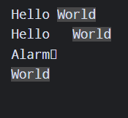

Question 2
Write a C++ program that asks for a temperature in Celsius and displays it in degree Fahrenheit. Formula: F = 9C/5 + 32.
#include <iostream>
using namespace std;
int main()
{
float C, F;
cout << "Enter Celsius: ";
cin >> C;
F = 9 * C / 5 + 32;
cout << "Fahrenheit = " << F;
return 0;
}

OUTPUT
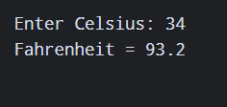

Question 3
Demonstrate for, while and do-while loops with possible variations, including a for loop without initialization and/or increment.
#include <iostream>
using namespace std;
int main()
{
int i = 1;
for (i = 1; i <= 5; i++)
cout << i << " ";
cout << endl;
i = 1;
for (; i <= 5; i++)
cout << i << " ";
cout << endl;
i = 1;
for (; i <= 5;)
{
cout << i << " ";
i++;
}
cout << endl;
i = 1;
while (i <= 5)
{
cout << i << " ";
i++;
}
cout << endl;
i = 1;
do
{
cout << i << " ";
i++;
} while (i <= 5);
return 0;
}

OUTPUT
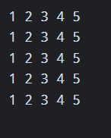

Question 4
Create a structure in C++ containing Student details: Name, Roll No, Degree, Hostel and CurrentCGPA. Include addDetails(), updateDetails(), updateCGPA(), updateHostel() and displaydetails().
#include <iostream>
using namespace std;
struct Student
{
string name, degree, hostel;
int rollNo;
float cgpa;
void addDetails()
{
cin >> name >> rollNo >> degree >> hostel >> cgpa;
}
void updateDetails()
{
cin >> name >> rollNo >> degree;
}
void updateCGPA()
{
cin >> cgpa;
}
void updateHostel()
{
cin >> hostel;
}
void displaydetails()
{
cout << "Name: " << name << endl;
cout << "Roll No: " << rollNo << endl;
cout << "Degree: " << degree << endl;
cout << "Hostel: " << hostel << endl;
cout << "CGPA: " << cgpa;
}
};
int main()
{
Student s;
cout << "Enter Name, Roll No, Degree, Hostel, CGPA: ";
s.addDetails();
s.displaydetails();
return 0;
}

OUTPUT
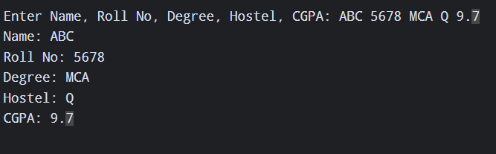

Question 5
Differentiate between private and public access/scope. Perform Question 4 using a class instead of a structure, with data members private and some member functions private and some public.
#include <iostream>
using namespace std;
class Student
{
private:
string name, degree, hostel;
int rollNo;
float cgpa;
void updateCGPA()
{
cgpa = 9.0;
}
public:
void addDetails()
{
name = "Maahi";
rollNo = 63;
degree = "BCA";
hostel = "Yes";
cgpa = 8.5;
}
void updateHostel()
{
hostel = "No";
}
void displaydetails()
{
cout << "Name: " << name << endl;
cout << "Roll No: " << rollNo << endl;
cout << "Degree: " << degree << endl;
cout << "Hostel: " << hostel << endl;
cout << "CGPA: " << cgpa;
}
};
int main()
{
Student s;
s.addDetails();
s.updateHostel();
s.displaydetails();
return 0;
}

OUTPUT
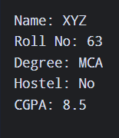

Question 6
Create a code snippet illustrating: (a) calling private member functions inside a public member function, and (b) accessing private member functions inside a public member function.
#include <iostream>
using namespace std;
class Demo
{
private:
void show()
{
cout << "Private Function";
}
public:
void display()
{
show();
}
};
int main()
{
Demo d;
d.display();
return 0;
}

OUTPUT
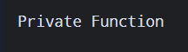

Question 7
Define a class Complex with private real and imaginary properties. Implement public set(), display(), and sum(Complex) methods to add two complex numbers and return the result.
#include <iostream>
using namespace std;
class Complex
{
private:
int real, imag;
public:
void set(int r, int i)
{
real = r;
imag = i;
}
void display()
{
cout << real << " + " << imag << "i";
}
Complex sum(Complex c)
{
Complex t;
t.real = real + c.real;
t.imag = imag + c.imag;
return t;
}
};
int main()
{
Complex c1, c2, c3;
c1.set(2, 3);
c2.set(4, 5);
c3 = c1.sum(c2);
c3.display();
return 0;
}

OUTPUT
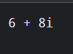

Question 8
Implement namespace in a program to illustrate the use of same-name variables and functions in different sections/libraries of the code.
#include <iostream>
using namespace std;
namespace A
{
int x = 10;
void show()
{
cout << "A: " << x << endl;
}
}
namespace B
{
int x = 20;
void show()
{
cout << "B: " << x << endl;
}
}
int main()
{
A::show();
B::show();
return 0;
}

OUTPUT
