OBJECT ORIENTED PROGRAMMING LAB
ASSIGNMENT – 4
Name | Maahi Thakur
Roll No. | 2026010063
Subject | Object Oriented Programming Lab
Question 1
Create a C++ program to demonstrate Single Inheritance. Create a base class Person with Name and Age. Create a derived class Student with Roll Number and Course. Accept and display the complete details of a student using inheritance.
#include <iostream>
using namespace std;
class Person
{
public:
string name;
int age;
};
class Student : public Person
{
public:
int rollNo;
string course;
void input()
{
cout << "Enter Name: ";
cin >> name;
cout << "Enter Age: ";
cin >> age;
cout << "Enter Roll No: ";
cin >> rollNo;
cout << "Enter Course: ";
cin >> course;
}
void display()
{
cout << "\nName: " << name;
cout << "\nAge: " << age;
cout << "\nRoll No: " << rollNo;
cout << "\nCourse: " << course;
}
};
int main()
{
Student s;
s.input();
s.display();
return 0;
}

OUTPUT
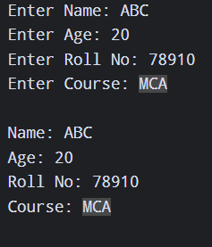

Question 2
Create a C++ program to demonstrate Multilevel Inheritance using Person → Employee → Manager. Person stores Name, Employee stores Employee ID, and Manager stores Department. Display all the details of the manager.
#include <iostream>
using namespace std;
class Person
{
public:
string name;
};
class Employee : public Person
{
public:
int empId;
};
class Manager : public Employee
{
public:
string department;
void display()
{
cout << "Name: " << name << endl;
cout << "Employee ID: " << empId << endl;
cout << "Department: " << department;
}
};
int main()
{
Manager m;
m.name = "Maahi";
m.empId = 101;
m.department = "IT";
m.display();
return 0;
}

OUTPUT
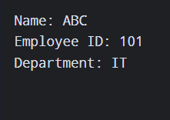

Question 3
Create a C++ program to demonstrate Multiple Inheritance. Create Academic with Marks and Sports with Sports Score. Create a derived class Result that inherits from both classes, calculates the total score and displays the result.
#include <iostream>
using namespace std;
class Academic
{
public:
int marks;
};
class Sports
{
public:
int sportsScore;
};
class Result : public Academic, public Sports
{
public:
void display()
{
cout << "Academic Marks: " << marks << endl;
cout << "Sports Score: " << sportsScore << endl;
cout << "Total Score: " << marks + sportsScore;
}
};
int main()
{
Result r;
r.marks = 80;
r.sportsScore = 15;
r.display();
return 0;
}

OUTPUT
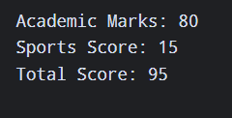

Question 4
Create a C++ program to demonstrate Hierarchical Inheritance. Create a base class Vehicle containing Brand and Model. Create Car with Number of Doors and Bike with Engine Capacity. Create separate objects and display their details.
#include <iostream>
using namespace std;
class Vehicle
{
public:
string brand;
string model;
};
class Car : public Vehicle
{
public:
int doors;
void display()
{
cout << "Car Brand: " << brand << endl;
cout << "Model: " << model << endl;
cout << "Doors: " << doors << endl;
}
};
class Bike : public Vehicle
{
public:
int engine;
void display()
{
cout << "Bike Brand: " << brand << endl;
cout << "Model: " << model << endl;
cout << "Engine Capacity: " << engine << " cc";
}
};
int main()
{
Car c;
c.brand = "Honda";
c.model = "City";
c.doors = 4;
Bike b;
b.brand = "Yamaha";
b.model = "R15";
b.engine = 155;
c.display();
cout << "\n\n";
b.display();
return 0;
}

OUTPUT
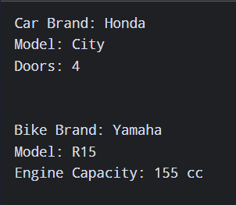

Question 5
Create a base class College with a constructor that initializes the College Name. Create a derived class Department with a constructor that initializes the Department Name. Create an object of the derived class and display both college and department information to show the order of constructor execution.
#include <iostream>
using namespace std;
class College
{
public:
College(string name)
{
cout << "College Constructor" << endl;
cout << "College Name: " << name << endl;
}
};
class Department : public College
{
public:
Department(string college, string dept)
: College(college)
{
cout << "Department Constructor" << endl;
cout << "Department: " << dept << endl;
}
};
int main()
{
Department d("Shoolini University", "CSE");
return 0;
}

OUTPUT
