AI-BASED INTELLIGENT ENQUIRY CHATBOT FOR HIMACHAL PRADESH COLLEGES
A PROJECT REPORT
Submitted by
MAAHI THAKUR
in partial fulfillment for the award of the degree
of
BACHELOR OF COMPUTER APPLICATIONS
IN
ARTIFICIAL INTELLIGENCE
SHOOLINI UNIVERSITY
MAY 2026

SHOOLINI UNIVERSITY
BONAFIDE CERTIFICATE
Certified that this project report titled “AI-Based Intelligent Enquiry Chatbot for Himachal Pradesh Colleges” is the bonafide work of Maahi Thakur, who carried out the project work under my supervision.

SIGNATURE SIGNATURE
Head of Department Er. Shubham Sharma
Supervisor

ABSTRACT
This project presents an AI-based intelligent enquiry chatbot developed to assist students in obtaining college-related information quickly and efficiently. The chatbot is designed to answer common queries related to fees, courses, hostel facilities, placements, and contact details.
The system uses Natural Language Processing (NLP) techniques to understand user input and process the text by performing operations such as tokenization and stopword removal. The processed text is then converted into numerical form using CountVectorizer, which allows machine learning models to analyze the data.
Two machine learning algorithms, Naive Bayes and Logistic Regression, are used for classifying the user queries into different categories (intents). Logistic Regression provides better accuracy and is selected as the final model for the system.
The chatbot offers a simple and user-friendly interface built using Streamlit, enabling users to interact with the system easily. The system reduces the need for manual enquiry and provides instant responses, saving time and effort for students.
In conclusion, the project demonstrates an efficient and practical solution for handling student queries using machine learning and NLP techniques.

TABLE OF CONTENTS

1. Introduction
1.1 General
1.2 Problem Statement
1.3 Objectives
2. Literature Review
2.1 Overview of Chatbots
2.2 Machine Learning in Chatbots
2.3 Existing Systems and Limitations
3. System Design / Methodology
3.1 System Architecture
3.2 Text Processing and Vectorization
3.3 Model Selection and Working
4. Implementation & Results
4.1 Tools and Technologies
4.2 Dataset and Model Training
4.3 Results and System Features
5. Conclusion & Future Scope
5.1 Conclusion
5.2 Future Scope
5.3 Advantages and Limitations
Appendix
References

CHAPTER 1: INTRODUCTION
1.1 General
In today’s digital environment, students often face difficulty in finding accurate and quick information related to colleges. Important details such as fees, courses, hostel facilities, and placement information are usually scattered across different sources, making the process time-consuming and confusing.
With the increasing use of technology, there is a need for an automated system that can provide instant and reliable responses to such queries. Chatbots are one such solution that can interact with users and provide information efficiently.

1.2 Problem Statement
Students generally spend a lot of time searching for basic college-related information. There is no single platform that provides all the required details in one place. Manual enquiry systems are slow and limited to working hours, which creates inconvenience for students.

1.3 Objectives
The main objectives of this project are:
- To develop an intelligent chatbot for handling student queries
- To provide instant responses related to fees, courses, hostel, and placements
- To reduce the need for manual enquiry
- To improve accessibility of information for students

CHAPTER 2: LITERATURE REVIEW
2.1 Overview of Chatbots
Chatbots are software applications designed to simulate human conversation and provide automated responses to user queries. They are widely used in various domains such as education, healthcare, banking, and customer support. Chatbots help in reducing manual effort by providing instant responses to frequently asked questions.
Chatbots can be classified into rule-based and AI-based systems. Rule-based chatbots respond based on predefined patterns, while AI-based chatbots use machine learning techniques to understand and process natural language queries.

2.2 Machine Learning Approaches
Machine Learning plays an important role in modern chatbot systems. It allows the chatbot to learn from data and improve its performance over time. In chatbot systems, machine learning algorithms are used for intent classification, which helps in identifying the purpose of user queries.
Algorithms such as Naive Bayes and Logistic Regression are commonly used for text classification tasks. These models analyze user input and predict the most relevant category, enabling the chatbot to provide accurate responses.

2.3 Existing Systems and Limitations
Traditional enquiry systems rely on manual methods such as enquiry desks, phone calls, and static websites. These methods are time-consuming and may not provide immediate responses.
Many early chatbot systems were rule-based and lacked flexibility in handling different variations of user queries. Some advanced systems use complex AI models, but they often require internet connectivity and high computational resources.
Therefore, there is a need for a simple, efficient, and scalable chatbot system that can work offline and support multiple colleges.

CHAPTER 3: SYSTEM DESIGN / METHODOLOGY
3.1 System Architecture
The system is designed using a modular architecture where each component performs a specific function. The main components include user input, preprocessing module, feature extraction, machine learning model, and response generation.
The overall workflow of the system is:
User Input → Preprocessing → Vectorization → Model → Response Output
This architecture ensures that the system processes user queries efficiently and provides accurate results.

3.2 Text Preprocessing
Text processing is an important step in the system. The user input is cleaned using preprocessing techniques such as converting text to lowercase, removing punctuation, and eliminating unnecessary words.
After preprocessing, the text is converted into numerical form using the CountVectorizer technique. This method represents text based on word frequency, allowing machine learning models to understand and process the input effectively.

3.3 Model Selection and Working
The system uses machine learning models such as Naive Bayes and Logistic Regression for intent classification. These models are trained using the dataset of query patterns.
Naive Bayes is fast and efficient, while Logistic Regression provides better accuracy. The final model predicts the intent of user queries and helps in retrieving the appropriate response from the dataset.

CHAPTER 4: IMPLEMENTATION & RESULTS
4.1 Tools and Technologies
The chatbot system is developed using Python as the primary programming language. Python is widely used in Artificial Intelligence and Machine Learning applications due to its simplicity and strong library support.
NLTK (Natural Language Toolkit) is used for text preprocessing tasks such as tokenization and cleaning of input data. Scikit-learn is used for implementing machine learning models like Naive Bayes and Logistic Regression. Streamlit is used to build a simple and interactive user interface for the chatbot. CountVectorizer is used for converting text into numerical form.

4.2 Dataset and Model Training
The dataset used in this project consists of approximately 400–500 query patterns related to multiple colleges. These queries are grouped into different categories such as fees, courses, hostel, placements, and contact details.
The text data is first preprocessed and then converted into numerical form using the Bag of Words technique. The machine learning models are trained using this processed dataset. Both Naive Bayes and Logistic Regression models are tested, and Logistic Regression provides better accuracy.

4.3 Results and System Feature
The chatbot system was tested using different types of user queries. It successfully classified most queries and provided relevant responses.
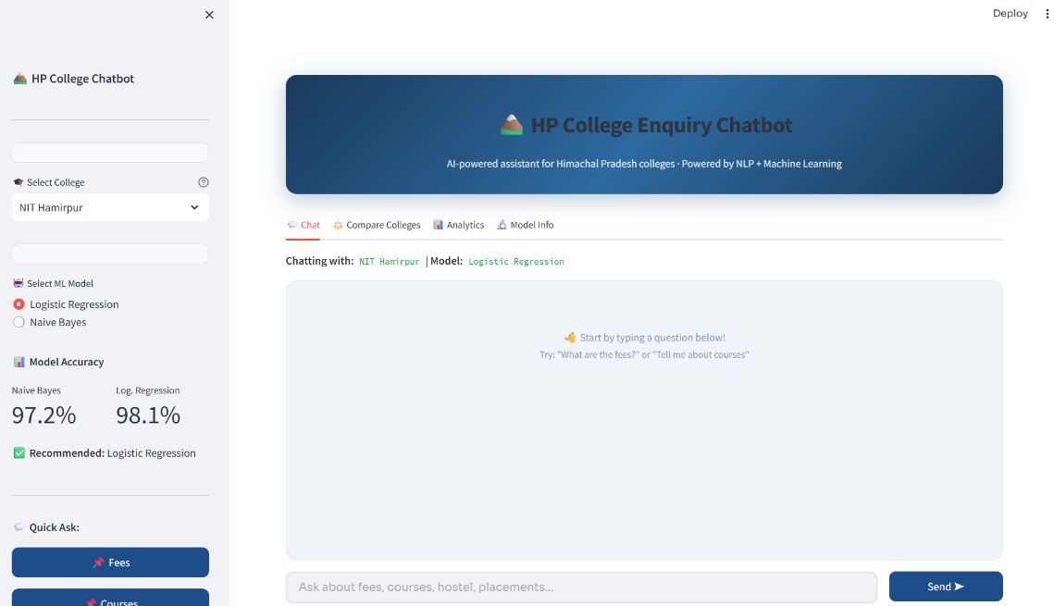
Figure 4.1: Chatbot Interface and Output Screen
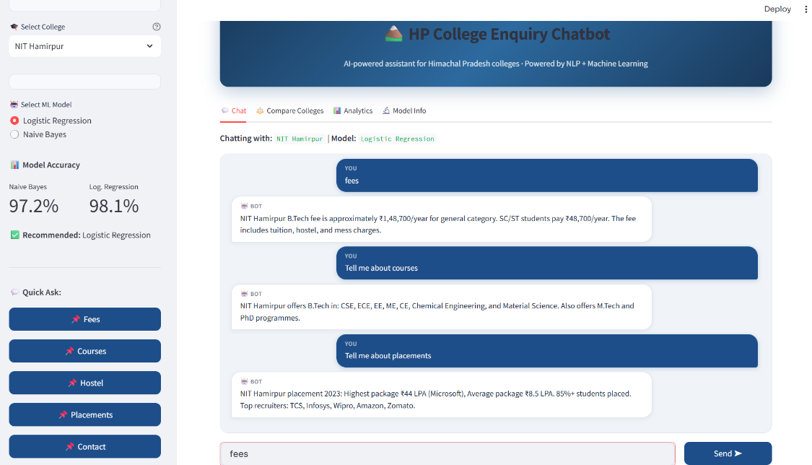
Figure 4.2: Sample Chatbot Interaction Output

CHAPTER 5: CONCLUSION & FUTURE SCOPE
5.1 Conclusion
This project presents a simple and effective AI-based chatbot for handling student queries related to college information. The system uses Natural Language Processing and Machine Learning techniques to understand user input and provide accurate responses.
The chatbot is able to classify queries into different categories such as fees, courses, hostel, and placements. It reduces the need for manual enquiry and provides instant responses to users.
Overall, the system is efficient, easy to use, and helps save time for students by providing quick and relevant information.

5.2 Future Scope
The project can be further improved and expanded in the following ways:
- Adding more colleges to increase the dataset
- Using advanced AI models for better accuracy
- Integrating voice-based interaction
- Deploying the chatbot on web or mobile platforms

5.3 Advantages and Limitations
Advantages:
- Provides instant responses
- Reduces manual effort
- Easy to use
- Saves time
Limitations:
- Limited dataset
- Cannot handle complex queries
- Accuracy depends on training data
APPENDIX
Appendix A: Text Preprocessing
import re
import string
def preprocess(text):
text = text.lower()
text = re.sub(r"[" + string.punctuation + r"]", " ", text)
tokens = text.split()
tokens = [t for t in tokens if len(t) > 1]
return " ".join(tokens)

Appendix B: Dataset Creation
def build_dataset():
X, y = [], []
for intent, patterns in INTENTS_DATA.items():
for pattern in patterns:
X.append(preprocess(pattern))
y.append(intent)
return X, y

Appendix C: Vectorization
from sklearn.feature_extraction.text import CountVectorizer
vectorizer = CountVectorizer(ngram_range=(1, 2))
X = vectorizer.fit_transform(X_raw)

Appendix D: Model Training
from sklearn.naive_bayes import MultinomialNB
from sklearn.linear_model import LogisticRegression
nb_model = MultinomialNB(alpha=0.5)
nb_model.fit(X_train, y_train)
lr_model = LogisticRegression(max_iter=500)
lr_model.fit(X_train, y_train)

Appendix E: Prediction
def predict_intent(text, vectorizer, model):
processed = preprocess(text)
vec = vectorizer.transform([processed])
intent = model.predict(vec)[0]
return intent

Appendix F: System Flow
User Input
↓
Preprocessing
↓
Vectorization (CountVectorizer)
↓
Machine Learning Model (LR / NB)
↓
Intent Prediction
↓
Response Output

REFERENCES
[1] Scikit-learn Documentation
https://scikit-learn.org/
[2] NLTK (Natural Language Toolkit) Documentation
https://www.nltk.org/
[3] Streamlit Documentation
https://streamlit.io/
[4] Python Official Documentation
https://www.python.org/
[5] Dataset and project implementation files (self-developed)

