PFAS Contamination Risk Prediction and Environmental Justice Analysis
Massachusetts Public Water Systems
Technical Memorandum
Maahum Yousuf, EIT
April 2026

1. Introduction
Per- and polyfluoroalkyl substances (PFAS) are a class of synthetic fluorinated chemicals that persist indefinitely in the environment and bioaccumulate in human tissue. Decades of industrial use in textile finishing, metal plating, semiconductor manufacturing, food packaging, and aqueous film-forming foam (AFFF) used in fire training have produced widespread contamination of drinking water sources across the United States.
In April 2024, EPA finalized the first National Primary Drinking Water Regulation for PFAS, establishing a Maximum Contaminant Level (MCL) of 4.0 ng/L (parts per trillion, ppt) for PFOA and PFOS individually. EPA also designated PFOA and PFOS as CERCLA hazardous substances the same year. Massachusetts adopted its own PFAS drinking-water standard in 2020 (310 CMR 22.07G): the sum of six PFAS compounds (PFOA, PFOS, PFHxS, PFNA, PFHpA, and PFDA, commonly called the PFAS6 sum) may not exceed 20 ppt.
EPA's Fifth Unregulated Contaminant Monitoring Rule (UCMR 5, monitoring cycle 2023-2025) is the most comprehensive national PFAS occurrence dataset to date. UCMR 5 required monitoring by all public water systems (PWSs) serving over 3,300 people and a stratified sample of smaller systems. Because smaller PWSs (which make up the majority of active systems in Massachusetts) are outside the mandatory tier, roughly 85% of MA water systems were not monitored under UCMR 5, leaving a large informational gap about likely PFAS exposures in smaller, often rural, communities.
This memorandum presents a screening-level analysis that asks three questions:
- Among Massachusetts PWSs already sampled under UCMR 5, where and how frequently is PFAS detected, and where are federal or state limits exceeded?
- For the ~1,600 untested MA systems, which are most likely to have PFAS contamination based on proximity to known PFAS source types (airports, military installations, landfills, wastewater treatment facilities, and industrial dischargers)?
- Do high-risk untested systems disproportionately serve Massachusetts-defined environmental-justice (EJ) communities?
The analysis is explicitly screening-level. It does not substitute for site-specific sampling or hydrogeologic investigation, and it is not a risk assessment or a compliance determination. Its purpose is to help state regulators, Licensed Site Professionals (LSPs), and consulting hydrologists prioritize where to sample next.

2. Data and Methods
2.1 Data Sources
All datasets were downloaded in April 2026 (Table 1).
Dataset | Source | Purpose
PFAS monitoring results (n = 46,070 MA rows) | EPA UCMR 5, Jan 2026 release | Detection locations, concentrations, exceedances
PWS source locations (n = 3,990 points; 1,818 PWSs) | MassGIS PWSDEP_PT | Spatial anchor for distance features
PWS service-area polygons (n = 523) | MassGIS DEP_PWS_Water_Service_Areas | EJ spatial overlay
Environmental-justice block groups (n = 2,604) | MassGIS 2020 EJ Populations | State-defined EJ criteria
21E contaminated sites (n = 2,287) | MassGIS C21E_PT | Priority-site cross-reference
Zone II / IWPA protection polygons (n = 2,965) | MassGIS zone2_zone1_iwpa | Source-water protection area overlay
Solid waste landfills (n = 672 polygons) | MassGIS SW_LD_POLY | Distance feature
POTW service areas (n = 331, WWTP proxy) | MassGIS DEP_Sewer_Service_Areas | Distance feature (centroid)
Industrial dischargers (n = 2,445) | MassGIS BWPMAJOR_PT | Distance feature
MWRA service polygons | MassGIS mwraservice | MWRA flag
Airports (n = 276 in MA) | OurAirports, filtered to US-MA | Distance feature (AFFF history)
Military installations (n = 7 in MA) | Hand-curated from DoD / state records | Distance feature

Table 1 - Datasets used in the analysis.
2.2 Non-Detect Handling
UCMR 5 reports concentrations in ug/L (ppb). Values were converted to ng/L (ppt) by multiplying by 1,000 for direct comparison with the federal MCL and MA MMCL. Non-detects (rows where the analytical result sign was '<' the minimum reporting level, MRL) were substituted at half the MRL, the standard practice for environmental occurrence datasets. Across the 46,070 MA UCMR 5 records, 1,362 (3.0%) were detections and the remaining 44,708 were non-detects.
2.3 Feature Engineering
All spatial layers were reprojected to EPSG:26986 (Massachusetts State Plane, meters) so that distance and area calculations could be performed directly in meters. For each of the 3,990 PWSDEP source points, nearest-neighbor distances to the closest airport, military installation, landfill (polygon centroid), POTW service-area centroid, and BWP major industrial discharger were computed using a scipy cKDTree. Within-buffer counts of landfills and industrial facilities at radii of 1, 3, 5, and 10 km were also computed. Per-PWS feature values were aggregated by taking the minimum distance and maximum buffer count across all source points belonging to a given PWSID (i.e., the worst case across the system's wells or intakes).
A groundwater flag was derived from the MassGIS TYPE attribute (GW, EGW). An MWRA flag was set by spatial intersection of each PWS source point with MWRA's water-service polygons (CODE in {W, WS}, representing 30 PWSs in the dataset). The final feature-engineered dataset contained 1,818 unique PWSs, of which 220 were successfully matched by PWSID to a record in the UCMR 5 MA summary (the remaining 43 UCMR 5 systems had PWSIDs not present in the PWSDEP point layer, most often very small transient non-community systems).
2.4 Risk Prediction Model
The modeling task was binary classification: does a given PWS have at least one PFAS detection above the MRL in UCMR 5? Features were the five nearest-neighbor distances (airport, military, landfill, WWTP, industrial, all in km), the landfills_within_5km and industrial_within_5km counts, and the is_groundwater indicator. The training pool consisted of the 220 UCMR 5-matched PWSs.
Two models were fit: logistic regression (LR) with features standardized and class weights balanced, and a random forest (RF) with 300 trees, max depth 5, and class weights balanced. Data were split 80/20 with stratified sampling (random seed 42) and each model was additionally evaluated with 5-fold cross-validated ROC AUC. Logistic regression was selected as the primary model on grounds of interpretability, provided its test AUC was within 0.02 of the random forest's. The trained LR model was then applied to the 1,598 untested systems to produce predicted PFAS-detection probabilities.
2.5 21E Priority Investigation Cross-Reference
The 2,287 MassDEP Chapter 21E contaminated sites were spatially joined to the 565 Zone II and 2,400 IWPA source-water protection polygons, producing 347 unique 21E records associated with at least one PWS protection area. Because the 21E schema has no structured contaminant field, a keyword scan was run over each site's NAME attribute using approximately fifty PFAS-relevant keywords covering AFFF / fire training, petroleum and fuel storage (UST releases), dry cleaning and laundry, metal plating, semiconductor manufacturing, textile finishing, waste disposal, and military installations. Sites matching any keyword and associated with a PWS that was NOT in the UCMR 5 testing set were designated priority investigation sites.
2.6 Environmental-Justice Analysis
PWS service-area polygons were overlaid on the MassGIS 2020 EJ Populations layer (all block groups meeting at least one of Massachusetts' four EJ criteria: income <= 65% of statewide median, minority population >= 40%, limited-English households >= 25% of total, or a combined minority-plus-income criterion). For each PWS, the area-fraction of its service territory falling inside any EJ block group was computed. Systems with positive overlap were flagged as serving an EJ community.
Two statistical tests were applied to the predicted-risk scores of untested systems, using service-area EJ flag as the grouping variable: (a) a chi-square test on the 2x2 contingency table of high-risk (score > 0.5) versus EJ-serving; and (b) a one-sided Mann-Whitney U test of the hypothesis that predicted risk scores are stochastically greater in EJ-serving than in non-EJ-serving PWSs.

3. Results
3.1 PFAS Occurrence Summary
UCMR 5 monitored 263 Massachusetts public water systems and produced 46,070 individual analytical results across 29 PFAS compounds (lithium, which is co-monitored under UCMR 5, was excluded from this analysis). Of those 263 systems, 143 (54.4%) had at least one PFAS detection. 106 systems (40.3%) had at least one sample exceeding the federal 4 ppt PFOA/PFOS MCL, and 34 systems (12.9%) had at least one sample whose PFAS6 sum exceeded the Massachusetts MMCL of 20 ppt. At the individual-result level, there were 429 federal MCL exceedances across all sample events. Figure 1 shows the spatial distribution of these detection outcomes.
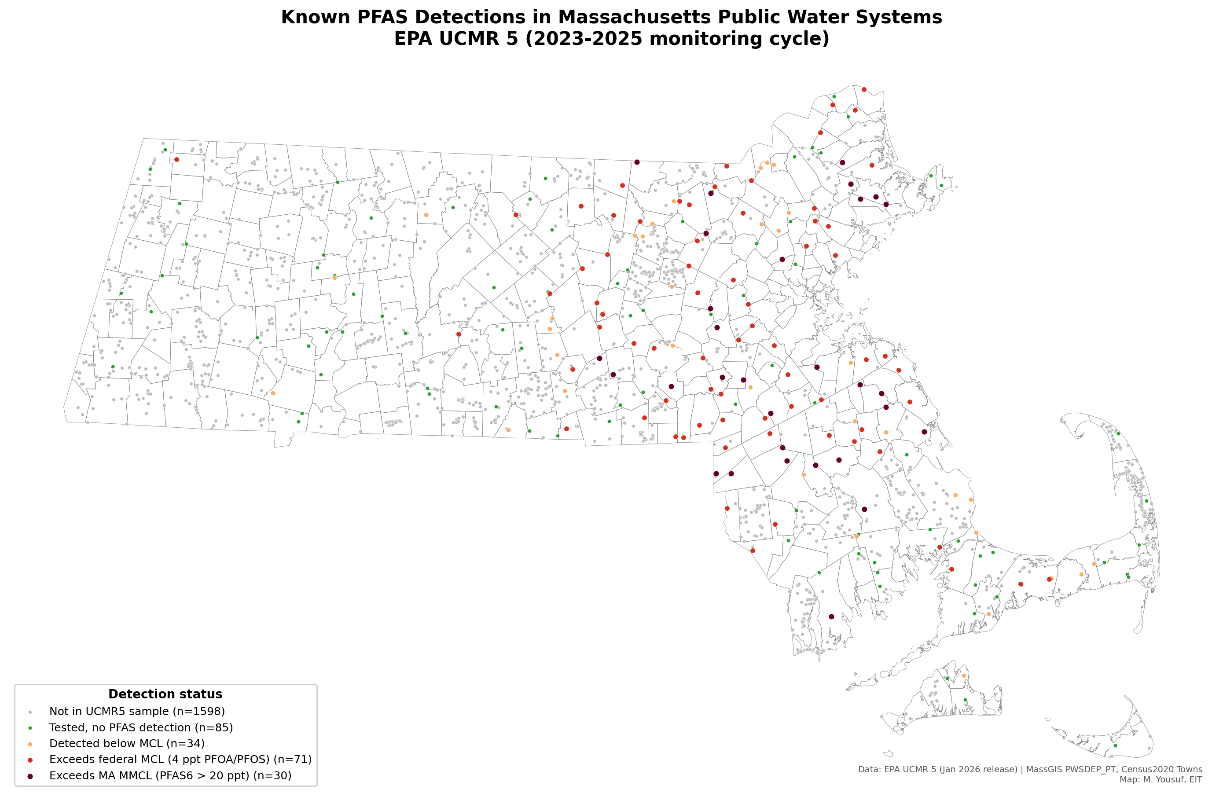
Figure 1 - UCMR 5 PFAS detections in Massachusetts public water systems. Each circle is one PWS source point, sized and colored by detection status. Boston-metro MWRA-served communities appear absent because MWRA's source points are in central-MA reservoirs, not in the metro area.
3.2 Risk Prediction Model Performance
The 220-system training pool had a positive-class prevalence of 61.4% (135 systems with at least one detection). Class balance was therefore modest but not severe, and class-balanced weighting was used to avoid favoring the majority class. Test-set ROC AUC was 0.885 for logistic regression and 0.841 for random forest. Five-fold cross-validated AUCs were 0.601 (+/- 0.123) for LR and 0.587 (+/- 0.083) for RF. The gap between test AUC and CV AUC suggests the 44-system test split happened to be favorable; the CV estimate is the more reliable indicator of out-of-sample performance. LR was selected as the primary model for its interpretable coefficients (Table 2).
Feature | LR coefficient (scaled) | RF Gini importance
dist_industrial_km | -0.36 (closer = higher risk) | 0.16
industrial_within_5km | +0.33 (more = higher risk) | 0.15
is_groundwater | +0.30 (GW = higher risk) | 0.02
dist_wwtp_km | +0.24 | 0.10
dist_airport_km | -0.22 (closer = higher risk) | 0.15
landfills_within_5km | +0.15 (more = higher risk) | 0.06
dist_landfill_km | +0.03 | 0.21
dist_military_km | -0.02 | 0.14

Table 2 - Feature importance. Logistic regression coefficients are on standardized features; positive values indicate higher detection probability.
Both models agree that proximity to industrial dischargers and to airports is the strongest signal: PWSs closer to these sources are more likely to have detected PFAS. Groundwater sources are more likely to show PFAS than surface-water sources. The positive dist_wwtp_km coefficient is counter-intuitive and may reflect a geographic confound: POTW service areas are densest in eastern MA, where many MWRA and already-tested large-system points are concentrated. Distance to landfills and military installations contribute little signal to the LR model but more in the random forest, suggesting a non-linear relationship that the RF captures.
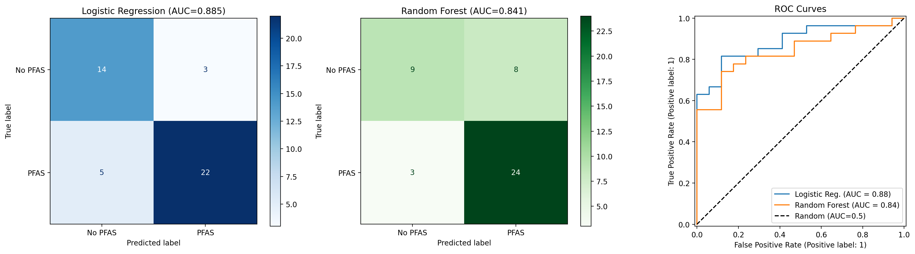
Figure 2 - Model evaluation: confusion matrices for LR and RF, and ROC curves comparing the two models against random classification.
3.3 Predicted Risk for Untested Systems
Applying the fitted LR model to the 1,598 untested PWSs produced the following risk-score distribution: 966 Low (score <= 0.25), 486 Moderate (0.25 - 0.50), 142 High (0.50 - 0.75), and 4 Very High (> 0.75). Figure 3 shows the geographic distribution; high-risk untested systems are concentrated in the I-495 belt and in parts of southeastern MA, consistent with proximity to industrial facilities and airports.
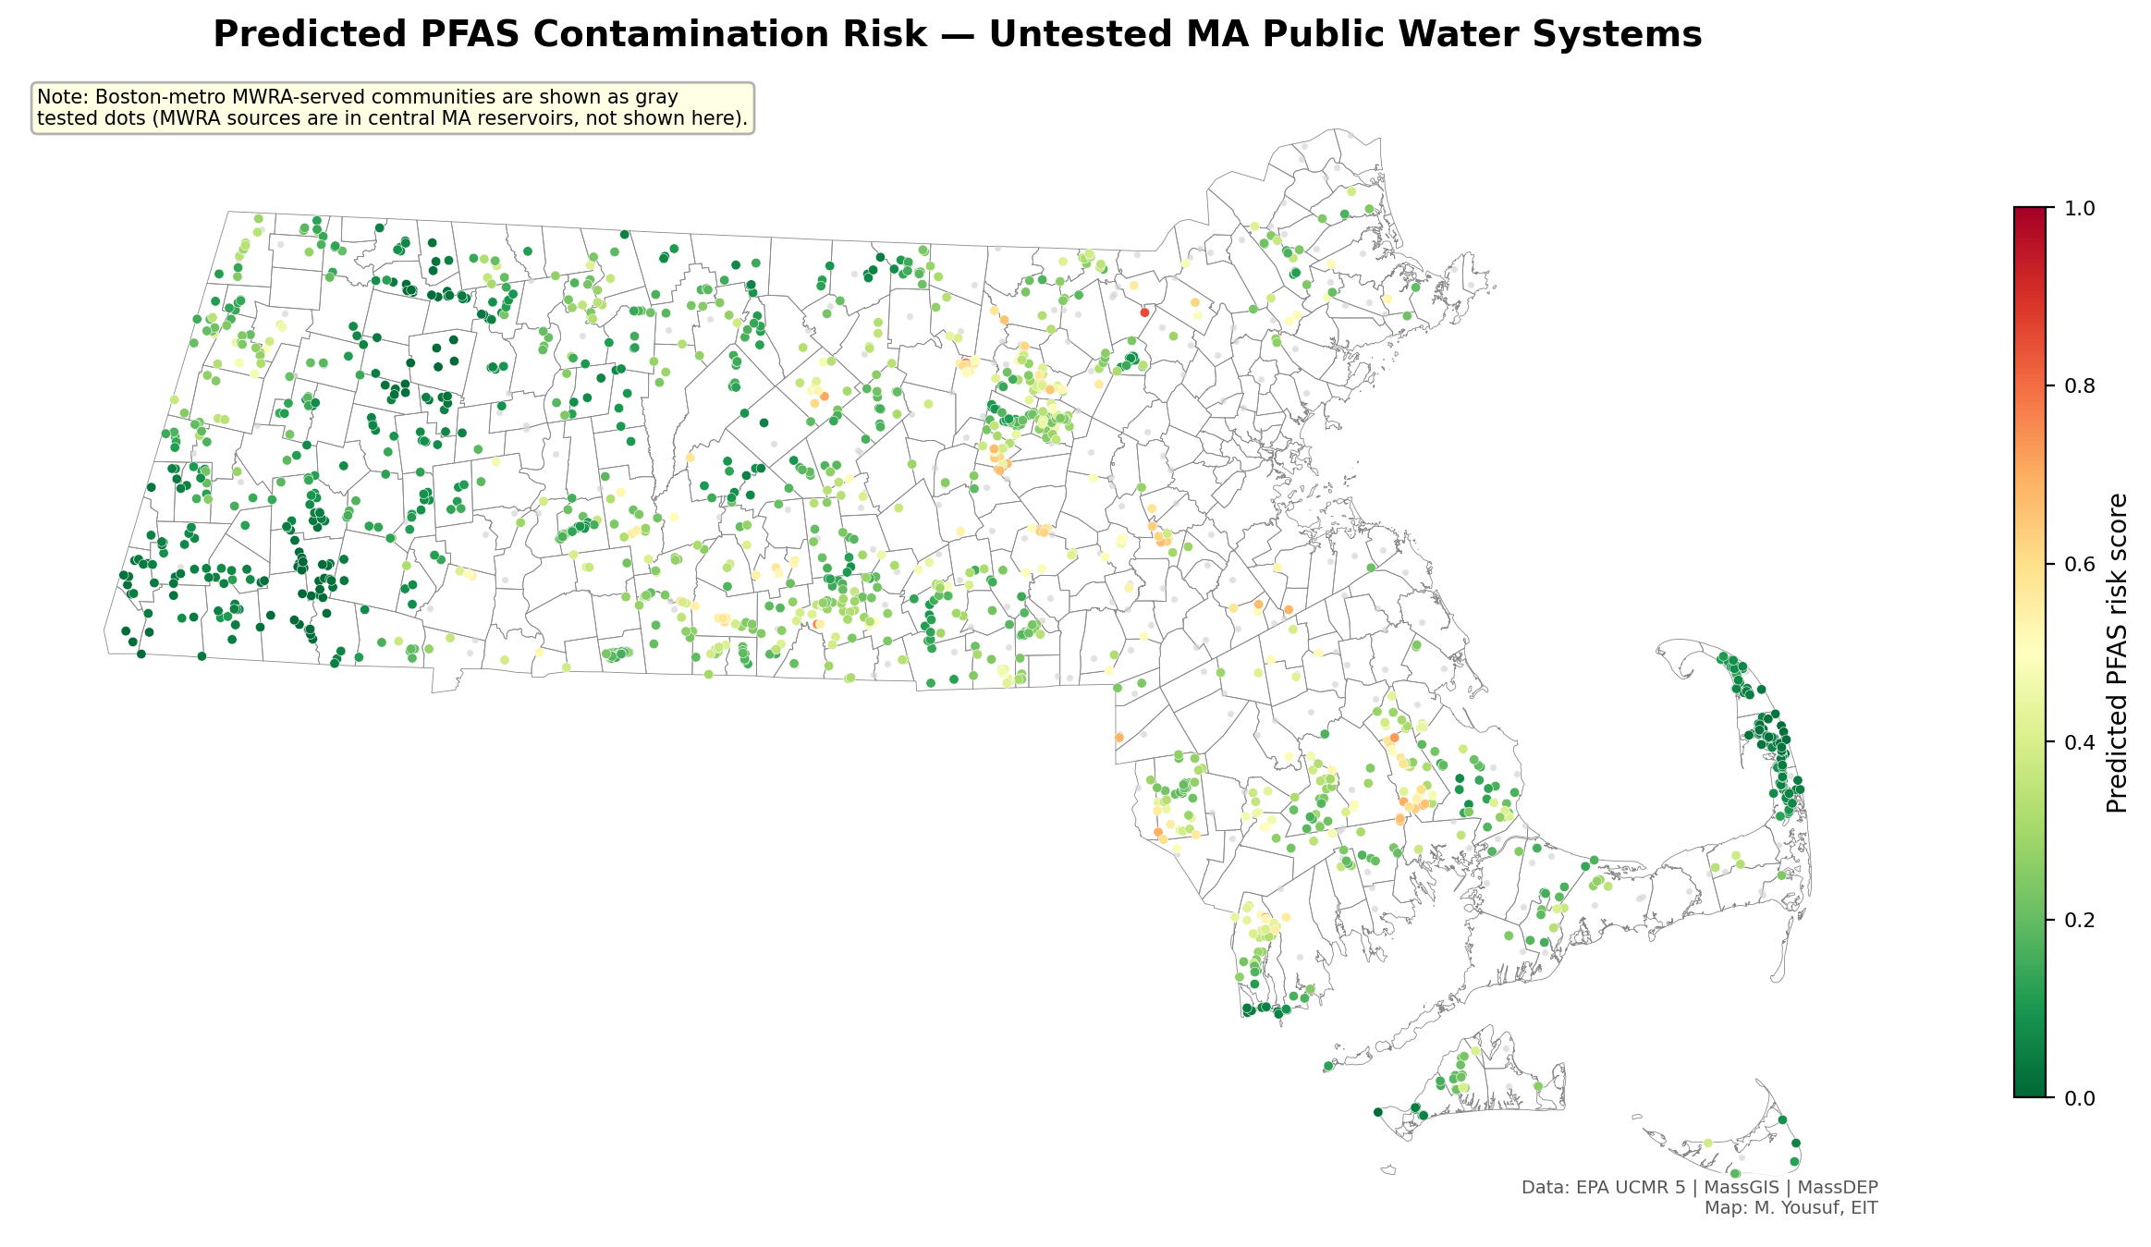
Figure 3 - Predicted PFAS detection risk for untested MA public water systems. Gray dots are UCMR 5-tested systems shown for context. Untested systems are colored on a green-to-red scale by predicted detection probability.
3.4 Environmental-Justice Disparity
Of the 1,598 untested systems, 49 (3.1%) serve an EJ community based on the MassGIS 2020 EJ-populations overlay of their MassDEP service-area polygons. Of those 49 EJ-serving systems, 21 (42.9%) are classified high-risk by the model. Of the 1,549 non-EJ-serving systems, 125 (8.1%) are classified high-risk. The disparity is 5.3x and is highly significant: chi-square = 65.1, p < 0.0001 on the 2x2 contingency table, and a one-sided Mann-Whitney U test rejects equality of risk-score distributions at p < 0.0001 with the EJ-serving group having higher scores. Mean predicted risk score was 0.412 in EJ service areas versus 0.231 in non-EJ service areas.
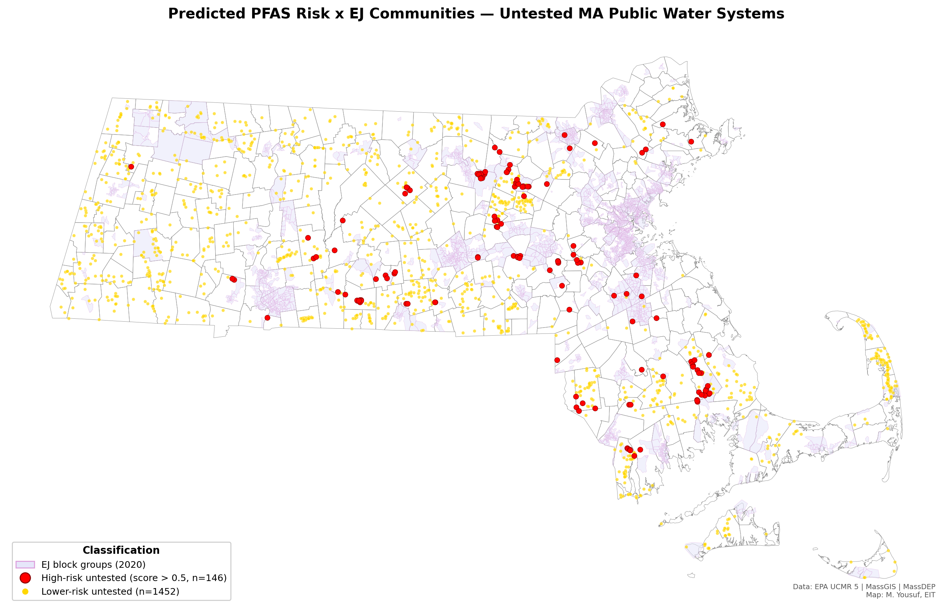
Figure 4 - High-risk untested PWSs (red) and lower-risk untested PWSs (gold) overlaid on 2020 MassGIS EJ block groups (lavender). High-risk systems are visibly clustered over EJ block groups.
The direction of this finding is consistent with the broader environmental-justice literature on drinking-water quality and with the 2022 GAO report on PFAS disparities, which found that disadvantaged communities face documented gaps in monitoring and remediation.
3.5 21E Priority Investigation Sites
Of 347 unique 21E sites located inside a Zone II or IWPA protection polygon, 37 had a site-name match to at least one PFAS-relevant keyword. Seven of those 37 are associated with a PWS that has not been tested under UCMR 5 and are therefore designated priority investigation sites (Figure 5). The top matching keywords were 'ust' (underground storage tank, n=7), 'fuel' (7), 'gas station' (5), and 'dump' (3). Notable entries include a former fire station in Stow (PWSID MA2286005) and 'Middlesex Petroleum' in Tyngsborough (PWSID MA3301047). Full details are in Appendix A.
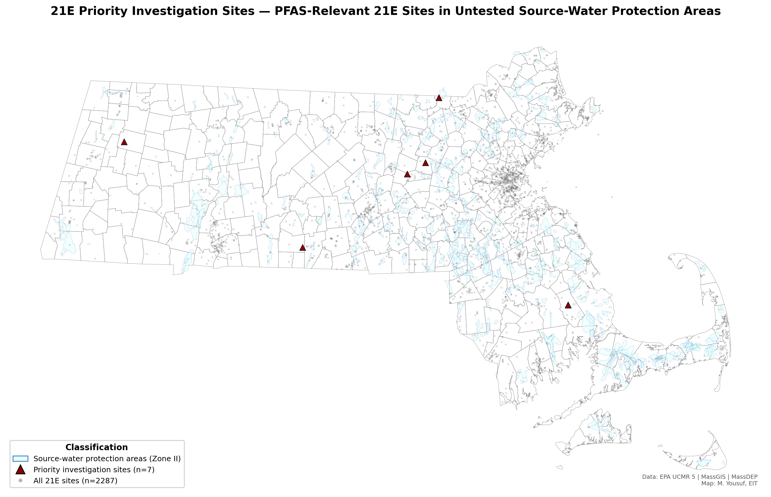
Figure 5 - 21E priority investigation sites (dark red triangles) inside Zone II source-water protection areas (light cyan) of untested PWSs. All 2,287 21E sites statewide are shown as faint gray dots for context.

4. Discussion
The UCMR 5 results confirm that PFAS contamination of public drinking-water supplies in Massachusetts is not isolated to a handful of military or industrial hotspots: 54% of tested systems had at least one detection, and 40% had at least one sample exceeding the federal 4 ppt PFOA/PFOS MCL. The MA PFAS6 MMCL (20 ppt) is a tighter cumulative standard that was exceeded by 13% of tested systems. These results, while alarming, are broadly consistent with preliminary national UCMR 5 summaries released by EPA in 2024.
The modest out-of-sample model performance (CV AUC ~ 0.60) is expected for a proximity-only screening model. Proximity is a blunt instrument: it ignores hydrogeologic transport, prevailing groundwater flow direction, the age and closure status of nearby sources, and the specific PFAS-use history of a given industrial facility. The model is nevertheless useful for prioritization - a system flagged high-risk is roughly 5x more likely to be in an EJ community than a low-risk system, which directly identifies a concrete, action-oriented finding for state agencies.
The 21E cross-reference addresses an information gap peculiar to Massachusetts' contaminated-site regulatory framework. Under Chapter 21E (the MCP, 310 CMR 40.0000), RTNs are assigned based on a release report and cleanup progression, not the specific suite of contaminants present. A site listed for a UST release in 1995 may in fact host AFFF-impacted soil, but absent a specific request, no PFAS sampling is required as part of the cleanup. Cross-referencing 21E sites with source-water protection areas for untested public water supplies therefore offers a concrete, targeted set of seven candidate sites that state regulators, LSPs, or consulting firms could prioritize for PFAS-specific analytical work.
5. Limitations
- UCMR 5 coverage is non-random. Selection favors larger systems, so the training pool under-represents small groundwater systems most vulnerable to localized contamination.
- Proximity-based features do not capture hydrogeologic transport, groundwater gradient, well-screen depth, or contaminant fate. Two wells equidistant from the same landfill can have fundamentally different exposures.
- MWRA-served systems serve approximately 50 metro-Boston municipalities via Quabbin/Wachusett reservoirs 60+ miles west of the served population. Their distance features are not directly comparable to independent groundwater sources. They are retained with an MWRA flag, and Map 1 includes a textual note explaining the apparent Boston-metro data gap.
- The training pool contains only 220 PWSs. CV AUC of 0.60 corresponds to a screening-level tool, not a concentration predictor.
- 21E keyword flagging over site-name strings produces both false positives (e.g., gas stations where the UST release was a gasoline spill with no PFAS history) and false negatives (industrial sites whose names do not mention their PFAS-relevant process).
- EJ analysis uses MassDEP estimated service-area polygons, not parcel-level customer connections, so 'serves EJ community' is an area-based approximation.
- Non-detect imputation at MRL/2 is standard practice but introduces uncertainty in any mean-concentration estimate.
- Industrial-discharger coverage uses the MassDEP BWP major-polluter point layer (2,445 points), which is restricted to facilities with major NPDES permits and does not include all small industrial sources.
6. Conclusions
PFAS contamination is pervasive among tested Massachusetts public water systems, and a screening-level proximity model identifies 146 of the 1,598 untested systems as plausibly high-risk. Those high-risk systems serve EJ communities at roughly 5x the rate that lower-risk systems do, a statistically robust disparity that warrants targeted follow-up.
Three concrete recommendations follow from this analysis: (1) MassDEP should prioritize the seven 21E priority investigation sites identified here for PFAS-specific soil and groundwater sampling as part of existing MCP cleanup activities; (2) any state-level PFAS sampling program for small untested systems should stratify its sample to include the ~50 EJ-serving high-risk systems identified here, both because they are the most likely to show exceedances and because doing so addresses a documented equity gap; and (3) future iterations should incorporate hydrogeologic gradient data, expand to include MassDEP's own non-UCMR sampling records, and refine the industrial proxy to include TRI-reporting facilities.
All outputs, code, and an interactive Streamlit application are available at the project's public GitHub repository.
References
- EPA (2024). National Primary Drinking Water Regulations: PFAS. 89 FR 32532. https://www.epa.gov/sdwa/and-polyfluoroalkyl-substances-pfas
- EPA (2026, Jan). UCMR 5 occurrence data. https://www.epa.gov/dwucmr/occurrence-data-unregulated-contaminant-monitoring-rule
- 310 CMR 22.07G. Massachusetts PFAS6 maximum contaminant level. MassDEP drinking-water regulation, 2020.
- 310 CMR 40.0000. Massachusetts Contingency Plan (MCP) for management of oil and hazardous material releases under Chapter 21E.
- U.S. GAO (2022). PFAS: Additional Actions Would Strengthen Federal Efforts to Assess and Respond. GAO-22-105088.
- MassGIS (2022, Nov). 2020 Environmental Justice Populations layer. Executive Office of Energy and Environmental Affairs.
- MassDEP. Estimated Public Drinking Water System Service Area Boundaries. MassGIS, 2024 update.

Appendix A - 21E Priority Investigation Sites
Seven MassDEP Chapter 21E sites are located inside the Zone II or IWPA source-water protection area of an untested Massachusetts public water system and have site names matching at least one PFAS-relevant keyword. Full tabular data is available at data/cleaned/21e_priority_investigation.csv.
RTN | Site name | Town | Keyword | Area | PWSID
2-0021075 | FMR Fire Station | Stow | fire | Zone II | MA2286005
1-0020098 | Friendly Fred's Gas Station | Windsor | gas station | IWPA | MA1345007
1-0020515 | MK Fuel County Line | Brimfield | fuel | IWPA | MA1043027
2-0012178 | Frank Realty Trust | Hudson | ust | IWPA | MA2028001
3-2014066 | Middlesex Petroleum | Tyngsborough | petroleum | IWPA | MA3301047
4-0030044 | UST Release | Carver | ust | IWPA | MA4052056
4-0030044 | UST Release | Carver | ust | IWPA | MA4052030

Appendix B - Feature Importance Plot
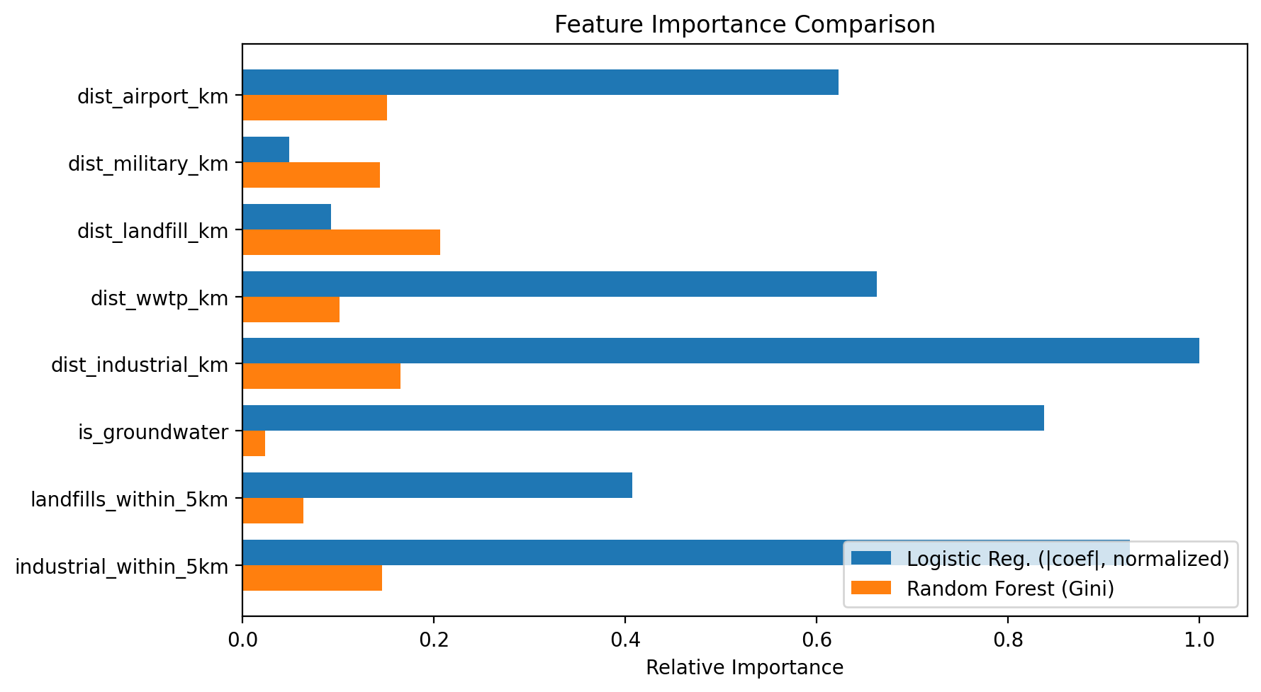
Figure A-1 - Logistic regression absolute coefficients (normalized) vs random-forest Gini importances for the eight features used in the risk prediction model.

