
SOMAVILLE UNIVERSITY
HAYAAT SUPERMARKET MANAGEMENT SYSTEM MOGADISHU SOMALIA
Written By

1 | Abdimajid haji adan nor | 13463
2 | Ilhaan Aden Mohamed | 15244
3 | Ikraam abdullahi ali | 12680
4 | Mohamed abshir | 12857
5 | Mohamed abdi kadir | 11940
6 | Ayan Ismail Ahmed | 13068
7 | Hamdi Abdinor Osman | 13285
8 | Abdi rahman Abdshir Awale | 12537
9 | Mohamed Said Mohamed | 16162
10 | Faduma Ali Musa | 10378
11 | Abdi Salan Ali Osman | 12954
12 | Cabdirisaq geesey cariif | 18095
13 | Suleiman Abdulle Mohamed | 13199

A PROPOSAL REPORT SUBMITTED TO Hayaat supermarket managemnets system in PARTIAL FULLFILLMENT OF THE REQUIREMENTS FOR THE AWARD OF BACHELOR OF COMPUTER SCEINCE OF SOMAVILLE UNIVERSITY
May, 2025

DECLARATION

This thesis is our original work and has not been presented for a degree in any other university.”

Name:Abdi majiid haji adan nor

Signature ……………………………………………..

Date ………………………………………………….. Name: Ilhaan Aden Mohamed
Signature ……………………………………………..

Date ………………………………………………….. Name: Ikraam abdullahi ali
Signature …………………………………………….. Name: Mohamed abshir
Date ………………………………………………….. Signature …………………………………………….. Name:Mohamed abdi kadir
Date ………………………………………………….. Name: Faduma Ali Musa
Signature …………………………………………….. Date ………………………………………………….. Name: Hamdi Abdinor Osman
Signature …………………………………………….. Name:
Date ………………………………………………….. Name: Suleiman Abdulle Mohamed
Signature …………………………………………….. Date ………………………………………………….. Name: Mohamed Said Mohamed
Signature …………………………………………….. Date ………………………………………………….. Name: Abdi rahman Abdshir Awale
Signature …………………………………………….. Date …………………………………………………..

Name: Ayan Ismail Ahmed
Signature …………………………………………….. Date ………………………………………………….. Name: Abdi salaan ali osman
Signature …………………………………………….. Date ………………………………………………….. Name: Cabdirisaq geesey cariif
Signature …………………………………………….. Date …………………………………………………..

APPROVAL
We certify that this Research report satisfies the partial fulfillment of the requirements for the award of the Bachelor Degree of Computer Science & it at Somaville University in Mogadishu Somalia, and has been carried out by the candidates under our supervision and was submitted with our approval

SUPERVISOR: ENG- Mohamud Ali Hilowle Signature …………………………………………….. DATE ………………………………………………...

DEDICATION
We dedicate this piece of work to our parents they have been source of inspiration, engine of courage and secret of our achievements. We also dedicate it to our sisters and brothers for all the support.

ACKNOWLWDGEMENT

We wish to acknowledge with profound gratitude to our supervisor Eng. Halkaan Supervisorka Magaciiisa ku Qor, for the tireless support he has provided to during the preparation and execution of this work.
We are also genuinely grateful to the entire staff of Somaville University for their generous support and guidance during our studies. Special thanks go to the lecturers who encouraged us to graduate our final project which entitled Supermarket Management system for introducing us to this very important and interesting discipline of computer science.
We would like to send most sincerely thank our classmates for the moral support and encouragement that they accorded to during the program.
Finally, we indebted to us fierily for their love, patience, and support during the entire time of us studies. Allah blesses you all.

Contents

Contents
DECLARATION 2
DEDICATION 5
ACKNOWLWDGEMENT 6
CHAPTER ONE 1
1.0 INTRODUCTION 1
1.1 BACKGROUND OF THE STUDY 1
1.2 STATEMENT OF THE PROBLEM 3
1.3 RESEARCH QUESTION 3
1.4 PURPOSE OF THE PROJECT 4
1.5 PROJECT OBJECTIVES 4
1.6 SCOPE OF THE STUDY 5
1.7 SAGNIFANCE IF THE STUDY 5
1.8 PROJECT ORGANIZATION 5
CHAPTER TWO 7
LITERATURE REVIEW 7
2.0 INTRODUCTION 7
2.3 EXISTTING STSTEMS 10
2.3.1 Tesco Supermarket 10
2.3.2 Hayaat Supermarket 11
2.3.3 Comparison of Relevance Research among existing systems 12
2.5 CHAPTER OF SUMMARY 13
CHAPTER THREE 14
REQUIREMENT ANALYSIS 14
3.0 INTRODUCTION 14
3.1 USER REQUIREMENT ANALYSIS 14
3.2 PRELIMINARY INVESTIGATION 15
3.3.1 Organizational Profile 16
3.3.2 Current System 17
3.3.3 Limitations of the Current System 17
3.4 DATA GATHERING 17
3.5 PROBLEM STATEMENT 19
3.6 FEASIBILITY STUDY 20
3.6.1 Technical Feasibility 20
3.6.2 Operational Feasibility 20
3.6.3 Economic Feasibility Study 21
3.6.3 Schedule Feasibility 21
3.7 USER REQUIREMENT SPECIFICATION 22
3.7.1 New Proposed System 22
3.7.2 Solution Strategy 23
Table 3.7.1. Solution strategy for criteria programming language 23
3.7.3 System Requirement Specification 23
3.7.3.1. System Interface 24
3.7.3.2. User interface 24
3.7.3.3. Software interface 24
3.4 CHAPTER SUMMARY 24
4.0 SYSTEM DESIGN 25
4.1 INTRODUCTION 25
4.2 DESIGN GOAL 25
4.3 DATABASE DESIGN 26
4.4 ENTITY RELATIONSHIP DIAGRAM (ERD) 27
4.4.1. Entity Relational Diagram Symbols 27
4.4.2. Normalization 28
4.4. DATA DICTIONARY 30
4.5 TABLE DESIGN 30
These tables below provide the complete database table details such as Field 30
Name, Descriptions, data types, and character lengths. Each of these tables represents the 30
characteristics and the attributes of data storage. The field column presents the names of each 30
database’s attributes, the description column gives the complete thought of each attribute, 30
the type column is their data type and the length is for their character lengths. Since the above- 30
mentioned tables given will be the basis for database designer on how would they do the student 30
rational database registration system has the complete description of the database and they will put 30
this into the program or data storage the same as the names given to each of the table’s schema 30
which will allow to create a database with suitable the attributes them constrains data type of binary 30
relational diagram entities 30
4.5.1. Table Users 30
4.5.2. Table Products 31
4.5.3. Table Customers 31
4.5.4. Table Orders 31
4.5.5. Table Sales 32
4.5.6. Table Login_Users 32
4.5.7. Table Categories 32
4.5.8. Table Employees 33
4.6. FORM DESIGN 33
4.6.1. Home Page of Supermarket Management System 34
4.6.2 Dashboard 35
4.7 REPORT DESIGN 36
4.7.1 Date report 36
4.8 CHAPTER SUMMARY 37
5.0 SYSTEM DEVELOPMENT 38
5.1 INTRODUCTION 38
5.2 CODING PHASE 38
5.3 TYPE OF TESTING METHODS 39
5.3.1. Unit Testing 39
5.3.2. Integration Testing 40
5.3.3. System Testing 40
5.4 USER DOCUMENTATION 43
5.5 IMPLEMETATION 44
5.5. CHPATER SUMMARY 44
6.0 INTRODUCTION 45
6.1 CONCLUSION 45
6.1.1 Achievements 46
6.1.2 Limitations 46
6.2 CONCLUSION REMARKS 47
REFERENCE 48

CHAPTER ONE

INTRODUCTION

In today’s rapidly evolving retail environment, effective management of supermarket operations is crucial for maintaining competitive advantage and ensuring customer satisfaction. Supermarkets, which are essential components of the retail sector, face increasing demands to streamline their processes, manage inventory, and improve overall service delivery. The complexities of handling a large volume of transactions, stock management, and customer interactions make it imperative for supermarket managers to adopt innovative solutions that can enhance operational efficiency.
This study focuses on the development of a Supermarket Management System, aimed at addressing the challenges supermarkets face in terms of inventory control, sales tracking, and customer relationship management. The project seeks to provide a comprehensive software solution that integrates various operational aspects, offering supermarket owners and managers a user-friendly platform for real-time data access and decision-making. By automating key tasks, this system is designed to not only reduce human error but also improve the overall customer experience, thereby contributing to the success and sustainability of supermarket operations.

BACKGROUND OF THE STUDY

With the rapid development of modern science and technology, computer technology has penetrated into all fields and becomes the necessary tools for various industries, especially the Internet technology promotion and the establishment of the information highway. It makes the IT industry increasingly shows its unique advantages in the market competition (Yongchang and Mengyao, 2015). Into the digital age, there is a huge data information waiting for processing and transmission, which makes the

further development and use of the database is particularly urgent. As some small and medium-sized supermarkets in the domestic market, they are falling behind the large and medium-sized supermarkets during the informatization, but for these enterprises' resource management, information storage and processing also shows the urgent need. To adapt to market competition, it requires efficient handling and management methods, so it is indispensable that accelerate the process of the computerization of supermarket (Yongchang and Mengyao, 2015).The essence of a supermarket management system is for an effective automation of the management of a supermarket. (Nnanyerem G. 2018).
The Supermarket Management System is a project that deals with supermarket automation and it includes both purchasing and selling of items. Supermarket management system is the system where all the aspects related to the proper management of supermarket is done. These aspects involve managing information about the various products, staff, managers, customers, billing etc. This system provides an efficient way of managing the supermarket information. Also allows the customer to purchase and pay for the items purchased.This study is based on the sales transaction and billing of items in a supermarket. This study is to produce software which manages the sales activity done in a supermarket, maintaining the stock details, maintaining the records of the sales done for a particular month/year. The users will consume less time in calculation and the sales activity will be completed within a fraction of seconds whereas manual system will make the user to write it down which is a long procedure and so paper work will be reduced and the user can spend more time monitoring the supermarket. The program will be user friendly and easy to use. The system will allow the user when to reorder for a particular goods.The system will display all the items whose name start with the letter selected by the user. He can select out of those displayed. Finally, a separate bill will be generated for each customer. This will be saved in the database. Any periodic records can be viewed at any time. If the stock is not available, the supermarket orders and buys from a prescribed vendor. The amount will be paid by deducting the total amount acquired in the sales activity. Admin provides a unique username and password for each employee through which they can login to proceed on their daily activities.

STATEMENT OF THE PROBLEM

Manual management of the supermarket encounter countless problem which varies from time consumption, poor communication, problem of physical count, daily purchase problem and ordering of supplies. Manual management of a supermarket slow down the updating of daily activities, also it can cause a misunderstanding in a supermarket operation process i.e., poor communication. The use of manual management system will always require either the presence either the supermarket owner or the employee to carry out stock taking which is always time consuming, operating with manual management system may cause an injury for the supermarket if transaction record is lost or misinterpret.

RESEARCH QUESTION

Here are clear research questions for a Supermarket Management System thesis:

- How can a supermarket management system improve the efficiency of inventory tracking and management?
- What are the key functionalities required in a supermarket management system to streamline sales and billing processes?
- How can customer data management in a supermarket system enhance customer satisfaction and loyalty?
- What role does a supermarket management system play in optimizing supplier and stock management

PURPOSE OF THE PROJECT

The purpose of this project is to design and develop an efficient Supermarket Management System that streamlines and automates the day-to-day operations of a supermarket. In today’s competitive retail environment, supermarkets face challenges in managing inventory, processing sales transactions, tracking customer data, and maintaining accurate financial records. Manual systems are often time- consuming, prone to human error, and inefficient in handling large volumes of data.
This system aims to address these challenges by providing a comprehensive software solution that facilitates effective inventory management, sales processing, supplier management, customer management, and report generation. The system will ensure real-time updates of stock levels, accurate billing processes, and easy access to sales and financial reports. It will also improve customer service by enabling faster checkout processes and better data management.
By implementing this supermarket management system, supermarket owners and managers can reduce operational costs, minimize stock wastage, improve decision-making through detailed reporting, and enhance overall productivity. Ultimately, the system will help modernize supermarket operations, making them more reliable, scalable, and responsive to both business needs and customer expectations.

PROJECT OBJECTIVES

- To know when to order for more goods, keep status and updates of transactions, thereby helping progress level,
- To determine stock taking and managerial decisions.

- To help the Administrator control different branches from one place.

- To come from old vission system like using books and using new system like supermarket management system

SCOPE OF THE STUDY

The scope of the project is to develop online Supermarket management system which will service the client.
There are three types of dimension scope which mentioned below

- Time scope of project should be Aprill 30th up to May 20-30th 2024

- Geography scope will be Hodan district, is one main district at Banadir region

- Content of scope. The content scope will be Supermarket management system

is to design and develop by using PHP as front end and MySQL (xampp) as back end

SAGNIFANCE IF THE STUDY

The online supermarket management system is significant to humanity in the following ways:
- The management system will be of great benefit to supermarkets and it will improve the managerial and administrative strength of the business and move the business forward to meet the demand of times and globalization in this era of technology.
- To explore the challenge being faced by the manual system.

- For easy record of goods and proper identification.

- This piece of work will add to the already existing literature review and act as a reference work for future researchers

PROJECT ORGANIZATION

Here is the Systematic writing of our final thesis chapters guided us to follow the regulation of

each chapter outlined its description of methodology writing as the following steps:

17.1. Chapter I- Introduction

This chapter will present briefly main concepts of background about the problem of Online Supermarket Management system including with it’s of objectives, scope, and significance of this project, expected outcome and how the project will be organized.
1.7.2. Chapter II- Literature Review

This chapter will present an overview of the project in details and discusses the relevant literature review of Supermarket managemnt system .and the gap analysis between existing system and proposal system for using tabulated table.
1.7.3. Chapter III- Requirement analysis-This chapter obviously will focus on requirement analysis system for utilizing process modeling including data flow diagram, (DFD) and unified modeling language (UML) and as well as requirement specification system which will be a part of this research like data gathering and feasibility study which to have develop proposed system of Supermarket Management System

CHAPTER TWO

LITERATURE REVIEW

INTRODUCTION

A supermarket is a self-service shop offering a wide variety of food, beverages and household products, organized into sections. This kind of store is larger and has a wider selection than earlier grocery stores, but is smaller and more limited in the range of merchandise than a hypermarket or big-box market (Wikipedia). In everyday U.S. usage, however, "grocery store" is synonymous with supermarket (oxford dictionary) and is not used to refer to other types of stores that sell groceries.
The supermarket typically has places for fresh meat, fresh produce, dairy, deli items, baked goods, etc. Shelf space is also reserved for canned and packaged goods and for various non food items such as kitchenware, household cleaners, pharmacy products and pet supplies. Some supermarkets also sell other household products that are consumed regularly, such as alcohol (where permitted), medicine, and clothing, and some sell a much wider range of nonfood products: DVDs, sporting equipment, board games, and seasonal items.
According (Meyer Z. 2017). A larger full-service supermarket combined with a department store is sometimes known as a hypermarket. Other services may include those of banks, cafés, childcare centers/creches, insurance (and other financial services), mobile phone services, photo processing, video rentals, pharmacies, and gas stations. If the eatery in a supermarket is substantial enough, the facility may be called a "grocerant", a blend of "grocery" and "restaurant"

The traditional supermarket occupies a large amount of floor space, usually on a single level. It is usually situated near a residential area in order to be convenient to consumers. The basic appeal is the availability of a broad selection of goods under a single roof, at relatively low prices. Other advantages include ease of parking and frequently the convenience of shopping hours that extend into the evening or even 24 hours of the day. Supermarkets usually allocate large budgets to advertising, typically through newspapers. They also present elaborate in-shop displays of products.

  - CONCEPTS ABOUT SUPERMARKET MANAGEMENT SYSTEM

Supermarket is a large form of the traditional grocery store, it is a self-service shop offering a wide variety of food and household products, organized into aisles. It is larger in size and has a wider selection than a traditional grocery store, but is smaller and more limited in the range of merchandise than a hypermarket or big-box market (Wikipedia).
According to Ballou, R.H. (1999), Supermarkets proliferated across Canada and the United States with the growth of automobile ownership and suburban development after World War II. Most North American supermarkets are located in suburban strip shopping centers as an anchor store along with other smaller retailers. They are generally regional rather than national in their company branding. Kroger is perhaps the most nationally oriented supermarket chain in the United States but it has preserved most of its regional brands, including Ralphs, City Market, King
Soopers, Fry's, Smith's, and QFC.

8

In Canada, the largest such chain is Loblaw, which operates stores under a variety of regional names, including Fortinos, Zehrs, No Frills, the Real Canadian Superstore, and the largest, Loblaws, (named after the company itself). Sobeys is Canada's second largest supermarket with locations across the country, operating under many banners (Sobeys IGA in Quebec). Québec's first supermarket opened in 1934 in Montréal, under the banner Steinberg's.

According To Yang, B., and Burns, N.D. (2003), said that, in the United Kingdom, self- service shopping took longer to become established. Even in 1947, there were just ten self- service shops in the country. In 1951, ex-US Navy sailor Patrick Galvani, son-in-law of Express Dairies chairman, made a pitch to the board to open a chain of supermarkets across the country. The UK's first supermarket under the new Premier Supermarkets brand opened in Streatham, South London, taking ten times as much per week as the average British general store of the time. Other chains caught on, and after Galvani lost out to Tesco's Jack Cohen in 1960 to buy the 212 Irwin's chain, the sector underwent a large amount of consolidation, resulting in 'the big four' dominant UK retailers of today: Tesco, Asda (owned by Wal-Mart), Sainsbury's and Morrisons.

According to Patton (1990), said that in the 1950s, supermarkets frequently issued trading stamps as incentives to customers. Today, most chains issue store-specific "membership cards," "club cards," or "loyalty cards". These typically enable the card holder to receive special members- only discounts on certain items when the credit card-like device is scanned at check-out. Sales of selected data generated by club cards are becoming a significant revenue stream for some supermarkets.
Pagh, J.D. and Cooper, M.C. (1998), said that it has been determined that the first true supermarket in the United States was opened by a former Kroger employee, Michael J. Cullen, on August 4, 1930, inside a 6,000-square-foot (560 m²) former garage in Jamaica, Queens in New York City. The store, King Kullen, (inspired by the fictional character

King Kong), operated under the slogan "Pile it high. Sell it low." At the time of Cullen's death in 1936, there were seventeen King Kullen stores in operation. Although Saunders had brought the world self-service, uniform stores and nationwide marketing, Cullen built on this idea by adding separate food departments, selling large volumes of food at discount prices and adding a parking lot.
Rietze S. (2006) debate about the origin of the supermarket, with King Kullen and Ralphs of California having strong claims. Other contenders included Weingarten's Big Food Markets and Henke & Pillot. To end the debate, the Food Marketing Institute in conjunction with the Smithsonian Institution and with funding from H.J. Heinz, researched the issue. It defined the attributes of a supermarket as "self-service, separate product departments, discount pricing, marketing and volume selling".
Other established American grocery chains in the 1930s, such as Kroger and Safeway at first resisted Cullen's idea, but eventually were forced to build their own supermarkets as the economy sank into the Great Depression, while consumers were becoming price- sensitive at a level never experienced before. Kroger took the idea one step further and pioneered the first supermarket surrounded on all four sides by a parking lot by Bowersox,
C. (2009).

EXISTTING STSTEMS

The purpose of this research is to find a way implementation that will provide a Solution not only to tourism hospitality as well as resort since it may be study a number of researches in this field by gathering enough information that will enhance the knowledge by comparing relevance research case studies of relating this article entitled ―Online Supermarket management system Management System for web based technology computerized system

Tesco Supermarket

Tesco was founded in 1919 by a man named Jack Cohen in London, UK. It started as a small market stall where Cohen sold surplus groceries. The name "Tesco" was created by

combining the initials of his supplier T.E. Stockwell and the first two letters of his own last name – COhen.
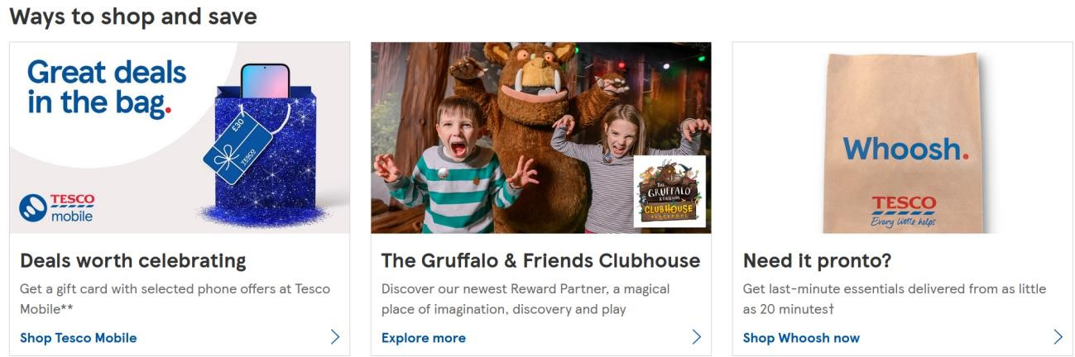

Website link: https://www.tesco.com

Hayaat Supermarket

HAYAT MARKET was founded in April 2020 by a group of local investors. headquartered in Mogadishu Somalia.
Hayat Market is the largest selection of quality products You’ll get all groceries, household necessities, electronics, toys, and many more



Website link: https://hayatmarket.com

Comparison of Relevance Research among existing systems

No | Feature | Hayat Supermarket | Tesco Supermarket
1 | Shopper Marketplace Views | Limited but growing online presence; offline  still strong | High online shopper engagement
2 | Product Ordering Experience | Online ordering available but slower due to less  experience | Fast and smart digital ordering
3 | Internet Connectivity | Mixed: Low-speed LAN offline + basic wireless for online  use | Wireless WAN internet available everywhere
4 | Data Management | Combination: Offline Microsoft Access + online  DBMS | Online DBMS (MySQL, SQL  Server 2014) /  (Oracle 9i)
5 | Interface Design | Basic navigation  offline; online interface improving | Smooth, user-  friendly online interface
6 | Login System | Offline login +  online login system | Secure online login  system
7 | User Friendliness | Moderate GUI offline; friendly and  improving online | Friendly and interactive online  GUI

  - GAP ANALYSIS

The system is conducted in order to find out the similarities and the differences among them since the comparison was done based on the following criteria including support modules of table book reservation management System will focus module e-table booking including information security, Connectivity internet technology, promote price satisfaction , DBMS recording , interface design, login system, graphical interface design, mobile application service and user friendliness are all above shown table of comparison among the existing systems which will be similarity to the new proposed system.

CHAPTER OF SUMMARY

This chapter is about the literature review that discusses the researches of existing systems, which gives a better understanding of furniture store management system. It also shows the similarities and the differences that the existing systems have by comparing them and discusses related things of the current system. It represented the border or limitation of the current system

CHAPTER THREE

REQUIREMENT ANALYSIS

INTRODUCTION
Requirement analysis is a crucial phase in the development of any information system, including a supermarket management system. It involves identifying, analyzing, and documenting the needs and expectations of the users and stakeholders. The goal is to understand what the users need from the system, both in terms of functionality and performance, and to ensure that these requirements are clearly defined and agreed upon before the design and implementation phases begin.

USER REQUIREMENT ANALYSIS

User requirements form the foundation of system development. When creating a system from the ground up, it is crucial to define detailed requirements for each process involved. In the case of the Online Supermarket Management System, all operational, financial, and legal aspects must be considered, particularly those relating to the retail and supply chain sectors in an e-commerce environment. The internet has revolutionized how businesses operate, turning the world into a global marketplace. With the widespread adoption of the internet, online shopping has become an essential part of modern consumer behavior. Today, users expect convenience, flexibility, and security in their shopping experiences. This trend has led to a growing demand for systems that allow customers to purchase groceries and household items online without visiting physical stores.
An Online Supermarket Management System is designed to address this demand by providing a user-friendly platform where customers can browse products, place orders, and make secure payments—all from the comfort of their homes, at any time of day. The system will simplify the shopping process, offering real-time stock updates, personalized recommendations, and a seamless checkout experience.

.

    - Functional Requirements: of the item.

Keep alert signal for

      - List the detail or expired items
      - Recording customer information
      - Verify the role of the user
      - Making product available for customers

    - Non Functional Requirements:

      - System must be against virus attacks.
      - The system should have higher speed.
      - System should be learnable and usable.ss

PRELIMINARY INVESTIGATION

The Supermarket Management System is designed to help retail supermarkets streamline and automate their daily activities including inventory management, sales processing, reporting, and customer service. Unlike online shopping systems that focus on e-commerce, this system targets in-store operations and aims to reduce manual work, improve service delivery, and ensure accurate transaction handling within a physical supermarket environment.
While traditional supermarkets struggle with paper-based systems or simple spreadsheets, modern businesses are beginning to adopt digital solutions to eliminate human errors, speed up services, and maintain accurate data across inventory, sales, and employee records. As the competitive market and rising customer expectations grow, supermarkets are learning to improve their service delivery, reduce waste, and enhance customer satisfaction using technology.

A preliminary investigation of the current manual system reveals a number of problems that can be addressed through a computerized supermarket management system. The fact-finding process shows that the supermarket faces the following challenges and opportunities for improvement:
Key Areas of Concern:

- Improved Customer Service
  - Speeding up billing and checkout processes.

- Support for Product Tracking
  - Accurate inventory records and low-stock alerts.

- Better Sales and Performance Reporting
  - Easy generation of daily, weekly, and monthly reports.

- Information Security Issues
  - Weak controls over manual records and sensitive data.

- Stronger Administrative Control
  - Better employee monitoring and cash flow tracking.

- Reduced Operating Costs
  - Less paperwork, fewer errors, and reduced staffing needs.

Organizational Profile

Hayaat Supermarket Management System is a market system which provides various services aimed at streamlining and automating the daily operations of a supermarket. The system offers essential features such as:
Product Management – Adding, editing, and categorizing products in the inventory. Sales Processing – Recording and managing sales transactions at the cashier level. Customer Management – Handling customer data and purchases.

Employee Management – Managing staff roles, access levels, and attendance. Reporting and Analytics – Generating daily, weekly, and monthly sales reports.
Stock Control – Monitoring product stock levels and issuing low-stock alerts. Payment Processing – Supporting multiple payment methods including cash, card, and mobile money.

Current System
Currently, the supermarket relies on a partially manual system for managing sales, inventory, and employee records. This system includes basic POS machines and manual stocktaking methods, which often result in data inconsistencies and delays in service.

Limitations of the Current System
- Administration Problems
- Lack of real-time data access.
- Errors in manual entry.
- Inefficient report generation.

- Technical Problems
- Limited system scalability.
- Inadequate integration between sales and inventory.
- Absence of data backup and recovery mechanisms.

DATA GATHERING
Data gathering was conducted using multiple methodologies to understand the needs and pain

points of users. These methods ensured comprehensive coverage of functional and non- functional requirements.
- Interviews: Conducted with store managers and cashiers to gather insights on daily operations and system expectations.
- Observations / Surveys: Observed workflows and surveyed customers to understand service delivery gaps.
- Questionnaires and Other Documents: Collected feedback from stakeholders using structured questionnaires and reviewed existing documentation.
3.4.2 Uniftied Modelling Language
Unified Modeling Language, (UML) is a standardized modeling language consisting of an integrated set of diagrams, developed to help system and software developers for specifying, visualizing, constructing, and documenting the artifacts of software systems, as well as for business modeling and other non-software systems. The UML represents a collection of best engineering practices that have proven successful in the modeling of large and complex systems.
The UML is a very important part of developing object oriented software and the software development process. The UML uses mostly graphical notations to express the design of software projects. Using the UML helps project teams communicate, explore potential designs, and validate the architectural design of the software which mostly summarized its features in usability used commonly are use case diagram , activity diagram, class diagram and as well as sequence diagram

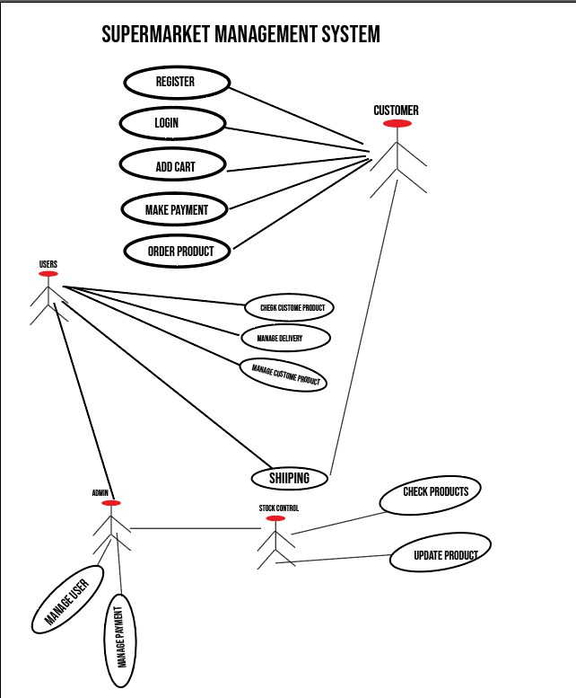

PROBLEM STATEMENT
The current system used by the supermarket is inefficient, prone to errors, and lacks integration between critical business functions. This has resulted in poor customer service, inaccurate data reporting, and challenges in inventory control. A robust, integrated supermarket management system is needed to overcome these challenges and improve overall performance.

FEASIBILITY STUDY

The feasibility study analyses potential solutions against a set of requirements, evaluates their ability to meet these objectives, describe a recommended solution, and offer a justification for this selection. The feasibility study technical information and cost data to determine the economic potential and practicality of a project. The feasibility study uses techniques that help evaluate a project and/or compare it with other projects. Feasibility study is a part of the system development life cycle, which aims to determine whether it is sensible to develop some system since there are divided into four types below:-

Technical Feasibility

The technically feasibility study basically centers on alternatives for hardware, software and design approach to determine the functional aspects of system relating the system implementing of online Grocery Management System which will be platform independent since it is being coded in PHP (using SUBLIMETEXT and XAMPP).HTML and CSS is used to create online web pages since DBMS should be used for MYSQL database for storing and retrieve data manipulation of scheme system while the hardware and software requirements must be compatible with all operating system (OS) who can operate any computer type of organization

No | Item | Quantity | Unit price t | Total
1 | Intel Pentium 4 3.5GHz | 3 | $270 | $810
2 | Hp Laser jet 1320 Printer | 3 | $45 | $135
3 | Windows 10 Pro | 3 | $200 | $600
Grand Total |  |  |  | $1,545
Table 3.6.1. Software & hardware of technical feasible

Operational Feasibility
Operational Feasibility is a measure of how people are able to work with system. This type of feasibility demands if the system will work when developed with their talented skill of professionalism or if organization should demand any alternative solution suggest for recruitment of new staffs or old staffs

should be upgraded for training courses regarding their workplace in side of organization as to compact the strategy solution for new proposed system must be forward for implementation of web technology system which has more features including GUI, user friendly interactive and portability with much
qualified insurance

No | Human resource cost planning training | Estimated expense costs
1 | Training cost for the existing | $40
2 | New staff recruitment | $180
3 | Training of the new staff | $60
Grand Total |  | $280
Table 3.6.2. Human Resource of Recruitment process

Economic Feasibility Study
Economic analysis is the most frequently used evaluating the effectiveness of proposed system, more commonly known as Benefit analysis or TCO which is to determine benefits and savings that are expected from candidate system and compare them with cost. If the benefits are more than the cost, then decision is made to design and implement the system. The cost and benefits must be tangible or intangible future cost analysis for new proposed system.
No | Assessment TCO Analysis | Expenses Budgets
1 | Technical | $1,545
2 | Operational | $280
3 | Development Cost | $120
4 | Grand Total | $1,945
Table 3.6.3.Economical Assessment Analysis

Schedule Feasibility
Typically this means estimating how long the system will take to develop, and if it can be completed in a given time period using some methods like payback period. Schedule feasibility is a measure of how reasonable the project timetable is. This involves questions such as how much

time is available to build the new system, when it can be built , whether it interferes with normal business operation, number of resources required, dependencies, can the system be developed any allocated time for its deadline milestone of project proposal new system

USER REQUIREMENT SPECIFICATION

In today’s digital age, e-commerce applications play a vital role in delivering convenient shopping experiences. The development of a web-based Online Supermarket Management System is essential to provide users—specifically, supermarket customers—with easy and efficient access to grocery shopping and product management.
The system should provide the following core functionalities for supermarket users (customers):

- Create Orders:
- Manage Their Account:
- Login to the System:
- Provide Payment Details:
- Generate Transaction Processes:
- Delivery Service Management

New Proposed System
Our observation case studies were found that mostly was one of the barriers to online shopping adoption has historically been the level of comfort (or should that be discomfort offline system) with technology that causes many consumers’ fears of technology were challenged unexpectedly during the pandemic and, since then, we have witnessed increased ease and adoption.
The new proposed online supermarket management system can be platform of bushiness transaction throughout web portal technology which discover and be influenced to purchase products attribute or services based on market place recommendations from friends, peers and trusted sources (like influencers) on social networks like Facebook, Instagram and Twitter which many social media platforms e-online system features, such as in-app checkout, stoppable posts and “ view and Buy Now” buttons that take users directly to a brand’s product page.

The new proposed system is visible and later, will have its usage of online supermarket management system that is able to shop transaction and records of payment method banks or EVC-Plus payment of every transaction that entrance has been it registered and. Also, this system will be implemented using PHP as front end and MySQL(Xampp) as back end

Solution Strategy
After we had discovered the current system’s problems, we decided to develop a new system, which meets the needs of the (Hayat Online Supermarket) This solution is associated with implementing sufficient reliable wedding management system, and wiping out the current existing problems; therefore, we considered the solutions and strategies proposed by experts to reach these goals with qualified programmed system.

Table 3.7.1. Solution strategy for criteria programming language

No | Programming Criteria implementation | Selected choice
Option 1 | JAVA with ANDROID and PHP with MYSQL | Best option
Option 2 | ASP.net with Oracle | Second option
Option 3. | PHP with Mysql | Third option

In our group discussion finally, we decided to take PHP as front end and MySQL as back-end in order to develop the new proposed solution strategy for final project graduation in 2024.

System Requirement Specification
Throughout the several meetings conducted with some of the restaurant holders in my

Home town and the problematic statement section, we were able to come up with a set of user stories that must be followed and analyzed during the design phase in order to address for problematic way with possible manner.

In this chapter, we will be listing the different user stories of shoppers with regards to each functional requirement of since the system requirement specification has three dimensions as following below: -

System Interface
        - PHP.As Front End
        - MySQL as Back End

User interface
        - Login Form
        - Admin Form
        - Shopper's registration Form
        - Manager’s form
        - Product item form
        - Shipping form
        - Change Password Form
        - Report Form

Software interface
        - Windows XP or Windows 10
        - MySQL with PHP
        - Web browsers

CHAPTER SUMMARY
This chapter has detailed the requirement analysis process for the supermarket management system. It has covered user needs, system limitations, data gathering methods, feasibility assessment, and the specifications for the proposed system. The findings from this chapter will guide the design and development of a system that meets the operational and strategic goals of the supermarket.

CHAPTER 4

4.0 SYSTEM DESIGN

4.1 INTRODUCTION

Design is the first step in the development phase for any techniques and principles for the purpose of defining a device, a process or system in sufficient detail to permit its physical realization. Once the software requirements have been analyzed and specified the software design involves three technical activities - design, coding,implementation and testing that are required to build and verify the software. The design activities are of main importance in this phase, because in this activity, decisions ultimately affecting the success of the software implementation and its ease of
maintenance are made. These decisions have the final bearing upon reliability and maintainability of the system. Design is the only way to accurately translate the customer’s requirements into finished software or a system. Design is the place where quality is fostered in development. Software design is a process through which requirements are translated into a representation of software. Software design is conducted in two steps. Preliminary design is concerned with the transformation of requirements into data.

4.2 DESIGN GOAL
There are many aspects to consider in the design of every system project. The importance of each should reflect the goals the system is trying to achieve. Some of these aspects are:
a. Efficiency – It is generally considered to be the most important. Given a piece of hardware on which the system will run and a piece of software to run it, the design should make full and efficient use of the facilities provided. The users should interact with the system without any delay.
b. Integrity- this means accuracy in simple terms. During design, integrity always related to data. Integrity is ensured when data are not corrupted by hardware or software and data should be
maintained; and accurately representing real world.
c. Compatibility - The system software is able to operate with other products that are designed for interoperability with another product.
d. Modularity – another term for modularity is a module or component. System based on modules makes understanding of the system easier, as consequence, reducing the cost to build the software.
e. Reliability- The system is able to perform a required function under stated conditions for a specified period of time.
f. Reusability - the system is capable to be enhanced and added further features and modification with slight or no modification at one of its major components.
g. Security – there is always a security concern in every system. Therefore, the system should protect any harmfulness from the computer themselves and access from unauthorized users.

4.3 DATABASE DESIGN
Designing a Database Like most tasks, building a database starts with a design. After all, you wouldn’t try to build a house without a blueprint, and most people wouldn’t attempt to prepare a new dish without a recipe. Like these other tasks, having a good design for your database is a major first step in creating a successful project. In designing a database application, you must set up not only the program’s routines for maximum performance, but you must pay attention also to the physical and logical layout of the data storage.

4.4 ENTITY RELATIONSHIP DIAGRAM (ERD)
An entity relationship diagram (ERD), also known as an entity relationship model, is a graphical representation that depicts relationships among people, objects, places, concepts or events within an information technology (IT) system. Entity Relational Diagram is a graphical modeling tool to standardize ER modeling; the modeling can be carried out with the help of pictorial representation of entities, attributes and relationships for the basic building blocks of ERD are Entity, Attributes, Relationship and lines entity is an object Entity types or Entity set is a collection of similar entities; an entity may belong to more than one entity type. A relationship is an association of 24 entities where the association includes one entity from other particular types
is meaningful association before entity types. Attributes are properties of entity types in other words; entities are described in a data base by a set of attributes

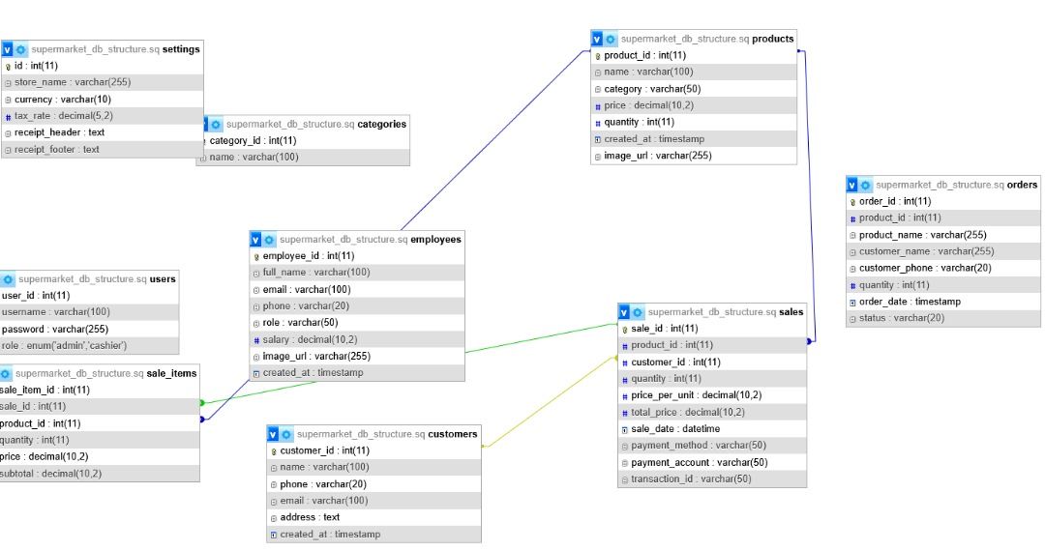

4.4.1. Entity Relational Diagram Symbols
ER diagram is used to represent database schema which will apply its shape of diagramed pictorial illustration symbols which are the following below illustrated
a. A rectangle represents an entity set
b. A Diamond represents Relationship
c. An ellipse represents an attribute.
d. Lines represent linking of attributes to entity sets & of entity sets to relationship sets.

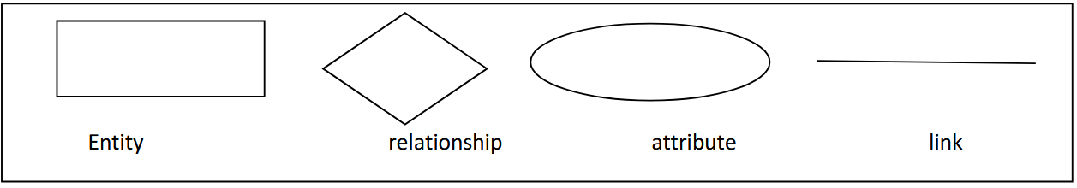

4.4.2. Normalization

Normalization is the process of organizing data in a relational database to reduce redundancy and improve data integrity. It involves decomposing large and complex tables into smaller, more manageable and related tables, while ensuring that data dependencies are logical. This process follows a series of steps known as normal forms, each with specific rules and goals.
In the Supermarket Management System, normalization was applied to ensure efficient storage, eliminate anomalies, and improve query performance. Below is how normalization was used in designing the system's database.
Unnormalized Table (UNF)
Sale_ID | Customer_Name | Customer_Phone | Product_Name | Product_Price | Quantity | Total
1 | Ali Ahmed | 615000000 | Sugar | 50 | 2 | 100
2 | Ali Ahmed | 615000000 | Rice | 80 | 1 | 80

Before normalization, a single table might store data like this:
First Normal Form (1NF)
Rule: Each field contains only atomic (indivisible) values; no repeating groups.
Action: Separate repeating groups into rows and assign unique identifiers.
Result:
- Customer data moved to its own table
- Product data stored separately
- Each sale recorded per row
Tables created:
- customers (customer_id, name, phone)
- products (product_id, name, price)
- sales (sale_id, customer_id, product_id, quantity, total)
Second Normal Form (2NF)
Rule: Must be in 1NF and all non-key attributes must depend on the whole primary key.

Action: Remove partial dependencies.
Updated Tables:
- sales (sale_id, customer_id, product_id, quantity)
- Calculated fields (like total) handled in queries, not stored
Third Normal Form (3NF)
Rule: Must be in 2NF and have no transitive dependencies (non-key depending on non-key).
Action: Ensure all attributes depend only on the primary key.
Final Structure:
1. customers (customer_id, name, phone)
2. products (product_id, name, category_id, price, quantity, image_url)
3. sales (sale_id, transaction_id, customer_id, product_id, quantity, sale_date, user_id)
4. orders (order_id, customer_id, product_id, quantity, order_date)
5. users (user_id, username, password, role)
6. categories (category_id, category_name)

4.4. DATA DICTIONARY

A data dictionary is a part of the metadata that is used to understand the data and the databases that contain it. The data dictionary identifies data elements and their attributes including names, definitions and units of measure and other information which is organized as a table with simple data dictionary is an organized collection data element names and definitions

4.5 TABLE DESIGN

These tables below provide the complete database table details such as Field

Name, Descriptions, data types, and character lengths. Each of these tables represents the

characteristics and the attributes of data storage. The field column presents the names of each

database’s attributes, the description column gives the complete thought of each attribute,

the type column is their data type and the length is for their character lengths. Since the above-

mentioned tables given will be the basis for database designer on how would they do the student

rational database registration system has the complete description of the database and they will put

this into the program or data storage the same as the names given to each of the table’s schema

which will allow to create a database with suitable the attributes them constrains data type of binary

relational diagram entities

4.5.1. Table Users

No | Field Name | Data type | Length | Description
1 | Id | int | 11 | Users_id as primary key
2 | Name | varchar | 200 | Users_name
3 | Phone | int | 11 | Users Phone Info
4 | Email | varchar | 200 | Users Email Info
5 | Username | varchar | 200 | The username of the user
6 | Password | varchar | 200 | The password of the user
7 | Image | text | - | The image of the user
8 | Pin | varchar | 200 | The user's pin
9 | Status | int | 11 | The status of the user (online/offline)
10 | Regdate | timestamp | Data | Time of registration

4.5.2. Table Products

No | Field Name | Data type | Length | Description
1 | Product_ID | int | 11 | Primary Key for product
2 | Name | varchar | 200 | Product name
3 | Category_ID | int | 11 | Foreign Key to category
4 | Price | decimal | 10,2 | Price of the product
5 | Quantity | int | 11 | Available quantity in stock
6 | Image_URL | varchar | 255 | Path to product image

4.5.3. Table Customers

No | Field Name | Data type | Length | Description
1 | Customer_ID | int | 11 | Primary Key
2 | Name | varchar | 200 | Customer full name
3 | Phone | varchar | 20 | Customer phone number

4.5.4. Table Orders

No | Field Name | Data type | Length | Description
1 | Order_ID | int | 11 | Primary Key
2 | Customer_ID | int | 11 | Foreign Key to customers
3 | Product_ID | int | 11 | Foreign Key to products
4 | Quantity | int | 11 | Number of items ordered
5 | Order_Date | datetime | - | Date of the order

4.5.5. Table Sales

No | Field Name | Data type | Length | Description
1 | Sale_ID | int | 11 | Primary Key
2 | Transaction_ID | varchar | 50 | Unique transaction code
3 | Customer_ID | int | 11 | Foreign Key to customer
4 | Product_ID | int | 11 | Foreign Key to product
5 | Quantity | int | 11 | Quantity sold
6 | Sale_Date | datetime | - | Date of the sale
7 | User_ID | int | 11 | User who processed the sale

4.5.6. Table Login_Users
No | Field Name | Data type | Length | Description
1 | user_id | int | 11 | Primary key
2 | username | varchar | 100 | Login username
3 | password | varchar | 255 | Hashed password
4 | role | varchar | 50 | Role of the user (e.g. admin, cashier)

4.5.7. Table Categories

No | Field Name | Data type | Length | Description
1 | category_id | int | 11 | Primary key
2 | name | varchar | 100 | Category name

4.5.8. Table Employees

No | Field Name | Data type | Length | Description
1 | employee_id | int | 11 | Primary key
2 | full_name | varchar | 200 | Full name of the employee
3 | email | varchar | 200 | Employee email address
4 | phone | varchar | 20 | Employee phone number
5 | role | varchar | 100 | Job role of the employee
6 | salary | decimal | 10,2 | Salary amount
7 | image_url | varchar | 255 | Path to employee image
8 | created_at | datetime | - | Record creation timestamp

4.6. FORM DESIGN
1. Form design is the process of creating a web form — where your site visitors can input and submit their information — while keeping the form's layout, format, UX, appearance, and other factors in mind. Great form design enhances UX and helps boost conversions .Form design is where the developer of the system deeply explains system tasks and how forms of the system are working together by observing the sequential flow.

4.6.1. Home Page of Supermarket Management System

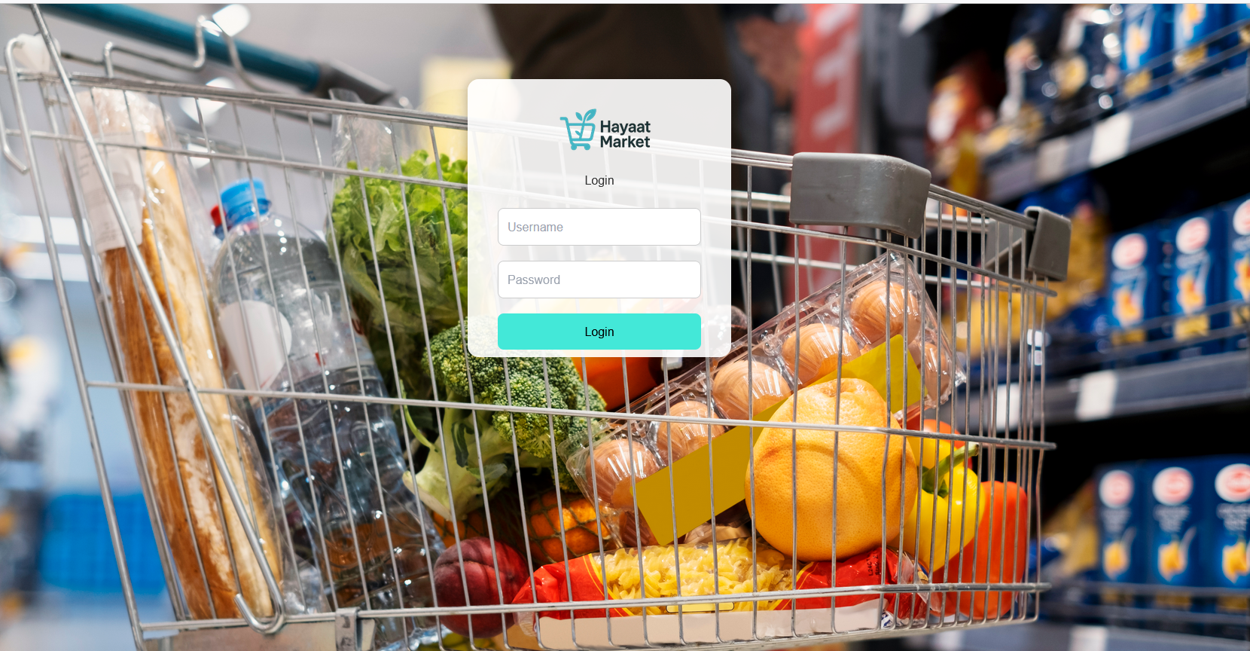

4.6.2 Dashboard
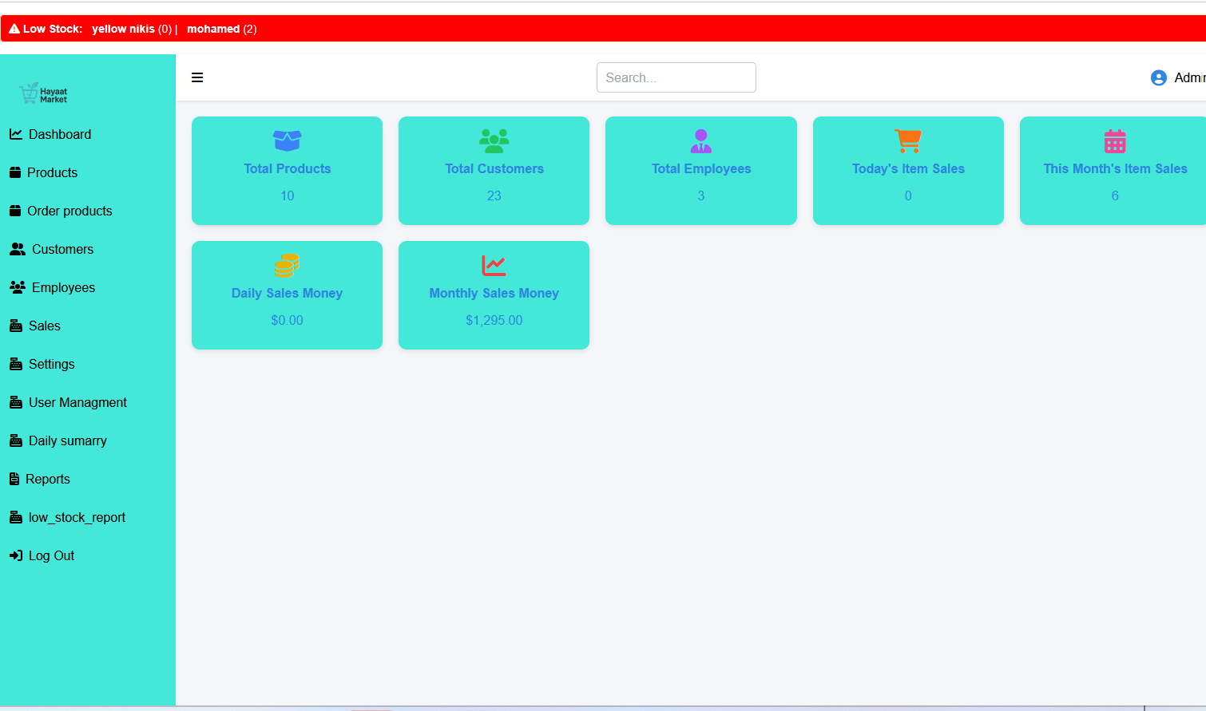

4.7 REPORT DESIGN
Report Design is a critical component in information systems, particularly in decision-making processes. In the context of the Supermarket Management System, report design refers to the planning and structuring of output documents that present summarized and organized data retrieved from the system's database. These reports enable managers, cashiers, and business owners to monitor operations, track performance, and make informed business decisions.

4.7.1 Date report

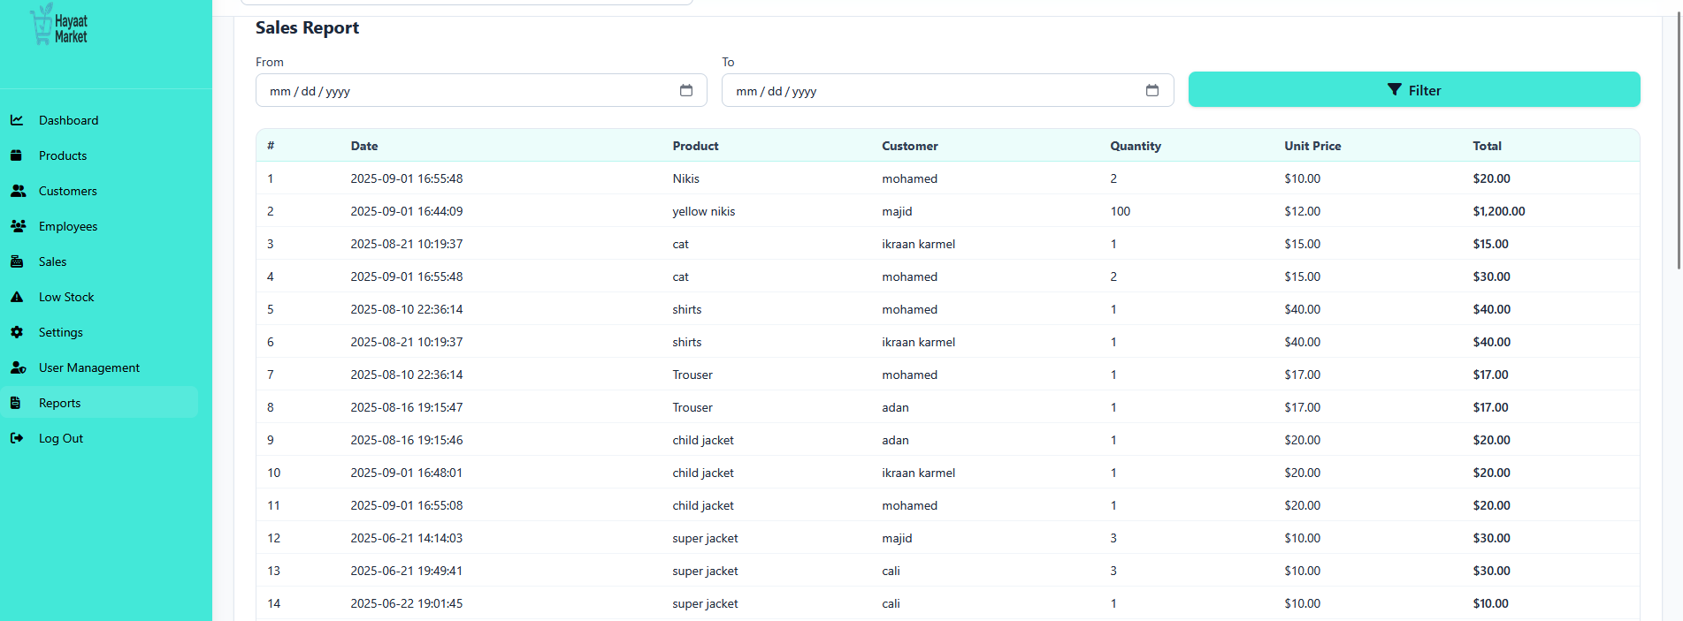

4.8 CHAPTER SUMMARY
In this chapter of summary, we deeply explained system design including design goal, database uninvesting, entity relationship diagram, data dictionary, table design, and as well as report design had been clearly specified, the result reached and will implement the next chapter forward others tasks remaining

CHAPTER FIVE

5.0 SYSTEM DEVELOPMENT

5.1 INTRODUCTION
This chapter, we will take it recommendation and conclusion of the project Supermarket management system (TBRMS)to present the conclusions and recommendation of the project. The purpose of this unit is to present the conclusions drawn from the results of the system analysis phase observation and then done future research recommendations.

5.2 CODING PHASE
The coding phase of the software life-cycle is concerned with the development of code that will implement the design. This code is written is a formal language called a programming language. Programming languages have evolved over time from sequences of one`s and zero`s directly interpretable by a computer, through symbolic machine code, assembly language into finally to higher-level language that are more understandable to humans. The coding phase includes system design in an integrated development environment. It also includes static code analysis and code review for multiple types of devices
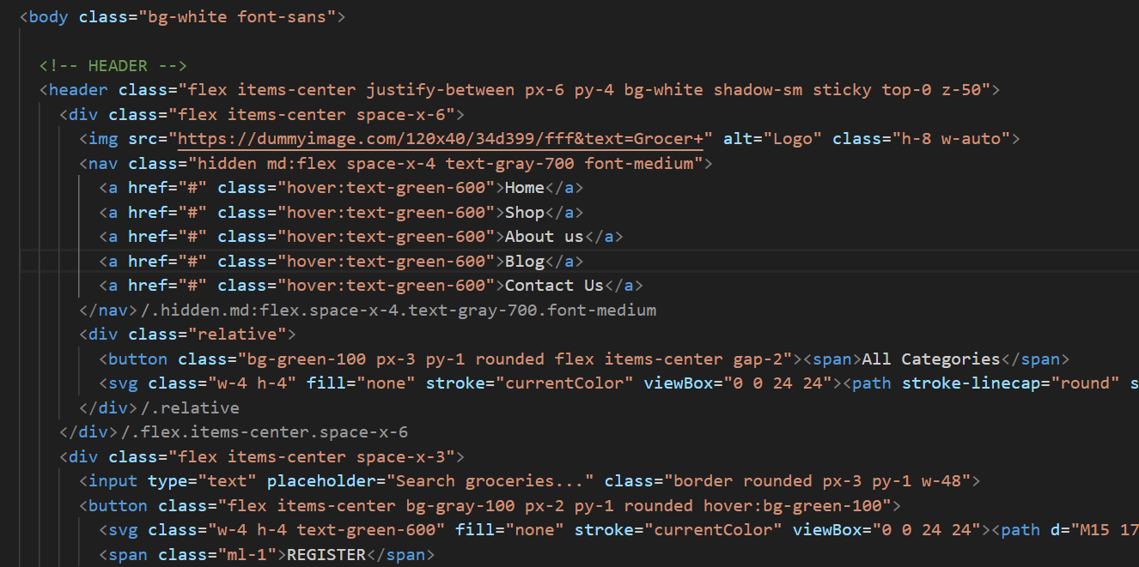
Fig 5.1.1. syntax’s of index.php e-TBRM

5.3 TYPE OF TESTING METHODS
There are different methods levels during the process of testing in software verification testing which we learned during our course of semester six of software engineering class mostly described that can be functionality or non-functionality development software engineering. Let’s see how our testing levels can be described for each illustration detailed with its case test plan strategies of user requirement implementation testing whether it can be black box testing or white box since its normally summarized four testing methods are commonly used

5.3.1. Unit Testing
This type of testing is performed by developers before the setup is handed over to the testing team to formally execute the test cases. Unit testing is performed by the respective developers on the individual units of source code assigned areas. The developers use test data that is different from the test data of the quality assurance team. The goal of unit testing is to isolate each part of the program and show that individual parts are correct in terms of requirements and functionality.

5.3.2. Integration Testing
Integration testing is systematic technique for constructing the software architecture while at the same time conducting tests to uncover errors associated interface the objective is to take unit tested components and build program structure that has been dictated by design. There is tendency to attempt no incremental integration; that is construct the program using a “big bang” Incremental integration is the antithesis of big bang approach. the program is constructed and tested in small increments, where errors are easier to isolate and correct; interface are more likely to be tested completely and a systematic test approach may be applied in the paragraphs that follow a number of different incremental integration strategies are discussed Top-down integration testing is incremental approaches to construction of software module are integrated by moving downward through the control hierarchy.

5.3.3. System Testing
System testing tests the system as a whole. Once all the components are integrated, the
application as a whole is tested rigorously to see that it meets the specified Quality Standards. This type of testing is performed by a specialized testing team. Since system testing is important because of the following reasons –
Case:1 Login form
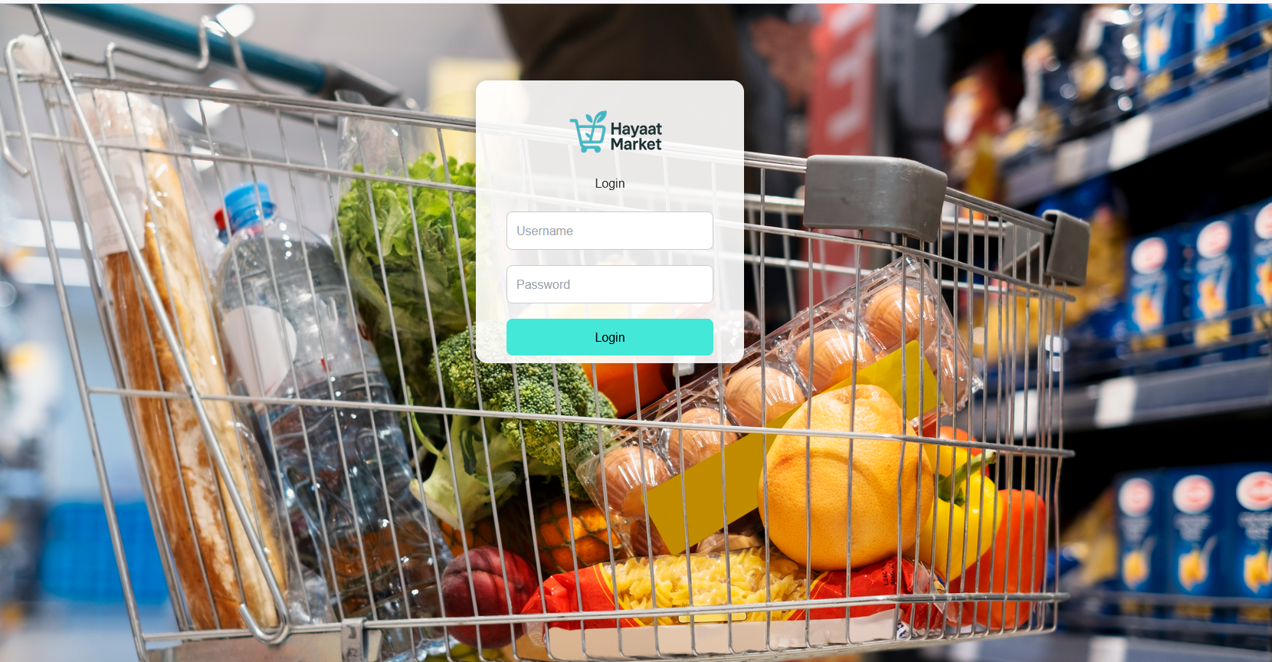Fig 5.3.3.1 login form

Case 2. Create New User form
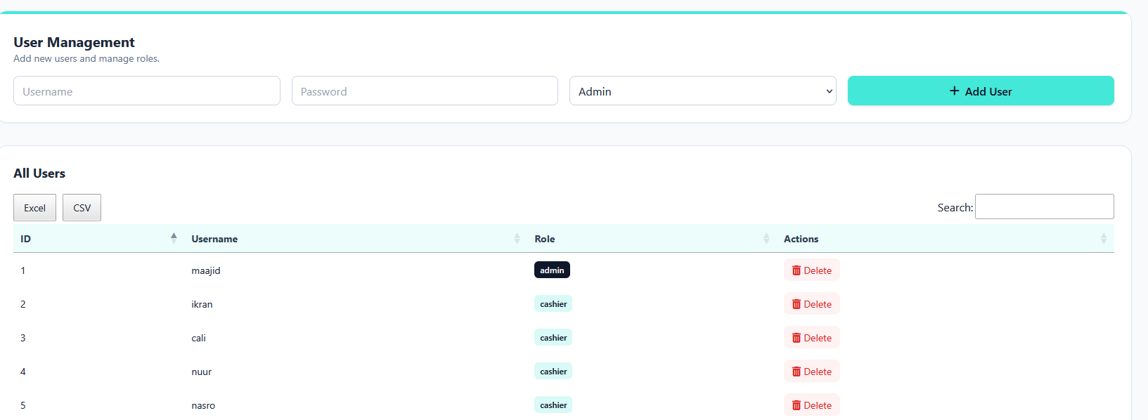
Fig 5.3.3.2 user form

Case 3. Web portal of application e-TBRMS

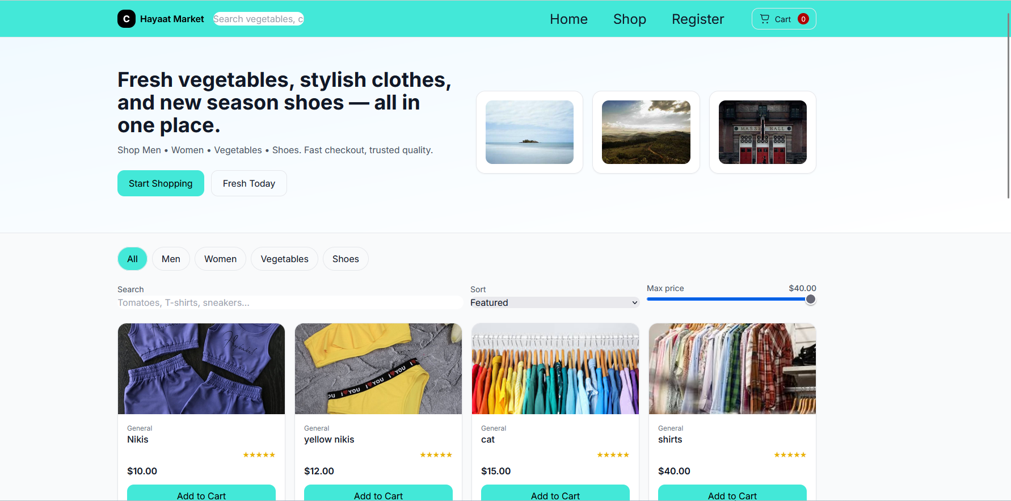
Fig 5.3.3.3 Web portal

Case 4. Customer Registration Form
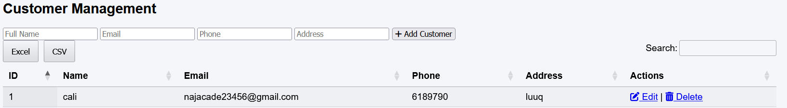
Fig 5.3.3.4 Customer Registration Form

Case 5. Product Registration Form

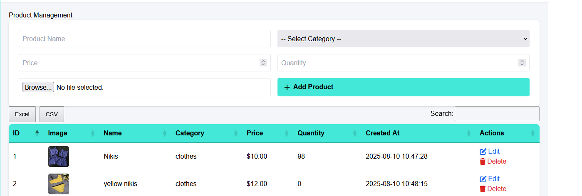
Fig 5.3.3.4 Product Registration Form

5.4 USER DOCUMENTATION
After the verification testing has been completed during its procedure of testing type including unit testing or system integration testing and then later focused on software application which will operate or designed software and hardware to run on a PC running windows XP and needs by using MSQL XAMP to be installed and front-end Microsoft Visual Studio. It needs about 10 MB of disk space to store the application and at least as much again to store data. Since XAMPP is the most popular PHP development environment is a completely free, easy to install Apache
distribution containing MariaDB, PHP, and Perl. The XAMPP open-source package has been setup to be incredibly easy to install and to use for its purpose MSQL XAMP Edition to be installed. Since User Documentation is system tool of methodology description looks like as complex to understand because it involved for renting, so it is very important to understand user documentation as deeply as possible, this guideline provides a complete reference

5.5 IMPLEMETATION
Implementation is the stage in the project where the theoretical design is turned into a working System and is giving confidence on the new system for the users that it will work efficiently, and effectively manner way. It involves careful planning, investigation of the current system and its constraints on implementing with design of methods to achieve the changeover, an evaluation of change over methods. Apart from planning major task of preparing the implementation are education and training of users. Implementation is where implement how the system works as
the sequential flow of Forms. As we mentioned above this application has different users and different privileges, so if your login the administrator you see the privileges do everything in this system since while the others
can see only their privileges and can register.

5.5. CHPATER SUMMARY
software life-cycle is concerned with the development of code that will implement the design.Code is written is a formal language called a programming language. Since the verification testing has been completed during its procedure of testing type. Software testing means to uncover error before implementing systems. The three software testing strategies used are unit testing which focus to uncover errors within the boundary of the module which is applying integration testing a technique for constructing the architecture while at the same time conducting tests to uncover
errors associated with interfacing of System testing.

CHAPTER SIX
CONCLUSION AND RECOMMENDATION

6.0 INTRODUCTION
This section concludes the findings of the Supermarket Management System (SMS), a web-based application designed using PHP for the frontend and MySQL (XAMPP) for the backend. The system provides a user-friendly interface for customers to place orders, make reservations, and manage supermarket availability. With this system, customers can easily customize their orders and view the status of products in real-time. The admin portal allows the owner to manage stock, track customer orders, and ensure the smooth running of supermarket operations. The system’s primary goal is to streamline the ordering process, reduce wait times, and enhance the customer experience through efficient management of orders and reservations.

6.1 CONCLUSION
The project demonstrates that, without a system like SMS, customers often face long waiting times due to unavailable products or delays in placing orders. This system solves that problem by allowing customers to place their orders online, view product availability, and make reservations as needed. With the implementation of the Supermarket Management System, customers can choose their desired products or reserve tables without waiting, which enhances their experience by making the process faster and more efficient.
As technology continues to evolve and people demand quicker services, SMS is poised to meet these needs. The system helps streamline supermarket operations, allowing customers to interact with the supermarket more conveniently, such as placing orders and booking items ahead of time. The system is expected to grow in importance as customers increasingly rely on web and mobile apps to make their shopping experiences smoother.

6.1.1 Achievements
The Supermarket Management System (SMS) is a sophisticated solution that automates the process of managing orders, reservations, and inventory. By digitizing the traditional ordering process, SMS not only makes the operations more efficient but also provides customers with a streamlined and modern experience. It improves overall supermarket operations, reduces errors, enhances customer satisfaction, and saves time for both customers and staff.
SMS offers a web-based platform that gives supermarket owners a comprehensive tool to manage inventory, track sales, and interact with customers. The easy-to-use interface and automated functions reduce wait times, optimize stock availability, and ensure customers can quickly find and purchase what they need.

6.1.2 Limitations
While the Supermarket Management System provides numerous benefits, there are certain limitations that need to be considered:
- Dependency on Technology: The system relies on internet connectivity and software functionality, meaning technical issues (such as server downtime or connectivity problems) could disrupt operations.
- Cost Considerations: For small or independent supermarkets, the initial setup and ongoing maintenance costs of implementing such a system could be a concern.
- Limited Customization: Off-the-shelf solutions may not always cater to specific needs or branding preferences of every supermarket, limiting flexibility.
- Integration Challenges: Compatibility issues may arise when trying to integrate SMS with existing point-of-sale (POS) systems or other software tools used by the supermarket, which could affect operational efficiency.

6.2 CONCLUSION REMARKS
Technology has advanced significantly, especially in the field of supermarket automation. The Supermarket Management System (SMS) brings a revolutionary impact to the way supermarkets operate by streamlining order processing, inventory management, and customer interactions. The system's automation features not only save time but also ensure a more effective and seamless operation, which greatly reduces the need for manual intervention.
By introducing SMS, supermarkets can reduce the risk of human error, improve staff performance, and enhance the overall customer experience. The system also provides a platform for customers to directly communicate with the supermarket, placing orders and customizing them as needed, improving customer satisfaction and ensuring they receive their desired products quickly. The integration of mobile apps allows customers to manage their shopping experience with just a few taps.
In conclusion, this system aims to enhance the shopping experience by providing a seamless interface for customers and efficient tools for supermarket management. The widespread adoption of SMS will likely transform the industry by making supermarkets more competitive and responsive to customer need
Recommendations
- Mobile Application Development: Further development of a dedicated mobile app would provide even more convenience for customers, allowing them to place orders, check product availability, and track deliveries directly from their phones.
- Cloud Integration: The system should consider integration with cloud storage solutions to enhance data accessibility, scalability, and backup options for supermarket owners.
- Advanced Analytics: Implement advanced reporting tools within the admin portal that offer detailed insights into sales trends, inventory turnover, and customer preferences to aid in decision-making.
- Customization Options: Supermarket owners should have more customization options within the system to cater to their unique needs, such as adding specific features or branding elements

REFERENCE

1: R.H. Ballou, (1999): Business Logistics Management: Planning, Organizing and Controlling the Supply Chain, 4th ed., Prentice-Hall International, London.

2: B. Yang, and N.D. Burns, (2003). "Implications of postponement for the supply chain", International Journal of Production Research, Vol. 41 No.9.

3: M.Q. Patton, (1990). Qualitative Evaluation and Research Methods, 2nd edition, New Bury Park, CA.

4: J.D. Pagh, and M.C. Cooper, (1998). "Supply chain postponement and speculation strategies: how to choose the right strategy", Journal of Business Logistics, Vol. 19
5: W3C, (2015). An analysis of implementing web in the class room. Information System Educational Journa
6: Wikipedia (https://en.m.wikipedia.org)
7: S. Rietze, (2008). “Examination of supply response”, WA 98237, Vol 7

8: C. Bowersox, (2009). “Inventory Speculation: Cause and Effect”, Ohio, United States 89511 9: “Grocery” (https://www.oxfordlearnersdictionaries.com/us/definition/english/grocery_1?
=grocery+store). Oxford Learner's Dictionary. Retrieved 13 July 2020.

10. Meyer, Zlati (5 April 2017). "Why 'Grocerants' are the new trend, taking bite out of restaurants"(https://www.usatoday.com/story/money/business/2017/04/05/grocer
nts-take-bite-out-restaurants/99723098/). USA Today. Retrieved 6 April 2017. "The phenomenon is growing fast enough both in prevalence and sophistication that the food industry has coined a name for these combination grocery stores and eateries – the 'grocerant.'"

