Buffer Overflow Vulnerability Report
Marco Alanis
In the course of this assignment, our mission was to exploit a Buffer Overflow vulnerability within a controlled environment known as SEED. The primary objective of this attack was to gain privileged control of the system by strategically inundating a container with more data than it could handle. As the data gets written into memory, and we approach the container's limits, a critical stage is reached wherein data continues to be written, subsequently overwriting crucial pieces of information such as the return address and the base pointer.
The art of this attack lies in the precision with which we pinpoint our position within the stack. By ensuring that the address of our malicious code aligns perfectly with the location of the return address pointer, we are able to redirect the program's code flow. In our case, this redirection resulted in gaining access to a shell with root privileges. To achieve this, we needed to ascertain the return address and carefully select an additional value that would land within the range of No-Operation (NOP) instructions, facilitating seamless execution.
Throughout this lab, I delved deeply into the intricacies of memory management, focusing particularly on the stack. Additionally, I honed my skills in navigating the GNU Debugger (GDB) and learned various debugging techniques, such as setting breakpoints and stepping through code.
Key registers within the process, including EBP, ESP, and EIP, played pivotal roles in our understanding and execution of the attack. EBP, or the Extended Base Pointer, served as a valuable reference point, pointing to the start of the stack frame, and allowed us to access function arguments and local variables. The ESP, or Extended Stack Pointer, directed us to the top of the stack, adapting its position depending on whether the stack was expanding or contracting. Lastly, the EIP, or Extended Instruction Pointer, held the memory address of the next instruction slated for execution, a critical piece of information in the context of our Buffer Overflow attack.

First step is to
Turn off ASLR and to give root ownership to my stack.c and stac files. Also, we need to SUID to both files as shown below. This is very important because I was debugging for hours trying to find out why I was not getting root or a successful attack was because I did not turn off ASLR and my files where running under seed and with no SUID

Then we need to get the value of the offset:
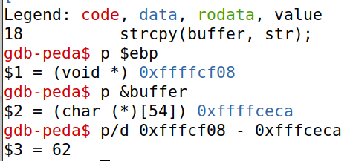
To get this we printed the ebp and the memory address of the buffer and substracted as shown below.

To this value of 62 we added 4 to point to the next address in the stack . This new value we put inside the exploit.py file as shown below.
Then the next step is to get the value of the return address. For this we get the memory address of ebp we got while in GDB: p $ebp = 0xffffcf08 and added a value that made it land withing the ranges of the NOP values. I started with 100, and got access to root when using the value 400. The result is shown below.

Now we compiled the python code and ran the command ./stack. The results are shown below.
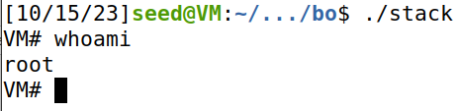

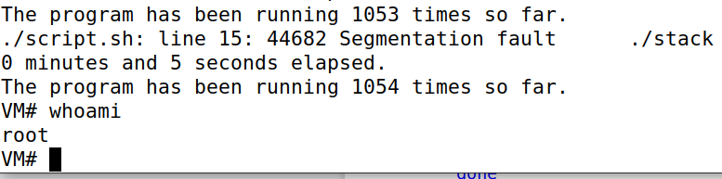
For the second part of the assignment, we turned on random space layout and we had this script that brute forced the address by adding 1 until we got access. I created a .sh file and pasted the code and let it run. To break in, I had to wait 5 seconds, but this depends on where the random space layout places the stack. The results are shown below.

