**CS-2001L**

**Data Structure and Algorithm**

**CAR RENTAL SYSTEM**

**Project Report By: ABDUL MALIK (cs201003)**

|  |  |
| --- | --- |
| 1. **SANJAY KUMAR** | **cs201125** |
| 1. **AYUSH KUMAR** | **cs201029** |

**Group Members:**

PROJECT LINK

<https://drive.google.com/file/d/1KG2OXVtMfnzkVy6omSlvJ4pqeEpb8LA7/view?usp=sharing>

`

Table of Contents

1.Introduction

2.Scope

3.Flow Chart

4. C code

5. Hardware/Software Requirements

5.1 Libraries , IDE

6. Screen Shots

# Introduction:

# This Project is Consist of System Application which is known CAR RENTAL SYSTEM

# Objectives that we need to create this Application

# User Info Needed(Creation of Account)

# List of cars with different Prices will be present for rent

# List of all rented cars then user will check which car has to rent or not

# Payment Method then Invoice will be print at the end

# Car Rental System is based on a concept to rent cars and generate rental invoice of a rental company. Before stepping into the main system a user has to pass through a login system to get access, then only the user can select cars with a different model and rent for certain days.

# 2. Scope

Car Rental System is based on a concept to rent cars firstly user will see menu page at the start then that will consist of all cars lists and rented cars list and option for book a car then he will see login page after loging into system the he will be asked for to select a car after selecting car he will be asked to pay his payment and then at list invoice will be print .

**Structure**

**MENU**

Rented Car

Quit Option

Book a Car

All Cars

Create Account

1. **Technical Detail**

Technical Detail Consist of What topics has been used to make this kind of project

**Data Structure and Algorithm Topic Used**

* + - Arrays
    - Sorting Alogs
    - Linked List
    - Recursion
    - Stack
    - Queue(Enqueue and Dequeue)

**Additional Concepts Used**

* + - Concepts of Class and Objects
    - File Handling
    - Inheritance
    - Set width
    - Loops
    - Sleep function
    - System CLS function

# Flow Chart

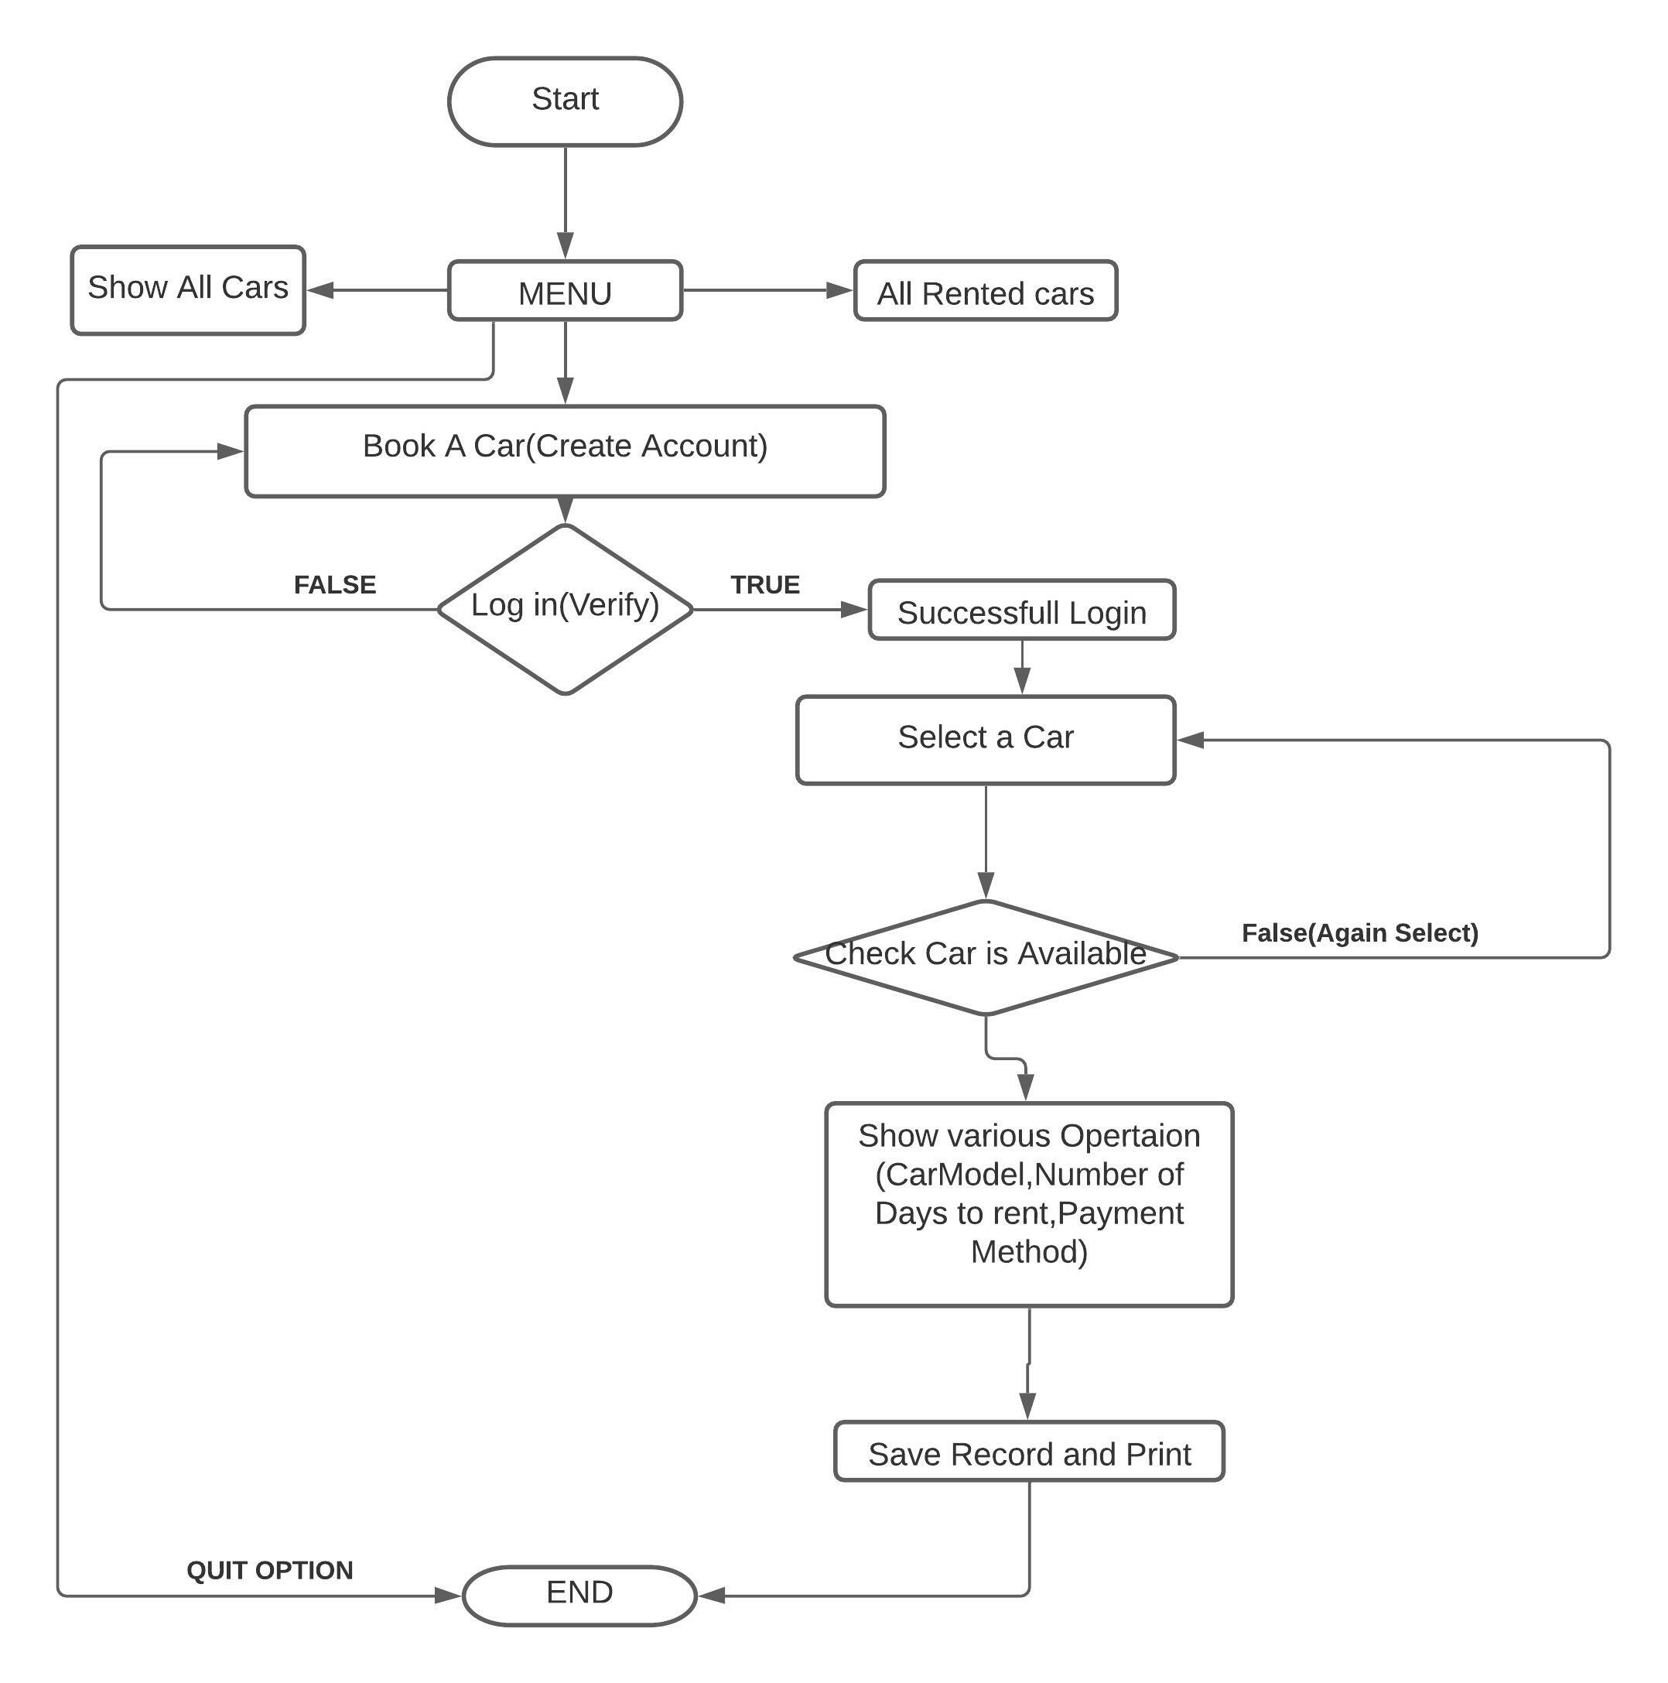

**4. C++ Code**

**#include <iostream>**

**#include <fstream>**

**#include <conio.h>**

**#include <unistd.h>**

**#include <iomanip>**

**#include <windows.h>**

**#include <string.h>**

**#define MAX 100**

**using namespace std;**

**//functions**

**void load();**

**void createAccount();**

**void menu();**

**void showCars();**

**void insertionSort();**

**void RentedCars();**

**//global variables**

**string customername;**

**string cnic;**

**string age;**

**string gender;**

**string password;**

**string cpassword;**

**class CustomerInfo{**

**public:**

**string data;**

**CustomerInfo *next;**

**CustomerInfo(string value){**

**data = value;**

**next = NULL;**

**}**

**};**

**CustomerInfo *head = NULL;**

**class paymentStack{**

**public:**

**int data;**

**paymentStack *next;**

**paymentStack(int value){**

**data = value;**

**next = NULL;**

**}**

**};**

**paymentStack *pts;**

**int peek(paymentStack* root){**

**if (root == NULL)**

**return 0;**

**return root->data;**

**}**

**void push(paymentStack** root, int data){**

**paymentStack* stackNode = new paymentStack(data);**

**(stackNode)->next = *root;**

**\*root = stackNode;**

**}**

**//Insert function**

**void insertNode(CustomerInfo **head, string data){**

**if (*head == NULL){**

**\*head = new CustomerInfo(data);**

**}**

**else{**

**CustomerInfo *temp = *head;**

**while (temp->next != NULL){**

**temp = temp->next;**

**}**

**temp->next = new CustomerInfo(data);**

**}**

**}**

**class carData{**

**private:**

**public:**

**string carmodel;**

**string carnumber;**

**char data;**

**};**

**// Queue Class**

**class QNode{**

**public:**

**string value;**

**QNode *next;**

**}*front = NULL, *rear = NULL;**

**int remainAmount;**

**int advanceAmount;**

**int rentalfee;**

**// inhereted class from carDataclass**

**class rent : public carData {**

**public:**

**int days, rentalfee; // additional int vatiables defined**

**void data(){**

**int login();**

**cout << "\n\n\n\t\t\t\t\t\t\t\t\t\t---------------------------------";**

**cout << "\n\t\t\t\t\t\t\t\t\t\t\tCREATE YOUR ACCOUNT \n";**

**cout << "\t\t\t\t\t\t\t\t\t\t---------------------------------\n\n";**

**cout << "\t\t\t\t\t\t\t\t\t\tEnter Your Name: ";**

**cin >> customername;**

**insertNode(&head, customername);**

**cout << "\n\n\t\t\t\t\t\t\t\t\t\tEnter CNIC-Number: ";**

**cin >> cnic;**

**insertNode(&head, cnic);**

**cout << "\n\n\t\t\t\t\t\t\t\t\t\tEnter your Age: ";**

**cin >> age;**

**insertNode(&head, age);**

**cout << "\n\n\t\t\t\t\t\t\t\t\t\tEnter Gender: ";**

**cin >> gender;**

**insertNode(&head, gender);**

**createAccount();**

**system("CLS");**

**cout << endl;**

**login();**

**do{**

**mainInfo:**

**cout << "\t\t\t\t---------------------------------------------" << endl;**

**cout << "\t\t\t\tPlease Select a Car" << endl; // giving user a choice to select among three different models**

**showCars();**

**cout << endl;**

**cout << "\t\t\t\tChoose a Car from the above options: ";**

**cin >> carmodel;**

**cout << endl;**

**if (carmodel == "A"){**

**cout<<"\t\t\t\tThis car already Rented---"<<endl;**

**sleep(3);**

**goto mainInfo;**

**}**

**else if (carmodel == "B"){**

**system("CLS");**

**cout << "You have choosen BMW model 2018AS" << endl;**

**ifstream inB("B.txt"); // displaying details of model B**

**char str[200];**

**while (inB){**

**inB.getline(str, 200);**

**if (inB)**

**cout << str << endl;**

**}**

**sleep(2);**

**}**

**else if (carmodel == "F"){**

**system("CLS");**

**cout << "You have choosen Ford model 2018DS" << endl;**

**ifstream inC("F.txt"); // displaying details of model C**

**char str[200];**

**while (inC){**

**inC.getline(str, 200);**

**if (inC)**

**cout << str << endl;**

**}**

**sleep(2);**

**}**

**do{**

**mainInfo:**

**cout << "\t\t\t\t---------------------------------------------" << endl;**

**cout << "\t\t\t\tPlease Select a Car" << endl; // giving user a choice to select among three different models**

**showCars();**

**cout << endl;**

**cout << "\t\t\t\tChoose a Car from the above options: ";**

**cin >> carmodel;**

**cout << endl;**

**if (carmodel == "A"){**

**cout<<"\t\t\t\tThis car already Rented---"<<endl;**

**sleep(3);**

**goto mainInfo;**

**}**

**else if (carmodel == "B"){**

**system("CLS");**

**cout << "You have choosen BMW model 2018AS" << endl;**

**ifstream inB("B.txt"); // displaying details of model B**

**char str[200];**

**while (inB){**

**inB.getline(str, 200);**

**if (inB)**

**cout << str << endl;**

**}**

**sleep(2);**

**}**

**else if (carmodel == "F"){**

**system("CLS");**

**cout << "You have choosen Ford model 2018DS" << endl;**

**ifstream inC("F.txt"); // displaying details of model C**

**char str[200];**

**while (inC){**

**inC.getline(str, 200);**

**if (inC)**

**cout << str << endl;**

**}**

**sleep(2);**

**}**

**else if (carmodel == "H"){**

**cout<<"\t\t\t\tThis car already Rented---"<<endl;**

**sleep(3);**

**goto mainInfo;**

**}**

**else if (carmodel == "M"){**

**system("CLS");**

**cout << "You have choosen Mercedes model 2018OW" << endl;**

**ifstream inC("M.txt"); // displaying details of model C**

**char str[200];**

**while (inC){**

**inC.getline(str, 200);**

**if (inC)**

**cout << str << endl;**

**}**

**sleep(2);**

**}**

**else if (carmodel == "S"){**

**system("CLS");**

**cout << "You have choosen Skoda model 2005Ps" << endl;**

**ifstream inC("S.txt"); // displaying details of model C**

**char str[200];**

**while (inC){**

**inC.getline(str, 200);**

**if (inC)**

**cout << str << endl;**

**}**

**sleep(2);**

**}**

**else if (carmodel == "T"){**

**cout<<"\t\t\t\tThis car already Rented---"<<endl;**

**sleep(3);**

**goto mainInfo;**

**}**

**sleep(2);**

**}**

**else if (carmodel == "V"){**

**system("CLS");**

**cout << "You have choosen VolksWagen model 2016SA" << endl;**

**ifstream inC("V.txt"); // displaying details of model C**

**char str[200];**

**while (inC){**

**inC.getline(str, 200);**

**if (inC)**

**cout << str << endl;**

**}**

**sleep(2);**

**}**

**else{**

**cout << "Invaild Car Model. Please try again!" << endl;**

**}**

**}while (carmodel != "A" && carmodel != "B" && carmodel != "F" && carmodel != "H" && carmodel != "M" && carmodel != "S" && carmodel != "T" && carmodel != "V");**

**cout << "--------------------------------------------------------------------------" << endl;**

**cout << "Please provide following Information"<<endl;**

**cout << "Number of days you wish to rent the car : ";**

**cin >> days;**

**cout << endl;**

**int choice;**

**string pin1, pin2;**

**cout << "\n\n\t\t----------------------------" << endl;**

**cout << "\t\t\tPayment Method: " << endl;**

**cout << "\t\t----------------------------" << endl;**

**cout << "\t\t1: CASH\t\t\t2: CARD" << endl;**

**cout << "\n\t\tEnter your Choice: ";**

**cin >> choice;**

**//system("CLS");**

**if (choice == 1){**

**cout << "\n\t\tEnter amount: ";**

**cin >> advanceAmount;**

**push(&pts, advanceAmount);**

**}**

**home1:**

**if (choice == 2){**

**cout << "\n\n\n\n\t\tEnter your PIN: ";**

**cin >> pin1;**

**cout << "\n\t\tVerify your PIN: ";**

**cin >> pin2;**

**if (pin1 == pin2){**

**cout << "\n\t\tEnter your Amout: ";**

**cin >> advanceAmount;**

**push(&pts, advanceAmount);**

**}**

**else{**

**cout << "\n\t\tPin Doesn't Match: " << endl;**

**cout << "\t\tTry Again";**

**sleep(2);**

**system("CLS");**

**goto home1;**

**}**

**}**

**}**

**void calculate(){**

**sleep(1);**

**system("CLS");**

**cout << "Calculating rent. Please wait......" << endl;**

**sleep(2);**

**if (carmodel == "A" || carmodel == "a")**

**rentalfee = days * 256;**

**if (carmodel == "B" || carmodel == "b")**

**rentalfee = days * 260;**

**if (carmodel == "F" || carmodel == "f")**

**rentalfee = days * 275;**

**if (carmodel == "H" || carmodel == "h")**

**rentalfee = days * 249;**

**if (carmodel == "M" || carmodel == "m")**

**rentalfee = days * 268;**

**if (carmodel == "S" || carmodel == "s")**

**rentalfee = days * 288;**

**if (carmodel == "T" || carmodel == "t")**

**rentalfee = days * 320;**

**if (carmodel == "V" || carmodel == "v")**

**rentalfee = days * 240;**

**remainAmount = advanceAmount - rentalfee;**

**}**

**void showrent(){**

**cout << "\n\t\t\t Car Rental - Customer Invoice " << endl;**

**cout << "\t\t\t\t ____________________________________________" << endl;**

**cout << "\t\t\t\t | Invoice No. :"<< "------------------|" << setw(10) << "#Cnb81353"<< " |" << endl;**

**cout << "\t\t\t\t | Customer Name:"<< "-----------------|" << setw(10) << (head)->data << " |" << endl;**

**cout << "\t\t\t\t | CNIC Number:"<< "-------------------|" << setw(10) << (head)->next->data << " |" << endl;**

**cout << "\t\t\t\t | Age:"<< "---------------------------|" << setw(10) << (head)->next->next->data << " |" << endl;**

**cout << "\t\t\t\t | Gender:"<< "------------------------|" << setw(10) << (head)->next->next->next->data << " |" << endl;**

**cout << "\t\t\t\t | Car Model :"<< "--------------------|" << setw(10) << carmodel << " |" << endl;**

**cout << "\t\t\t\t | Number of days :"<< "---------------|" << setw(10) << days << " |" << endl;**

**cout << "\t\t\t\t | Your Rental Amount is :"<< "--------|" << setw(10) << rentalfee << " |" << endl;**

**cout << "\t\t\t\t | Remain: Money :"<< "----------------|" << setw(10) << remainAmount << " |" << endl;**

**cout << "\t\t\t\t | Advance :"<< "----------------------|" << setw(10) << peek(pts) << " |" << endl;**

**cout << "\t\t\t\t ________________________________________________________" << endl;**

**cout << "\n";**

**cout << "\t\t\t\t | Total Rental Amount is :"<< "-------|" << setw(10) << rentalfee << " |" << endl;**

**cout << "\t\t\t\t ________________________________________________________" << endl;**

**cout << "\t\t\t\t # This is a computer generated invoce and it does not" << endl;**

**cout << "\t\t\t\t require an authorised signture #" << endl;**

**cout << " " << endl;**

**cout << "\t\t\t\t ------------------------------------------------------------" << endl;**

**cout << "\t\t\t\t You are advised to pay up the amount before due date." << endl;**

**cout << "\t\t\t\t Otherwise penelty fee will be applied" << endl;**

**cout << "\t\t\t\t -------------------------------------------------------------" << endl;**

**int f;**

**system("PAUSE");**

**ofstream fileOut; // Create Object of Ofstream**

**ifstream fin;**

**fin.open("CustomerInfo.txt");**

**fileOut.open ("CustomerInfo.txt",ios::app); // Append mode**

**if(fin.is_open())**

**fileOut<<"\n"<<customername<<"\t\t"<<carmodel<<"\t\t"<<cnic;**

**fin.close();**

**fileOut.close(); // Closing the file**

**system("CLS");**

**ifstream inf("thanks.txt");**

**char str[300];**

**while (inf){**

**inf.getline(str, 300);**

**if (inf)**

**cout << str << endl;**

**}**

**inf.close();**

**}**

**};**

**void createAccount(){**

**int ch;**

**cout << "\n\n\t\t\t\t\t\t\t\t\t\tCreate Password: ";**

**cin>>password;**

**cout << "\n\n\t\t\t\t\t\t\t\t\t\tConfirm Password: ";**

**cin>>cpassword;**

**if (password == cpassword)**

**{**

**cout << "\n\t\t\t\tAccount Created Succesfully" << endl;**

**sleep(2);**

**system("CLS");**

**}**

**else**

**{**

**cout << "\n\t\t\t\tPassword Doest Not Match" << endl;**

**cout << "\t\t\t\tTry Again" << endl;**

**sleep(2);**

**system("CLS");**

**createAccount();**

**}**

**}**

**class welcome{**

**public:**

**int welcom(){**

**ifstream in("welcome.txt"); // displaying welcome ASCII image text on output screen fn1353**

**if (!in){**

**cout << "Cannot open input file.\n";**

**}**

**char str[1000];**

**while (in){**

**in.getline(str, 1000); // delim defaults to '\n' cp**

**if (in)**

**cout << str << endl;**

**}**

**in.close();**

**sleep(1); // function which waits for (n) seconds**

**}**

**};**

**void menu(){**

**char choice;**

**rent obj2;**

**welcome objc;**

**mainhome:**

**cout << "\n\n\t\t\t\t\t\t\t\t\t__________________________________\n"<< endl;**

**cout << "\t\t\t\t\t\t\t\t\t\t\tMENU" << endl;**

**cout << "\t\t\t\t\t\t\t\t\t__________________________________" << endl;**

**cout << "\t\t\t\t\t\t\t\tEnter S to List all cars\n"<< endl;**

**cout << "\t\t\t\t\t\t\t\tEnter B to Book a CAR\n"<< endl;**

**cout << "\t\t\t\t\t\t\t\tEnter R to Show Rented Cars\n"<< endl;**

**cout << "\t\t\t\t\t\t\t\tEnter Q to Quit\n"<< endl;**

**cout << "\t\t\t\t\t\t\t\tEnter your Choice: ";**

**choice = toupper(getch());**

**if (choice == 'S'){**

**showCars();**

**getch();**

**system("cls");**

**objc.welcom();**

**goto mainhome;**

**}**

**else if (choice == 'B'){**

**system("cls");**

**objc.welcom();**

**obj2.data();**

**obj2.calculate();**

**obj2.showrent();**

**}**

**else if (choice == 'R'){**

**RentedCars();**

**objc.welcom();**

**goto mainhome;**

**}**

**else if (choice == 'Q')**

**exit(1);**

**}**

**/*---------------------MAIN FUNCTION---------------------------------*/**

**int main(){**

**system("color 57");**

**welcome obj1;**

**obj1.welcom(); // welcom function is called**

**menu();**

**return 0; // end of the program**

**}**

**//LOGIN**

**int login(){**

**string pass = "";**

**char ch;**

**int choice;**

**cout << "\n\n\n\n\n\n\n\n\n\t\t\t\t\t\t\t\t\t\t-------------------------------" << endl;**

**cout << "\t\t\t\t\t\t\t\t\t\t|\t LOG IN\t\t|" << endl;**

**cout << "\t\t\t\t\t\t\t\t\t\t--------------------------------" << endl;**

**cout << "\n\n\t\t\t\t\t\t\t\t\t\tEnter a Password You Created: ";**

**ch = _getch();**

**while (ch != 13){ // character 13 is enter**

**pass.push_back(ch);**

**cout << '*';**

**ch = _getch();**

**}**

**if (pass == cpassword){**

**cout << "\n\n\n\t\t\t\t\t\tAccess Granted! \n";**

**sleep(3);**

**system("CLS");**

**load();**

**system("CLS");**

**}**

**else{**

**cout << "\n\n\t\t\t\t\t\t\tAccess Aborted...\n\t\t\t\t\t\t\tPlease Try Again\n\n";**

**sleep(2);**

**cout << "\n\t\t\t\t\t\t\t\t\t\tEnter 1: For try Again" << endl;**

**cout << "\t\t\t\t\t\t\t\t\t\tEnter 2: For Forgot Password" << endl;**

**cout << "\t\t\t\t\t\t\t\t\t\tEnter your choice: ";**

**cin >> choice;**

**if (choice == 1){**

**system("CLS");**

**login();**

**}**

**else{**

**system("CLS");**

**createAccount();**

**login();**

**}**

**}**

**}**

**void next_position(int x, int y){**

**COORD c;**

**c.X = x;**

**c.Y = y;**

**SetConsoleCursorPosition(GetStdHandle(STD_OUTPUT_HANDLE), c);**

**}**

**void load(){**

**int r, c, q;**

**next_position(90, 25);**

**printf("Loading");**

**for (r = 1; r <= 15; r++){**

**for (q = 0; q <= 100000000; q++); // to display the character slowly**

**cout << ".";**

**}**

**system("CLS");**

**}**

**void sortStrings(char arr[][MAX], int n){**

**char temp[MAX];**

**// Sorting strings using bubble sort**

**for (int i = 0; i < n - 1; i++){**

**for (int j = 0; j < n - 1 - i; j++){**

**if (strcmp(arr[j], arr[j + 1]) > 0){**

**strcpy(temp, arr[j]);**

**strcpy(arr[j], arr[j + 1]);**

**strcpy(arr[j + 1], temp);**

**}**

**}**

**}**

**}**

**void showCars(){**

**system("CLS");**

**welcome objc;**

**objc.welcom();**

**cout << "\n\n\t\t\t\t\t\t\t\t\t\t-----------------------------------" << endl;**

**cout << "\t\t\t\t\t\t\t\t\t\t|\t ALL CARS\t\t |" << endl;**

**cout << "\t\t\t\t\t\t\t\t\t\t-----------------------------------" << endl;**

**cout << "\n\t\t\t\t\t____________________________________________________________________________________\n"**

**<< endl;**

**cout << "\t\t\t\t\t CAR NAME\t\tCAR MODEL\tCOLOR\t\tMax-Speed \tCAR PRICE" << endl;**

**cout << "\t\t\t\t\t____________________________________________________________________________________" << endl;**

**int price[10] = {256, 260, 275, 249, 268, 288, 320, 240};**

**string model[10] = {"2016MD", "2018AS", "2018DS", "2017LA", "2018OW", "2005Ps", "2008PW", "2010QW"};**

**string color[10] = {"Red", "black", "yellow", "Blue", "Red", "Brown", "Silver", "Black"};**

**string maxs_peed[10] = {"100 Km/h ", "150 Km/h", "150 Km/h", "170 Km/h", "130 Km/h", "140 Km/h", "130 Km/h", "120 Km/h", "150 Km/h"};**

**// SORT ONLY CAR NAMES**

**char arr[][MAX] = {"Hyundai", "BMW\t", "Mercedes", "Audi\t", "Ford\t", "Skoda\t", "Volkswagun", "Toyota"};**

**int n = sizeof(arr) / sizeof(arr[0]);**

**sortStrings(arr, n);**

**for (int i = 0; i < n; i++){**

**cout << "\t\t\t\t\t" << i + 1 << " " << arr[i] << "\t\t" << model[i] << "\t\t" << color[i] << "\t\t" << maxs_peed[i] << "\t" << price[i] << "\n"**

**<< endl;**

**}**

**}**

**void enQ(string newVal){**

**QNode *newNode = new QNode();**

**newNode->value = newVal;**

**if (front == NULL){**

**front = newNode;**

**rear = newNode;**

**}**

**else{**

**rear->next = newNode;**

**rear = newNode;**

**}**

**}**

**void deQ(){**

**QNode *newNode = new QNode();**

**if (front == rear){**

**front = rear = NULL;**

**}**

**else{**

**newNode = front;**

**front = front->next;**

**}**

**}**

**void display(QNode *ptr){**

**while (ptr != NULL){**

**cout << "\n\t\t\t\t\t" << ptr->value << endl;**

**ptr = ptr->next;**

**}**

**}**

**void RentedCars(){**

**system("CLS");**

**welcome objc;**

**objc.welcom();**

**cout << "\n\n\n\t\t\t\t\t\t\t\t---------------------------------------------" << endl;**

**cout << "\t\t\t\t\t\t\t\t\t\tALL RENTED CARS" << endl;**

**cout << "\t\t\t\t\t\t\t\t---------------------------------------------\n"<< endl;**

**cout << "\t\t\t\t\t__________________________________________________________________________________________________________________\n"<< endl;**

**cout << "\t\t\t\t\tUSER ID\t\t"<< "Name\t\t"<< "Car Name\t"<< "Car Price\t"<< "Car Model\t"<< "Qty\t\t"<< "RentDays";**

**cout << "\n\t\t\t\t\t__________________________________________________________________________________________________________________" << endl;**

**//enqueue data**

**enQ("cs201003\tABDUL MALIK\tAudi\t\t256.00\t\t2016MD\t\t2\t\t4\t\t");**

**enQ("cs201125\tSANJAY KUMAR\tHyundai\t\t249.00\t\t2017LA\t\t3\t\t2\t\t");**

**enQ("cs201029\tAYUSH KUMAR\tToyota\t\t320.00\t\t2008PW\t\t1\t\t5\t\t");**

**//print data**

**display(front);**

**//dequeue data**

**deQ();**

**deQ();**

**deQ();**

**getch();**

**system("CLS");**

**}**

# 5. Hardware/Software Requirement

## 5.1 Libraries

**#include <iostream>**

**#include <fstream>**

**#include <conio.h>**

**#include <unistd.h>**

**#include <iomanip>**

**#include <windows.h>**

**#include <string.h>**

**6. Screen Shorts**

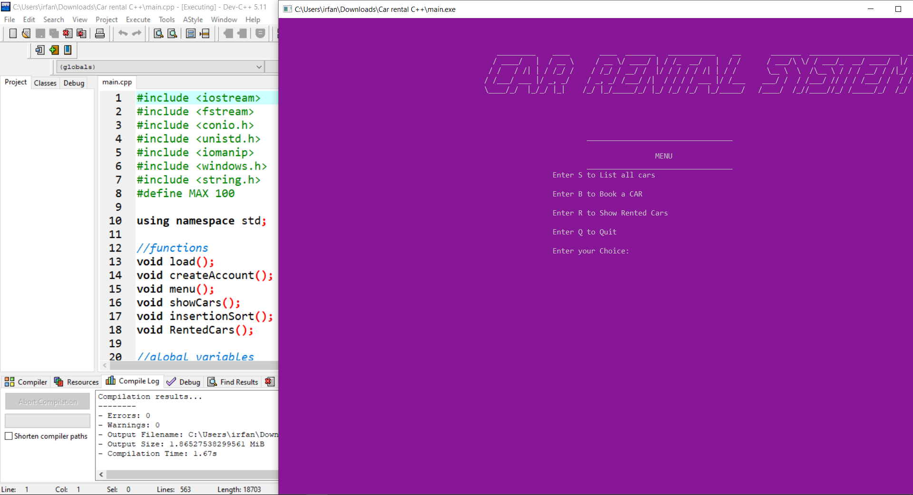

MENU PAGE

* + At First Menu Page will be Shown you can check and go back same menu page

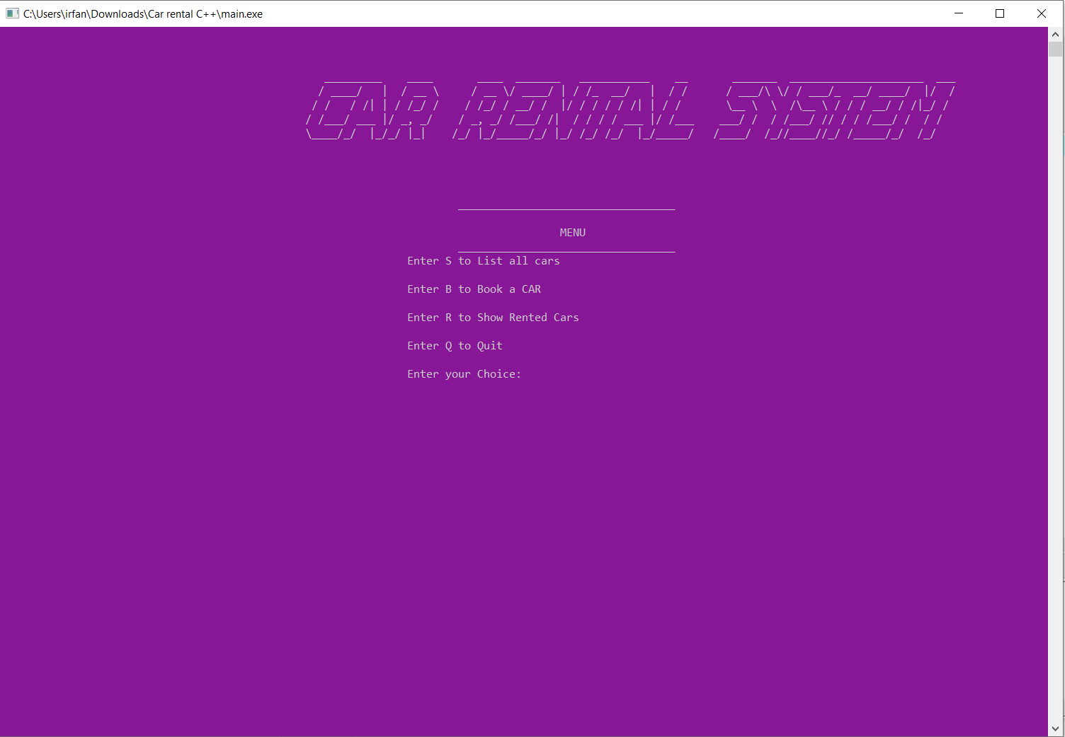

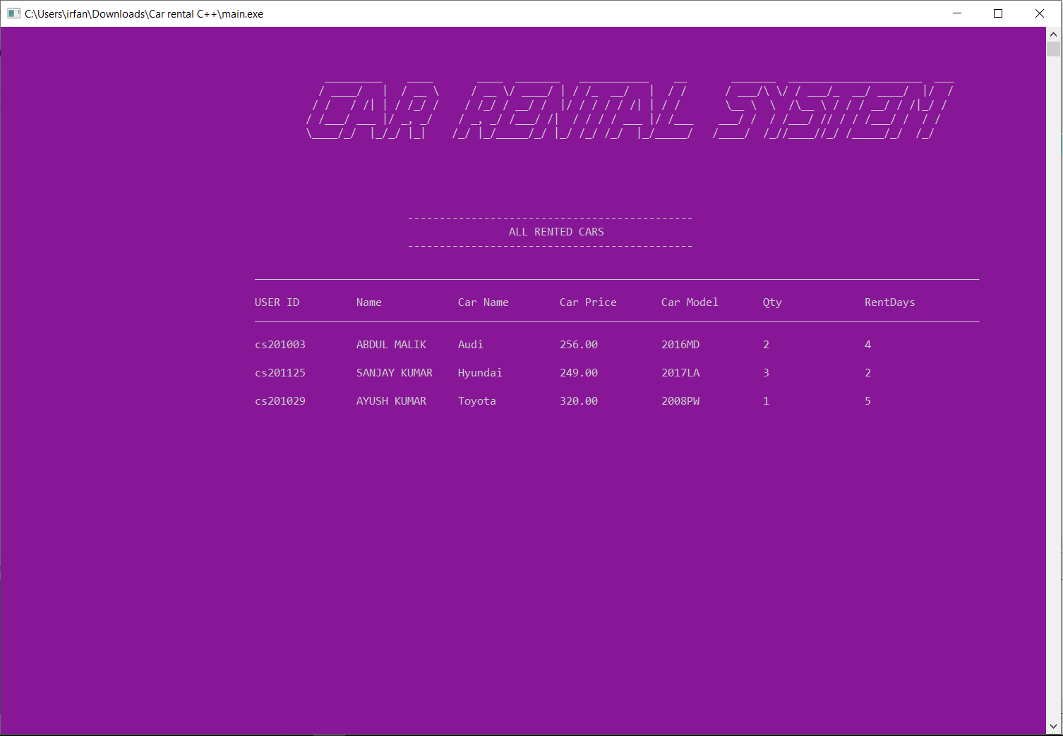

BOOK A CAR(Create Account)

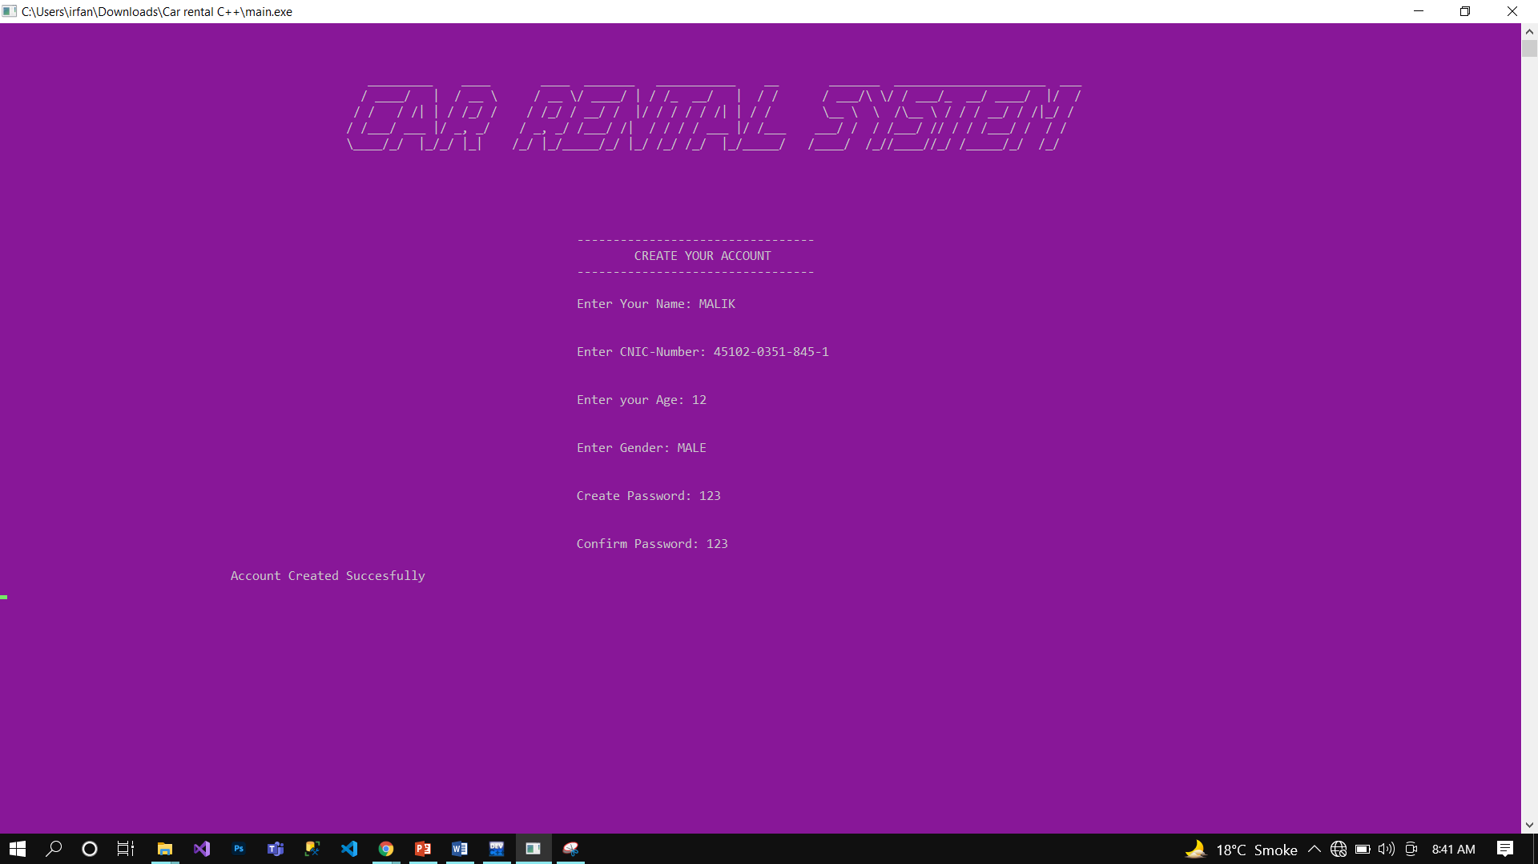

LOG IN

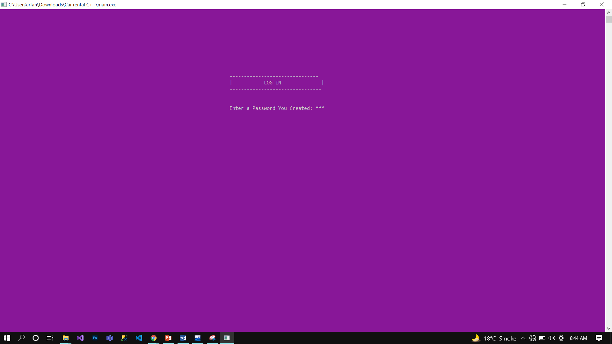

SELECT CAR

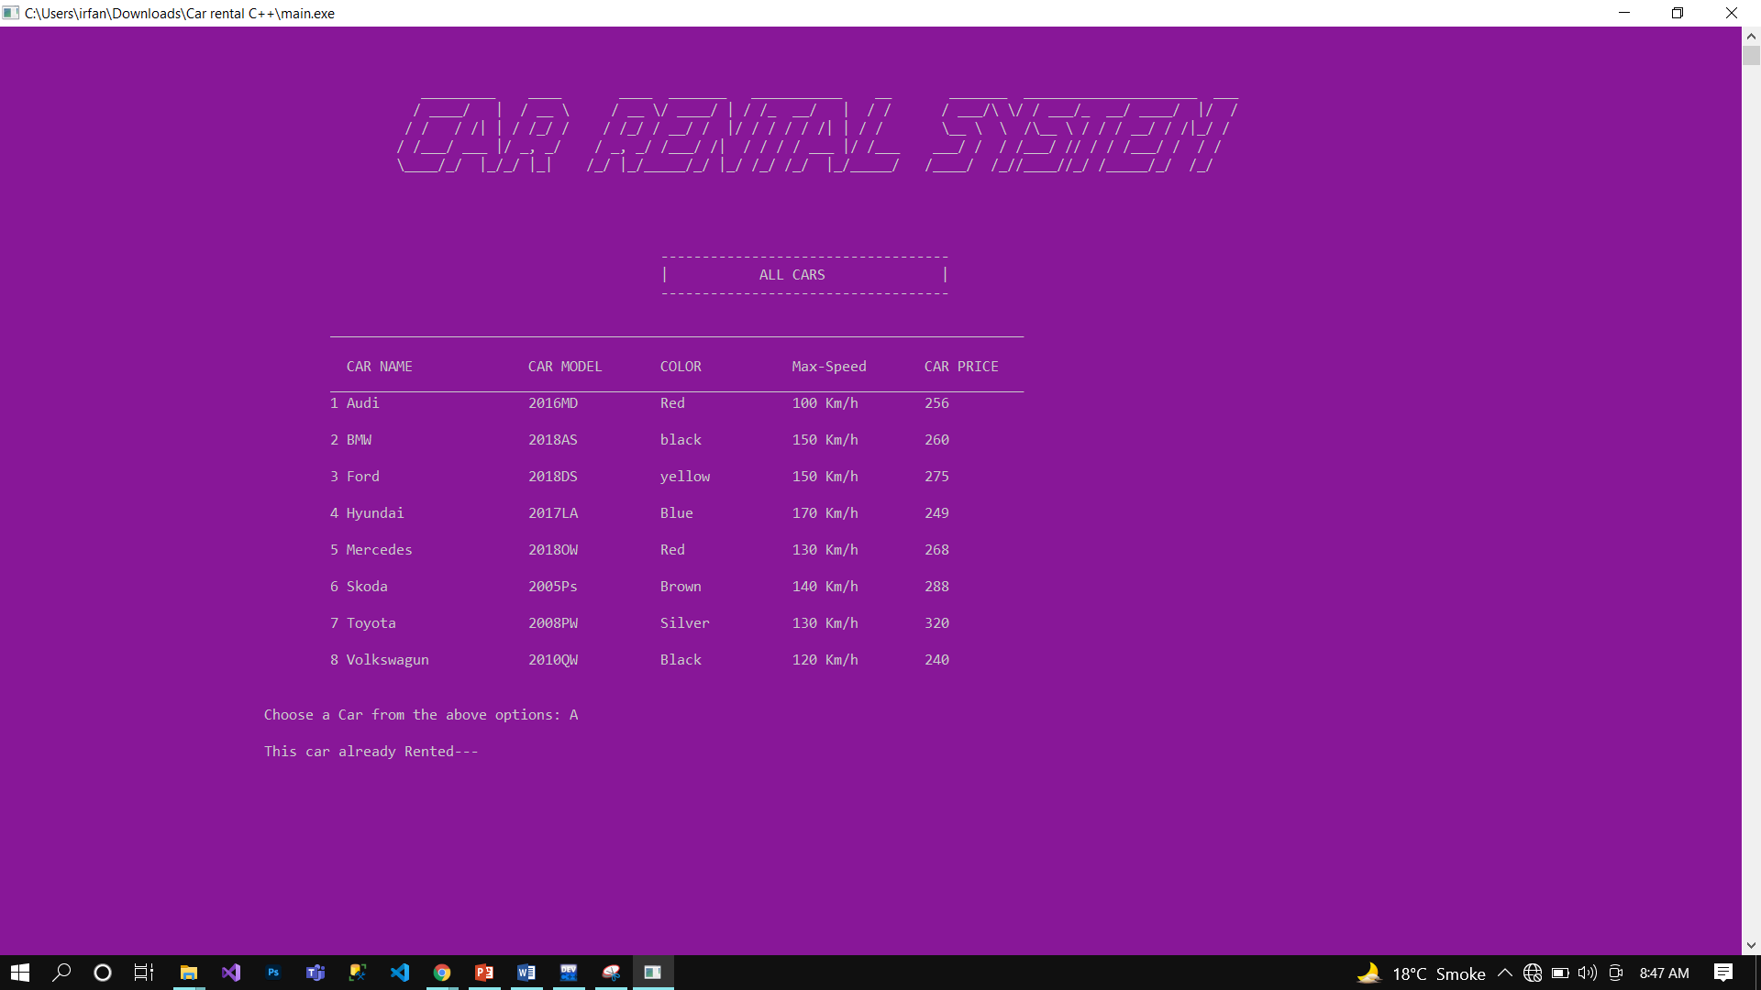

**PAYMENT METHOD:**

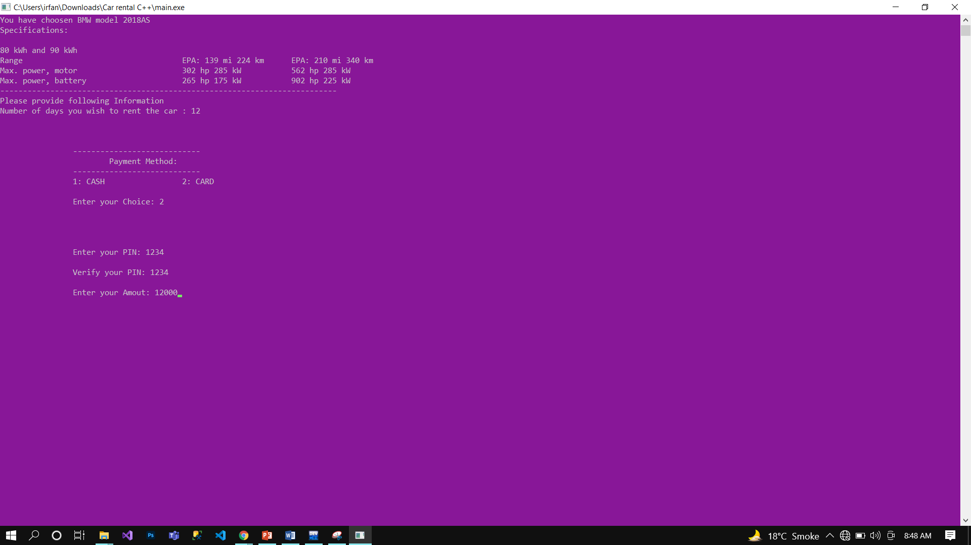

INVOICE

