# IMDB Advanced Search Actor Oscars

## Test Plan

1. Navigate to IMDB

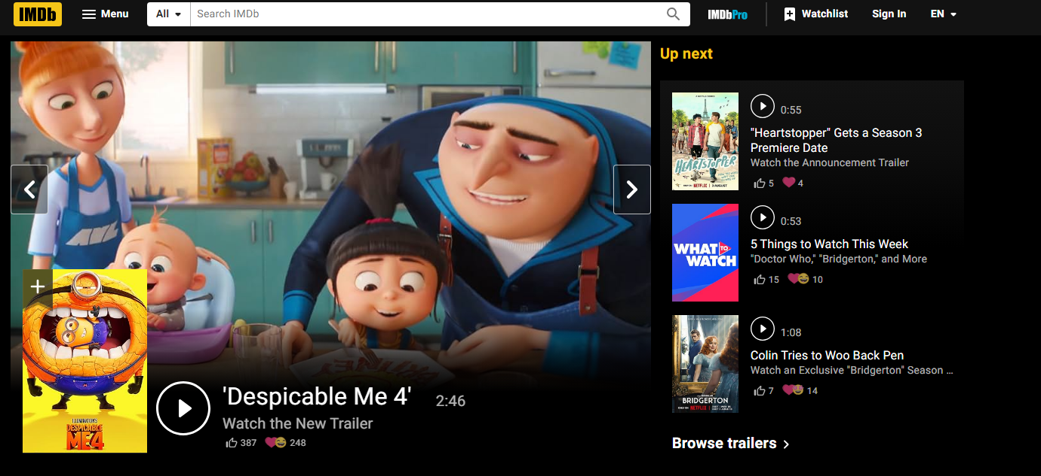

1. Click on “All” button



1. Click on “Advanced search”

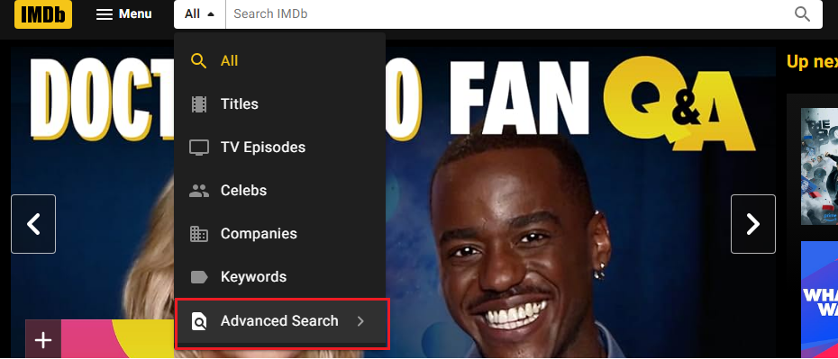

1. Wait until the page loads and click in “Names” button

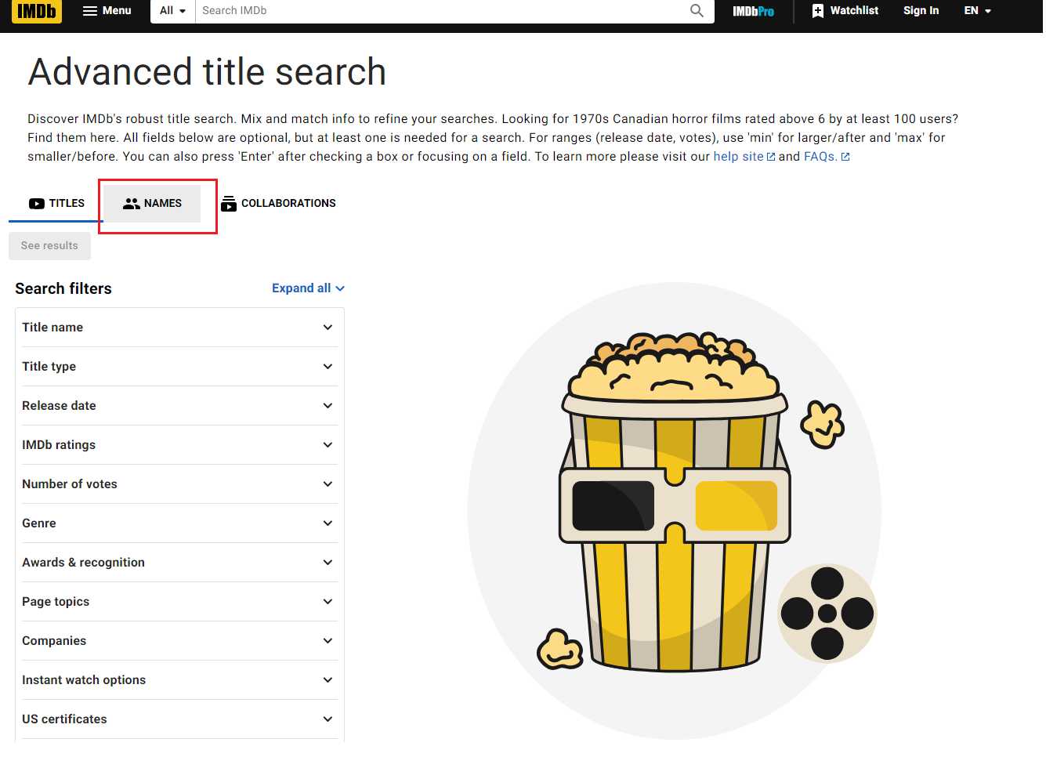

1. Click on “Expand all” and wait until it unfold

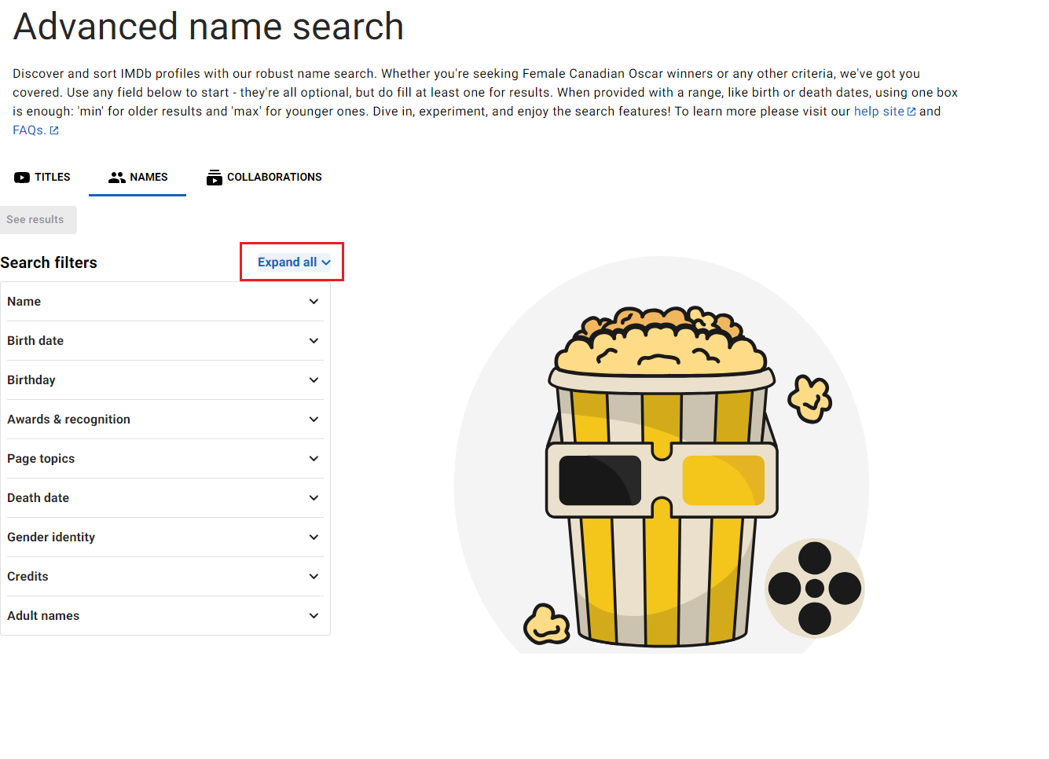

1. Write actor’s name

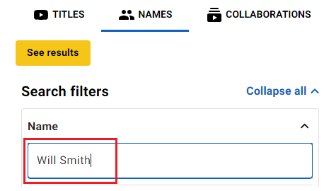

1. Select Oscar-Winning and click on it

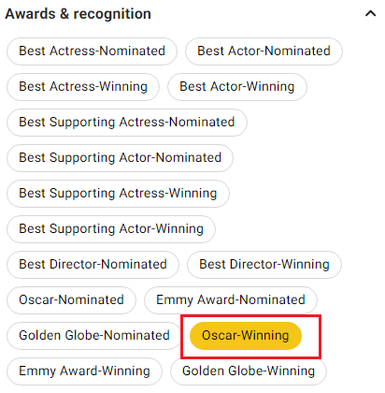

1. Click on “See results”



1. Click on the name of the actor

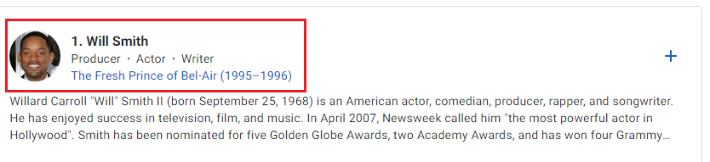

1. Click on “Awards”

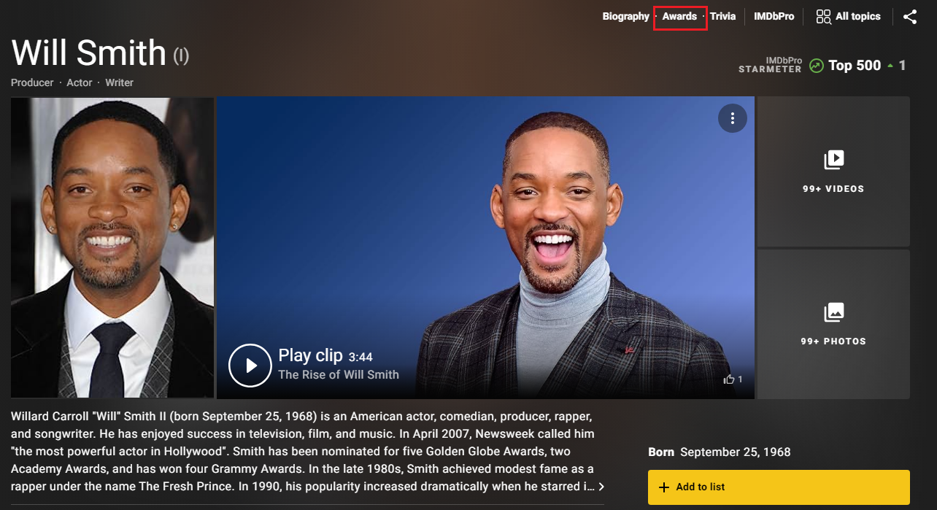

1. Check if he/she has won a Oscar

