

West Visayas State University

CICT



**E- Brgy Health Center Management System**

MA. AMCEL T. MACABOTAS | CHARLENE MAE PURA

PRINCESS B. POJOL | COLEEN TABAGO

March 2022



**“E-BRGY HEALTH CENTER MANAGEMENT SYSTEM”**

**MANUAL GUIDE**

Institute of Information and Communications Technology

West Visayas State University

La Paz, Iloilo City



by

Maria Amcel T. Macabotas

Charlene Mae Pura

Princess B. Pojol

Colleen Tabago

June 2022

**Disclaimer**

This software project and its corresponding documentation entitled “E-Brgy, Health Center Management System” is submitted to the College of Information and Communications Technology, West Visayas State University, in partial fulfillment of the requirements for the degree, Bachelor of Science in Information Systems and Information Technology. It is the product of our own work, except where indicated text.

We hereby grant the College of Information and Communications Technology permission to freely use, publish in local or international journal/conferences, reproduce, or distribute publicly the paper and electronic copies of this software project and its corresponding documentation in whole or in part, provided that we are acknowledged.

**Table of Contents**

Page

1. Guide for deploying and using the system’s main function
2. Introduction 5
3. System Requirements 6
4. Installation 7
5. Troubleshooting for fixing possible bugs 15
6. FAQ (Frequently Asked Questions) 20

**Guide for deploying and using the system's main functions**

**Introduction**

The brgy. health workers experience hard time tracking and reporting web in the real-time updating and monitoring the different patient’s data. E-brgy. health center management system is a system for documenting data of patients and generate reporting and promotion tools for brgy. health workers. The system is composed of web applications to help the user systematize their datas and develop systems that will track, report, and give real-time update and monitoring of patients' incoming schedules. It generate brgy. health center data for the different stakeholders. Provide visualization analysis, interpretation of all patient’s data and understand the relationship pattern and trends.

**System Requirements**

* Wi-Fi or mobile data to enable internet access.
* Ready Brower
* SMS/ Mobile Phone Network

**System Installation**

1. Activate the data connection phone if you have a mobile phone [android](https://paradacreativa.es/en/how-to-update-android/), go to the menu Settings> Network and Internet> Mobile network select the [SIM card](https://paradacreativa.es/en/how-to-cut-the-sim-card/) you are using and put ON switch Data connection or WIFI.

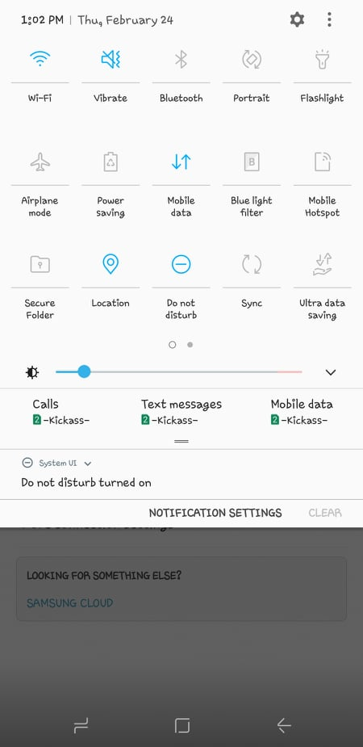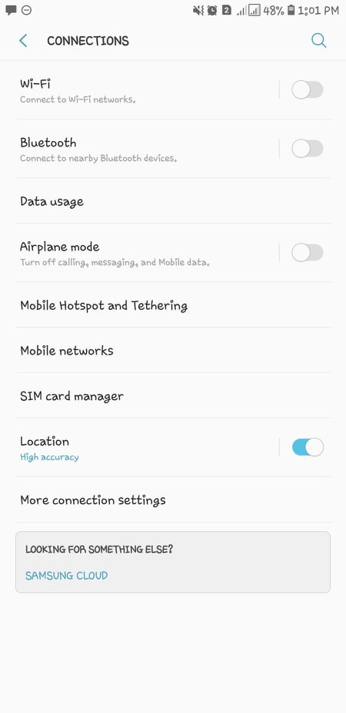

1. Go to the browser of your device:

* For **Patients** just open this link [https://ccmp-ebrgy.site/patient-login](https://ccmp-ebrgy.site/patient-login?fbclid=IwAR2d0ZvAGVqnCW5mEXjV1VOyT0TCPHAm4D-DosnLdoLDg9_iSQMzXKGo0a0) on your browser.

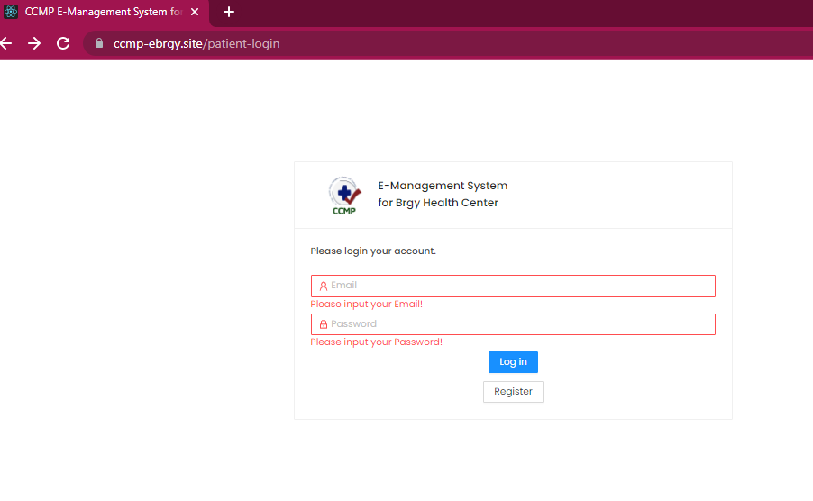2.1. Then, click the register if you are not yet registered. Fill in the form for registration of consultation/updating status of your consultation then click submit

* 1. After successfully creating an account and registering, you are now ready to start using the system. You can monitor the schedule of your appointment.

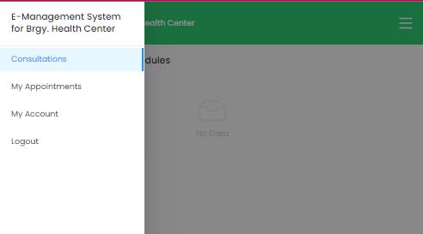

1. Once you are registered, automatically it will store to the database of the system.

* Here is the link for administrative support staff https://ccmp-ebrgy.site/admin/doctors.

* 1. Here is dashboard of the system where the admin can monitor/track the patients’ appointments and status of consultation and also up to date the queue system of patients and doctor. Click next to inform for the next queue.

* 1. Patients can get SMS notifications with reminders of their appointments, information about how to prepare for their appointment. With messaging through possible to share details such as the number of open counters, current waiting, and transaction time.

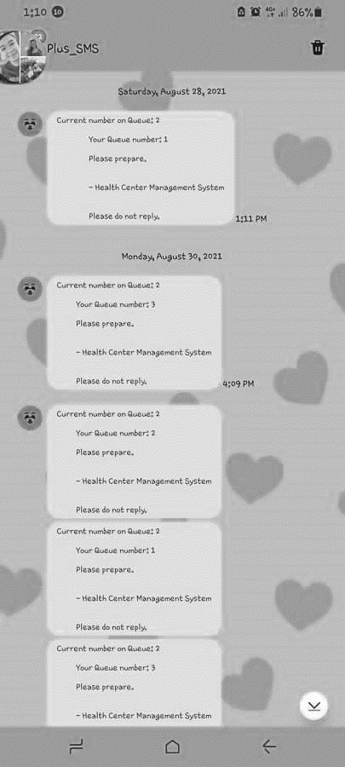

* 1. A screenshot of a computer

     Description automatically generated with medium confidenceAdmin can create schedule for the availability and consultation of the doctor/medical staff and for updating. Just click “create schedule”.
  2. After you click the “create schedule” bottom. Fill in the form then, click submit.

* 1. Click report where you can find all the input data in the system. It can also print out the data of consulted patients and consultations conducted.

* 1. A screenshot of a computer

     Description automatically generatedClick doctor for the data information of medical staff in health center and for the creation of E-Brgy, Health Center Management System (EBHCMS) account for doctor.
  2. Click “add a doctor” if not yet registered. And here’s the form below.

1. After creating an account for doctor, go to the website: <https://ccmp-ebrgy.site/doctor/patients>.

Then sign in the registered account of doctor, enable to receive, and review patients’ data of information. Here’s is the form below.

**Troubleshooting for fixing possible bugs**

(APP.txs)

import React, { lazy, Suspense, useEffect } from "react";

import Spinner from "./components/hoc/spinner/spinner.component";

import ErrorBoundary from "./components/hoc/error-boundary/error-boundary.component";

import { Route, Switch } from "react-router-dom";

import setAuthToken from "./utils/setAuthToken";

import PatientLoginPage from "./pages/patients/login-form/login.page";

const SecretaryRoutes = lazy(() => import("./routes/secretary.routes"));

const LoginPage = lazy(() => import("./pages/secretary/login/login.page"));

const PatientRegistrationPage = lazy(

  () => import("./pages/patients/registration-form/registration.page")

);

const PatientsRoutes = lazy(() => import("./routes/patients.routes"));

const DoctorRoutes = lazy(() => import("./routes/doctor.routes"));

const DoctorLogin = lazy(() => import("./pages/doctor/login/login.page"));

const App: React.FC = () => {

  useEffect(() => {

    setAuthToken(localStorage.getItem("atkn"));

  }, []);

  return (

    <>

      <Suspense fallback={<Spinner />}>

        <ErrorBoundary>

          <Switch>

            <Route path="/admin" component={SecretaryRoutes} />

            <Route path="/login" component={LoginPage} />

            <Route path="/patients" component={PatientsRoutes} />

            <Route path="/patient-login" component={PatientLoginPage} />

            <Route path="/doctor" component={DoctorRoutes} />

            <Route path="/doctor-login" component={DoctorLogin} />

            <Route

              path="/patient-registration"

              component={PatientRegistrationPage}

            />

          </Switch>

        </ErrorBoundary>

      </Suspense>

    </>

  );

};

export default App;

**(Packagejson)**

{

    "name": "health-center-client",

    "version": "0.1.0",

    "private": true,

    "dependencies": {

        "@loadable/component": "^5.15.0",

        "@reduxjs/toolkit": "^1.5.1",

        "@testing-library/jest-dom": "^5.11.10",

        "@testing-library/react": "^11.2.6",

        "@testing-library/user-event": "^12.8.3",

        "@types/jest": "^26.0.22",

        "@types/node": "^12.20.10",

        "@types/react": "^17.0.3",

        "@types/react-dom": "^17.0.3",

        "@types/react-query": "^1.1.2",

        "@types/react-redux": "^7.1.16",

        "@types/react-router-dom": "^5.1.7",

        "@types/redux": "^3.6.0",

        "@types/redux-logger": "^3.0.8",

        "@types/styled-components": "^5.1.9",

        "antd": "^4.15.1",

        "axios": "^0.21.1",

        "dotenv": "^8.2.0",

        "moment": "^2.29.1",

        "react": "^17.0.2",

        "react-dom": "^17.0.2",

        "react-query": "^3.13.10",

        "react-redux": "^7.2.3",

        "react-router-dom": "^5.2.0",

        "react-scripts": "4.0.3",

        "react-snap": "^1.23.0",

        "react-to-print": "^2.12.6",

        "redux": "^4.0.5",

        "redux-logger": "^3.0.6",

        "redux-thunk": "^2.3.0",

        "reselect": "^4.0.0",

        "sass": "^1.32.10",

        "styled-components": "^5.2.3",

        "typescript": "^4.2.4",

        "typescript-fsa-redux-thunk": "^2.10.1",

        "uuid": "^8.3.2",

        "web-vitals": "^1.1.1"

    },

    "scripts": {

        "start": "react-scripts start",

        "build": "react-scripts build",

        "test": "react-scripts test",

        "eject": "react-scripts eject",

        "postbuild": "react-snap"

    },

    "eslintConfig": {

        "extends": [

            "react-app",

            "react-app/jest"

        ]

    },

    "browserslist": {

        "production": [

            ">0.2%",

            "not dead",

            "not op_mini all"

        ],

        "development": [

            "last 1 chrome version",

            "last 1 firefox version",

            "last 1 safari version"

        ]

    },

    "devDependencies": {

        "@types/loadable__component": "^5.13.3"

    }

}

**Frequently Asked Questions**

1. **What is e-brgy health center management system?**

* E-brgy. health center management system is a system for documenting data of patients and generate reporting and promotion tools for brgy. health workers. Helps user to systematize their datas and develop systems that will track, report, and give real-time update and monitoring of patients' incoming schedules.

1. **What is e-brgy health center management system software?**

* Virtual queuing via smartphone
* Staff apps to arrive and serve customers
* Patients and healthcare staff notifications
* Real-time monitoring of operations

1. **How can using e-brgy health center management system benefit my practice?**

* Improve access to services with appointment scheduling – by offering patients to schedule appointments, can estimate the expected number of patients.
* Decrease actual waiting time by better time management and with the regulations to maintain a safe distance and a limit of maximum number of people in indoor space.
* Provide visualization analysis, interpretation of all patient’s data and understand the relationship pattern and trends.
* Providing accurate, up-to-date, and complete information about patients.
* Enhancing [privacy and security](https://www.healthit.gov/topic/privacy-security/security-risk-assessment-videos) of patient data.

1. **Which industries benefit the most of e-brgy health center management system?**

* Local Government Unit
* Health center
* Health care
* Public Sector

**Contact details of the development team**



Ms. Maria Amcel T. Macabotas – 09517375534

Ms. Princess B. Pojol – 09951950046

Ms. Charlene Mae Pura – 09275591944

Ms. Coleen Tabago – 09096966207





