
Technical Document
Manage Backlog — SDD
SOFTWARE DESIGN DOCUMENT
Manage Backlog · Sprint Planning Board

Software Design Document (SDD) — Manage Backlog
Feature: Manage Backlog (Sprint planning board) Apex controller: force-app/main/default/classes/controller/managebacklog/ManageBacklogController.cls LWC: force-app/main/default/lwc/manageBacklog/ Date: 2026-06-20
Image references below follow the requested marker convention: the image file name is wrapped between `###########################` lines, immediately before and after the embedded image. All images live in `force-app/backlog-images/`.

1. Architecture Overview
┌──────────────────────────── manageBacklog (parent LWC) ─────────────────────────────┐
│ State (principal): sprints[], backlogTickets[], statusOptions, memberOptions, │
│ ticketTypeOptions, epics, priorityOptions │
│ Derived (getters/utils): formatSprint(), enrichTickets(), formatTicket() │
│ │
│ Children: │
│ • c-choose-project → emits projectchosen │
│ • c-ao-create-ticket-modal → reusable Create-Ticket modal (backlog & sprint mode) │
│ • c-ao-ticket-item → one ticket row (delete, summary, status, priority, │
│ assignee, epic, sub-tasks, select, drag handle) │
│ • c-ticket-view → right-side peek panel (links, subtasks, description) │
│ • ao-* controls → c-ao-btn / c-ao-input / c-ao-combobox / c-ao-checkbox │
└───────────────────────────────────────────────────────────────────────────────────────┘
│ @salesforce/apex/ManageBacklogController.*
▼
┌──────────────────── ManageBacklogController (APIResponse envelope) ──────────────────┐
│ Thin orchestration: blank-check inputs → DomainCorrectness.require* → delegate. │
└───────────────────────────────────────────────────────────────────────────────────────┘
│
▼
SprintService · TicketService · StatusService · EpicService · ProjectService ·
WorkflowService · ValidateFieldService · NameSequenceService · DomainCompleteValidator
Response envelope. Every controller method returns APIResponse { success, message, data }. The LWC treats success === false (or a thrown Apex error) as failure and toasts the message.
Data shape used by the page (from loadBacklogData): { sprints, status, ticketTypes, members, epics, backlogTickets, priorityOptions }.

2. API Calls (Apex @AuraEnabled methods)
Legend: C = cacheable=true (wire-friendly), I = imperative (DML).

2.1 Page bootstrap & search
Method | Kind | Params | Returns (`data`) | LWC usage
loadBacklogData | C | projectId | {sprints,status,ticketTypes,members,epics,backlogTickets,priorityOptions} | _loadData() imperative call on mount
loadBacklogTickets | C | projectId, offset, pageSize | Ticket__c[] | backlog Prev/Next paging
loadTicketsBySprint | C | sprintId, offset, pageSize | Ticket__c[] | sprint expand + paging
loadTicketBySearchTerm | C | projectId, searchTerm | Ticket__c[] (SOSL) | @wire ticket-view link search
loadTicketTypes | C | projectId | TicketType__c[] | (available)
loadMembers | C | projectId | ProjectMember__c[] | (available)
getProjectStatuses | C | projectId | Status__c[] | (available)
loadUsers | C | — | User[] | (available)
loadProjects | C | — | Project__c[] | choose-project

2.2 Sprint lifecycle
Method | Kind | Params | Effect
createSprint | I | duration, startDate, goal, projectId | insert sprint (future, totals 0, name auto)
updateSprint | I | sprintId, duration, startDate, goal | update sprint fields
startSprint | I | sprintId | future → in_progress (one active per project)
completeSprint | I | sprintId | in_progress → completed (drops from page)
deleteSprint | I | sprintId | soft delete + clear Sprint__c on its tickets

2.3 Ticket create / update / move / delete
Method | Kind | Params | Effect
createTicketFromBacklog | I | summary, ticketTypeId, currentStateId, description, storyPoint, assignedToId, epicId, priority | create sprint-less ticket
createTicketFromSprint | I | …same… + sprintId | create ticket in sprint + bump totals
updateTicket | I | ticketId, summary, description, storyPoint, priority, assignedToId, currentStateId | patch fields
updateTicketSummary | I | ticketId, summary | inline summary edit
updateTicketDescription | I | ticketId, description | description edit
updateTicketPriority | I | ticketId, priority | priority combo (✓)
assignTicket | I | ticketId, memberId | assignee combo
changeTicketState | I | ticketId, fromStatusId, toStatusId | workflow transition; returns {isEndStatus, updatedSprint}
updateTicketEpic | I | ticketId, epicId | set/clear epic
moveTicketToSprint | I | ticketId, sprintId | link + increase sprint totals; returns {updatedSprint}
moveTicketToBacklog | I | ticketId | unlink + decrease totals; returns {updatedSprint}
moveTicketPosition | I | movedTicketId, beforeTicketId | reorder (recompute Score__c); returns {movedTicket}
deleteTicket | I | ticketId | soft delete; returns {updatedSprint}
deleteTickets | I | ticketIds[] | bulk soft delete; returns {updatedSprints}
linkToTicket | I | fromTicketId, toTicketId, linkType | create ticket link; returns {ticketLink}
loadTicketLinkedTo | C | ticketId | {ticketLinkTo[]}
loadTicketLinkedToType | C | — | link-type options

2.4 Epic
Method | Kind | Params
createEpic | I | name, summary, projectId, description, startDate, endDate
updateEpic | I | epicId, name, summary, description, startDate, endDate
getEpicsByProject | C | projectId
getEpicById | C | epicId

2.5 Sub-task
Method | Kind | Params
loadSubtasks | C | ticketId
createSubtask | I | summary, ticketId, description, assigneeId, currentStateId, storyPoint, startDate
updateSubtaskSummary | I | subtaskId, summary
updateSubtask | I | subtaskId, summary, description, assigneeId, currentStateId, storyPoint
assignSubtask | I | subtaskId, memberId
deleteSubtask | I | subtaskId
deleteSubtasks | I | subtaskIds[]

2.6 Wires actually bound in manageBacklog.js
• @wire(loadTicketLinkedToType) → _ticketLinkedToTypeOptions
• @wire(loadTicketBySearchTerm, { projectId: '$_projectId', searchTerm: '$_ticketViewSearchTerm' })
• @wire(loadTicketLinkedTo, { ticketId: '$_linkedToTargetTicketId' })
• @wire(loadSubtasks, { ticketId: '$_subtasksTargetTicketId' })
All other reads/writes are imperative Apex calls inside handlers (then/catch/finally), flipping isLoading and toasting via _showSuccess / _showError.

3. Sequence Flows (key interactions)
3.1 Page load
mount → read localStorage.projectId
├─ none → render <c-choose-project>; on projectchosen → set _projectId → _loadData()
└─ present → _loadData() → loadBacklogData(projectId)
→ map: sprints.map(formatSprint), enrichTickets(backlog)
3.2 Change ticket status
c-ao-ticket-item ▸ ticketstatechange → changeTicketState(ticketId, from, to)
success → _updateTicketStateEverywhere(ticketId, to)
→ if data.isEndStatus: _updateSprintStoryPoints(updatedSprint) + "no further transitions" toast
failure → _reKeyTicket(ticketId) (revert combo) + error toast
3.3 Backlog → Sprint drag
dragstart (page) → record source container/ticket
drop on sprint → moveTicketToSprint(ticketId, sprintId)
success → _deleteBacklogTicket + formatSprint(updatedSprint)
→ if sprint expanded: _enrichSprintWithAddedTicket(...)

4. UI / UX Specification

4.1 Page load — Backlog + non-completed sprint containers
On load the page renders the Sprints panel (every future/in_progress sprint container, collapsed) and the Backlog panel beneath it. Each sprint header carries the name, the StartDate → endDate range, the status badge (e.g. IN_PROGRESS), and the action buttons Start / Complete / Edit / Delete / + Ticket. The backlog header carries + Sprint and + Ticket.
###########################
load-page-state-v00.png
###########################
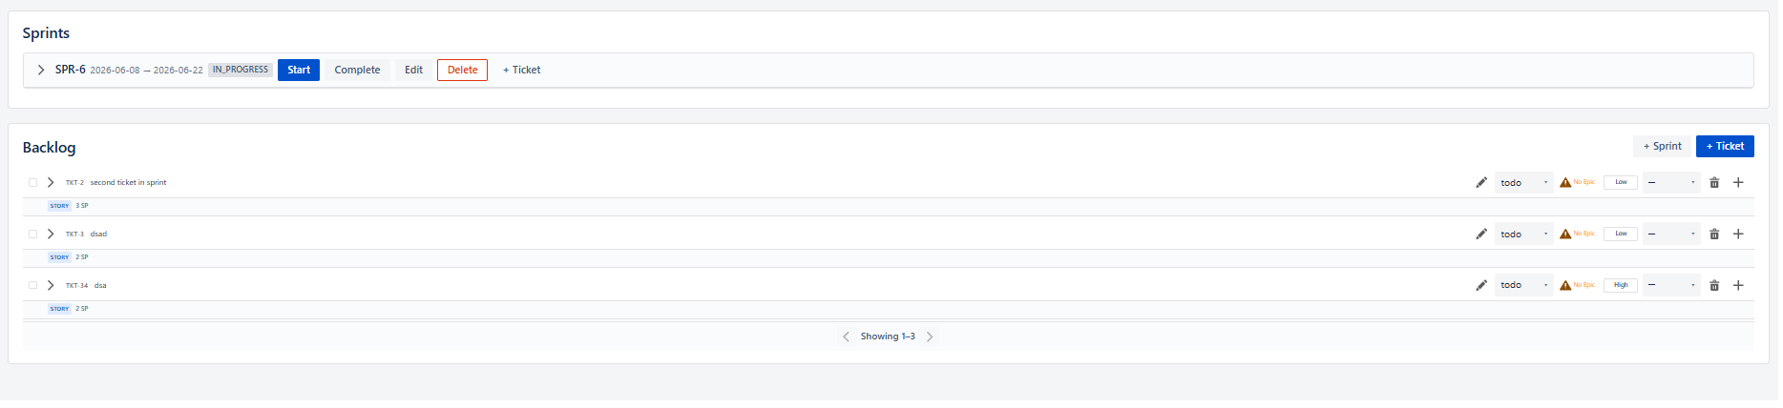
###########################
load-page-state-v00.png
###########################

4.2 Sprint container — dates, status, buttons, story-point line, paged tickets
Expanding a sprint shows the goal line, the Story Points progress line (ended / total SP · percent% with a progress bar), the paged list of ticket containers (5 per page, Page N with Prev/Next chevrons). This is the container that holds many ticket containers and the total-vs-ended story-point indicator.
###########################
expand-sprint-state-v01.png
###########################
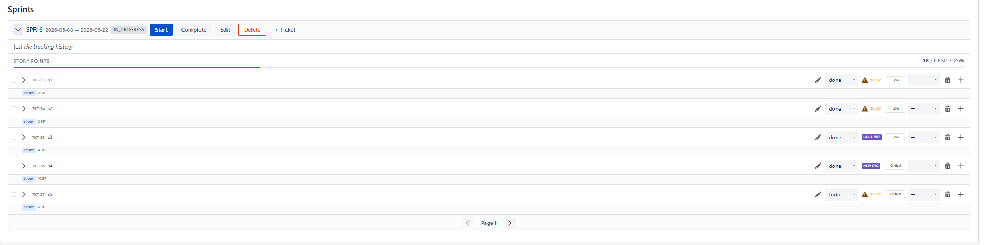
###########################
expand-sprint-state-v01.png
###########################
• Start → confirm → startSprint → status future → in_progress.
• Complete → confirm → completeSprint → status in_progress → completed; the sprint **no longer
shows** on the page.
• Edit → opens the Edit-Sprint modal pre-filled with the current values.
• Delete → confirmation pop-up; on confirm deleteSprint (tickets returned to backlog).
• + Ticket → opens the reusable Create-Ticket modal in sprint mode.

4.3 Backlog container — paged ticket rows
The backlog lists active, sprint-less tickets ordered by score, 5 per page, with a Showing 1–N indicator and Prev/Next chevrons. Tickets can be dragged from here onto a sprint.
###########################
backlog-container.png
###########################
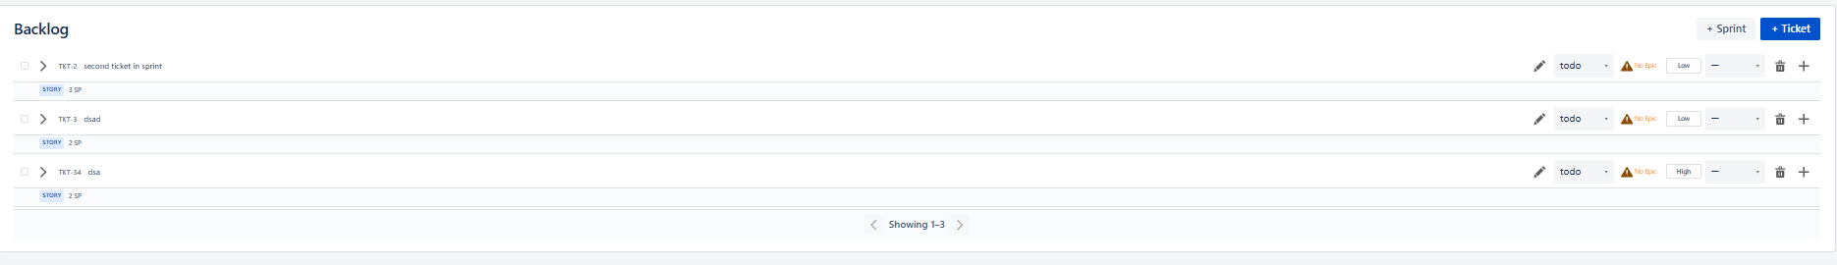
###########################
backlog-container.png
###########################

4.4 Create-Sprint modal (+ Sprint)
Fields: Duration (days) *, Start Date *, Goal *. Buttons Cancel / Create. Submitting calls createSprint(duration, startDate, goal, projectId).
###########################
create-sprint-modal.png
###########################
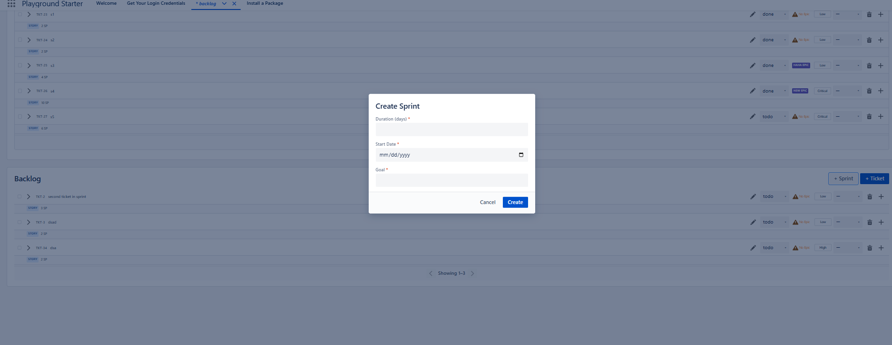
###########################
create-sprint-modal.png
###########################

4.5 Edit-Sprint modal (Edit)
Same fields as create, pre-filled with the sprint's current Duration / Start Date / Goal. Button label is Update; submitting calls updateSprint(sprintId, duration, startDate, goal).
###########################
edit-sprint-modal.png
###########################
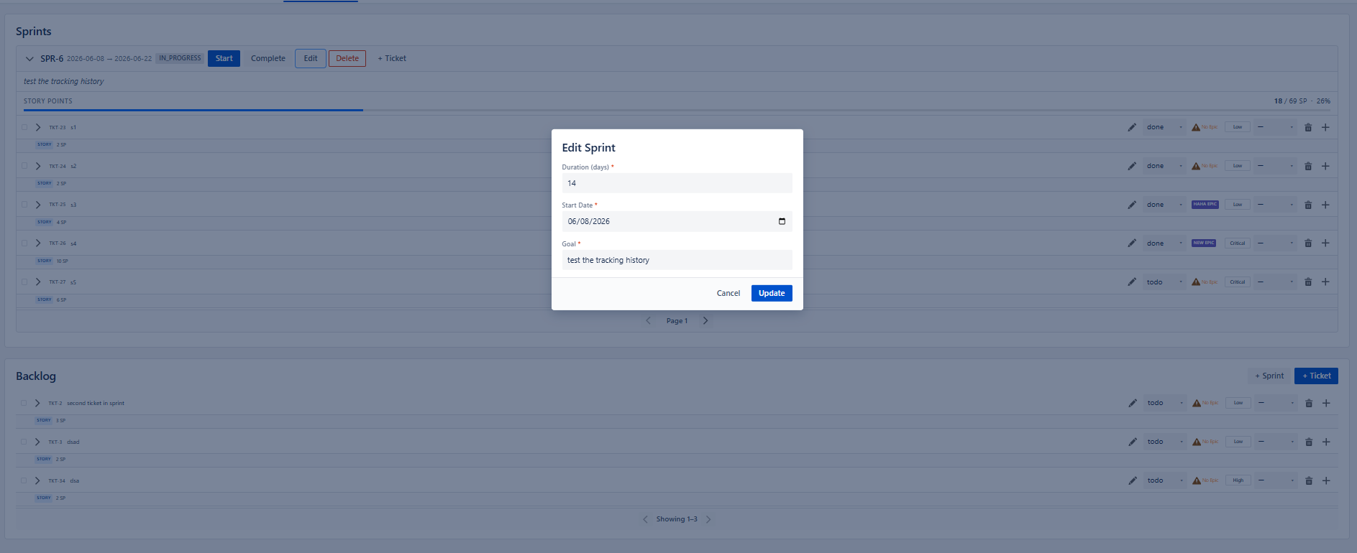
###########################
edit-sprint-modal.png
###########################

4.6 Create-Ticket modal (+ Ticket — reused across the project)
The single c-ao-create-ticket-modal is reused for both backlog and sprint creation. Fields: Summary, Description, Story Points, Ticket Type, State, Priority. Buttons Cancel / Create. In sprint mode the modal receives sprint-id and the parent calls createTicketFromSprint; otherwise createTicketFromBacklog.
###########################
create-ticket-modal.png
###########################
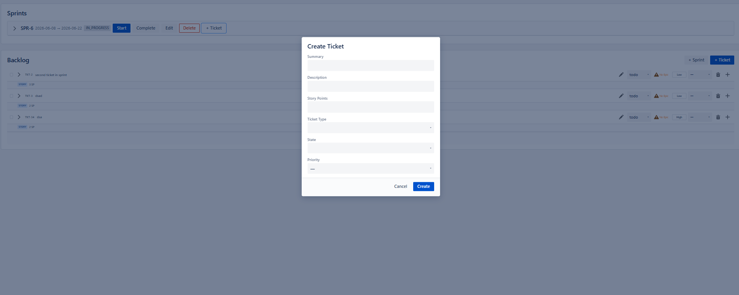
###########################
create-ticket-modal.png
###########################

4.7 Ticket container (row)
A row shows the ticket name, summary, epic label (No Epic when unset, clickable), current status combo, priority combo, assignee combo, plus the type/story-point chip (e.g. STORY 3 SP). Trailing controls: edit-summary (pencil), epic label, status combo, priority combo, assignee combo, delete (trash), and add-subtask (+). The leading chevron expands the sub-tasks; the leading checkbox selects for bulk delete.
###########################
ticket-container-row.png
###########################
###########################
ticket-container-row.png
###########################

4.8 Change priority — combo with confirm (✓) and close (✕)
Clicking the priority combo reveals a checkmark (confirm) and a close button. Confirming validates the value (Critical / High / Medium / Low) and calls updateTicketPriority.
###########################
change-priority-value.png
###########################
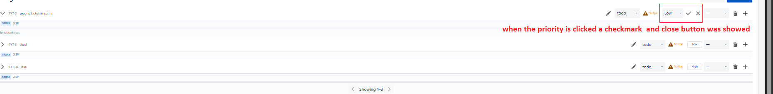
###########################
change-priority-value.png
###########################

4.9 Expand ticket — sub-tasks list
The ticket's expand chevron lazy-loads (loadSubtasks) and lists its sub-tasks beneath the row. Each sub-task supports summary edit, assignee change, and delete.
###########################
show-sub-task-for-ticket-container.png
###########################
###########################
show-sub-task-for-ticket-container.png
###########################

4.10 Create-Subtask modal (+ on a ticket)
Fields: Summary *, Description, Assignee, State, Story Points. Buttons Cancel / Create; submitting calls createSubtask.
###########################
create-sub-task-modal.png
###########################
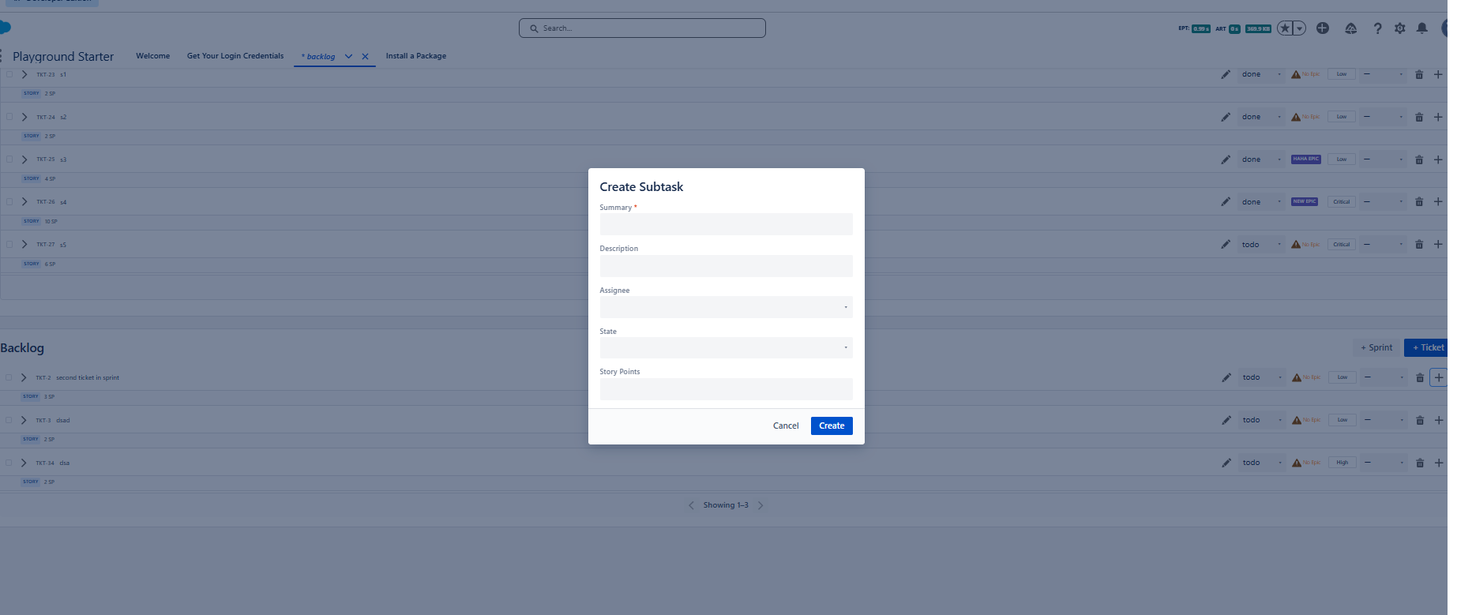
###########################
create-sub-task-modal.png
###########################

4.11 Update Epic Parent modal (epic label → choose existing or create new)
Clicking the epic label opens the epic modal. The user can pick an existing epic or create a new one. The create form fields: Epic Name *, Summary *, Description, Start Date, End Date. Creating calls createEpic then updateTicketEpic; choosing an existing epic calls updateTicketEpic directly.
###########################
create-epic-modal.png
###########################
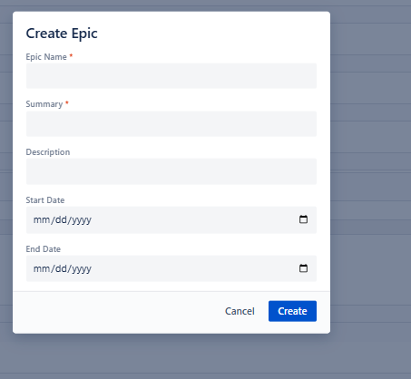
###########################
create-epic-modal.png
###########################

5. State, Paging & Drag-and-Drop Design
• Paging. PAGE_SIZE = 5 (backlogSprintUtils.js). Backlog tracks backlogOffset / backlogHasMore;
each sprint tracks its own offset / hasMore / currentPage / isFirstPage / isLastPage / offsetLabel. "has more" is inferred from rawTickets.length === PAGE_SIZE.
• Derived sprint view-model. formatSprint(raw) adds endDate (= start + duration days),
isComplete, storyPointsPercent, chevron/expansion/paging defaults, and drag-feedback classes.
• Derived ticket view-model. enrichTickets(...) / formatTicket(...) map epicName,
ticketTypeName, assigneeName, isSelected, a stable _key, and dropIndicatorClass.
• Mutators are "everywhere"-aware. Because a ticket can appear in the backlog and (when loaded)
in a sprint, patches go through _patchTicketEverywhere / _updateTicket…Everywhere so both copies stay consistent without a second fetch.
• Drag and drop. handlePageDragStart records the source container/ticket via DOM traversal
(dataTransfer is empty on dragstart). Sprint→different-sprint is blocked (dropEffect='none'). Same-container drops route to moveTicketPosition (reorder); cross-container drops route to moveTicketToSprint / moveTicketToBacklog. Top drop-zones allow inserting before the first item.
• Optimistic revert. On a failed status change the ticket is re-keyed (_reKeyTicket) to force the
combo to re-render its server value.

6. Error Handling & Loading
• Each imperative call sets isLoading = true, then in finally resets it; success === false
throws inside then so the shared catch toasts err.body?.message || err.message.
• Page-level load failure sets errorMessage and hides content (shouldShowContent).
• Confirmations (_confirm) gate destructive actions (sprint delete, bulk delete) behind the
confirmation dialog before any Apex call.

7. Traceability (SRS → API)
SRS | API call(s)
FR-2 page load | loadBacklogData
FR-4 / FR-8 paging | loadBacklogTickets, loadTicketsBySprint
FR-9..FR-13 sprint actions | startSprint, completeSprint, updateSprint, deleteSprint
FR-14/FR-15 create ticket | createTicketFromBacklog, createTicketFromSprint
FR-17 inline ops | updateTicketSummary, changeTicketState, updateTicketPriority, assignTicket, updateTicketEpic, deleteTicket
FR-18 epic | createEpic, updateTicketEpic, getEpicsByProject
FR-19 bulk delete | deleteTickets
FR-20/FR-21 sub-tasks | createSubtask, loadSubtasks, updateSubtaskSummary, assignSubtask, deleteSubtask, deleteSubtasks
FR-22..FR-24 move/reorder | moveTicketToSprint, moveTicketToBacklog, moveTicketPosition
FR-25 peek panel links | loadTicketLinkedTo, loadTicketLinkedToType, linkToTicket, loadTicketBySearchTerm

