
Technical Document
Session Log
Time: 32 minutes
ADD A “CREATE VALIDATION FIELD” FLOW TO MANAGEWORKFLOW
Development Run · Orchestrated Skill Chain · 2026-06-10

Session Log — Add “Create Validation Field” to manageWorkflow
A full record of the development run session: every question asked (via the interactive tool), the user’s response, and the files / fields read between each question. Ordered chronologically.
- Date: 2026-06-10
- Skill chain: agile-development-orchastrator → add-interactive-with-data-persistance-functionality-in-pather → shared FAQ → apex-method-resolution
- Outcome: new ValidateField__c create flow (LWC modal + controller + service + tests)

Phase 0 — Orchestrator routing

Reads before Q1
- force-app/skills/development/ (glob of all skill .md files)
- agile-development-orchastrator-skill.md — trigger is development run; defines Steps 1–6 and the AskUserQuestion-only interaction constraint.

Q1 — Bug or task?
Q: Is this a bug or a task?
A: Task

Q2 — Which task option?
Q: Which task option? (A) new component / (B) new functionality / (C) add existing component
A: B — New functionality

Q3 — Parent or child?
Q: Is this new functionality on a parent (pather) component or a child component?
A: Parent (pather)

Reads after Q3 (delegating to the task-skill)
- add-interactive-with-data-persistance-functionality-in-pather.md — entry gate + Steps 0–6.
- Step 0 mandatory-guide activation: frontmatter (all six, read in parallel):
Guide | Mode | Applies when
lwc-path-architecture-guide.md | required | always
lwc-apex-call-implementation-guide.md | required | component calls Apex
lwc-error-handling-guide.md | required | always (via ShowToastEvent)
pather_lwc_state_management_checklist-guide.md | required | before emitting pather state code
apex-path-architecture-guide.md | required | only if a new Apex method/class is created
apex-input-architecture-guide.md | required | only if a new Apex method takes params
pather-add-functionality-faq.md — the question iteration (questions .1–.8).

Phase 1 — Interview FAQ (prefix = Step 2)

Q2.1 — Parent LWC
Q: Which parent LWC (name or path) is this new functionality for?
A: manageWorkflow

Reads after Q2.1 (Step 1 entry-gate verification)
- manageWorkflow.js — grep for @salesforce/apex/ / @wire.
Finding: imports from ManageWorkflowPageController (getWorkflow, createStatus, addWorkflowTransition, …, addValidationRule). Entry gate passed (existing parent already uses Apex).

Q2.2 — Sub-components
Q: Which sub-component(s) does this new functionality apply to?
A: Transition detail panel

Q2.3 — User stories
Q: What are the user stories? Each operation (Load / Update / Create / Delete) needs its own story.
A: “As a user I want to create a new validation field” (one Create operation)
(First attempt errored — AskUserQuestion requires ≥2 options; re-asked with two options.)

Q2.4 — Behavior prompt
Q: Give me the functionality behavior prompt. It must cover every user story.
A: (see prompt below)
we should have a add validation rule button in the Transition detail
when the button is clicked a modal was show that show :
- combo box to choose the field api name
- combo box to choose the type of the validation
create button
cancel button
Coverage check (semantic): the single story create a new validation field is covered by the modal’s Create path. ✓

Reads after Q2.4 (validation sub-step)
- ask-user-for-lwc-validation.md — gate question + “required fields come from the object’s for lwc table in OBJECT_VALIDATION_LWC_APEX.md”.

Q2.5a — Validation needed?
Q: Does this component need any validation before it dispatches an event / calls Apex?
A: Yes

Q2.5b — Which validations?
Q: Which validations must run before the Create call?
A: Required fields only (both combo boxes mandatory; messages from the object’s for lwc table)

Q2.6 — Data state
Q: Which state provides the data? Name the source object and field.
A: “ai do that” (delegated determination to the assistant)

Reads after Q2.6 (determining the data state)
- Grep addValidationRule across force-app/main/default → found in manageWorkflow.js, ManageWorkflowPageControllerTest.cls, lwc/README.md.
- Glob objects/*alidation*/** → no files (no ValidationRule__c metadata in source).
- Glob objects/*/fields/* → discovered ValidateField__c with fields FieldName__c, Type__c, ErrorMessage__c, RecordStatus__c.
- Grep addValidationRule|ValidateField__c in ManageWorkflowPageController.cls → no match (controller no longer defines addValidationRule).
- Grep ValidationRule__c in classes/ → present in WorkflowConfigDTO, the test, and WorkflowService (getValidationRuleById, getPendingRules, insertValidationRule).
- Read controller (top 60) + glob ValidationRule__c/fields/* (none) + read test testAddValidationRule (356–376) → old signature wrote ValidationRule__c.TicketField__c.
- Grep @AuraEnabled in the controller → full method list (no addValidateField / addValidationRule).
- Grep ValidateField__c in classes/ → no files (no Apex backs the new object).
Field metadata read:
Field | Definition
Type__c | required Picklist, value Isn’t Empty (default)
FieldName__c | required, restricted Picklist of Ticket field API names (AssignedTo__c, CurrentState__c, …, Ticket_Type__c)
ErrorMessage__c | required Text(255)
RecordStatus__c | soft-delete status
Determined data state: ValidateField__c → FieldName__c (field combo) + Type__c (type combo); ErrorMessage__c derived server-side; RecordStatus__c soft-delete.

Q2.7 — Reusable base component
Q: Should the modal use existing base components?
A: c-ao-combobox + c-ao-btn

Reads after Q2.7 (Apex method resolution sub-step)
- apex-method-resolution.md — Branches A/B/C + Creation Sub-Loop (.1 what it does → recurse, .2 where, .3 cacheable).

Q2.8.1 — Which Apex method?
Q: Which Apex method should persist the new ValidateField__c?
A: C — Create it

Q2.8.1 (Creation Sub-Loop) — What should the controller do?
Q: What should the new controller method do?
A: Insert via a Service (controller validates inputs, delegates to ValidateFieldService.createValidateField)

Q2.8.1 depth-2 — Service method (recursed)
Q: ValidateFieldService.createValidateField doesn’t exist. What should it do?
A: Build + insert ValidateField__c (set RecordStatus active, derive ErrorMessage__c, one DML, return the record)
(No further unresolved symbols → recursion ends.)

Q2.8.2 — Where should the methods live?
Q: Where should the two new methods live?
A: Controller existing + new Service (addValidateField in ManageWorkflowPageController.cls; createValidateField in a new ValidateFieldService.cls under classes/domain/)

Q2.8.3 — Cacheable?
Q: Should addValidateField be cacheable? (It performs an insert.)
A: Not cacheable → imperative LWC call; @wire branches skipped.

Phase 2 — Implementation context gathering (after FAQ)

Reads after Q2.8.3
- manageWorkflow.js (full) — found handleCloseTransitionDetail() already calls undefined closeValidationRuleModal(); validators validateValidationType / validateTicketField already imported; principal state is workflowData; _toast helper exists.
- Grep validation refs + read workflowValidator.js — sidecar already exports the two required-field rules.
- manageWorkflow.html (full) — modal patterns (modal-backdrop / modal-container / … / close-button) and the Transition Detail header actions.
- aoCombobox.js — API: label, placeholder, value, options ({label,value}), emits change → event.detail.value.
- OBJECT_VALIDATION_LWC_APEX.md — revealed the inconsistency: documents ValidationRule__c but has no ValidateField__c entry.
Disambiguation surfaced here — the repo is mid-migration; the two validation objects disagree (see Phase 3).

Reads after the disambiguation (Apex patterns)
- ManageWorkflowPageController.cls (190–320) — createStatus / createTransition / addWorkflowTransition delegation style + end-of-class.
- WorkflowService.cls (1–160) — service shape, insertValidationRule, ServiceException, WorkflowConstants usage.
- StatusService.cls — per-object service template (createStatus → build + insert + ServiceException).
- Glob + read WorkflowConstants.cls (RECORD_STATUS_ACTIVE = 'active'), APIResponse.cls (2- & 3-arg constructors), DomainCorrectness.cls (requireXExists precondition).
- StatusService.cls-meta.xml — apiVersion 62.0 (reused for the new class meta); controller end (319–340) is the insertion point.

Phase 3 — Object disambiguation (blocking decision)
Q: Which object should the new “validation field/rule” persist to? (repo mid-migration; the two objects disagree)
A: ValidateField__c (rules are global, not per-transition; ErrorMessage__c derived server-side)
Evidence presented:
 | ValidationRule__c (old) | ValidateField__c (chosen)
In validation doc | ✅ | ❌
Service / DTO / test support | ✅ | ❌ (none)
Transition lookup | ✅ WorkflowTransition__c | ❌ (global)
Controller method | removed in “delete validation rule” | none yet (to be created)

Phase 4 — Code emitted
Concern | File
Service (build + insert) | classes/domain/ValidateFieldService.cls (new) + .cls-meta.xml
@AuraEnabled addValidateField | ManageWorkflowPageController.cls
Tests | removed dead ValidationRule__c tests; added testAddValidateField + missing-field test
Import swap + state + getters + handlers | lwc/manageWorkflow/manageWorkflow.js
Button + modal (two combos, btn) | lwc/manageWorkflow/manageWorkflow.html
Validator (reused) | lwc/manageWorkflow/workflowValidator.js
Checklists walked: task-skill Step 5 (7 rows) + pather_lwc_state_management_checklist (Rules 0–7). Bulkification skipped (single-record insert). soql-exclude-deleted N/A (no SELECT in the create path).

Phase 5 — End-of-skill decisions (Step 6)

Reads after Step 6 answers
- lwc-css-design-guide.md — Atlassian/Jira palette, §9.5 modal recipe, §8 input recipe.
- Grep manageWorkflow.css modal rules — existing rules already space stacked combos → no new CSS needed.
- ManageWorkflowPageControllerTest.cls (full) — to remove the dead validation-rule tests.

Q (multi) — Styling / Profiling / Broken test
Q (a): Apply lwc-css-design-guide to the new button + modal now? → Yes (satisfied by reuse — no new CSS)
Q (b): Run apex-method-monitor on addValidateField? → No, skip profiling
Q (c): The old validation-rule test blocks Apex deployment — how to handle? → Remove the dead tests (and add an addValidateField test)

Phase 6 — Loop back
Q: Start another development iteration, or are you done?
A: Done → orchestrator exited.

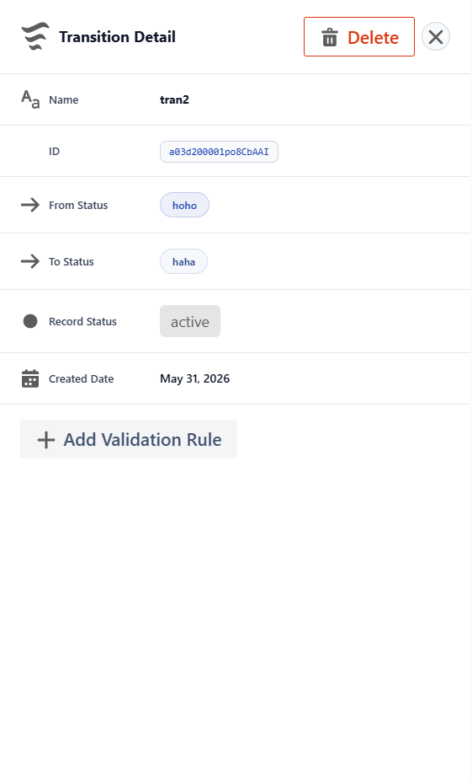

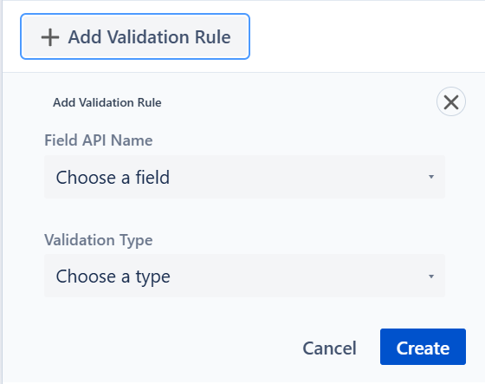

Fail Case :
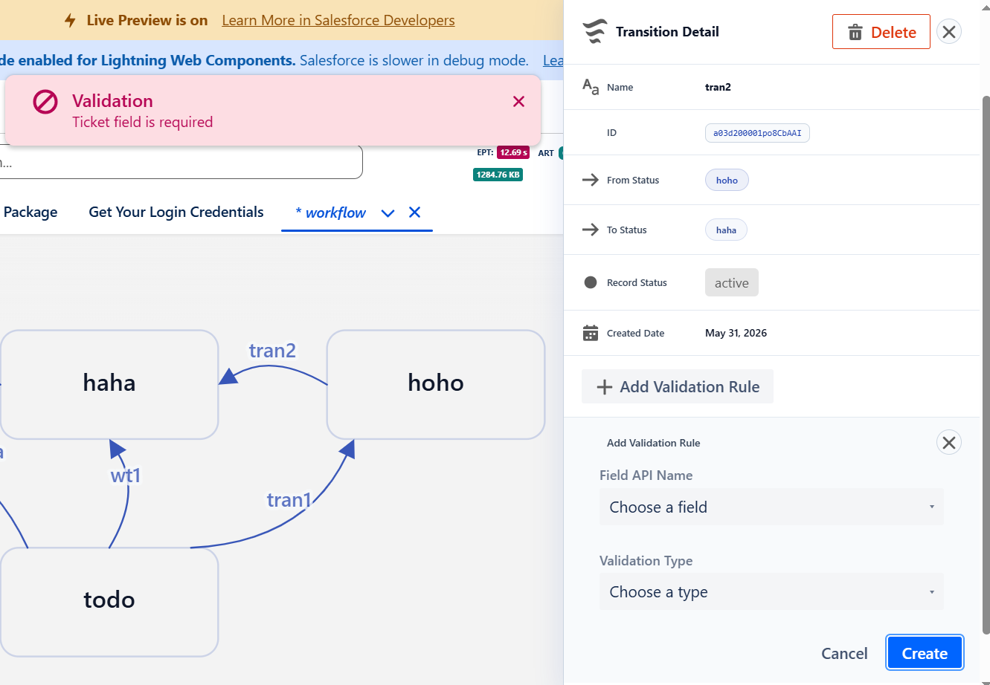

Success case:
