
Technical Document
Skills Path Architecture
AUTOMATING THE DEVELOPMENT PHASE OF THE AGILE SDLC
Reliability · Consistency · Maintainability

Skills Path Architecture
How force-app/skills/development/ is shaped to automate the Development phase of the Agile SDLC for the developer while adapting to this project's architecture and rules, and how that shape resolves three concrete challenges: reliability, consistency, maintainability.

1. The goal
This skill set is not a grab-bag of recipes. It targets one intersection of the SDLC and one role, under one set of constraints.
Question | Answer
Which SDLC phase does this automate? | The Development phase of Agile.
Who uses it? | The developer.
For what? | To implement a task (the bug flow is reserved for later).
Constrained by what? | The project's architecture and rules — LWC architecture, Apex bulkification, soft-delete filter, required fields, controller → Service → APIResponse layering.
Restated:
Build a skill that automates the Development phase of the Agile SDLC for the developer, that adapts to this project's architecture, rules, and framework, and that delivers reliability, consistency, and maintainability without architectural overhead.
The rest of this document is the architecture that meets that goal, organized by the three challenges it has to solve.

2. From a flat pool to an orchestrator
The current shape is the third design in a progression — each step fixes the problem the previous one left open.

Solution 1 — One flat pool of skills
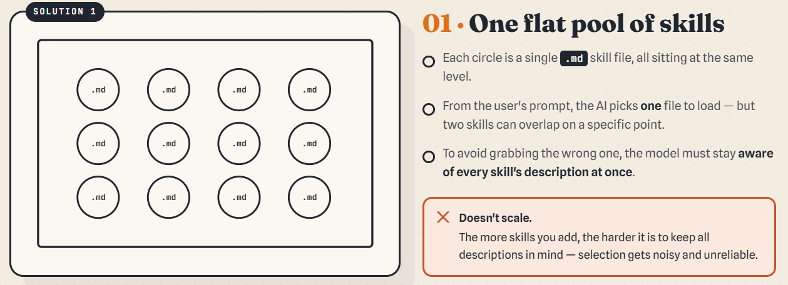One flat pool of skills
- Each circle is a single .md skill, all sitting at the same level.
- From the prompt the model picks one file — but two skills can overlap on a point.
- To avoid grabbing the wrong one, the developer must stay aware of every skill's description at once.
✗ Doesn't scale. Being aware of every skill is impossible once the system grows, and it costs more time on every prompt. The more skills you add, the noisier and less reliable selection gets.
Developer should be aware in all skill to avoid the conflict which is impossible and if it was it take along of time for check.

Solution 2 — Group into skills & sub-skills
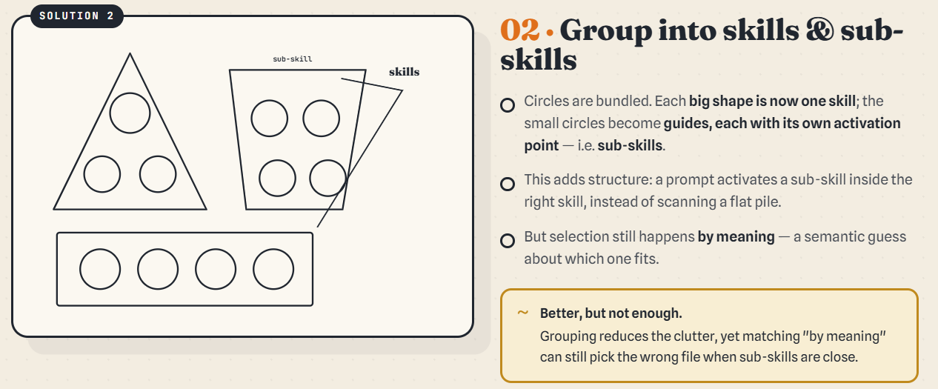Group into skills and sub-skills
- Circles are bundled: each big shape is one skill; the small circles become guides (sub-skills), each with its own activation point.
- A prompt activates a sub-skill inside the right skill instead of scanning a flat pile.
~ Better, but not enough. Selection still happens by meaning — a semantic guess — so it can still pick the wrong file when two sub-skills are close.

Solution 3 — Wrap it in an orchestrator
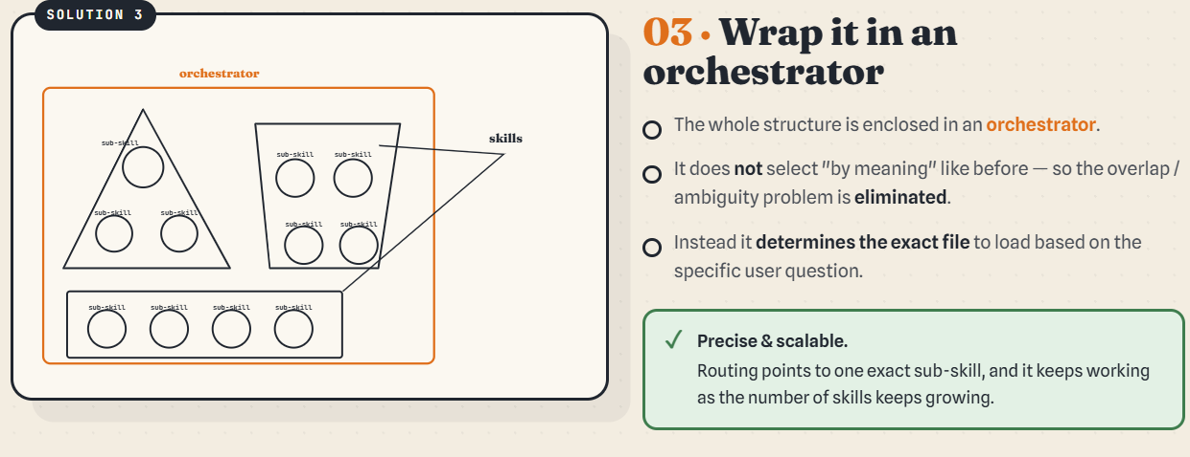Wrap it in an orchestrator
- The whole structure is enclosed in an orchestrator.
- It does not select “by meaning”, so the overlap/ambiguity problem is eliminated.
- It determines the exact file to load from the specific user question.
✓ Precise & scalable. Routing points to one exact sub-skill, and it keeps working as the number of skills grows.

3. The three challenges (with examples)

2.1 Reliability — the right skill must fire even when the user didn't name it
Problem. A skill only fires if the model picks it. If the user's prompt doesn't name a downstream skill, it gets silently skipped.
Solution. Make the call explicit inside the calling skill, so it cannot be missed regardless of wording.
Example. The user says “create a new parent LWC” — nothing about CSS. The parent task-skill itself names the CSS handoff as a fixed step:
create-new-parent-lwc-component.md:207 — Step 4 — Optionally apply lwc-css-design

2.2 Consistency — same intent, same path, every time
Problem. With N skills directly addressable, the user's wording decides which one fires. Same intent, different phrasings, different paths.
Solution. One entry point — the orchestrator — and an AskUserQuestion flow that turns the prompt into a fixed set of answers, so the user's intent is captured with 100% certainty.
Example. Any dev request enters agile-development-orchastrator-skill.md and answers two AskUserQuestion calls: bug vs. task, then A/B/C + parent/child. Three different phrasings of “build a feature on a parent LWC” all land on the same row:
B — create new functionality / parent → add-interactive-with-data-persistance-functionality-in-pather.md

2.3 Maintainability — a new task can't fan out edits across every other task
Problem. When several task-skills need the same sub-step, in-lining it in each one means every change has to touch every copy.
Solution. Extract the shared sub-step into one file under task-skill/guide/ and have each task-skill call it.
Example. Both add-interactive-with-data-persistance-functionality-in-pather.md and lwc-parent-event-handler-generator.md need to resolve “which Apex method backs this?”. Instead of asking that interview manually in each file, both call guide/apex-method-resolution-guide.md — the three-branch interview (existing-known / existing-find / create-new) lives in exactly one file.

4. Adaptation to project architecture and rules
The orchestrator does not invent rules — it routes work into skills that already encode the project's rules. The chain of constraints, as they fire during a typical “create a new parent LWC” iteration:
- Orchestrator — classifies as task / option A / parent.
- create-new-parent-lwc-component — Step 0 mandates lwc-architecture end-to-end (page vs. child, principal state shape, localStorage keys, Apex methods, event names, sidecar utils / validator, meta.xml exposure).
- Per-iteration sub-skill (A → functionality, B → event handler) runs its full disciplined interview, then hands off to the shared Apex-method-resolution protocol when controller methods need to be resolved.
- Final Verification — the project-wide MANDATORY skills declared in CLAUDE.md are checked: bulkified Apex (apex-bulk-soql), soft-delete filter (soql-exclude-deleted), required fields per OBJECT_VALIDATION_LWC_APEX.md (object-required-fields), thin controller → Service → APIResponse layering (lwc-architecture).
- Optional CSS handoff — Step 4 asks whether to apply lwc-css-design so the new parent drops in next to manageBacklog / manageWorkflow without visual tuning.
Every project-specific rule has exactly one home, and the orchestrator guarantees the rules are reached — not left to the model to remember.

5. Current file layout (for reference)
force-app/skills/development/
├── agile-development-orchastrator-skill.md ← single entry
├── architecture/
│ ├── lwc-architecture.md
│ └── lwc-css-design.md
├── contract/
│ ├── object-required-fields-skill.md
│ └── soql-exclude-deleted-skill.md
├── guard/
│ ├── apex-governor-limit-guard.md
│ ├
│
├── performance/
│ ├── apex-bulk-soql.md
│ └── apex-method-monitor.md
└── task-skill/
├── add-functionality-in-child-lwc-component.md
├── add-interactive-with-data-persistance-functionality-in-pather.md
├── create-new-child-lwc-component.md
├── create-new-parent-lwc-component.md
├── lwc-parent-event-handler-generator.md
└── guide/
└── apex-method-resolution-guide.md
└── lwc-request-loading-guide.md
└── lwc-error-handling-guide.md

