
Technical Document
Manage Ticket Tracking — SDD
SOFTWARE DESIGN DOCUMENT
Manage Ticket Tracking · Sprint Board

Software Design Document (SDD) — Manage Ticket Tracking
Feature: Manage Ticket Tracking (Sprint board) Apex controller: force-app/main/default/classes/controller/manageTicketTracking/ManageTicketTrackingController.cls LWC: force-app/main/default/lwc/manageTicketTracking/ Date: 2026-06-21
Image references below follow the marker convention used across these design documents: the image file name is wrapped between ########################### lines, immediately before and after the embedded screenshot.

1. Architecture Overview
┌─ manageTicketTracking (parent LWC) ─────────────────────────────────────────┐
│ Principal state: _sprint = { ...sprint, tickets[] } (de-normalized) │
│ each ticket carries: ticketType{ workflowTransitions[] }, ticketTypeName, │
│ assigneeName, isEndStatus, key + _statuses[] (the board lanes) │
│ UI-only state (outside principal): _activeTicketViewId, drag state, │
│ _searchTerm/_ticketSearchResults, _linkedTo/_subtasks/_history/_comments │
│ target ids │
│ Derived getters: columns · activeTicketViewModel · sprintDateRange · │
│ storyPointsPercent · isTicketViewOpen · ticketViewSearchOptions │
│ │
│ Children │
│ c-ticket-board-column (one per status): header(name+count) · cards · │
│ 'Drop here' when isValidTarget · card click -> ticketviewopen · │
│ dragstart/drop -> status change │
│ c-ticket-view (centered modal): summary · status · description · │
│ linked work items · sub-tasks · history · comments │
└──────────────────────────────────────────────────────────────────────────────┘
│ imperative writes + @wire(cacheable=true) reads
▼
ManageTicketTrackingController
→ StatusService · WorkflowService · ProjectService · TicketService · SprintService
→ Status__c · WorkflowTransition__c · Ticket__c · Sprint__c · Subtask__c · …
Response envelope. Every controller method returns APIResponse { success, message, data }. The LWC treats success === false (or a thrown Apex error) as failure and toasts it via _showError; successful writes patch the principal state from the returned data, never from an optimistic draft.
Data shape used by the page (from loadManageTicketTrackingPage): { status, workflows, sprint_tickets, members, ticketTypes, sprint }. buildSprintTickets nests each ticket’s type and that type’s workflow transitions onto the ticket, and derives isEndStatus from the statuses whose isEnd__c is true — so the board needs no further round-trips to compute columns or valid drop targets.

2. API Calls (Apex @AuraEnabled methods)
Legend: C = cacheable=true (wire-friendly), I = imperative (DML). All methods return APIResponse{success,message,data}.

2.1 Page bootstrap & search
Method | Kind | Params | Returns (`data`) | LWC usage
loadManageTicketTrackingPage | C | projectId | {status, workflows, sprint_tickets, members, ticketTypes, sprint} | _loadData() imperative call on mount
loadTicketBySearchTerm | C | projectId, searchTerm | Ticket__c[] (SOSL, special chars escaped) | @wire — ticket-view link search
loadTicketLinkTypes | C | projectId | {ticketLinkTypes} | @wire — link-type combobox options

2.2 Ticket status change (board move + ticket-view combo)
Method | Kind | Params | Effect
changeTicketState | I | ticketId, fromStatusId, toStatusId | requireTransitionAllowed + requireValidateFieldsPass; on pass writes CurrentState__c; if the new status is an end status bumps the sprint ended SP; returns {isEndStatus, updatedSprint}

2.3 Ticket inline edits & links
Method | Kind | Params | Effect
updateTicketSummary | I | ticketId, summary | inline summary edit; returns Ticket__c
updateTicketDescription | I | ticketId, description | rich-text description edit; returns Ticket__c
loadTicketLinkedTo | C | ticketId | {ticketLinkTo} — the ticket’s links
linkToTicket | I | fromTicketId, toTicketId, linkType | create link; returns {ticketLink} DTO
createTicketLink | I | fromTicketId, toTicketId, linkType | create link (no DTO returned)

2.4 Sub-tasks
Method | Kind | Params | Effect
loadSubtasks | C | ticketId | Subtask__c[] for the ticket
createSubtask | I | summary, ticketId, description, assigneeId, currentStateId, storyPoint, startDate | create sub-task (summary required; rest optional); returns Subtask__c

2.5 History & comments
Method | Kind | Params | Effect
loadTicketHistory | C | ticketId | TicketHistoryDto[] (activity feed)
loadTicketComments | C | ticketId | TicketCommentDto[] (newest first)
createTicketComment | I | ticketId, message | add comment; returns TicketCommentDto

2.6 Wires actually bound in manageTicketTracking.js
• @wire(loadTicketLinkTypes, { projectId: '$_projectId' }) → _ticketLinkTypes
• @wire(loadTicketLinkedTo, { ticketId: '$_linkedToTargetTicketId' }) → patches the linkedTo slice
• @wire(loadTicketBySearchTerm, { projectId: '$_projectId', searchTerm: '$_searchTerm' }) → _ticketSearchResults
• @wire(loadSubtasks, { ticketId: '$_subtasksTargetTicketId' }) → patches the subtasks slice
• @wire(loadTicketHistory, { ticketId: '$_historyTargetTicketId' }) → patches the history slice
• @wire(loadTicketComments, { ticketId: '$_commentsTargetTicketId' }) → patches the comments slice; the result is kept so re-expanding the same ticket re-fetches via refreshApex
All writes (changeTicketState, updateTicketSummary, updateTicketDescription, linkToTicket, createSubtask, createTicketComment) and the initial page load are imperative Apex calls inside handlers (then/catch/finally), toasting via _showSuccess / _showError.

3. Sequence Flows (key interactions)
3.1 Page load
connectedCallback → loadStyle(aoTheme) → read localStorage.projectId
├─ none → render <c-choose-project>; on projectchosen → _projectId → _loadData()
└─ present → _loadData() → loadManageTicketTrackingPage(projectId)
success → set _statuses, statusOptions, memberOptions, epics, priorityOptions
→ _setSprintFromResponse → buildSprintTickets (nest type + transitions,
derive isEndStatus) → _sprint → columns getter renders the board
no sprint→ _sprint = null → "No active sprint" banner (columns hidden)
fail/throw→ errorMessage set → error toast, content hidden
3.2 Drag-and-drop status change
card dragstart (c-ticket-board-column) → ticketdragstart{ ticketId, fromStatusId, ticketTypeId }
parent: set _dragTicketId / _dragFromStatusId / _dragTicketType
→ getValidTargetStatusIds(type, fromStatus) → _validTargetStatusIds
→ columns getter flags isValidTarget → only those columns show "Drop here"
drop on a column (accepted only when isValidTarget) → ticketdrop{ toStatusId }
parent handleTicketDrop:
toStatus == fromStatus → ignored
validateChangeTicketState(id, to) → client required-field guard
findTransitionId(type, from, to)==null → "This transition is not allowed by the workflow."
else → changeTicketState(ticketId, fromStatusId, toStatusId)
success → _applyTicketStateChange: move card + re-key; if isEndStatus,
fold updatedSprint.TotalEndedStoryPoint__c onto _sprint (SP line)
dragend → _clearDragState
3.3 Open ticket view & inline edits
card click → ticketviewopen → handleOpenTicketView sets _activeTicketViewId
isTicketViewOpen → true ; activeTicketViewModel = _findTicketById(id)
render centered modal <c-ticket-view ticket={activeTicketViewModel}>
├─ ticketsummaryupdate → updateTicketSummary → _setTicketSummary
├─ ticketstatuschange → changeTicketState → _applyTicketStateChange
├─ ticketdescriptionupdate → updateTicketDescription → _setTicketDescription
└─ closeticketview / backdrop click → clear _activeTicketViewId (+ wire targets)
3.4 Lazy-load detail sections (expand → cacheable wire → patch slice)
ticketlinkedtoexpand → _linkedToTargetTicketId → loadTicketLinkedTo → _setTicketLinkedTo
subtasksexpand → _subtasksTargetTicketId → loadSubtasks → _setTicketSubtasks
tickethistoryexpand → _historyTargetTicketId → loadTicketHistory → _setTicketHistory
ticketcommentsexpand → _commentsTargetTicketId → loadTicketComments → _setTicketComments
re-expand same comments id → refreshApex(_commentsWireResult)
ticketsearch → _searchTerm → loadTicketBySearchTerm → _ticketSearchResults (combobox)
ticketlinkcreate → linkToTicket → _addTicketLink (append)
subtaskcreate → createSubtask → _addTicketSubtask (append)
ticketcommentcreate → createTicketComment → _addTicketComment (prepend, newest first)

4. UI / UX Specification

4.1 Page load — sprint header, story-point line, status columns
On load the page shows the active sprint header (name and start → end date range, where the end is derived from start + Duration__c, plus the goal) and the Story Points line (ended / total SP and percent with a progress bar). Beneath it the board renders one column per project status (in order); each column header shows the status name and its ticket count, and holds 0..many ticket cards. If there is no in_progress sprint a “No active sprint” banner replaces the board.
###########################
Manage-ticket-tracking-default.png
###########################
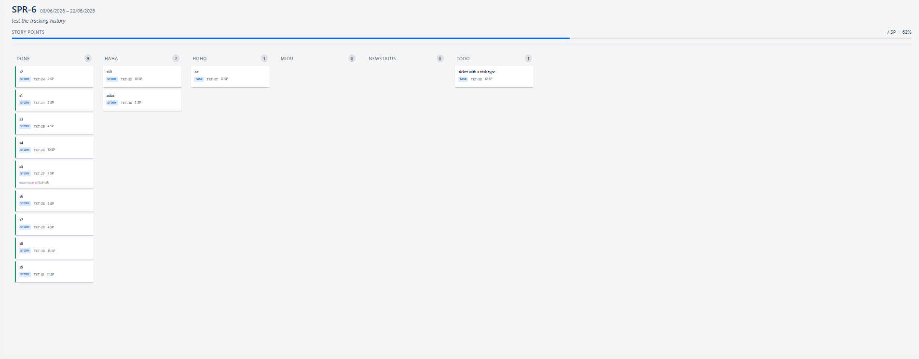

4.2 Ticket card (tracking-card) & the Done (green) border
Each card (c-ao-ticket-item, variant="tracking-card") shows the ticket name, ticket type, summary, story points, and the assigned member name. A card whose current status is an end status (isEndStatus, from statuses with isEnd__c = true) carries data-end-status="true", which the column CSS renders as a 3px green left border (#00875A) to signal the ticket has finished. Clicking a card dispatches ticketviewopen and opens the ticket-view pop-up.

4.3 Drag-and-drop — type-aware drop targets
On drag start the system highlights only the columns reachable from the card’s current status for that ticket type (getValidTargetStatusIds reads the type’s own workflowTransitions); valid columns gain the valid-target style and a “Drop here” hint, and only they accept a drop. Because each ticket type points at its own workflow, a Story and a Task expose different reachable columns from the same status.
###########################
Ticket-type-story-move.png
###########################
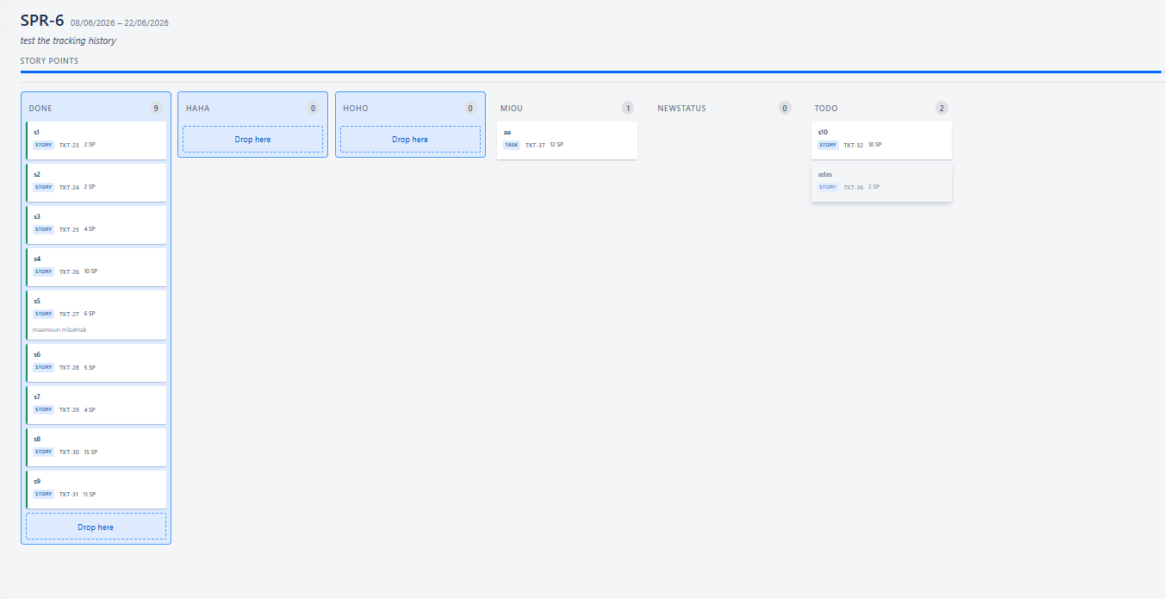
###########################
Ticket-type-task-move.png
###########################
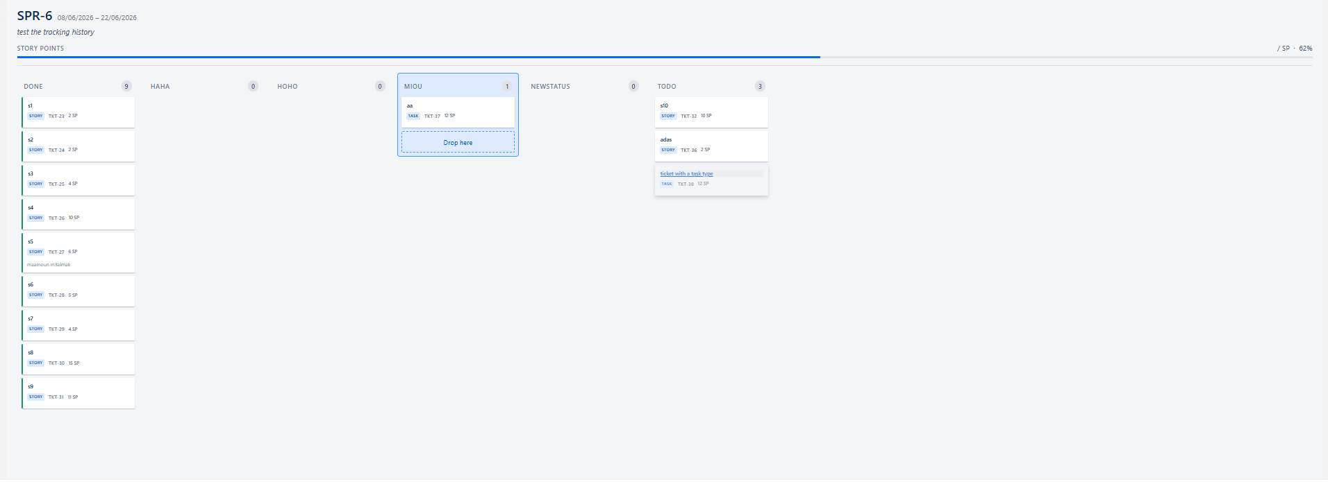

4.4 Ticket view pop-up (c-ticket-view)
Clicking a card opens the ticket view as a modal centered on the screen over a backdrop (clicking the backdrop or × closes it). It shows the TKT-id, summary, current status combo, description, and the Linked work items / Sub-tasks / History / Comments sections. Status changes here run the same workflow + validate-field gate as a board move.
###########################
Ticket-view-pop-up.png
###########################
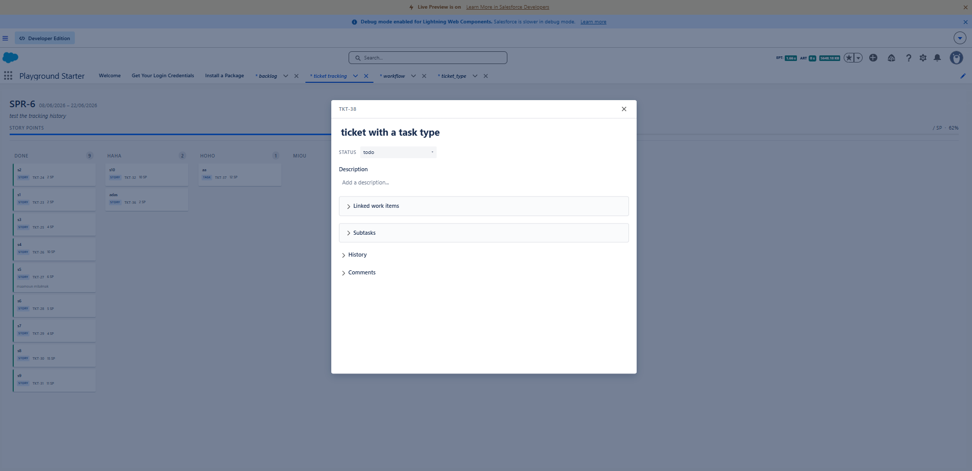

4.5 Edit description (rich text)
Clicking the description opens a rich-text editor with Save / Cancel; Save dispatches ticketdescriptionupdate → updateTicketDescription and patches the principal ticket from the response.
###########################
Ticket-view-click-on-description.png
###########################
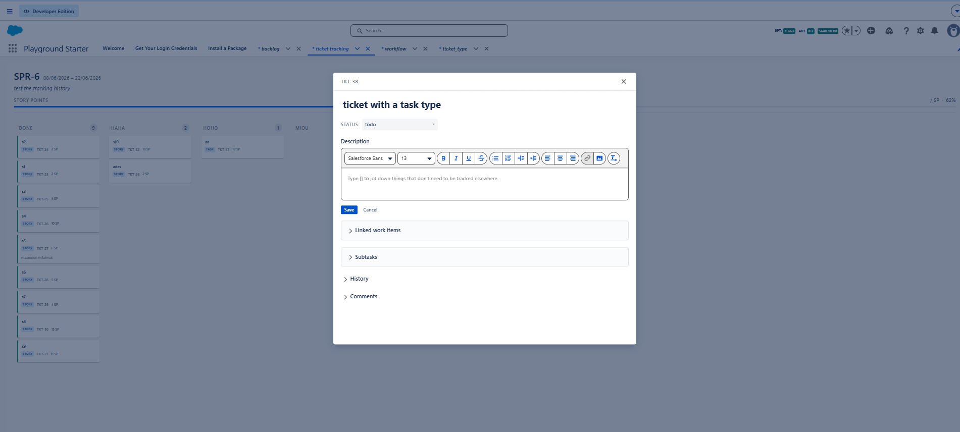

4.6 Linked work items
Expanding Linked work items fires loadTicketLinkedTo and lists the ticket’s links; an empty list shows “No linked items.” Clicking + reveals the add-link row: choose a Link type and search a target ticket (loadTicketBySearchTerm, min 2 characters), then Link (linkToTicket appends the returned link).
###########################
Ticket-view-expand-ticket-view.png
###########################
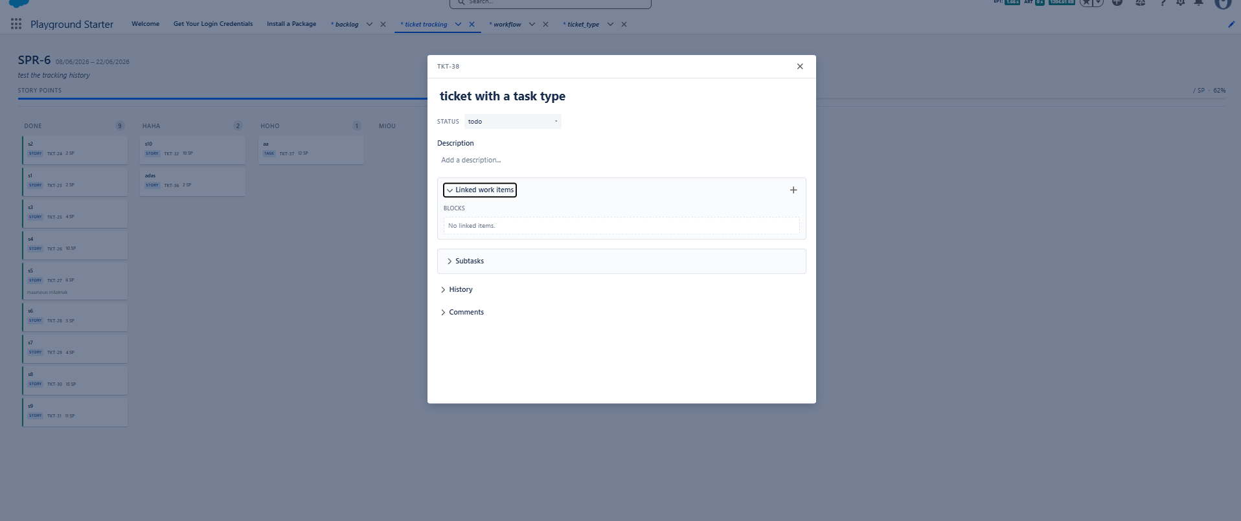
###########################
Ticket-view-click-plus.png
###########################
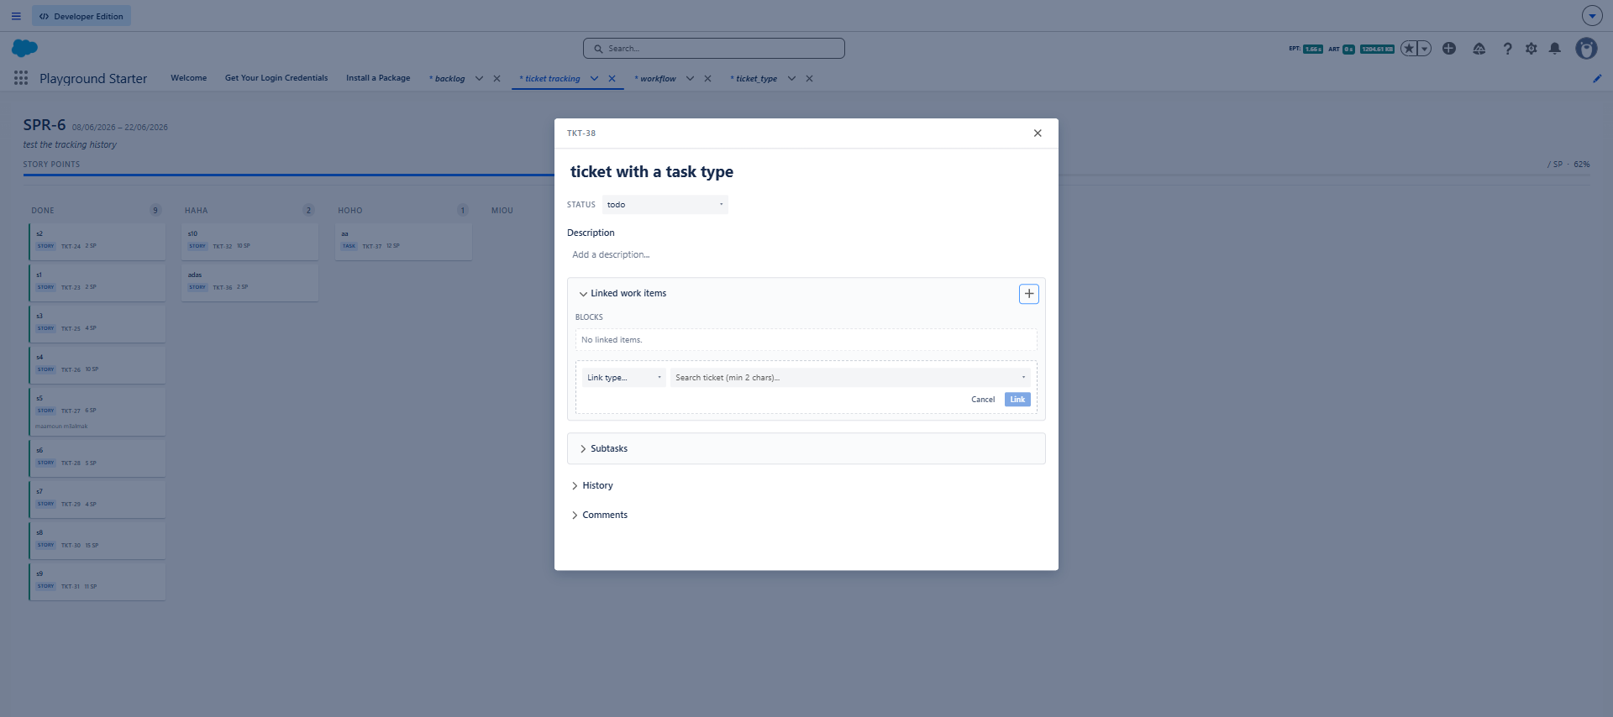

4.7 Sub-tasks
Expanding Sub-tasks fires loadSubtasks and lists them; empty shows “No subtasks.” Clicking + opens the create-sub-task form: Summary (required) plus optional Assignee, Current State, Start Date, Story Point, and a rich-text Description; Create calls createSubtask and appends the result.

###########################
Ticket-view-expand-subtask.png
###########################
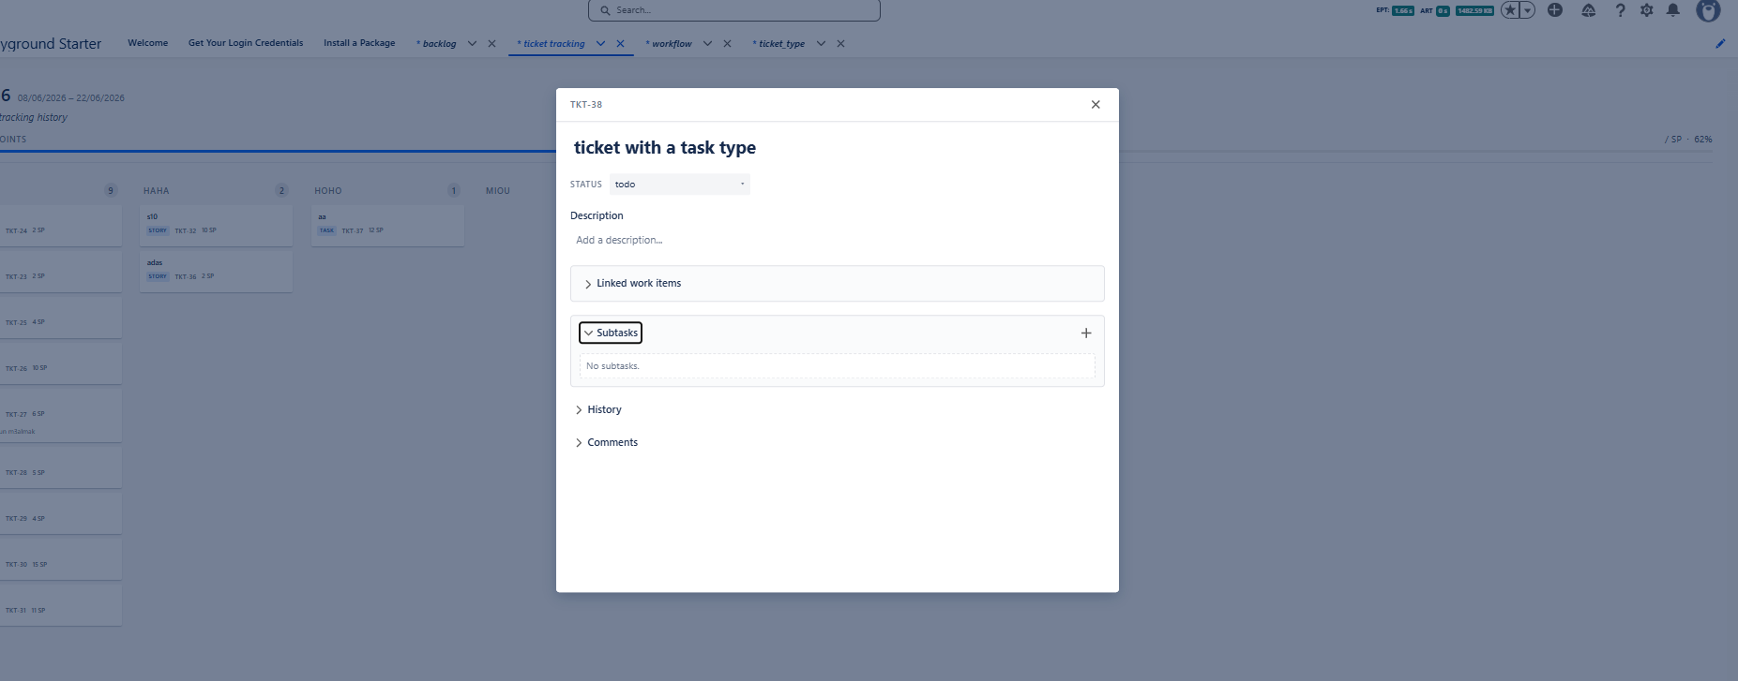
###########################
Ticket-view-click-plus-subtask.png
###########################
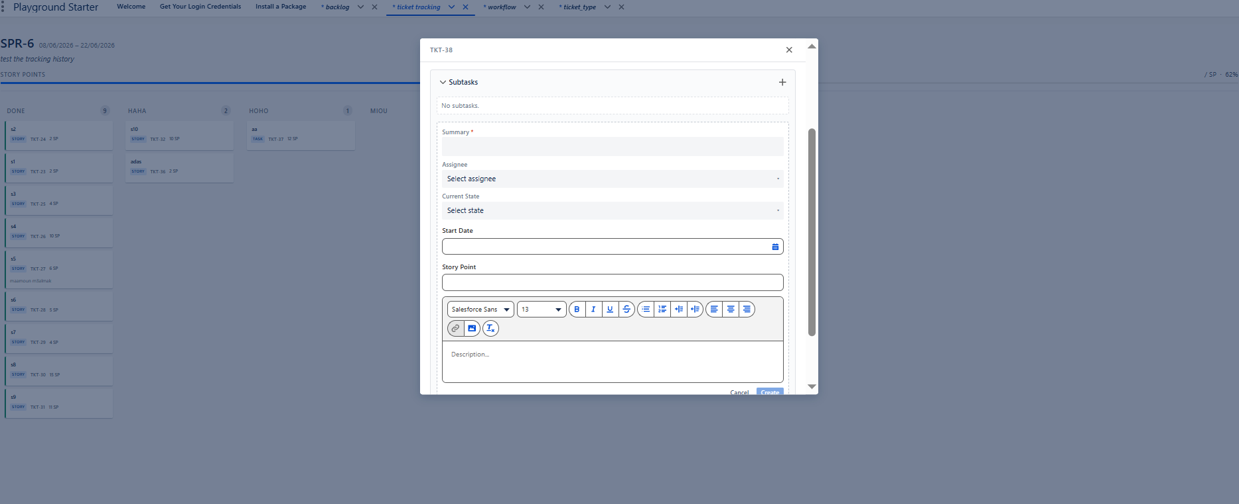

4.8 History
Expanding History fires loadTicketHistory and shows the ticket’s activity feed (e.g. “Ticket created”), each entry with its author and timestamp.
###########################
Ticket-view-expand-history.png
###########################
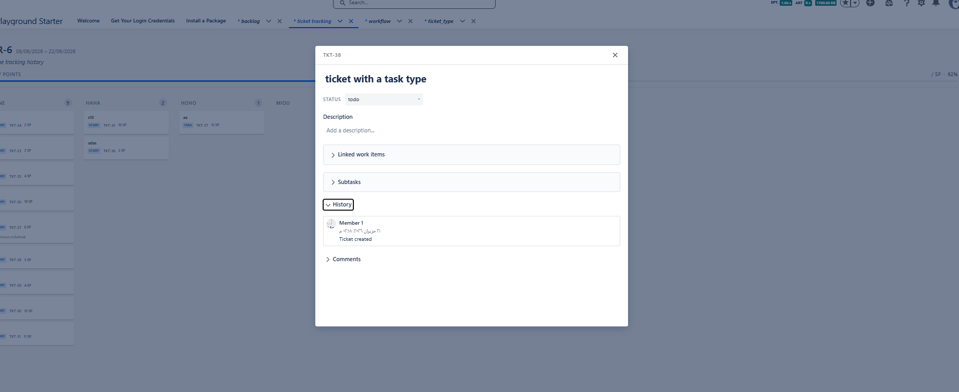

4.9 Comments
Expanding Comments fires loadTicketComments and shows the add-comment box and the existing comments (newest first), each with author and timestamp; posting calls createTicketComment and prepends it. Re-expanding the same ticket refreshes via refreshApex.
###########################
Ticket-view-expand-comment.png
###########################
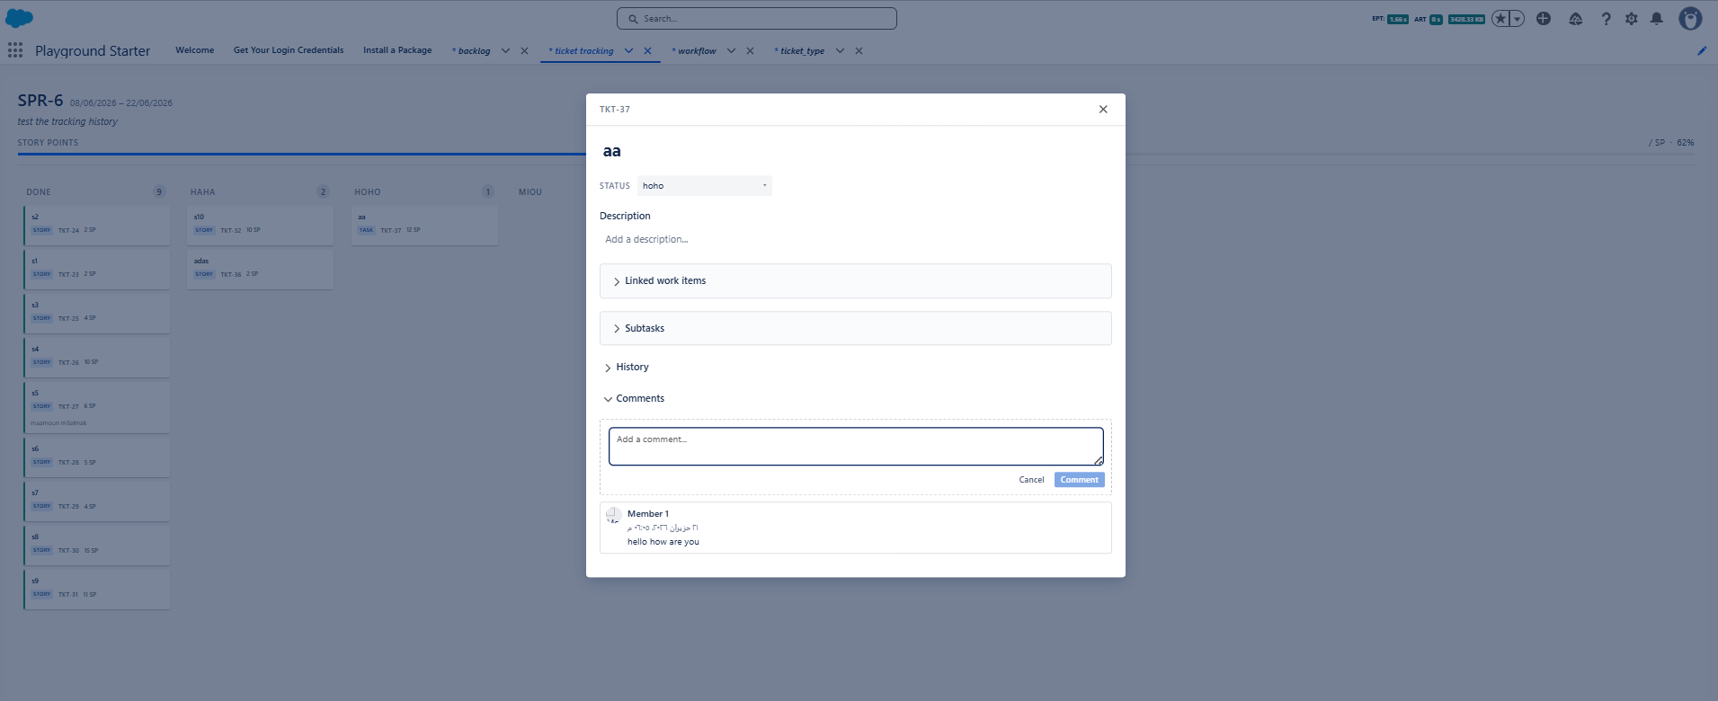

5. State, Drag-and-Drop & Derived View Design
• Principal state. One de-normalized _sprint = { ...sprint, tickets[] } (plus _statuses for the lanes). Every displayed value is a getter derived on read — columns, activeTicketViewModel, sprintDateRange, storyPointsPercent, isTicketViewOpen, ticketViewSearchOptions — never a parallel tracked field.
• De-normalized ticket shape. buildSprintTickets nests each ticket’s ticketType and that type’s workflowTransitions onto the ticket and precomputes ticketTypeName, assigneeName, and isEndStatus. The data is duplicated across tickets on purpose: the page only reads types/workflows, so there is no shared state to keep in sync.
• Derived columns. buildColumns(_statuses, tickets, _validTargetStatusIds) builds the lanes, fills each with the tickets whose CurrentState__c equals the status, and flags isValidTarget for the highlighted drop targets.
• Mutators only (R5). Writes go through named immutable mutators — _writeSprint / _patchTicket and the _set…/_add… family — with no inline spreads elsewhere; each ticket field update re-keys the card (newTicketKey) so LWC re-renders exactly that one card.
• Drag-and-drop. Valid targets are computed in the browser (getValidTargetStatusIds); the column only preventDefaults dragover / accepts drop when isValidTarget. handleTicketDrop ignores same-column drops, applies the client guards (validateChangeTicketState, findTransitionId), then calls changeTicketState; dragend always clears the drag state.
• No paging. Unlike the backlog, the board loads the single active sprint’s active tickets in one shot (ordered by Score__c) and distributes them across columns — there is no per-list paging.

6. Error Handling & Loading
• isLoading gates the board (a c-ao-spinner shows while _loadData runs); shouldShowContent hides the board while loading or when an error is set.
• Every imperative call checks res.success — on false it calls _showError(res.message) and aborts the patch; thrown Apex errors are caught and surfaced via _errMsg (err.body?.message || fallback).
• Page-level load failure sets errorMessage and toasts, so the board is not shown with partial data.
• Server guards mirror the client: each @AuraEnabled method blank-checks required params and returns APIResponse(false, "<field> is required"), then DomainCorrectness.require* verifies referenced records before any DML; loadTicketBySearchTerm escapes SOSL/SOQL special characters.

7. Traceability (SRS → API)
SRS | API call(s) / mechanism
FR-1..FR-3 load & active sprint | loadManageTicketTrackingPage (SprintService.loadActiveSprint)
FR-4/FR-5 sprint header & SP line | loadManageTicketTrackingPage → sprintDateRange, storyPointsPercent
FR-6..FR-8 columns & cards | buildColumns / buildSprintTickets (derived from the page load)
FR-9 Done green border | isEndStatus (statuses.isEnd__c) → data-end-status CSS
FR-10..FR-14 move | getValidTargetStatusIds, findTransitionId (client) → changeTicketState
FR-15..FR-17 open/close/summary | ticketviewopen, closeticketview, updateTicketSummary
FR-18 status from view | changeTicketState
FR-19 description | updateTicketDescription
FR-20/FR-21 links | loadTicketLinkedTo, loadTicketLinkTypes, loadTicketBySearchTerm, linkToTicket
FR-22/FR-23 sub-tasks | loadSubtasks, createSubtask
FR-24 history | loadTicketHistory
FR-25/FR-26 comments | loadTicketComments, createTicketComment

