
Technical Document
Manage Workflow — SDD
SOFTWARE DESIGN DOCUMENT
Manage Workflow · Workflow Designer

Software Design Document (SDD) — Manage Workflow
Feature: Manage Workflow (Workflow designer) Apex controller: force-app/main/default/classes/controller/manageWorkflow/ManageWorkflowPageController.cls LWC: force-app/main/default/lwc/manageWorkflow/ Date: 2026-06-22
Image references below follow the marker convention used across these design documents: the image file name is wrapped between ########################### lines, immediately before the screenshot belongs. This document ships without the screenshots — so each marker pair encloses a one-line comment describing the image that should be placed there instead of an embedded image.

1. Architecture Overview
┌─ manageWorkflow (parent LWC) ────────────────────────────────────────────────┐
│ Principal state: workflowData = { │
│ id, projectStatus:[ { id, name } ], │
│ workflow:{ id, name, transitions:[ │
│ { id, name, fromStatus, toStatus, recordStatus, validateFields[] } ] } } │
│ UI-only state (outside principal): _projectId · _workflowId · │
│ clickedStatusIds · selectedFromStatus/selectedToStatus · │
│ selectedTransitionId · _isValidationDetailExpanded · _wiredTransitionId · │
│ config (responsive) · modal flags (status/transition/workflow/validation) │
│ Derived getters: sortedStatuses · statusPositions · statusesWithSVGData · │
│ activeTransitionLines · pendingTransitionLines · svgViewBox · │
│ activeTransition · validationFields · showTransitionDetail │
│ │
│ workflowUtils.js (pure): getResponsiveConfig · gatherSortedStatuses · │
│ calculatePositions · calculateTransitionLines · createArrowPath · │
│ getRectIntersection · getSvgViewBox · getStatusesWithSVGData · toggleClick │
│ workflowValidator.js (pure): validateStatusName · validateTransition · │
│ validateTransitionName · validateValidationType · validateTicketField · │
│ validateTransitionId │
│ │
│ Children │
│ <c-choose-project> (step 1, project picker) │
│ workflow list (step 2): cards + Create-Workflow modal │
│ SVG canvas (step 3): status rects · transition arrows (active/pending) │
│ modals: create status · create transition · transition-detail panel · │
│ add-validation-rule section │
└──────────────────────────────────────────────────────────────────────────────┘
│ imperative writes/reads + @wire(loadValidateFields, cacheable=true)
▼
ManageWorkflowPageController
→ WorkflowService · StatusService · ValidateFieldService · DomainCorrectness
→ Workflow__c · Status__c · WorkflowTransition__c · ValidateField__c · Project__c
Response envelope. Every controller method returns APIResponse { success, message, data }. The LWC treats success === false (or a thrown Apex error) as failure and toasts it via _toast(...,"error"); successful writes patch the principal state from the returned data (the persisted record), never from an optimistic draft.
Data shape used by the editor (from getWorkflow → WorkflowConfigDTO): { id, projectStatus:[{id,name}], workflow:{ id, name, transitions:[{id,name,fromStatus,toStatus,recordStatus}] } }. A transition’s validateFields[] are not part of this payload — they are loaded lazily per transition by loadValidateFields and folded onto the owning transition inside the same principal state, so the canvas needs no further round-trip to draw the graph.

2. API Calls (Apex @AuraEnabled methods)
Legend: C = cacheable=true (wire-friendly), I = imperative (cacheable=false or DML). All methods return APIResponse{success,message,data}.

2.1 Workflow list & editor bootstrap
Method | Kind | Params | Returns (`data`) | LWC usage
loadWorkflowsByProject | C | projectId | Workflow__c[] (Id, Name, RecordStatus__c, dates) | _loadWorkflowsForProject() — called imperatively to build the list
getWorkflow | I | workflowId | WorkflowConfigDTO {projectStatus, workflow{transitions}} | _loadWorkflow() on entering the editor (cacheable=false)
createWorkflow | I | name, projectId | Workflow__c | Create-Workflow modal → then opens editor on the new id

2.2 Status (node) creation
Method | Kind | Params | Effect
createStatus | I | name, projectId | creates a project Status__c; returns the record → _addStatus({id,name})

2.3 Transition create / lifecycle
Method | Kind | Params | Effect
addWorkflowTransition | I | workflowId, name, fromStatusId, toStatusId | creates a WorkflowTransition__c in pending status; returns it → _addPendingTransition(...)
activateWorkflowTransition | I | workflowTransitionId | pending → active; LWC → _setTransitionRecordStatus(id,"active")
deleteWorkflowTransition | I | workflowTransitionId | soft delete (record status → deleted); LWC → _removeTransition(id)
updateFullWorkflowTransition | I | workflowId | activates all pending transitions of the workflow; returns the activated count

2.4 Validation rules
Method | Kind | Params | Effect
loadValidateFields | C | transitionId | ValidateField__c[] for the transition (wire, on expand)
addValidateField | I | workflowTransitionId, fieldName, type | creates a ValidateField__c; returns it → _addTransitionValidateField(id, ...)

2.5 Wires actually bound in manageWorkflow.js
• @wire(loadValidateFields, { transitionId: '$_wiredTransitionId' }) → maps each ValidateField__c and folds the list onto the open transition via _setTransitionValidateFields. The gate _wiredTransitionId stays undefined (wire dormant) until the user expands the detail, so selecting a transition does not by itself fetch its rules; collapsing clears the gate so the next expand re-fires.
All other interactions — the workflow list load, getWorkflow, and every write (createWorkflow, createStatus, addWorkflowTransition, activateWorkflowTransition, deleteWorkflowTransition, updateFullWorkflowTransition, addValidateField) — are imperative Apex calls inside handlers (then/catch/finally), toasting via _toast.
The controller also exposes endpoints this LWC does not bind (getProjectStatuses, loadWorkflows, loadStatuses, loadTransitions, getWorkflowTransitionById, getTicketTypeById, updateWorkflow). They are available for reuse but out of scope for the Manage Workflow page.

3. UI / UX Specification

3.1 Step 1 — project picker
If there is no projectId the page renders <c-choose-project>; on projectchosen the project is stored and the workflow list loads.
###########################
manage-workflow-choose-project.png
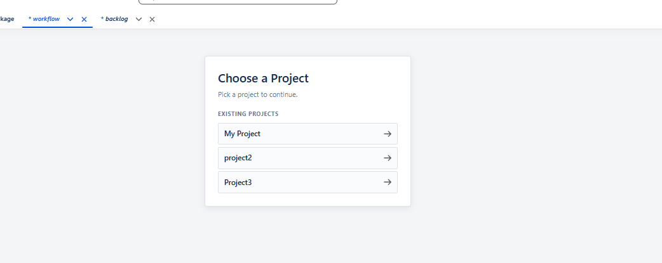
The Choose Project splash shown when no project is selected (the <c-choose-project> child).

3.2 Step 2 — workflow list
With a project but no workflow selected the page shows the “Workflows” heading, a Create New Workflow button, and one card per workflow (name + record status) each with an Edit button; an empty project shows “No workflows for this project yet — create one to get started.” The Create New Workflow modal takes a name and, on success, opens the editor on the new workflow.
###########################
manage-workflow-list.png
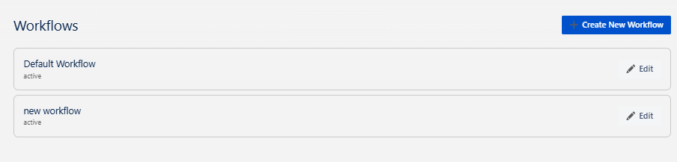

The workflow list: “Workflows” heading, “Create New Workflow” button, and workflow cards (name + record status + Edit).
###########################
manage-workflow-create-modal.png
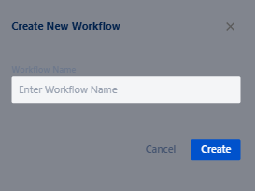
The Create New Workflow modal: a Workflow Name input with Cancel / Create.

3.3 Step 3 — the visual editor (toolbar, legend, canvas)
The editor renders a toolbar (Back · Create Status · Update Workflow) and an info span that reads “Click two statuses to create a transition”, or “From: X → To: Y” once a source is selected. A legend distinguishes Active vs Pending transitions. The canvas is a single SVG whose viewBox is derived from the status count and the responsive config.
###########################
manage-workflow-editor.png
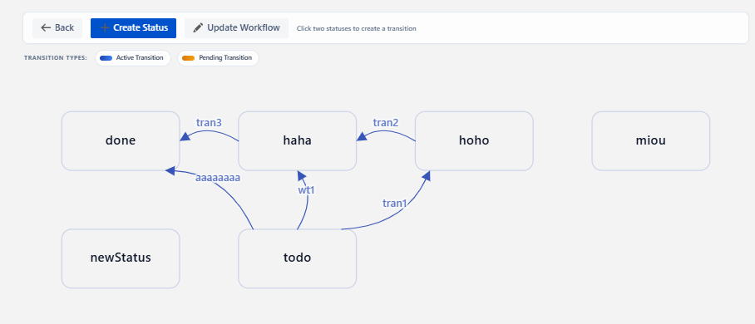
The editor: toolbar, Active / Pending legend, status nodes in a grid, and curved transition arrows (solid = active, dashed = pending) with name labels.

3.4 Status nodes & selection
Each status is a rounded rectangle labelled with the status name; clicking a node selects it (highlighted via clickedStatusIds). The first click sets the From status; clicking it again deselects; clicking a different node sets the To status and opens the Create Transition dialog. Create Status adds a new node.
###########################
manage-workflow-status-selected.png
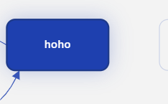
A status node selected as “From” (highlighted), with the toolbar info span showing “From: <status>”.

4.5 Transition arrows (active vs pending)
Transitions are drawn as quadratic-Bézier curved arrows between node edges (getRectIntersection finds where the curve meets each rectangle; createArrowPath curves it to avoid overlapping nodes). Active transitions are solid; pending transitions are dashed. Each arrow carries the transition name at its mid-point and an explicit arrow-head polygon at the target end.
###########################
manage-workflow-create-transition.png
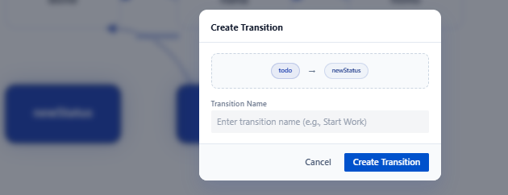
The Create Transition dialog after selecting two nodes: “From → To” badges and a Transition Name field with Cancel / Create Transition.
###########################
manage-workflow-create-transition.png
###########################

3.6 Transition detail panel
Clicking an arrow opens the detail panel: Name, Id, From / To status badges, Record Status badge, and Created Date. While the transition is pending an Activate action is shown; Delete (with a confirm prompt) soft-deletes it; Close dismisses the panel. The panel also hosts Add Validation Rule and Show / Hide Validation Details.
###########################
manage-workflow-transition-detail.png
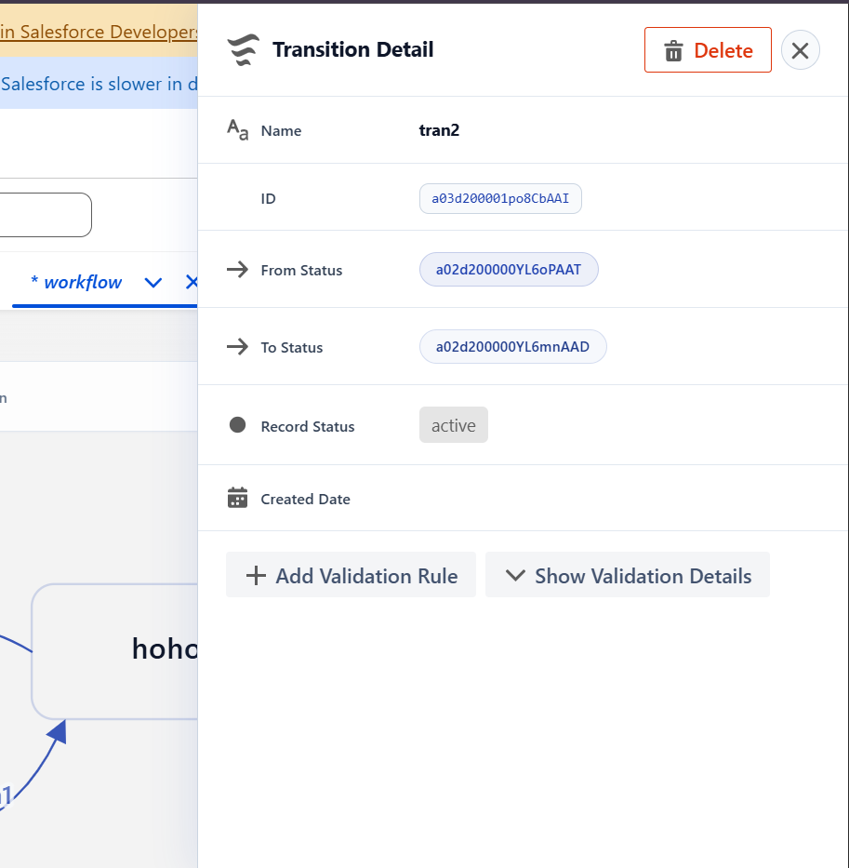
The transition detail panel: Name / Id / From / To / Record Status / Created Date, with Activate (pending) · Delete · Close and the Add Validation Rule / Show Validation Details controls.
###########################
manage-workflow-transition-detail.png
###########################

3.7 Validation rules
Add Validation Rule opens an inline section with a Field API Name combobox (mirroring the ValidateField__c field picklist) and a Validation Type combobox; Create persists the rule and folds it onto the transition. Show Validation Details expands the rule list (loaded on expand via loadValidateFields); an empty transition shows “No validation details for this transition.”
###########################
manage-workflow-add-validation-rule.png
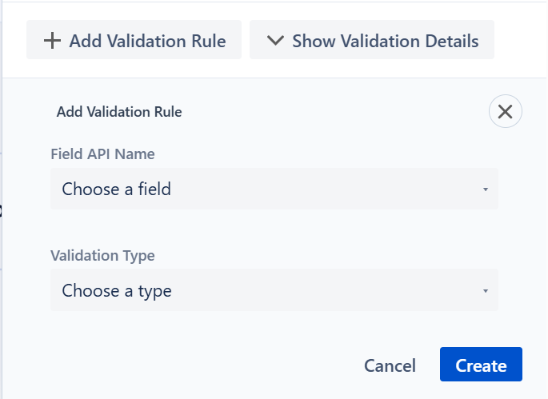
The Add Validation Rule inline section: Field API Name and Validation Type comboboxes with Cancel / Create.
###########################
manage-workflow-validation-details.png
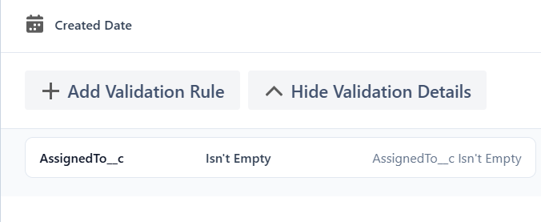
A transition expanded to show its validation rules (field · type · error message rows).

4. Traceability (SRS → API)
SRS | API call(s) / mechanism
FR-1 select project | <c-choose-project> → localStorage projectId
FR-2/FR-3 workflow list & empty state | loadWorkflowsByProject → _workflows / empty-state getter
FR-4 create workflow | createWorkflow → _enterWorkflowEditor
FR-5/FR-6 open editor & load config | getWorkflow (WorkflowConfigDTO)
FR-7 back to list | handleBackToWorkflowList (+ ResizeObserver teardown)
FR-8 render status nodes | gatherSortedStatuses → statusesWithSVGData (derived)
FR-9 create status | createStatus → _addStatus
FR-10 responsive layout | getResponsiveConfig via ResizeObserver
FR-11/FR-12 select two statuses & dialog | handleStatusClick → openCreateTransitionModal
FR-13 pending transition | addWorkflowTransition → _addPendingTransition
FR-14/FR-16 arrows & labels | calculateTransitionLines (active vs pending sets)
FR-15 legend | static legend (active / pending)
FR-17 transition detail | handleTransitionClick → activeTransition (derived)
FR-18 activate | activateWorkflowTransition → _setTransitionRecordStatus
FR-19 delete | deleteWorkflowTransition (soft) → _removeTransition
FR-20 close panel | handleCloseTransitionDetail
FR-21 add validation rule | addValidateField → _addTransitionValidateField
FR-22 view validation rules | loadValidateFields (wire, on expand) → _setTransitionValidateFields
FR-23 update workflow | updateFullWorkflowTransition → _activatePendingTransitions

