
Technical Document
Skills Path Architecture
AUTOMATING THE DEVELOPMENT PHASE OF THE AGILE SDLC
Reliability · Consistency · Maintainability

Skills Path Architecture
How force-app/skills/development/ is shaped to automate the Development phase of the Agile SDLC for the developer while adapting to this project's architecture and rules, and how that shape resolves three concrete challenges: reliability, consistency, maintainability.

1. The goal
This skill set is not a grab-bag of recipes. It targets one intersection of the SDLC and one role, under one set of constraints.
Question | Answer
Which SDLC phase does this automate? | The Development phase of Agile.
Who uses it? | The developer.
For what? | To implement a task (the bug flow is reserved for later).
Constrained by what? | The project's architecture and rules — LWC architecture, Apex bulkification, soft-delete filter, required fields, controller → Service → APIResponse layering.
Restated:
Build a skill that automates the Development phase of the Agile SDLC for the developer, that adapts to this project's architecture, rules, and framework, and that delivers reliability, consistency, and maintainability without architectural overhead.
The rest of this document is the architecture that meets that goal, organized by the three challenges it has to solve.

2. From a flat pool to an orchestrator
The current shape is the third design in a progression — each step fixes the problem the previous one left open.

Solution 1 — One flat pool of skills
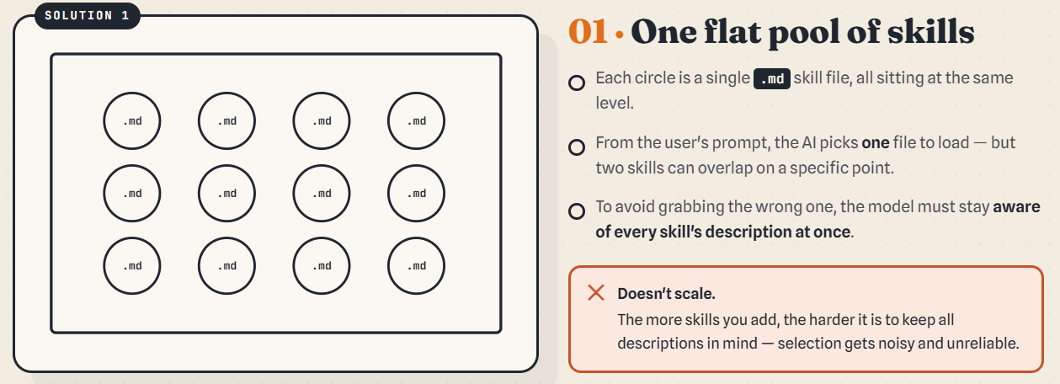One flat pool of skills
- Each circle is a single .md skill, all sitting at the same level.
- From the prompt the model picks one file — but two skills can overlap on a point.
- To avoid grabbing the wrong one, the developer must stay aware of every skill's description at once.
✗ Doesn't scale. Being aware of every skill is impossible once the system grows, and it costs more time on every prompt. The more skills you add, the noisier and less reliable selection gets.
Developer should be aware in all skill to avoid the conflict which is impossible and if it was it take along of time for check.

Solution 2 — Group into skills & sub-skills
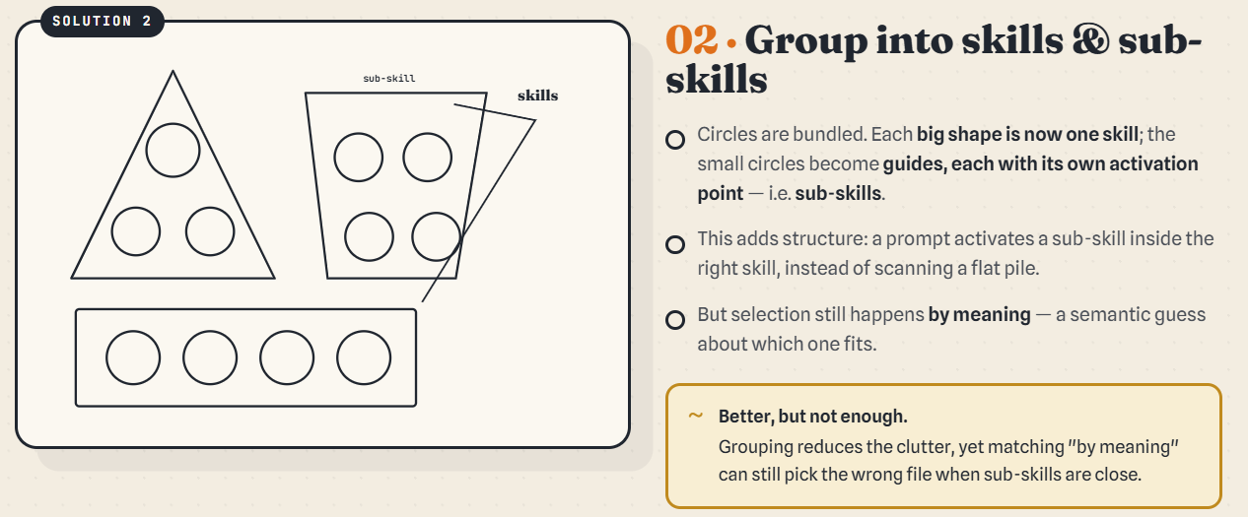Group into skills and sub-skills
- Circles are bundled: each big shape is one skill; the small circles become guides (sub-skills), each with its own activation point.
- A prompt activates a sub-skill inside the right skill instead of scanning a flat pile.
~ Better, but not enough. Selection still happens by meaning — a semantic guess — so it can still pick the wrong file when two sub-skills are close.

Solution 3 — Wrap it in an orchestrator
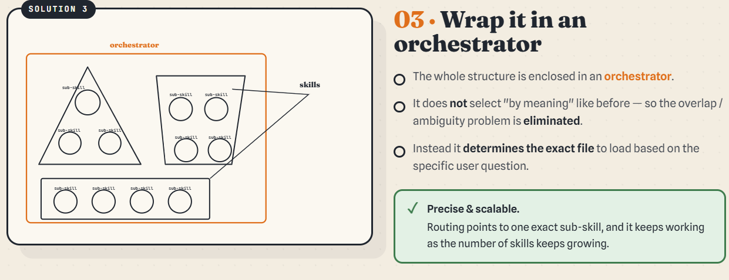Wrap it in an orchestrator
- The whole structure is enclosed in an orchestrator.
- It does not select “by meaning”, so the overlap/ambiguity problem is eliminated.
- It determines the exact file to load from the specific user question.
✓ Precise & scalable. Routing points to one exact sub-skill, and it keeps working as the number of skills grows.

3. The three challenges (with examples)

3.1 Reliability — the right skill must fire even when the user didn't name it
Problem. A skill only fires if the model picks it. If the user's prompt doesn't name a downstream skill, it gets silently skipped.
Solution. Make the call explicit inside the calling skill, so it cannot be missed regardless of wording.
Example. The user says “create a new parent LWC” — nothing about CSS. The parent task-skill itself names the CSS handoff as a fixed step:
create-new-parent-lwc-component.md:207 — Step 4 — Optionally apply lwc-css-design

3.2 Consistency — same intent, same path, every time
Problem. With N skills directly addressable, the user's wording decides which one fires. Same intent, different phrasings, different paths.
Solution. One entry point — the orchestrator — and an AskUserQuestion flow that turns the prompt into a fixed set of answers, so the user's intent is captured with 100% certainty.
Example. Any dev request enters agile-development-orchastrator-skill.md and answers two AskUserQuestion calls: bug vs. task, then A/B/C + parent/child. Three different phrasings of “build a feature on a parent LWC” all land on the same row:
B — create new functionality / parent → add-interactive-with-data-persistance-functionality-in-pather.md

3.3 Maintainability — a new task can't fan out edits across every other task
Problem. When several task-skills need the same sub-step, in-lining it in each one means every change has to touch every copy.
Solution. Extract the shared sub-step into one file under task-skill/guide/ and have each task-skill call it.
Example. Both add-interactive-with-data-persistance-functionality-in-pather.md and lwc-parent-event-handler-generator.md need to resolve “which Apex method backs this?”. Instead of asking that interview manually in each file, both call guide/apex-method-resolution-guide.md — the three-branch interview (existing-known / existing-find / create-new) lives in exactly one file.

4. Skill types — one type per development step
Extracting a shared sub-step into a guide (3.3) is the first move, but it raises a deeper question: where, in general, does shared logic belong? Ordinary code answers with layers — common logic is pushed down into a service, helper, or utility, and every caller reuses it. Skills have no such mechanism: each skill is a flat Markdown file, and no compiler enforces where logic lives. The split therefore has to be designed by convention. The convention adopted here is that each skill type mirrors one step the developer actually takes, so the development step — not the file — decides where logic belongs.

4.1 One type per development step
A developer never implements a task in a single motion. They move through a fixed sequence of steps, and the AI has to reproduce each one. Each step maps to exactly one skill type:
Developer step | What the AI must know | Skill type
Identify the issue type — so they know how to think | bug vs. task | Orchestrator
Narrow to a sub-type — still, so they know how to think | A / B / C, parent / child | Orchestrator
Read the user story | the story, turned into usable context | FAQ
Analyse the exact behaviour of each story or task | the precise behaviour expected | FAQ
Implement against the framework and project constraints | the implementation rules | Guide
The orchestrator owns classification — issue type, then sub-type. The FAQ owns context-gathering — read the story, pin down behaviour. The guide owns implementation. Walking these steps in order is the job of the normal skill — the task-skill, or pather — which is the spine the other three types hang off.

4.2 What each type must contain
Because each type owns a different step, each has a different shape and a different set of obligations.
Type | Must contain | Fires on its own? | Effect on caller context
Orchestrator | the entry classification — issue type, then sub-type (nothing new beyond Section 2) | Yes — it is the single entry point | Routes only; produces the path, not the content
Normal skill (pather) | name, description, a mandatory guide, an entry point, steps, and an example (optional) | Yes — it is named and described | The spine: it records what every skill it calls returns
FAQ | a defined return; questions only — no input tied to the caller's context | No — it has no name or description, so it needs a caller | Enriches the caller with context; makes no decision on the caller's context, but may validate its own (e.g. the behaviour gathered must cover every user story)
Guide | implementation steps only | No — it runs only once the caller holds clean context | Does not enrich the caller; implementation-level only

4.3 How skills communicate — the context contract
Typing the skills is only half the design; the other half is the direction context flows between them. Two rules govern it.
First, an FAQ writes context and the pather remembers it. An FAQ takes no caller-dependent input — it only asks its questions and returns a defined block of context. Because it has no name or description, it cannot fire on its own; a caller must invoke it. The pather records what the FAQ returns in its own context, so a later step can rely on it being there.
Second, a guide reads context and writes none back. A guide is pure implementation: it enriches nothing. It runs correctly only when the pather already holds clean, complete context — which is exactly the context the FAQ produced and the pather remembered.
So the four types form a one-directional flow:
Orchestrator (route) → FAQ (gather and return context) → Pather (remember context, walk the steps) → Guide (implement on that context)
Each type owns one step, so each change lands in one place: a new behaviour question changes an FAQ, a new implementation rule changes a guide, new routing changes the orchestrator — and none of them forces edits across the task-skills. That is the maintainability fix in full: not faked code layers, but one skill type per development step, joined by a context contract that only ever flows forward.

4.4 Skill architecture — contents per type
What each skill type must contain, stated as a spec.
Orchestrator — step: know the issue type, then the sub-type, so the AI knows how to think
- Issue-type classification (e.g. bug vs. task)
- Sub-type classification under that issue type
- Routing to the exact skill based on those answers
- Nothing new beyond this — it only decides the path; it does not produce content
FAQ — step: read the user story / pin down behaviour, to enrich the caller with context
- No name and no description (this is what stops it from self-firing)
- Requires a caller — it cannot run automatically
- No input tied to the caller’s context — it doesn’t read the pather’s state
- Questions only — it asks questions to gather and return context
- Common iterations with no decision or validation based on the caller’s context
- May validate its own context — e.g. when it gives behaviour in a sub-step, that behaviour must cover all user stories
- A defined return — what it hands back must be specified, so the caller knows what it receives
Normal skill (pather) — step: the spine that walks the developer’s path
- Name
- Description
- A mandatory guide (the guide it must use)
- An entry point
- Steps
- An example (optional)
- Responsibility: it must declare, in its own context, what each skill it calls returns — so it remembers that context for when a guide later needs it
Guide — step: implement against the framework + project constraints
- Implementation-level content only
- Does not enrich the caller’s (pather’s) context — it returns nothing into it
- Precondition: it runs only when the pather already holds clean, good context (the context the FAQ produced and the pather remembered)

5. Adaptation to project architecture and rules
The orchestrator does not invent rules — it routes work into skills that already encode the project's rules. The chain of constraints, as they fire during a typical “create a new parent LWC” iteration:
- Orchestrator — classifies as task / option A / parent.
- create-new-parent-lwc-component — Step 0 mandates lwc-architecture end-to-end (page vs. child, principal state shape, localStorage keys, Apex methods, event names, sidecar utils / validator, meta.xml exposure).
- Per-iteration sub-skill (A → functionality, B → event handler) runs its full disciplined interview, then hands off to the shared Apex-method-resolution protocol when controller methods need to be resolved.
- Final Verification — the project-wide MANDATORY skills declared in CLAUDE.md are checked: bulkified Apex (apex-bulk-soql), soft-delete filter (soql-exclude-deleted), required fields per OBJECT_VALIDATION_LWC_APEX.md (object-required-fields), thin controller → Service → APIResponse layering (lwc-architecture).
- Optional CSS handoff — Step 4 asks whether to apply lwc-css-design so the new parent drops in next to manageBacklog / manageWorkflow without visual tuning.
Every project-specific rule has exactly one home, and the orchestrator guarantees the rules are reached — not left to the model to remember.

6. Current file layout (for reference)
force-app/skills/development/
├── agile-development-orchastrator-skill.md ← single entry
├── architecture/
│ ├── lwc-architecture.md
│ └── lwc-css-design.md
├── contract/
│ ├── object-required-fields-skill.md
│ └── soql-exclude-deleted-skill.md
├── guard/
│ ├── apex-governor-limit-guard.md
│ ├
│
├── performance/
│ ├── apex-bulk-soql.md
│ └── apex-method-monitor.md
└── task-skill/
├── add-functionality-in-child-lwc-component.md
├── add-interactive-with-data-persistance-functionality-in-pather.md
├── create-new-child-lwc-component.md
├── create-new-parent-lwc-component.md
├── lwc-parent-event-handler-generator.md
└── guide/
└── apex-method-resolution-guide.md
└── lwc-request-loading-guide.md
└── lwc-error-handling-guide.md

