1. **HOME:**
2. **ABOUT US:**

**Vision**

Our vision is to reach at the apex point of this sector by providing new generation, innovative and customer required services. We are highly determined to customer satisfaction and our motto **“Travel with a Smile”**

**Mission**

IT’S Holidays Ltd.  is committed to providing world class, personal and enthusiastic travel management services. We want to establish our team as the optimum service provider by innovative and convenient services. We are continuously bringing new and exciting tour packages thus helping to explore the beauty of world.

**Management**

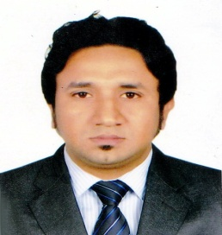 **Chairman Message**

It gives me immense pleasure that With the motto “**Travel with a Smile”** in mind “**ITS Holidays Ltd. ”**(**International Travel Services & Holidays Ltd.)** is a familiar name in the travel and tourism sector of Bangladesh, is engaged in the healthy growth of travel trade. It is run by a team of young, energetic, professionals fully conversant with modern day's travel trends and it's practices, who have background with various reputed Airlines and travel Agencies. ITS Holidays Ltd. is a new generation company engaged in providing customer oriented innovative services in Worldwide Air Ticketing, Hotel Reservation, Package Tour, Pick up & Drop, Health & Medical Tourism, Student Consultancy, Hajj & Umrah Packages and Worldwide Visa Processing.

❖ **Managing Director Message**

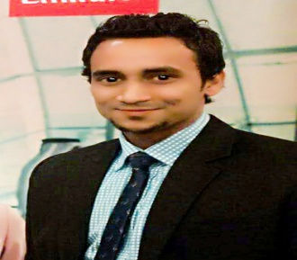

“**ITS Holidays” is**one of inbound and outbound  traveler-centric Specialist providing sustainable, quality and excellent  travel services to consistently meet and exceed our customer’s satisfaction. With our combined expertise and years of experience employees, we have an in-depth understanding of travelers’ needs and wants. Come onboard with us on a memorable journey, full of surprises, mystique, diverse cultural encounter, gastronomic adventure and a world of natural wonders.

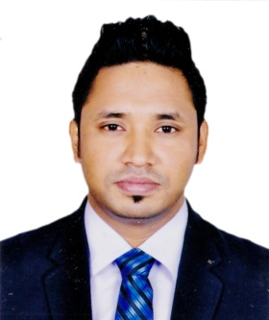 **Executive Director Message**

We have the ambition to announce tour package for all the beautiful countries of the world with the excellence of service. We want our honorable guests to be a part of our growth, we want each of their trips with us to be memorable and enjoyable starting from the moment they open our brochure.

**4.   Affiliation**

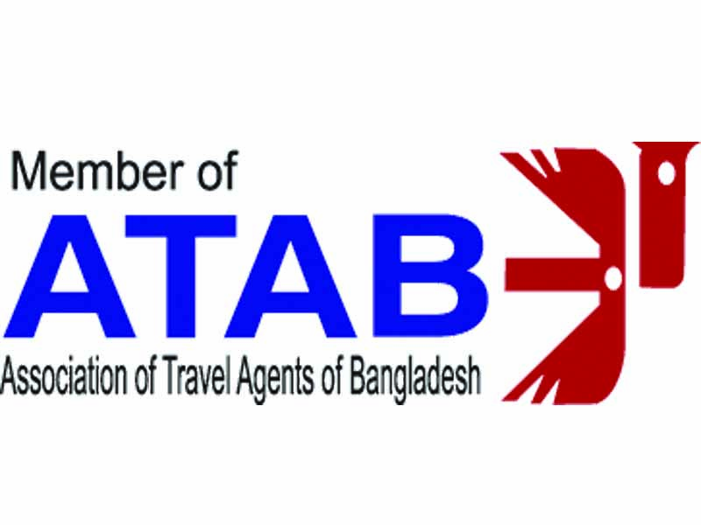ITS Holidays is presently affiliated with the following association-



International Air Transport Association  ASSOCIATION OF TRAVEL AGENTS OF BANGLADESH – ATAB



Tour Operators' Association of Bangladesh-TOAB Bangladesh Tourism Board (BTB)

**Our Clients**

Our comprehensive travel experience in delivering quality services, through our exceptional organizational skills, has enabled us to provide continued services to the following major Multi-national, International & Domestic corporate clients:

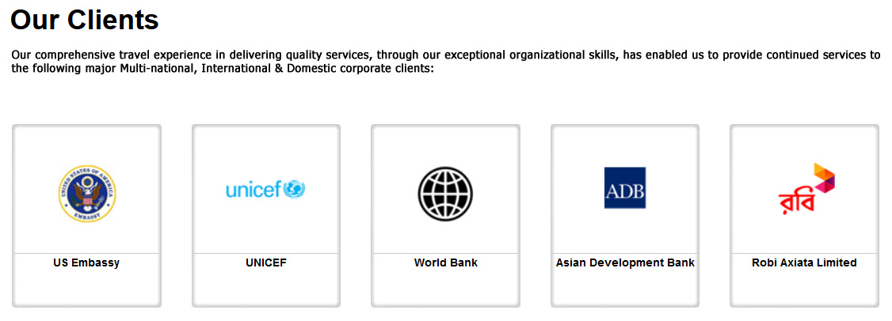

1. **AIR TICKETING:**

Our dedicated staff is awaiting your call round the 24/7.We operate special tours upon request with Competitive fares. We arrange e-tickets by using most modern technology in the world.

We are working with various airlines; such as: Emirates Airways, Etihad Airways, Saudi Arabian Airlines, Qatar Airways, Gulf Air, Malaysia Airlines, Singapore Airlines, Thai Airways, Kuwait Airways, GMG Airlines, Air India Express, Biman Bangladesh Airlines, China Southern etc. Besides selling package, we also arrange tickets of all destinations of the world.  
We have a strong relation with all the Airlines. As a reflection of that we can issue ticket at competitive price in regular basis.



[https://www.**biman**-**airlines**.com/](https://www.biman-airlines.com/) <http://www.emirates.com/ae/english/> [www.**qatarairways**.com](http://www.qatarairways.com)

1. **HOLIDAY PACKAGES:**
2. **Inbound : Enjoy the natural beauty of Bangladesh with the ITS Holidays Ltd.**

**Cox’s Bazar Tour Sundarban Bandarban Sylhet Rangamati Kuakata Saint-Martin Khagrachari**

1. **Outbound : Explore the mysterious beauty of the world with the ITS Holidays Ltd.**

**Asia Continent**

1. **Malaysia**
2. **Thailand**
3. **Singapore**
4. **China**
5. **India**
6. **Nepal**
7. **Bhutan**
8. **Srilanka**
9. **Maldives**
10. **Vietnam**
11. **Japan**
12. **Korea**
13. **Brunei**
14. **Cambodia**
15. **Indonesia**
16. **Jordan**
17. **Kuwait**
18. **Laos**
19. **Myanmar**
20. **Qatar**
21. **Philippines**
22. **Saudi Arabia**
23. **United Arab Emirates**
24. **Uzbekistan**
25. **Yemen**

**Europe Continent**

**1 Russia**

**2 France**

**3 Spain**

**4 Sweden**

**5 Norway**

**6 Germany**

**7 Finland**

**8 Poland**

**9 Italy**

**10 United Kingdom**

**11 Romania**

**12 Belarus**

**13 Greece**

**14 Portugal**

**15 Austria**

**16 Republic of Ireland**

**17 Georgia**

**18 Lithuania**

**19 Latvia 64,589**

**20 Bosnia and Herzegovina**

**21 Denmark**

**22 Switzerland**

**23 Netherlands**

**24 Belgium**

**25 Turkey\***

**26 Cyprus**

**North America Continent**

1. **USA**
2. **Canada**
3. **Mexico**

**South America Continent**

1. **Brazil**
2. **Argentina**

**Australia**

1. **Australia**
2. **New Zealand**

**Africa Continent**

1. **Egypt**
2. South Africa
3. **HOTEL RESERVATION:**

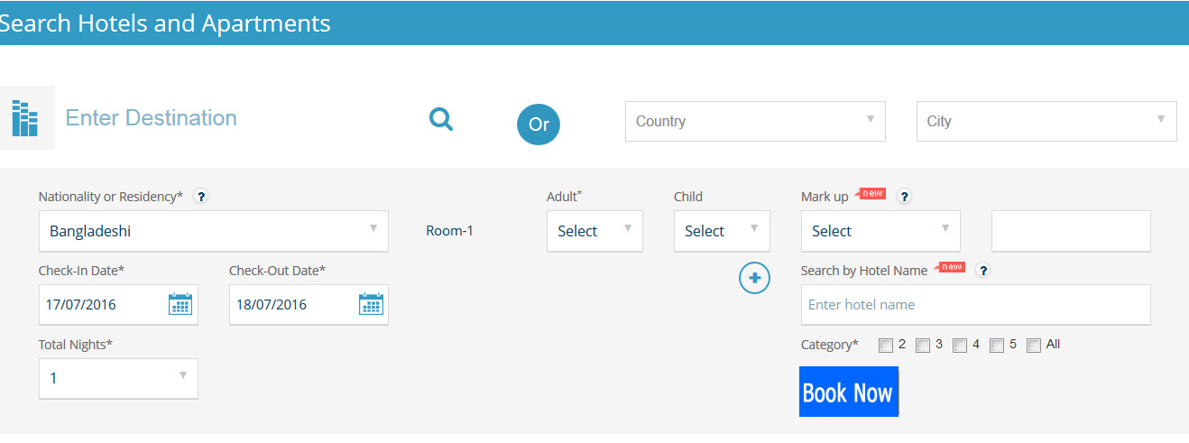

* Over 250,000+ Hotels and apartments worldwide
* 50,000+ Sightseeing items and over 4500 Tours in 450 cities
* 5,500+Transfer Options in Over 850 Airport and City Locations
* Instant confirmations
* Last minute availability and deals from hotels direct
* Flexible conditions
* Round the clock service by our experienced travel professionals
* Easy and efficient booking engine
* We offer complete white label solution with customized back office to your requirements
* If you already have a booking engine, you can connect our 200,000 discounted hotels through simple XML interface

1. **VISA INFO:**

[http://www.visathing.com/#](http://www.visathing.com/)

**To ease your life, we have collected visa information for over 150 Countries. All the visa information is updated on our web portal to serve you for Business & Visit purpose.**

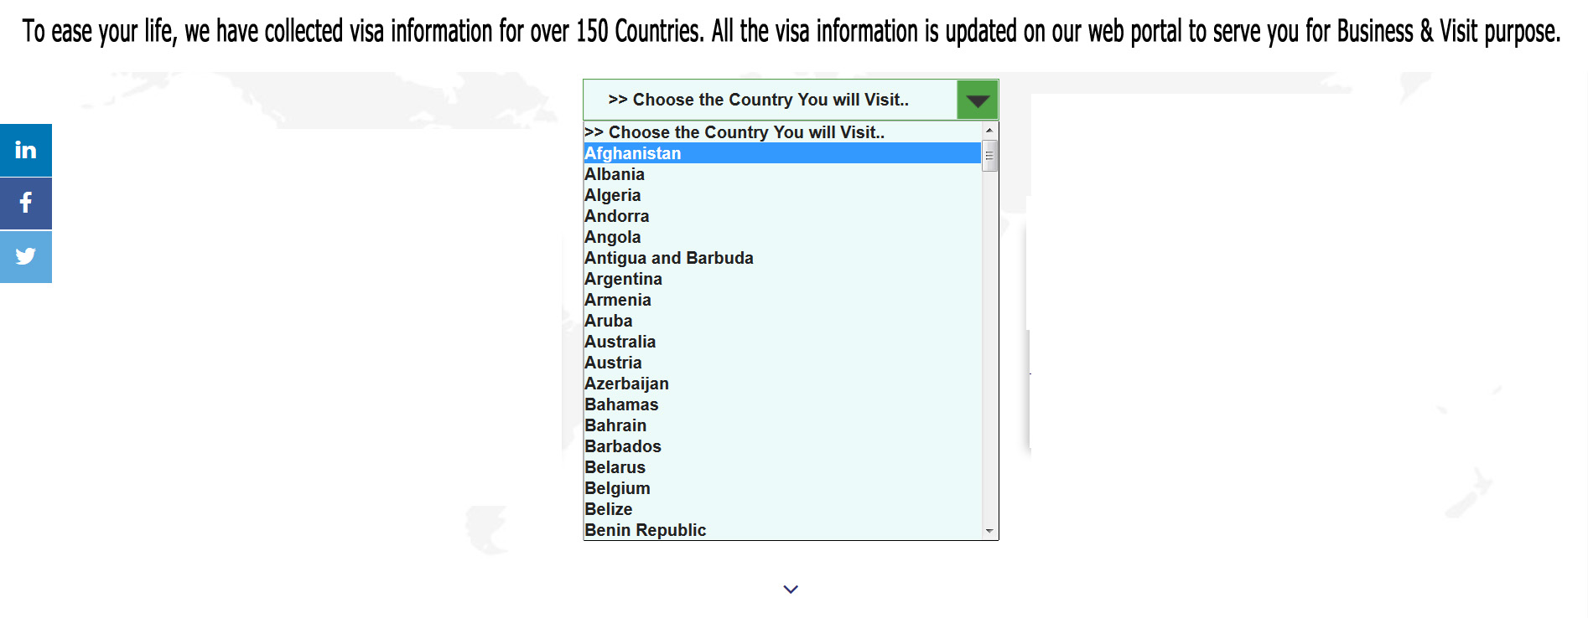

1. **OUR GSA AND PSA:**

**(Under Construction)**

1. **OTHER SERVICES:**

**@ Organizing Hajj and Umrah Package Tours.**

**@ Pick up & Drop facilities**

**@ Health & Medical Tourism**

**@ Student Consultancy**

**@ E-payment Facilities**

1. **GALLARY**

**Photo**

**Video**

1. **CONTACT US**