CHECKING HADOOP IS INSTALLED OR NOT AND IT’S VERSION

hdoop@admin1-HP-280-G4-MT-Business-PC:~$ hadoop version

Hadoop 3.2.1

Source code repository https://gitbox.apache.org/repos/asf/hadoop.git -r b3cbbb467e22ea829b3808f4b7b01d07e0bf3842

Compiled by rohithsharmaks on 2019-09-10T15:56Z

Compiled with protoc 2.5.0

From source with checksum 776eaf9eee9c0ffc370bcbc1888737

This command was run using /home/hdoop/hadoop-3.2.1/share/hadoop/common/hadoop-common-3.2.1.jar

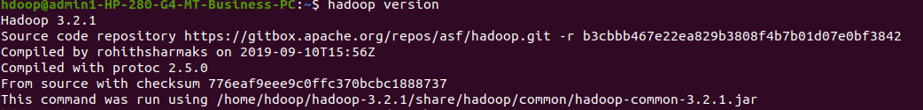

CREATING DIRECTORY

hdoop@admin1-HP-280-G4-MT-Business-PC:~$ hdfs dfs -mkdir /manvesh

USING LS COMMAND

hdoop@admin1-HP-280-G4-MT-Business-PC:~$ hdfs dfs -ls /

Found 3 items

drwxr-xr-x - hdoop supergroup 0 2022-05-24 09:13 /manvesh

drwxrwxr-x - hdoop supergroup 0 2021-07-28 12:58 /tmp

drwxr-xr-x - hdoop supergroup 0 2021-07-28 12:56 /user

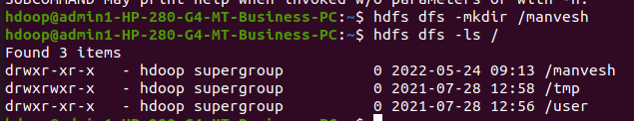

ADDING EMPTY FILES

**touchz**: It creates an empty file.

hdoop@admin1-HP-280-G4-MT-Business-PC:~$ hdfs dfs -touchz /manvesh/file1.txt

hdoop@admin1-HP-280-G4-MT-Business-PC:~$ hdfs dfs -touchz /manvesh/file2.txt

hdoop@admin1-HP-280-G4-MT-Business-PC:~$ hadoop fs -ls /manvesh

Found 2 items

-rw-r--r-- 1 hdoop supergroup 0 2022-05-24 09:30 /manvesh/file1.txt

-rw-r--r-- 1 hdoop supergroup 0 2022-05-24 09:30 /manvesh/file2.txt

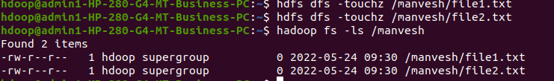

MOVING FILE FROM LOCAL TO HADOOP USING PUT COMMAND

**copyFromLocal (or) put:** To copy files/folders from local file system to hdfs store. This is the most important command. Local filesystem means the files present on the OS.

hdfs dfs -put /home/hdoop/manvesh_1nt19is080 /1nt19is080

Manvesh_1nt19is080 -> local file

1nt19is080 -> destination directory

CHECKING FILE AT DESTINATION

hdoop@admin1-HP-280-G4-MT-Business-PC:~$ hadoop fs -ls /1nt19is080

Found 1 items

drwxr-xr-x - hdoop supergroup 0 2022-05-24 09:48 /1nt19is080/manvesh_1nt19is080

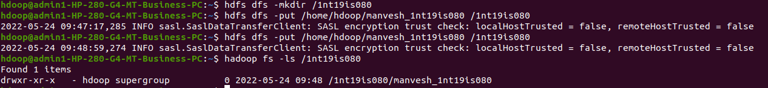

MOVING FROM HADOOP TO LOCAL

hdfs dfs -get /1nt19is080/manvesh_1nt19is080 /home/hdoop/Desktop

hdoop@admin1-HP-280-G4-MT-Business-PC:~$ hadoop fs -ls /manvesh

Found 2 items

-rw-r--r-- 1 hdoop supergroup 0 2022-05-24 09:30 /manvesh/file1.txt

-rw-r--r-- 1 hdoop supergroup 0 2022-05-24 09:30 /manvesh/file2.txt

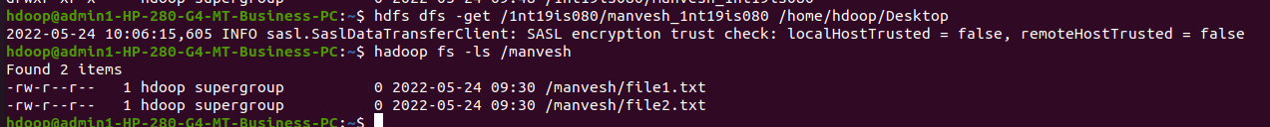

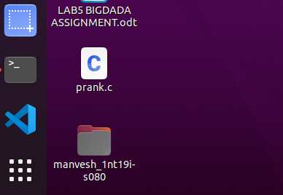

MOVING FILE WITHIN HADOOP(From one directory to another)

hdfs dfs -cp /manvesh/file1.txt /1nt19is080

Manvesh -> source

File1.txt -> file

1nt19is080 -> destination

Checking it moved or not:

hdoop@admin1-HP-280-G4-MT-Business-PC:~$ hadoop fs -ls /1nt19is080

Found 2 items

-rw-r--r-- 1 hdoop supergroup 0 2022-05-24 10:18 /1nt19is080/file1.txt

drwxr-xr-x - hdoop supergroup 0 2022-05-24 09:48 /1nt19is080/manvesh_1nt19is080

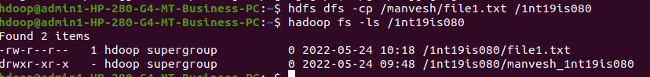

SIZE OF FILES IN DIRECTORY

hdoop@admin1-HP-280-G4-MT-Business-PC:~$ hdfs dfs -du -h /manvesh

0 0 /manvesh/file1.txt

0 0 /manvesh/file2.txt

hdoop@admin1-HP-280-G4-MT-Business-PC:~$ hdfs dfs -du -h /1nt19is080

0 0 /1nt19is080/file1.txt

68 68 /1nt19is080/manvesh_1nt19is080

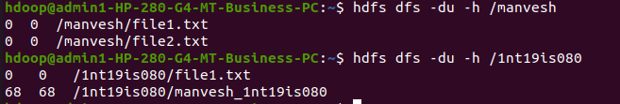

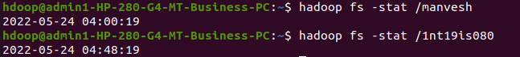

APPEN