DELETION:
before deletion:

db.myCollection.find()
{ "_id" : ObjectId("624bbb5182655d8432ca4bcc"), "name" : "navindu", "age" : 22 }
{ "_id" : ObjectId("624bbb5182655d8432ca4bcd"), "name" : "kavindu", "age" : 23 }
{ "_id" : ObjectId("624bbb5182655d8432ca4bce"), "name" : "john doe", "age" : 25, "location" : "colombo" }
{ "_id" : ObjectId("624bbfbd82655d8432ca4bd1"), "name" : "navindu", "age" : 22 }
{ "_id" : ObjectId("624bbfbd82655d8432ca4bd2"), "name" : "kavindu", "age" : 20 }
{ "_id" : ObjectId("624bbfbd82655d8432ca4bd3"), "name" : "john doe", "age" : 25, "location" : "colombo" }

deleting:
db.myCollection.remove({"name":"john doe"})
WriteResult({ "nRemoved" : 2 })

after deletion:
db.myCollection.find()
{ "_id" : ObjectId("624bbb5182655d8432ca4bcc"), "name" : "navindu", "age" : 22 }
{ "_id" : ObjectId("624bbb5182655d8432ca4bcd"), "name" : "kavindu", "age" : 23 }
{ "_id" : ObjectId("624bbfbd82655d8432ca4bd1"), "name" : "navindu", "age" : 22 }
{ "_id" : ObjectId("624bbfbd82655d8432ca4bd2"), "name" : "kavindu", "age" : 20 }

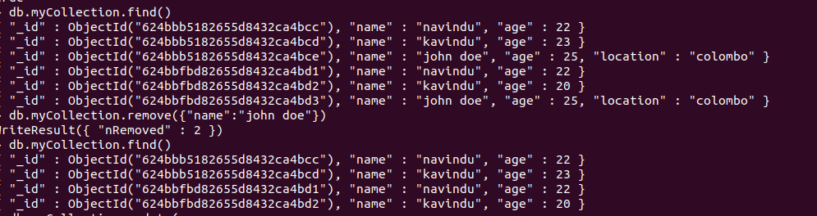

UPDATE USING UNSET:
db.myCollection.update(
... {"name":"navindu"},
... {
... $unset: {"age":""}
... }
... )
CHANGE after update:
db.myCollection.find()
{ "_id" : ObjectId("624bbb5182655d8432ca4bcc"), "name" : "navindu" }
{ "_id" : ObjectId("624bbb5182655d8432ca4bcd"), "name" : "kavindu", "age" : 23 }
{ "_id" : ObjectId("624bbfbd82655d8432ca4bd1"), "name" : "navindu", "age" : 22 }
{ "_id" : ObjectId("624bbfbd82655d8432ca4bd2"), "name" : "kavindu", "age" : 20 }
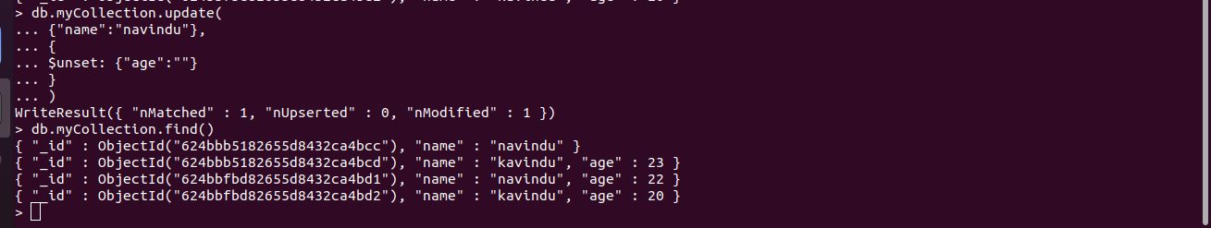
AND OPERATION:
db.myCollection.find({$and:[{"name":"navindu","age":22}]})
{ "_id" : ObjectId("624bbfbd82655d8432ca4bd1"), "name" : "navindu", "age" : 22 }

OR OPERATION:
> db.myCollection.find({$or:[{"name":"kavindu","age":20}]})
{ "_id" : ObjectId("624bbfbd82655d8432ca4bd2"), "name" : "kavindu", "age" : 20 }

