AGGREGATE FUNCTIONS:

Data for it-

db.cities.find()

{ "_id" : ObjectId("62550809a1bef425c78b3c17"), "name" : "Seoul", "country" : "South Korea", "continent" : "Asia", "population" : 25.674 }

{ "_id" : ObjectId("62550809a1bef425c78b3c18"), "name" : "Mumbai", "country" : "India", "continent" : "Asia", "population" : 19.98 }

{ "_id" : ObjectId("62550809a1bef425c78b3c19"), "name" : "Lagos", "country" : "Nigeria", "continent" : "Africa", "population" : 13.463 }

{ "_id" : ObjectId("62550809a1bef425c78b3c1a"), "name" : "Beijing", "country" : "China", "continent" : "Asia", "population" : 19.618 }

{ "_id" : ObjectId("62550809a1bef425c78b3c1b"), "name" : "Shanghai", "country" : "China", "continent" : "Asia", "population" : 25.582 }

{ "_id" : ObjectId("62550809a1bef425c78b3c1c"), "name" : "Osaka", "country" : "Japan", "continent" : "Asia", "population" : 19.281 }

{ "_id" : ObjectId("62550809a1bef425c78b3c1d"), "name" : "Cairo", "country" : "Egypt", "continent" : "Africa", "population" : 20.076 }

{ "_id" : ObjectId("62550809a1bef425c78b3c1e"), "name" : "Tokyo", "country" : "Japan", "continent" : "Asia", "population" : 37.4 }

{ "_id" : ObjectId("62550809a1bef425c78b3c1f"), "name" : "Karachi", "country" : "Pakistan", "continent" : "Asia", "population" : 15.4 }

{ "_id" : ObjectId("62550809a1bef425c78b3c20"), "name" : "Dhaka", "country" : "Bangladesh", "continent" : "Asia", "population" : 19.578 }

{ "_id" : ObjectId("62550809a1bef425c78b3c21"), "name" : "Rio de Janeiro", "country" : "Brazil", "continent" : "South America", "population" : 13.293 }

{ "_id" : ObjectId("62550809a1bef425c78b3c22"), "name" : "São Paulo", "country" : "Brazil", "continent" : "South America", "population" : 21.65 }

{ "_id" : ObjectId("62550809a1bef425c78b3c23"), "name" : "Mexico City", "country" : "Mexico", "continent" : "North America", "population" : 21.581 }

{ "_id" : ObjectId("62550809a1bef425c78b3c24"), "name" : "Delhi", "country" : "India", "continent" : "Asia", "population" : 28.514 }

{ "_id" : ObjectId("62550809a1bef425c78b3c25"), "name" : "Buenos Aires", "country" : "Argentina", "continent" : "South America", "population" : 14.967 }

{ "_id" : ObjectId("62550809a1bef425c78b3c26"), "name" : "Kolkata", "country" : "India", "continent" : "Asia", "population" : 14.681 }

{ "_id" : ObjectId("62550809a1bef425c78b3c27"), "name" : "New York", "country" : "United States", "continent" : "North America", "population" : 18.819 }

{ "_id" : ObjectId("62550809a1bef425c78b3c28"), "name" : "Manila", "country" : "Philippines", "continent" : "Asia", "population" : 13.482 }

{ "_id" : ObjectId("62550809a1bef425c78b3c29"), "name" : "Chongqing", "country" : "China", "continent" : "Asia", "population" : 14.838 }

{ "_id" : ObjectId("62550809a1bef425c78b3c2a"), "name" : "Istanbul", "country" : "Turkey", "continent" : "Europe", "population" : 14.751 }

MATCH FUNCTION:

Choosing cities of continent north america

> db.cities.aggregate([

... { $match: { "continent": "North America" } }

... ])

{ "_id" : ObjectId("62550809a1bef425c78b3c23"), "name" : "Mexico City", "country" : "Mexico", "continent" : "North America", "population" : 21.581 }

{ "_id" : ObjectId("62550809a1bef425c78b3c27"), "name" : "New York", "country" : "United States", "continent" : "North America", "population" : 18.819 }

Choosing cities of continent north america and asia

> db.cities.aggregate([

... { $match: { "continent": { $in: ["North America", "Asia"] } } }

... ])

{ "_id" : ObjectId("62550809a1bef425c78b3c17"), "name" : "Seoul", "country" : "South Korea", "continent" : "Asia", "population" : 25.674 }

{ "_id" : ObjectId("62550809a1bef425c78b3c18"), "name" : "Mumbai", "country" : "India", "continent" : "Asia", "population" : 19.98 }

{ "_id" : ObjectId("62550809a1bef425c78b3c1a"), "name" : "Beijing", "country" : "China", "continent" : "Asia", "population" : 19.618 }

{ "_id" : ObjectId("62550809a1bef425c78b3c1b"), "name" : "Shanghai", "country" : "China", "continent" : "Asia", "population" : 25.582 }

{ "_id" : ObjectId("62550809a1bef425c78b3c1c"), "name" : "Osaka", "country" : "Japan", "continent" : "Asia", "population" : 19.281 }

{ "_id" : ObjectId("62550809a1bef425c78b3c1e"), "name" : "Tokyo", "country" : "Japan", "continent" : "Asia", "population" : 37.4 }

{ "_id" : ObjectId("62550809a1bef425c78b3c1f"), "name" : "Karachi", "country" : "Pakistan", "continent" : "Asia", "population" : 15.4 }

{ "_id" : ObjectId("62550809a1bef425c78b3c20"), "name" : "Dhaka", "country" : "Bangladesh", "continent" : "Asia", "population" : 19.578 }

{ "_id" : ObjectId("62550809a1bef425c78b3c23"), "name" : "Mexico City", "country" : "Mexico", "continent" : "North America", "population" : 21.581 }

{ "_id" : ObjectId("62550809a1bef425c78b3c24"), "name" : "Delhi", "country" : "India", "continent" : "Asia", "population" : 28.514 }

{ "_id" : ObjectId("62550809a1bef425c78b3c26"), "name" : "Kolkata", "country" : "India", "continent" : "Asia", "population" : 14.681 }

{ "_id" : ObjectId("62550809a1bef425c78b3c27"), "name" : "New York", "country" : "United States", "continent" : "North America", "population" : 18.819 }

{ "_id" : ObjectId("62550809a1bef425c78b3c28"), "name" : "Manila", "country" : "Philippines", "continent" : "Asia", "population" : 13.482 }

{ "_id" : ObjectId("62550809a1bef425c78b3c29"), "name" : "Chongqing", "country" : "China", "continent" : "Asia", "population" : 14.838 }

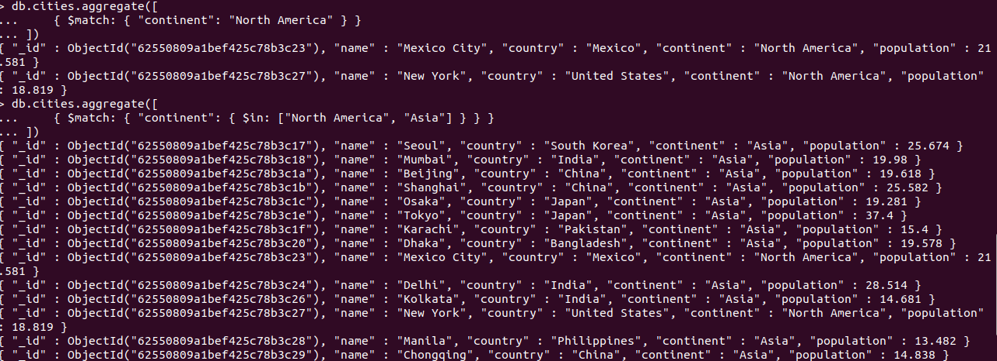

SORTING FUNCTION:

db.cities.find().sort({ "population": -1 })

{ "_id" : ObjectId("62550809a1bef425c78b3c1e"), "name" : "Tokyo", "country" : "Japan", "continent" : "Asia", "population" : 37.4 }

{ "_id" : ObjectId("62550809a1bef425c78b3c24"), "name" : "Delhi", "country" : "India", "continent" : "Asia", "population" : 28.514 }

{ "_id" : ObjectId("62550809a1bef425c78b3c17"), "name" : "Seoul", "country" : "South Korea", "continent" : "Asia", "population" : 25.674 }

{ "_id" : ObjectId("62550809a1bef425c78b3c1b"), "name" : "Shanghai", "country" : "China", "continent" : "Asia", "population" : 25.582 }

{ "_id" : ObjectId("62550809a1bef425c78b3c22"), "name" : "São Paulo", "country" : "Brazil", "continent" : "South America", "population" : 21.65 }

{ "_id" : ObjectId("62550809a1bef425c78b3c23"), "name" : "Mexico City", "country" : "Mexico", "continent" : "North America", "population" : 21.581 }

{ "_id" : ObjectId("62550809a1bef425c78b3c1d"), "name" : "Cairo", "country" : "Egypt", "continent" : "Africa", "population" : 20.076 }

{ "_id" : ObjectId("62550809a1bef425c78b3c18"), "name" : "Mumbai", "country" : "India", "continent" : "Asia", "population" : 19.98 }

{ "_id" : ObjectId("62550809a1bef425c78b3c1a"), "name" : "Beijing", "country" : "China", "continent" : "Asia", "population" : 19.618 }

{ "_id" : ObjectId("62550809a1bef425c78b3c20"), "name" : "Dhaka", "country" : "Bangladesh", "continent" : "Asia", "population" : 19.578 }

{ "_id" : ObjectId("62550809a1bef425c78b3c1c"), "name" : "Osaka", "country" : "Japan", "continent" : "Asia", "population" : 19.281 }

{ "_id" : ObjectId("62550809a1bef425c78b3c27"), "name" : "New York", "country" : "United States", "continent" : "North America", "population" : 18.819 }

{ "_id" : ObjectId("62550809a1bef425c78b3c1f"), "name" : "Karachi", "country" : "Pakistan", "continent" : "Asia", "population" : 15.4 }

{ "_id" : ObjectId("62550809a1bef425c78b3c25"), "name" : "Buenos Aires", "country" : "Argentina", "continent" : "South America", "population" : 14.967 }

{ "_id" : ObjectId("62550809a1bef425c78b3c29"), "name" : "Chongqing", "country" : "China", "continent" : "Asia", "population" : 14.838 }

{ "_id" : ObjectId("62550809a1bef425c78b3c2a"), "name" : "Istanbul", "country" : "Turkey", "continent" : "Europe", "population" : 14.751 }

{ "_id" : ObjectId("62550809a1bef425c78b3c26"), "name" : "Kolkata", "country" : "India", "continent" : "Asia", "population" : 14.681 }

{ "_id" : ObjectId("62550809a1bef425c78b3c28"), "name" : "Manila", "country" : "Philippines", "continent" : "Asia", "population" : 13.482 }

{ "_id" : ObjectId("62550809a1bef425c78b3c19"), "name" : "Lagos", "country" : "Nigeria", "continent" : "Africa", "population" : 13.463 }

{ "_id" : ObjectId("62550809a1bef425c78b3c21"), "name" : "Rio de Janeiro", "country" : "Brazil", "continent" : "South America", "population" : 13.293 }

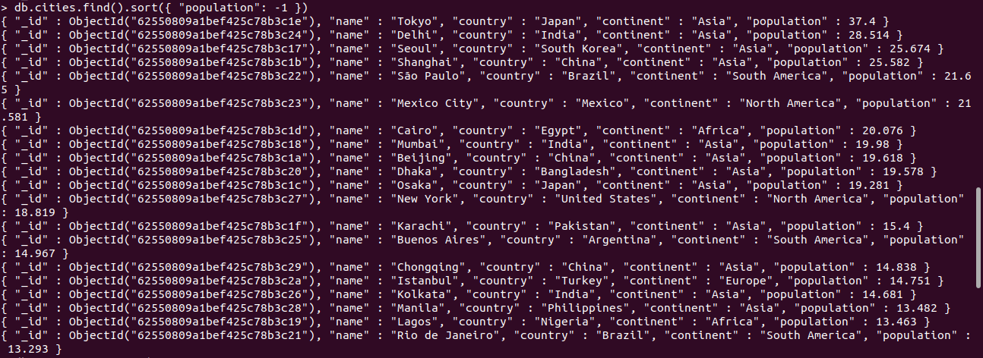

GROUP FUNCTION:

> db.cities.aggregate([

... { $group: { "_id": "$continent" } }

... ])

{ "_id" : "Africa" }

{ "_id" : "Asia" }

{ "_id" : "South America" }

{ "_id" : "Europe" }

{ "_id" : "North America" }

> db.cities.aggregate([

... {

... $group: {

... "_id": {

... "continent": "$continent",

... "country": "$country"

... }

... }

... }

... ])

OUTPUT:

{ "_id" : { "continent" : "North America", "country" : "Mexico" } }

{ "_id" : { "continent" : "Africa", "country" : "Nigeria" } }

{ "_id" : { "continent" : "Asia", "country" : "Japan" } }

{ "_id" : { "continent" : "Asia", "country" : "Philippines" } }

{ "_id" : { "continent" : "Europe", "country" : "Turkey" } }

{ "_id" : { "continent" : "South America", "country" : "Argentina" } }

{ "_id" : { "continent" : "Asia", "country" : "Bangladesh" } }

{ "_id" : { "continent" : "Asia", "country" : "China" } }

{ "_id" : { "continent" : "North America", "country" : "United States" } }

{ "_id" : { "continent" : "Asia", "country" : "South Korea" } }

{ "_id" : { "continent" : "Asia", "country" : "India" } }

{ "_id" : { "continent" : "Africa", "country" : "Egypt" } }

{ "_id" : { "continent" : "Asia", "country" : "Pakistan" } }

{ "_id" : { "continent" : "South America", "country" : "Brazil" } }

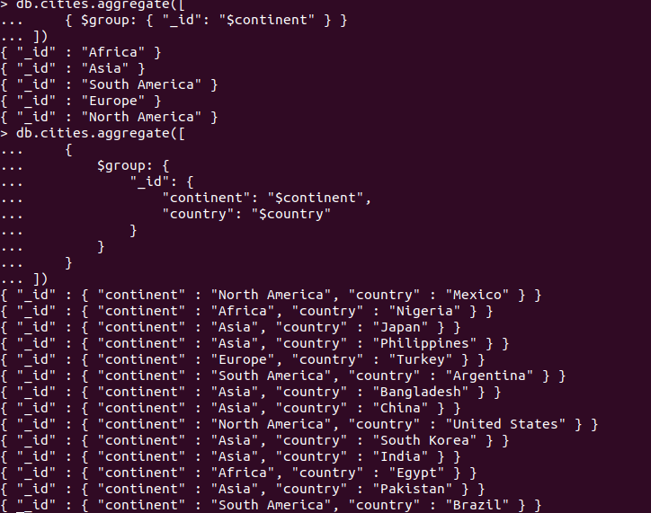

## **the $project Aggregation Stage**

> db.cities.aggregate([

... {

... $project: {

... "_id": 0,

... "location": {

... "country": "$country",

... "continent": "$continent",

... },

... "name": "$name",

... "population": "$population"

... }

... }

... ])

OUTPUT:

"location" : { "country" : "South Korea", "continent" : "Asia" }, "name" : "Seoul", "population" : 25.674 }

{ "location" : { "country" : "India", "continent" : "Asia" }, "name" : "Mumbai", "population" : 19.98 }

{ "location" : { "country" : "Nigeria", "continent" : "Africa" }, "name" : "Lagos", "population" : 13.463 }

{ "location" : { "country" : "China", "continent" : "Asia" }, "name" : "Beijing", "population" : 19.618 }

{ "location" : { "country" : "China", "continent" : "Asia" }, "name" : "Shanghai", "population" : 25.582 }

{ "location" : { "country" : "Japan", "continent" : "Asia" }, "name" : "Osaka", "population" : 19.281 }

{ "location" : { "country" : "Egypt", "continent" : "Africa" }, "name" : "Cairo", "population" : 20.076 }

{ "location" : { "country" : "Japan", "continent" : "Asia" }, "name" : "Tokyo", "population" : 37.4 }

{ "location" : { "country" : "Pakistan", "continent" : "Asia" }, "name" : "Karachi", "population" : 15.4 }

{ "location" : { "country" : "Bangladesh", "continent" : "Asia" }, "name" : "Dhaka", "population" : 19.578 }

{ "location" : { "country" : "Brazil", "continent" : "South America" }, "name" : "Rio de Janeiro", "population" : 13.293 }

{ "location" : { "country" : "Brazil", "continent" : "South America" }, "name" : "São Paulo", "population" : 21.65 }

{ "location" : { "country" : "Mexico", "continent" : "North America" }, "name" : "Mexico City", "population" : 21.581 }

{ "location" : { "country" : "India", "continent" : "Asia" }, "name" : "Delhi", "population" : 28.514 }

{ "location" : { "country" : "Argentina", "continent" : "South America" }, "name" : "Buenos Aires", "population" : 14.967 }

{ "location" : { "country" : "India", "continent" : "Asia" }, "name" : "Kolkata", "population" : 14.681 }

{ "location" : { "country" : "United States", "continent" : "North America" }, "name" : "New York", "population" : 18.819 }

{ "location" : { "country" : "Philippines", "continent" : "Asia" }, "name" : "Manila", "population" : 13.482 }

{ "location" : { "country" : "China", "continent" : "Asia" }, "name" : "Chongqing", "population" : 14.838 }

{ "location" : { "country" : "Turkey", "continent" : "Europe" }, "name" : "Istanbul", "population" : 14.751 }

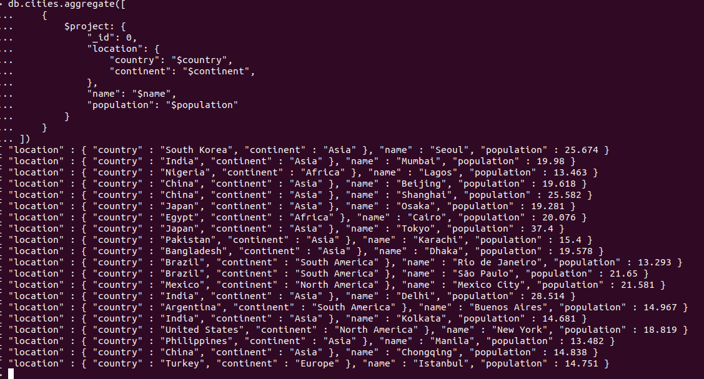

PIPELINE AGGREGATE FUNCTION:

data -

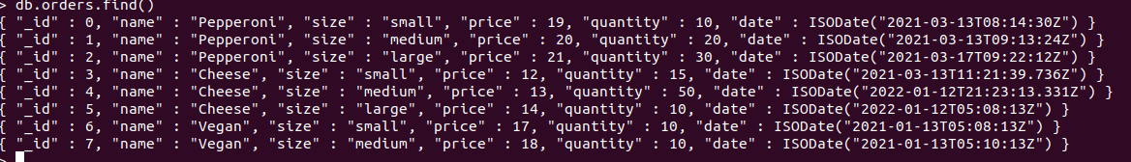

Group and Match function :

### **Total Order Quantity**

> db.orders.aggregate( [

... {

... $match: { size: "medium" }

... },

... {

... $group: { _id: "$name", totalQuantity: { $sum: "$quantity" } }

... }

... ] )

{ "_id" : "Cheese", "totalQuantity" : 50 }

{ "_id" : "Pepperoni", "totalQuantity" : 20 }

{ "_id" : "Vegan", "totalQuantity" : 10 }

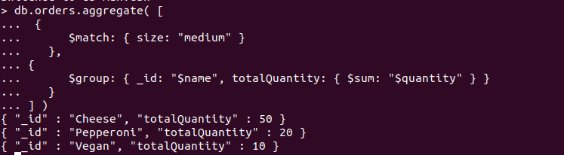

**Total Order Value and Average Order Quantity**

db.orders.aggregate( [

... {

... $match:

... {

... "date": { $gte: new ISODate( "2020-01-30" ), $lt: new ISODate( "2022-01-30" ) }

... }

... },

... {

... $group:

... {

... _id: { $dateToString: { format: "%Y-%m-%d", date: "$date" } },

... totalOrderValue: { $sum: { $multiply: [ "$price", "$quantity" ] } },

... averageOrderQuantity: { $avg: "$quantity" }

... }

... },

... {

... $sort: { totalOrderValue: -1 }

... }

... ] )

{ "_id" : "2022-01-12", "totalOrderValue" : 790, "averageOrderQuantity" : 30 }

{ "_id" : "2021-03-13", "totalOrderValue" : 770, "averageOrderQuantity" : 15 }

{ "_id" : "2021-03-17", "totalOrderValue" : 630, "averageOrderQuantity" : 30 }

{ "_id" : "2021-01-13", "totalOrderValue" : 350, "averageOrderQuantity" : 10 }

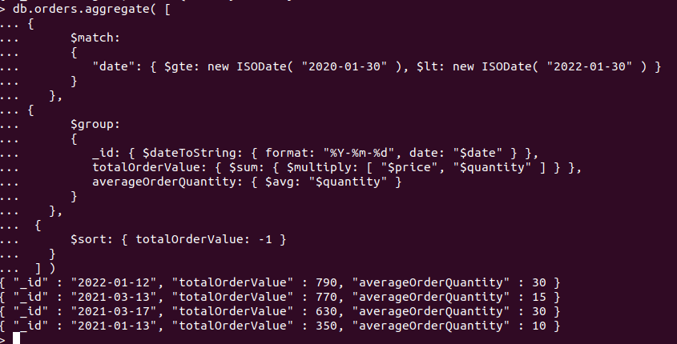

MAPREDUCE:

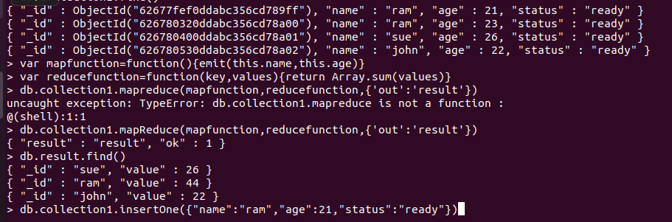

var mapfunction=function(){emit(this.name,this.age)}

var reducefunction=function(key,values){return Array.sum(values)}

> db.collection1.mapReduce(mapfunction,reducefunction,{'out':'result'})

{ "result" : "result", "ok" : 1 }

> db.result.find()

{ "_id" : "sue", "value" : 26 }

{ "_id" : "ram", "value" : 44 }

{ "_id" : "john", "value" : 22 }

> db.collection1.insertOne({"name":"ram","age":21,"status":"ready"})