**Wealth Hacker Homepage**

<http://www.wealthhacker.com>

FTP: wealthhacker.com u:whacker p:wh321

MySQL: database: whacker_news u:whacker_news p: wh321!

cPanel: <https://162.248.99.10:2083> u:whacker p: wh321

**Task 1**

Insert latest RSS news items into homepage, taken from a list of stock symbols rss search.

Look at /quote/index.php

This template uses /inc/simplepie.inc to include news for each stock symbol query into the page template.

It uses code for rss: [http://www.bing.com/news/search?q='.$_GET['symbol'].'&format=rss](http://www.bing.com/news/search?q='.$_GET%5b'symbol'%5d.'&format=rss)

**Collecting News Items**

For the homepage, I will supply a list of stock symbols, and a cron job should run every hour collecting the latest news items for each symbol in the list (possibly up to 30 symbols). It should then only store the latest 10 news articles by date and time, and display these results on the page. All other news items can be deleted.

**Inserting into page**

The Bing News query will return news URLs in this format:

<http://www.bing.com/news/apiclick.aspx?ref=FexRss&aid=&tid=20ea1ece20bb4dc8ab408cb71bbc8133&url=http://www.bidnessetc.com/26802-microsoft-sway-the-newest-arrow-in-microsoft-offices-quiver/&c=mhhLdxriQDowoT9gKoe62ScSTqxXwtDiRtXXz8RE_jU&mkt=en-us>

Before displaying on the homepage, all Bing data should be stripped from the URL and leave only the article URL. So in this example above, everything before &url= and everything after &c= would be removed. Leaving only:

<http://www.bidnessetc.com/26802-microsoft-sway-the-newest-arrow-in-microsoft-offices-quiver/>

This URL would then be the article link, using the article title as the text for the link.

The item description from the RSS feed used as the text for each article, the date used, and an image.

The images I have are stored in two directories. img/newsimg/one/ and img/newsimg/two/

Each row should use one unique image from each directory. So, on every page load, you never see the same image. Look again at /quote/index.php

This uses an idea which you may be able to implement for homepage.

$dir = 'img/newsimg/two';

$files = scandir($dir);

unset($files[0]);

unset($files[1]);

shuffle($files);

You can view the index.php template , I have inserted commented code into it.

**Task 2**

Latest stock prices viewed box

In the right sidebar of the homepage, you will see the box, latest stock prices viewed.

Any queries to the URL: <http://www.wealthhacker.com/quote/symbol> the symbol is stored for the last 5 queries to the page.

For instance, <http://www.wealthhacker.com/quote/bac>

If bac (Bank of America) is queried last, this displays in No 1 position. The Symbol in the box should link to the relevant quote query.

Task 3

Search for stocks, list drop down.

<http://www.wealthhacker.com/quote/msft>

I will supply a list of stocks which are available in the Yahoo database. There are thousands!

I want to enable the search feature to auto complete as a user is typing a company symbol or name. I would imagine we need to create a database table with all symbols and names in it, and associate the related /quote/symbol url for search.

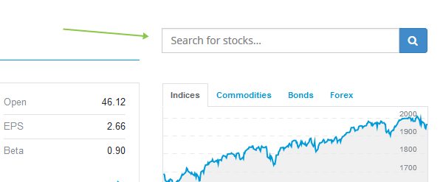

See example on <http://money.cnn.com/data/us_markets/>

Type G into the search box on the top right, and it shows available quotes. Then continue to GOOG and the results narrow down until you are only left with Google.