DiagBox-AutosarBCM User Guide



**HISTORY OF THE DOCUMENT**

|  |  |  |  |  |
| --- | --- | --- | --- | --- |
| **Edition** | **Date** | **Nature of the modification** | **Author** | **Reviewer** |
| 0.1 | 11-June-2024 | Document Created | Fulya Çakıroğlu |  |

**CONTENTS**

OVERVIEW 4

ABBREVIATION 4

Introduction to the Tool 4

Installation of the Tool 4

Main Window and Features 5

Connection Creation 5

Input/DTC 7

Trace 12

Features 13

Tools 18

Options 18

Trace Dialog 24

Control Check 24

EMC Monitor 25

Environmental Test 26

Help 28

# OVERVIEW

This document’s objective is to instruct and guide all DiagBox-AutosarBCM Tool users. The document includes instructions on how to use, set up, and configure this tool as well as several examples.

# ABBREVIATION

|  |  |
| --- | --- |
| **Abbreviation** | **Definition** |
| CAN | Controller Area Network |
| UDS | Unified Diagnostic Services |

# Introduction to the Tool

The DiagBox-AutosarBCM is a tool designed to perform the following diagnostic tasks:

* Scan and find hardware device (e.g. Intrepid, Vector, or Kvaser) connected to ECU automatically.
* Connection with the ECU thanks to the already-founded hardware device.
* Transmit, receive CAN & UDS messages.
* Log the data for both connections and transmit and receive processes.

# Installation of the Tool

Below steps should be followed and details should be taken into account.

* The tool can be installed by “.exe” which is shared with the user.
* On the installation, install mode should be selected as “Install for me only”.

Selection of the Install Mode

* The installation path should be remain as it is.

Installation Path

* After installation is completed, the tool will be asking a key to the user. For the license activation of the tool steps that need to be followed can be checked from the User Guide of that window.

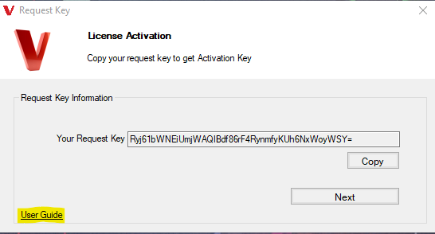

Guide for the License Activation

# Main Window and Features

Each pop-up of the tool can be closed with the “ESC” key.

## Connection Creation

The connection can be created with the ECU by clicking on the Start Connection button.

Start Connection

If there is any device connected to the PC, it will be shown in the pop-up window(Figure5), if there is no device found, then pop-up will be opened with the Warning message(Figure 6).

Hardware Connected to the PC

No Device Connected

Device can be selected and “Connect” button should be clicked, If the connection is established with the ECU via hardware device, “Start Connection” will be changed to “Stop Connection” and “Offline” will be changed to “Online {device name}”.

If there is any issue with connection creation, the pop-up will be opened with the issue message, issue details can be found in the “dev.log” file in the installation path of the tool. Some common and possible issue reasons are listed below:

* Hardware drivers may not be installed.
* Connection with the ECU and hardware may not be wired correctly.

## Input/DTC

Input/DTC tab can be used to transmit and receive CAN and UDS messages with general CAN message format.

#### Input

Input Panel

When a card is connected and a file is imported, a screen appears where all fields are disabled. To transmit data to these fields and view messages received from the card, it is necessary to change the session. The disabled fields vary according to sessions, with some fields remaining disabled in certain sessions.

Session Dropdown Menu

Input Screen when the Start Button is Clicked

When the start button located in the upper left corner is clicked, all data begins to be read, and the interpreted version of the data is displayed next to it. When clicked again, the data flow stops, and the last received data continues to be displayed.

TCMM_Input Control

Each control has its own buttons. If the control has sub-controls, they are displayed below in a list format. The 'X' marked button clears incoming data, while the 'Read' button displays the interpreted version of incoming data.

**Top Right Corner:** It shows the current success rate of sent and received messages. The percentage indicates the overall success rate, while the two numbers indicate the number of successful sends (up arrow) and receives (down arrow).

Transmitted and Received Data Count

Service Window

When you click on the titles of the controls, a window specific to that control appears on the right side. If the control supports data sending, a page in the appropriate format opens for each, and data can be transmitted using the "Send" button located below. If the control does not support data transmission and is only for reading purposes, a "Service not supported" message is displayed.

Window for Read Only Services

Some control elements may contain sub-controls or sub-items, allowing users to send multiple pieces of data simultaneously. In this case, clicking on the control title opens a panel on the right side where a list of sub-controls under the selected control title is displayed. Users can select the desired sub-controls from this list, configure the data if necessary, and then click the "Send" button to transmit the data.

Multiple Data Transmit

#### DTC

Buttons DTC Tab

Not all controls in the input tab are included; only those with DTC controls are listed. There are two buttons in the top right corner:

Read DTC: Displays the data

Clear DTC: Sends clear DTC UDS command and clears the displayed data

Reading Data on DTC Tab

## Trace

Trace tab includes basic logs of the tool such as connection details, received and transmitted messages.

Trace panel grid includes received response messages to the transmitted messages. If the response message includes “7F” which means that it is negative feedback, message row will be written with red color. If it is positive feedback, it will be displayed in green color.

Trace window can be cleared with the “Clear” button in its view.

Clear of the trace

Trace window content can be saved to the local as LogFile (.txt) format.

Saving of the trace window

## Features

#### Import

This XML file contains various settings and configurations used by the application. It includes sections for general settings, services, sessions, controls, payloads, DTC failure types, environmental test configurations, continuous read lists, and connection mappings.

The Settings section defines general configuration parameters such as namesPadding, TxInterval, and DTCWaitingTime. The Services section lists various diagnostic services with their request and response IDs. The Sessions section describes the available diagnostic sessions and the services available for each session. The Controls section details the control items and their associated services and responses. The Payloads section includes various data configurations. The DTCFailureTypes section defines different failure types. The EnvironmentalTest and EnvironmentalConfig sections specify environmental test parameters. The ConnectionMappings section shows how input and output signals are connected. Config file contains like this configurations.

XML Content as an Example

By importing this structured file, the application can display items and the operations that can be performed with them on the main page. This allows users to view and interact with the available settings and configuration options. Users can perform actions related to these items and see detailed information on how the system operates. This enables users to make changes to specific controls and services, customizing the application's functionality to meet their needs.

The Pop-up That Opens When Clicked the Import Button

#### Sessions

##### Default Session ($01)

The Default Session is used to monitor the vehicle's normal operation and provide basic diagnostic services. It also activates the default diagnostic session on servers and does not manage diagnostic application timeout. For instance, the TesterPresent service is not necessary to keep the session active. Whenever a server is powered on, it should initiate the default diagnostic session. Unless another diagnostic session is started, the default diagnostic session will remain active as long as the server is powered.

##### Programming Session ($02)

The Programming Session enables all necessary diagnostic services for supporting memory programming on a server. It is used to perform software updates to ECU memory and improve performance. The Programming Session should automatically suspend the recording of DTCs by the ECU and suspend transmission of diagnostic frames when entering the programming session, regardless of whether it is operating in bootloader software.

##### Extended Diagnostic Session ($03)

The Extended Diagnostic Session is used to enable scheduled diagnostic service functionalities (e.g., I/O control). The diagnostic functionalities in this session must encompass all diagnostic functionalities supported in Default Session. This session is particularly useful when users need to perform specific diagnostic operations, expecting more detailed responses from the ECU (e.g., reading/writing values, starting/stopping routines). It is used for more complex diagnostic procedures and facilitates more interactive communication with the ECU.

The Extended Diagnostic Session activates various features accessible to the user via the "Options" menu on the interface. These features include functions like "Control Check" and "Environmental Test," allowing users to conduct specific checks and tests on the vehicle or device.

#### ECUReset

The ECUReset is a specialized service used to initiate the resetting process of an Electronic Control Unit (ECU) in vehicles. This service is designed to send a reset command to the ECU in order to reset a specific operation or state. It is particularly useful when the ECU needs to be taken out of an error state or when a specific operation cycle needs to be restarted.

ECUReset Button

#### Clear Fields

If there is no valid configuration, no action is taken. However, if a valid configuration exists, the configuration is enabled and specific checks are performed. If the type of the first document is appropriate, the previous configuration is cleared, and the new configuration is loaded. When the session information is valid, session filtering is executed. Finally, the counters for sent and received messages are reset, ensuring that the counts start from zero. These actions allow the user to update and clear the configuration in the system and enable session filtering.

Clear Fields Button

#### Tester Present

The TesterPresent service is used to inform the Electronic Control Unit (ECU) of the presence of a vehicle test tool. It indicates that the test tool is connected to the ECU and communication is established. In the background, it periodically checks if the test tool is still communicating with the ECU over specific intervals.

The service automatically becomes active when the connection is initiated, continuously reminding the ECU of the presence of the test tool. This ensures that the ECU is aware of the test tool's connection and remains ready to perform necessary operations.

The TesterPresent service is crucial for maintaining continuous communication between the test tool and the ECU, enhancing reliability during prolonged testing or diagnostic procedures. It ensures uninterrupted communication between the test tool and the ECU, crucial for reliable diagnostics and testing processes.

Tester Present Menu

#### Filter

Filtering is performed using a search box. Users can limit all the items below by typing a name into the search box. This allows for fast and effective searches, enabling users to access the information they are looking for more quickly.

Search Box for Filtering

# Tools

In the Tools menu, various options such as Options, Control Check, and Environmental Test are available. This menu serves as a comprehensive toolkit where users can access additional functionalities tailored to managing controls and conducting environmental tests.

## Options

To access the settings of the DiagBox-AutosarBCM tool, please click on the settings icon.

Options Page Content

#### Tool

##### General

Flush to UI: Controls how many log messages you see on the trace.

Flush to file: Sets how many lines of logs are written before saving to a file.

Rolling after: Decides when to start a new log file based on its size in megabytes.

File Path: Tells the tool where to save the log files on your computer.

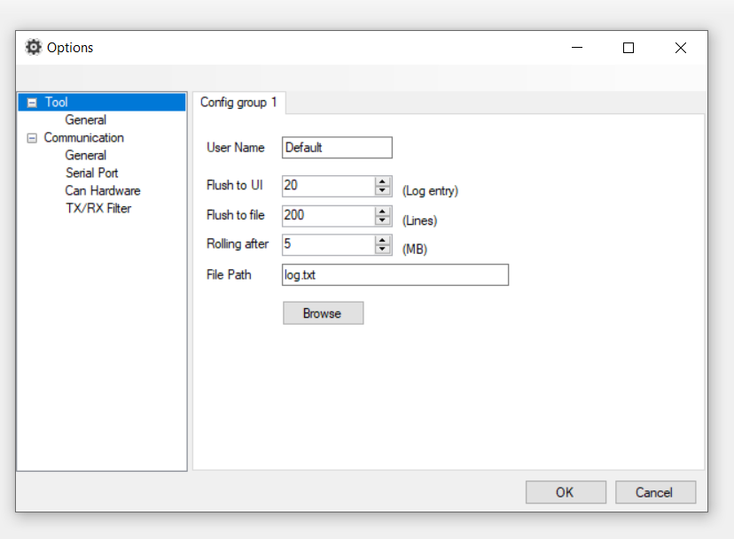

Options Default Page

#### Communication

##### General

General Part of Communication

The part where data is configured according to the ISO-TP (ISO Transport Protocol) standard.

##### Serial Port Configuration

In addition to CAN devices, DiagBox-AutosarBCM now supports connecting to devices through Serial Ports. Various parameters are available to establish a SerialPort connection. Here is a guide on how to set each one:

Port: Enter the appropriate port number through which the device connects in the textbox.

Baud Rate: Input the correct data transmission rate in the Baud Rate field.

Data Bits: Define the number of data bits for the communication in the Data Bits field.

Parity: Select a parity setting from the dropdown menu to ensure error checking during data transmission.

Stop Bits: Choose an option from the dropdown menu to dictate how the communication ends.

Read Timeout and Write Timeout: Determine the timeout durations for read and write operations by setting values in the Read Timeout and Write Timeout fields, respectively.

Remember to save the settings after configuring them to apply the new configurations.

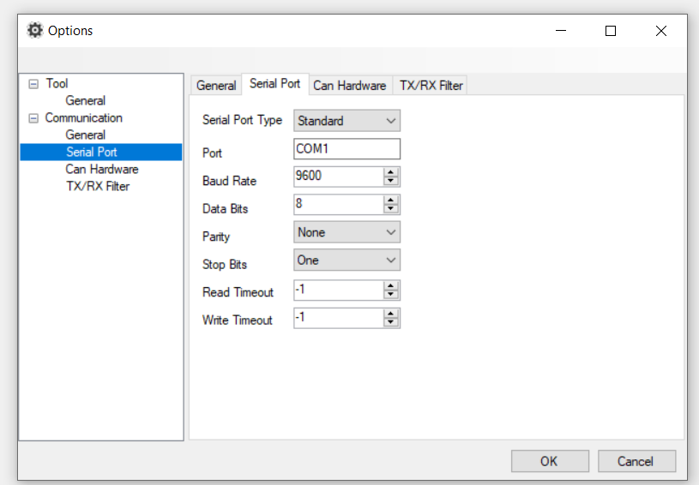

Serial Port Tab in Options

##### CAN Hardware Bit Rate Configuration

Setting the bit rate is an essential process to facilitate the correct pace for data transmission over the CAN bus. Here is how you can set the bit rate and the various options available:

* Click on the settings icon to open the settings menu and select Can Network from the Communication heading.
* Select Device: Under the 'Options' section, you will find a dropdown menu to select your device. The available options are:
  + Intrepid
  + Kvaser (TBD)
  + Vector (TBD)
* Bit Rate Setting: Depending on your selected device, you will now select the desired bit rate from the following options:
  + 0
  + 2000
  + 33333
  + 50000
  + 62500
  + 83333
  + 100000
  + 125000
  + 250000
  + 500000
  + 800000
  + 1000000

Bit Rate Options: Explanation

* 0: Disables the bit rate, halting any communication over the CAN bus.
* 2000 to 1000000: Various bit rate settings to suit different data transmission requirements, ranging from very basic setups to environments necessitating very high-speed data transmission.

Can Hardware Tab in Options

##### TX/RX Filter

Next to the "Add" button, specify the unwanted messages to be displayed in the text box. When the button is clicked, these messages will appear in the blank space on the left. This section is designed to filter TX/RX messages. Messages in the monitoring window are filtered according to the filtered data list on the TX/RX page.

TX/RX Filter

Notes:

* Ensure the selected bit rate is compatible with other devices on your network to maintain seamless communication.
* Higher bit rates allow faster data transmission but might increase the risk of errors; hence, a balance is necessary.

For further guidance, you may refer to the referenced documentations or contact support.

* CAN network selection is used to direct communication between different networks in a vehicle. The purpose of the selection is to regulate data transmission that needs to take place over a specific network, which facilitates targeted diagnostics and system checks. You can choose your preferred CAN network based on the unique needs and configurations of setup.

## Trace Dialog

Each control in the table has a pop-up window that displays all transmitted and received data. This window provides users with the opportunity to observe data flows in detail for each control. Transmitted data is listed in the sent format along with timestamps, and received data is similarly displayed. Users can monitor the data flow in real-time using this pop-up window.

Trace dialog can be cleared with the “Clear” button in its view.

Trace Dialog Pop-up

## Control Check

The application allowed reading or sending data individually or collectively to/from the controls, but with the newly introduced pop-up, multiple controls can be selected, making it easier to perform desired operations efficiently. However, for these control operations to work, the ECU be in the Extended Diagnostic Session mode. Control check operations only function in this mode.

Control Check Window

On the left side of the table, desired controls can be selected using checkboxes. The button in the top left corner labeled "Start" initiates the selected controls, while the "Save" button allows the table to be saved to the device.

Control Type: “Input" displays services where only reading is performed, while "Output" shows services where data transmission occurs in this section.

Interval: Pressing "Start" specifies how often this operation will occur in seconds.

Control Order: Selecting the "Horizontal" option allows individual controls to be toggled on and off, whereas choosing the "Vertical" option opens all selected controls initially and then closes them all.

## EMC Monitor

When the "Start" button is pressed on this screen, all control units are started, and the data of the changed units are displayed on the screen. When the "Export" button is clicked, this displayed data is saved to the device in CSV format.

The filter feature in the upper right corner allows users to search through the data in the table by entering the letter or word they want. Thanks to this feature, users can quickly and easily filter and find data that meets certain criteria.

EMC Monitor Window

## Environmental Test

This window is used for conducting comprehensive testing. After configuring the desired opening and closing times for each DID in seconds, it is monitored and controlled through this interface. However, it is important to note that these operations only function in the Extended Diagnostic Session mode. In this mode, the ECU allows for more advanced diagnostic and control operations capabilities to perform the environmental test accurately.

When the start button is pressed, the test begins. From the moment the test starts, the elapsed time is displayed under "Time." The cycle and loop count of the test are also shown next to "Time" and continue to increase throughout the duration of the test.

On the right side, the number of all transmitted and received data items is displayed. The total count of received and transmitted data for sub-controls is consolidated into one count each. Additionally, the ratio of received to transmitted data is calculated and displayed as a percentage next to these counts.

Environmental Test Pop-up

For each DID, DTC and write status are individually listed. The write status is updated based on incoming data to display the interpreted version of the data. If it's a DTC, the DTC status is also updated with a description of the incoming data.

The arrows next to the title indicate the count of transmitted and received messages, with the ratio of incoming to outgoing messages displayed as a percentage on the left. Unlike the upper section where these numbers are consolidated, here they are calculated separately for each DID.

The DID in Environmental Test

When the user starts and subsequently stops the environmental test, all the items that have been activated and deactivated during this period are saved as a text file (txt file). This text file records all the operations and statuses that occurred during the test in detail. After the test is completed, the user can open this text file to easily review and analyze what happened during the test, which items were activated or deactivated, and which operations were performed. This feature provides great convenience for verifying the accuracy and integrity of the tests, identifying potential issues, and better understanding the test processes. Additionally, it is an important tool for documenting the test results and generating reports when necessary.

Log File Content for Environmental Test

# Help

Help of the tool includes “About” for now, in the about, version of the current release, integrated products are defined.

About from the Help