**PROJECT REPORT**

**Fake News Detection Using Python and Machine Learning**

Team name:Tricoders

Team members:

1) Kethu ram T A

2) Maanicavasagan P

3) Kiran vignesh S

**Ⅰ. Introduction:**

Fake news is hardly a brand-new concept. It should be noted that publishers used incorrect and misleading material to advance their interests, so the concept existed even before the development of the Internet. Since the internet's inception, more and more people have switched from using traditional media outlets to online platforms to access information. The latter option is not only speedier and more convenient, but it also enables consumers to access a number of periodicals at once. But as content providers started exploiting what has come to be known as clickbait, the idea of false news was redefined as a result of this evolution.Fake news is hardly a brand-new concept. It should be noted that publishers used incorrect and misleading material to advance their interests, so the concept existed even before the development of the Internet. Since the internet's inception, more and more people have switched from using traditional media outlets to online platforms to access information. The latter option is not only speedier and more convenient, but it also enables consumers to access a number of periodicals at once. But as content providers started exploiting what has come to be known as clickbait, the idea of false news was redefined as a result of this evolution.Because of this, content publishers have not made much of an attempt to refrain from using clickbait and publishing inaccurate information, despite the concerns that users have voiced about these topics. Tech firms like Google, Facebook, and Twitter have, at best, made an effort to address this specific issue. These attempts haven't done much to address the issue, though, since the organizations have resorted to not paying the people connected to these sites the money they would have made from the increased traffic.Users, on the other hand, still have to deal with websites that post fake material and whose presence generally makes it more difficult for readers to engage with legitimate news.

**Ⅱ.RELATED WORK:**

Fake news detection using machine learning and Python has been an active area of research and development. Numerous studies and projects have focused on this topic, employing various machine learning techniques and Python libraries. Here are some notable works in the field of fake news detection using machine learning and Python:

1.By Karim et al. (2018) in "Combating Fake News: A Survey on Identification and Mitigation Techniques": This survey study provides an overview of several machine learning-based false news detection methods. It covers commonly used Python-based tools and modules for feature extraction, classification, and data preprocessing.

2. "Fake News Detection Using Machine Learning: A Systematic Literature Review" by Ruchansky et al. (2017): This review paper summarizes the existing literature on fake news detection using machine learning. It discusses different datasets, features, and classification algorithms used in the field. Python-based libraries like scikit-learn and NLTK are commonly mentioned.

3.. Zhao et al. (2015)'s "Detecting Rumors and Fake News on Social Media: A Data Mining Perspective": This research focuses on utilizing machine learning algorithms to identify rumors and false information on social media. Python is used for feature extraction, classification, and data collecting. The article explores various feature representations and classification techniques.

4. "Fake News Detection on Twitter Using Machine Learning Techniques" by Mishra et al. (2018): This study presents a machine learning-based approach for fake news detection on Twitter. Python libraries such as scikit-learn and TensorFlow are used for feature extraction and classification. The authors explore different features, including user-based, content-based, and temporal features.

These works can serve as a starting point for understanding the approaches and techniques used in fake news detection using machine learning and Python. However, please note that the field is continuously evolving, and new research papers and projects are regularly published.

**Ⅲ.CONTRIBUTION:**

The report is an example of a machine learning system our team created to identify real news from fake news.The most prevalent machine learning techniques employed by false news detection systems include Support Vector Machines, Random Forests, Decision Trees, Stochastic Gradient Descent, Logistic Regression, and others. In this project, we made an effort to put one of these algorithms into practise so that we could train and evaluate our findings and use the logistic algorithm to get the most accurate results.

Logistic regression, a component of the Supervised Learning approach, is one of the most well-known Machine Learning algorithms. Using a number of independent variables, the categorical dependent variable is predicted. Logistic regression is used to forecast the result of a categorical dependent variable. Difficulties Because it can assign probabilities and categorise new data using continuous and discrete datasets, the logistic regression method is a key machine learning tool. The most efficient variables for the classification can be easily found when using logistic regression to classify the observations using various forms of data. Although it is referred to as logistic regression because it classifies samples using predictive modelling, logistic regression really employs the idea of regression.

**Ⅳ.Evaluation:**

The performance of the model was evaluated based on metrics such as confusion matrix,which shows the number of true and fake news prediction and classification report,which provides a detailed analysis on the metrics such as recall,F1- score,precision and accuracy_score where the model achieved an accuracy of 98.83%

Classification Report ,Confusion Matrix and Accuarcy:

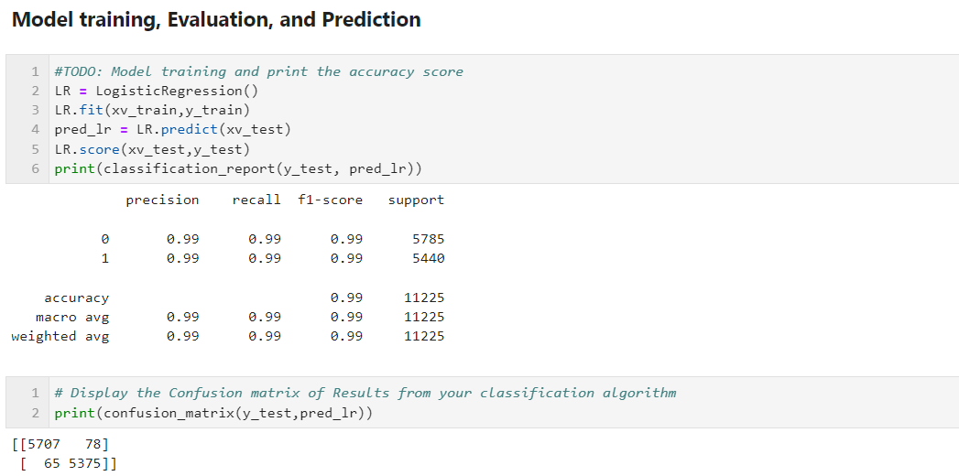

**Ⅴ.Future works:**

While our study yields promising results, there are several avenues for future research. We discuss potential areas for improvement, such as exploring alternative machine learning algorithms, incorporating deep learning techniques,ensemble learning techniques and leveraging additional data sources. We also suggest extending the model to handle multi-class classification, as fake news detection often involves classifying news into multiple categories of misinformation**.**

**Ⅵ.Conclusion:**

The ultimate bewilderment that results from compendiums thinking something that isn't true to be true is caused by fake news.This is the risk posed by false news, as many in modern society are still unable to tell the difference between the two in their day-to-day activities. However, by using machine learning to determine if news is fake or not, this issue may undoubtedly be resolved. within the scope of.Here, we used logistic regression to estimate the accuracy, which was 99 for both true and false news.

**Ⅶ.Reference Papers:**

1.A SMART SYSTEM FOR FAKE NEWS DETECTION USING MACHINE LEARNING https://www.researchgate.net/publication/339022255_A_smart_System_for_Fake_ News_Detection_Using_Machine_Learning.

2. "Casebased learning, pedagogical innovation, and semantic web technologies," IEEE Trans. Learn. Technol., vol. 5, no. 2, pp. 104–116, 2012. A. Martnez-Garcia, S. Morris, M. Tscholl, F. Tracy, and P. Carmichael.

3. https://indianexpress.com/article/technology/ social/whatsapp-fight-against fake-news-top features-to curb-spread-of-misinformation.

4. . H Gupta, M S Jamal. S. Madsetty and M. S. Desarkar, "A framework for real-time sparn detection in Twitter," 2018 10th International Conference on Communication Systems & Networks(COMSNETS),Bengaluru.

5.A Hybrid Approach to Fake News Detection on Social Media, E. M. Okoro, B. A. Abara, A. O. Umagba, A. A. Ajonye, and Z. S. Isa, vol. 37, no. 2, pp. 454–462, 2018.

6.P. R. Humanante-Ramos, F. J. Garcia Penalvo, and M. A. Conde-Gonzalez, “PLES in Mobile Contexts: New Ways to Personalize Learning," Rev. Iberoam. Tecnol. del Aprendiz., vol. 11, no. 4, pp. 220-226,2016. 7. Rubin, V. (2017). Deception detection and rumor debunking for social media. Handbook of Social Media Research Methods.

7. Using N-Gram Analysis and Machine Learning Techniques to Spot Online Fake News

ECE Department, University of Victoria, Victoria, BC, Canada School of Computer Science, University of Windsor, Windsor, ON, Canada Hadeer Ahmed, Issa Traore, and Sherif Saad

8.A Naive Bayes classifier technique was created by Volydimyr Mesyura and Mykhailo Granik for the purpose of identifying bogus news.

9.A model for detecting false news has been presented by Deepak S. and Bhadrachalam Chitturia.

10.To detect bogus news, Ms. Smita Vinit designed a hybrid model. It uses SVM and Naive Bayes algorithms in conjunction.