AI-AUGMENTED SDLC
Process Definition
Stages, inputs and outputs, manual and AI responsibilities, validation of AI output, and the process flows for new features, change requests, and issue fixes and service requests.
Document ID | PD-AISDLC-01
Version | 1.0 — Draft for review
Product | Fixed Assets Suite: web application with microservices, mobile application, internal web applications
Modules | Asset master, depreciation, labelling and tracking, data validation and audit
Owner | Solution Architect
Approval body | AI Governance Council
Status | Draft — pending Council approval
Date | 30 October 2026
Classification | Internal

How to read this document
Sections 1 to 3 explain the principles and the overall flow. Section 4 defines each stage in detail. Section 5 gives the three process flows by work type. Sections 6 to 8 describe how AI output is validated, the shared Context Pack and traceability. Sections 9 to 11 cover roles, governance, the templates and how to implement the process.

Document control

Version history
Version | Date | Author | Summary of change
0.1 | 16 Oct 2026 | Solution Architect | Framework outline presented to the team
1.0 | 30 Oct 2026 | Solution Architect | Full process definition, templates and Context Pack structure

Approvals
Role | Name | Decision | Date | Signature / Jira ref
Solution Architect (owner) |  | [Approve / Reject]
QA Lead |  | [Approve / Reject]
Delivery Manager |  | [Approve / Reject]
Security Lead |  | [Approve / Reject]
Product Owner |  | [Approve / Reject]

Related documents
ID | Document | Relationship
T01 – T15 | Process templates (templates folder) | Filled in at the stages defined in section 4
X01 | AI SDLC Tracker Workbook | RTM, gate log, AI usage log, waiver register
/ai-context | Common Context Pack (CP-00 to CP-99) | Loaded by every AI step; section 7
Session deck | AI-SDLC Implementation deck | Explains this process and its roll-out to the team

Contents

If the contents list is empty, right-click it in Word and choose Update Field.

1 Introduction

1.1 Purpose
Developers across the Fixed Assets suite now use AI to draft requirements, documents, code, tests and release material. AI makes first drafts fast, but it also makes it easy to skip the steps that kept the product consistent: signed requirement documents, coding and naming standards checked by PMD and Sonar, a fixed project structure with shared base classes, written test scenarios, Jira traceability and Jenkins-controlled releases.
This document defines one process that keeps the speed and restores the discipline. For every stage it states what goes in, what comes out, which work is manual and which is AI-generated or AI-assisted, how AI output is proven valid, and who signs the gate before the output becomes the next stage’s input.

1.2 Scope
In scope | Out of scope
All three product surfaces: web application with microservices, mobile application, internal web applications | Selection and procurement of AI tools (owned by the Council and IT, recorded in CP-40)
All work types: new applications and features, enhancements and change requests, issue fixes and service requests | Infrastructure provisioning and platform operations not delivered through the product pipeline
All SDLC stages from intake to production closure, and the feedback loop | Commercial, contractual and HR processes
Every person who creates, reviews or approves a product artifact, whether or not they use AI | Personal productivity use of AI that produces no product artifact

1.3 Audience and how to use this document
If you are… | Read first | Then use
Product Owner or Business Analyst | Sections 2, 3, 4.1 to 4.3, 5 | T01, T04, T10, T11
Technical Writer | Sections 2, 4.3, 6, 7 | T02, T10, T11
Architect or Tech Lead | All sections; you own sections 3, 7 and 9 | T03, T04, T09, T10, T14
Developer | Sections 2, 4.5, 4.6, 5.3, 6, 7, 8 | T09, T11, Context Pack
QA or Automation Engineer | Sections 2, 4.7, 4.8, 6 | T07, T08, T10, T11
Release Manager or DevOps | Sections 4.9, 4.10, 5.3 | T12, T13, T10
Delivery Manager or Council member | Sections 2, 3, 9, 10, 11 | X01, T15

1.4 Definitions and abbreviations
Term | Meaning
AI operator | The person who runs an AI prompt and is accountable for its output until it is reviewed.
AI-G / AI-A / AI-X | AI-Generated, AI-Assisted, AI Not Permitted. See section 2.2.
Context Pack (CP) | The versioned folder /ai-context holding the standards, registries, templates and examples that every AI prompt loads. Section 7.
CR | Change Request: a change to behaviour that is already baselined.
Gate (G0 to G9) | The recorded decision that closes a stage. A stage output becomes the next stage input only after its gate.
Golden example | A reviewed reference implementation for a surface that AI is told to imitate (CP-99).
NBV, SLM, WDV, CWIP | Net book value; straight-line method; written-down value; capital work in progress.
NF | New application or new feature.
Parity check | The automated comparison that approved test cases equal executed plus automated plus formally deferred cases.
RCA | Root Cause Analysis (T06).
RTM | Requirement Traceability Matrix, held in X01.
SFVD | The screens, fields, validations and data document (T02) that development and testing both work from.
SME | Subject-matter expert, here usually a fixed-asset accounting expert.
SR | Issue fix or service request: a defect, or an operational change to data, configuration or access.

2 Principles, Process Modes and AI Permissions

2.1 Principles
- AI drafts, a person decides, the gate records. AI output is never a deliverable as generated. It becomes one only when a named reviewer accepts it and the gate is recorded in T10.
- Context is shared, never personal. Standards, structure, shared libraries, style classes, registries and test data live in one versioned Context Pack that every prompt loads.
- Nothing moves without an ID. Every artifact, commit, test case and defect carries its requirement, CR or SR ID. If it is not linked it does not ship.
- Reuse before create. A new utility, base method, style class, validation ID or service is justified in writing, or it is not created.
- Evidence or it did not happen. A gate passes only with a recorded artifact: checklist, scan result, approval. Verbal sign-off is not a gate.

2.2 Process modes
Every input, activity and output in this document is tagged with one mode. The tag tells you who produces it and how much verification it needs.
Mode | Name | Meaning | Verification required
M | Manual | Performed and owned entirely by a named person. AI is not used to produce the output. | Role checklist and gate (L2, L4)
AI-G | AI-Generated | AI produces the draft from approved inputs and the Context Pack. A named person must validate it before it is used. It is never a deliverable as generated. | All four levels (L1 to L4) and the universal checklist in 6.3
AI-A | AI-Assisted | A person produces the output. AI is used only to summarise, search, scan or suggest. The person decides. | The person confirms every AI suggestion before acting on it
AUTO | Automated | Deterministic tooling with no AI judgement: Jenkins pipeline, PMD, Sonar, OpenAPI diff, link-check jobs. | Result attached to the gate as evidence
AI-X | AI Not Permitted | AI must not be used for this activity under any circumstances. | Not applicable: AI must not be used

A combined tag such as “AI-G → M”
means AI generates the draft and a person then validates, completes and owns it. The output is only usable after the person’s step.

2.3 What AI may and may not do
AI-Generated, then validated (AI-G) | AI-Assisted only (AI-A) | AI not permitted (AI-X)
- Requirement register and acceptance criteria drafts  - SFVD drafts  - Design notes, OpenAPI contracts, migration drafts  - Code and unit tests (except P1 / P2 fixes)  - Test cases, test data and automation scripts  - Release notes and runbook drafts  - Fixes for P3 / P4 defects after RCA approval | - Intake and log summaries  - Duplicate and impact searches across the RTM and code  - Code review aids: diff summary, deviation scan, duplicate detection  - Regression selection suggestions for CRs  - Defect description drafts  - Post-deployment log summaries | - Classifying work type or setting severity  - Approving any gate, pull request or release  - Answering its own open questions or assumptions  - Root cause analysis for any defect  - Fixes for P1 and P2 defects  - Scripts that change cost, accumulated depreciation or NBV  - Executing deployments, rollbacks or production data changes  - Prompts containing production personal data, financial records or secrets  - Creating new validation IDs, error codes or style classes outside the registry process

2.4 Rules for every AI interaction
- Use only AI tools on the approved list in CP-40, through company accounts.
- Never put production personal data, financial records, credentials or secrets into a prompt. Use seed data from CP-31.
- Start from the approved, versioned input of the previous stage, never from memory or an unapproved draft.
- Use the stage prompt template from CP-50. Do not combine two stages in one prompt.
- Record every AI-G use in T11: tool, prompt template and version, Context Pack version, sections generated, assumptions.
- You own what AI produces for you. “The AI generated it” is not accepted at review.
- If AI repeatedly gets something wrong, raise a Context Pack change (T14); do not just fix your own copy.

3 Process Overview

3.1 The master flow
Ten stages take every piece of work from intake to a closed, audited release. Requirements, SFVD and design are sequential; test design (S6) runs in parallel with design and development from the moment the SFVD is baselined; both tracks converge at test execution (S7).
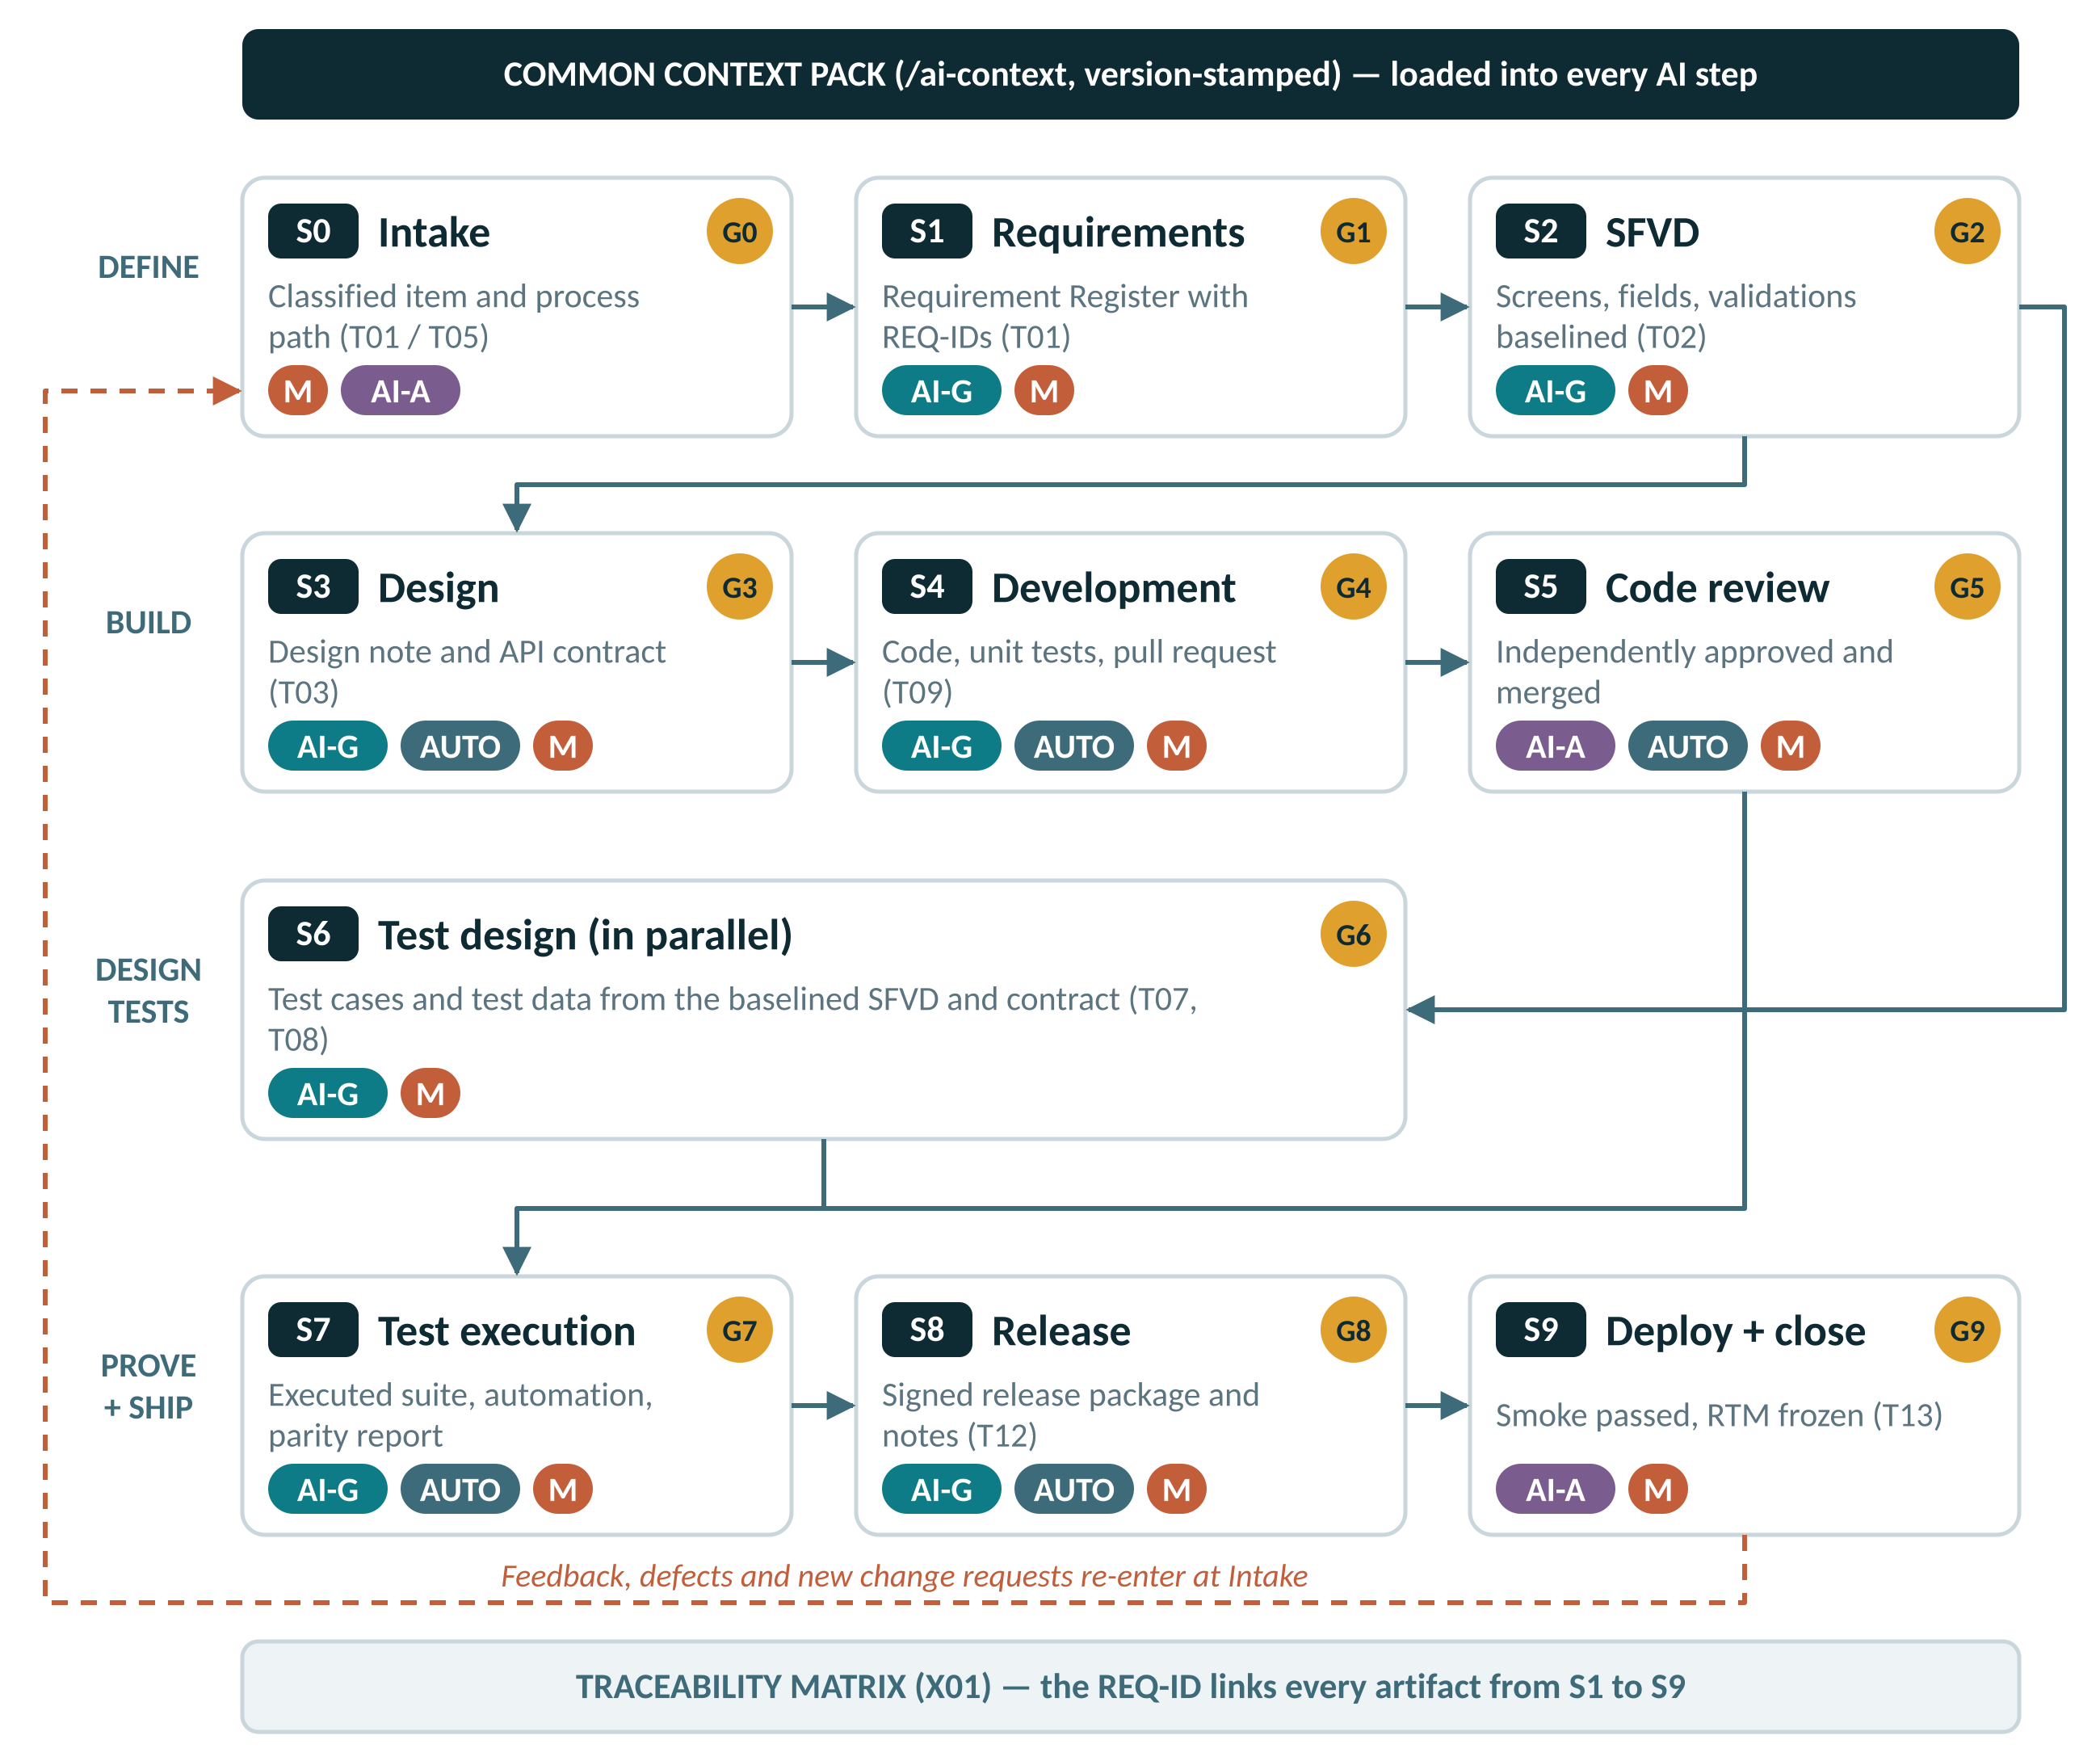
Figure 1 — Master AI SDLC flow: stages, gates and modes

3.2 Anatomy of a stage
Every stage runs the same loop. Learning this loop once is enough to work in any stage.
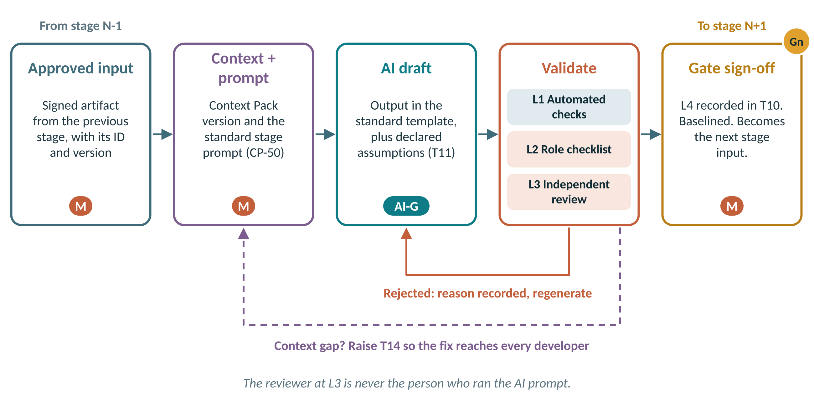
Figure 2 — The loop every stage follows, including rejection and context-gap handling
- Approved input. Only the signed output of the previous gate, identified by ID and version.
- Context and prompt. The current Context Pack version and the stage prompt template from CP-50.
- AI draft. AI produces the output in the standard template and lists every assumption and open question.
- Validate. L1 automated checks, L2 role checklist, L3 independent review (section 6).
- Gate sign-off. L4: the gate owner records the decision in T10. The output is baselined and released to the next stage.
If the output is rejected, the reason is recorded and the stage repeats. If the cause is missing or wrong context, the AI operator also raises a Context Pack change (T14) so the same error is not generated for anyone else.

3.3 Stage summary
Stage | Key input | Key output | Output mode | Gate | Accountable
S0 Intake and Classification | Work item description and attachments | Classified Jira item: work type, ID, module, severity (Jira) | M | G0 | Delivery Manager
S1 Requirements and Review Points | Business requirement note and client review points | Requirement Register v1.0 with REQ-IDs and acceptance criteria (T01 Part C) | AI-G → M | G1 | Product Owner
S2 SFVD: Screens, Fields, Validations | Approved Requirement Register | SFVD vX.Y (T02) | AI-G → M | G2 | BA Lead
S3 Solution Design and Interface Contract | Finalised SFVD | Solution Design Note (T03) | AI-G → M | G3 | Architect
S4 Development | SFVD section, API contract and design note | Source code and unit tests (Code repository) | AI-G → M | G4 | Tech Lead
S5 Code Review | Pull request diff and T09 checklist | Approved pull request or review comments (Code repository) | M | G5 | Tech Lead
S6 Test Design | Finalised SFVD and API contract | Test Case Specification (T07) | AI-G → M | G6 | QA Lead
S7 Test Execution and Automation | Approved test suite | Execution report (Test management tool) | M | G7 | QA Lead
S8 Build and Release | Merged code and the release scope from Jira | Release package (immutable, checksummed) (Artifact repository) | AUTO | G8 | Delivery Manager
S9 Deploy, Verify and Close | Signed release package | Deployment record and smoke results (T13) | M | G9 | Delivery Manager

3.4 Work-type classification and routing
Every work item is classified at intake (S0) into one of three work types. The work type decides which stages apply and in what depth. Classification is a manual decision: AI may summarise the request but must not classify it.
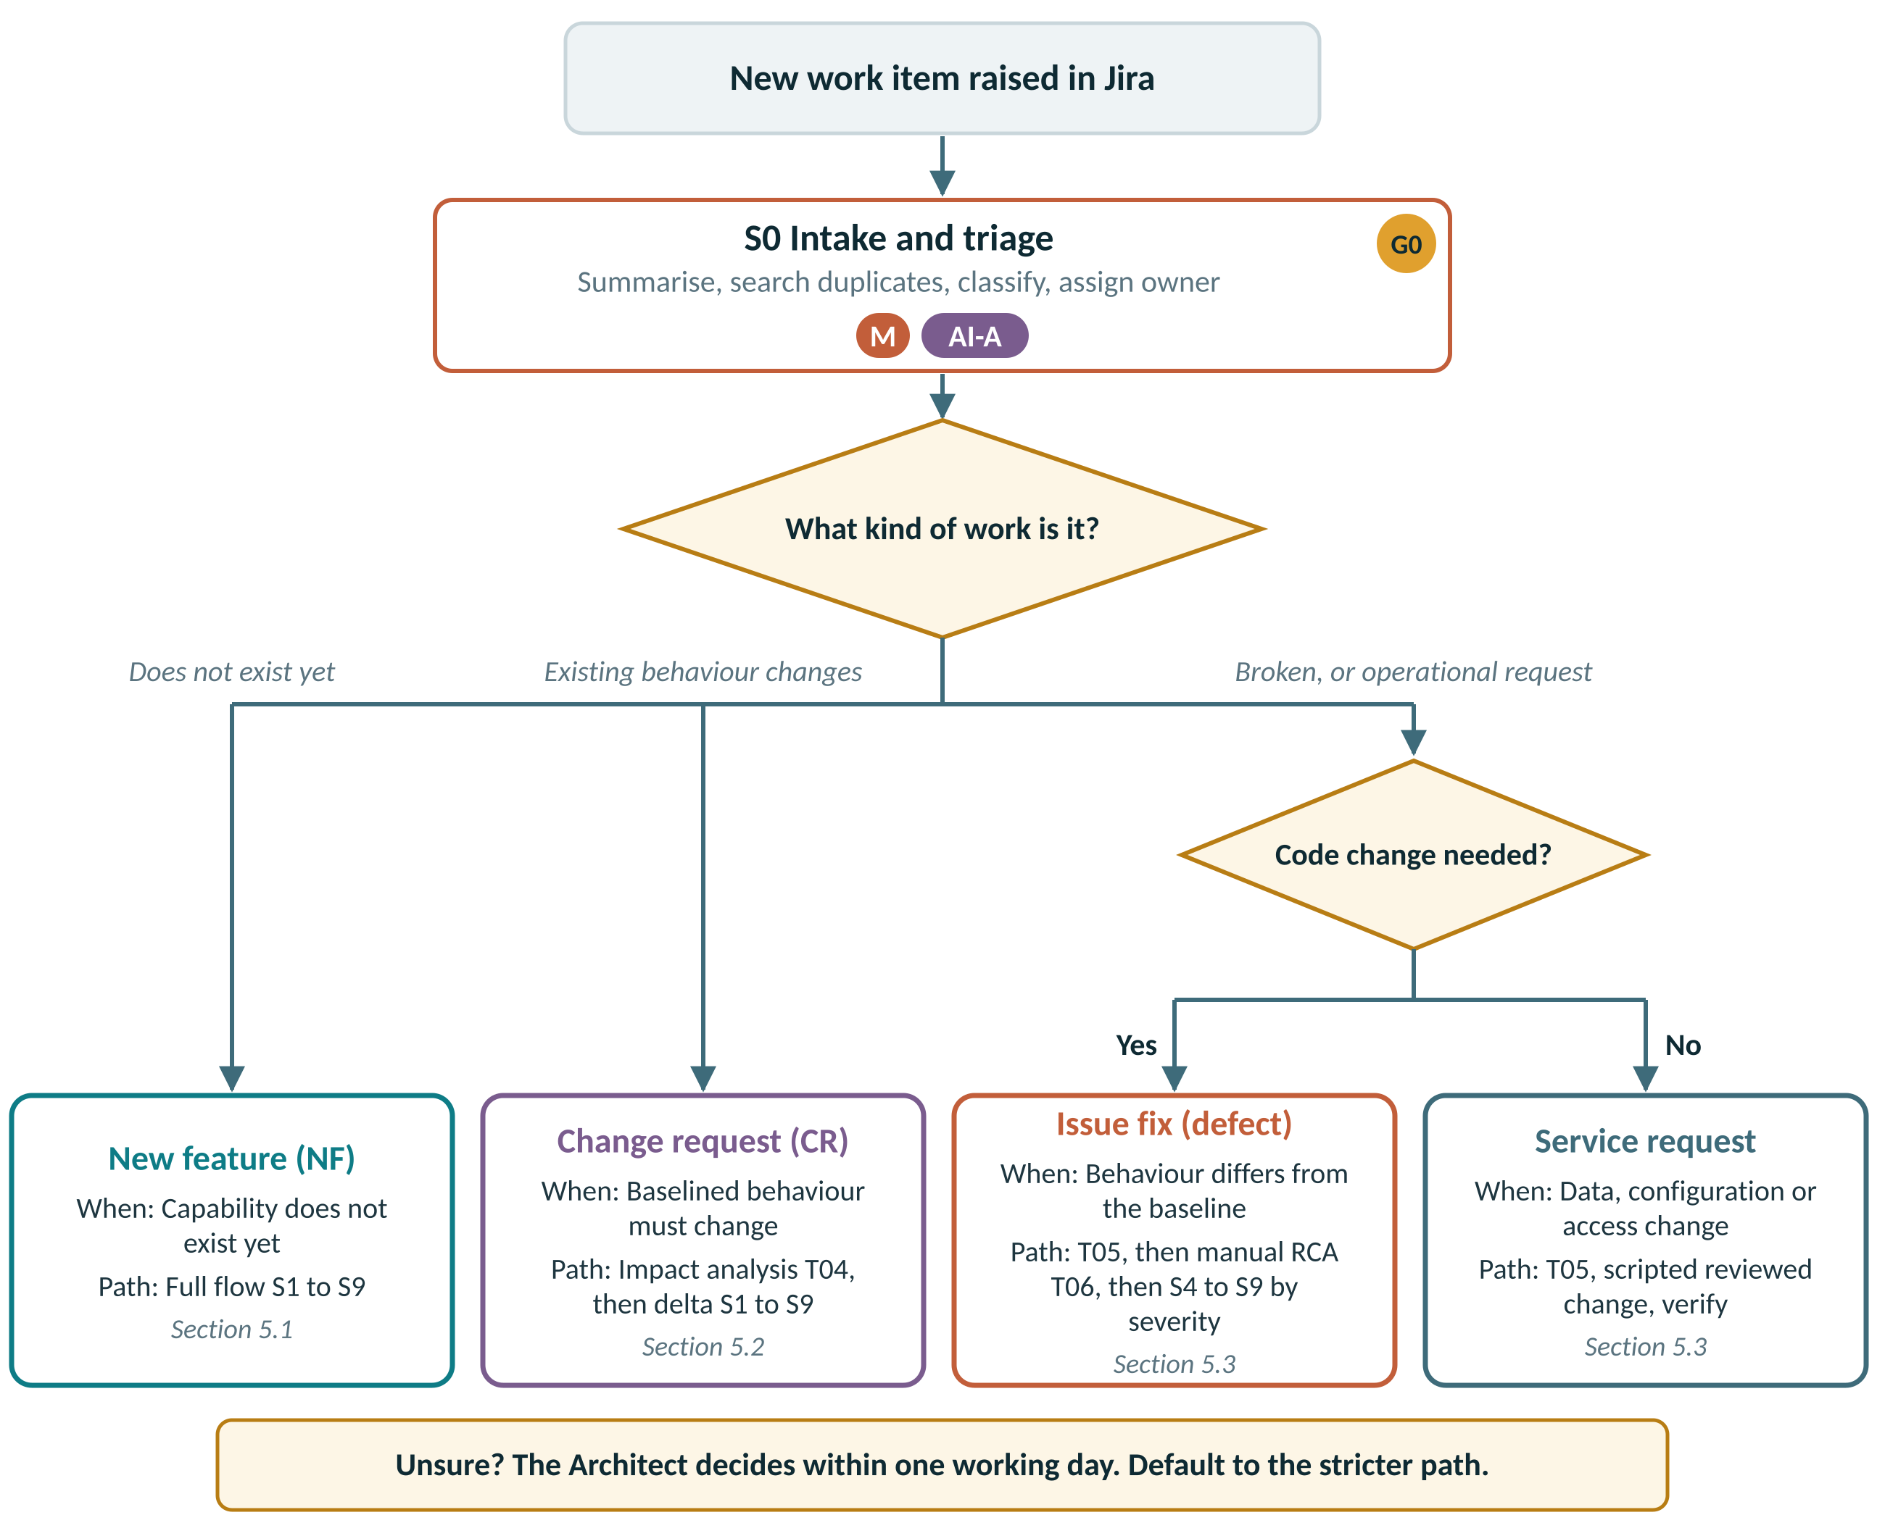
Figure 3 — Classifying a work item and routing it to its process path
Question asked at intake | Answer | Classify as
Does the capability exist in the baselined product? | No | NF: new feature or application
Does baselined behaviour, a rule, a screen, a report or an interface need to change on purpose? | Yes | CR: change request
Does the product behave differently from the baselined SFVD or requirement? | Yes | SR: defect fix
Is the request to change data, configuration or access with no code change? | Yes | SR: service request
A “defect” where the product matches the SFVD but the business now wants something else | — | Re-route as CR
A “service request” that turns out to need code | — | Re-route as CR or defect

3.5 Tailoring by work type
All stages exist for all work types, but the depth differs. Full means the stage runs as defined in section 4. Delta means only the affected parts are produced or updated. Conditional means the stage runs only when the stated trigger applies. Light means a reduced form defined in section 5.
Stage | New feature | Change request | Issue / SR | Notes for CR | Notes for Issue / SR
S0 Intake | Full | Full | Full | Intake + baseline link | Triage form (T05)
S1 Requirements | Full | Delta | Conditional | Impact analysis (T04); new / revised REQ-IDs | RCA (T06) replaces requirements for defects
S2 SFVD | Full | Delta | Conditional | Affected sections, change-marked, version bump | Only if designed behaviour changes
S3 Design | Full | Conditional | Conditional | If contract, schema or cross-service change | If the fix changes a contract or schema
S4 Development | Full | Full | Full | Full | AI permission set by severity
S5 Code review | Full | Full | Full | Full + backward-compatibility check | Second reviewer for P1 / P2
S6 Test design | Full | Delta | Light | New cases + impacted regression selection | Failing test first + targeted regression
S7 Test execution | Full | Delta | Light | New + impacted regression + smoke | Targeted + regression pack
S8 Release | Full | Full | Conditional | Scheduled release | Hotfix path for P1 / P2
S9 Deploy | Full | Full | Full | Full | Full + extended monitoring

4 Stage Definitions
Each stage below follows the same structure: purpose and entry criteria; the inputs AI receives and how each is prepared; the activities with their mode; the outputs and their templates; how AI output is validated at each verification level; the manual review checklist that the gate owner signs in T10; the exit gate and AI rule; and the RACI.
The checklists here are reproduced as fillable forms in T10 and as CP-60 in the Context Pack, so AI can self-check against the same list before a person reviews.

4.1 S0 Intake and Classification
Purpose. Register every new work item, classify it as a New Feature, Change Request or Issue / Service Request, link it to the current baseline, and route it to the correct process path.
Entry criteria. Work item raised in Jira by business, support or an internal team. Requester and business contact identified.

Inputs
Input | Source / template | Prepared by | Mode
Work item description and attachments | Jira | Requester | M
Current baseline: RTM, SFVD versions, release history | X01 Tracker, document repository | Business Analyst | M
Logs, screenshots, error references (issues only) | Support, monitoring tools | Support | M
Classification rules | Section 3.4 of this document | — | M

Activities
# | Activity | Performed by | Mode
1 | Log the item with requester, module, surface(s) and business priority | Requester / BA | M
2 | Summarise long descriptions, e-mail threads and logs into a structured intake summary | BA / Triage Lead | AI-A
3 | Search the RTM and backlog for duplicates and related items | BA | AI-A
4 | Classify the work type (NF / CR / SR); assign ID and module prefix | BA (Architect if unclear) | M
5 | For issues: set provisional severity P1 to P4 | Triage Lead | M
6 | Assign the accountable owner and process path; record Gate G0 | Delivery Manager | M

Outputs
Output | Template / location | Mode | Owner
Classified Jira item: work type, ID, module, severity | Jira | M | BA
Intake summary | T01 Part A (NF/CR) or T05 (SR) | AI-A → M | BA / Triage Lead
Duplicate and related-item links | Jira links | AI-A → M | BA
Gate G0 record | T10 | M | Delivery Manager

How the AI output is validated
Level | What is applied in this stage
L1 Automated | Jira mandatory-field validation (work type, module, requester).
L2 + L3 Techniques | V1 Source cross-check, V2 Assumption register review (section 6.2).
How to apply | The AI intake summary is compared line by line with the original request; any statement not in the source is removed. Each suggested duplicate is opened and confirmed by a person.
L4 Sign-off | Gate G0 recorded in T10 by Delivery Manager.

Manual review checklist (gate G0)
✓ | Reviewer confirms
 | Work type classified using the rules in section 3.4; borderline cases decided by the Architect
 | Intake summary reflects the original request: nothing added, nothing lost
 | Duplicates and related items confirmed by a person, not accepted from the AI suggestion
 | Module prefix, surface(s) and requester recorded
 | Severity set for issues (P1 to P4) with a one-line justification
 | Accountable owner and process path assigned

Exit gate G0
G0 Intake approved: item classified, ID assigned, owner named, process path selected.
AI rule: AI may summarise and search. AI must not classify the work type or set severity.

R BA / Triage Lead | A Delivery Manager | C Architect | I Requester

4.2 S1 Requirements and Review Points
Purpose. Turn the business need into an approved, uniquely identified requirement register with acceptance criteria. This register is the root of all traceability.
Entry criteria. G0 passed; work type NF, or CR after impact analysis (T04).

Inputs
Input | Source / template | Prepared by | Mode
Business requirement note and client review points | T01 Part B | Business / Product Owner | M
Current workflow, screen inventory and report list | Existing SFVD, live product | BA | M
Domain glossary: asset classes, SLM / WDV, useful life, CWIP, impairment, disposal, label formats | CP-00 | Architect | M
Integration, validation and non-functional expectations | Business, Architect | BA | M
Context Pack sections CP-00, CP-40 and stage prompt P-S1 | /ai-context | — | M

Activities
# | Activity | Performed by | Mode
1 | Prepare the business requirement note with review points | BA with Business | M
2 | Generate the draft register: one ID per requirement, acceptance criteria, impact map, assumptions and open questions | BA using AI | AI-G
3 | Reconcile the register with the source: every statement mapped, nothing invented | BA | M
4 | Walk through open questions with the business and record answers | BA, Product Owner | M
5 | Verify domain and statutory rules (depreciation, capitalisation thresholds, audit retention) | BA with domain SME | M
6 | Approve the register, freeze REQ-IDs and create RTM rows | Product Owner | M

Outputs
Output | Template / location | Mode | Owner
Requirement Register v1.0 with REQ-IDs and acceptance criteria | T01 Part C | AI-G → M | BA
Assumption and open-question log, fully resolved | T11 | AI-G → M | BA
Impact map across microservices, mobile and internal web | T01 Part D | AI-G → M | BA
RTM rows created | X01 RTM sheet | M | BA
Gate G1 record | T10 | M | Product Owner

How the AI output is validated
Level | What is applied in this stage
L1 Automated | Template completeness check; REQ-ID format and uniqueness check in the RTM.
L2 + L3 Techniques | V1 Source cross-check, V2 Assumption register review, V4 Count reconciliation, V7 Independent re-derivation (section 6.2).
How to apply | Every requirement must trace to a sentence in the source note, and every sentence in the note must be covered. Differences in the count are explained in writing. A domain SME re-derives two worked examples by hand.
L4 Sign-off | Gate G1 recorded in T10 by Product Owner.

Manual review checklist (gate G1)
✓ | Reviewer confirms
 | Every statement in the source note maps to at least one REQ-ID
 | No requirement exists without a source statement (nothing invented by AI)
 | Each requirement is atomic, testable and has acceptance criteria
 | Every AI-declared assumption and open question is answered by the business, not by AI
 | Depreciation, capitalisation and statutory rules verified by a domain SME
 | Impact on microservices, mobile and internal web identified
 | Non-functional needs captured: volume, response time, retention, security
 | REQ-IDs follow the convention and are unique in the RTM
 | AI Usage Declaration (T11) attached with the Context Pack version

Exit gate G1
G1 Requirements approved: register v1.0 signed by the Product Owner, REQ-IDs frozen, RTM rows created.
AI rule: AI may structure, de-duplicate and draft acceptance criteria. AI must not answer its own open questions or decide scope.

R Business Analyst | A Product Owner | C Architect, QA Lead | I Development, Release

4.3 S2 SFVD: Screens, Fields, Validations
Purpose. Specify every screen, field, validation, error message and business flow precisely enough that development and testing work from the same truth.
Entry criteria. G1 passed.

Inputs
Input | Source / template | Prepared by | Mode
Approved Requirement Register | T01 | BA | M
SFVD template and two approved SFVDs as worked examples | T02, CP-99 | Tech Writer | M
Data dictionary and entity relationship model | Architecture repository | Architect | M
Validation and error-code registry | CP-23 | Architect | M
UI style guide and component catalogue | CP-21 | UI Lead | M
Naming conventions | CP-11 | — | M
Existing SFVD (CR: affected sections only) | Document repository | Tech Writer | M

Activities
# | Activity | Performed by | Mode
1 | Generate the SFVD draft per screen: purpose, actors, flow, field table, validations, error codes, user stories, UI references | Tech Writer using AI | AI-G
2 | Verify field by field against the data dictionary | Tech Writer | M
3 | Verify every validation ID and error code exists in the registry; raise a registry change for genuinely new ones | Tech Writer, Architect | M
4 | Verify reuse call-outs: the named components and validators exist and fit | Architect | M
5 | Business walkthrough of flows and screens | BA, Product Owner | M
6 | Baseline the SFVD; update the requirement-screen-field matrix; release to Dev and QA the same day | Tech Writer | M

Outputs
Output | Template / location | Mode | Owner
SFVD vX.Y | T02 | AI-G → M | Tech Writer
RTM screen and field columns | X01 RTM sheet | M | Tech Writer
Registry change requests, if any | T14 | M | Architect
Gate G2 record | T10 | M | BA Lead

How the AI output is validated
Level | What is applied in this stage
L1 Automated | Template structure check; Screen-to-REQ-ID link check; Registry lookup script for validation and error IDs (manual lookup until scripted).
L2 + L3 Techniques | V1 Source cross-check, V2 Assumption register review, V3 Registry lookup, V4 Count reconciliation, V5 Golden-example comparison (section 6.2).
How to apply | Every identifier the AI writes (field, validation ID, error code, style class, component) is looked up in the registry or data dictionary. An identifier that cannot be found is treated as invented and the section is rejected.
L4 Sign-off | Gate G2 recorded in T10 by BA Lead.

Manual review checklist (gate G2)
✓ | Reviewer confirms
 | Every screen and field maps to a REQ-ID
 | Every field matches the data dictionary: name, type, length, mandatory
 | Every validation ID and error code exists in the registry; none invented
 | Business flows match the approved register, including negative and exception flows
 | UI references use only approved style classes and components
 | Reuse call-outs verified against the shared library index
 | Mobile offline behaviour stated where applicable
 | Audit-trail fields and role permissions specified for every screen
 | AI assumption list resolved; AI Usage Declaration attached

Exit gate G2
G2 SFVD baselined: matrix updated, document released to Development and QA on the same day.
AI rule: AI may draft. AI must not create new fields, validation IDs, error codes or style classes.

R Tech Writer / BA | A BA Lead | C Architect, QA Lead, Product Owner | I Development, Mobile, Release

4.4 S3 Solution Design and Interface Contract
Purpose. Decide how the change is built across services and surfaces, and agree the API contract before any code is written.
Entry criteria. G2 passed. For CR and SR: only when the impact analysis or RCA shows a contract, schema or cross-service change.

Inputs
Input | Source / template | Prepared by | Mode
Finalised SFVD | T02 | — | M
Service map, bounded contexts and event topics | Architecture repository, CP-22 | Architect | M
Existing OpenAPI specifications | Contract repository | Tech Lead | M
Database schema and migration standard | CP-10, CP-11 | DBA | M
Shared library index | CP-20 | Architect | M
Non-functional, security and authorisation model | CP-40 | Security | M

Activities
# | Activity | Performed by | Mode
1 | Generate the design draft: service impact, OpenAPI contract, DTO and entity design, sequence diagrams, migration draft, reuse plan | Tech Lead using AI | AI-G
2 | Run OpenAPI lint and diff, and SQL migration lint | Jenkins | AUTO
3 | Architecture review: boundaries, reuse, backward compatibility, versioning | Architect | M
4 | Database review: indexes, migration, rollback | DBA | M
5 | Security review: authorisation, PII, audit fields | Security | M
6 | Merge the contract to the contract repository; record the design decision | Tech Lead | M

Outputs
Output | Template / location | Mode | Owner
Solution Design Note | T03 | AI-G → M | Tech Lead
OpenAPI contract | Contract repository | AI-G → M | Tech Lead
Migration and rollback scripts (draft) | Code repository | AI-G → M | DBA
Architecture decision record | T03 section 8 | M | Architect
Gate G3 record | T10 | M | Architect

How the AI output is validated
Level | What is applied in this stage
L1 Automated | OpenAPI lint; OpenAPI diff against the previous version; SQL migration lint.
L2 + L3 Techniques | V2 Assumption register review, V3 Registry lookup, V5 Golden-example comparison, V6 Deterministic tool checks, V9 Explain-back (section 6.2).
How to apply | Every class, library or service the design proposes to reuse is checked in the shared library index. The OpenAPI diff is the evidence for backward compatibility; a breaking change without a version bump is rejected automatically.
L4 Sign-off | Gate G3 recorded in T10 by Architect.

Manual review checklist (gate G3)
✓ | Reviewer confirms
 | No cross-service database access; bounded contexts respected
 | Contract backward compatible, or the version bumped with consumers listed
 | The capability does not already exist in another service
 | Base classes and shared libraries reused; no parallel utilities designed
 | Error envelope, pagination and naming follow CP-22
 | Mobile offline and synchronisation impact addressed
 | Migration reversible; rollback script present and reviewed by the DBA
 | Authorisation, audit fields and PII handling reviewed by Security
 | Design decision and the alternatives considered are recorded

Exit gate G3
G3 Design approved: contract merged to the contract repository before coding starts.
AI rule: AI may draft designs and contracts. AI must not merge a contract or approve a breaking change.

R Tech Lead | A Architect | C DBA, Security, QA Lead | I All development teams

4.5 S4 Development
Purpose. Implement the approved design inside the existing structure, reusing shared code, with unit tests.
Entry criteria. G3 passed, or G1 / RCA approval for a change without design impact. Task carries a REQ-ID or defect ID.

Inputs
Input | Source / template | Prepared by | Mode
SFVD section, API contract and design note | T02, T03 | — | M
Coding standards, naming conventions, folder structure | CP-10, CP-11, CP-12 | — | M
Shared library index and UI style guide | CP-20, CP-21 | — | M
Golden reference example for the surface | CP-99 | — | M
REQ-ID or defect ID | Jira | — | M
Static analysis rule set | Jenkins configuration | — | M

Activities
# | Activity | Performed by | Mode
1 | Create the branch named with the ID | Developer | M
2 | Generate code inside the existing structure, unit tests, configuration, i18n keys and migration | Developer using AI | AI-G
3 | Search the shared library before accepting any new class, utility or CSS | Developer | M
4 | Run the local build, unit tests, PMD and Sonar scan | Build tooling | AUTO
5 | Self-review against the T09 checklist; remove unused and alternative code | Developer | M
6 | Raise a pull request of 400 lines or fewer with T09 and the AI Usage Declaration | Developer | M

Outputs
Output | Template / location | Mode | Owner
Source code and unit tests | Code repository | AI-G → M | Developer
Pull request with completed checklist | T09 | M | Developer
AI Usage Declaration in the pull request | T11 (short form) | M | Developer
CI results | Jenkins | AUTO | Developer

How the AI output is validated
Level | What is applied in this stage
L1 Automated | Compile and unit tests; PMD and Checkstyle; Sonar quality gate; Coverage on new code; Duplication; Secret scan; Naming lint.
L2 + L3 Techniques | V3 Registry lookup, V5 Golden-example comparison, V6 Deterministic tool checks, V8 Execution evidence, V9 Explain-back (section 6.2).
How to apply | Deterministic gates catch standards, duplication and security problems; the developer then proves understanding through explain-back. For a defect fix the failing test must be committed before the fix.
L4 Sign-off | Gate G4 recorded in T10 by Tech Lead.

Manual review checklist (gate G4)
✓ | Reviewer confirms
 | Shared library searched; no duplicate utility, validator, base method or CSS created
 | Package, class, method and file names follow CP-11
 | Layering and folder placement follow CP-12
 | No hardcoded values, credentials or environment-specific configuration
 | Exception handling, logging and audit trail follow CP-10
 | Queries checked for N+1, pagination and index use
 | Unit tests cover new logic, including boundary and negative cases
 | No unused or commented-out AI-generated alternatives remain
 | Branch name and every commit carry the REQ-ID or defect ID
 | Pull request 400 lines or fewer, or split; T09 completed
 | The developer can explain every line

Exit gate G4
G4 Pull request ready: CI green, checklist complete, AI usage declared.
AI rule: AI may generate code and tests. For P1 and P2 defects AI is not permitted (see section 5.3).

R Developer | A Tech Lead | C Architect | I QA

4.6 S5 Code Review
Purpose. Independent human verification that the code is correct, consistent, reusable and secure before it is merged.
Entry criteria. G4 passed.

Inputs
Input | Source / template | Prepared by | Mode
Pull request diff and T09 checklist | Code repository | Developer | M
SFVD section and API contract | T02, T03 | — | M
Standards and shared library index | CP-10 to CP-22 | — | M
Sonar results and contract diff | Jenkins | — | AUTO

Activities
# | Activity | Performed by | Mode
1 | Generate a review aid: diff summary, standards-deviation scan, duplicate detection, missing-test hints | Reviewer using AI | AI-A
2 | Confirm the CI quality gate result | Jenkins | AUTO
3 | Review business logic against the SFVD line by line | Reviewer | M
4 | Check reuse, layering, naming and contract adherence | Reviewer | M
5 | Security and data-access review (Security consulted for sensitive changes) | Reviewer | M
6 | Approve or request changes; record the decision | Reviewer | M

Outputs
Output | Template / location | Mode | Owner
Approved pull request or review comments | Code repository | M | Reviewer
Merge with REQ-ID in the message | Code repository | M | Reviewer
Gate G5 record (pull request approval) | Code repository / T10 | M | Tech Lead

How the AI output is validated
Level | What is applied in this stage
L1 Automated | Sonar quality gate; Duplication and coverage thresholds; OpenAPI diff; Pull request size check.
L2 + L3 Techniques | V6 Deterministic tool checks, V9 Explain-back (section 6.2).
How to apply | The AI review aid is advisory. Each AI finding is verified by the reviewer before it is raised, and the absence of AI findings is never treated as approval.
L4 Sign-off | Gate G5 recorded in T10 by Tech Lead.

Manual review checklist (gate G5)
✓ | Reviewer confirms
 | Reviewer is not the developer who ran the AI prompt
 | Business logic matches the SFVD and acceptance criteria
 | Reuse opportunities enforced, not merely noted
 | Contract adherence and backward compatibility confirmed
 | Security, authorisation, input validation and PII handling checked
 | Tests are meaningful: they assert behaviour and include negative cases
 | Sonar: zero blocker and critical issues; duplication and coverage within thresholds
 | All review comments resolved; nothing the reviewer cannot explain is merged

Exit gate G5
G5 Code approved and merged by an independent reviewer.
AI rule: AI may assist the reviewer. AI never approves or merges.

R Reviewer (peer or Tech Lead) | A Tech Lead | C Architect, Security | I QA, Product Owner

4.7 S6 Test Design
Purpose. Derive complete test cases and test data from the baselined SFVD and contract, in parallel with design and development.
Entry criteria. G2 passed (and G3 for contract-based cases).

Inputs
Input | Source / template | Prepared by | Mode
Finalised SFVD and API contract | T02, contract repository | — | M
Test case template and ID convention | T07, CP-30 | QA Lead | M
Test data and seed data specification | T08, CP-31 | QA Lead | M
Boundary and negative scenario pattern library | CP-30 | QA Lead | M
Index of the existing regression suite | Test management tool | QA | M
Device, browser and role matrix | CP-30 | QA Lead | M

Activities
# | Activity | Performed by | Mode
1 | Generate test cases: functional, validation, UI, flow, integration, cross-surface; positive and negative; expected results; REQ mapping; automation flag | QA Engineer using AI | AI-G
2 | Generate test data requirements mapped to the seed structure | QA Engineer using AI | AI-G
3 | Coverage reconciliation: every REQ-ID and every field validation covered | QA Engineer | M
4 | Remove duplicates of existing regression cases | QA Engineer | M
5 | Verify expected results against the SFVD; SME re-calculates financial values | QA Lead, domain SME | M
6 | Approve the suite; baseline it in the test management tool; update the RTM | QA Lead | M

Outputs
Output | Template / location | Mode | Owner
Test Case Specification | T07 | AI-G → M | QA Engineer
Test Data Specification | T08 | AI-G → M | QA Engineer
RTM test columns | X01 RTM sheet | M | QA Engineer
Gate G6 record | T10 | M | QA Lead

How the AI output is validated
Level | What is applied in this stage
L1 Automated | RTM coverage check: REQ-IDs without a test case are flagged; Duplicate test title check.
L2 + L3 Techniques | V1 Source cross-check, V2 Assumption register review, V4 Count reconciliation, V7 Independent re-derivation (section 6.2).
How to apply | Counts are reconciled (REQ-IDs and field validations in, test cases out). Expected results for depreciation, label and audit scenarios are recalculated by a domain SME independently of the AI.
L4 Sign-off | Gate G6 recorded in T10 by QA Lead.

Manual review checklist (gate G6)
✓ | Reviewer confirms
 | Every REQ-ID has at least one positive and one negative case
 | Every field validation in the SFVD has a test case
 | Expected results traced to SFVD text, not inferred
 | Depreciation, label and audit expected values independently re-calculated by the SME
 | No duplicate of an existing regression case
 | Test data follows the seed structure; personal and financial data masked
 | Priority, regression and automation tags set
 | Device, browser and role coverage matches the matrix

Exit gate G6
G6 Test suite approved and baselined in the test management tool.
AI rule: AI may draft cases and data. AI must not decide expected results for financial calculations without SME verification.

R QA Engineer | A QA Lead | C BA, Developer | I Product Owner, Release

4.8 S7 Test Execution and Automation
Purpose. Execute the approved suite, automate the agreed cases, and prove that nothing was silently dropped.
Entry criteria. G5 and G6 passed. Build deployed to the test environment.

Inputs
Input | Source / template | Prepared by | Mode
Approved test suite | Test management tool | QA Lead | M
Seed data script | CP-31 / T08 | QA | M
Environment configuration and test accounts | Environment matrix | DevOps | M
Automation framework patterns and locator standard | CP-30 | Automation Lead | M
Existing regression pack | Automation repository | QA | M

Activities
# | Activity | Performed by | Mode
1 | Load seed data | Seed script | AUTO
2 | Generate automation scripts: page objects, locators, data-driven steps | Automation Engineer using AI | AI-G
3 | Review scripts one-to-one against approved cases; verify assertions | Automation Engineer, QA Lead | M
4 | Execute manual and automated tests | QA | M
5 | Draft defect reports from failures | QA using AI | AI-A
6 | Run the automation parity check; record deferrals with reasons | QA Lead | AUTO

Outputs
Output | Template / location | Mode | Owner
Execution report | Test management tool | M | QA
Automated scripts added to the regression pack | Automation repository | AI-G → M | Automation Engineer
Defects linked to REQ-IDs | Jira | AI-A → M | QA
Automation parity report | X01 / Jenkins | AUTO | QA Lead
Gate G7 record | T10 | M | QA Lead

How the AI output is validated
Level | What is applied in this stage
L1 Automated | Parity check: approved = executed + automated + formally deferred; Flaky test detection by re-run; RTM test-status update.
L2 + L3 Techniques | V4 Count reconciliation, V8 Execution evidence (section 6.2).
How to apply | On a sample of AI-generated scripts the reviewer deliberately changes one expected value and confirms the script fails. A script that still passes has no real assertion and is rejected.
L4 Sign-off | Gate G7 recorded in T10 by QA Lead.

Manual review checklist (gate G7)
✓ | Reviewer confirms
 | Every automated script maps one-to-one to an approved case; no steps dropped
 | Assertions verify expected results, proven by a deliberate-fail check on a sample
 | No hardcoded data, fixed waits or environment coupling
 | Scripts are independent and repeatable in any order
 | Parity: approved = executed + automated + formally deferred
 | Every failure has a defect linked to its REQ-ID
 | Deferred cases have a reason, an owner and a target release

Exit gate G7
G7 Test exit: parity 100%, no open P1 or P2 defects, evidence attached.
AI rule: AI may draft scripts and defect descriptions. AI must not mark a test as passed.

R Automation Engineer / QA | A QA Lead | C Developer | I Product Owner, Release

4.9 S8 Build and Release
Purpose. Produce a signed, immutable and traceable release package.
Entry criteria. G7 passed.

Inputs
Input | Source / template | Prepared by | Mode
Merged code and the release scope from Jira | Jira, code repository | Release Manager | M
Version and branching policy | CP-10 | — | M
Release note template | T12 | — | M
Environment configuration matrix | DevOps | DevOps | M
Migration and rollback scripts | Code repository | DBA | M
RTM snapshot | X01 | QA Lead | AUTO

Activities
# | Activity | Performed by | Mode
1 | Build the immutable artifact with a version tag | Jenkins | AUTO
2 | Generate release notes from commits and REQ-IDs, config diff summary and rollback steps | Release Manager using AI | AI-G
3 | Reconcile release notes with the RTM and Jira scope | Release Manager | M
4 | Verify configuration differences for each environment | DevOps | M
5 | Migration dry run on a production-like copy | DBA / DevOps | M
6 | Record release approval | Delivery Manager | M

Outputs
Output | Template / location | Mode | Owner
Release package (immutable, checksummed) | Artifact repository | AUTO | DevOps
Release Note | T12 | AI-G → M | Release Manager
Deployment Runbook (draft) | T13 | AI-G → M | DevOps
Gate G8 record | T10 | M | Delivery Manager

How the AI output is validated
Level | What is applied in this stage
L1 Automated | Version uniqueness; Artifact checksum; RTM link check: every REQ in scope has passed tests.
L2 + L3 Techniques | V1 Source cross-check, V4 Count reconciliation, V6 Deterministic tool checks (section 6.2).
How to apply | Three counts must agree: Jira scope, release-note lines and RTM rows. Each release-note line is traced to a merged pull request.
L4 Sign-off | Gate G8 recorded in T10 by Delivery Manager.

Manual review checklist (gate G8)
✓ | Reviewer confirms
 | Version number unique and follows policy; artifact checksum recorded
 | Every release-note line traces to a merged pull request and REQ-ID; nothing omitted
 | Known issues and deferred cases listed
 | Configuration differences verified for each environment; no secrets in notes
 | Migration dry run passed; rollback tested
 | Open defects accepted or deferred in writing
 | Release approval recorded before promotion

Exit gate G8
G8 Release approved: signed package, RTM snapshot attached.
AI rule: AI may draft notes and runbooks. AI must not trigger a build promotion.

R Release Manager | A Delivery Manager | C DevOps, Architect, QA Lead | I All teams

4.10 S9 Deploy, Verify and Close
Purpose. Deploy safely, prove it works in production, and close the loop with a frozen audit baseline.
Entry criteria. G8 passed. Deployment window approved.

Inputs
Input | Source / template | Prepared by | Mode
Signed release package | Artifact repository | DevOps | M
Deployment runbook and smoke checklist | T13 | DevOps | M
Backup confirmation and rollback plan | T13 | DBA / DevOps | M
Monitoring dashboards and alert thresholds | Monitoring tools | DevOps | M

Activities
# | Activity | Performed by | Mode
1 | Pre-deployment validation and backup confirmation | DevOps | M
2 | Deploy through the Jenkins pipeline following the runbook | Jenkins | AUTO
3 | Execute the smoke pack | QA | M
4 | Summarise post-deployment logs and metrics for anomalies | DevOps using AI | AI-A
5 | Monitor for the agreed window; decide go or rollback | DevOps, Delivery Manager | M
6 | Business sign-off; freeze the RTM; close Jira items; raise context-gap changes | PO, BA, Architect | M

Outputs
Output | Template / location | Mode | Owner
Deployment record and smoke results | T13 | M | DevOps / QA
Monitoring summary | T13 | AI-A → M | DevOps
Business sign-off | T10 | M | Product Owner
Frozen RTM for the release | X01 | M | BA
Context Pack change requests | T14 | M | Architect

How the AI output is validated
Level | What is applied in this stage
L1 Automated | Pipeline deployment log; Health checks; Alerting.
L2 + L3 Techniques | V8 Execution evidence (section 6.2).
How to apply | The AI log summary is checked against the dashboards; an anomaly is confirmed in the source logs before any action. "No anomalies" from AI is never accepted without the dashboard check.
L4 Sign-off | Gate G9 recorded in T10 by Delivery Manager.

Manual review checklist (gate G9)
✓ | Reviewer confirms
 | Backup confirmed by a named person before deployment
 | Deployment executed from the runbook; deviations recorded
 | Smoke pack 100% passed, executed by QA rather than the deployer
 | Monitoring window completed with no unexplained errors
 | Rollback decision owner named before deployment started
 | Business sign-off recorded
 | RTM frozen and versioned with the release
 | Lessons learned captured; context gaps raised on T14

Exit gate G9
G9 Release closed: smoke passed, monitoring clean, RTM frozen.
AI rule: AI may summarise logs. AI must not execute deployment or rollback actions.

R DevOps | A Delivery Manager | C QA Lead, Product Owner, Architect | I All teams

5 Process Flows by Work Type
This section gives the end-to-end flow for each work type. Figures 4 and 5 are swimlane diagrams: lanes are roles, columns are stages, colours are modes and the amber badges are gates. Figure 6 is a flowchart because the issue and service-request path branches twice.

5.1 New application or new feature (NF)
When. A capability that does not exist today: a new application, module, screen set, service or integration. Examples: Mobile RFID scanning for physical asset verification; New lease-asset module; New integration with the ERP general ledger.
All ten stages run in full. The flow diagram is on the next page.

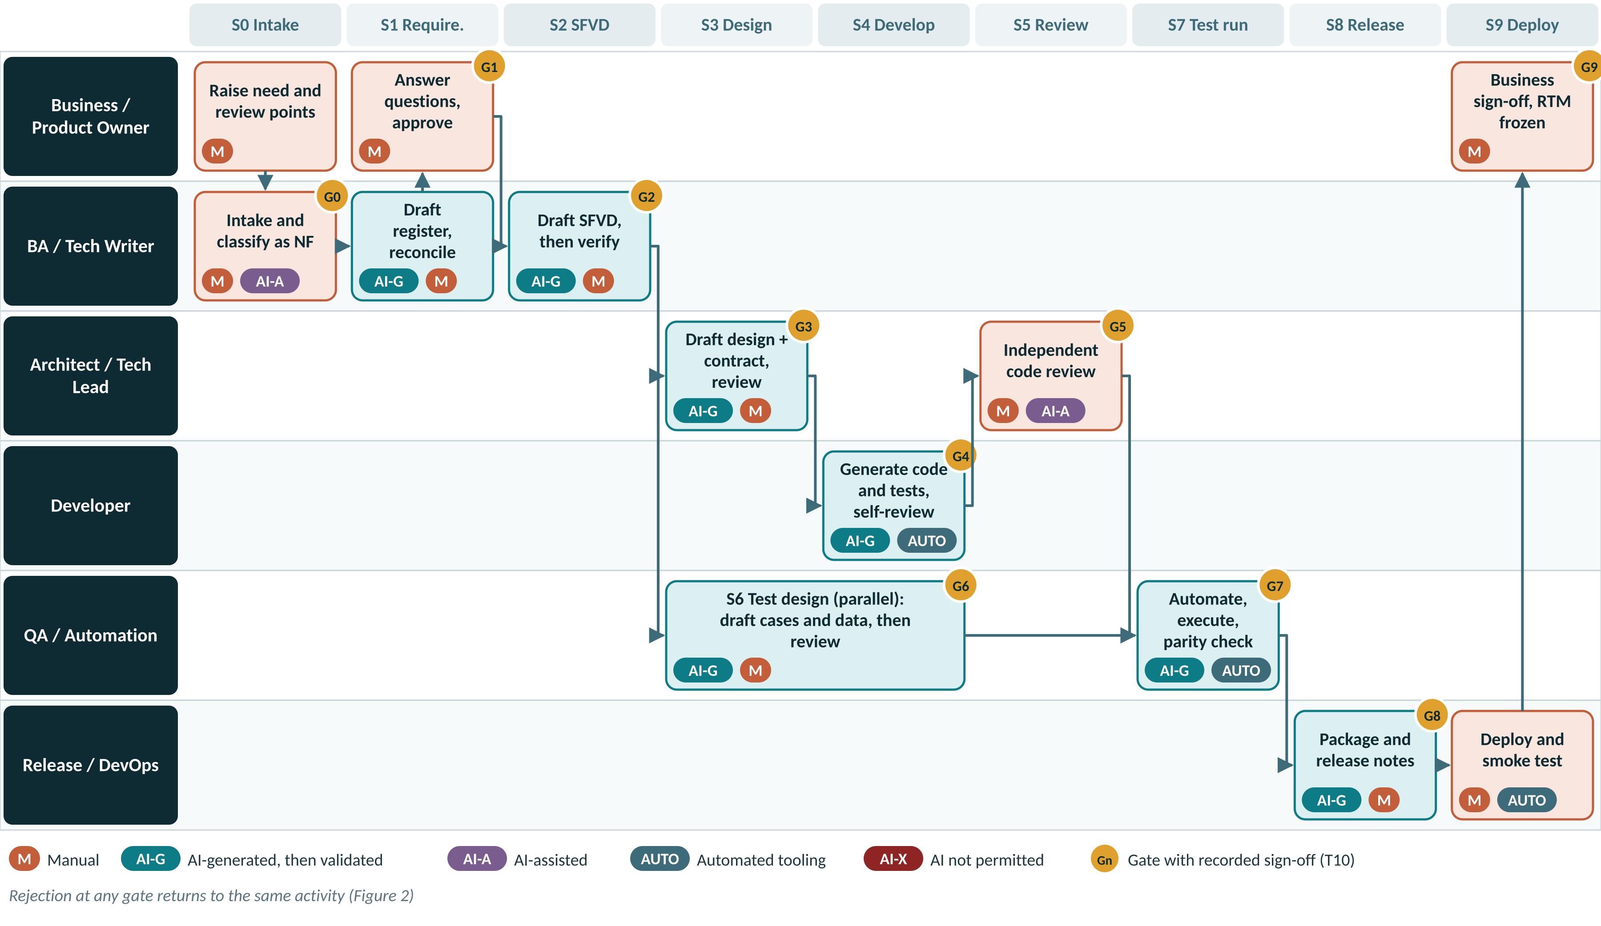
Figure 4 — New feature swimlane: roles, stages, modes and gates

Step-by-step: new feature
# | Stage | Activity | Who | Mode | Output | Gate
1 | S0 | Raise the need with review points | Business | M | T01 Part A
2 | S0 | Intake and classify as NF; register module prefix if new | BA | M + AI-A | Jira item | G0
3 | S1 | Draft register, reconcile, resolve open questions | BA | AI-G → M | T01, T11
4 | S1 | Approve register; freeze REQ-IDs | Product Owner | M | T10 | G1
5 | S2 | Draft SFVD, verify fields and registry IDs | Tech Writer | AI-G → M | T02, T11 | G2
6 | S3 | Draft design and contract; architecture, DB and security review | Tech Lead, Architect | AI-G → M | T03 | G3
7 | S6 | Draft test cases and data; SME verification (starts at G2) | QA | AI-G → M | T07, T08 | G6
8 | S4 | Generate code and tests; self-review; pull request | Developer | AI-G → M | T09, T11 | G4
9 | S5 | Independent code review | Reviewer | M + AI-A | Merged PR | G5
10 | S7 | Automate and execute; parity check | QA, Automation | AI-G → M + AUTO | Parity report | G7
11 | S8 | Package, release notes, runbook | Release Manager | AI-G → M | T12, T13 | G8
12 | S9 | Deploy, smoke, monitor, business sign-off | DevOps, QA, PO | M + AUTO | T13, T10 | G9

Rules specific to new features
- A new module gets its prefix registered in CP-00 before S1 starts, so IDs are valid from the first requirement.
- The first feature on a new surface or service creates that surface’s golden example (CP-99) during S3 and S4. The Architect reviews it; later features imitate it.
- Any new shared component, validator or style class is added to CP-20, CP-21 or CP-23 in the same release, through T14.
- Architecture spikes may use AI freely, but spike code is never merged. Findings are recorded in T03.
- Non-functional baselines are fixed at S1: asset volumes, depreciation run window, month-end close time, mobile offline duration.

5.2 Enhancement or change request (CR)
When. A change to behaviour, rules, screens, reports or interfaces that already exist and are baselined. Examples: Pro-rata daily depreciation for mid-year additions; Add cost-centre filter to the asset register report; New label template field.
A CR starts with an impact analysis (T04) instead of a fresh requirement register. Documents are updated as deltas, and regression testing is selected from the RTM. The flow diagram is on the next page.

CR classification
Class | Criteria (any one is enough for Major) | Effect on the flow
Minor | No contract or schema change; one surface; estimated at five working days or fewer | S3 not run; design notes recorded in T04 section 6. S6 and S7 delta.
Major | Contract or schema change; more than one surface; more than five working days; any change to a financial calculation | S3 run in full with contract versioning and migration review. SME re-derivation mandatory at S6.

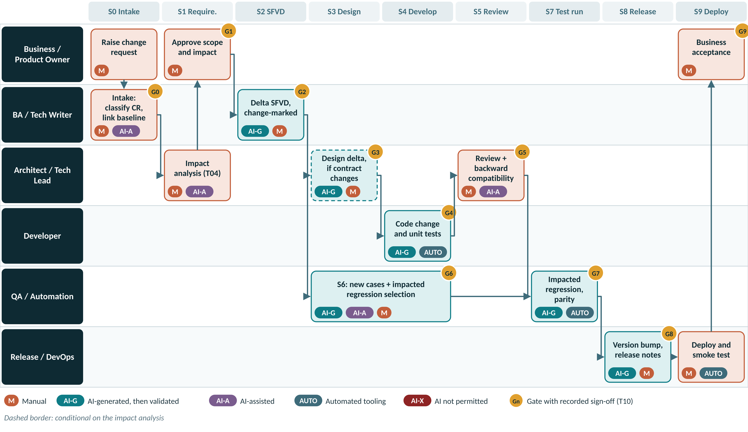
Figure 5 — Change request swimlane: impact analysis first, then delta stages

Step-by-step: change request
# | Stage | Activity | Who | Mode | Output | Gate
1 | S0 | Raise CR; link to the baselined REQ-IDs and SFVD version | Requester, BA | M + AI-A | Jira CR | G0
2 | S1 | Impact analysis: AI searches RTM and code; Architect confirms each item | Architect, BA | M + AI-A | T04
3 | S1 | Approve scope, effort, impact and CR class | Product Owner | M | T04, T10 | G1
4 | S2 | Update affected SFVD sections with change marks; bump version | Tech Writer | AI-G → M | T02 delta, T11 | G2
5 | S3 | Major CR only: design delta, contract version, migration | Tech Lead, Architect | AI-G → M | T03 | G3
6 | S6 | New cases + regression selection proposed from RTM; QA Lead confirms | QA | AI-G + AI-A → M | T07, T08 | G6
7 | S4 | Code change and unit tests | Developer | AI-G → M | T09, T11 | G4
8 | S5 | Review including backward compatibility | Reviewer | M + AI-A | Merged PR | G5
9 | S7 | Execute new and impacted regression; parity | QA | AI-G → M + AUTO | Parity report | G7
10 | S8 | Version bump, release notes listing the CR | Release Manager | AI-G → M | T12 | G8
11 | S9 | Deploy, smoke, business acceptance | DevOps, PO | M + AUTO | T13, T10 | G9

Rules specific to change requests
- No CR is approved without a completed T04. AI may search the RTM and code for impact, but the Architect confirms every impacted item.
- A changed requirement keeps its ID with a revision suffix (DEP-REQ-214.r2). New behaviour gets a new ID. Retired requirements are marked retired, never deleted.
- The SFVD is updated in place with change marks and a minor version bump; the revision table lists the CR ID and changed sections.
- Regression selection: AI proposes impacted cases from the RTM and the changed files; the QA Lead confirms. The minimum is impacted cases plus smoke plus the critical-path pack (depreciation run, month-end close, label print, verification sync).
- Mobile apps in the field cannot all be updated at once. APIs must keep serving the previous mobile release (N-1) until the Council retires it.
- For changed financial rules, the PO and Finance decide whether the change is prospective or retrospective. A retrospective change needs Finance approval recorded in T04.

5.3 Issue fix or service request (SR)
When. Something is broken (defect), or an operational request that changes data, configuration or access rather than designed behaviour. Examples: Depreciation run posts duplicate entries for transferred assets (defect); Correct useful life for 42 assets (data SR); Add a role to a user group (access SR).
Triage (T05) decides whether a code change is needed. If not, the request follows the service-request track: a scripted, reviewed and reversible change. If code is needed it is a defect: the root cause is always analysed manually, and severity decides whether AI may help with the fix.
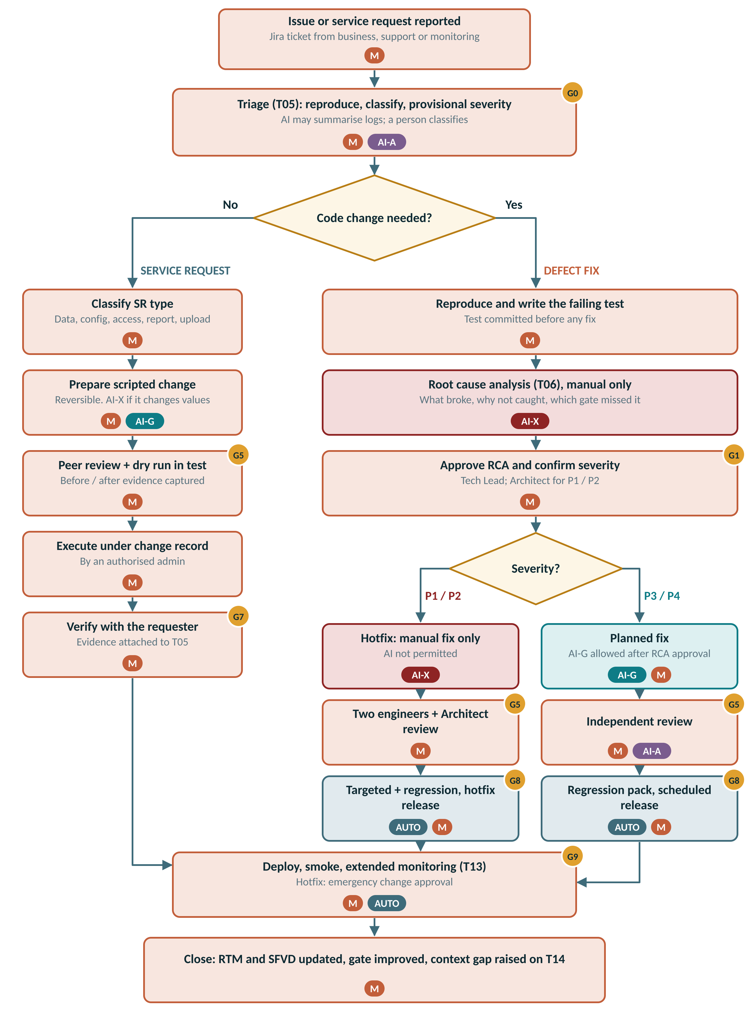
Figure 6 — Issue fix and service request flow

Severity and AI permission
Severity | Definition | Response | AI permission | Review | Release path
P1 Critical | Production down, financial misstatement (e.g. wrong depreciation posted to ledger), data loss or security breach | Immediate; hotfix | AI-X for RCA and fix. AI-A only to summarise logs. | Two engineers + Architect | Emergency change
P2 High | Major function impaired; workaround is costly or risky | Hotfix within SLA | AI-X for RCA and fix. AI-A only to summarise logs. | Two engineers | Hotfix release
P3 Medium | Function impaired; acceptable workaround exists | Next scheduled release | RCA manual. Fix AI-G permitted after RCA approval. | Independent reviewer | Scheduled release
P4 Low | Cosmetic or minor inconvenience | Planned | RCA manual (short form). Fix AI-G permitted. | Independent reviewer | Scheduled release

Service request types
Type | Examples | Controls
Data correction | Fix asset master records, re-run depreciation for a period, correct location or custodian | Scripted, reversible, before/after evidence. Scripts that change cost, accumulated depreciation or NBV are AI-X; other scripts AI-G with peer review and dry run.
Configuration change | Asset class useful life, depreciation rate table, label template, approval limits | Change record with old and new values; peer review; verification in test first. AI-A only.
Access and role change | Add or remove users, roles, location access | Approved by data owner; executed by admin; AI-X.
Report or export tweak | Column order, filter default, format | If code changes: re-route as a CR. If configuration only: change record and verification.
Bulk master-data upload | New asset batch, transfer batch | Upload template validation; sample verification of 10% or 20 rows, whichever is greater. AI-A for validation summaries.

Step-by-step: defect fix
# | Stage | Activity | Who | Mode | Output | Gate
1 | S0 | Triage: reproduce, classify, provisional severity | Triage Lead | M + AI-A | T05 | G0
2 | S4 | Write the failing test that reproduces the defect | Developer | M | Test in branch
3 | S1 | Root cause analysis: cause, why not caught, gate missed | Developer, Tech Lead | AI-X | T06
4 | S1 | Approve RCA; confirm severity and AI permission | Tech Lead (Architect for P1/P2) | M | T06, T10 | G1
5 | S2 | Update SFVD only if designed behaviour changes | Tech Writer | AI-G → M | T02 delta
6 | S4 | Fix: P1/P2 manual only; P3/P4 AI-G allowed | Developer | AI-X / AI-G → M | T09, T11 | G4
7 | S5 | Review: two engineers + Architect for P1/P2 | Reviewers | M | Merged PR | G5
8 | S7 | Failing test passes; targeted + regression pack | QA | AUTO + M | Report | G7
9 | S8 | Hotfix (P1/P2) or scheduled release (P3/P4) | Release Manager | AI-G → M | T12 | G8
10 | S9 | Deploy, smoke, extended monitoring; close | DevOps, QA | M + AUTO | T13, T10 | G9

Step-by-step: service request
# | Stage | Activity | Who | Mode | Output | Gate
1 | S0 | Triage and classify SR type | Triage Lead | M + AI-A | T05 Part A | G0
2 | S4 | Prepare scripted, reversible change with rollback | Developer / Admin | M or AI-G → M | T05 Part C
3 | S5 | Peer review and dry run in test; before/after evidence | Peer reviewer | M | T05 Part D | G5
4 | S9 | Execute under change record | Authorised admin | M | Change record
5 | S9 | Verify with requester; attach evidence; close | Requester, Triage Lead | M | T05 Part E | G9

Rules specific to issues and service requests
- Reproduce first. The failing test is committed before the fix and stays in the regression pack.
- Root cause analysis is always manual (AI-X). AI may summarise logs to help, but the cause is written by the engineer.
- Every RCA names the gate that should have caught the defect. That gate’s checklist, the Context Pack or the regression pack is improved, or a waiver is logged.
- Hotfix branches are cut from the release tag and merged back to the main branch after release.
- Scripts that change cost, accumulated depreciation or NBV are AI-X, need two reviewers and a dry run on a production-like copy.
- Production data and configuration are changed only by an authorised admin under a change record, never directly by a developer.
- A service request that needs code, or that reveals a defect, is re-routed as a CR or a defect.

6 AI Output Validation Framework
AI output fails in predictable ways: it invents plausible identifiers, omits items silently, drifts from house standards, and gets domain rules subtly wrong while sounding certain. Validation is therefore not a general read-through. It is a fixed set of levels and techniques, each aimed at one failure mode, applied the same way by everyone.

6.1 Four levels of verification
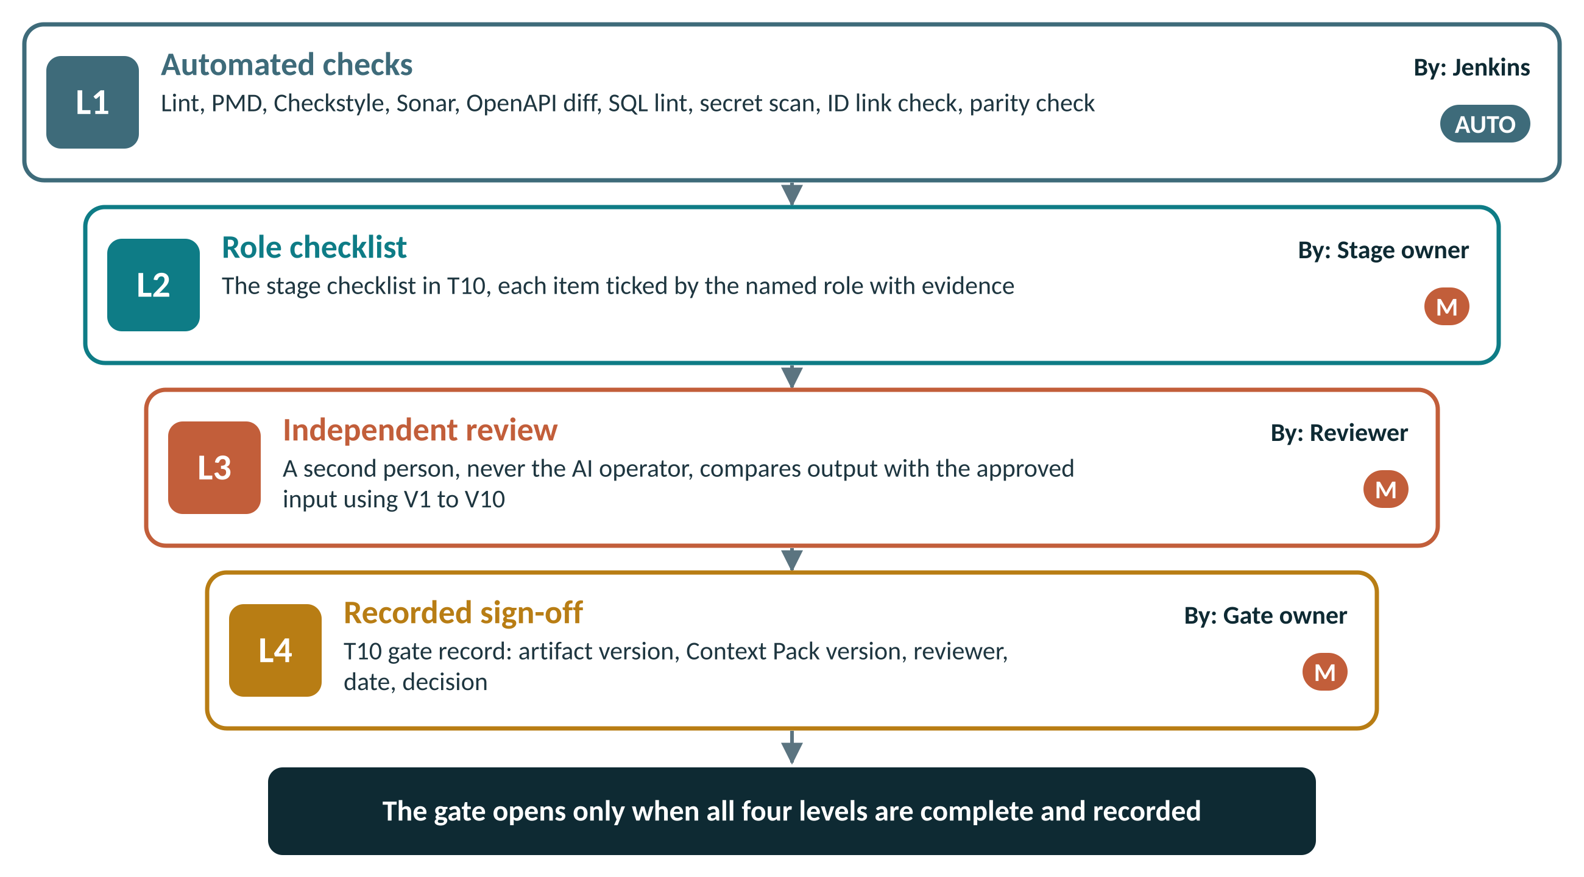
Figure 7 — The four verification levels that close every gate
Level | Who | What it proves | Evidence
L1 Automated | Jenkins and tools | Objective rules are met: standards, quality, security, contract compatibility, ID links, parity | Pipeline result link in T10
L2 Role checklist | The stage owner | Every stage-specific check has been made by the accountable role | Ticked checklist in T10
L3 Independent review | A reviewer who is not the AI operator | The output matches the approved input, with no invented or missing content | Reviewer name and findings in T10
L4 Recorded sign-off | The gate owner | The decision was taken and is auditable | T10 record + X01 gate log

6.2 Validation techniques
Each stage in section 4 names the techniques it uses. The reviewer applies them as described here.
ID | Technique | Catches | How to apply | Stages
V1 | Source cross-check | Invented content and omissions | Map every output item to a source item, and every source item to an output item. Unmapped output is removed; unmapped source is added. | S0, S1, S2, S6, S8
V2 | Assumption register review | Silent guesses presented as fact | The stage prompt requires AI to list every assumption and open question. The reviewer resolves each one; an unresolved item blocks the gate. | Every AI-G stage
V3 | Registry lookup | Invented identifiers | Every field, validation ID, error code, class, style class and API named by AI is looked up in the data dictionary or Context Pack registry. | S2, S3, S4
V4 | Count reconciliation | Silent omission | Compare counts in and out: statements to REQs, dictionary columns to fields, REQs to test cases, approved cases to executed cases, scope to release notes. | S1, S2, S6, S7, S8
V5 | Golden-example comparison | Structure and naming drift | Compare the output with the CP-99 reference artifact for the same surface: same sections, same patterns, same naming. | S2, S3, S4
V6 | Deterministic tool checks | Standards, quality and security defects | Lint, PMD, Checkstyle, Sonar, OpenAPI diff, SQL lint, secret scan, ID link check. Objective and blocking. | S3, S4, S5, S8
V7 | Independent re-derivation | Wrong domain logic that looks right | A domain SME calculates sample values without looking at the AI output (for example WDV for a mid-year addition) and compares. | S1, S6, S7
V8 | Execution evidence | Claims that were never run | Tests are executed and results attached. Defect fixes show fail-before and pass-after. Automation is proven by a deliberate-fail check. | S4, S7, S9, SR
V9 | Explain-back | Code or design nobody understands | The author explains any AI-generated element on request. If it cannot be explained it is reworked, however plausible it looks. | S3, S4, S5
V10 | Regeneration consistency | Ambiguous inputs | For critical artifacts only: regenerate once from the same input. Material differences mean the input is ambiguous; fix the input, not the output. | S1, S2, S3 (optional)

6.3 Universal AI output acceptance checklist
Apply this checklist to every AI-generated artifact, in addition to the stage checklist. It is repeated in T11.
✓ | Before accepting any AI-generated output
 | Generated from an approved, versioned input; input ID and version recorded
 | Standard stage prompt template used; Context Pack version recorded
 | AI Usage Declaration (T11) completed: tool, prompt template, sections generated
 | Assumption list present, and every assumption resolved by a person
 | Every output item traces to a source item; no orphan content
 | No invented identifiers: fields, validation IDs, error codes, APIs, classes, style classes
 | Reuse verified: every referenced component exists and is actually used
 | Structure follows the template; naming follows CP-11
 | Domain rules spot-checked by independent re-derivation where financial values are involved
 | No personal data, production data or secrets in the prompt or the output
 | Reviewer is not the AI operator; sign-off recorded in T10

6.4 Domain spot-check library
Fixed-asset accounting is where AI output most often looks right and is wrong. When an artifact touches these areas, the domain SME re-derives at least two scenarios independently (technique V7). The exact rules come from the company’s accounting policy; this list says where to look.
Area | What to re-derive or verify
Straight-line depreciation | Monthly charge; partial first period when the put-to-use date is mid-month; salvage value applied once
Written-down value | Rate applied to opening WDV; pro-rata on additions during the year; disposals removed from the base
Change of estimate | Change of useful life or method applied prospectively only, never restated
Impairment and revaluation | Subsequent depreciation recalculated on the revised carrying amount
Disposal and retirement | Depreciation stops from the disposal date; gain or loss computed on NBV
CWIP and capitalisation | No depreciation before the capitalisation date; capitalisation thresholds respected
Period boundaries | Financial year end, leap years, closed periods cannot be posted to
Rounding | Rounding rule and the treatment of the final-period residual
Labels and tags | Barcode or RFID format, uniqueness, re-print, transfer between locations
Physical verification and audit | Verification statuses, discrepancy handling, audit trail: who, when, old value, new value

6.5 Handling rejected AI output
- The reviewer records the rejection and the reason in T10 (decision “Reject”) and in the Jira item.
- The AI operator classifies the cause: wrong or ambiguous input, missing or wrong context, prompt not followed, or genuine model error.
- Wrong input: return it to the previous stage owner. The previous gate is re-opened if needed.
- Missing or wrong context: raise T14 to fix the Context Pack, then regenerate.
- Prompt not followed or model error: correct manually or regenerate; note it in T11.
- The corrected output goes through the full verification again. It is never accepted on the strength of the previous review.
- Repeated rejections for the same cause are reported to the Council through the monthly metrics.

6.6 Evidence to retain
Evidence | Where it lives | Retention
AI Usage Declaration and assumption register (T11) | Attached to the artifact or the pull request | Life of the release + audit period
Gate record (T10) | Jira gate transition + X01 Gate Log | Life of the product
Pipeline results (L1) | Jenkins build linked from the pull request | Per Jenkins retention, linked from T10
Review comments (L3) | Pull request or document comments | Life of the release
Frozen RTM per release | X01, versioned with the release | Life of the product
Waivers (T15) | Council folder + X01 Waiver Register | Life of the product

7 Common Context Pack

7.1 Purpose and structure
Consistent AI output is an input problem. If every developer gives AI the same standards, registries and examples, AI produces the same shape of output for everyone. The Context Pack is the single, versioned place where that shared input lives. Only the top layer, the task prompt and its approved input, differs from one person to another.
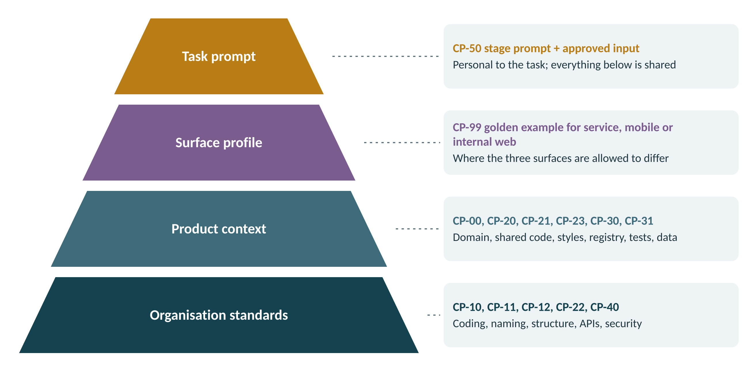
Figure 8 — Context layers: only the task prompt is personal

7.2 Files and owners
File | Content | Owner | Update trigger
AI-INSTRUCTIONS.md | Root instruction file loaded by every AI tool; points to /ai-context and states the binding rules | Architect | Any change to the rules
CP-00 product-overview.md | Modules, surfaces, module prefixes, domain glossary (asset class, SLM, WDV, CWIP, NBV, impairment, label) | Architect | New module or term
CP-10 coding-standards.md | Layering, exceptions, logging, transactions, audit trail, versioning policy | Architect | Standards change
CP-11 naming-conventions.md | Packages, classes, methods, tables, columns, API paths, events, branches, commits, test IDs | Architect | Standards change
CP-12 folder-structure.md | Canonical project skeleton per surface and where each kind of file goes | Architect | Structure change
CP-20 shared-library-index.md | Every base class, utility, validator and component, with when to use it and the do-not-rewrite list | Tech Leads | Any shared code added or retired
CP-21 ui-style-guide.md | Design tokens, approved style classes, component catalogue for web and mobile | UI Lead | Style change
CP-22 api-contract-standards.md | REST conventions, versioning, pagination, error envelope, event naming | Architect | Standards change
CP-23 validation-and-error-registry.md | Every validation ID and error code with message text; the only source for SFVD and code | Architect | Approved registry change
CP-30 test-standards.md | Test case template, ID convention, negative-pattern library, automation and locator patterns, device matrix | QA Lead | Standards change
CP-31 test-data-and-seed.md | Seed data structure, standard asset fixtures, masking rules, data builders | QA Lead | Data model change
CP-40 security-and-compliance.md | Authorisation model, PII handling, audit log rules, secrets policy, AI data rules | Security | Policy change
CP-50 prompt-templates/ | One approved prompt per stage, S0 to S9 | Architect + QA Lead | Prompt improvement
CP-60 review-checklists.md | The gate checklists from T10, so AI can self-check before a human reviews | Council | Checklist change
CP-99 golden-examples/ | One reference feature per surface (service, mobile, internal web) for AI to imitate | Tech Leads | Quarterly refresh
Starter versions of every file, with the sections each owner must complete, are provided in the ai-context folder of this package.

7.3 How the pack is loaded
- The pack lives at /ai-context in the main repository, so it is versioned, reviewed and branched like code.
- AI-INSTRUCTIONS.md at the repository root states the binding rules and points to /ai-context. Each approved AI tool has a one-line pointer file in the location that tool reads automatically, so whichever approved tool is used loads the same rules.
- The current version is held in /ai-context/VERSION and is recorded in T11, in the pull request description and in every T10 gate record.
- Surface profiles are selected in the prompt (“profile: microservice”, “profile: mobile”, “profile: internal web”).

7.4 Change control
- Anyone raises T14 describing the gap, with an example of the wrong AI output it causes.
- The file owner drafts the change as a pull request to /ai-context.
- Two approvals are required: the file owner and one Council member.
- On merge, VERSION is bumped (minor for additions, major for rule changes) and a short note goes to all three surface teams the same day.
- Target lead time from T14 to merge: five working days. Lead time is reported monthly.

7.5 Standard stage prompt structure
Every prompt for a deliverable uses the eight blocks below. The stage templates in CP-50 pre-fill blocks 1, 2, 5, 6 and 8; the AI operator completes blocks 3, 4 and 7.
# | Block | Purpose
1 | ROLE | Sets the perspective and the surface profile.
2 | CONTEXT | Names the Context Pack version; makes it binding.
3 | INPUT | Approved artifact IDs and versions — referenced, never retyped.
4 | TASK | One stage deliverable only.
5 | CONSTRAINTS | Reuse rules; what must not be created; what to do when something is missing.
6 | OUTPUT FORMAT | The template to fill, so review is mechanical.
7 | TRACEABILITY | IDs to stamp on every section; Context Pack and prompt version.
8 | SELF-CHECK | Standards applied, reuse decisions, assumptions, open questions. Non-negotiable.

Example: stage S2 prompt
ROLE: You are a senior technical writer, Fixed Assets suite (internal web).
CONTEXT: Load /ai-context at CP v1.3. Treat every file as binding, not advisory.
INPUT: Requirement Register DEP-RR v1.0, requirements DEP-REQ-210 to DEP-REQ-218.
TASK: Write SFVD sections for these requirements' screens, nothing else.
CONSTRAINTS: Use only fields in the data dictionary and IDs in CP-23, and only style
classes in CP-21. If something you need does not exist, list it under
OPEN QUESTIONS. Do not invent it.
OUTPUT FORMAT: Fill template T02 sections 3 to 7 exactly.
TRACEABILITY: Put the REQ-ID against every screen, field and validation.
Stamp "CP v1.3, P-S2 v3" in the header.
SELF-CHECK: End with (a) standards applied, (b) reuse decisions, (c) ASSUMPTIONS,
(d) OPEN QUESTIONS. Never answer your own open questions.

8 Traceability and Identifiers

8.1 The traceability chain
The requirement ID is the thread that ties every artifact together. It is what lets us prove coverage at audit, see the impact of a change before making it, and trace a defect back to the gate that missed it.
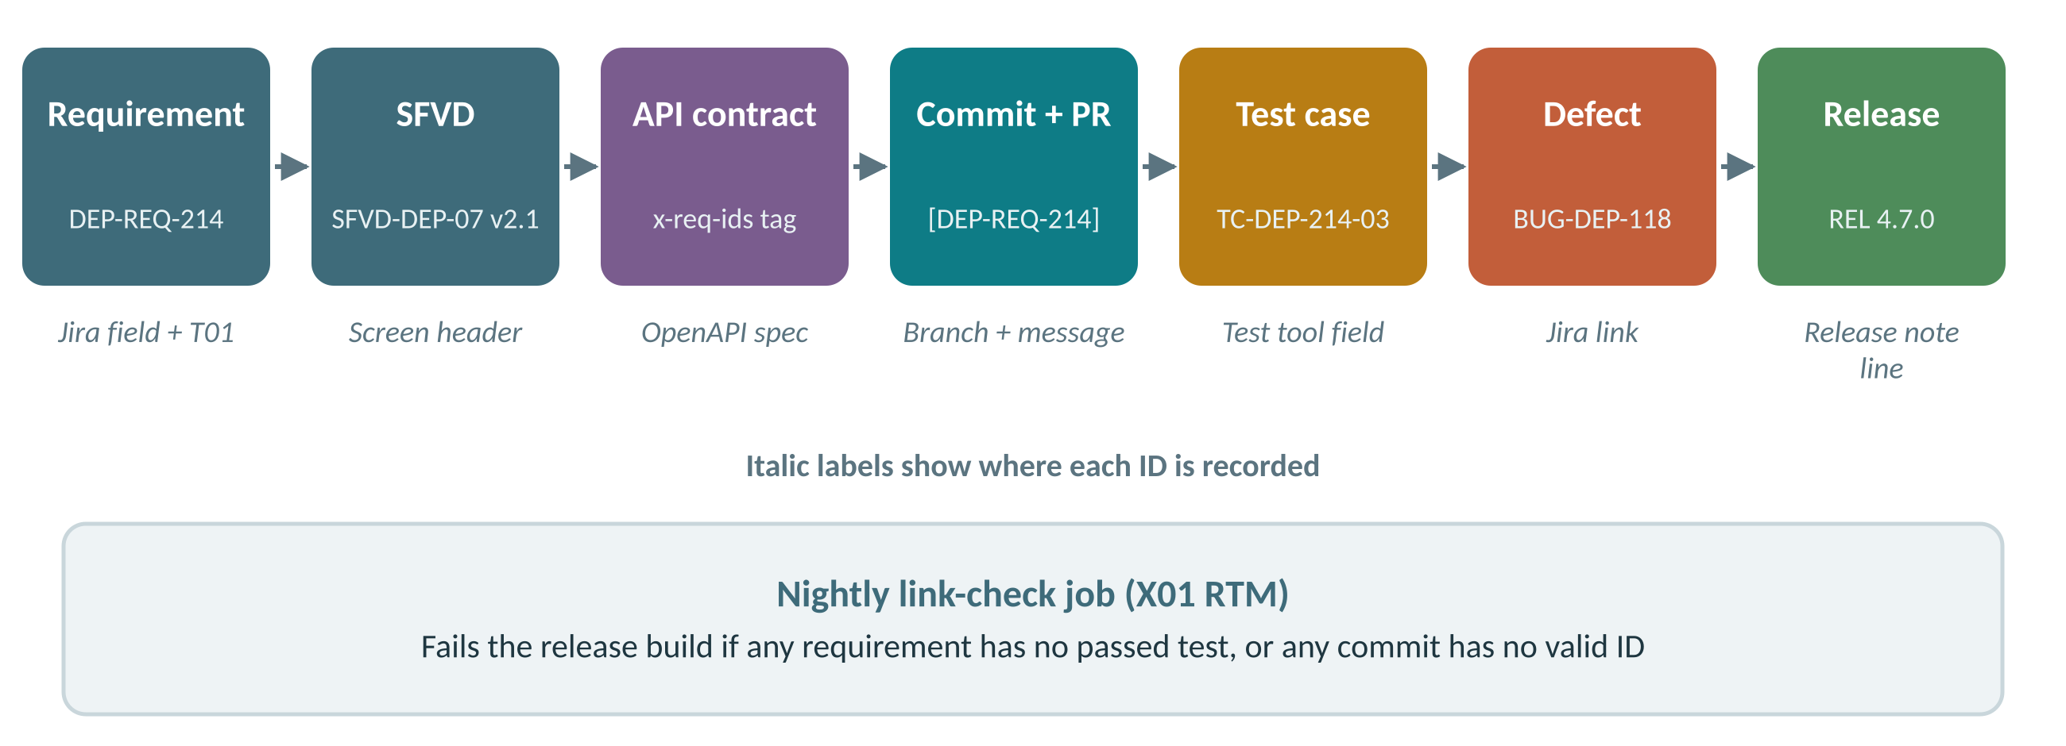
Figure 9 — The traceability chain and where each ID is recorded

8.2 ID conventions
Item | Format | Example
Module prefix | FAM asset master · DEP depreciation · LBL labelling and tracking · AUD validation and audit · PLT platform | DEP
Requirement | <MOD>-REQ-<nnn>; a revised requirement keeps its ID with .r<n> | DEP-REQ-214, DEP-REQ-214.r2
Change request | CR-<yyyy>-<nnn> | CR-2026-031
Service request | SR-<yyyy>-<nnnnn> | SR-2026-00412
Defect | BUG-<MOD>-<nnn> | BUG-DEP-118
SFVD | SFVD-<MOD>-<nn> v<major>.<minor> | SFVD-DEP-07 v2.1
Test case | TC-<MOD>-<REQ nnn>-<nn> | TC-DEP-214-03
Branch | <type>/<ID>-<short-description> | feature/DEP-REQ-214-prorata-wdv
Commit message | [<ID>] <imperative summary> | [DEP-REQ-214] Apply daily pro-rata to WDV additions
Release | REL <major>.<minor>.<patch> | REL 4.7.0
Context Pack | CP v<major>.<minor> | CP v1.3
Prompt template | P-<stage> v<n> | P-S2 v3

8.3 Where each ID must appear
ID | Must appear in
REQ-ID | T01 register, Jira story, SFVD screen and field rows, OpenAPI x-req-ids, branch name, commit message, test case, release note line
CR ID | T04, Jira CR, revision note of each affected REQ, SFVD revision table, release note
SR / BUG ID | T05 or T06, branch name, commit message, failing test name, release note
Test case ID | T07, test management tool, automation script annotation, RTM
Context Pack version | T11, pull request description, T10 gate record
Prompt template version | T11

8.4 Automated traceability checks
- A commit-message check (Git hook and Jenkins stage) rejects commits without a valid ID.
- OpenAPI lint requires an x-req-ids tag on every new or changed operation.
- A nightly job rebuilds the RTM in X01 from Jira, Git and the test management tool, and flags requirements without code or passed tests.
- The release job fails if any requirement in scope lacks a passed test, or if the parity check does not reconcile.

9 Roles, Responsibilities and Governance

9.1 Roles
Role | Responsibilities in the AI SDLC
Product Owner (PO) | Owns scope and priority; approves G1 and the business sign-off at G9; answers business open questions.
Business Analyst (BA) | Runs intake and requirements; operates AI for the register; owns the RTM rows.
Technical Writer | Operates AI for the SFVD; verifies fields, validations and registry IDs.
Architect | Owns the Context Pack and this process; approves G3; decides classification disputes; chairs the Council.
Tech Lead | Operates AI for design; accountable for G4 and G5; maintains the shared library index.
Developer | Operates AI for code and tests; owns every line it generates; completes T09.
Reviewer | Independent of the AI operator; approves or rejects the pull request.
QA Lead / QA Engineer | Operates AI for test cases and data; owns G6 and G7 and the parity check.
Automation Engineer | Operates AI for automation scripts; proves assertions by deliberate-fail checks.
Domain SME | Independently re-derives financial and audit values for verification.
Release Manager | Operates AI for release notes; reconciles scope; prepares G8.
DevOps | Owns pipelines, deployment, monitoring and rollback; accountable for S9 execution.
Security | Consulted on designs and sensitive changes; owns CP-40.
Delivery Manager | Accountable for G0, G8 and G9; owns schedule but cannot bypass a gate.
AI Governance Council | Architect (chair), QA Lead, Delivery Manager, Security. Owns thresholds, waivers, audits and metrics.

9.2 RACI matrix
R responsible, A accountable, C consulted, I informed. Accountable cells are shaded. PO Product Owner; BA Business Analyst; TW Technical Writer; ARC Architect; TL Tech Lead; DEV Developer; REV Reviewer; QA QA Lead / Engineer; REL Release Manager; OPS DevOps; SEC Security; DM Delivery Manager.
Stage | PO | BA | TW | ARC | TL | DEV | REV | QA | REL | OPS | SEC | DM
S0 Intake | I | R |  | C |  |  |  |  |  |  |  | A
S1 Requirements | A | R |  | C |  | I |  | C | I |  |  | I
S2 SFVD | C | A | R | C |  | I |  | C | I
S3 Design |  |  |  | A | R | I |  | C |  |  | C
S4 Development |  |  |  | C | A | R |  | I
S5 Code review | I |  |  | C | A |  | R | I |  |  | C
S6 Test design | I | C |  |  |  | C |  | A/R | I
S7 Test execution | I |  |  |  |  | C |  | A/R | I
S8 Release | I |  |  | C |  |  |  | C | R | C |  | A
S9 Deploy | C | C |  | C |  |  |  | C | I | R |  | A

Separation of duties
The person who ran the AI prompt for an output is never the person who signs the L3 review or the gate for that output.

9.3 AI Governance Council
Item | Definition
Members | Solution Architect (chair), QA Lead, Delivery Manager, Security Lead. Product Owner attends for scope or business-rule topics.
Owns | This document, the Context Pack, gate thresholds, the approved AI tool list, waivers, audits and metrics.
Weekly (30 minutes) | Open T14 and T15 items, gate exceptions, pilot feedback.
Monthly | Drift audit: a 10% sample of AI-assisted merges scored against the T10 checklists. Metrics review (9.5).
Quarterly | Refresh golden examples and prompt templates; review thresholds; retire stale context.
Every release | RTM frozen; open waivers reviewed and cleared or renewed.

9.4 Waivers and escalation
- Any deviation from a rule or gate needs a T15 waiver: what is waived, why, the risk, the owner and an expiry no later than 90 days.
- Only the Council approves a waiver. Schedule pressure alone is not a reason.
- For a P1 incident the Delivery Manager and Architect may approve verbally; the T15 is completed within two working days.
- Waivers are logged in X01 and reviewed at every release.

9.5 Metrics
Metric | Definition | Target | Reviewed
RTM completeness | REQ-IDs with linked code and passed tests ÷ REQ-IDs in scope | 100% | Each release
Automation parity | (Executed + automated + deferred) ÷ approved cases | 100% | Each release
ID discipline | Commits carrying a valid ID ÷ all commits | 100% | Weekly
Gate evidence | Gates with a T10 record ÷ gates passed | 100% | Monthly audit
AI declaration | AI-G artifacts with a T11 declaration ÷ AI-G artifacts | 100% | Monthly audit
Unresolved assumptions at gate | Assumptions still open when a gate is signed | 0 | Each gate
Review findings per AI-assisted PR | Reviewer findings ÷ AI-assisted pull requests | Falling trend | Monthly
Escaped defects | Production defects per release, by stage of origin | Falling trend | Each release
Defects traced to a missed gate | Defects whose RCA names a gate that should have caught them | Each one actioned | Monthly
Stage cycle time | Working days from stage entry to gate | Baseline, then falling | Monthly
Context Pack lead time | Days from T14 raised to merged | ≤ 5 working days | Monthly
Baselines are measured in the first pilot month. Targets marked “trend” are judged on direction, not an absolute number.

10 Support Documents and Templates
The process depends on a small set of documents. Templates T01 to T15 and the tracker workbook X01 are filled in manually, with AI drafting where the mode allows. The Context Pack files are reference documents that AI reads. The configuration artifacts make the tools enforce the process automatically.

10.1 Document lifecycle map
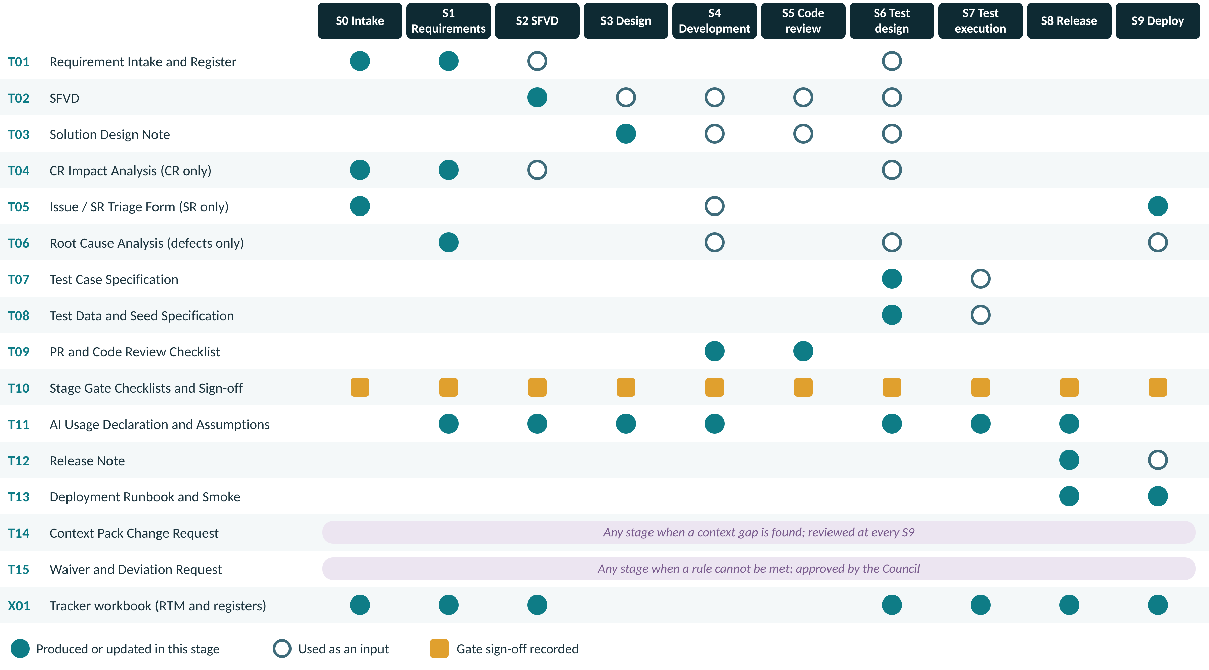
Figure 10 — Which document is produced, used and signed at each stage

10.2 Templates register
ID | Template | Purpose | Stage | Work types | Owner | How it is filled | File
T01 | Requirement Intake and Register | Captures the request, review points, the requirement register with REQ-IDs and acceptance criteria, and the surface impact map | S0, S1 | NF, CR | Business Analyst | AI-G draft, completed and signed manually | templates/T01-*.docx
T02 | SFVD (Screens, Fields, Validations, Data) | Screens, fields, validations, error codes, flows, user stories and UI references | S2 | NF, CR (delta), SR (if behaviour changes) | Tech Writer | AI-G draft, verified manually | templates/T02-*.docx
T03 | Solution Design Note | Service impact, API contract summary, data design, migration, NFRs and the architecture decision record | S3 | NF, CR major | Tech Lead | AI-G draft, reviewed by Architect | templates/T03-*.docx
T04 | Change Request Impact Analysis | Impact on REQs, documents, services, contracts, data, tests and effort; CR approval | S0, S1 (CR) | CR | Architect / BA | AI-A (RTM and code search); decisions manual | templates/T04-*.docx
T05 | Issue and Service Request Triage Form | Reproduction, classification, severity, and for SRs the change details and verification | S0 (SR) | SR | Triage Lead | Manual (AI-A summary of logs) | templates/T05-*.docx
T06 | Root Cause Analysis | Root cause, why it was not caught, which gate missed it, corrective and preventive actions | SR defect path | SR | Developer + Tech Lead | Manual only (AI-X) | templates/T06-*.docx
T07 | Test Case Specification | Test cases with IDs, steps, expected results, REQ mapping and tags | S6 | All | QA Engineer | AI-G draft, verified manually | templates/T07-*.docx
T08 | Test Data and Seed Data Specification | Seed structure, standard fixtures, masking rules and data per case | S6, S7 | All | QA Engineer | AI-G draft, verified manually | templates/T08-*.docx
T09 | Pull Request and Code Review Checklist | Developer self-review and independent reviewer checklist | S4, S5 | All code changes | Developer, Reviewer | Manual | templates/T09-*.docx
T10 | Stage Gate Checklists and Sign-off | One checklist and sign-off block per gate, G0 to G9, with the four verification levels | All | All | Gate owner | Manual | templates/T10-*.docx
T11 | AI Usage Declaration and Assumption Register | Tool, prompt template, Context Pack version, sections generated, assumptions and how each was resolved | Every AI-G step | All | AI operator | Manual | templates/T11-*.docx
T12 | Release Note | Version, scope by REQ-ID, known issues, configuration changes, deferred items | S8 | All | Release Manager | AI-G draft, reconciled manually | templates/T12-*.docx
T13 | Deployment Runbook and Smoke Checklist | Pre-checks, steps, smoke tests, monitoring window, rollback | S8, S9 | All | DevOps | AI-G draft, executed manually | templates/T13-*.docx
T14 | Context Pack Change Request | Proposal to add or change a Context Pack file, with reason and approval | Any | All | Anyone; approved by Council | Manual | templates/T14-*.docx
T15 | Waiver and Deviation Request | Request to bypass a rule or gate, with risk, owner and expiry | Any | All | Requester; approved by Council | Manual | templates/T15-*.docx
X01 | AI SDLC Tracker Workbook (Excel) | RTM, gate log, AI usage log, waiver register, Context Pack version log, defect-to-gate analysis | All | All | BA, QA Lead, Council | Manual, with automated feeds where available | templates/X01-AI-SDLC-Tracker.xlsx

10.3 Configuration artifacts
Artifact | Where | What it enforces
Pull request template (T09 as markdown) | Repository: pull request template location for your Git host | Every PR carries the checklist, IDs, AI usage and Context Pack version
Commit-message ID check | Git hook + Jenkins stage | No commit without a valid REQ, CR, SR or BUG ID
Jenkins quality stages | Jenkinsfile | PMD, Checkstyle, Sonar gate, coverage, duplication, OpenAPI diff, secret scan, ID check
Jenkins release stages | Release pipeline | RTM link check and parity check before promotion
Jira configuration | Jira administration | Work types, custom fields (Work Type, Module, Severity, AI Usage, CP Version), gate statuses that require a T10 attachment
Test management fields | Test management tool | REQ-ID link and automation flag on every case
AI-INSTRUCTIONS.md and tool pointer files | Repository root | Every approved AI tool loads the same rules and Context Pack

10.4 Storage, naming and versioning
Document | Location | File name | Versioning
T01, T02, T03, T07, T08 | Document repository /<module>/<release>/ | <ID>_<Txx>_v<x.y> e.g. SFVD-DEP-07_T02_v2.1 | Minor for edits; major at gate baseline
T04, T05, T06 | Attached to the Jira CR, SR or bug | <CR/SR/BUG ID>_<Txx> | Single version, updated until closed
T09 | Pull request description | — | Pull request history
T10, T11 | Jira gate transition; X01 logs | <ID>_G<n>_T10, <ID>_T11 | One per gate or AI use
T12, T13 | Release folder | REL-<version>_<Txx> | One per release
T14, T15 | Council folder; X01 registers | CPCR-<nnn>, WVR-<nnn> | One per request
Context Pack | Git /ai-context | As in section 7.2 | CP v<major>.<minor> in VERSION

11 Implementation
The process is introduced in phases so delivery does not stop. Gates start in warning mode and become blocking only after the pilot has tuned them. The implementation deck that accompanies this document explains each step to the team.

11.1 Readiness checklist
✓ | Ready to start the pilot when all are true | Evidence
 | This document approved by the AI Governance Council | [evidence / link]
 | Council members named and the weekly slot booked | [evidence / link]
 | /ai-context created; every CP file at v1.0 with owner sections completed | [evidence / link]
 | AI-INSTRUCTIONS.md and the approved-tool pointer files committed | [evidence / link]
 | Approved AI tool list and AI data rules published in CP-40 | [evidence / link]
 | Templates T01 to T15 published in the document repository | [evidence / link]
 | X01 tracker created for each product line | [evidence / link]
 | Jira issue types, fields and gate statuses configured | [evidence / link]
 | Branch naming and commit-message ID check enabled | [evidence / link]
 | Jenkins quality and release stages running in warning mode | [evidence / link]
 | Test management tool has REQ-ID and automation-flag fields | [evidence / link]
 | Pilot items chosen: one NF, one CR and one SR, covering all three surfaces between them | [evidence / link]
 | Team trained: awareness session for all; hands-on session per role | [evidence / link]

11.2 Roll-out phases
Phase | Weeks | Outcomes | Exit criterion
0 Mobilise | 1 – 2 | Approve this document; form the Council; create /ai-context; publish templates | Readiness items 1 to 6 complete
1 Foundation | 3 – 4 | Context Pack v1.0; stage prompts; Jira, Git and Jenkins configured in warning mode; training | All readiness items complete
2 Pilot | 5 – 8 | One NF, one CR and one SR through the full process; weekly retrospective; Context Pack v1.1 | Three pilots closed at G9 with complete evidence
3 Enforce | 9 – 12 | Gates blocking; all new work on the process; first monthly audit | Audit shows at least 90% checklist compliance
4 Sustain | Ongoing | Quarterly refresh; metrics reviewed monthly | Metrics on target for two consecutive quarters

11.3 Jira workflow and gates
Jira status | Stage | Transition requires
Intake | S0 | Work type, module, requester, severity (issues)
Requirements | S1 | G0 record; T04 for CRs; T06 for defects
Specification | S2 | G1 record (T10) attached
Design | S3 | G2 record; skipped for Minor CR and SR without contract change
In development | S4 | G3 record or approved skip
In review | S5 | Pull request linked; CI green (G4)
Test design | S6 (sub-task) | Starts at G2; closes with G6 record
In test | S7 | G5 and G6 records
Release ready | S8 | G7 record; parity report
Deployed | S9 | G8 record; release note
Closed | — | G9 record; RTM frozen

Appendix A Worked Examples
Illustrative only
These examples show how the process is applied. IDs, counts and findings are illustrative, not records of real work.

A.1 New feature: RFID scanning for physical verification (mobile)
Finance Operations want field staff to verify assets with handheld RFID readers instead of barcode scans.
Stage | What happened | Artifact | Mode
S0 | Classified NF in the LBL module; mobile and verification service affected | Jira epic | M
S1 | AI drafted 14 requirements from a three-page note. Reconciliation removed 2 invented ones (offline photo upload) and added 1 missed (resume a partial scan). SME confirmed verification statuses. | LBL-REQ-101 to 114 | AI-G → M
S2 | SFVD for six mobile screens. Registry lookup rejected three invented error codes; reuse of the shared scan component confirmed. | SFVD-LBL-04 v1.0 | AI-G → M
S3 | New batch verification endpoint; OpenAPI diff showed an additive change only; offline sync queue approved. | T03, contract v1.4 | AI-G → M
S6 | 61 cases drafted; 7 duplicates of existing regression removed; SME verified discrepancy rules. | T07, T08 | AI-G → M
S4–S5 | Five pull requests under 400 lines. Reviewer rejected a new date utility that duplicated an existing validator. | T09 | AI-G → M
S7–S9 | Parity: 54 automated + 7 manual = 61 approved. Released, smoke passed, RTM frozen. | T12, T13 | AUTO + M

A.2 Change request: daily pro-rata depreciation for mid-year additions
CR-2026-031 changes the written-down-value calculation so additions are depreciated from the day they are put to use.
Stage | What happened | Artifact | Mode
S0–S1 | AI searched the RTM and code; Architect confirmed impact on DEP-REQ-214, SFVD-DEP-07 section 4.2 and the calculation engine. Classified Major (financial calculation). Finance approved prospective application. | T04 | M + AI-A
S2 | SFVD section 4.2 updated with change marks; v2.0 to v2.1; DEP-REQ-214 revised to .r2. | T02 delta | AI-G → M
S6 | AI proposed 38 regression cases from the RTM; QA Lead added month-end close. SME hand-calculated three scenarios, including a leap-year addition. | T07 | AI-G + AI-A → M
S4–S9 | Code change reviewed for backward compatibility; regression passed; released as a minor version. | T09, T12 | AI-G → M

A.3 Defect (P2): duplicate depreciation entries for transferred assets
BUG-DEP-118: assets transferred mid-month received two depreciation postings.
Stage | What happened | Artifact | Mode
S0 | Triage reproduced the defect; severity P2 (financial misstatement contained before close). | T05 | M + AI-A
S1 | Manual RCA: the transfer event consumer was not idempotent. Gate missed: S6 had no transfer-within-period case. | T06 | AI-X
S4–S5 | Failing test committed first; fix written manually; two engineers and the Architect reviewed. | T09 | M
S8–S9 | Hotfix release with targeted and regression tests. Preventive actions: idempotency rule added to CP-10, transfer pattern added to CP-30 via T14. | T12, T14 | M

A.4 Service request: correct useful life for 42 assets
SR-2026-00412: 42 assets in the class “Computers” were registered with the wrong useful life.
Stage | What happened | Artifact | Mode
S0 | Classified as a data-correction SR. Changes future depreciation, so it is a financial-value change. | T05 Part A | M
S4 | Script written manually (AI-X because it changes financial values), with a rollback script. | T05 Part C | AI-X
S5 | Two reviewers; dry run on a production-like copy; before and after extracts compared. | T05 Part D | M
S9 | Executed by an authorised admin under a change record; next depreciation run verified with Finance. | T05 Part E | M

Appendix B Quick Reference Card
One line per stage: what AI produces, the three checks most often missed, and who signs the gate. Print it and keep it next to the screen.
Stage | AI produces | Top three human checks | Gate · signs
S0 Intake | Summarise long descriptions, e-mail threads and logs into a structured intake summary | - Work type classified using the rules in section 3.4; borderline cases decided by the Architect  - Intake summary reflects the original request: nothing added, nothing lost  - Duplicates and related items confirmed by a person, not accepted from the AI suggestion | G0 · Delivery Manager
S1 Requirements | Draft register | - Every statement in the source note maps to at least one REQ-ID  - No requirement exists without a source statement (nothing invented by AI)  - Each requirement is atomic, testable and has acceptance criteria | G1 · Product Owner
S2 SFVD | SFVD draft per screen | - Every screen and field maps to a REQ-ID  - Every field matches the data dictionary: name, type, length, mandatory  - Every validation ID and error code exists in the registry; none invented | G2 · BA Lead
S3 Design | Design draft | - No cross-service database access; bounded contexts respected  - Contract backward compatible, or the version bumped with consumers listed  - The capability does not already exist in another service | G3 · Architect
S4 Development | Code inside the existing structure, unit tests, configuration, i18n keys and migration | - Shared library searched; no duplicate utility, validator, base method or CSS created  - Package, class, method and file names follow CP-11  - Layering and folder placement follow CP-12 | G4 · Tech Lead
S5 Code review | A review aid | - Reviewer is not the developer who ran the AI prompt  - Business logic matches the SFVD and acceptance criteria  - Reuse opportunities enforced, not merely noted | G5 · Tech Lead
S6 Test design | Test cases | - Every REQ-ID has at least one positive and one negative case  - Every field validation in the SFVD has a test case  - Expected results traced to SFVD text, not inferred | G6 · QA Lead
S7 Test execution | Automation scripts | - Every automated script maps one-to-one to an approved case; no steps dropped  - Assertions verify expected results, proven by a deliberate-fail check on a sample  - No hardcoded data, fixed waits or environment coupling | G7 · QA Lead
S8 Release | Release notes from commits and REQ-IDs, config diff summary and rollback steps | - Version number unique and follows policy; artifact checksum recorded  - Every release-note line traces to a merged pull request and REQ-ID; nothing omitted  - Known issues and deferred cases listed | G8 · Delivery Manager
S9 Deploy | Summarise post-deployment logs and metrics for anomalies | - Backup confirmed by a named person before deployment  - Deployment executed from the runbook; deviations recorded  - Smoke pack 100% passed, executed by QA rather than the deployer | G9 · Delivery Manager

