**IDE LAB EXAM**

G.MAANSI

221710310017

CSE B10

**7.a)**

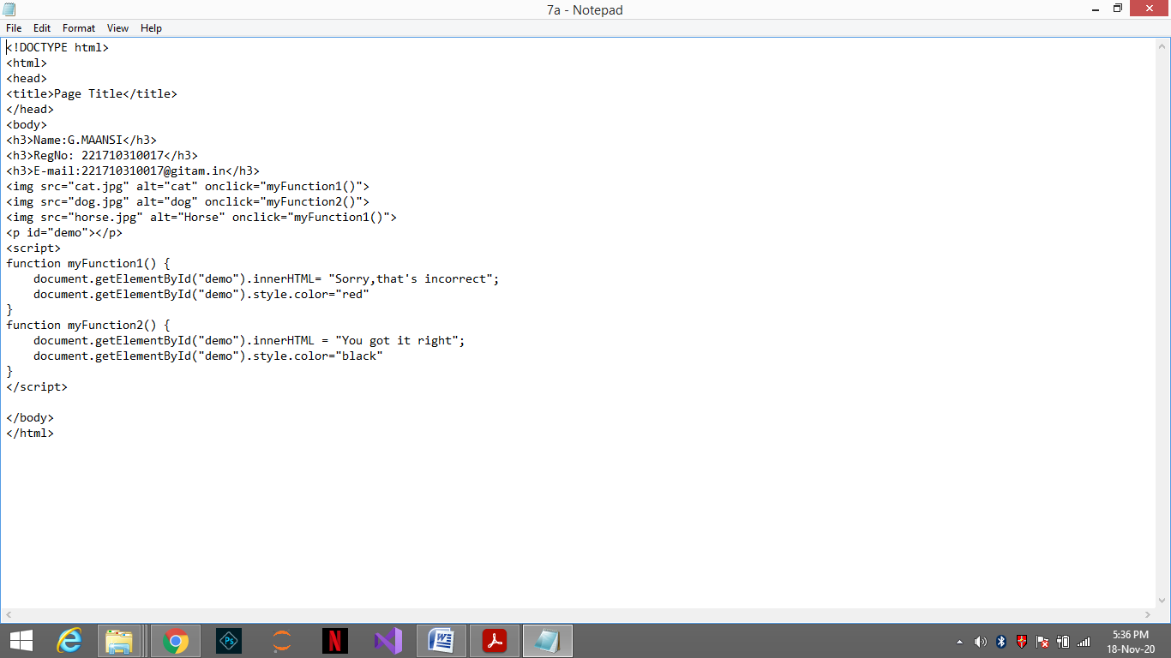

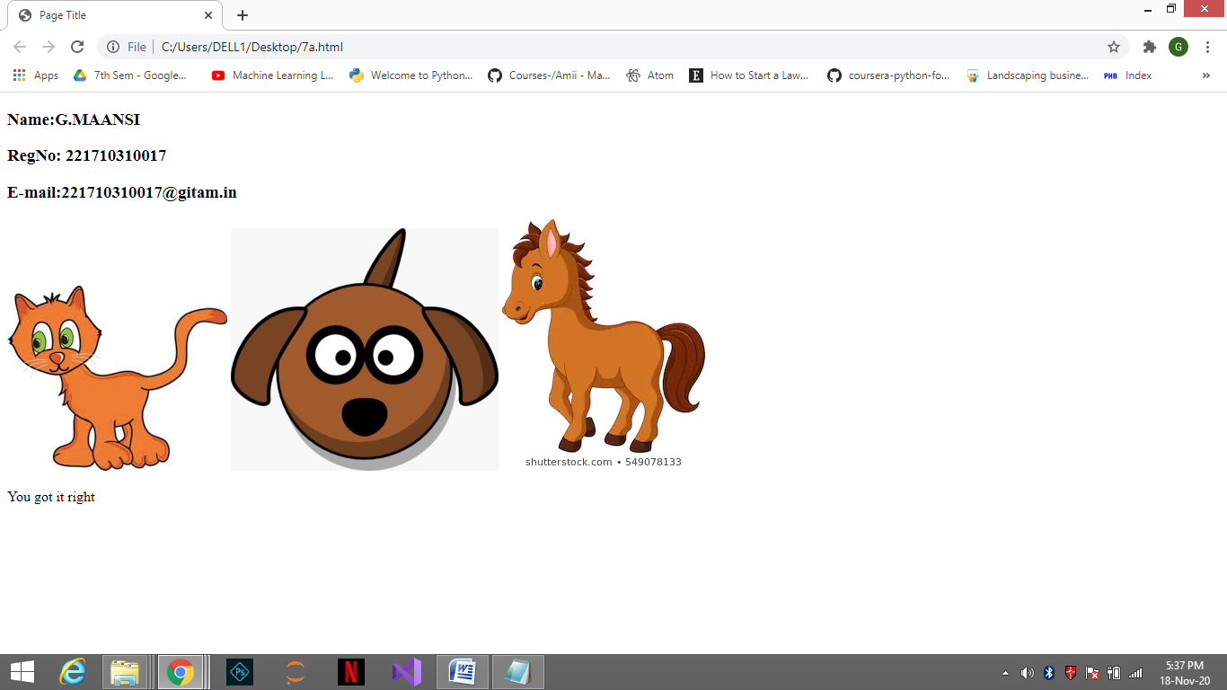

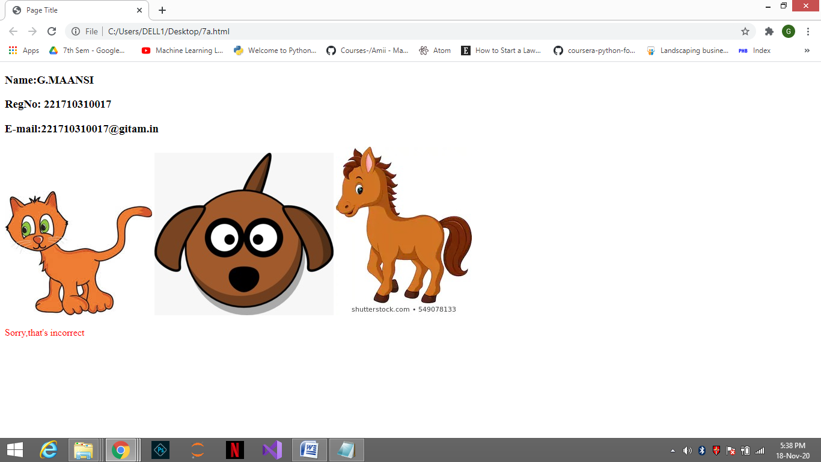

**7.b) Write a javascript program to swap two halves of a given array of integers of even length.**

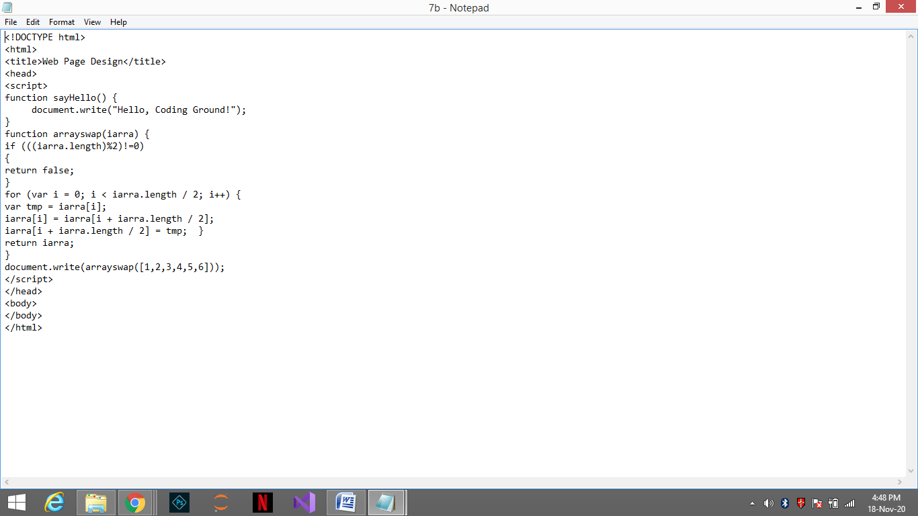

**Output:**

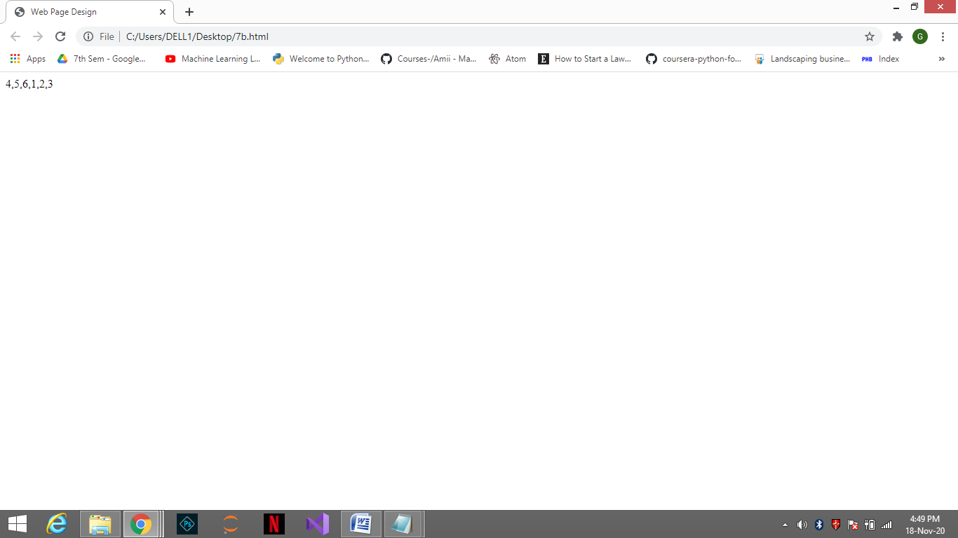

**7.c) Write a function sum that calculates the sum of all elements of a two dimensional array.**

