IDE Test Feedback
Technical documentation for mod_idetestfeedback
Plugin release 1.0.0 (version 2026092400)
Requires Moodle 4.5 or later; supported 4.5 to 5.3
Maanus Roosioks · 27 September 2026
Contents
Architecture 2
System context 2
Components 4
Data model 6
Tables 6
Indexes 9
Submission flow 10
Sequence 10
Validation 10
After the run is stored 11
Viewing and feedback 12
Run lists 12
Run detail 12
Teacher feedback 13
Capabilities and roles 15
Default role assignments 15
What each capability controls 15
Core capabilities the plugin relies on 16
Setting up the middleware account 16
Data lifecycle 17
Deleting runs 17
Privacy export 17
Backup and restore 17

Architecture
mod_idetestfeedback is a Moodle activity module. Students' IDEs submit unit test runs to it through a web service. Students and teachers read those runs on the activity page, and teachers can comment on individual test results.

System context

Trust boundary
The IDE never talks to Moodle directly. The Java middleware logs the student in through OAuth, then calls mod_idetestfeedback_submit_test_run with a token that belongs to its own service account. Moodle attributes the run to the email parameter, which is the identity the middleware asserts.
The service account is therefore the trust boundary. Only it may call the service: mod/idetestfeedback:submit is a system capability that no role receives, and the ide_test_results service is installed disabled and accepts only authorised users. The student named in the call must still be allowed to submit: they are checked for enrolment, access to the activity, the :recordruns capability and the submission window, so the service account can't add runs where a student couldn't. The Capabilities and roles chapter describes every capability and the account setup.
Everything else the client sends is treated as data. Moodle computes every stored hash itself, strips credentials from repourl, and enforces capturedisabled by dropping the code whatever the client included.
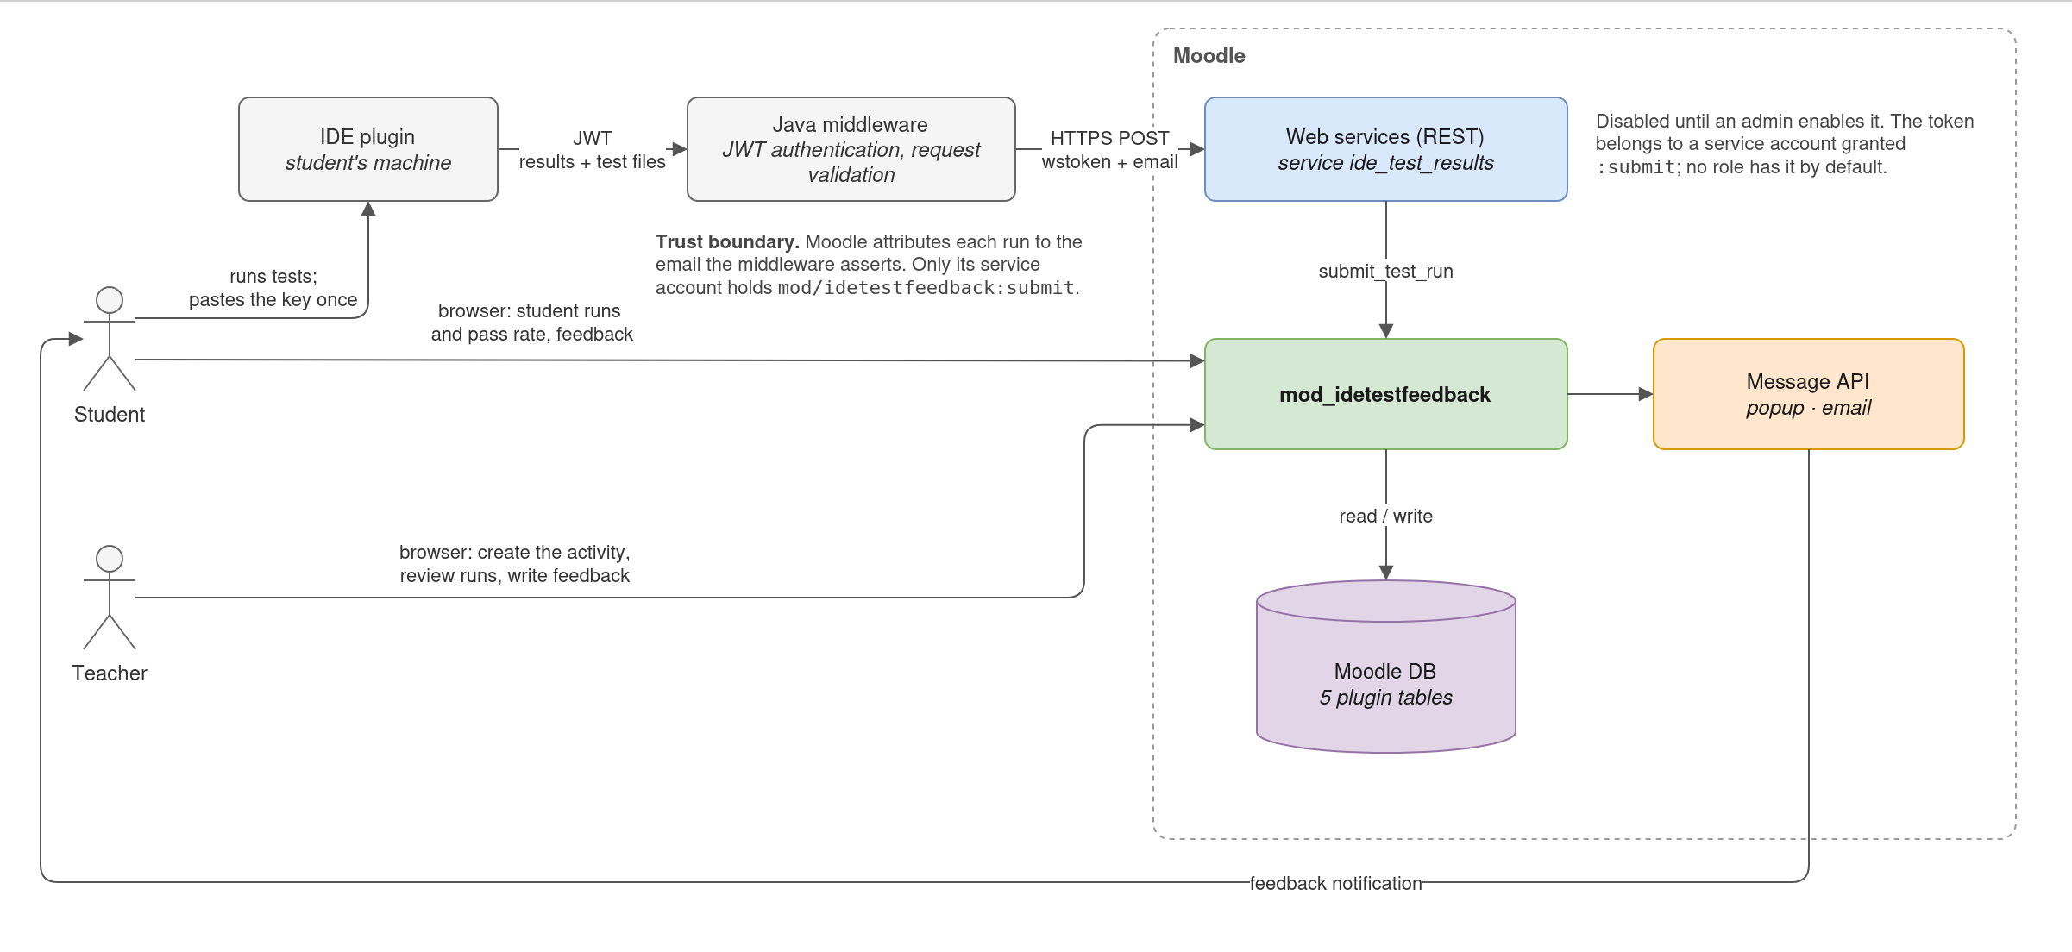
Figure 1. System context

Components
Layer | Where | Responsibility
Entry points | external/submit_test_run.php, view.php, index.php | - external/submit_test_run.php receives web service calls, validates the submission and stores it.  - view.php creates the controller with the page's parameters and calls it.  - index.php is Moodle's standard list of all IDE Test Feedback activities in a course.
Controller | classes/view.php | Checks user rights, saves feedback, shows lists of runs, run results and file contents.
Domain | classes/local/ | The plugin's own logic: turning a submission into stored rows, handling captured source code and repository URLs, teacher feedback, and the rules for run status, source location and the submission window.
Output | classes/output/, templates/ | Uses renderables and templates to display data in HTML.
Persistence | classes/local/repository.php | All database reads and writes. Writes that store or delete runs take a per-activity lock, so a delete can't remove shared file content that a new run is linking to at the same moment.
Subsystem callbacks | lib.php, classes/privacy/, backup/moodle2/, classes/completion/, classes/event/ | The points where Moodle calls the plugin on its own.

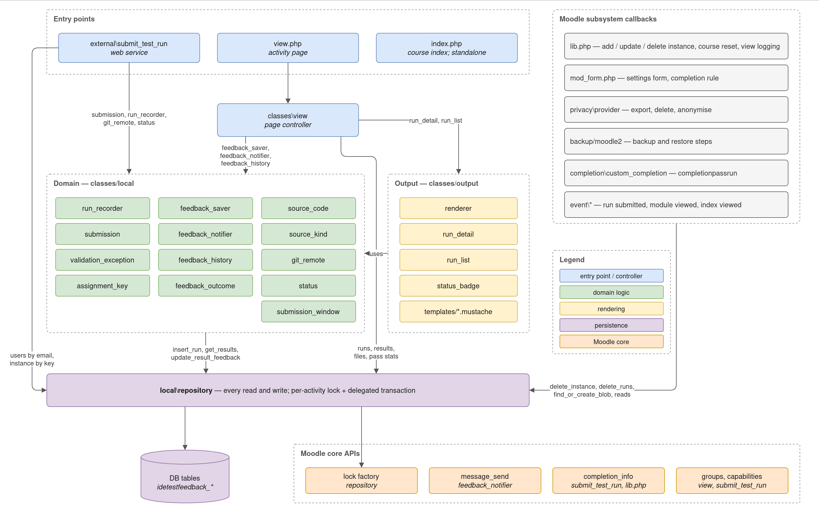
Figure 2. Components

Data model
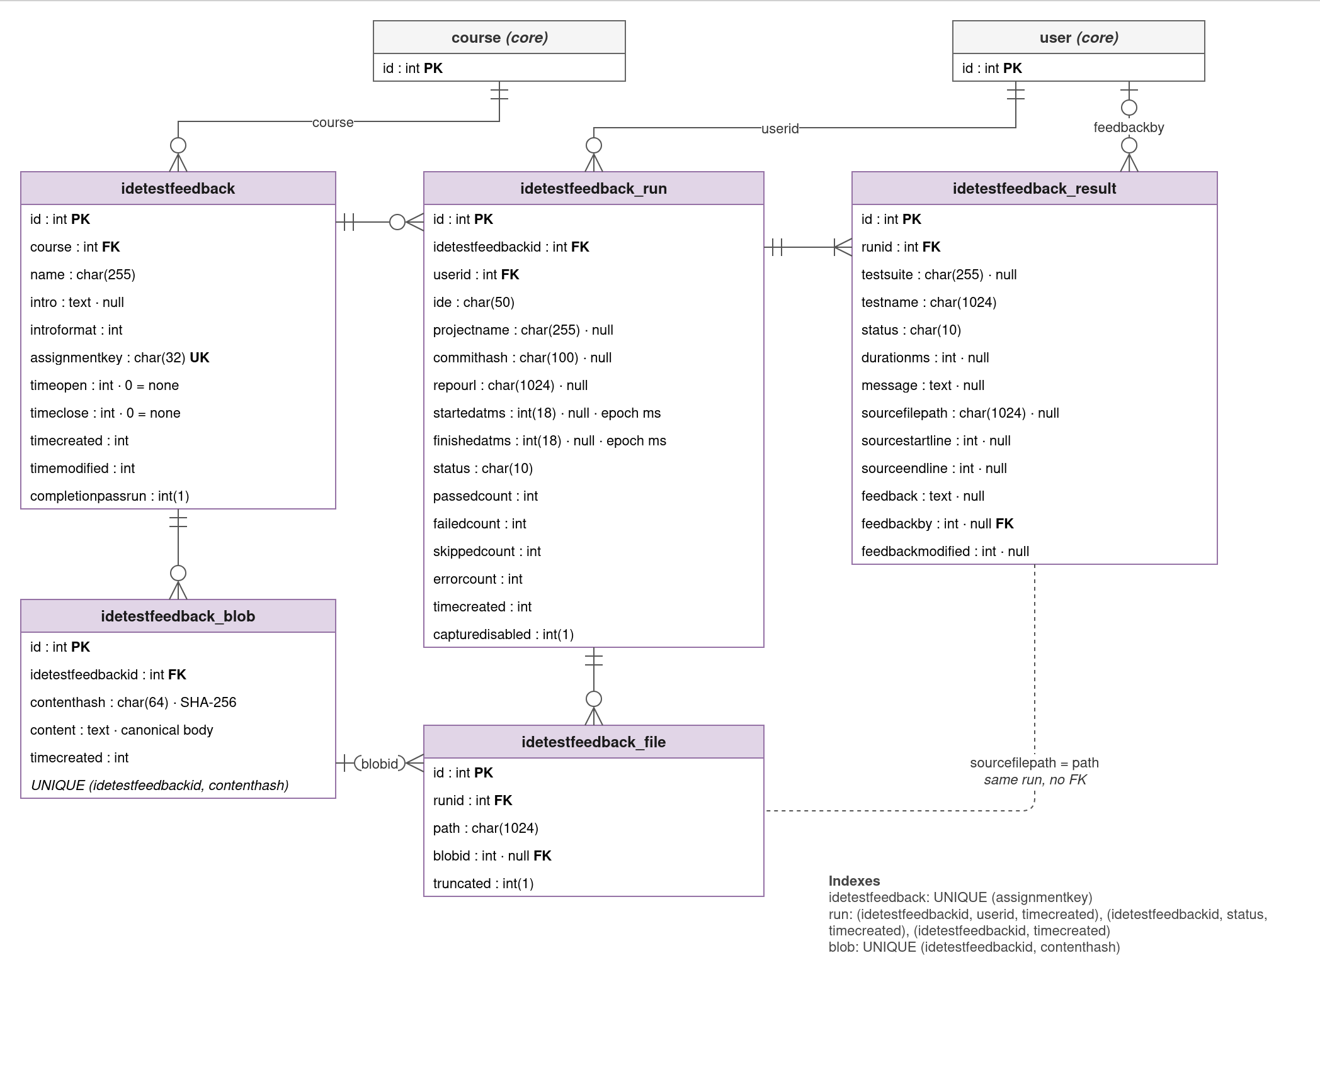
Figure 3. Data model

Tables
The plugin owns five tables. Each has an id primary key. Times are Unix timestamps in seconds, except columns ending in ms, which hold epoch milliseconds as the IDE reported them. In the tables below, null marks a column that may be empty; every other column is required.

idetestfeedback
The activity itself: one row per IDE Test Feedback activity, created by idetestfeedback_add_instance() when a teacher adds it to a course and updated when they edit its settings.
Column | Type | Description
course | int(10) | Course the activity belongs to. Foreign key to course.id.
name | char(255) | Activity name.
intro, introformat | text null, int(4) | Description shown on the course page, and its text format.
assignmentkey | char(32) | Key students paste into their IDE to send runs here. 32 random hex characters, generated on creation and never changed by editing. Unique across the site.
timeopen | int(10) | Start of the submission window, or 0 for no start.
timeclose | int(10) | End of the submission window, or 0 for no end.
timecreated, timemodified | int(10) | When the activity was created and last edited.
completionpassrun | int(1) | 1 when the activity counts as complete once the student has a run in which every test passed.

idetestfeedback_run
One test run: a row per accepted submission, written by run_recorder in a single transaction with its results and files. Runs are never updated afterwards.
Column | Type | Description
idetestfeedbackid | int(10) | Activity the run was submitted to. Foreign key to idetestfeedback.id.
userid | int(10) | Student the run belongs to, resolved from the submitted email. Foreign key to user.id.
ide | char(50) | IDE identifier as sent, for example VSCODE.
projectname | char(255) null | Project the tests ran in.
commithash | char(100) null | Commit the tests ran against.
repourl | char(1024) null | Git remote url with any credentials removed. Null when not sent or longer than 1024 characters.
startedatms, finishedatms | int(18) null | When the IDE started and finished the run.
status | char(10) | Overall result: ERROR if any test errored, otherwise FAILED if any failed, otherwise PASSED if any passed, otherwise SKIPPED.
passedcount, failedcount, skippedcount, errorcount | int(6) | Number of results with each status.
timecreated | int(10) | When Moodle received the run.
capturedisabled | int(1) | 1 when the student turned off sending source code; the run then has no file bodies.

idetestfeedback_result
One test case within a run. A run has at least one result. Only the three feedback columns change after the run is stored.
Column | Type | Description
runid | int(10) | Run the result belongs to. Foreign key to idetestfeedback_run.id.
testsuite | char(255) null | Suite or class the test belongs to.
testname | char(1024) | Name of the test.
status | char(10) | PASSED, FAILED, SKIPPED or ERROR.
durationms | int(10) null | How long the test took, in milliseconds.
message | text null | Failure or error message.
sourcefilepath | char(1024) null | File the IDE found the test in. Matches idetestfeedback_file.path in the same run; it is not a foreign key, because the file may not have been captured. Null when the test wasn't found.
sourcestartline, sourceendline | int(10) null | The first and last line of the test's declaration, counted from 1 as in an editor; both lines belong to the test. Null when the file was found but the test could not be located in it.
feedback | text null | The teacher's comment on this result, as plain text.
feedbackby | int(10) null | Teacher who last edited the comment. Foreign key to user.id; set to null when that teacher's data is deleted, while the comment stays.
feedbackmodified | int(10) null | When the comment was last edited.

feedback, feedbackby and feedbackmodified are set together, and a teacher clearing the comment clears all three.

idetestfeedback_file
One file captured with a run. The row records that the run captured the path; the content itself is stored in idetestfeedback_blob, so identical files are kept only once.
Column | Type | Description
runid | int(10) | Run the file was captured with. Foreign key to idetestfeedback_run.id.
path | char(1024) | Path relative to the repository root. Unique within a run; run_recorder enforces this, since the database doesn't.
blobid | int(10) null | The file's content. Foreign key to idetestfeedback_blob.id. Null when capture was disabled, the IDE sent no content, or the content was empty.
truncated | int(1) | 1 when the content is not the whole file: the IDE or Moodle truncated it.

idetestfeedback_blob
The content of captured files, stored once per distinct content per activity. Every file row with the same content in the same activity points at the same blob, whether it came from another run of the same student or from another student. A blob is deleted as soon as no file row points at it.
Column | Type | Description
idetestfeedbackid | int(10) | Activity the content belongs to. Foreign key to idetestfeedback.id.
contenthash | char(64) | SHA-256 of content, computed by Moodle. Unique within the activity.
content | text | The file content in canonical form: LF line endings, no byte order mark or IDE truncation marker, and no trailing whitespace on lines or at the end.
timecreated | int(10) | When this content was first stored in the activity.

Indexes
Moodle adds an index for every foreign key. The explicit ones:
Index | Serves
idetestfeedback (assignmentkey) unique | Resolving a submission's activity
run (idetestfeedbackid, userid, timecreated) | Student run list, pass rate, completion check, feedback history
run (idetestfeedbackid, status, timecreated) | Teacher run list filtered by status
run (idetestfeedbackid, timecreated) | Teacher run list, newest first
blob (idetestfeedbackid, contenthash) unique | Blob find-or-create

Submission flow
A run enters through mod_idetestfeedback_submit_test_run (classes/external/submit_test_run.php). This chapter follows one request from the HTTP call to the stored rows.

Sequence
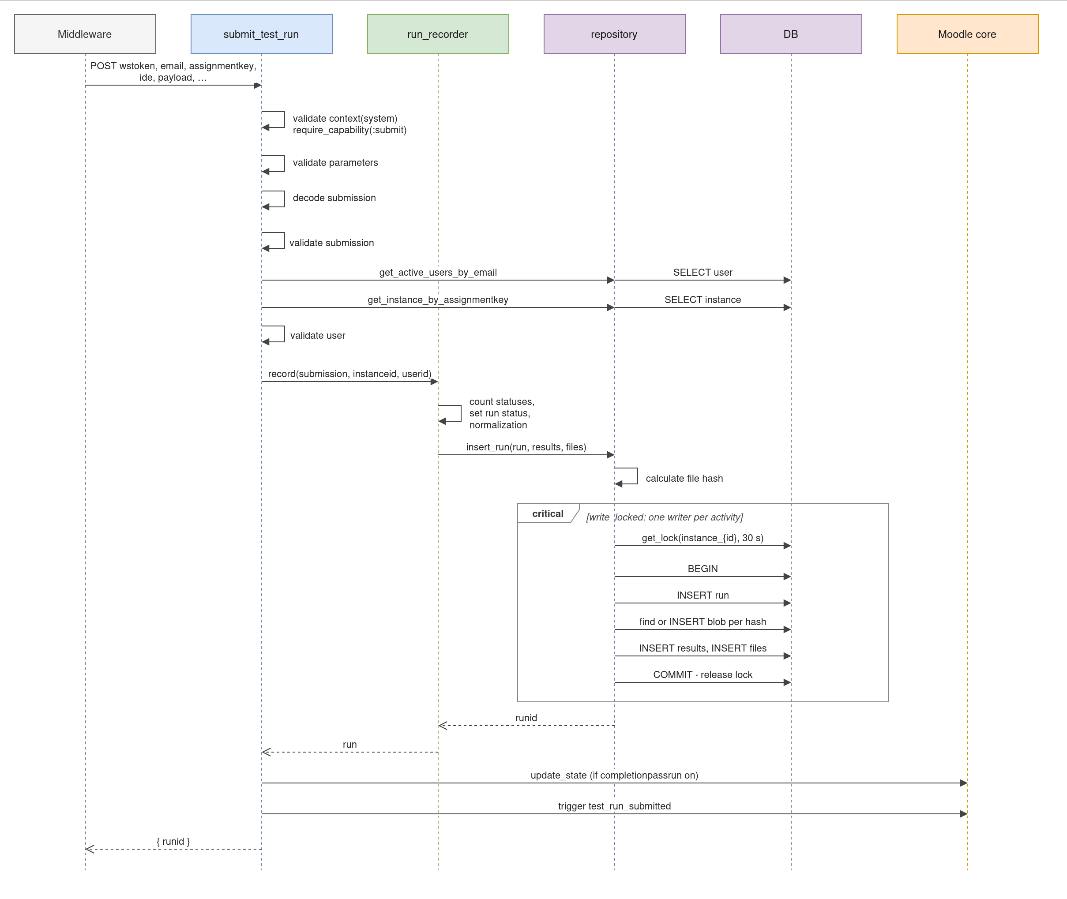
Figure 4. Submission sequence
execute() validates, decodes, resolves the student and activity, and only then hands the submission to run_recorder, so nothing is written until every check has passed. A failure throws, and the REST server returns Moodle's standard error object (exception, errorcode, message) with a localised message.

Validation
execute() checks a submission in four stages and stops at the first failure: the calling account's permission, the shape of the payload (valid JSON within content limits), the values themselves (no blank names, known statuses, sensible times and line ranges), and finally whether the student may submit to this activity now (a single active account, enrolment, access, user rights, the submission window). Each failure has its own error code.

After the run is stored
- Completion. When completionpassrun is on and completion is enabled, the student's state is recalculated. The rule needs a PASSED run with skippedcount = 0, because a run is PASSED as soon as nothing failed, even if tests were skipped.
- Event. \mod_idetestfeedback\event\test_run_submitted is triggered with the run as its object, the student as user and related user, and the run's status in other. Its URL opens the run.

Viewing and feedback
Everything a person sees goes through view.php, which hands its query parameters to the controller classes/view.php.

Run lists
Both lists show 50 runs per page, newest first, through the run_list renderable.
Teacher list. It follows the activity's group mode through the standard group menu; in separate groups, a viewer who may not see all groups and belongs to none sees a notice instead of runs. The student filter lists only students with runs in the current group. Columns: student, IDE, project, commit, status, passed, failed (failed plus errored), submitted.
Student list. The viewer's own runs, with the number of runs and the pass rate: the share of runs whose status is PASSED. Unlike the completion rule, it counts runs with skipped tests.

Run detail
run_detail (classes/output/run_detail.php) exports everything the page needs, and the renderer assembles four templates:
- Summary (run_detail.mustache): the student (for :viewall viewers), IDE, project, repository and commit (linked when browsable), status, passed out of total, skipped, timing, a capture disabled flag, and when the run arrived.
- Results (run_results.mustache): 50 per page, errors first, then failures, skips and passes, each sorted by suite and name. The feedback column appears when the viewer can comment or any result already has feedback.
- Feedback form (run_feedback_form.mustache): for viewers who can comment, it wraps the results with a text box per row and the Notify student by message tick box.
- Files (run_files.mustache): every captured file.

Source code
Each result row can expand to the code the test ran:
- The excerpt is cut from the run's copy of the file, joined on the path. A test below the point where a large file was clipped has no body; it is flagged as truncated rather than stored twice.
- When a run captured no files at all, a missing path doesn't mean the test wasn't found, so the row shows no source section.
- Line numbers start at the test's own start line.
The Files section shows bodies inline in path order until 1 MB has been shown; later files link to a page of their own. Each body shows its hash, and truncated files get a badge.
Syntax highlighting uses Prism from filter_codehighlighter, loaded only when a highlighted block is on the page, whether or not the filter is enabled, and skipped if the plugin isn't installed. run_detail::language_of() maps extensions to the grammars that build ships: C, C++, C#, CSS, markup, Java, JavaScript, PHP, Python and Ruby.

Teacher feedback
Saving. feedback_saver::save() walks the run's own results, so a posted id from another run is ignored. Results the form didn't post are left alone, which matters because the form shows one page of results at a time. Text is trimmed and compared with what is stored, and unchanged rows are skipped. A blank box clears the feedback, its author and its timestamp. Feedback is stored as plain text and escaped by format_text(FORMAT_PLAIN) on the way out.
Notifying. When the tick box is ticked and at least one result gained non-empty feedback, feedback_notifier sends one message from the teacher to the run's owner. It lists each changed test (suite#name) with its new text and links to the run. The feedback message provider is on by default for popup and email; students can change that in their notification preferences.
Since-feedback badges. A test is compared with the most recent earlier result of the same test that carried feedback: same student and activity, a run submitted before this one, and feedback written before this run arrived. Tests match on suite and name, trimmed and case-insensitive. feedback_outcome::between() classifies the pair:
At feedback | Now | Badge
FAILED / ERROR | PASSED | Fixed since feedback
FAILED / ERROR | FAILED / ERROR | Still failing since feedback
PASSED | FAILED / ERROR | Failing since feedback

Any other pair gets no badge, and neither does a result that carries feedback of its own.

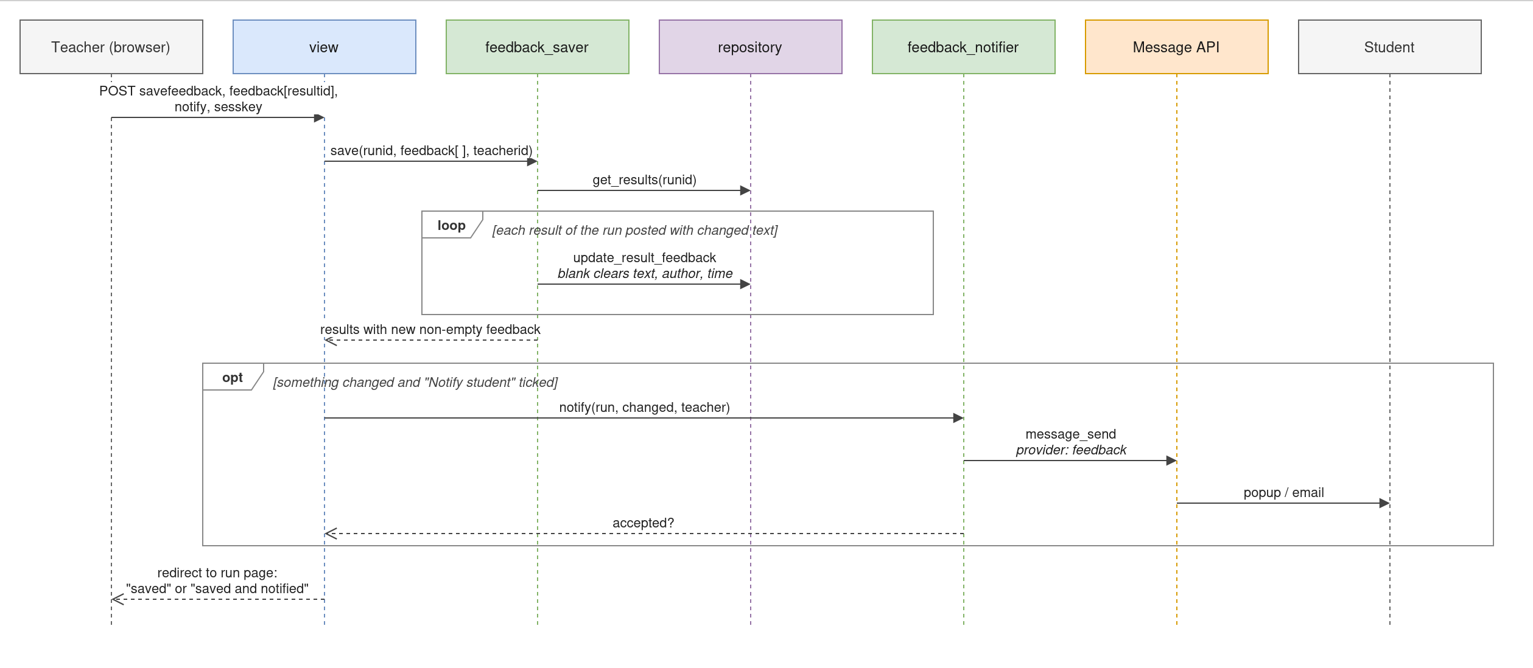
Figure 5. Feedback sequence

Capabilities and roles
The plugin defines six capabilities in db/access.php.

Default role assignments
On installation, Moodle gives each capability to the roles built on the listed archetypes. Administrators can change this per role, or per activity through Permissions.
Capability | Student | Non-editing teacher | Teacher | Manager
mod/idetestfeedback:view | Allow | Allow | Allow | Allow
mod/idetestfeedback:viewall | — | Allow | Allow | Allow
mod/idetestfeedback:comment | — | Allow | Allow | Allow
mod/idetestfeedback:recordruns | Allow | — | — | —
mod/idetestfeedback:submit | — | — | — | —
mod/idetestfeedback:addinstance | — | — | Allow | Allow

No role receives :submit; it is for the middleware's service account alone. :addinstance is cloned from moodle/course:manageactivities, so it follows whoever may already add activities. Site administrators pass every capability check, but a run attributed to one still fails because administrators aren't enrolled as students.
Capability | Name shown in Moodle | Context | Type | Risks
:view | View own IDE test results | Activity | read | —
:viewall | View all students' IDE test results | Activity | read | Personal data
:comment | Add feedback to students' test results | Activity | write | Spam
:recordruns | Have own IDE test runs recorded | Activity | write | —
:submit | Submit IDE test results via API | System | write | Personal data, spam
:addinstance | Add a new IDE Test Feedback activity | Course | write | Spam, XSS

What each capability controls

mod/idetestfeedback:view
- Opening the activity requires it, unless the viewer has :viewall. With :view alone, the viewer sees and opens only their own runs.
- A submission is accepted only if the student it names has it in the activity.
- index.php shows an activity's assignment key only to users with :view or :viewall there.
- Feedback notifications appear in a user's notification preferences only when they hold it, because the feedback message provider names it.

mod/idetestfeedback:viewall
Runs contain students' names, code, repository URLs and commit history, hence the personal-data risk.
- The activity shows the teacher run list, with group menu and filters, instead of the viewer's own runs.
- Run pages name the student.

mod/idetestfeedback:comment
Saving feedback can message the student, hence the spam risk. It takes effect only together with :viewall: only then does the run page show the feedback boxes, and saving checks both.

mod/idetestfeedback:recordruns
Checked for the student a run is attributed to, not for the calling account. Only students have it by default, so a teacher running the tests in their own IDE is rejected instead of appearing among the class's results.

mod/idetestfeedback:submit
Checked first on every web service call, against the account that owns the token. Its holder can create runs for any user by naming their email, hence both risks and the system context.

mod/idetestfeedback:addinstance
The standard activity-module capability, checked by Moodle core when an activity is added. The plugin never checks it.

Core capabilities the plugin relies on
Capability | Effect in this plugin
moodle/site:viewfullnames | Which name format run lists, filters and run pages use
moodle/site:accessallgroups | In separate groups, lets a :viewall viewer see every group's runs
webservice/rest:use | Required by Moodle's REST server for the middleware account; no role has it by default

Setting up the middleware account
- Create a user for the middleware. It needs no course enrolments.
- Create a role assignable in the system context that allows mod/idetestfeedback:submit and webservice/rest:use, and assign it to that user in the system context.
- Enable web services and the REST protocol. Enable the IDE Test Results Service, which is installed disabled, and add the user as an authorized user.
- Create a token for the user on that service and configure the middleware with it.
The account needs nothing else: every later check is made against the student.

Data lifecycle

Deleting runs
Every path ends in repository::purge_runs(), run under the activity lock:
- Course reset with Delete all submitted test runs ticked calls delete_runs() for each activity in the course.
- Deleting the activity removes its runs and the instance row in one locked transaction.
- Privacy, whole context deletes every run in the activity.
- Privacy, specific users first detaches those users from feedback they wrote on other people's runs (feedbackby becomes null; the text stays with the student it was written for), then deletes their own runs.

Privacy export
The export writes each of the user's runs, with its results and file bodies, under Test runs, and the feedback they wrote as a teacher under Feedback given to other students. The provider also declares a link to core_message, because feedback notifications are Moodle messages.

Backup and restore
The backup has no blob element: each file carries its body inline. On restore, find_or_create_blob() canonicalises and hashes each body again, so bodies deduplicate inside the new activity as they would on submission. Runs, results and files travel only when the backup includes user data. A feedbackby whose user isn't in the backup restores as null, keeping the text. The assignment key is kept unless the site already uses it, as when duplicating an activity; then a fresh one is generated.

